Name: Hitanshi Meshram
CS(AIML)-A
Batch: 03
Roll no. 41

Experiment no.: 03-B Date: 22nd August, 25

Title:
Write the client server programs using UDP Berkeley socket primitives for wired /wireless
network for following
a. To say Hello to Each other
b. Calculator (Trigonometry)

Aim and Objectives:
- To understand the working of UDP (User Datagram Protocol) in socket programming.
- To establish communication between client and server in a connectionless environment.
- To implement basic message passing using UDP sockets.
- To develop an application that performs trigonometric computations (sin, cos, tan, etc.) requested by the client and processed by the server.
- To gain hands-on experience with Berkeley socket.

Theory:
UDP (User Datagram Protocol) is a connectionless transport protocol that sends data as independent datagrams. It is faster and lightweight compared to TCP but does not guarantee delivery, order, or reliability.
Berkeley Socket Primitives in UDP:
- socket(): create socket
- bind(): assign IP & port (server)
- sendto(): send message
- recvfrom(): receive message
- close(): close socket
Client-Server Model in UDP:
- Server binds to a port and waits for client messages.
- Client sends datagrams without prior connection.
- Communication is stateless and each message includes the destination address.

Program:
UDP_helloserver.cpp
#include <iostream>
#include <cstring>
#include <unistd.h>
#include <arpa/inet.h>

#define PORT 9000
#define BUF_SIZE 1024

int main() {
int sockfd;
char buffer[BUF_SIZE];
struct sockaddr_in servaddr, cliaddr;

sockfd = socket(AF_INET, SOCK_DGRAM, 0);
if (sockfd < 0) {
perror("Socket creation failed");
exit(EXIT_FAILURE);
}

memset(&servaddr, 0, sizeof(servaddr));
memset(&cliaddr, 0, sizeof(cliaddr));

servaddr.sin_family = AF_INET;
servaddr.sin_addr.s_addr = INADDR_ANY;
servaddr.sin_port = htons(PORT);

if (bind(sockfd, (const struct sockaddr *)&servaddr, sizeof(servaddr)) < 0) {
perror("Bind failed");
exit(EXIT_FAILURE);
}

socklen_t len = sizeof(cliaddr);
int n = recvfrom(sockfd, buffer, BUF_SIZE, 0, (struct sockaddr *)&cliaddr, &len);
buffer[n] = '\0';
std::cout << "Client: " << buffer << std::endl;

const char *hello = "Hello from server";
sendto(sockfd, hello, strlen(hello), 0, (const struct sockaddr *)&cliaddr, len);

close(sockfd);
return 0;
}

UDP_helloclient.cpp
#include <iostream>
#include <cstring>
#include <unistd.h>
#include <arpa/inet.h>

#define PORT 9000
#define BUF_SIZE 1024

int main() {
int sockfd;
char buffer[BUF_SIZE];
struct sockaddr_in servaddr, cliaddr;

sockfd = socket(AF_INET, SOCK_DGRAM, 0);
if (sockfd < 0) {
perror("Socket creation failed");
exit(EXIT_FAILURE);
}

memset(&servaddr, 0, sizeof(servaddr));
memset(&cliaddr, 0, sizeof(cliaddr));

servaddr.sin_family = AF_INET;
servaddr.sin_addr.s_addr = INADDR_ANY;
servaddr.sin_port = htons(PORT);

if (bind(sockfd, (const struct sockaddr *)&servaddr, sizeof(servaddr)) < 0) {
perror("Bind failed");
exit(EXIT_FAILURE);
}

socklen_t len = sizeof(cliaddr);
int n = recvfrom(sockfd, buffer, BUF_SIZE, 0, (struct sockaddr *)&cliaddr, &len);
buffer[n] = '\0';
std::cout << "Client: " << buffer << std::endl;

const char *hello = "Hello from server";
sendto(sockfd, hello, strlen(hello), 0, (const struct sockaddr *)&cliaddr, len);

close(sockfd);
return 0;
}

UDP_calc_server.cpp
#include <iostream>
#include <cstring>
#include <unistd.h>
#include <cmath>
#include <arpa/inet.h>

#define PORT 9001
#define BUF_SIZE 1024

double toRadians(double value, bool isDeg) {
return isDeg ? value * M_PI / 180.0 : value;
}

int main() {
int sockfd;
char buffer[BUF_SIZE];
struct sockaddr_in servaddr, cliaddr;

sockfd = socket(AF_INET, SOCK_DGRAM, 0);
if (sockfd < 0) {
perror("Socket creation failed");
exit(EXIT_FAILURE);
}

memset(&servaddr, 0, sizeof(servaddr));
servaddr.sin_family = AF_INET;
servaddr.sin_addr.s_addr = INADDR_ANY;
servaddr.sin_port = htons(PORT);

if (bind(sockfd, (struct sockaddr *)&servaddr, sizeof(servaddr)) < 0) {
perror("Bind failed");
exit(EXIT_FAILURE);
}

socklen_t len = sizeof(cliaddr);
while (true) {
int n = recvfrom(sockfd, buffer, BUF_SIZE, 0, (struct sockaddr *)&cliaddr, &len);
buffer[n] = '\0';

std::string input(buffer);
if (input == "quit") break;

char func[10], unit[10] = "rad";
double value;
sscanf(buffer, "%s %lf %s", func, &value, unit);

bool isDeg = (strcmp(unit, "deg") == 0);
double result = 0.0;

if (strcmp(func, "sin") == 0)
result = sin(toRadians(value, isDeg));
else if (strcmp(func, "cos") == 0)
result = cos(toRadians(value, isDeg));
else if (strcmp(func, "tan") == 0)
result = tan(toRadians(value, isDeg));
else
snprintf(buffer, BUF_SIZE, "Invalid function");

snprintf(buffer, BUF_SIZE, "Result: %.6f", result);
sendto(sockfd, buffer, strlen(buffer), 0, (struct sockaddr *)&cliaddr, len);
}

close(sockfd);
return 0;
}

UDP_calc_client.cpp
#include <iostream>
#include <cstring>
#include <unistd.h>
#include <arpa/inet.h>

#define BUF_SIZE 1024

int main(int argc, char *argv[]) {
if (argc != 3) {
std::cerr << "Usage: " << argv[0] << " <server_ip> <port>" << std::endl;
return 1;
}

int sockfd;
char buffer[BUF_SIZE];
struct sockaddr_in servaddr;

sockfd = socket(AF_INET, SOCK_DGRAM, 0);
if (sockfd < 0) {
perror("Socket creation failed");
exit(EXIT_FAILURE);
}

memset(&servaddr, 0, sizeof(servaddr));
servaddr.sin_family = AF_INET;
servaddr.sin_port = htons(atoi(argv[2]));
servaddr.sin_addr.s_addr = inet_addr(argv[1]);

socklen_t len = sizeof(servaddr);

while (true) {
std::cout << "Enter expression (e.g., sin 30 deg) or quit: ";
std::string expr;
std::getline(std::cin, expr);

sendto(sockfd, expr.c_str(), expr.length(), 0, (struct sockaddr *)&servaddr, len);

if (expr == "quit") break;

int n = recvfrom(sockfd, buffer, BUF_SIZE, 0, (struct sockaddr *)&servaddr, &len);
buffer[n] = '\0';
std::cout << buffer << std::endl;
}

close(sockfd);
return 0;
}

Sample output:
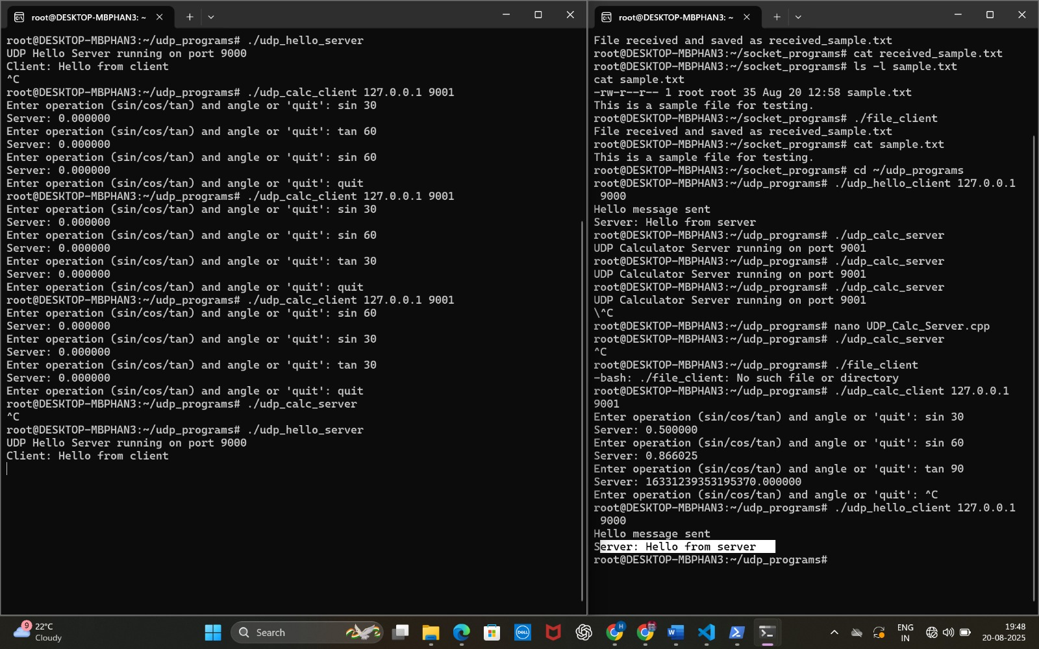

Conclusion:
The UDP client-server programs demonstrate how connectionless communication can be achieved using Berkeley socket primitives. The Hello program shows simple message exchange, while the trigonometric calculator highlights practical request-response communication. Though UDP lacks reliability and ordering, it provides fast, lightweight, and efficient data transfer, making it suitable for real-time applications where speed is more critical than guaranteed delivery.

