**Setting up a React Native Environment: Step-By-Step Guide**

# **System Requirements**

1. CPU: 12th Gen Intel(R) Core(TM) i7-1260P 2.10 GHz
2. Ram Size: 16.0 GB
3. Windows Version: Windows 11 Home (64-bit operating system)

# **Installation and Configuration Instructions**

1. Install NodeJS by clicking on this link: <https://nodejs.org/en/download/>
2. Add npm to PATH. In order to do this, click on windows start > search “path” > click on “Edit the system environment variables”. You should have this screen pop up on your display:

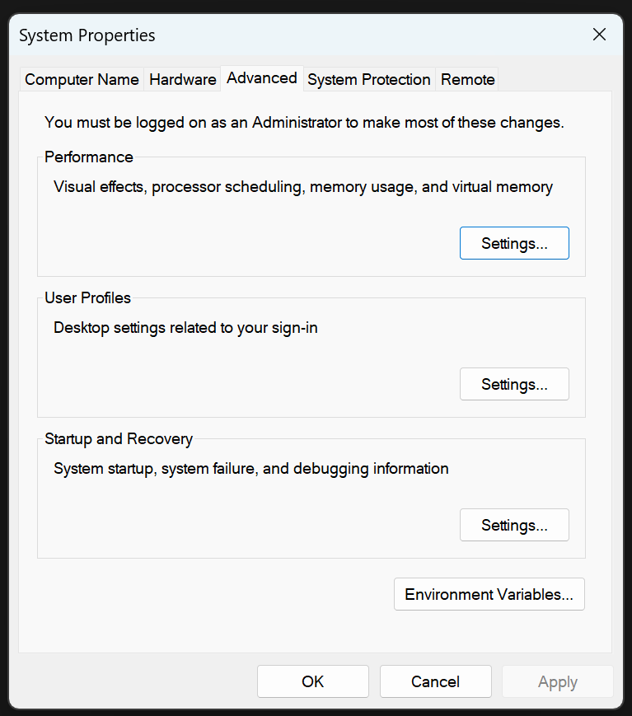

1. Click on “Environment Variables…” > under the user variables section, click on “Path” > once the “Path” is highlighted, click on “Edit”. After the completion of this step, you should be on this screen:

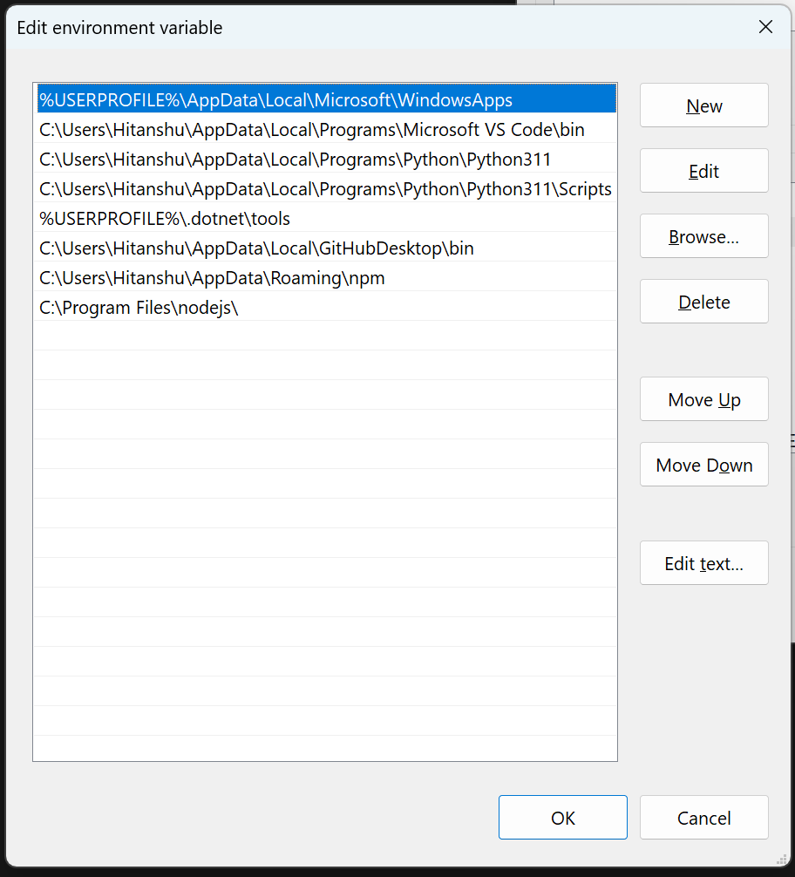

1. Click on “New” on the above displayed screen.
2. Copy and paste the path where NodeJS is installed. If you did not specify a particular path during the installation of NodeJS, you can just copy and paste the default path that is “C:\Program Files\nodejs\”. The location to paste the path is highlighted in the following image:

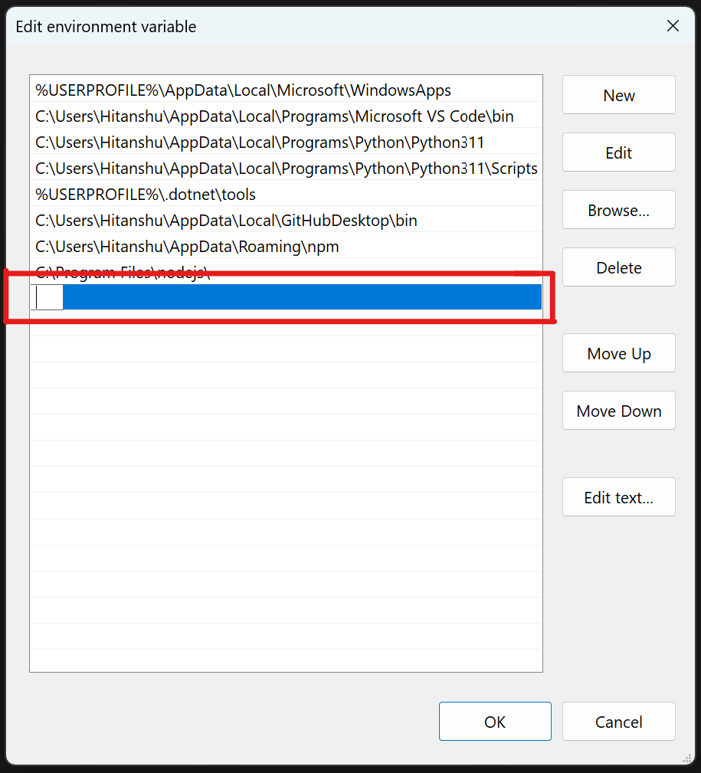

1. Click on “OK” after pasting the correct path and then exit the program.
2. Checkpoint: Paste the following commands in order into the command line and then compare the output with the image below. It might not be exactly the same depending on the version of your install but you should see the version even if it’s not the same.The commands are:

* “npm -v” or “npm -version”
* “npx -v” or “npx -version”
* “node -v” or “node -v”

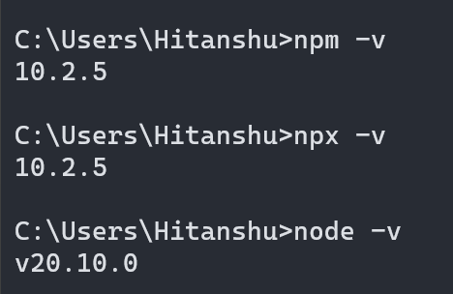

1. The last step is to install “ExpoGo” in order to view and run your project. You can install this app on your phone by going to the App Store/Play Store and simply searching “ExpoGo”. The app icon should look like this:

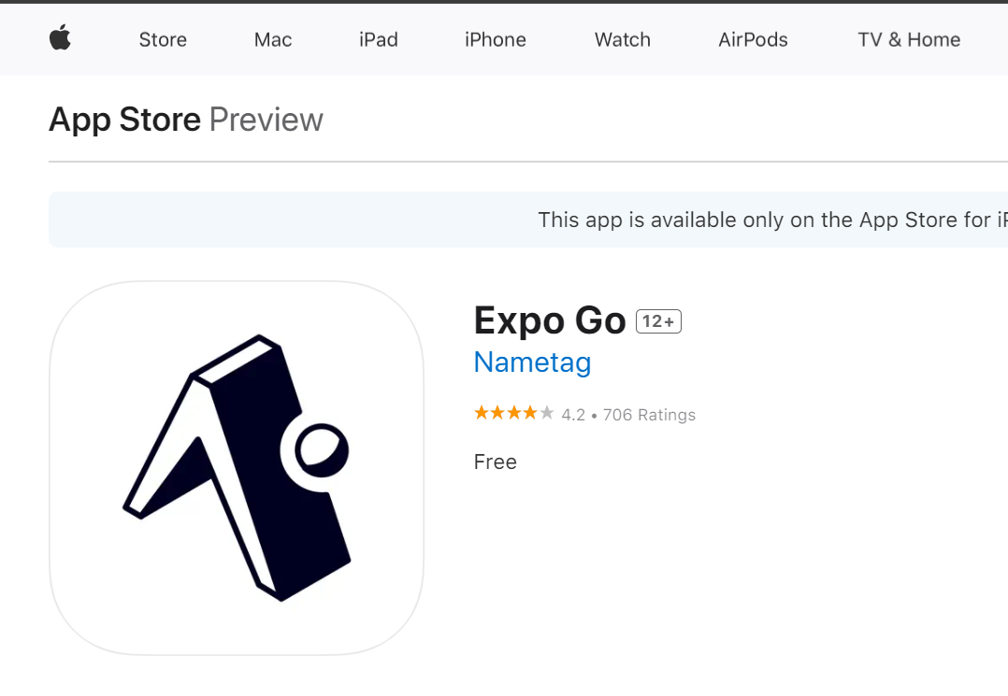

# **Project Creation**

1. Open command line by searching “cmd” on windows start menu.
2. Copy the path where you want to create this project and then run the following command but replace the “path” with your copied path:

* cd “path”

1. Once you are in the desired directory, copy and paste the following code with your desired project name in place of “project name”

* npx create-expo-app “project name”

This will create a new react native app/project in your desired directory.

# **Running The Project**

1. Open command line by searching “cmd” on windows start menu.
2. Locate the newly created project in the file explorer and copy its path. Use the “cd” command to go to that directory in command line. The command for that looks like this:

* cd “path”

1. Once you are in the project directory, write “npm start” in the command line to run the project using ExpoGo that was installed earlier. Running this command will display a QR code as shown in the image below:

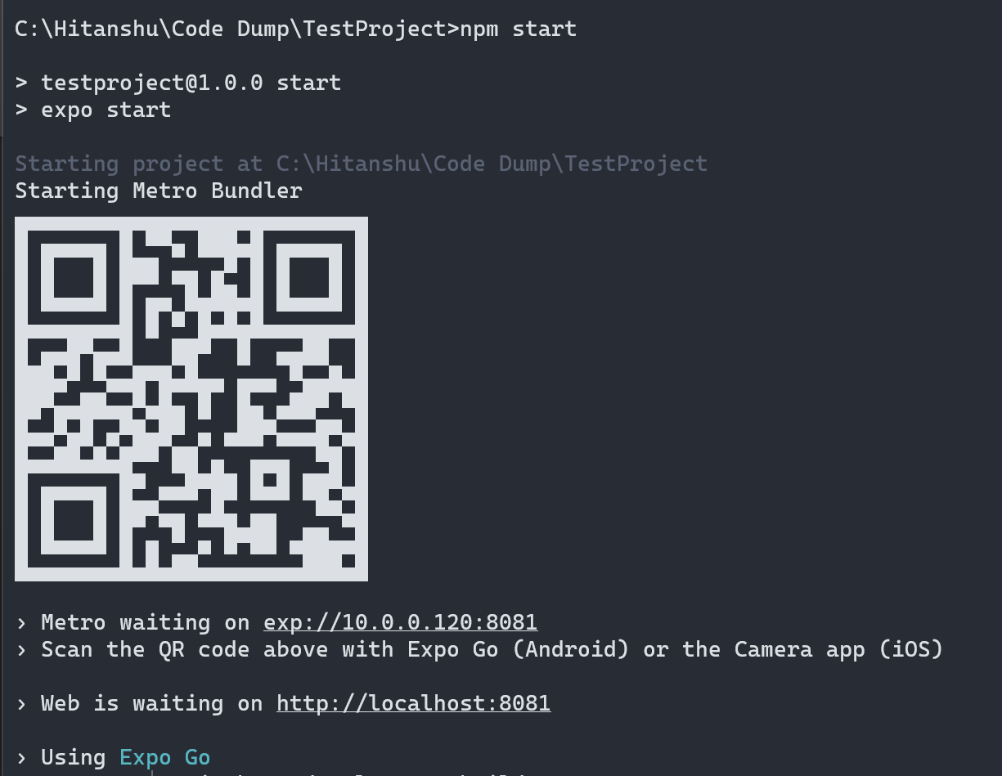

1. Scan this QR code using your smartphone camera. This will show the option to open ExpoGo. Click on that option and it will launch the ExpoGo app where you will be able to see the output of your project. Initial output will look like the image below:

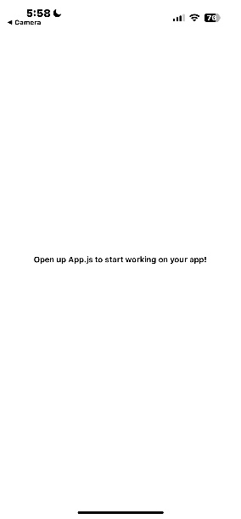

1. Congratulations! You have successfully ran your first react native project.

# **Troubleshooting**

1. Whenever you get an error during running the commands, always make sure that there are no typing errors.
2. Make sure you add the correct path while adding npm to the environment variables.

# **Resources**

1. Tutorial for running the project: <https://reactnative.dev/docs/environment-setup?guide=native>).
2. React Native Official Documentation: <https://reactnative.dev/docs/getting-started>
3. NodeJS Official Documentation: <https://nodejs.org/docs/latest/api/>