Automated Invoice Payment Notification System
Zapier Agents + Google Sheets + Gmail
Project Documentation
Hitarth Parikh - 25030242024

1. Project Overview
The project implements an automated invoice payment notification and confirmation system using Zapier Agents, Google Sheets and Gmail. The existing Google Sheet acts as the source of invoice information. The agent reads the records, checks the payment status and team, and sends an email only for invoices whose status is Pending. Maintenance invoices are routed to Accountant 1, while Project invoices are routed to Accountant 2.
A second stage handles the accountant's reply. When an accountant replies confirming that the payment has been completed, the system identifies the invoice from the email and updates the Status of the corresponding existing Google Sheet row to Completed. No new invoice row is created.

2. Existing Google Sheet
The Google Sheet contains the following fields: Sr. No., Invoice Id, Type, Name, Amount, Account No, Bank Name, Status and Transaction ID. The sheet already contains invoice records and is used as the data source for the agent.
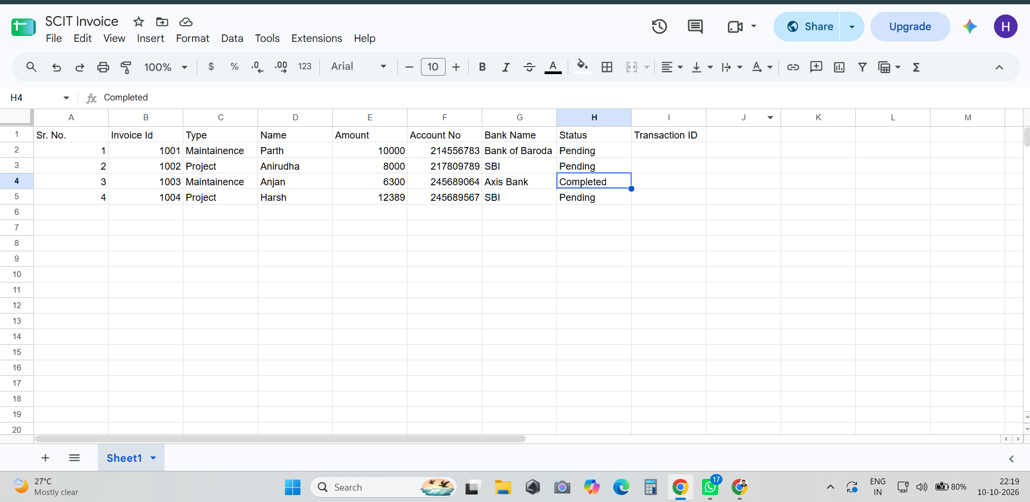
Figure 1. Existing Google Sheet before the payment confirmation update.

3. Zapier Agent – Payment Notification
A Zapier Agent was configured to read the existing Google Sheet and autonomously determine which invoices require payment reminders. The agent checks the Status field first. Completed records are skipped, while Pending records are processed.
For a Pending invoice, the agent checks the Type field. If the Type is Maintenance, the payment reminder is sent to Accountant 1. If the Type is Project, the reminder is sent to Accountant 2. The email dynamically includes the Invoice ID, Name, Type, Amount, Account Number, Bank Name and current Payment Status.
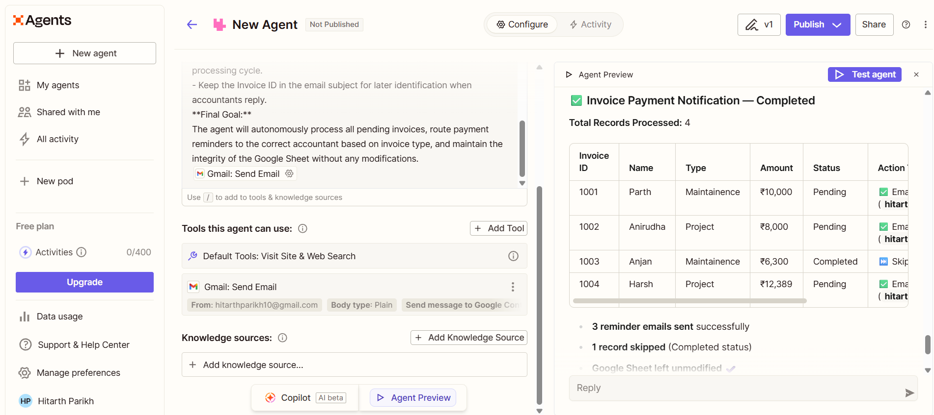
Figure 2. Zapier Agent configuration and preview showing the notification process.
In the demonstrated run, four invoice records were processed. Three Pending invoices (1001, 1002 and 1004) resulted in reminder emails, while Invoice 1003 was skipped because its status was already Completed. The Google Sheet remained unchanged during this stage.

4. Automated Email Notifications
The generated email uses the Invoice ID in the subject so that the invoice can later be identified when the accountant replies. The subject follows the format: [PAYMENT PENDING] Invoice <Invoice ID> | <Type>.
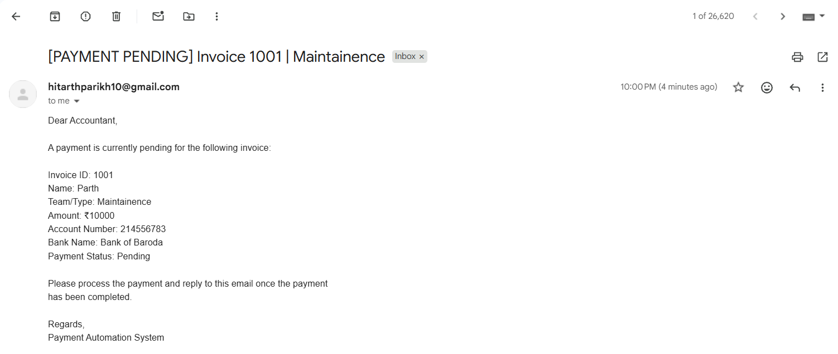
Figure 3. Payment-pending email generated for a Project invoice.
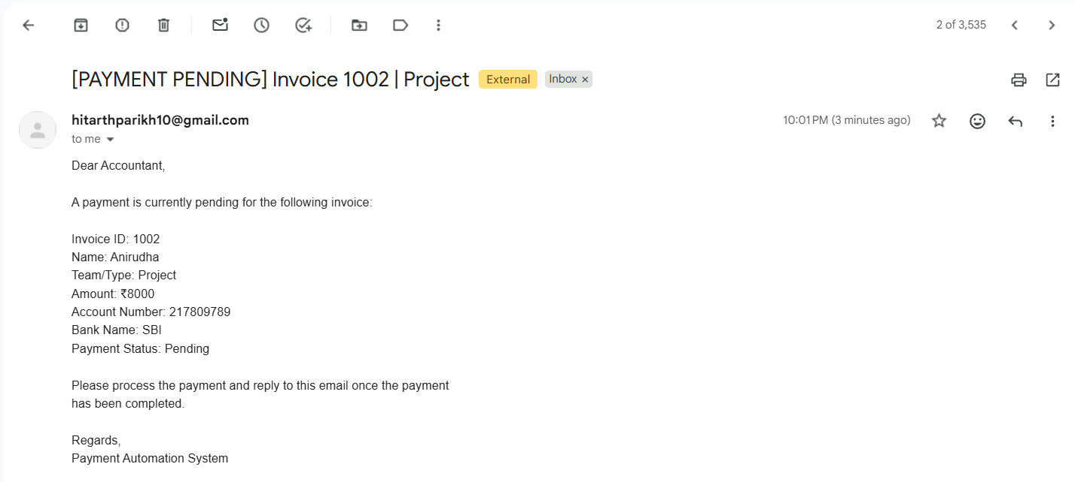
Figure 4. Payment-pending email generated for a Maintenance invoice.
The emails provide the accountant with the relevant payment details and instruct the recipient to reply once the payment has been completed.

5. Accountant Reply and Payment Confirmation
After receiving the payment reminder, the accountant replies to the same email thread. For example, the accountant can reply with a simple confirmation such as “Payment Done.” This reply becomes the input for the second automation stage.
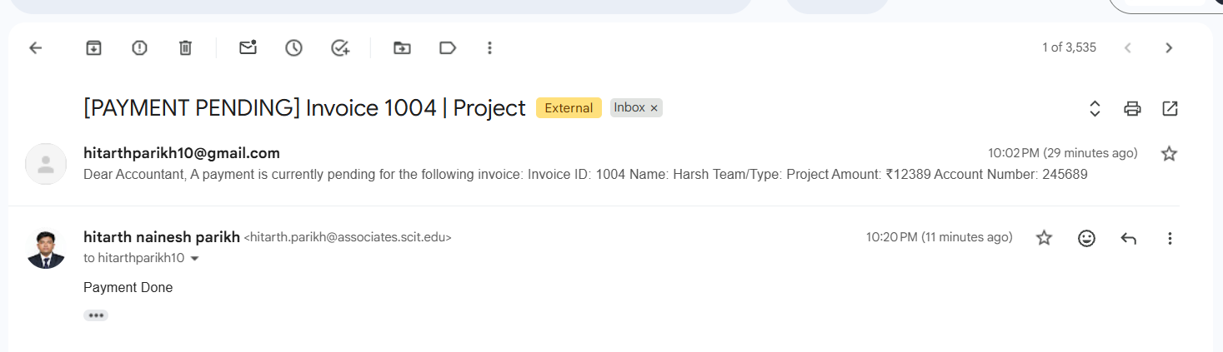
Figure 5. Accountant reply confirming that the payment has been completed.

6. Updating the Existing Google Sheet
The second Zapier Agent identifies the invoice associated with the reply using the Invoice ID from the payment email. It then finds the matching existing row in the Google Sheet and changes only the Status field from Pending to Completed. The existing row is updated; no new row or column is created.
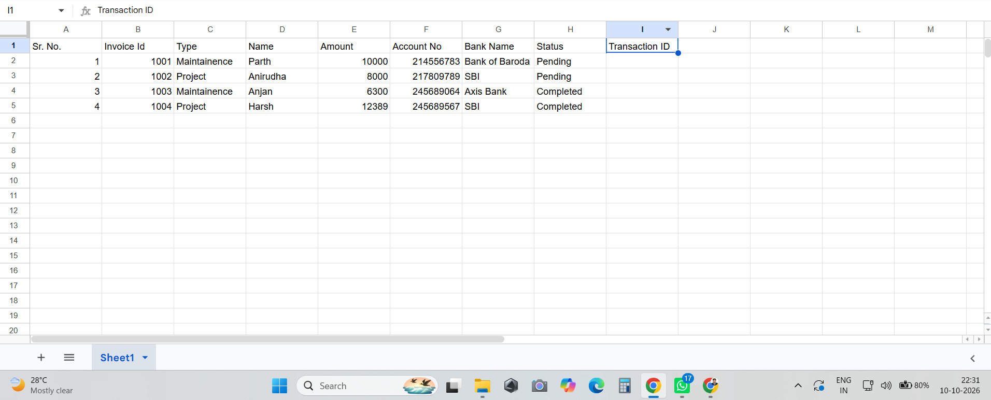
Figure 6. Google Sheet after the payment confirmation: Invoice 1004 is marked Completed.

7. End-to-End Workflow
- 1. Google Sheet provides the existing invoice and payment information.
- 2. Zapier Agent reads the records and checks the Status field.
- 3. Completed invoices are ignored and no email is sent.
- 4. Pending invoices are checked against the Type/Team field.
- 5. Maintenance invoices are routed to Accountant 1; Project invoices are routed to Accountant 2.
- 6. Gmail sends the payment-pending notification with the invoice details.
- 7. Accountant replies to the notification after completing the payment.
- 8. The second agent identifies the Invoice ID from the email reply.
- 9. The agent finds the matching existing row in Google Sheets.
- 10. The Status field is changed from Pending to Completed.

8. Key Features and Benefits
- Automated payment reminders reduce manual follow-up.
- Team-based routing ensures the email reaches the correct accountant.
- Completed invoices are automatically skipped during notification processing.
- Invoice ID provides a reliable link between the email and the spreadsheet record.
- The existing Google Sheet structure is preserved; the system updates the existing record rather than creating duplicates.
- The workflow demonstrates an agent-based automation using real business data and email interaction.

9. Conclusion
The completed solution automates the basic invoice payment follow-up cycle. Zapier Agents use the Google Sheet as the source of truth, intelligently route pending payment reminders based on invoice type, and use accountant email responses to complete the payment status update. This reduces repetitive manual work while maintaining a clear and traceable connection between each invoice, its notification email and its final payment status.

