Multi-Agent AI Research & Response Workflow
n8n + Ollama + Tavily
Brief Project Documentation
Hitarth Parikh - 25030242024

1. Overview
The workflow implements a simple multi-agent AI system in n8n for answering research-oriented user questions. A chat message is received by the workflow, passed to a Research Agent, enriched using the Tavily web-search tool, and then forwarded to a Final Response Agent. Ollama is used as the local chat-model provider for the agents. The design separates research from response generation so that the final agent can focus on presenting a clear answer.

2. Overall Architecture
The workflow follows a sequential two-agent architecture:
- Chat Trigger – receives the user's question.
- AI Agent 1 – Research Agent – interprets the question and gathers relevant information.
- Tavily Search – connected as a tool to Agent 1 for live web research.
- Ollama Chat Model – supplies the language model used by the agents.
- AI Agent 2 – Final Response Agent – converts the research output into the final user-facing response.
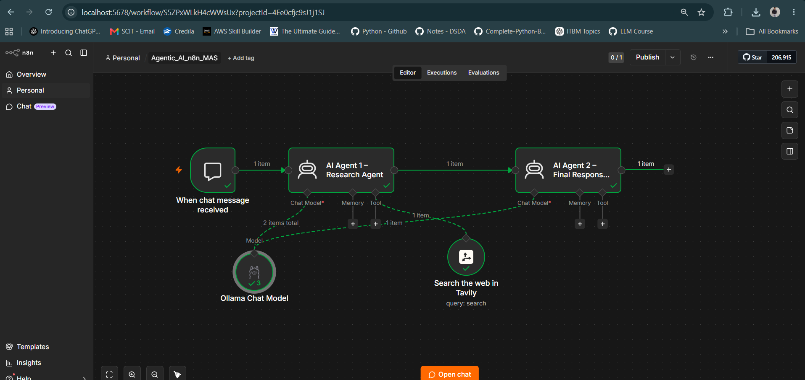
Figure 1. Complete n8n workflow showing the chat trigger, two agents, Ollama model and Tavily tool.

3. AI Agent 1 – Research Agent
AI Agent 1 is responsible for the research stage. Its system message defines it as a Research Agent in a multi-agent system. The agent receives the original user question and is instructed to research it and provide accurate, relevant information to the Final Response Agent.
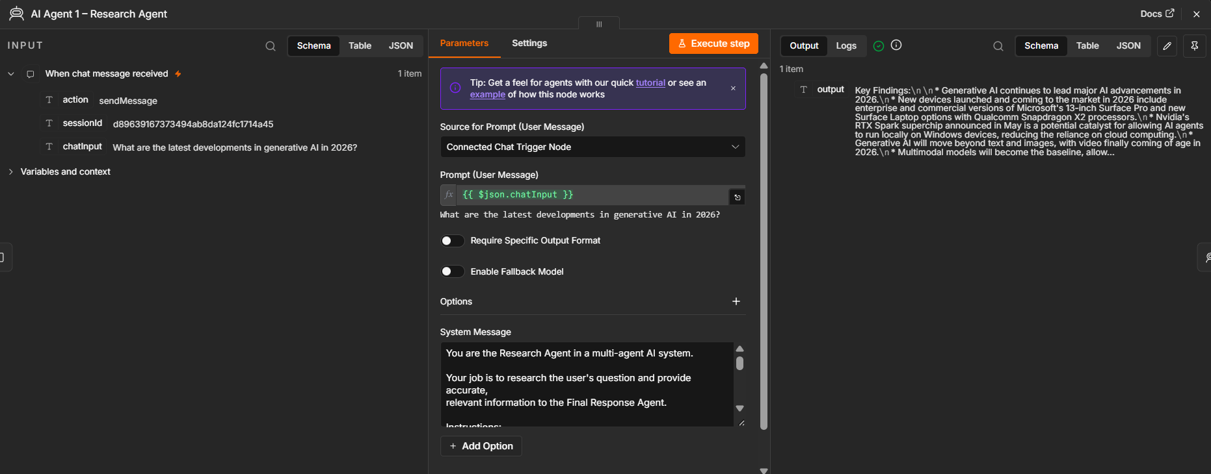
Figure 2. AI Agent 1 – Research Agent configuration and output.

Key responsibilities
- Understand the user's original question.
- Identify the information required to answer it.
- Use the connected web-search tool when current or external information is required.
- Summarize the important findings rather than producing an unnecessarily long response.
- Pass research findings to the next agent.

4. Tavily Web Search Tool
Tavily is connected to the Tool input of the Research Agent. The tool allows the agent to generate a search query automatically and retrieve relevant web results. In the demonstrated test, the generated query was "generative AI latest developments 2026". The returned results include titles, URLs, content snippets, scores and publication dates, which gives the Research Agent external information to work with.
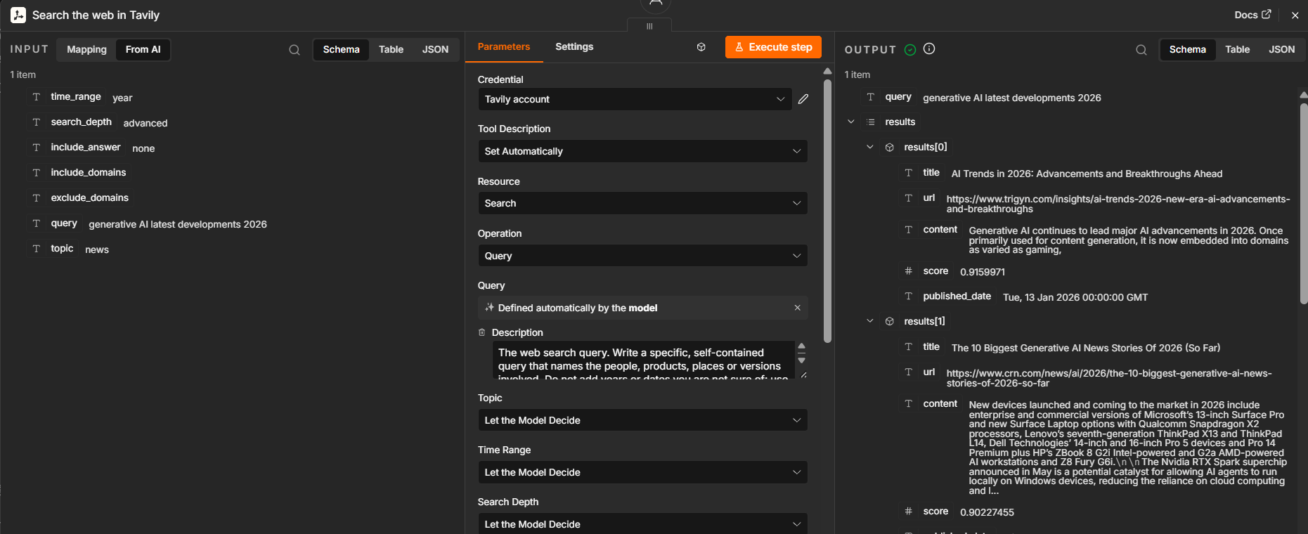
Figure 3. Tavily Search tool connected to the Research Agent.
This is important because a local language model by itself may not know the latest developments. The Tavily tool provides a mechanism for grounding the research stage in current web information.

5. Ollama Chat Model
Ollama is used as the chat-model provider for the workflow. The screenshots show an Ollama account/credential and the llama3.1:latest model being used. The model is connected to the Chat Model input of the AI agents. This enables the workflow to run the language-model reasoning locally through Ollama rather than relying only on a cloud-hosted model.
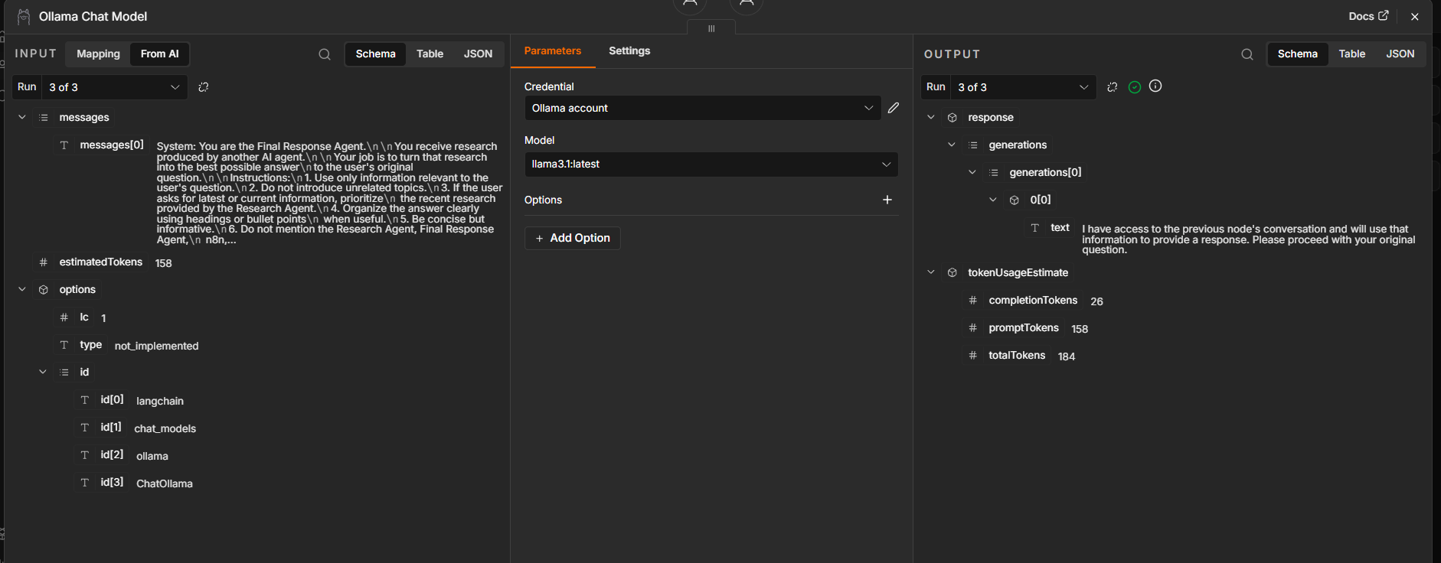
Figure 4. Ollama Chat Model configuration using llama3.1:latest.

6. AI Agent 2 – Final Response Agent
AI Agent 2 is the final response layer. It receives the output generated by Agent 1 and turns the research into a useful answer for the user. Its system message instructs it to use relevant information, avoid unrelated topics, prioritize recent research for current questions, organize the response clearly, and remain concise.
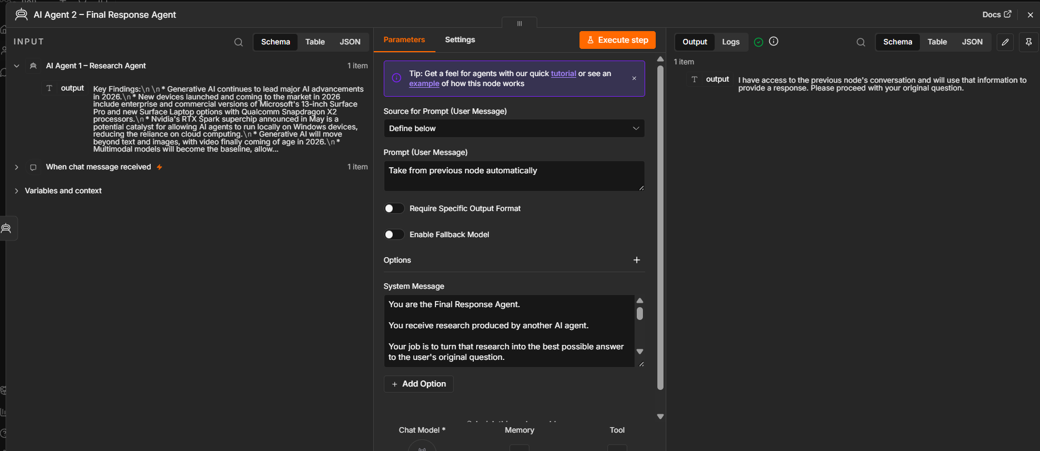
Figure 5. AI Agent 2 – Final Response Agent configuration.
The important architectural point is that Agent 2 is not responsible for performing the original web research. It acts as a synthesis and presentation layer. This separation makes the workflow easier to understand and demonstrates cooperation between specialized agents.

7. Data Flow Between the Agents
- The Chat Trigger provides the original user message.
- Agent 1 receives the message and performs the research task.
- Tavily is invoked by Agent 1 when web information is required.
- Agent 1 produces structured/key findings from the retrieved information.
- Agent 2 receives the previous node's output and generates the final answer.
- The final output is displayed in the n8n chat interface.

8. Testing and Results
The workflow was tested with the question: "What are the latest developments in generative AI in 2026?" The execution completed successfully across the trigger, Research Agent, Tavily tool and Final Response Agent.
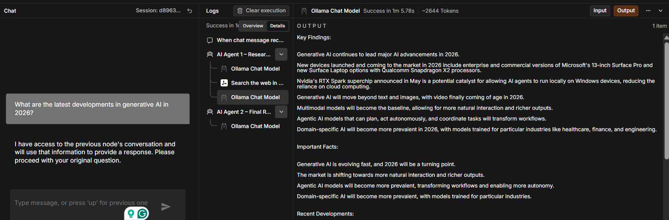
Figure 6. Research output generated after the Tavily-assisted research stage.
The research stage identified themes such as generative AI advances, multimodal models, agentic AI, domain-specific AI and newer AI hardware. The search tool also returned external sources that were used as research inputs.
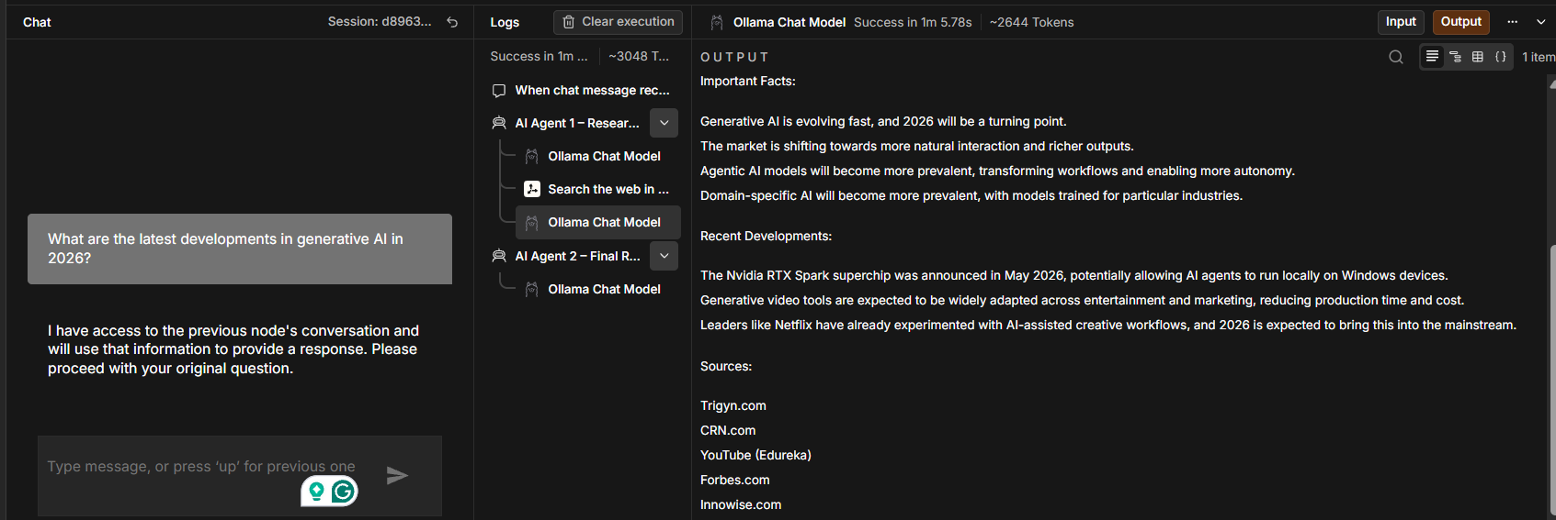
Figure 7. Final response output generated by the second agent.
The final agent organizes the available findings into sections such as Important Facts and Recent Developments. This demonstrates the intended pipeline: research first, response generation second.

9. Final Workflow Summary
Overall, the project demonstrates a basic but functional multi-agent architecture in n8n. The system combines a chat interface, two specialized AI agents, a local Ollama model and a Tavily web-search tool. The Research Agent focuses on information gathering, while the Final Response Agent focuses on synthesis and communication.
- Input: User question through n8n Chat Trigger.
- Research: AI Agent 1 + Tavily web search.
- Model: Ollama llama3.1:latest.
- Synthesis: AI Agent 2.
- Output: Concise final response in the n8n chat interface.
The workflow can be extended later by adding memory, additional specialized tools, structured output, source citation handling, or more domain-specific agents. For the current implementation, the two-agent structure keeps the architecture simple while clearly demonstrating agent collaboration.

