Movie Mood Bot – Langflow Chatbot
Simple AI Movie Recommendation Chatbot
Implementation, Workflow and Testing Documentation

1. Project Overview
The Movie Mood Bot is a simple conversational chatbot created in Langflow. Its purpose is to recommend movies based on the user's mood or movie preference. The chatbot uses a language model to understand the user's message and generate three suitable movie recommendations along with short explanations and one best recommendation.

Objective
- Create a simple chatbot without using a database, RAG pipeline, vector database or external movie API.
- Accept a natural-language message from the user.
- Use a prompt template to provide instructions to the language model.
- Generate short, conversational movie recommendations.
- Test the chatbot using different user inputs such as happy and thriller moods.

2. Langflow Workflow
The chatbot is implemented using four main Langflow components. The components are connected in a sequential pipeline so that the user's message is passed through the prompt and language model before the final response is displayed.
Component | Purpose | Flow
Chat Input | Receives the user's message. | User message →
Prompt Template | Combines the bot instructions with the user's message. | → Prompt
Language Model | Processes the prompt and generates recommendations. | → AI response
Chat Output | Displays the generated response to the user. | → Final output

Overall architecture: Chat Input → Prompt Template → Language Model → Chat Output

Langflow Flow Screenshot
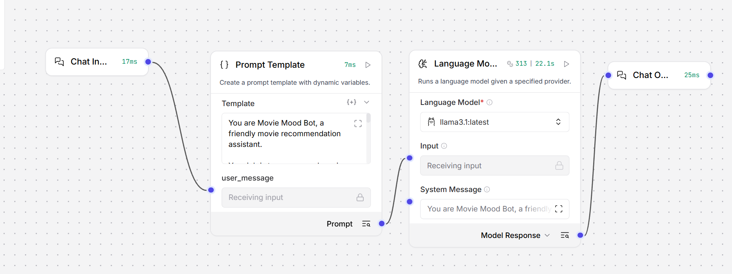
Figure 1. Movie Mood Bot workflow in Langflow

3. Prompt and Language Model Configuration
The Prompt Template defines the role and expected behaviour of the chatbot. The user's message is passed into the dynamic variable user_message. The prompt instructs the model to provide three movie recommendations, include the genre and a short reason for each recommendation, and finish with one best recommendation.
The Language Model component is configured with the locally running Ollama model:
llama3.1:latest
Using Ollama allows the chatbot to run with a local language model instead of depending on paid API credits. The model receives the prompt generated by the Prompt Template and returns the recommendation text to Chat Output.

4. Chatbot Testing
The completed flow was tested through the Langflow Playground using different user messages. The tests demonstrate that the chatbot can adapt its recommendations according to the requested mood or genre.

Test Case 1 – Happy and Energetic Mood
Input: "I am feeling happy and energetic. Recommend some movies."
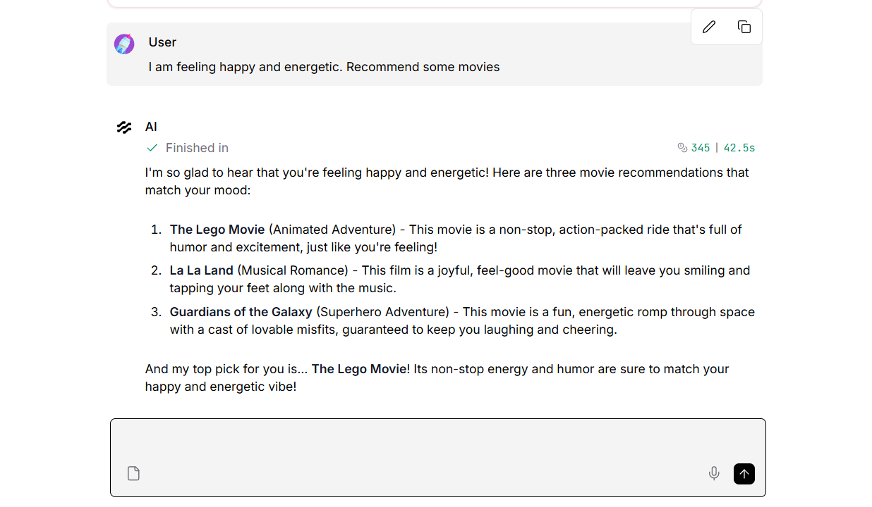
Figure 2. Response for a happy and energetic mood
The chatbot returned three recommendations: The Lego Movie, La La Land and Guardians of the Galaxy. It also selected The Lego Movie as the top recommendation because of its energetic and humorous tone.

Test Case 2 – Thriller Movies
Input: "Recommend some thriller movies."
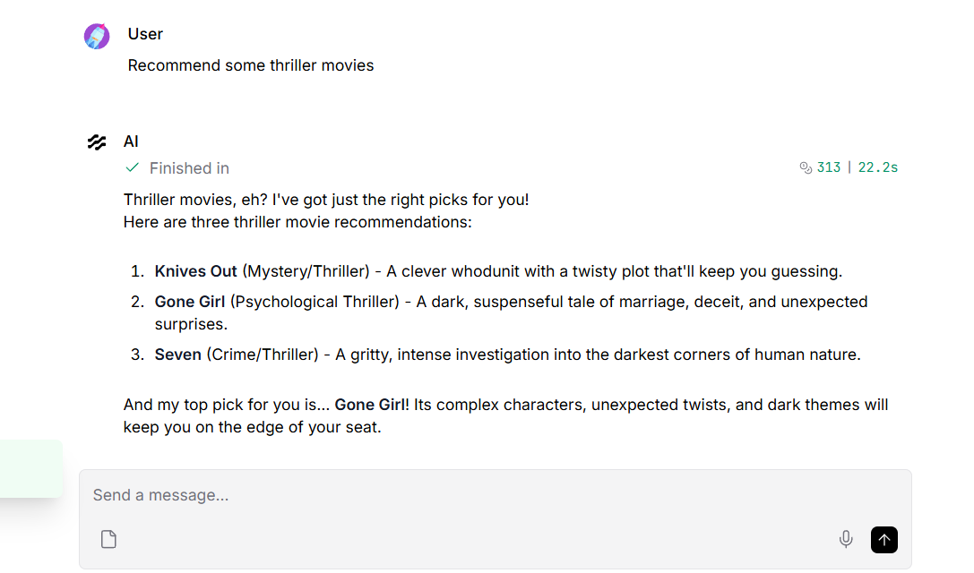
Figure 3. Response for a thriller movie request
The chatbot returned three thriller recommendations: Knives Out, Gone Girl and Seven. It selected Gone Girl as the top recommendation and briefly explained why it matched the requested genre.

5. Results and Observations
- The chatbot successfully accepts natural-language user input through the Chat Input component.
- The Prompt Template provides a consistent role and response format to the model.
- The local Ollama llama3.1:latest model generates the final recommendations.
- The chatbot can respond differently depending on the user's mood or requested genre.
- The Playground provides an interactive interface for testing multiple conversations.

6. End-to-End Execution
The complete execution process is as follows:
1. User enters a request in Chat Input.
2. The request is passed to the user_message variable in Prompt Template.
3. Prompt Template combines the user message with the Movie Mood Bot instructions.
4. The generated prompt is sent to the Ollama llama3.1:latest language model.
5. The model generates movie recommendations based on the request.
6. Chat Output displays the final response in the Playground.

7. Conclusion
The Movie Mood Bot demonstrates a basic Langflow-based chatbot using a simple linear workflow. It does not require a complex agent architecture or external data source. The combination of Chat Input, Prompt Template, Ollama Language Model and Chat Output is sufficient to create and test a functional conversational movie recommendation system.

