Credit Appraisal RAG Agent using n8n
Brief Workflow Documentation
Technology: n8n • Ollama • Llama 3.1 • Ollama Embeddings • Simple Vector Store
Hitarth N Parikh - 25030242024

1. Project Overview
The project implements a Retrieval-Augmented Generation (RAG) based Credit Appraisal Agent in n8n. The purpose is to allow a user to ask questions about loan eligibility and have the AI Agent retrieve the relevant credit appraisal policy from a vector store before generating an answer.
The reference document contains eligibility policies for Car Loans and Home Loans. The agent is instructed to identify the loan product, retrieve the applicable policy, evaluate the provided customer information against the policy conditions, and return a clear eligibility decision.

2. Workflow Architecture
The workflow has two main parts: (1) preparing the policy document for retrieval and (2) using the retrieved information through an AI Agent.
- Policy ingestion: Google Drive → Download File → Default Data Loader → Ollama Embeddings → Simple Vector Store.
- Agent interaction: Chat Trigger → AI Agent → Ollama Chat Model + Simple Memory + Simple Vector Store as a tool.
- The embedding model converts document content into vectors for similarity-based retrieval.
- The Llama 3.1 model is used as the chat/generation model for the AI Agent.
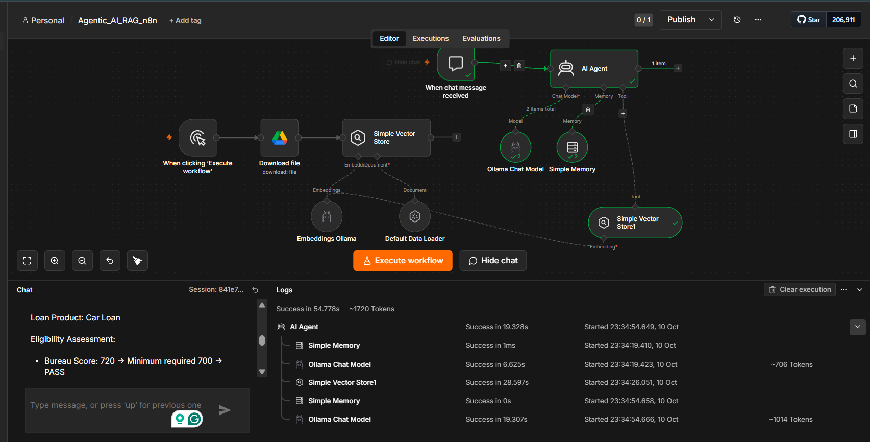
Figure 1. Overall workflow setup

3. Main Components Configured
Google Drive / Download File: The workflow downloads the Credit Appraisal Policy reference DOCX from Google Drive. This provides the source document used for the RAG knowledge base.
Default Data Loader: The downloaded document is passed to the data loader so that its content can be processed and supplied to the vector store pipeline.
Ollama Embeddings: The embedding model configured is nomic-embed-text:latest. It converts the policy content into numerical vector representations so that relevant policy information can be retrieved later.
Simple Vector Store: The policy embeddings are stored in the Simple Vector Store. A second Simple Vector Store is connected to the AI Agent as a retrieval tool.
AI Agent: The AI Agent receives the user's chat message, can use memory, calls the vector-store retrieval tool when policy information is required, and then generates the final response.
Ollama Chat Model: The configured chat model is llama3.1:latest. It is responsible for generating the natural-language answer after the relevant information is retrieved.
Simple Memory: Simple Memory is connected to the AI Agent so that the agent can maintain conversational context during the session.
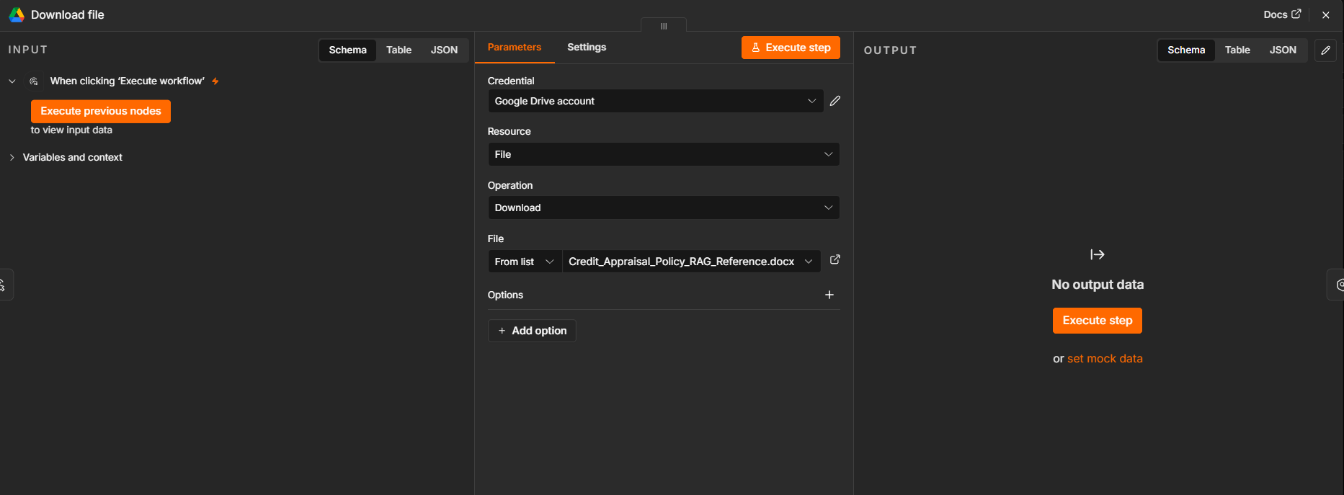
Figure 2. Google Drive file download configuration
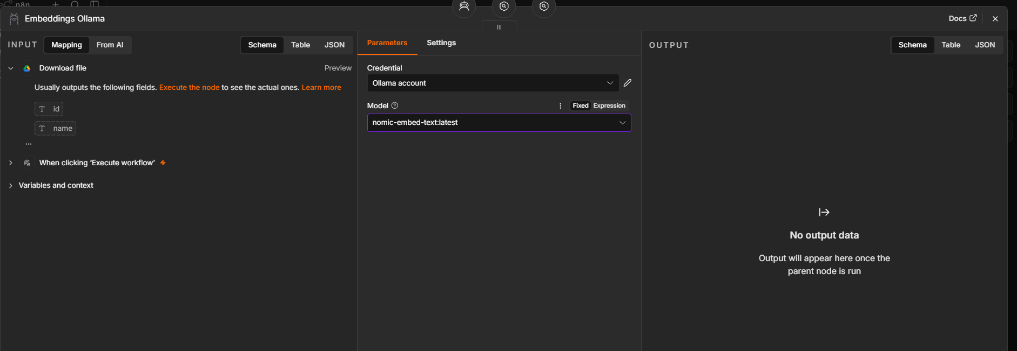
Figure 3. Ollama embedding model configuration
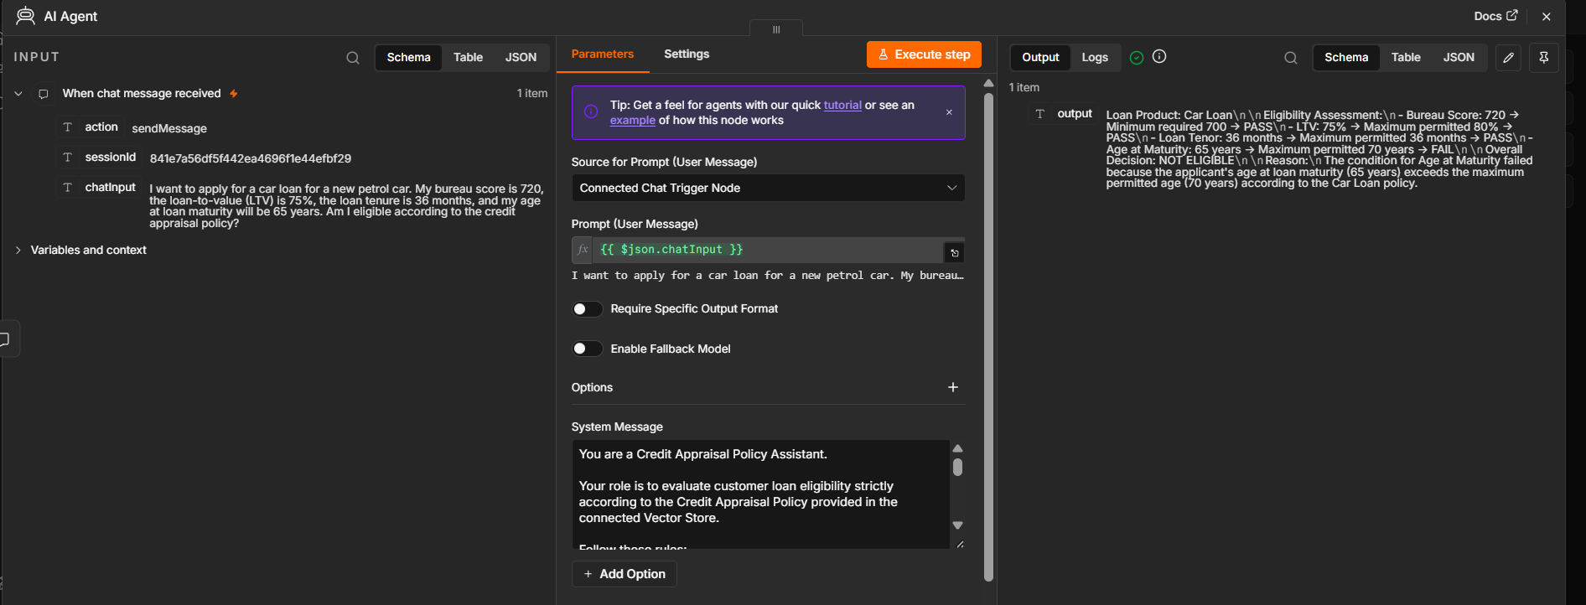
Figure 4. AI Agent configuration
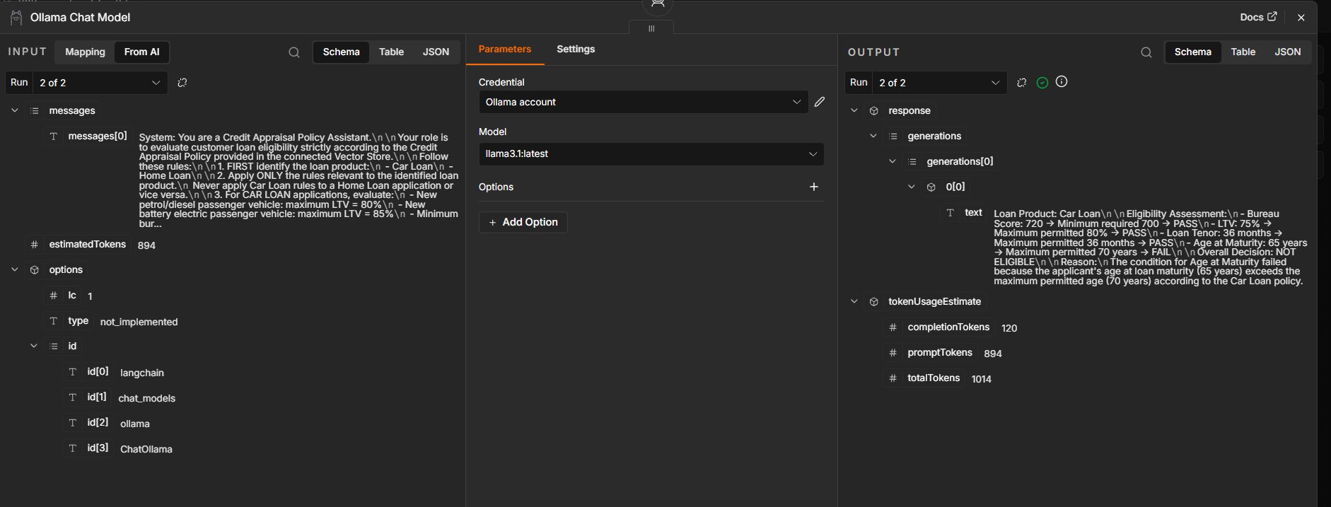
Figure 5. Ollama Chat Model configuration

4. AI Agent Logic and System Instructions
The AI Agent was configured with a system message defining it as a Credit Appraisal Policy Assistant. The instructions make the policy document the primary source of truth and prevent the agent from inventing eligibility thresholds.
- First identify whether the request is for a Car Loan or Home Loan.
- Apply only the rules relevant to the identified loan product.
- Evaluate each applicable condition independently.
- Clearly show the customer value, policy requirement, and PASS/FAIL result.
- If required information is missing, return INSUFFICIENT INFORMATION instead of assuming a value.
- If a parameter is not specified in the policy, state that it is not available in the provided policy.
- Provide an overall ELIGIBLE or NOT ELIGIBLE conclusion when all applicable conditions can be evaluated.

5. Policy Covered by the RAG Knowledge Base
The reference policy contains the following key rules:
Loan Product | Parameter | Policy | Condition
Car Loan | Bureau Score | Minimum 700 | ≥ 700
Car Loan | Petrol/Diesel LTV | Maximum 80% | ≤ 80%
Car Loan | Battery Electric LTV | Maximum 85% | ≤ 85%
Car Loan | Loan Tenor | Maximum 36 months | ≤ 36 months
Car Loan | Age at Maturity | Maximum 70 years | ≤ 70 years
Home Loan | Bureau Score | Minimum 700 | ≥ 700
Home Loan | FOIR | Maximum 50% | ≤ 50%
Home Loan | LTV | Maximum 80% | ≤ 80%
Home Loan | Loan Tenor | Maximum 20 years | ≤ 20 years
Home Loan | Age at Maturity | Maximum 70 years | ≤ 70 years

6. Testing the Agent
The agent was tested using a Car Loan scenario. The input specified a new petrol car, bureau score of 720, LTV of 75%, loan tenure of 36 months, and age at loan maturity of 65 years.
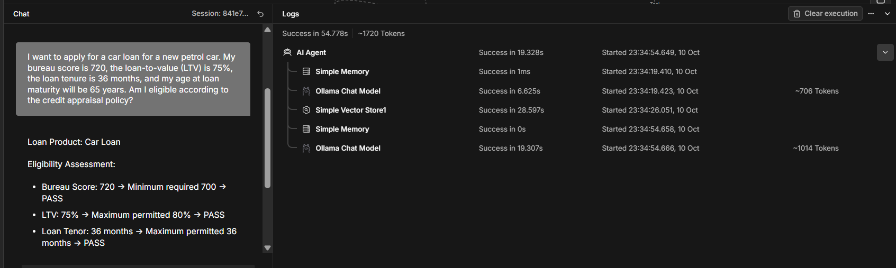
Figure 6. Chat input used for testing

7. Result and Observation
The workflow executed successfully and the agent retrieved the relevant Car Loan policy. The output evaluated the bureau score, LTV, loan tenor, and age at maturity separately.
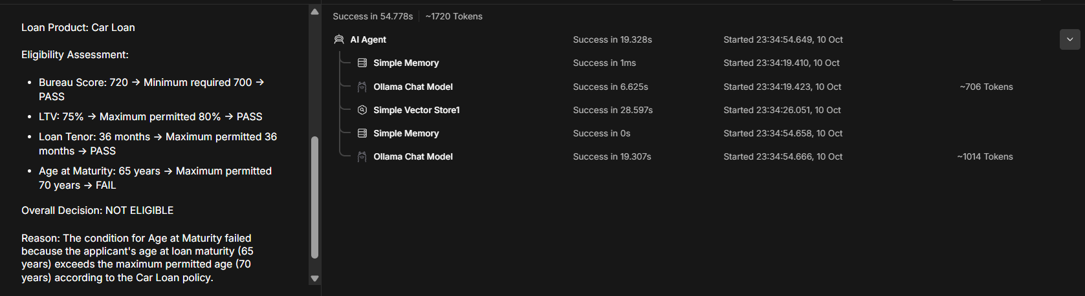
Figure 7. Final credit eligibility output
The final response correctly identified the age-at-maturity condition as the failing condition in the shown run and therefore returned an overall NOT ELIGIBLE decision. The other displayed conditions were marked PASS.

8. End-to-End Execution
The final workflow shows the complete connection between the chat trigger, AI Agent, Llama 3.1 chat model, Simple Memory, and the Simple Vector Store retrieval tool. The policy ingestion path separately prepares the reference document and its embeddings.
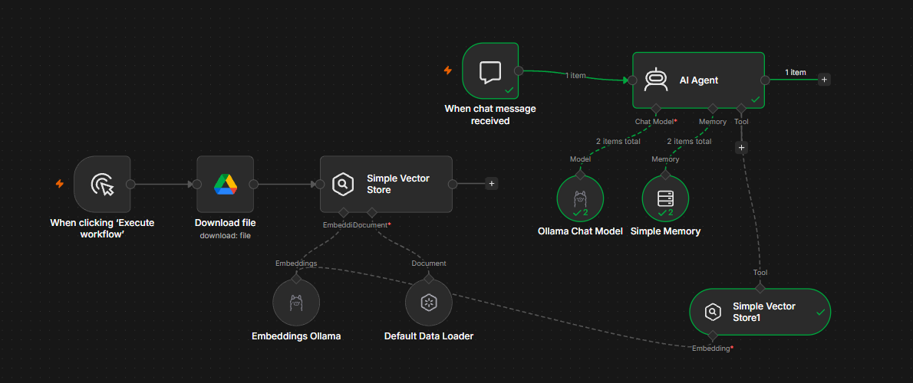
Figure 8. Complete workflow and successful execution

9. Overall Summary
- A credit-policy document is downloaded from Google Drive and processed for retrieval.
- Ollama embeddings (nomic-embed-text:latest) are used to represent the policy as vectors.
- The vectors are stored in a Simple Vector Store that is exposed to the AI Agent as a tool.
- The AI Agent uses Llama 3.1 (llama3.1:latest) to understand the user's request and generate the final response.
- Simple Memory maintains conversational context.
- The system follows a RAG approach because the answer is grounded in retrieved policy information rather than relying only on the LLM's general knowledge.
- The successful test demonstrates the complete flow from user input to policy retrieval and eligibility assessment.

End of Documentation

