Social Network Analysis Using a Graph Database
Hitarth Parikh
25030242024

1. User Attributes
User | Age | City | Profession | Activity | Influence
Rahul | 29 | Pune | Data Scientist | 92 | 87
Priya | 27 | Mumbai | AI Engineer | 88 | 82
Amit | 31 | Pune | Entrepreneur | 76 | 79
Neha | 25 | Delhi | Researcher | 95 | 91
Karan | 30 | Pune | Software Engineer | 69 | 73
Sneha | 28 | Mumbai | Product Manager | 84 | 86
Arjun | 26 | Bengaluru | ML Engineer | 91 | 89
Meera | 32 | Delhi | Consultant | 72 | 77

2. Create the Users
CREATE
(r:User {name:'Rahul', age:29, city:'Pune', profession:'Data Scientist', activityLevel:92, influenceScore:87}),
(p:User {name:'Priya', age:27, city:'Mumbai', profession:'AI Engineer', activityLevel:88, influenceScore:82}),
(a:User {name:'Amit', age:31, city:'Pune', profession:'Entrepreneur', activityLevel:76, influenceScore:79}),
(n:User {name:'Neha', age:25, city:'Delhi', profession:'Researcher', activityLevel:95, influenceScore:91}),
(k:User {name:'Karan', age:30, city:'Pune', profession:'Software Engineer', activityLevel:69, influenceScore:73}),
(s:User {name:'Sneha', age:28, city:'Mumbai', profession:'Product Manager', activityLevel:84, influenceScore:86}),
(ar:User {name:'Arjun', age:26, city:'Bengaluru', profession:'ML Engineer', activityLevel:91, influenceScore:89}),
(m:User {name:'Meera', age:32, city:'Delhi', profession:'Consultant', activityLevel:72, influenceScore:77});
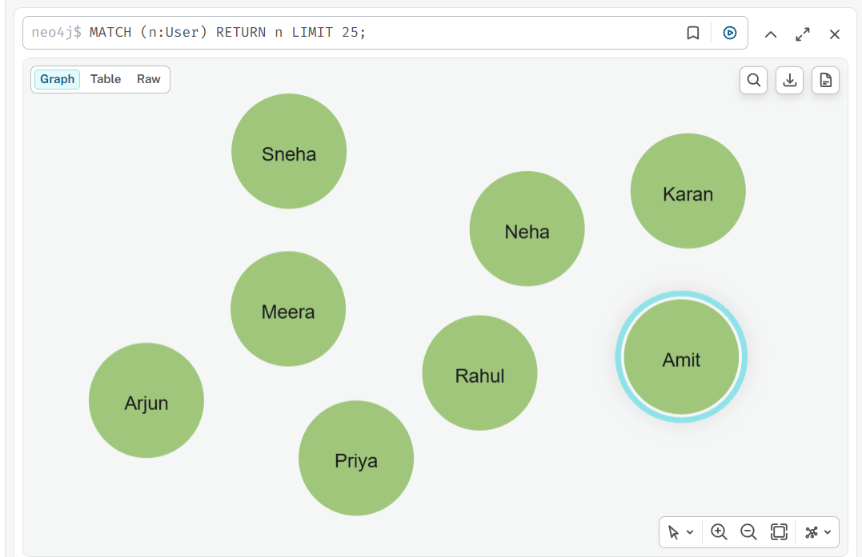

3. Create Friendship Relationships
MATCH
(r:User {name:'Rahul'}), (p:User {name:'Priya'}), (a:User {name:'Amit'}), (n:User {name:'Neha'}),
(k:User {name:'Karan'}), (s:User {name:'Sneha'}), (ar:User {name:'Arjun'}), (m:User {name:'Meera'})
CREATE
(r)-[:FRIEND {since:2021, strength:0.91}]->(p),
(r)-[:FRIEND {since:2022, strength:0.75}]->(a),
(r)-[:FRIEND {since:2023, strength:0.64}]->(k),
(p)-[:FRIEND {since:2022, strength:0.83}]->(n),
(p)-[:FRIEND {since:2021, strength:0.89}]->(s),
(n)-[:FRIEND {since:2023, strength:0.71}]->(ar),
(n)-[:FRIEND {since:2022, strength:0.68}]->(m),
(a)-[:FRIEND {since:2024, strength:0.62}]->(k),
(s)-[:FRIEND {since:2023, strength:0.77}]->(ar),
(ar)-[:FRIEND {since:2024, strength:0.66}]->(m);
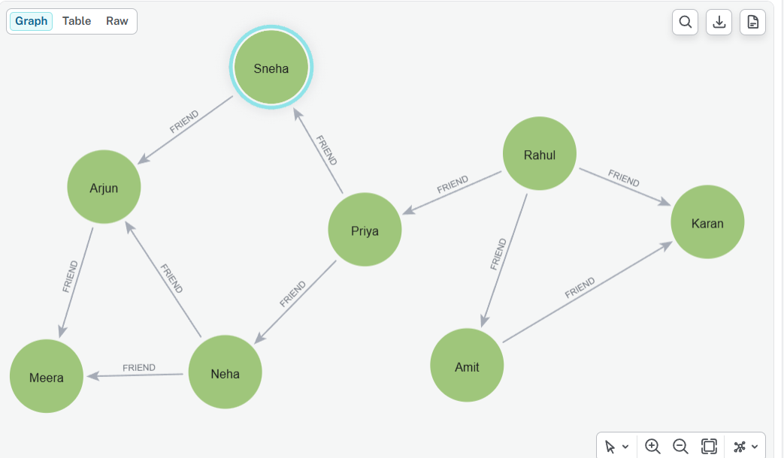

4. Create Groups
CREATE
(g1:Group {name:'Artificial Intelligence', category:'Technology', members:420}),
(g2:Group {name:'Data Science', category:'Technology', members:350}),
(g3:Group {name:'Startup Founders', category:'Business', members:210});
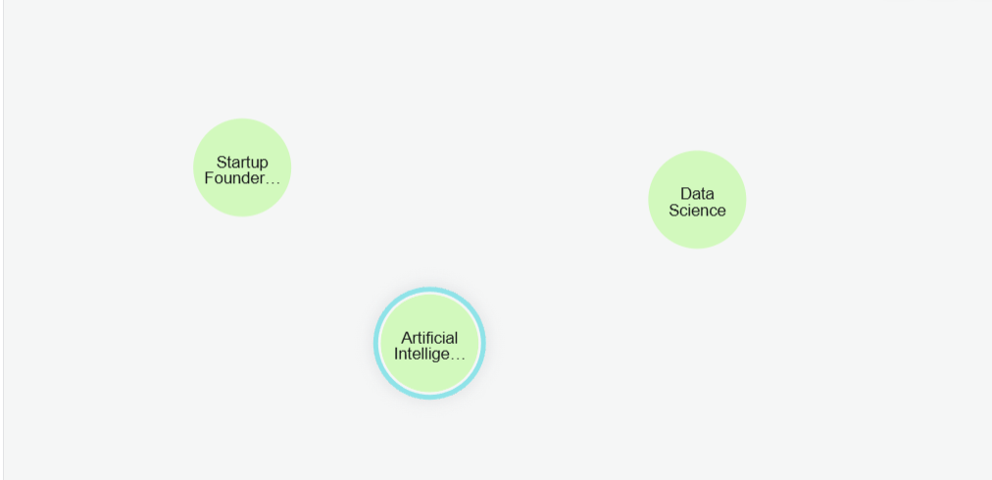

5. Connect Users to Groups
MATCH
(r:User {name:'Rahul'}), (p:User {name:'Priya'}), (n:User {name:'Neha'}), (a:User {name:'Amit'}),
(s:User {name:'Sneha'}), (ar:User {name:'Arjun'}),
(g1:Group {name:'Artificial Intelligence'}), (g2:Group {name:'Data Science'}),
(g3:Group {name:'Startup Founders'})
CREATE
(r)-[:MEMBER_OF {role:'Member', since:2022}]->(g1),
(r)-[:MEMBER_OF {role:'Moderator', since:2021}]->(g2),
(p)-[:MEMBER_OF {role:'Member', since:2023}]->(g1),
(p)-[:MEMBER_OF {role:'Member', since:2022}]->(g2),
(n)-[:MEMBER_OF {role:'Researcher', since:2021}]->(g1),
(n)-[:MEMBER_OF {role:'Member', since:2023}]->(g2),
(a)-[:MEMBER_OF {role:'Founder', since:2022}]->(g3),
(s)-[:MEMBER_OF {role:'Member', since:2023}]->(g1),
(ar)-[:MEMBER_OF {role:'Member', since:2022}]->(g1),
(ar)-[:MEMBER_OF {role:'Member', since:2023}]->(g2);
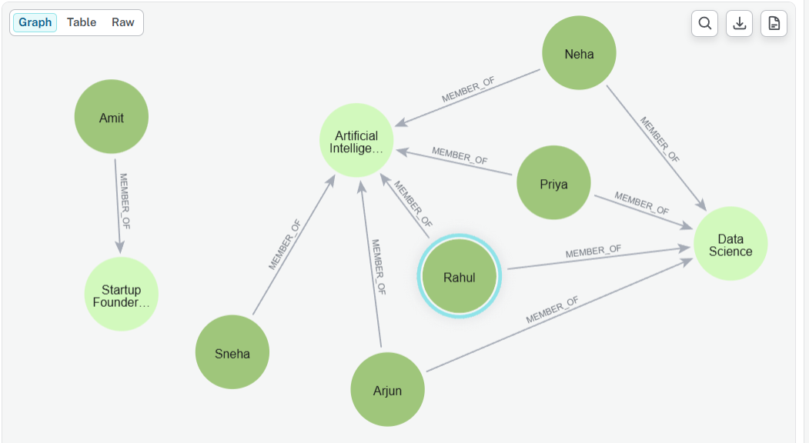

6. Create Comments
Comments are modeled as independent nodes so each comment can have its own sentiment, toxicity, likes, timestamp and topic.
CREATE
(c1:Comment {id:'C001', text:'Graph databases are very useful for connected data.', sentiment:'Positive', toxicity:0.02, likes:34, timestamp:'2026-08-20'}),
(c2:Comment {id:'C002', text:'I think Graph RAG can improve knowledge retrieval.', sentiment:'Positive', toxicity:0.01, likes:41, timestamp:'2026-08-21'}),
(c3:Comment {id:'C003', text:'The performance depends heavily on the graph structure.', sentiment:'Neutral', toxicity:0.03, likes:18, timestamp:'2026-08-21'}),
(c4:Comment {id:'C004', text:'Interesting perspective on community detection.', sentiment:'Positive', toxicity:0.00, likes:29, timestamp:'2026-08-22'}),
(c5:Comment {id:'C005', text:'I disagree with this approach.', sentiment:'Negative', toxicity:0.12, likes:9, timestamp:'2026-08-22'});
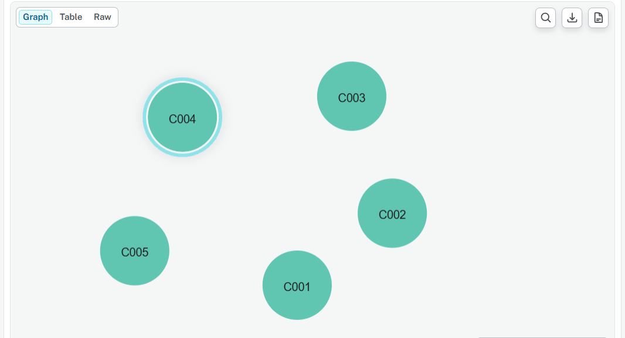

7. Connect Users to Comments
MATCH
(r:User {name:'Rahul'}), (p:User {name:'Priya'}), (n:User {name:'Neha'}), (a:User {name:'Amit'}), (s:User {name:'Sneha'}),
(c1:Comment {id:'C001'}), (c2:Comment {id:'C002'}), (c3:Comment {id:'C003'}), (c4:Comment {id:'C004'}), (c5:Comment {id:'C005'})
CREATE
(r)-[:COMMENTED {time:'10:30'}]->(c1),
(p)-[:COMMENTED {time:'11:10'}]->(c2),
(n)-[:COMMENTED {time:'12:15'}]->(c3),
(a)-[:COMMENTED {time:'13:20'}]->(c4),
(s)-[:COMMENTED {time:'14:05'}]->(c5);
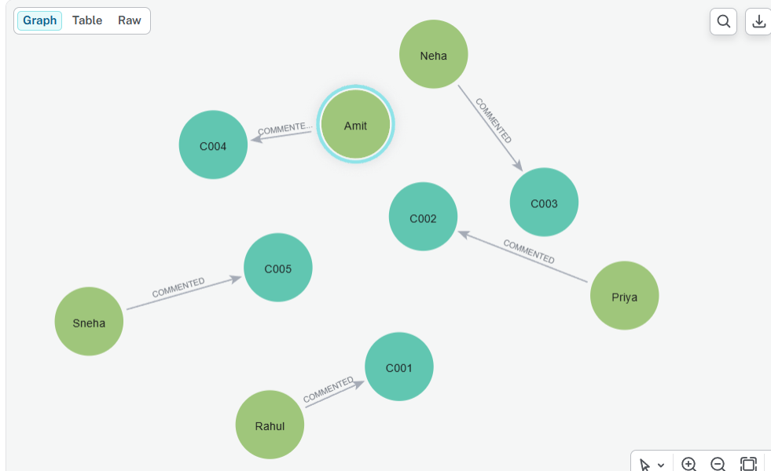

8. Comments as Conversation Nodes
MATCH
(p:User {name:'Priya'}), (n:User {name:'Neha'}),
(c1:Comment {id:'C001'}), (c3:Comment {id:'C003'})
CREATE
(p)-[:REPLIED_TO]->(c1),
(n)-[:REPLIED_TO]->(c1),
(p)-[:REPLIED_TO]->(c3);
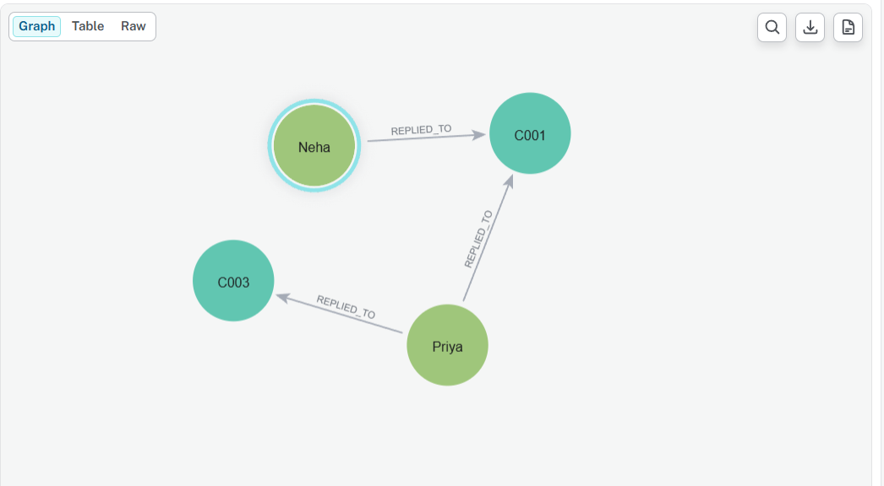

9. Create Topics
CREATE
(t1:Topic {name:'Graph Database'}),
(t2:Topic {name:'Graph RAG'}),
(t3:Topic {name:'Community Detection'}),
(t4:Topic {name:'Social Network Analysis'});
MATCH
(c1:Comment {id:'C001'}), (c2:Comment {id:'C002'}), (c3:Comment {id:'C003'}), (c4:Comment {id:'C004'}),
(t1:Topic {name:'Graph Database'}), (t2:Topic {name:'Graph RAG'}), (t3:Topic {name:'Community Detection'})
CREATE
(c1)-[:ABOUT]->(t1),
(c2)-[:ABOUT]->(t2),
(c3)-[:ABOUT]->(t1),
(c4)-[:ABOUT]->(t3);
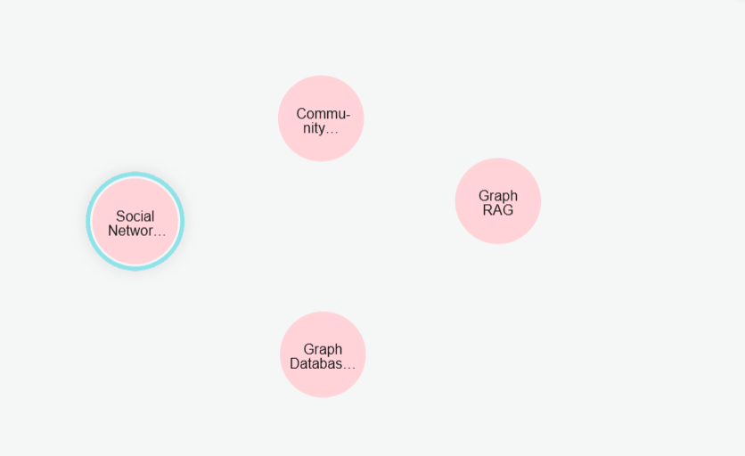

13. Important Cypher Patterns
Operation | Pattern
Create node | CREATE (u:User {...})
Find node | MATCH (u:User {...})
Create relationship | CREATE (a)-[:FRIEND]->(b)
Find relationship | MATCH (a)-[r:FRIEND]->(b)
Any relationship | MATCH (a)-[r]-(b)
Variable-length path | MATCH path=(a)-[:FRIEND*1..3]-(b)
Return graph | RETURN a, r, b
Return path | RETURN path
Filter | WHERE condition
Count | COUNT(x)
Update | SET u.property = value
Delete relationship | DELETE r
Delete node + relationships | DETACH DELETE u

12. Graph Visualization
Purpose | Cypher | Typical result
Tabular | MATCH (u:User)-[:FRIEND]->(f) RETURN u.name, f.name | Names/rows
Graph | MATCH (u:User)-[r:FRIEND]->(f) RETURN u,r,f | Nodes + edges
Path | MATCH path=(u)-[:FRIEND*1..3]-(v) RETURN path | Connected path

Exercise 1 — Display the Complete User Network
Returns a visual network containing users and user-to-user relationships.
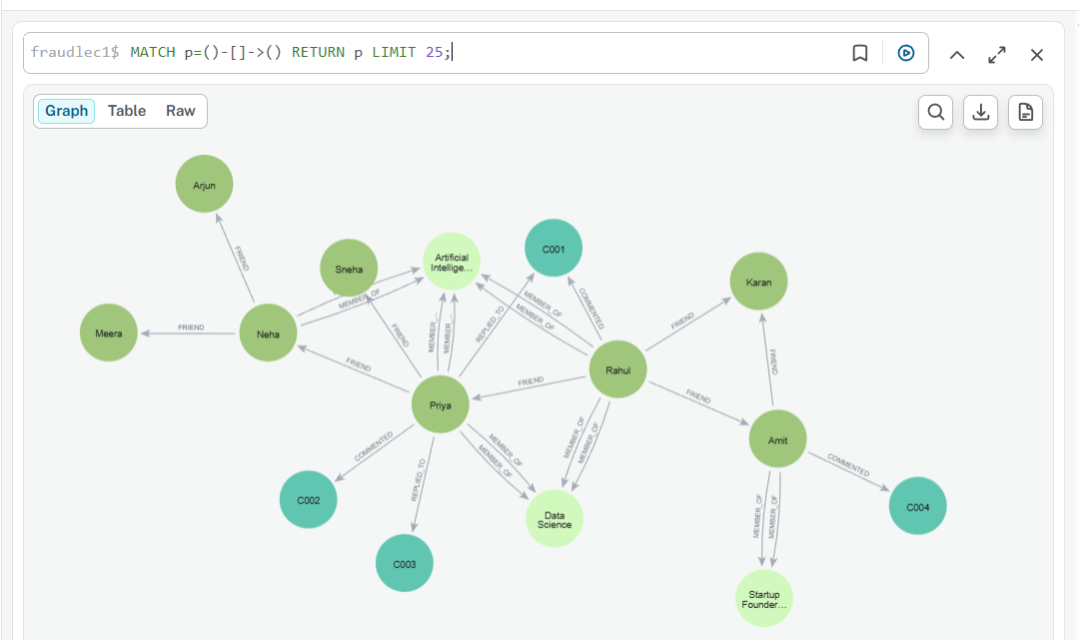

Exercise 2 — Display Only Friendships
Shows the friendship graph.
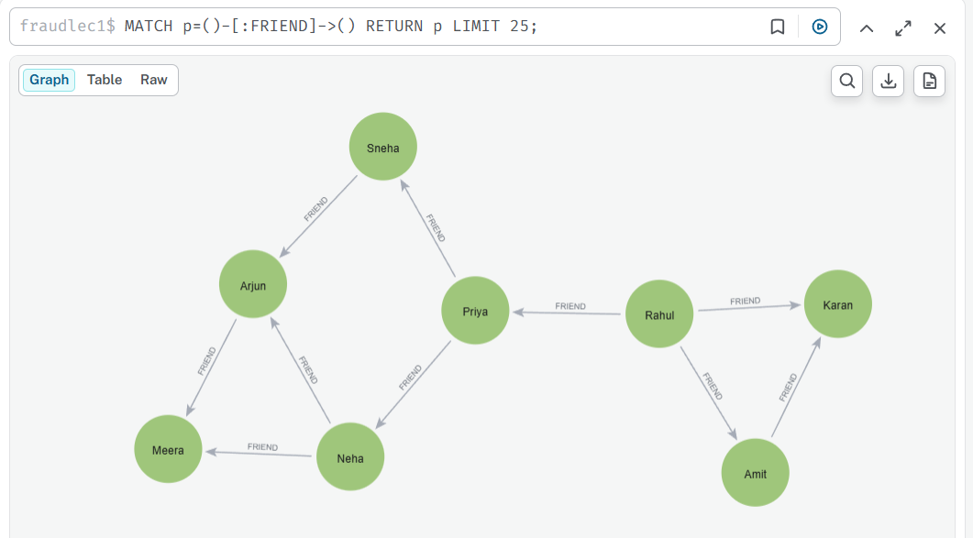

Exercise 3 — Rahul's Immediate Network
Builds Rahul's one-hop ego network.
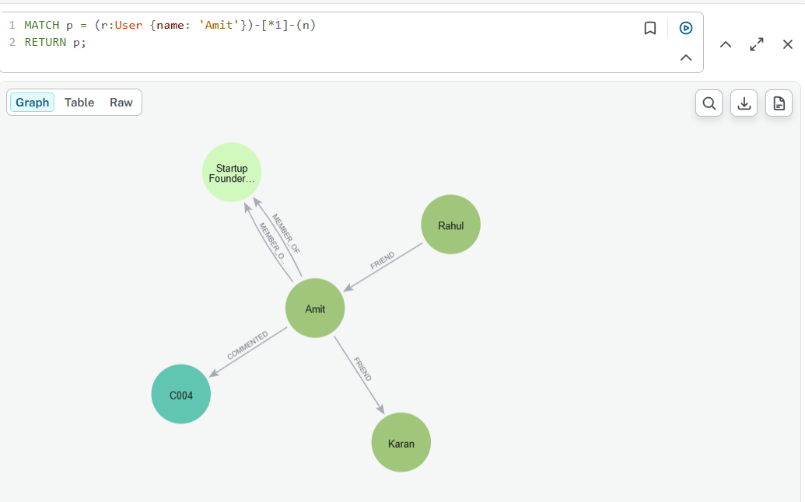
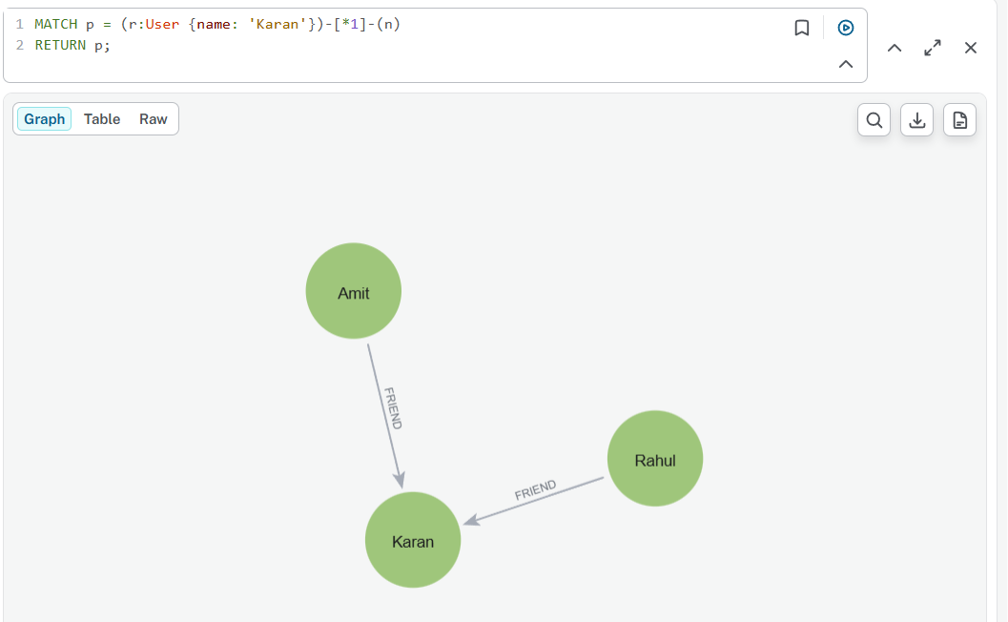

Exercise 4 — Rahul's Friends-of-Friends
Visualizes exactly two friendship hops.
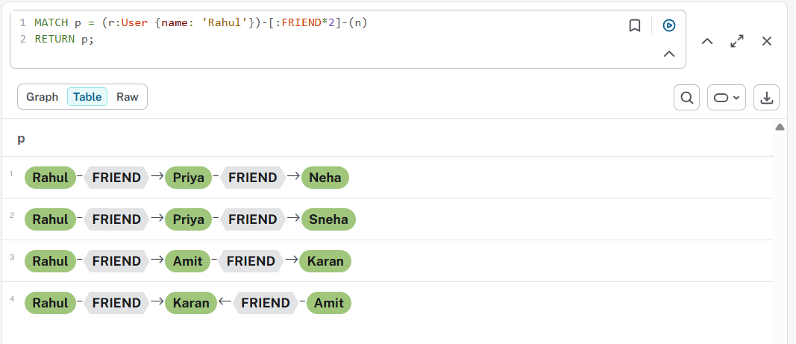
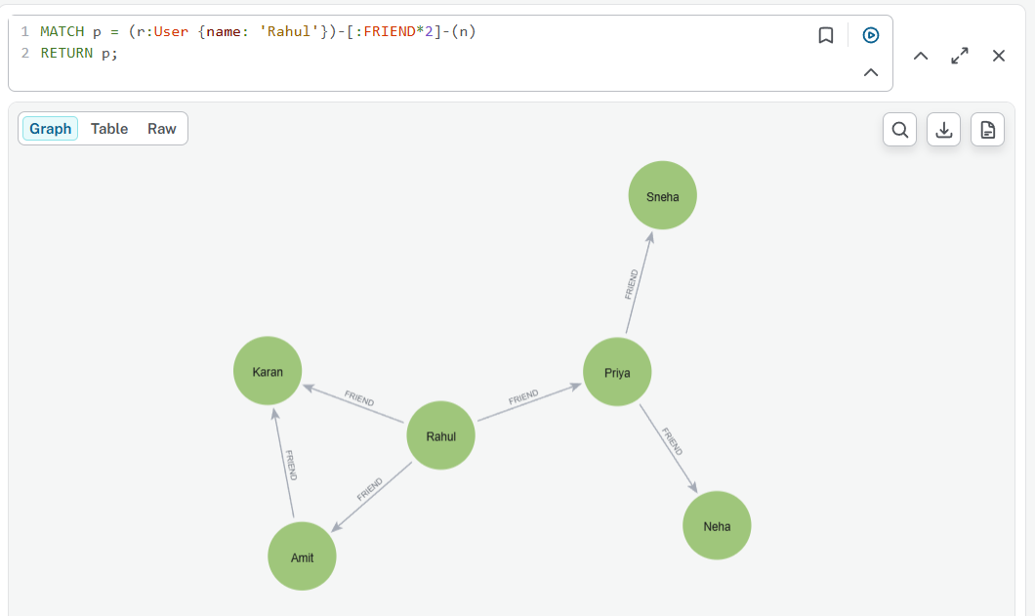

Exercise 5 — One to Three Hops
Visualizes Rahul's wider social neighborhood.
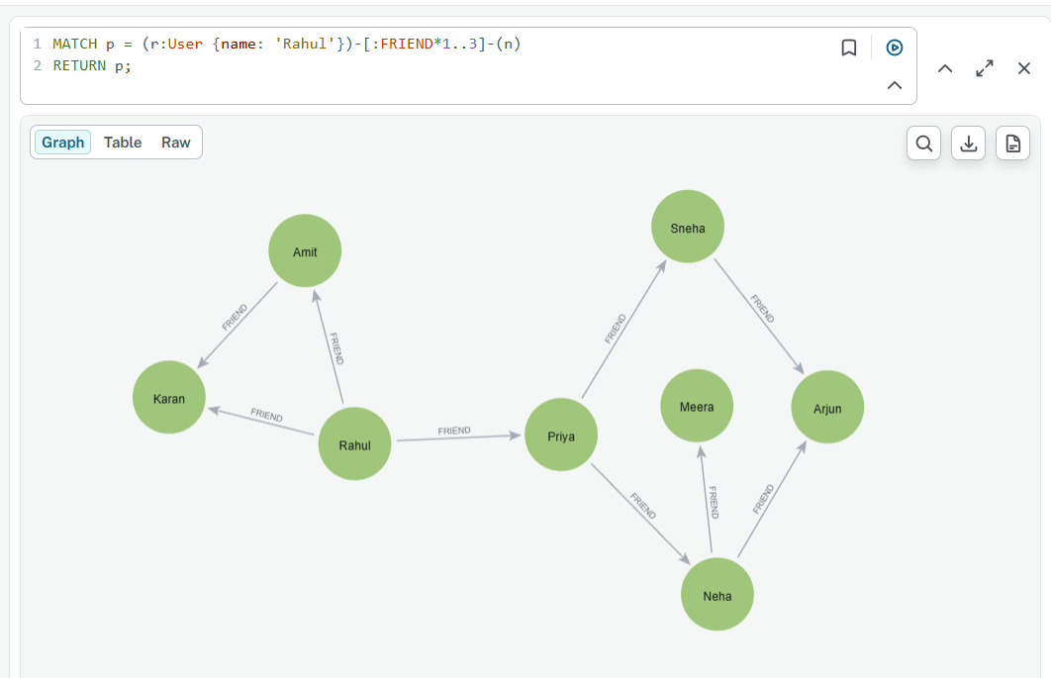

Exercise 6 — Connection Between Rahul and Karan
Returns friendship paths connecting the two users.
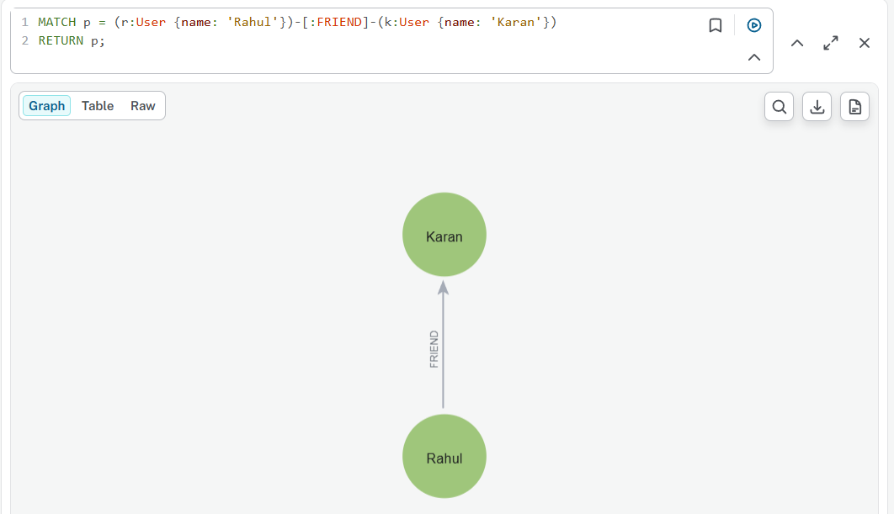

Between Rahul and Arjun
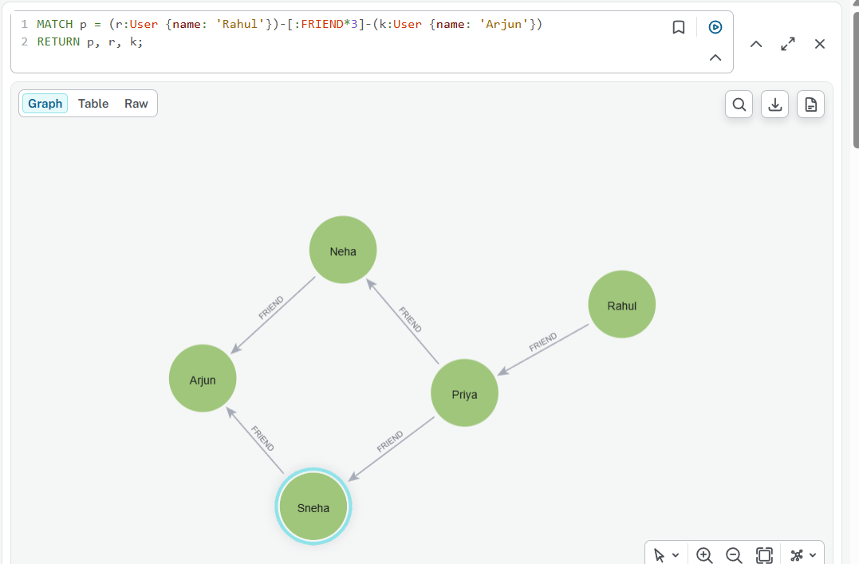

Exercise 7 — Shortest Social Connection (Any user)
Finds the shortest friendship route.
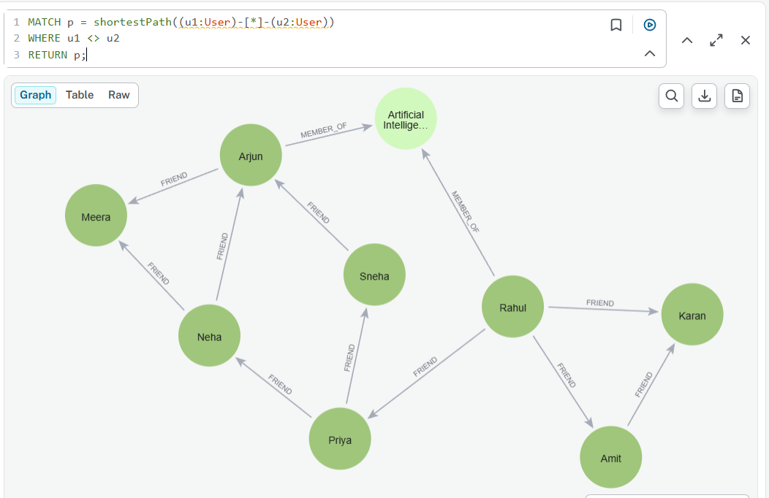

Exercise 8 — Longest Social Connection
Finds the shortest friendship route.

Exercise 9 — Users and Groups
Visualizes community/group membership.
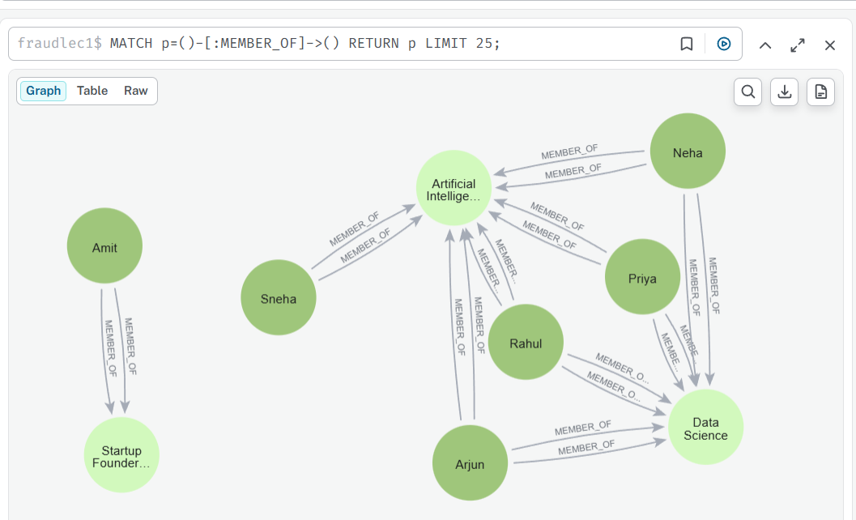

Exercise 10 — Users and Their Comments
Visualizes who made which comment.
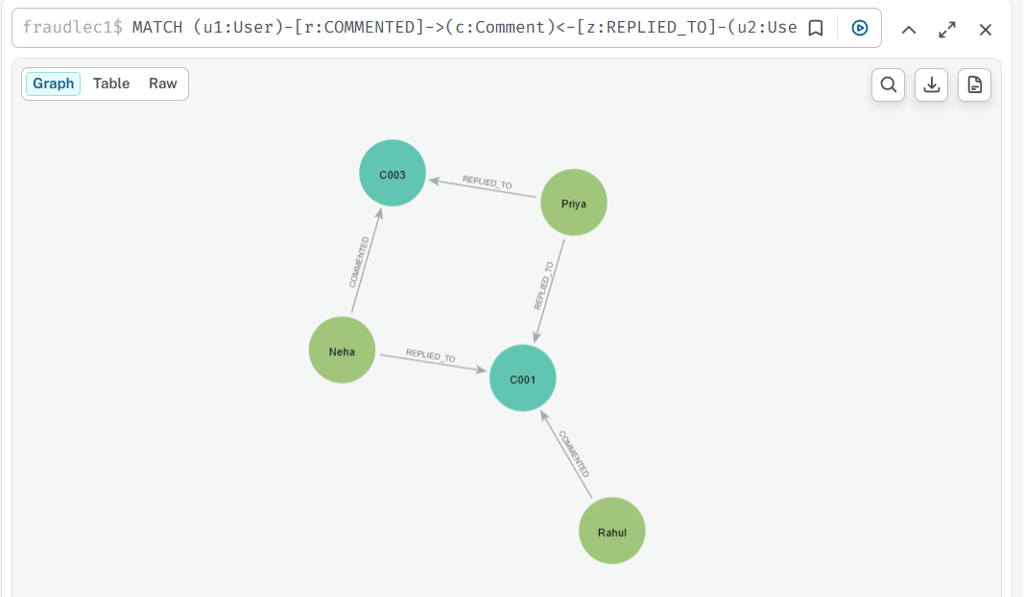

Exercise 11 — Comment Conversation Network
Shows users participating in a comment conversation.
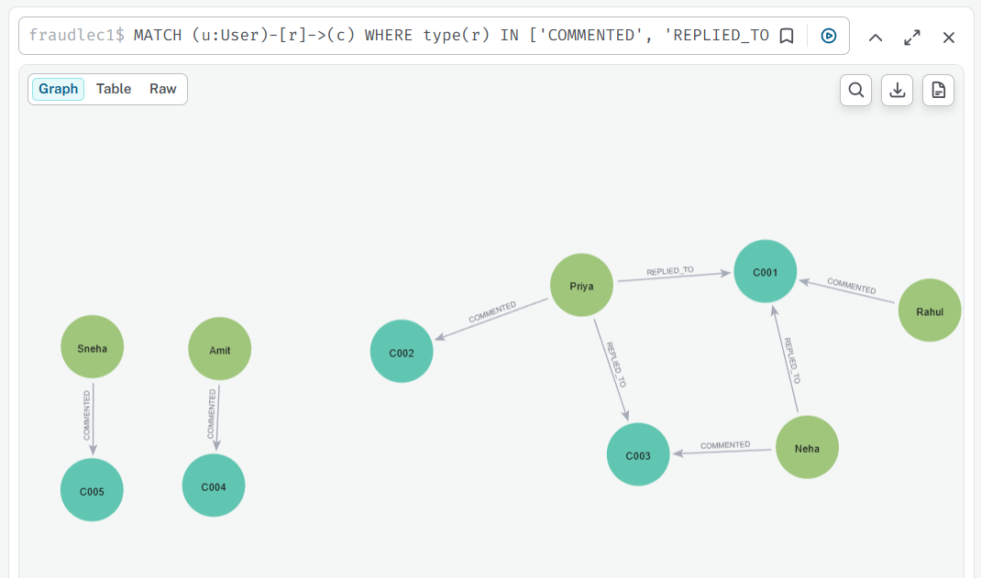

Exercise 12 — Users, Comments and Topics
Connects people to topics through comments.
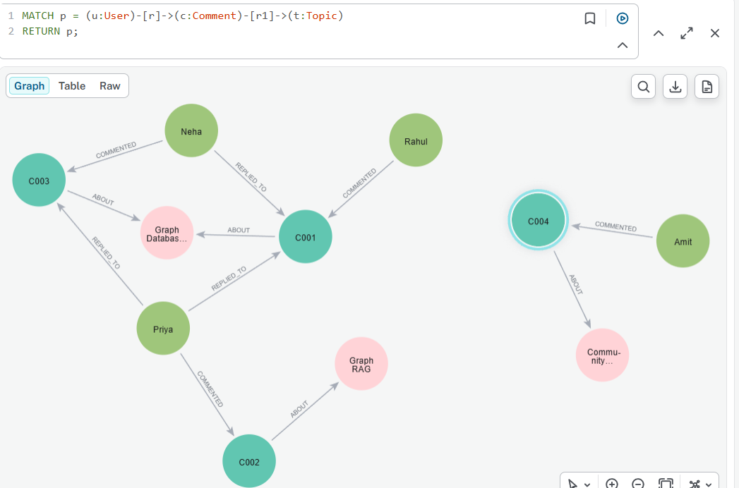

Exercise 13 — Shared Topic Network
Visualizes users discussing the same topic.
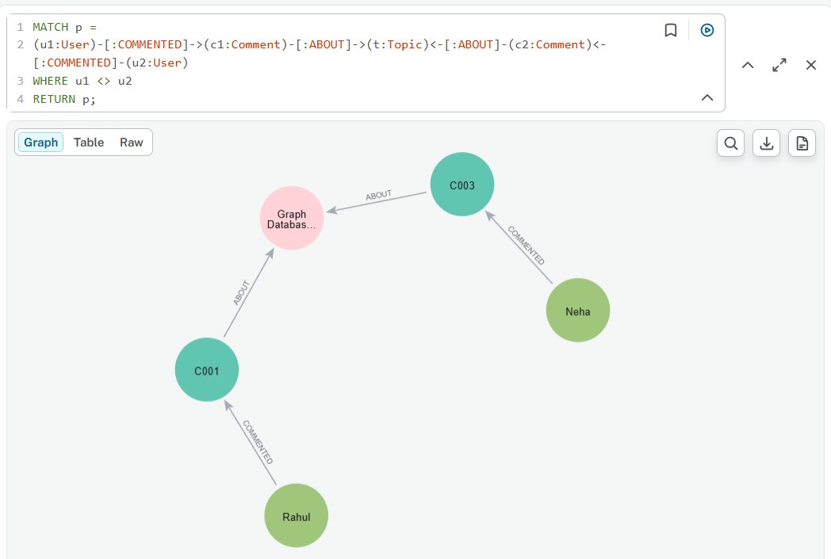

Exercise 14 — High-Toxicity Interaction
Visualizes conversations around high-toxicity comments.
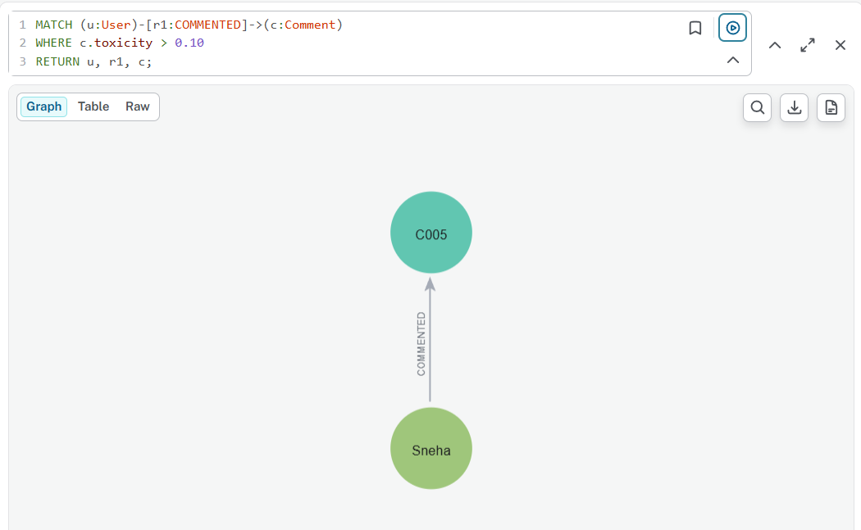

Exercise 15 — Friend Recommendation Graph
Returns the graph structure behind a friend recommendation.
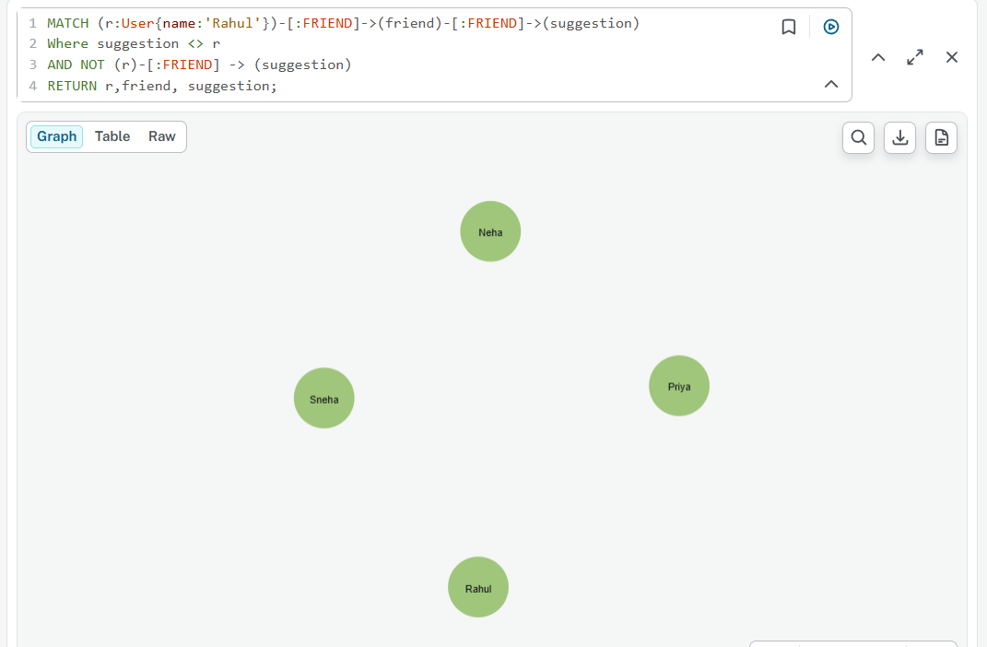

Exercise 16 — Complete Social Interaction Graph
Visualizes all currently modeled relationships.

