PRISM ARCHITECTURE · PART 01
System Overview
Layers, threading, startup, module map
Product Prism · version 1.3.0
Commit 20292f4
Drawn 26 August 2026
Source docs/architecture/ — Markdown is the master

System Overview

1.1 What Prism is, precisely
A single-process native desktop application, written in Python 3.12 against PySide6 (Qt 6), shipped as a portable per-OS binary built with PyInstaller.
It has:
- No web front end. No Electron, no embedded browser view, no localhost server. Every screen is a Qt widget.
- No backend of its own for customer data. The only Prism-operated server is the licence server, and it never receives customer content — only a licence id, a device fingerprint, an app version, and usage counters.
- No database. All persistent state is flat files: JSON under ~/.prism, and CSV in a folder the customer chooses (deliberately, so the register stays theirs and opens in Excel).
- No AI model of its own. It orchestrates other people's: Groq over HTTP for fast structured work, and the user's own logged-in web tools (ChatGPT, Claude, Perplexity, Canva, NotebookLM, Apollo…) driven through a real Chrome window with Selenium.

Why that shape
The target customer is a small Indian manufacturer. Two constraints follow and explain nearly every architectural decision:
Constraint | Consequence in the code
The customer's design files and correspondence must not leave their machine | Gerber files never reach an AI (cmd_gerber passes attachments=[], asserted by test). Triage sends only a 1,500-character snippet, and only for senders local rules could not settle. A "Keep everything on this computer" switch removes even that.
The customer already pays for ChatGPT/Claude and will not pay again per token | Automation drives the tools in their Chrome, signed in as them. There are no API bills for the heavy tools, and no new subscription to sell them.

1.2 The two repositories
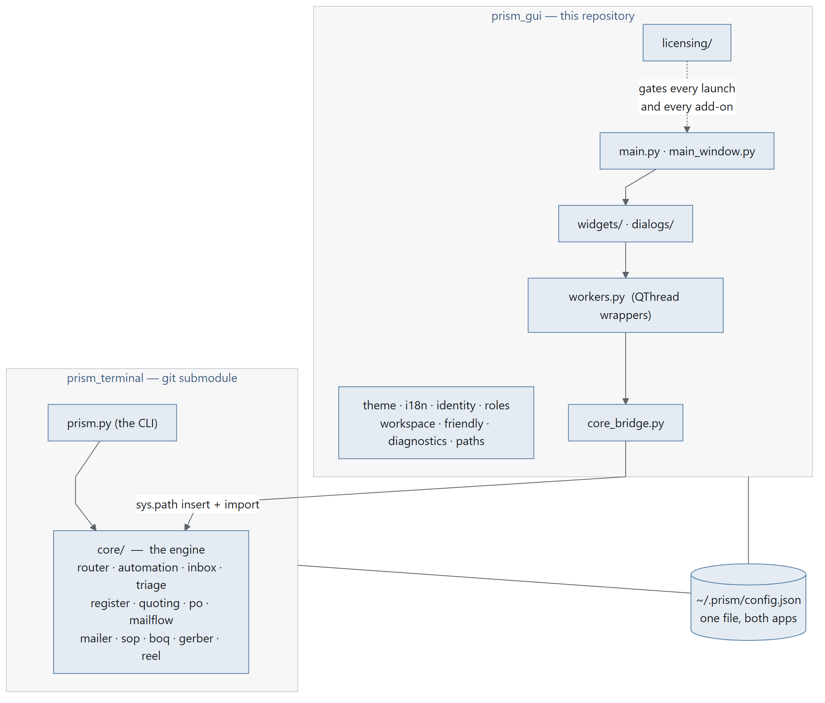
Diagram 1.1
prism_terminal is pinned as a git submodule (see .gitmodules) to github.com/HitarthTrivedi/prism_terminal.
The submodule always wins. paths.resource('prism_terminal') resolves to ./prism_terminal and is checked first. A sibling ../prism_terminal checkout is ignored; core_bridge._warn_about_sibling() prints a note naming both paths when it finds two, because believing the opposite once cost an afternoon spent editing a copy that was never loaded.
Operational trap, already recorded: two checkouts of prism_terminal on one dev machine is a known hazard — docs/AFTER_THE_MERGE.md §5. Decide one way or the other; do not keep both.

1.3 The layer model
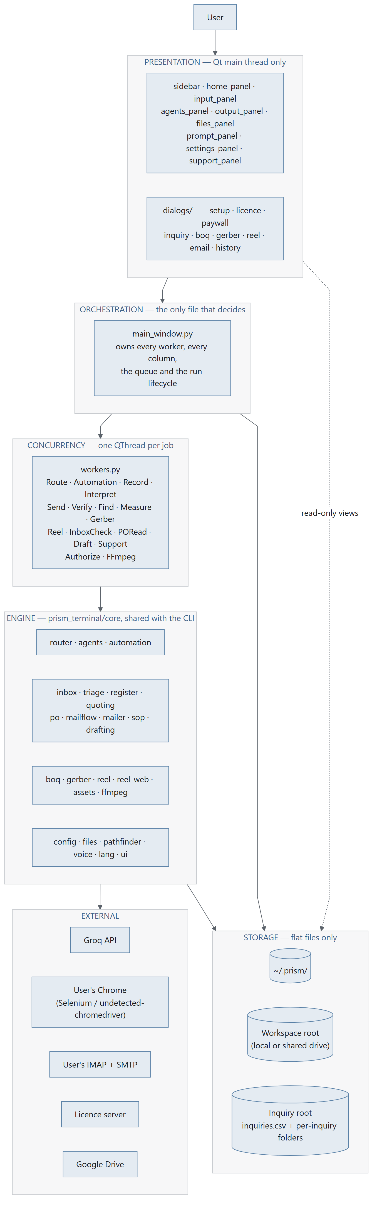
Diagram 1.2

The rule that keeps the layers honest
main_window.py is the only file that makes decisions.
Widgets emit signals and render what they are given. Dialogs collect input and return it. workers.py classes do one job off the UI thread and emit a result. The engine knows nothing about Qt. Everything that decides what happens next — which worker to start, what to do with its result, when to persist, when to stop for a human — lives in main_window.py or in the add-on dialog that owns that screen.
This is why main_window.py is 2,131 lines and why that is not, by itself, a problem to fix. It is also why a change to behaviour almost always lands in one file.

1.4 Process and threading model
Prism is single-process. Concurrency is QThread, never multiprocessing, and never asyncio.

Diagram 1.3

The four rules
- Nothing touches a widget from a worker thread. Workers communicate exclusively by Qt signal; Qt marshals the call back onto the main thread.
- Every worker is owned by the window that started it and is retired in closeEvent. MainWindow._retire_workers() asks each live worker to stop and then waits up to _WORKER_WAIT_MS = 10000 ms. InquiryDialog.closeEvent does the same for its own workers.
- Long-running work is interruptible, not killable. AutomationWorker.stop() sets a flag the engine polls at safe points (_sleep_interruptibly, should_stop callbacks). There is no thread termination.
- Cleanup order matters and has bitten before. _retire_listener() exists because dropping a wake-word listener while its thread was still running crashed the interpreter — see tests/ coverage for GIL-related cleanup.

Where blocking actually happens
Job | Typical duration | Worker
Groq routing call | 1–5 s | RouteWorker
Licence authorise | up to 45 s (cold host) | AuthorizeWorker
Browser pipeline (per stage) | 35 s – 30 min | AutomationWorker
IMAP fetch + triage, one mailbox | 5 s – 3 min | InboxCheckWorker
SMTP blast | 2 s per recipient (SEND_DELAY) | SendWorker
Gerber measurement | 2 s – 2 min | GerberWorker
Reel encode | 1–10 min | ReelWorker

1.5 Startup sequence
main.py :: main() — the order is load-bearing, and each step's comment in the source explains what breaks if it moves.
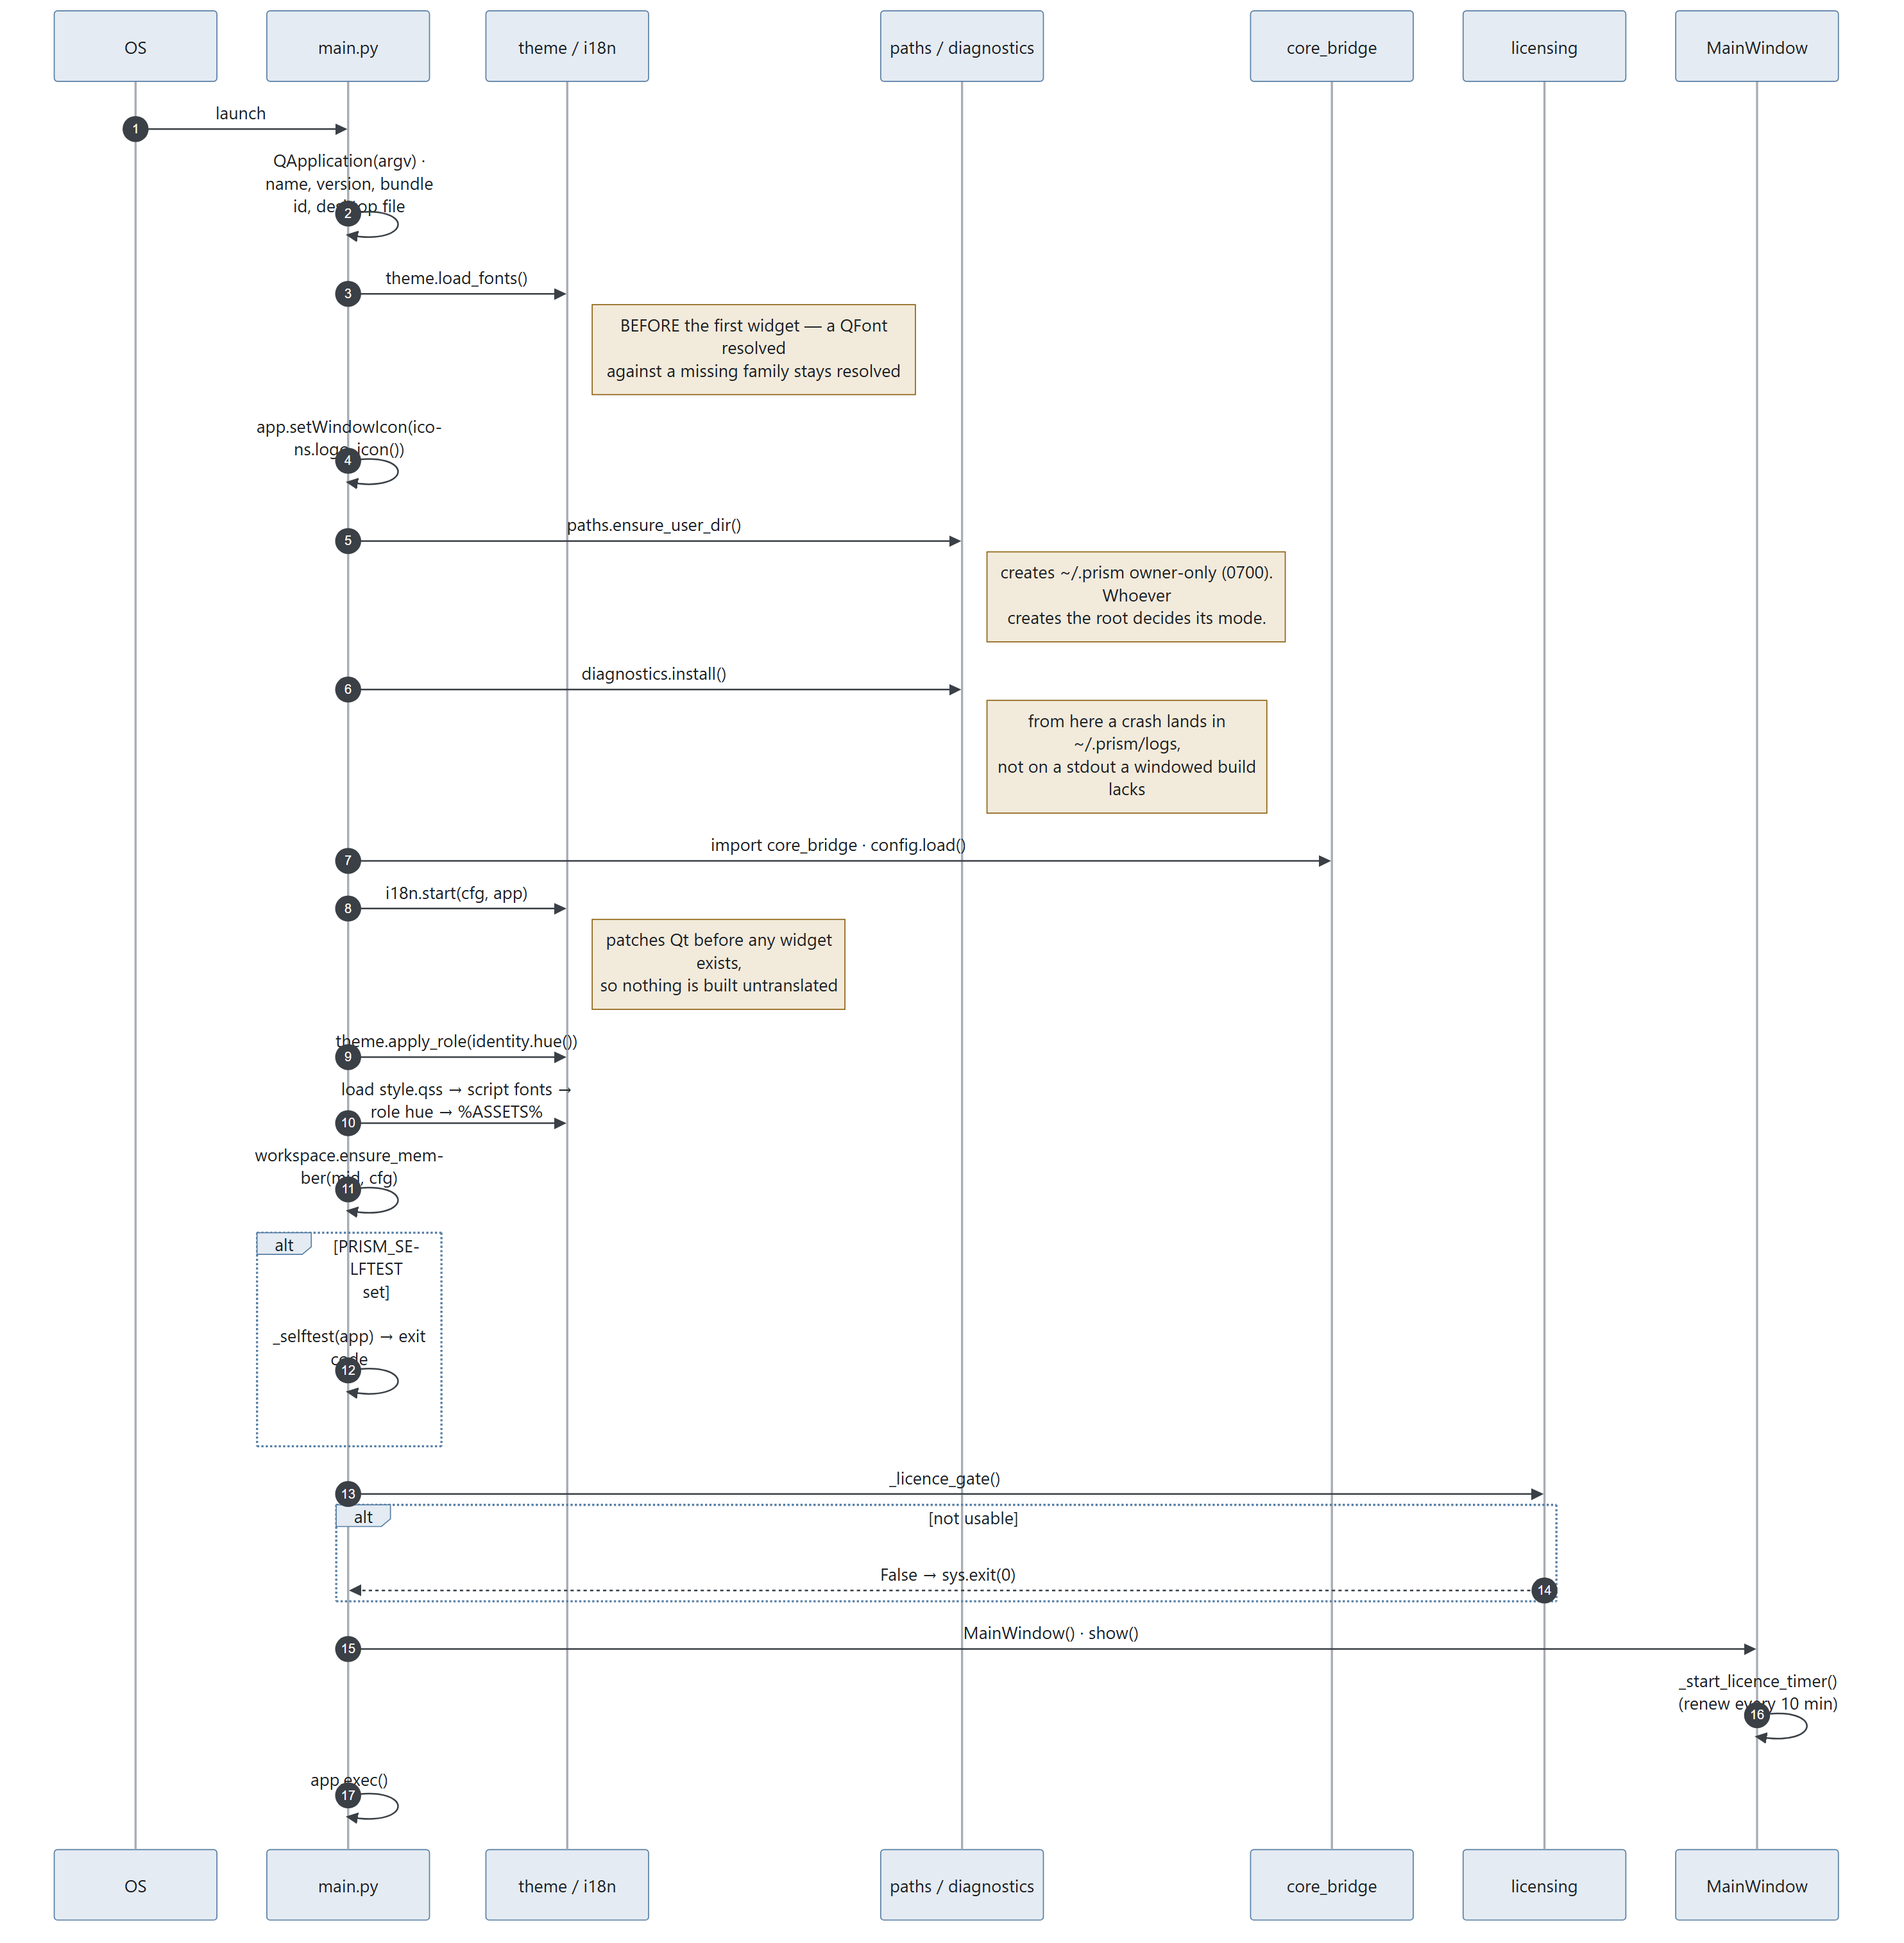
Diagram 1.4

What each step protects
Step | Moving it breaks
theme.load_fonts() first | Widgets built before the font is registered stay on the fallback sans forever
paths.ensure_user_dir() before diagnostics | ~/.prism gets created by whatever runs first, inheriting the ambient umask instead of 0700
diagnostics.install() before anything fallible | A crash in a windowed build has nowhere to print
i18n.start() before the first widget | Untranslated widgets, permanently
Stylesheet after i18n and theme.apply_role | Both rewrite the QSS; whichever runs last wins
Licence gate before MainWindow | The window reaches for the licence server during construction

1.6 Module map

Application root (prism_gui/)
File | Lines | Responsibility
main.py | 327 | Entry point, startup order, licence gate, --selftest, paywall registration
main_window.py | 2,131 | The only decision-maker: owns all workers, all three columns, the task queue, the run lifecycle, all add-on entry points
core_bridge.py | 258 | Puts prism_terminal/core on sys.path; lazy get_*() / *_available() accessors so heavy optional deps are probed, not imported at boot
workers.py | 511 | 16 QThread wrappers — the entire concurrency surface
dashboard_data.py | 355 | Read-only projections for Home and register screens (recent runs, counts, sparklines, register views, currency formatting)
theme.py | 597 | Industry design tokens; per-role accent hue; stylesheet rewriting
i18n.py | 441 | Interface translation; patches Qt before any widget exists; script-aware font stacks
identity.py | 191 | Who is signed in (designation key), display name, accent hue, view-as
roles.py | 211 | The eight roles, their hues, their default agent picks
workspace.py | 305 | Per-member folders on a shared drive; the team roster; read permissions
plans.py | 210 | What each plan includes — the single table the app and licence server share
friendly.py | 347 | Any error → title, plain English, numbered next steps
diagnostics.py | 300 | Crash logs to ~/.prism/logs
paths.py | 129 | Resource resolution frozen vs. source; ~/.prism helpers; open/reveal a result
app_meta.py | 20 | Name, version (1.3.0), bundle id, publisher, support email
favorites.py | 51 | Starred file/folder persistence
awake.py | — | Keep-awake during long runs
cloud.py | — | Cloud file attach
wakeword.py | — | Best-effort "Prism" wake-word polling loop (not a real engine — see §1.8)
support_kb.py | 1,618 | The support answer book
style.qss | 45 KB | The Industry theme — everything QSS can express

widgets/ — presentation
File | Lines | Shows
controls.py | 1,767 | The shared component library: square switch, tool chip, step mark, pills
simple_panels.py | 1,582 | Six screens: Guide, AI tools registry, History, and three status screens
output_panel.py | 1,461 | The run console — live per-step results, Copy output, Open in tool
support_panel.py | 1,244 | Help & support: answer book left, conversation right
settings_panel.py | 1,216 | Settings as one screen with a grouped section list
agents_panel.py | 1,144 | The plan — steps, plain-English names, tool chips
sidebar.py | 1,105 | Left rail: brand, nav groups, add-on shelf with padlocks, favourites
home_panel.py | 886 | Home — the command centre
input_panel.py | 683 | The task card — the front door
inquiry_panel.py | 675 | Inquiry automation as a screen rather than a dialog
tour.py | 490 | Six-step progressive onboarding
files_panel.py | 374 | "Files you mentioned"
register_table.py, blueprint.py, ask_panel.py, prompt_panel.py, icons.py, markdown.py | — | Register table, hairline frame with registration marks, shared ask box, "Behind the scenes", 24×24 stroked line icons, markdown → Qt rich text

dialogs/ — modal flows
File | Lines | Flow
inquiry_dialog.py | 2,618 | The five-tab Email automation screen, plus quotation, PO review, reminder, edit-row dialogs
inquiry_setup_dialog.py | 1,013 | Mailboxes, folders, terms, who's-who — asked once
setup_dialog.py | 1,003 | Setup, with per-section deep links from the rail
email_dialog.py | 687 | Email blast: recipients, draft, confirm-and-send
reel_dialog.py | 468 | Reel / Studio
license_dialog.py | 418 | Activation, expiry, licence problems
boq_dialog.py | 410 | Quantities off a CAD drawing
history_dialog.py | 392 | Past runs, re-rendered from stored JSON
gerber_dialog.py | — | PCB job measurement — no AI sees the design
paywall.py, problem_dialog.py, guide_dialog.py, drive_dialog.py, ai_directory_dialog.py, completion_dialog.py, contact_dialog.py, base.py | — | Locked-add-on pitch, friendly errors, the guide, Drive picker, tool catalogue, run completion, contact the team, shared modal chrome

licensing/ — the gate
File | Lines | Responsibility
__init__.py | 879 | The whole public surface: state, has, require, activate, authorize, refresh, report_usage, selftest
authorization.py | 285 | The lease cache and the offline policy, in one place
client.py | 267 | HTTP to the licence server; timeouts sized for a cold host
store.py | 251 | ~/.prism/license.json, atomic and 0600
lease.py | 233 | Lease wire format and verification
payload.py | 186 | Server-published configuration format and verification
status.py | 169 | The state machine: none / valid / grace / stale / expired / tampered
device.py | 150 | Machine fingerprint for seat counting (three tiers)
token.py | 145 | Licence token format, signing input, verification
designation.py | 142 | The second key: who this person is and what job they do
secretstore.py | 132 | OS credential store, with a file fallback
meter.py | 130 | Usage metering — what was consumed, never what was written
keyformat.py | 65 | The key the customer types: PRSM-…, Crockford-ish alphabet, checksum
keys.py | 43 | Ed25519 public keys; DEVELOPMENT keys trusted from source only

prism_terminal/core/ — the engine (18,708 lines)
File | Lines | Responsibility
automation.py | 3,222 | Browser automation: Chrome profile seeding, driver setup, per-stage prompt construction, typing, waiting, scraping, downloads, image harvesting, failover
gerber.py | 2,120 | RS-274X and Excellon parsing, copper geometry, track width, spacing, board outline, drills, cross-check against CAM reports
reel.py | 1,810 | Vertical video: frames drawn with Pillow, encoded with FFmpeg
reel_web.py | 1,765 | Prism Studio: the frames are a real web page filmed in a paused Chromium
inbox.py | 1,009 | IMAP: host discovery, read-only fetch, header-batching, backfill, parsing, attachments
boq.py | 827 | DXF/DWG geometry: lengths, areas, counts, per-layer and per-block
router.py | 785 | The routing brain (Groq): query enrichment, stage selection, guardrails, model fallback chain
quoting.py | 742 | Rate lists, cost sheets, matching, Decimal arithmetic, quotation rendering
agents.py | 720 | The agent registry: every tool, its URL, selectors, waits, specialty, cost
mailflow.py | 565 | The daily loop — one check() that never raises and never sends
triage.py | 559 | Sorting the inbox: local rules first, batched AI only for the unknown
register.py | 556 | The inquiry register CSV: numbering, threading, atomic writes, status transitions
mailer.py | 502 | SMTP: recipient parsing, discovery prompts, draft parsing, bulk send
po.py | 406 | Reading a purchase order and comparing it to the quotation
sop.py | 392 | Sending SOPs to customers at their current revision
remote.py | 328 | The LAN/relay bridge for driving Prism from a phone
ffmpeg.py | 323 | FFmpeg location, download, SHA-256 verification
assets.py | 310 | Reel assets: background cutout, ink ratio, the asset table
drafting.py | 307 | Writing the awkward emails using the browser tools
ui.py, onboarding.py, pathfinder.py, voice.py, files.py, config.py, checklog.py, lang.py | — | Terminal UI, CLI onboarding, natural-language file finder, push-to-talk voice, attachments, config, check logging, language

1.7 The window layout
The window follows direction 1b ("Workbench") of the Prism Directions design canvas, rendered in the Industry design system: #f2f2f3 canvas, slate-blue #5980a6 accent, Barlow / Barlow Condensed, square corners, hairline borders with blueprint registration marks.
It auto-sizes to the screen it is on: 92% / 88% of available width/height, capped at 1360×880, floor 1060×640.
Three fixed columns. The old QDockWidgets are gone — nothing can be dragged out, closed, or lost behind a tab, so there is no View menu.
┌───────────────┬───────────────────────────────┬──────────────┐
│ RAIL │ WORK (two-page stack) │ CONTEXT │
│ │ │ (collapses │
│ brand │ ┌─ Composing ──────────────┐ │ to 44px) │
│ Home │ │ task card │ │ │
│ How to use │ │ · kicker, state chip │ │ Files you │
│ AI tools │ │ · 16px editable task │ │ mentioned │
│ History │ │ · Speak / Add file / │ │ · Keep │
│ Settings │ │ Add folder / Make a │ │ · Change │
│ wake word │ │ plan │ │ │
│ │ │ Your plan │ │ Behind the │
│ ADD-ONS │ │ · one row per stage │ │ scenes │
│ Email autom. │ │ · include marker, icon, │ │ (collapsed) │
│ BOQ │ │ plain-English name, │ │ · what you │
│ Email │ │ tool chip │ │ said │
│ BOM (soon) │ │ Start the work │ │ · task brief│
│ │ └──────────────────────────┘ │ · each │
│ WORKSPACE │ ┌─ Running ────────────────┐ │ stage's │
│ Status │ │ live per-step cards │ │ prompt │
│ Login tabs │ │ · Copy output │ │ │
│ │ │ · Open in tool │ │ │
│ CONFIGURE │ │ Back to the plan │ │ │
│ Licence … │ └──────────────────────────┘ │ │
│ │ │ │
│ FAVORITES │ │ │
└───────────────┴───────────────────────────────┴──────────────┘
The accent hue shifts with the signed-in member's role, so a glance says whose copy this is. Only the hue moves — every swatch keeps its lightness, so contrast is identical in every role and nothing needs re-checking for legibility.
Anything not in the licence shows a padlock and opens the pitch rather than failing.

1.8 Known architectural limitations
These are documented, deliberate, and should be quoted honestly to customers. Sourced from the repo README.md "Known limitations" and verified in code.
Limitation | Detail
Wake word is best-effort | wakeword.py is a polling loop — record ~2 s, check for silence, transcribe if not silent, look for "prism". Not a real local wake-word engine. Expect seconds of lag and occasional misses. Swap in Porcupine / OpenWakeWord to make it production-grade.
NotebookLM automation is unverified | automation._run_notebooklm is best-effort and has not been checked against a live session.
Typed queries do not auto-scan for file mentions | Only spoken input runs the interpreter. A GUI has real Attach buttons; prose-scanning a typed sentence adds risk for no benefit.
Email automation's send path and PO screen have never run against a real mailbox | Written and unit-tested. Reading is the well-covered half. This is the single biggest verification gap in the product.
plans.py feature names and blurbs are not in the translation catalogue | They render in English regardless of interface language.
One machine writes the register | Several mailboxes are supported; several machines writing one register is deliberately not built. The office PC that stays on does the writing; everyone else reads. Trigger for changing this is in docs/DEFERRED.md.
No offline licence fallback | If the licence server cannot be reached and no lease covers the action, the answer is no. This is a deliberate trade — see LICENSING.md.

