PRISM ARCHITECTURE · PART 02
Data Model
Every file, every field, the ER diagram
Product Prism · version 1.3.0
Commit 20292f4
Drawn 26 August 2026
Source docs/architecture/ — Markdown is the master

Data Model

2.1 The storage map
Prism has no database. Everything persistent is a flat file, in one of three places.
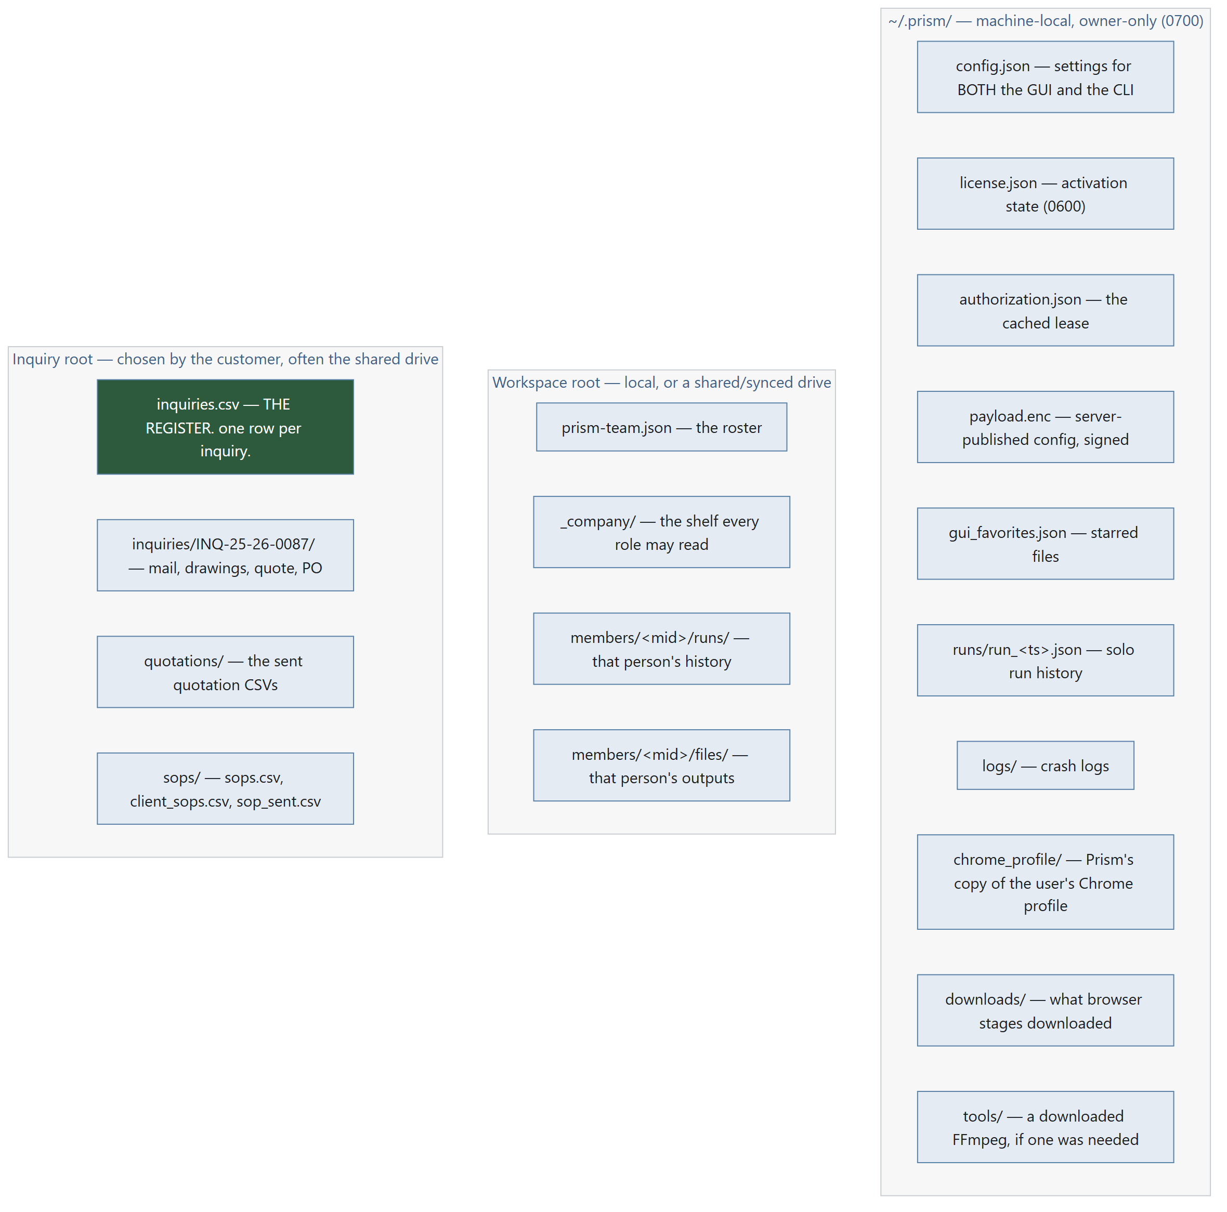
Diagram 2.1

Why the split
Location | Holds | Never holds
~/.prism/ | Credentials, licence state, machine-local caches | Anything another machine needs
Workspace root | Per-member run history and outputs | Passwords — ever
Inquiry root | The register and everything belonging to an inquiry | Passwords — ever

The rule, stated once: mailbox and SMTP passwords live only in ~/.prism/config.json on the machine that does the checking. They never touch the shared folder. That is why "one machine writes, everyone reads" is a design rule and not an accident.

2.2 Entity–relationship diagram
The register is the hub. Everything else either feeds it or hangs off it.

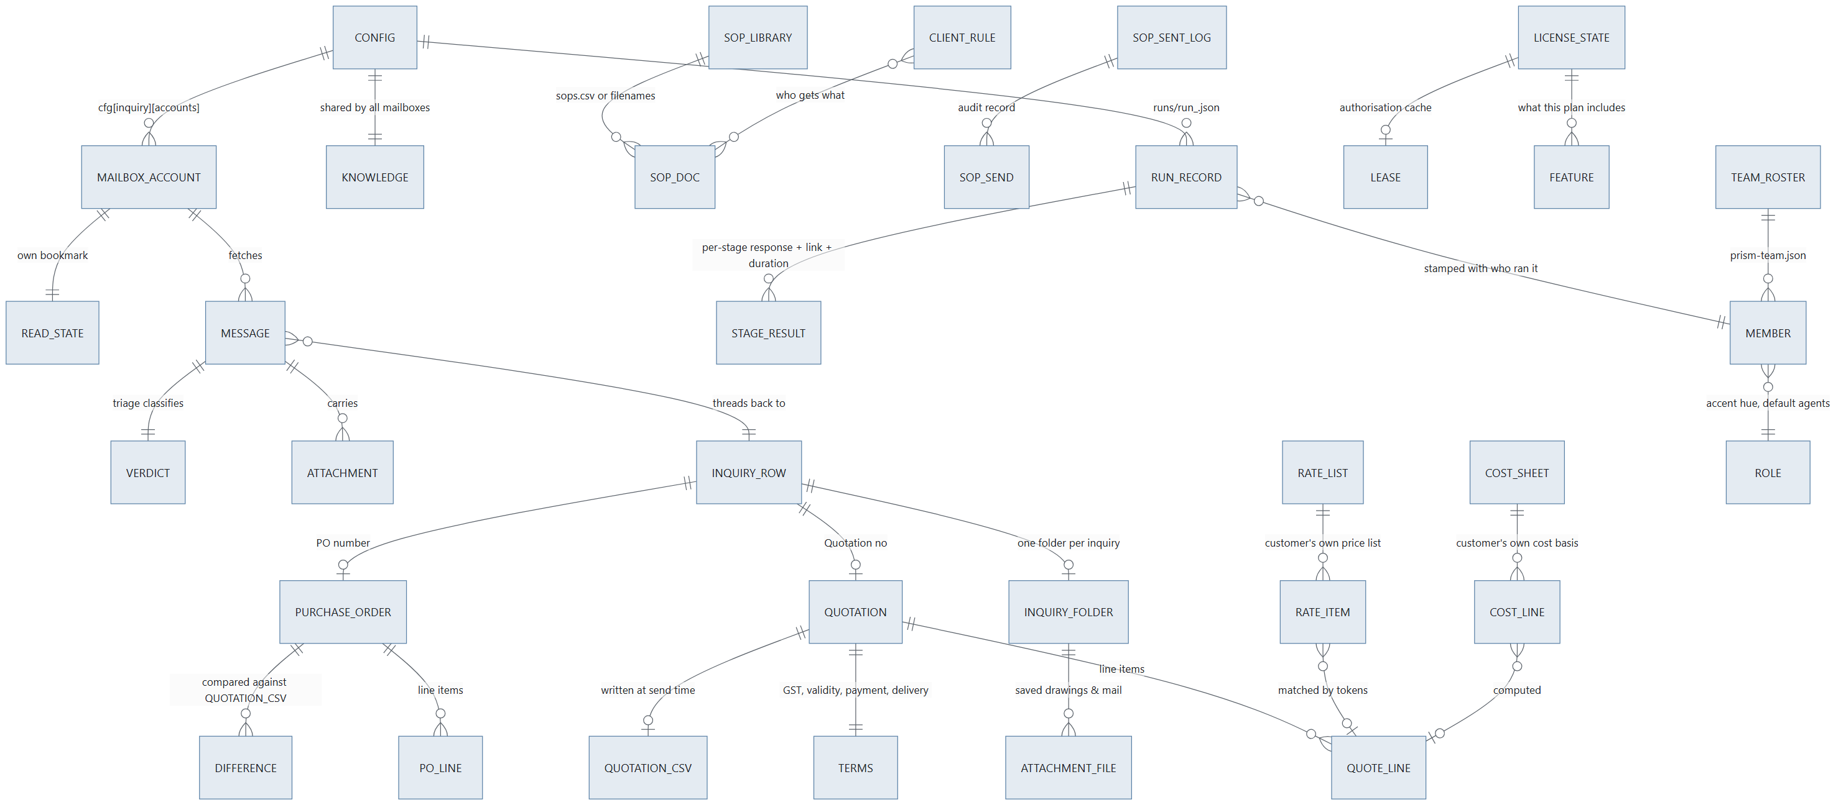
Diagram 2.2

2.3 ~/.prism/config.json — the shared configuration
Written by prism_terminal/core/config.py. Both the GUI and the CLI read and write this file; set an API key in either and the other sees it immediately.
Written atomically: temp file in the same directory, os.replace(). A file that fails to parse is quarantined (moved aside, path reported) rather than overwritten — config._quarantine().

Root keys — engine defaults (config.DEFAULT)
Key | Type | Default | Meaning
api_key | str | "" | Groq API key (gsk_…). The only AI credential Prism holds.
profile | str | "" | Free-text "what do you do" — steers routing
agents | dict | {} | {category: agent_name} — only categories the user enabled
chrome_version | str | "" | Pinned Chrome major version; "" = auto-detect
chrome_profile | str | "" | Which real Chrome profile to copy logins from ("Profile 20" or an address). "" = whichever Chrome used last. Chrome need not have a profile called "Default" — assuming it did meant nothing was ever copied on some machines.
onboarded | bool | false | Has setup been completed
model | str | "llama-3.3-70b-versatile" | Preferred Groq model; the fallback chain starts here

Additional root keys written by the GUI
Key | Type | Meaning
inbox | dict | Single-mailbox reading credentials (legacy shape, still honoured)
email | dict | The sending account (SMTP)
inquiry | dict | The whole Email-automation configuration — see below
workspace_root | str | Where per-member folders live; a shared drive makes it a team
output_language | str | The language the AI tools answer in (separate from the interface language)
language | str | The interface language (en, hi, gu)
designation | str | The signed-in member's designation key (PRSD1…)

cfg["inbox"] — reading account (legacy single mailbox)
Field | Type | Meaning
address | str | The mailbox address
password | str | App password / mailbox password — plaintext, machine-local only
host | str | IMAP host, discovered or typed
port | int | 993 (SSL) or STARTTLS port
folder | str | Defaults to INBOX

inbox.is_configured(cfg) requires address, password and host.

cfg["email"] — sending account (SMTP)
Same four fields plus port semantics: 465 → SMTP_SSL, otherwise STARTTLS. mailer.is_configured(cfg) requires address, password, host.

cfg["inquiry"] — the Email-automation configuration
Written whole by dialogs/inquiry_setup_dialog.py :: _save().
Key | Type | Meaning
accounts | list[dict] | The mailbox list. Each entry: address, password, host, port, folder, and its own state bookmark
account | dict | Mirror of accounts[0] minus state — kept so a config written by this version still opens in the previous one
state | dict | Mirror of accounts[0]["state"] — same backwards-compatibility reason
folder | str | The inquiry root. Default ~/Prism Inquiries. Point it at a shared drive and the whole office reads one register
rate_list | str | Path to the customer's own price list (CSV or XLSX)
cost_sheet | str | Path to the customer's own cost sheet
company | str | Company name, printed on the quotation
signature | str | Email signature
terms | dict | gst_percent, validity_days, payment, delivery
pricing_policy | str | Path to the bargaining-limits file. With no such file, the negotiation prompt is instructed to offer nothing on price at all
followup_days | int | Days of silence before a reminder (default 2)
max_reminders | int | How many reminders before stopping (default 3)
auto_minutes | int | Automatic check interval
auto_followup | bool | Send due reminders unattended
local_only | bool | "Keep everything on this computer" — no message content reaches Groq at all
knowledge | dict | own_domains, customers, vendors (lists) and learned ({address: category})

accounts_of(cfg) is the one reader that understands both shapes. It prefers the list; if there is no list it wraps the legacy account as entry one and carries the legacy state with it, so an existing customer's first multi-mailbox check continues from where their last single-mailbox check stopped instead of re-importing a month of mail.

Read bookmark — inbox.State
One per mailbox. Getting this wrong either re-imports hundreds of old mails as fresh inquiries or skips everything new forever.
Field | Type | Meaning
uidvalidity | int | The server's folder generation. A server may renumber a folder (rebuild, migration) and signals it by changing this. Storing it means a renumber is detected instead of corrupting the register
last_uid | int | Highest UID seen — the "new mail" watermark
floor_uid | int | How far down the recency window this mailbox has been read. Newest mail is fetched first; older mail inside the window is backlog, worked a chunk at a time
backfilled | bool | Set once a backlog search comes back empty, so the steady state costs one SEARCH and nothing else

Why floor_uid exists: without it, a first check on a busy mailbox handed back the oldest 200 of 766 messages — three minutes of waiting to be shown a month-old newsletter, with the real inquiries four checks away.

2.4 The inquiry register — inquiries.csv
The single most important artefact in the product. An ordinary CSV that opens in Excel and stays the customer's whatever happens to Prism.
Defined in prism_terminal/core/register.py. Written atomically. Hand-added columns survive a rewrite. A register open in Excel produces the sentence "close it in Excel" (RegisterLocked), not a lost row.

Columns, in file order
# | Column | Written by | Notes
1 | Inquiry no | next_number() | INQ/25-26/0087 — prefix / financial year / zero-padded serial
2 | Date received | from_message() | From the message date
3 | Time received | _clock() | Time as well as date. Two inquiries from one customer on one morning are indistinguishable in a date-only register, and "which came first" is exactly the question asked when someone revises their requirement an hour later
4 | Customer | Groq details extraction
5 | Contact person | Groq details extraction
6 | Email | Message sender
7 | Phone | Groq details extraction
8 | Product asked | product_summary() | Also used to match a rate list
9 | Quantity | Groq details extraction
10 | Drawing | Attachment save | Filename(s) filed into the inquiry folder
11 | Status | Lifecycle | See the state machine below
12 | Quotation no | mark_quoted() | QTN/25-26/0042
13 | Quotation date | mark_quoted()
14 | Quotation value | mark_quoted() | Indian lakh grouping
15 | Reminders sent | note_reminder() | Counter, capped by max_reminders
16 | Last contact | Several
17 | Result | mark_converted() / mark_lost()
18 | Reason if lost | mark_lost()
19 | PO number | mark_converted()
20 | PO date | mark_converted()
21 | Order value | mark_converted()
22 | Folder | from_message() | Path to this inquiry's folder
23 | Notes | Various
24 | Thread | add_thread() | Not for reading. Message-ID / References identifiers that tie a reply back to its row. This is what stops one conversation becoming four rows
+ | Mailbox | _stamp_mailboxes() | Which address the inquiry arrived at. Added when several mailboxes feed one register

Status lifecycle
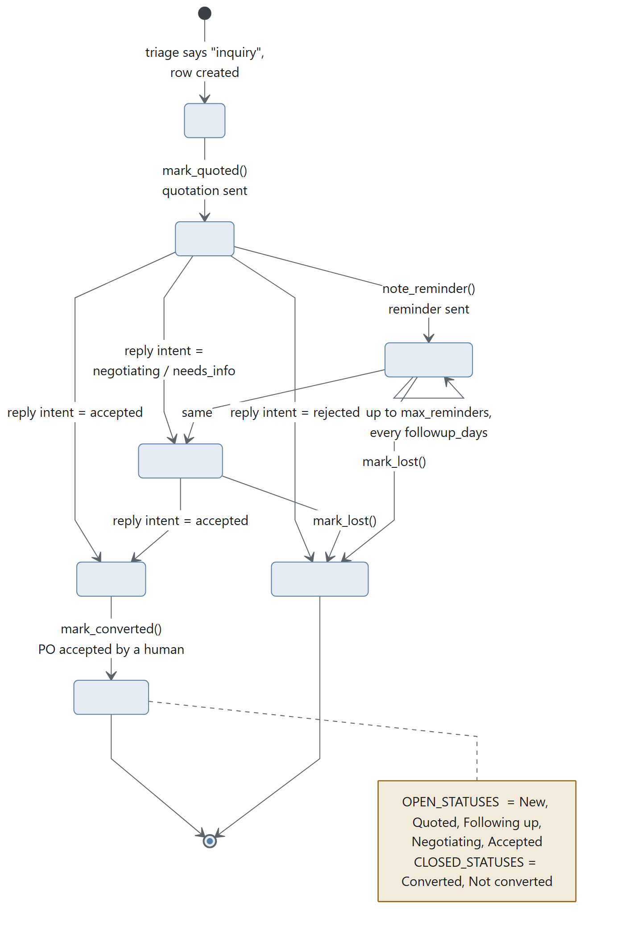
Diagram 2.3
REPLY_STATUS maps the reply intent onto the status: accepted → Accepted, rejected → Not converted, negotiating → Negotiating, needs_info → Negotiating.

Numbering
fy_label() returns "25-26" for any date from 1 April 2025 to 31 March 2026 — the Indian financial year. next_number(rows, prefix, when) reads the existing Inquiry no column, finds the highest serial in the current financial year, and returns the next. An imported register therefore carries on from the customer's own numbering rather than restarting.

Threading — how a reply finds its row
thread_key(message) collects Message-ID, In-Reply-To and References. find_by_thread(rows, message) matches by conversation first, then by sender. add_thread(row, message) folds new identifiers into the row without losing the old ones.

2.5 The inquiry folder
mailflow.Paths.folder_for("INQ/25-26/0087") → <root>/inquiries/INQ-25-26-0087/
The number carries slashes and a slash in a path is a directory separator, so it becomes hyphens on disk. Reversible by eye, which is what matters when somebody is looking for it.
<inquiry root>/
├── inquiries.csv ← THE REGISTER
├── inquiries/
│ └── INQ-25-26-0087/
│ ├── <saved attachments> ← drawings, specs (safe_name()d)
│ └── <the mail itself>
├── quotations/
│ └── QTN-25-26-0042.csv ← written AT SEND TIME
└── sops/
├── sops.csv ← the library index
├── client_sops.csv ← who gets what
└── sop_sent.csv ← the audit log
inbox.safe_name(name, fallback) strips [<>:"/\|?*\x00-\x1f] so an attachment filename cannot escape its folder or upset Windows.

2.6 Quotation

In memory
Terms — from cfg["inquiry"]["terms"]
Field | Type | Default
gst_percent | Decimal | 18
freight | Decimal | 0
discount_percent | Decimal | 0
validity_days | int | 15
payment | str | "100% against proforma invoice"
delivery | str | "2–3 weeks from receipt of confirmed order"
currency | str | "INR"
notes | str | ""

QuoteLine
Field | Type | Meaning
description | str
quantity | Decimal
unit | str | "nos"
rate | Decimal
hsn | str | HSN tax code
basis | str | Where the rate came from — "rate list", "cost sheet", "entered by hand". Printed on the internal copy so any figure can be traced later
amount | property | rupees(rate × quantity)

Quotation — number, date, customer, contact, email, inquiry_no, lines[], terms, breakdown.
Every total is a property, in one place, so the arithmetic cannot disagree with itself:
subtotal = Σ line.amount
discount = subtotal × discount_percent / 100
taxable = subtotal − discount + freight
gst = taxable × gst_percent / 100
total = taxable + gst
valid_until = date + validity_days
No AI ever touches a figure. All arithmetic is Decimal with ROUND_HALF_UP (quoting.rupees()) — the way an invoice rounds, never banker's rounding. indian_currency() renders 1,42,500.00 with lakh grouping, which is what the reader expects to see.

On disk — quotations/<number>.csv
Written by quoting.write_csv() in utf-8-sig (so Excel opens it correctly).
Quotation no , QTN/25-26/0042
Date , 14-08-2026
Customer , <name>
Inquiry no , INQ/25-26/0087
(blank)
Sr | Description | HSN | Quantity | Unit | Rate | Amount | Rate source
1 | … | … | … | nos | … | … | rate list
(blank)
Subtotal | …
Discount% | -… (if any)
Freight | … (if any)
GST 18% | …
Total | …
This file is load-bearing. It is what the PO comparison reads back — "the quotation actually sent", not a re-derivation. The comparison is refused on any mismatch.

2.7 Purchase order
POLine — description, quantity, unit, rate, amount.
settled() fills in whichever of quantity × rate = amount was left out. POs routinely print only two of the three. Derived by arithmetic only, never by asking a model to work it out.
PurchaseOrder
Field | Type | Meaning
number | str
date | date
buyer | str
lines | list[POLine]
delivery_date | date
total | Decimal | The printed total
terms | str
reference | str | Our quotation number, when they quote it
source | str | The file it was read from
computed_total | property | Σ line.amount
value | property | Printed total wins, else the sum of lines — the printed one may legitimately include freight or tax the lines do not, and it is the figure both sides will quote at each other later
missing() | method | Fields a person must still supply — this drives the form Prism shows

Difference — one row of the comparison. Kind is MONEY or NOTE.
The rate-gap rule: a rate difference is measured in money, multiplied out by quantity. Ninety paise on five thousand pieces is ₹4,500 walking past a one-rupee tolerance.

2.8 Pricing inputs — the customer's own files

Rate list (cfg["inquiry"]["rate_list"]) → RateItem
CSV or XLSX (needs openpyxl). load_rates() finds the header row by scanning for one that names a description and a rate, then maps columns through _COLUMN_ALIASES — code/item code/sku/part no/cat no/…, and similar alias sets for description, rate, unit, HSN.
Extra columns like Rate @ 100 become quantity slabs (_SLAB_HEADER). RateItem.rate_for(quantity) returns the deepest slab reached.
Matching is match_item(query, items): tokenise (tokens() — words and numbers, lowercased, polite noise removed via _STOPWORDS), score, return the best five with a reason for each, in the owner's own words, shown next to every match. is_confident(matches, margin=1.6) is true only when the best row is clearly ahead of the runner-up.
RateFileError always carries the fix in its text.

Cost sheet (cfg["inquiry"]["cost_sheet"]) → CostLine
The owner's own cost basis: name, basis, rate. Basis is one of per_kg · per_piece · per_lot · percent.
cost_sheet(lines, weight_kg, quantity) runs it for one job and returns a CostBreakdown. Shown, never hidden — every line of the working appears on screen.
Weight helpers, for spring manufacturers specifically:
Function | Computes
density_for(material) | kg/m³ from DENSITY_KG_PER_M3 (steel 7850, stainless 7930, brass…)
wire_weight_kg(dia, length, material) | Weight of a length of round wire or bar
coil_length_mm(mean_dia, total_coils) | π × mean diameter × coils
spring_wire_weight_kg(wire_dia, outer_dia, total_coils, material) | Weight of one helical spring, from the three numbers on the drawing

2.9 Mail records (in memory only)
Message — prism_terminal/core/inbox.py
Field | Type | Purpose
uid, message_id, date |  | Identity and ordering
from_name, from_addr, to[] |  | Who
subject, body |  | Content
attachments[] | list[Attachment] | name, mime, data, size
in_reply_to, references[] |  | Thread link — what stops one conversation becoming four rows
list_unsubscribe, auto_submitted, precedence |  | The famous bulk markers
list_id, list_help, feedback_id |  | The less famous ones. Atlassian notifications carry List-Help and a Salesforce Marketing Cloud Feedback-ID and no unsubscribe header at all — they were the only mail in a real 40-message sample the rules could not place, and one ended up in the register as a customer inquiry
headers_only | bool | True when only headers were downloaded. Mail that says in its own headers that it is a mailshot is settled without a body, so the body never crosses the wire — that is most of what a real inbox contains, and it is where the three minutes went
sender_domain | property
snippet(limit=1500) | method | Subject plus the opening of the body — what triage shows an AI, and deliberately short: the less of somebody's correspondence that leaves the building, the more honestly we can describe what Prism does with it

Verdict — category, source, reason, is_reply, actionable.
source is "rule" · "learned" · "ai" · "none" — shown in the UI, so a wrong answer can be traced to the thing that produced it instead of blamed on "the AI".
Categories: inquiry · order · payment · promotion · vendor · internal · other · unsorted. Only inquiry and order are ACTIONABLE, and only those two are worth an AI call when the rules are unsure.
Knowledge — persisted in cfg["inquiry"]["knowledge"].
Field | Type | Meaning
own_domains | set | The company's own domains
customers | set | Addresses or domains
vendors | set | Addresses or domains
learned | dict | address → category, grown from corrections

Every field here makes the rules smarter and the AI less necessary — which is both cheaper and more private. learn() remembers a correction, and that sender is never sent to an AI again. Shared across every mailbox on purpose: a sender is the same sender whichever address they wrote to.
mailflow.Item — one thing that came out of a check and may need a person: kind (inquiry · reply · order · sop), message, row, folder, files[], intent, note.
mailflow.Result — counts, sorted_mail[(Message, Verdict)], new_inquiries[], replies[], orders[], followups[], sops[], state, knowledge, error, fetched.
unsorted_by_failure is kept apart from ordinary unsorted mail. One means "we read it and it is unclear"; the other means "we never got to read it at all", and only the second is a reason to go and look yourself. A real inquiry was lost inside the first meaning once, which is why it has a name.

2.10 SOP records
Entity | Source | Fields
SopDoc | sops.csv, else filenames | code, title, revision, path, applies-to, date; newer_than(revision)
ClientRule | client_sops.csv | which customers receive which documents; matches(address)
Send log | sop_sent.csv | Date sent, Customer, Email, SOP code, Title, Revision, Reason, Inquiry no
Pending | computed | what should go out now, with the reason for each

Revision is parsed from _REVISION (_rev2, -v1.1, (R3)) and code from _CODE. The log is written atomically like the register — it is an audit record.

2.11 Run history — runs/run_<ts>.json
Written by config.save_run(record, runs_dir). The GUI passes a per-member folder (workspace.runs_dir(mid, cfg)) so one person's history does not land in another's; the CLI writes to ~/.prism/runs.
Key | Type | Meaning
query | str | The user's own words
routing | dict | {stage: {questions, needed}} — what the router decided
responses | dict | {stage: [text, …]}
links | dict | {stage: url} — where the work is
attachments | list[str] | Names, not dicts — matches what the CLI writes
agents | dict | GUI only: which tool actually ran each step, so History can name them instead of showing bare stage keys
durations | dict | GUI only: how long each step took. The panel had timed every stage all along and the number died with the widget — which is why "this one is slow" was never answerable
error | str | Present only on a failed run
member | dict | {mid, name, role} — stamped so a run file is self-describing even if copied out of its folder

member is always the real member, never identity.viewing(). An admin reading someone else's profile and then starting a run files that run under themselves.

2.12 Team and identity
prism-team.json at the workspace root: [{mid, name, role}, …].
workspace.member_id(role, name) builds the stable folder name — role first, so an ls of the members directory groups by job.
Path | Holds
<root>/prism-team.json | The roster
<root>/_company/ | The shared shelf every role may read
<root>/members/<mid>/runs/ | That member's history
<root>/members/<mid>/files/ | That member's outputs

SOLO = "personal" is the member id for a single-user copy that has not been pointed at a shared workspace.
Roles (roles.py): owner · manager · sales · marketing · operations · engineering · accounts · hr. Each carries an accent hue; GENERAL_HUE = 210 is Prism's own, used for anyone without a role. roles.default_agents(key, available) picks one tool per stage that role uses.

2.13 Licence state
Full treatment in 05-licensing.md; the storage shape is here.
File | Mode | Holds
~/.prism/license.json | 0600, atomic | Activation state: token, licence id, cached claims, clock high-water mark
~/.prism/authorization.json | 0600 | The cached lease, plus the last failed-attempt timestamp for RETRY_INTERVAL throttling
~/.prism/payload.enc | 0600 | The server-published configuration blob, verbatim and signed
OS credential store | — | The reusable licence key, when the machine has one (secretstore.py, service "Prism (Alphakore)"). Falls back to the file

LicenseState — usable(), days_left() (rounded up), has(feature). Statuses: none · valid · grace · stale · expired · tampered. CLOCK_TOLERANCE = 1 day; clock_rolled_back() compares against the stored high-water mark.
Lease — a verified authorisation grant, constructed only from claims that passed lease.verify(). States: NONE · FRESH · GRACE · STALE · TAMPERED. Scopes: core · workflow · grok.

2.14 Data classification — what leaves the machine
The single table to hand a customer who asks "where does my data go".
Data | Leaves the machine? | To where | Controlled by
Mailbox / SMTP passwords | Never | — | Stored in ~/.prism/config.json only
Full email bodies | Never | — | Only a ≤1,500-char snippet, and only for unsettled senders
Email snippets (unknown senders only) | Yes, conditionally | Groq | local_only switch removes even this
Inquiry details extraction | Yes | Groq | local_only
Purchase-order text | Yes | Groq | local_only → typed-in boxes instead
Gerber / PCB design files | Never — hard rule | — | cmd_gerber passes attachments=[]; asserted by test
CAD drawings (BOQ) | Yes | The browser tools the user chose | write_files = [cad_file] + templates + note_files — deliberately different from Gerber; see docs/AFTER_THE_MERGE.md §2
Quotation figures | Never to an AI | — | All arithmetic is Python Decimal
The register | Never | — | Local or the customer's own shared drive
Task text and attachments (main pipeline) | Yes | The user's own logged-in tools, in their own Chrome | The user picks the tools
Licence id, device fingerprint, app version, usage counters | Yes | Licence server | Unavoidable — this is the licence check
Email content, customer names, file contents | Never to the licence server | — | meter.py records what was consumed, never what was written

