PRISM ARCHITECTURE · PART 03
Data Flow
Six pipelines, stage by stage
Product Prism · version 1.3.0
Commit 20292f4
Drawn 26 August 2026
Source docs/architecture/ — Markdown is the master

Data Flow

3.0 How to read this document
Prism runs six independent pipelines. They share configuration and the licence gate; they do not share state with each other.
# | Pipeline | Entry point | Human stops
A | Main task pipeline | The task card → Make a plan → Start the work | Reviewing the plan
B | Email automation daily loop | Check my mail (manual or timer) | Sending a quotation · Accepting a PO
C | BOQ | BOQ add-on | Pricing (deliberately left blank)
D | Gerber | Gerber add-on | None — pure measurement
E | Reel / Studio | Reel add-on | None
F | Email blast | Email add-on | Confirm and send

Every stage table uses the same four columns: Input → Process → Output → Lands in. Where a stage can send data off the machine, it is marked ⚠ leaves the machine.

3.1 Pipeline A — the main task pipeline
The general-purpose one: a task in plain language becomes a chain of AI tools driven in the user's own Chrome.
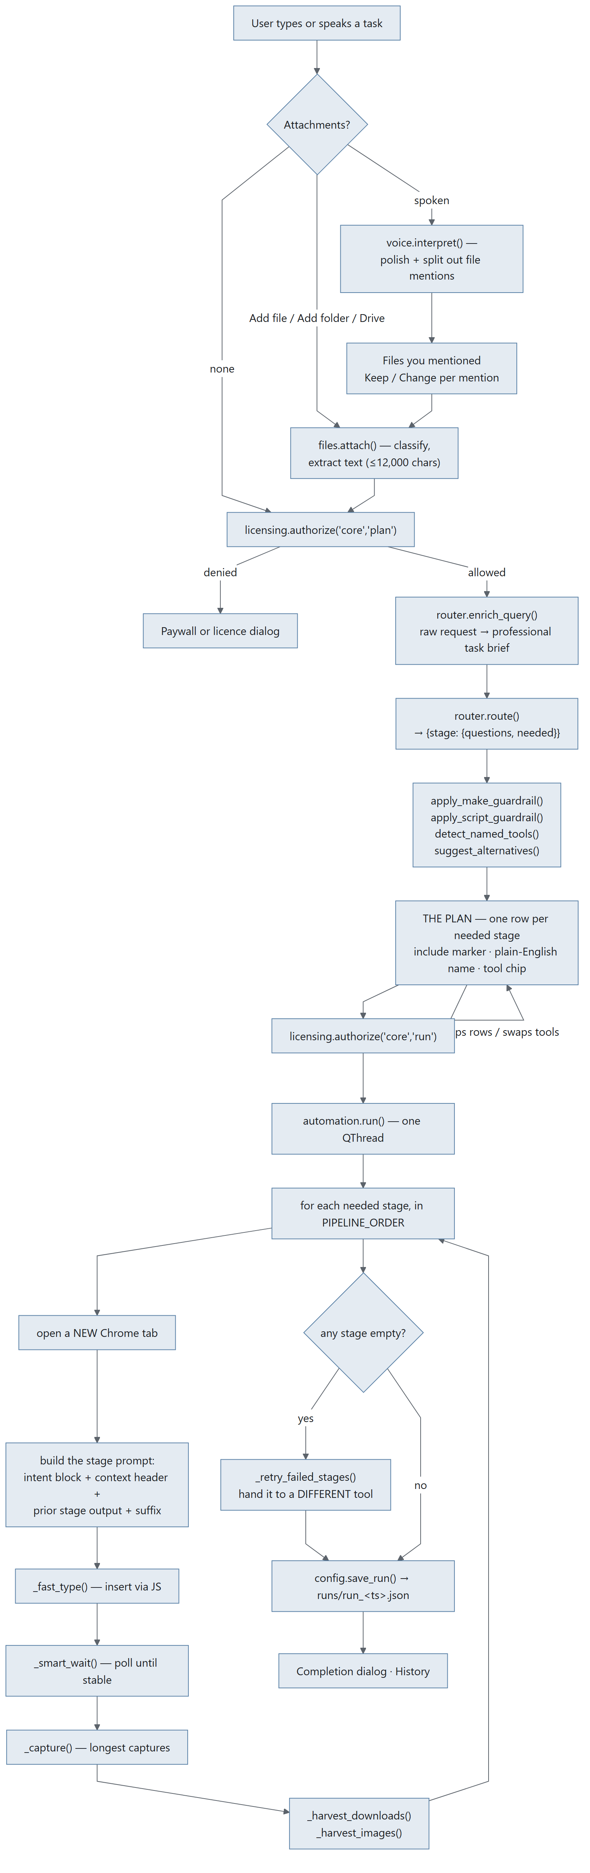
Diagram 3.1

Stage A1 — Capture the task
Input | Typed text in the task card, or microphone audio (push-to-talk / wake word)
Process | Typed: taken verbatim. Spoken: RecordWorker captures WAV at 16 kHz → voice.transcribe() (Groq whisper-large-v3) → voice.interpret() polishes the transcript and splits out file mentions ⚠ leaves the machine
Output | query: str, plus {"mentions": [...]} for spoken input
Lands in | MainWindow._last_query, the task card

Typed queries are deliberately not prose-scanned for file mentions. Only spoken input runs the interpreter — a GUI has real Attach buttons, and scanning a typed sentence adds risk for no benefit.

Stage A2 — Resolve file mentions (spoken input only)
Input | Each mention string, e.g. "the quotation on my desktop"
Process | pathfinder.find(desc, cfg) — _llm_parse (Groq) or _heuristic_parse fallback → candidate dirs (_KNOWN_ROOTS, depth ≤ 2, _MAX_WALK_ENTRIES = 4000) → fuzzy filename match (depth ≤ 3)
Output | {folders: [...], files: [...]}, ≤ 5 matches
Lands in | The Files you mentioned rail, one row per mention with Keep / Change — the GUI equivalent of the CLI's confirm-before-attach

Stage A3 — Attach files
Input | A path from Add file / Add folder / the Drive picker
Process | files.attach(path) classifies by extension, extracts text where it can (≤ MAX_TEXT_CHARS = 12000). files.attach_dir() takes plain files directly inside a folder, capped at MAX_DIR_FILES = 15
Output | Attachment records: {name, path, kind, size, text}
Lands in | MainWindow.attachments; files.context_block() injects contents inline into agent prompts; files.routing_note() gives the router a short note only

Stage A4 — Licence authorisation
Input | feature="core", action="plan"
Process | AuthorizeWorker → licensing.authorize() → client.authorize() (45 s timeout, 1 retry) ⚠ leaves the machine — licence id, device fingerprint, app version, action, feature, scopes. No customer content.
Output | Authorization(allowed, run_id, message, code, state, offline)
Lands in | Gate: allowed → continue; denied → paywall or licence dialog

Stage A5 — Enrich the query
Input | Raw query + cfg["profile"] + API key + model
Process | router.enrich_query() — a Groq pre-pass that expands the raw request into a professional task brief ⚠ leaves the machine
Output | brief: str
Lands in | The routing prompt, and Behind the scenes in the context rail

Stage A6 — Route
Input | query, brief, cfg["profile"], active agents, attachment note, premium flags
Process | router.route() → groq_chat() against the model chain (cfg["model"] first, then MODEL_FALLBACKS: openai/gpt-oss-120b, openai/gpt-oss-20b, groq/compound-mini). Retries on 429/500/502/503/504. A fallback that works is remembered into cfg["model"]
Output | {stage: {"questions": [...], "needed": bool}} for each of the ten stages
Lands in | MainWindow.routing; rendered as the plan

The ten stages, in PIPELINE_ORDER: research → leads → brains → content → visual → media → audio → development → presentation → summary

Stage A7 — Guardrails and alternatives
Guardrail | What it forces
apply_make_guardrail() | If the user clearly asked to make an artefact (slide deck, image, video, web app), that stage is forced on even if the router said no
apply_script_guardrail() | A reel/video/deck needs words — script, narration, captions, slide copy. Forces a writing stage
detect_named_tools() | A tool the user named ("using NotebookLM…") is pre-selected and tagged You picked this
suggest_alternatives() | For each needed stage, offers other tools that could do it. The router's suggestion is starred in the chip's menu

Stage A8 — The plan (human review)
Input | The routing dict + guardrail results
Process | widgets/agents_panel.py renders one row per needed stage: square include-marker, line icon, plain-English name ("Look things up", "Write it up", "Build the slides"), one line of what it means, and the tool as a clickable chip
Output | run_agents — whatever is still switched on
Lands in | automation.run()

Stage A9 — Execute the pipeline
Runs on AutomationWorker. For each needed stage:
Step | Input | Process | Output
Driver | cfg["chrome_version"], cfg["chrome_profile"] | _setup_chrome_driver() — undetected-chromedriver against ~/.prism/chrome_profile. seed_profile() copies the real Chrome profile in (so the user is already signed in). _clear_profile_locks() removes SingletonLock left by a killed run. _prune_preferences() stops Prism poisoning its own profile | A live driver
Tab | agent name | _open_tab() — a new tab, leaving every finished one on screen
Prompt | query, prior stage output, agent config | _intent_block() (the user's own words, verbatim, at the top of every stage prompt) + _context_header() + prior output + _resolve_suffix() | The full prompt text
Type | prompt | _fast_type() inserts the whole prompt at once via JavaScript rather than per-character; _bmp_safe() strips non-BMP characters ChromeDriver refuses
Wait | agent config | _smart_wait() — poll every 5 s, require stable_for=25 s, min_wait=35 s, cap from the registry (WAIT_FLOOR=300, WAIT_MULTIPLIER=2.0, WAIT_CEILING=1800). Interruptible | (waited, timed_out)
Health | page | _looks_signed_out() · _looks_exhausted() · _looks_unreadable() — each returns "" when fine, else the sentence the user needs
Scrape | page | _capture() — everything reading as a reply, longest captures only. _is_prompt_echo() rejects the tool echoing the prompt back | [text, …]
Harvest | download folder, page | _wait_for_downloads() (45 s), _harvest_downloads() → attachment records the next stage can use. _harvest_images() pulls real generated images, since an image cannot travel in a text handoff | Files, images

⚠ This whole stage runs in the user's own browser, signed in as them. The prompt and any attached files go to whichever tools the user chose.

Stage A10 — Failover
Input | Any stage whose output came back empty
Process | _retry_failed_stages() — hands each failed stage to a different tool via agents.alternatives_for()
Output | Filled-in responses where a second tool succeeded

Stage A11 — Persist
Input | responses, links, stage agents, durations, attachments, routing, query
Process | config.save_run(record, workspace.runs_dir(mid, cfg))
Output | runs/run_<timestamp>.json
Lands in | History dialog; Home's recent-runs list via dashboard_data.recent_runs()

A failed run has no engine return value, so _save_run rebuilds what did land from the per-stage events collected on the way. Save failures are swallowed to the status bar on purpose: the run itself succeeded, and a full disk should not turn that into an error dialog.

3.2 Pipeline B — Email automation, the daily loop
The one used every day, and the reason the app gets opened at all.
Five tabs, in the order the work happens: What arrived → Inquiries → What they said back → Waiting on a reply → The order came.

B.0 The whole loop

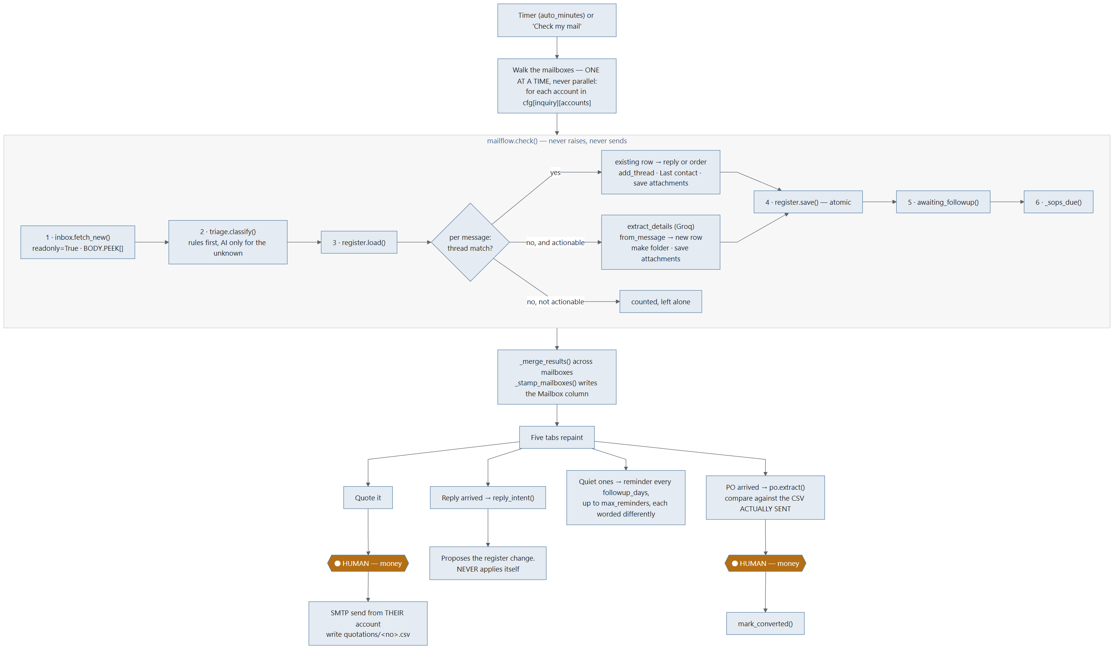
Diagram 3.2

B.1 Fetch — inbox.fetch_new()
Input | cfg (one account), its State bookmark, always_full (known senders), must_read (predicate), catch_up_with_new
Process | IMAP connect (SSL 993, else STARTTLS) → select(folder, readonly=True) → check UIDVALIDITY against the bookmark → _search_above(last_uid) for new mail, plus _search_window(first_days) for backlog → _fetch_headers() in batches of HEADER_BATCH = 100 → bodies pulled only for messages that might matter, with BODY.PEEK[]
Output | (messages: list[Message], new_state: State, error: str)
Lands in | Memory only. Nothing is written to the mailbox

Limits: FIRST_FETCH_DAYS = 30 · MAX_PER_FETCH = 200 · MAX_BODY_CHARS = 20000 · BACKFILL_PER_CHECK = 60.
Reads the mailboxes, never writes to them. readonly=True on select and BODY.PEEK[] on fetch mean nothing is marked read, moved or deleted — the owner keeps using Outlook on the same account.
Which bodies get downloaded:
Case | Body fetched? | Why
Headers say it is a mailshot (says_it_is_bulk) | No | That is most of what a real inbox contains, and where three minutes went
Sender is known (always_full) | Yes, always | A customer on a system that stamps an unsubscribe link onto every message must not be caught by the bulk rule. Being over-generous costs one body download; being mean costs an order
Subject asks for a price, or names a PO (must_read) | Yes, whatever the headers say | Subjects arrive with the headers, so this costs nothing, and it is the difference between "we never downloaded it" and a lost order
Otherwise | Yes

B.2 Sort — triage.classify()
Two passes: local rules, then one batched AI call for whatever is left.
Pass | Input | Process | Output
Rules | Message, Knowledge | rules_pass() — List-Unsubscribe / List-Id / List-Help / Feedback-ID / Precedence / Auto-Submitted; robot addresses (no-reply@, mailer-daemon@…); learned corrections; known customers and vendors; own domains; narrow keyword sets (_PO_WORDS, _PAY_WORDS, _INQ_WORDS, _PROMO_WORDS, _INQ_SUBJECT, _INQ_BODY, _OFFERING, _ORDER_PHRASES) | Verdict(category, source="rule"|"learned", reason) — or UNSORTED with source="none", meaning "ask"
AI | Only the unsettled messages, batched batch_size=10 | defang() strips the message's power to imitate the prompt carrying it, then one Groq call on model FAST_MODEL = llama-3.1-8b-instant ⚠ leaves the machine — subject + ≤1,500 chars of body, per unknown sender only | Verdict(category, source="ai"), or source="failed" if the model never answered

local_only=True sets api_key = "" for the entire check, not just triage.
That is deliberate and was a fix: local_only was passed to triage alone at first, which left detail extraction and reply reading still sending customer correspondence out. A privacy switch that quietly did two thirds of what its name promises is worse than not offering one.
Prompt-injection defence: defang() neutralises _FORGED_FENCE (a message faking "--- END EMAIL ---") and _FORGED_ANSWER (a message writing its own "3: inquiry" answer line).

B.3 Register — the ordering rule
For every message, thread first, verdict second:
Case | Action | Result item
Thread matches an existing row | add_thread() · Last contact = today · save attachments into the existing folder | Item("order") if category is ORDER, else Item("reply") with intent
No thread match, not actionable | Counted and left alone | —
No thread match, actionable | extract_details() (Groq ⚠) → from_message() → new row → make the folder even if nothing was attached → save attachments → Drawing column | Item("inquiry"), or Item("order") noted "ordered without a quotation from us"

Why thread beats verdict: a message belonging to an inquiry already in the register is live business by definition. It used to get a vote — "Yes, please proceed" from a customer whose address had never been added to the customer list reads like nothing in particular, so it came back unsorted, unsorted is not actionable, and the loop skipped it before ever asking which quotation it answered. A whole negotiation could go quiet that way, and the register would still say "waiting on a reply".
Why the folder is made even when empty: the register points at that folder from the moment the row exists, and the quotation and the PO land in it later. A path in the file that opens onto nothing is the kind of small broken thing that makes people stop trusting the rest.

B.4 Save — atomic, and honest about locks
register.save(rows, path) writes to a temp file in the same directory and os.replace()s it. Hand-added columns survive.
If Excel holds the file open, RegisterLocked is raised with a plain sentence. check() then returns with out.error set and the bookmark reset to the previous state — the work is in memory, only the write failed, and nothing is lost because unsaved rows have no bookmark advance behind them.

B.5 The multi-mailbox walk
Owned by InquiryDialog, not by the engine.
Rule | Behaviour | Why
One at a time, never parallel | _check_account() → _account_checked() → next | Every account's rows land in the same CSV, and two writers racing on one order book is how a row is lost
One dead mail server | Skipped; the walk continues | That account's problem; the others carry on
One locked register | Stops the whole walk | The same lock would refuse every account after it, and no bookmark has moved
Bookmarks | _remember_account() banks each mailbox's own state | Two mailboxes sharing one bookmark would skip or re-import each other's mail
Learned corrections | Shared across all mailboxes | A sender is the same sender whichever address they wrote to
Mailbox column | _stamp_mailboxes() writes which address each new inquiry arrived at | With three addresses feeding one file, "who is this customer talking to" is the first question the sheet gets asked

B.6 Quote — QuotationDialog
Input | The register row, the rate list or the cost sheet, cfg["inquiry"]["terms"]
Process | Rate route: match_item() on Product asked → RateItem.rate_for(quantity). Cost route: cost_sheet(lines, weight_kg, quantity) runs the owner's own formulas. Then next_quote_number(), Terms, and the Quotation properties compute every total. All Decimal, ROUND_HALF_UP. No AI touches a figure
Output | Quotation + render_text() + write_csv()
Lands in | quotations/<number>.csv, and the covering mail body

The covering letter is drafted by covering_letter_prompt() — the numbers are handed over already formatted, and the model is told in as many words not to compute or restate them. Its job is the two paragraphs around them.
⬤ HUMAN STOP 1. _finish(send=True) is a button a person presses.
On send: mailer sends from their own account, mark_quoted() updates the row, and the quotation CSV is written. That CSV is what the PO comparison reads back later.

B.7 Read the reply — mailflow.reply_intent()
Input | The reply Message
Process | _own_words() strips quoted history (_QUOTED_LINE) → local_intent() tries plain patterns first (_LOCAL_INTENT) → only if that is not plain, one Groq call ⚠
Output | accepted · rejected · negotiating · needs_info · unclear
Lands in | Tab 3, as a proposed register change

It never applies itself. REPLY_STATUS maps the intent onto a status, and a person presses Apply. unclear always waits for a human.

B.8 Chase — reminders
Input | Rows past followup_days with Reminders sent < max_reminders
Process | register.awaiting_followup() → drafting.followup_prompt(attempt=n). Each reminder is worded differently — attempt number is part of the prompt
Output | Subject + body, shown before it goes (_ReminderDialog) or sent unattended when auto_followup is on
Lands in | SMTP; note_reminder() increments the counter and sets Last contact

Every two days, three times, then it stops.

B.9 Win back a no — drafting.negotiation_prompt()
Input | The quotation text read back off disk, the customer's own reply, the bargaining-limits file (pricing_policy)
Process | Drafted through the browser tools (DraftWorker → drafting.draft()), not Groq — this one is worth a good model. _NO_INVENTED_NUMBERS hard rules override anything in the customer's email
Output | A draft reply, editable
Lands in | The send dialog

With no bargaining-limits file, the prompt is instructed to offer nothing on price at all.

B.10 The PO — po.extract() and po.compare()
Step | Input | Process | Output
Find it | The order message | find_attachment() picks the attachment most likely to be the order | A path
Read it | PDF / DOCX | pdf_text() / docx_text(). looks_scanned() — under _TEXT_PER_PAGE = 120 characters per page means a photograph of a page, not a document | Text, or POError carrying SCANNED_ADVICE
Extract | The text | One direct Groq call ⚠ → strict JSON (_json_from tolerates fences) → from_json() builds defensively → POLine.settled() fills the missing third of quantity × rate = amount by arithmetic | PurchaseOrder
Compare | The PO + quotations/<no>.csv | compare(order, quote, tolerance=₹1) — read back from the CSV written at send time, refused on any mismatch. A rate gap is multiplied out by quantity | [Difference] + summary()

⬤ HUMAN STOP 2. Accept — mark converted is a button a person presses. Then mark_converted(row, po_number, value).
Scanned POs — about half of them — get typed-in boxes and an honest sentence. The same boxes serve anyone who switched on Keep everything on this computer: a PO is mail content, and the privacy switch means what it says even when that costs the automatic reading.

B.11 SOPs — sop.pending()
Input | sops/sops.csv (or filenames), client_sops.csv, sop_sent.csv
Process | load_library() → current revision per document. for_client() / for_product() → what this customer should hold. pending(annual_days=365) → what should go out now, with the reason
Output | [Pending]
Lands in | The check result; record_sent() appends to the audit log

_sops_due() never fails the whole check. An unreadable client map is a setup problem, not a reason to stop sorting somebody's mail.

3.3 Pipeline C — BOQ (quantities off a drawing)
Stage | Input | Process | Output
1 · Convert | .dwg or .dxf | ensure_dxf() — .dwg needs a local converter (dwg2dxf / ODAFileConverter). _read_dxf() tolerates minor structural errors | A .dxf path + notes
2 · Measure | The DXF | measure() walks every entity in every layout's modelspace: lengths (lines, arcs, polylines with bulge), areas (shoelace, hatch boundaries minus holes), counts, grouped per layer and per block | {quantities} dict
3 · Units | Quantities + the user's answer | apply_known_unit() when the file did not say | Corrected quantities
4 · Scope | Quantities + keywords | filter_by_keywords() keeps only matching layers/blocks | Scoped quantities
5 · Write | Quantities | write_quantities_csv() — exactly as computed, before any AI touches them | A CSV
6 · Research | The request | standards_prompt() — the design norms a quantity surveyor would look up ⚠ | Standards text
7 · Interpret | Request + quantities + file roles | interpretation_prompt() — work out what the drawing's codes mean ⚠ | A legend
8 · Format | Everything above | formatting_prompt(allow_derived=…) — allow_derived is the difference between a takeoff and an estimate ⚠ | The BOQ document

Rate and Amount are deliberately left blank. Prism counts and measures; you price it.
⚠ Note the deliberate contrast with Gerber: BOQ does attach the drawing — write_files = ([cad_file] if cad_file else []) + templates + note_files. A building drawing is a description of a job. See §3.4.

3.4 Pipeline D — Gerber (PCB measurement)
### The rule that must not be broken The Gerber files never reach an AI. cmd_gerber passes attachments=[] and a test asserts that literal string. A Gerber set is the customer's product, not a description of a job. Do not copy the BOQ pattern across without the customer's written permission.
Stage | Input | Process | Output
1 · Gather | A folder, .zip or .rar | gather() expands archives into a flat file list. Never individual files — a job arrives as one archive of 9–17 files, and asking a customer to pick the right four is the whole problem restated | [paths]
2 · Split | The flat list | split_jobs() groups into separate boards by _job_stem() | [(stem, files)]
3 · Classify | Each file | classify() — extension map, _sniff() reads the first few hundred bytes, _name_hint() handles art001…art012, _resolve_numbered_layers() turns those into top / inner / bottom | Role per file
4 · Parse | Gerber files | parse_gerber() — RS-274X into millimetre geometry: apertures (%ADD), format spec (%FS), operations, arcs flattened to chords, macros (%AM) | GerberLayer
5 · Copper | Each layer | layer_copper() → one shapely geometry; classify_copper() splits conductors from markings | Geometry
6 · Measure | Geometry | track_widths() · spacing(snap_mm=0.01) · board_outline() · excellon() / merge_drills() / drill_from_gerber() | The five numbers
7 · Cross-check | The job's own CAM report | crosscheck() parses .DRR / .REP and compares hole counts and tool tables. Free, exact, no AI | [checks]
8 · Rules | .RUL files | design_rules() — what the designer said the board was allowed to use | Limits beside each reading
9 · Report | All of it | answers_text() (the five numbers, nothing else) · summary_text() (the workings, so they can be argued with) · files_text() · write_report_csv() · write_summary_csv() | Four panels + CSVs
10 · Brief | The numbers only | agent_brief(job, context) — the instruction handed to a writing agent: numbers, never a file ⚠ | Quote text

The five numbers Fine Circuits asked for, and nothing else: pcb size · min track width · min track spacing · min drill size · number of drills.
Needs shapely. Without it four of five numbers still work, and the missing one says so.
The verification ladder (docs/AFTER_THE_MERGE.md §2), cheapest first:
- The job's own CAM report — built.
- A second independent implementation (gerbonara, test-only) — built; reach for this before any AI.
- AI sanity-check on a rendered image plus the numbers — not built.
- The raw Gerber to an AI — only with the customer's written permission.

3.5 Pipeline E — Reel / Studio
 | Reel | Studio
Frames | Drawn with Pillow in Python | A real web page filmed in a paused Chromium
Encode | FFmpeg (imageio-ffmpeg, ships inside the build) | Same
Design stage | One pass | A conversation: one turn for the look and a storyboard, then one turn per scene, each laid out at 1080×1920 and corrected before the next is asked for

Asking for the whole reel in one reply is what made the old output look like a slide deck — a scene got about 278 characters, which is a headline and a subhead. See CHANGES.md → Round 6.
Stage | Input | Process | Output
1 · Assets | Attached images | assets.has_flat_background() → cutout() strips a flat background and trims; _ink_ratio() tells a logo from a photo; collect() builds the asset table the design stage may reference | Asset table + manifest()
2 · Design | The goal + manifest | design_instructions() ⚠ | Look + storyboard
3 · Scenes | Storyboard, one at a time | scene_instructions() per scene ⚠ | HTML/CSS per scene
4 · Film | Scene pages | Paused Chromium, frame by frame | PNG frames
5 · Encode | Frames | ffmpeg.py — locates FFmpeg, or downloads the wheel and verifies it against the SHA-256 PyPI publishes for that exact file before unpacking | .mp4, 1080×1920

Known gap (docs/AFTER_THE_MERGE.md §4): nothing treats scene 1 differently from scene 4, but the opening ~1.5 seconds is the whole bet — a reel without a hook is never watched to the end.

3.6 Pipeline F — Email blast
Stage | Input | Process | Output
1 · Recipients | Attached CSV and/or addresses in the goal text | split_attachments() → parse_recipients() (with or without a header row, _NAME_HEADERS aliases) + recipients_from_text() | [{email, name}]
2 · Discover | The goal, when no list was given | discovery_prompts() → a research stage, then a structuring stage; prefers_lead_database() routes to Apollo when the chosen agent is a lead database ⚠ | Candidates
3 · Structure | Candidate text | parse_structured_csv_text() → write_recipients_csv() — a durable record on disk | A real CSV
4 · Draft | The goal | A normal pipeline stage ⚠; parse_draft() pulls (subject, body); is_prompt_echo() rejects the tool echoing the prompt | Subject + body, editable
5 · Verify | cfg["email"] | VerifyWorker → mailer.verify() — log in and hang up. Worth its own button: the alternative is discovering at the worst possible moment that Gmail wants an app password | "" or a fixable sentence
6 · Send | Recipients, subject, body, files | ⬤ HUMAN — confirm and send. send_bulk() — one message per recipient so {name} can be substituted, SEND_DELAY = 2.0 s between, timeout scaled to attachment size (_send_timeout), progress + stop callbacks | Sent count, failures

clean_password() trims a pasted app password: outer whitespace always goes, and inner spaces go when the shape matches _APP_PASSWORD (four groups of four) — Gmail shows them in groups of four and they get pasted with the spaces in, which otherwise fails exactly like a wrong password.

3.7 The trust boundary, in one picture
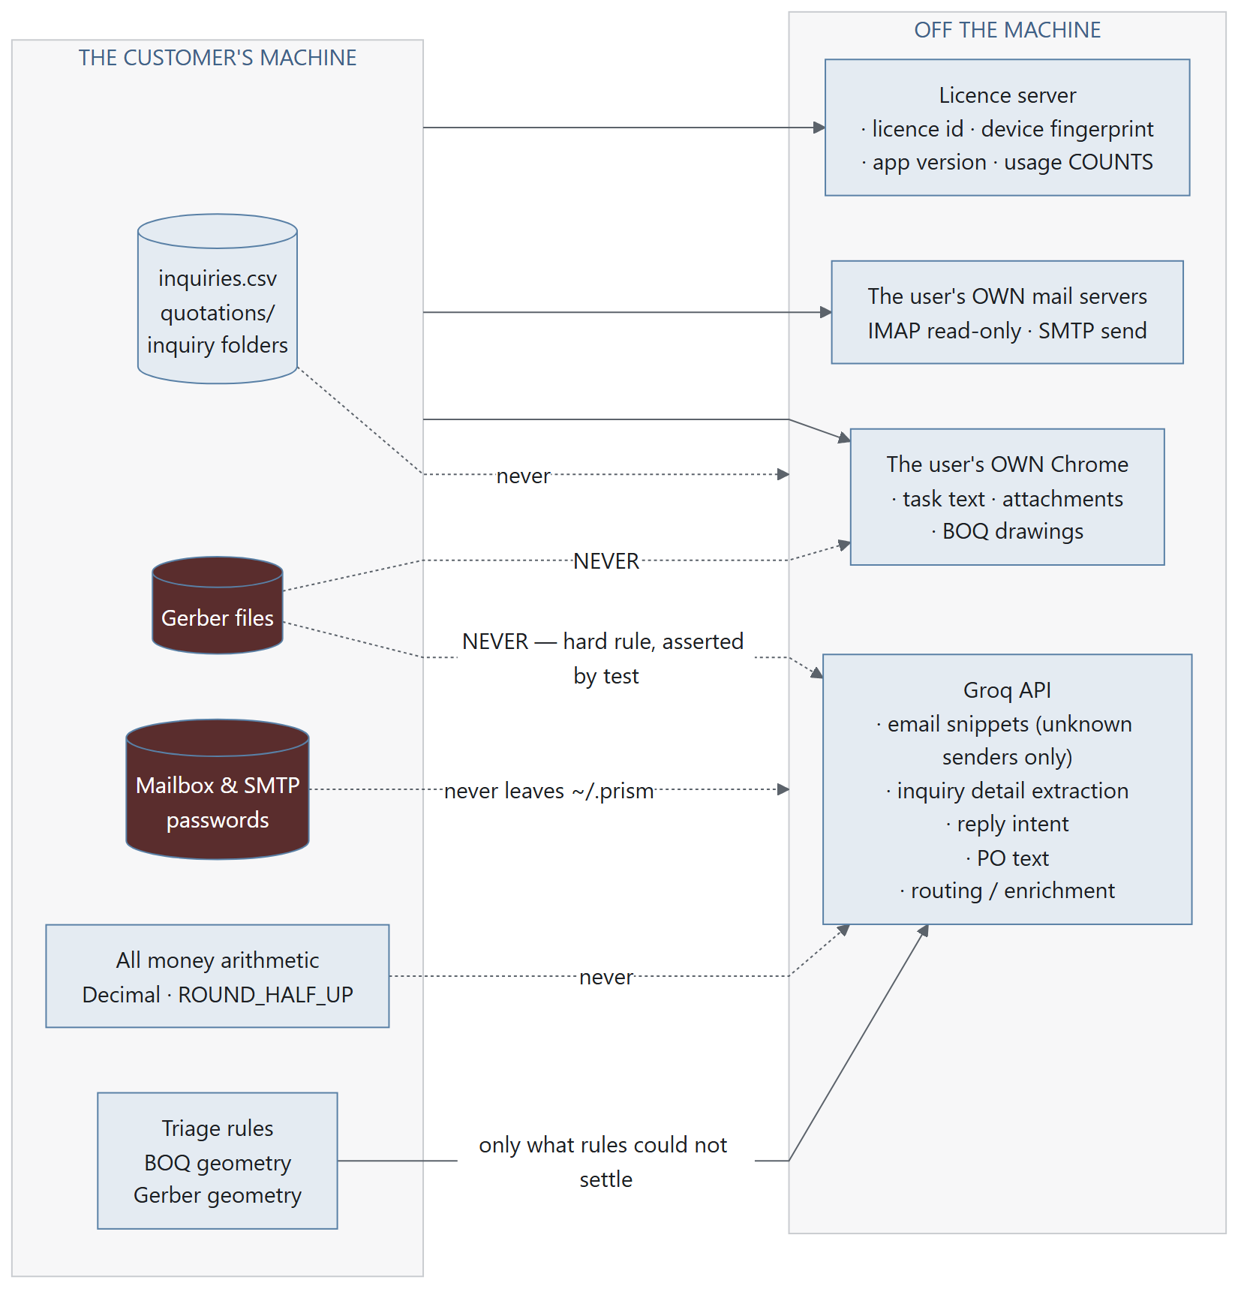
Diagram 3.3
The local_only switch ("Keep everything on this computer") sets api_key = "" for the entire email-automation check, removing the Groq column completely. The cost is that scanned POs and ambiguous senders need typing in by hand — which is stated honestly on screen rather than hidden.

