PRISM ARCHITECTURE · PART 05
Licensing and Authorisation
The gate on every launch
Product Prism · version 1.3.0
Commit 20292f4
Drawn 26 August 2026
Source docs/architecture/ — Markdown is the master

Licensing and Authorisation
Product reasoning and the trade this design makes live in LICENSING.md. Issuing keys is SHIPPING.md. This document is the mechanism.
Every launch and every add-on goes through licensing/. The server signs a compact claims blob; the app verifies it offline against an Ed25519 public key baked into the bundle.

5.1 The two keys
Prism has two different signed keys, and confusing them is the first mistake a new maintainer makes.
 | Licence key | Designation key
Module | keyformat.py → token.py | designation.py
Prefix | PRSM (typed) → PRSMv1 (token) | PRSD1
Answers | May this machine run Prism, and with what features? | Who is this person, and what job do they do?
Scope | The company's licence, one seat per machine | One member of that company
Drives | The gate, the paywall, the plan | The accent hue, the member folder, default agents
Where stored | ~/.prism/license.json + OS credential store | cfg["designation"]

designation.looks_like_one(text) exists so the activation dialog can tell them apart from what was pasted.

The licence key format
PRSM-XXXXX-XXXXX-XXXXX-XXXXX
Property | Value
ALPHABET | 0123456789ABCDEFGHJKMNPQRSTVWXYZ — Crockford-style, no I/L/O/U
BODY_LEN | 20 characters, grouped in 5s
Checksum | Last character, over the preceding 19
_CONFUSIONS | I→1, L→1, O→0, U→V on input

normalise(text) turns anything a user could plausibly paste into canonical form. is_well_formed(text) is structural and self-consistent only — it says nothing about whether the key is real.

5.2 The three signed artefacts
All three are PREFIX.payload_b64.signature_b64, Ed25519, verified offline against keys.public_keys().
Artefact | Prefix | Module | Lives in | Says
Token | PRSMv1 | token.py | license.json | This licence, this machine, these features, until this date
Lease | PRSMLv1 | lease.py | authorization.json | This machine may do these scopes, until this time, with this offline window
Payload | PRSMPv1 | payload.py | payload.enc | Published configuration: agent selector overrides, Groq model chain
(Designation) | PRSD1 | designation.py | config.json | This person, this role, in this org

Verification is always device-bound. token.verify(token, device_fp=…, public_keys=…) fails if the fingerprint does not match. NBF_SKEW = 300 s tolerates modest clock drift.
keys.py: DEVELOPMENT keys are trusted from source only. A frozen build accepts production keys alone.
payload.py limits: MAX_BYTES = 256 KB; selectors are filtered to an allow-list (selectors_for), and the model chain to models_for. A payload that fails raises PayloadError, which is always non-fatal — the caller falls back to what shipped.

5.3 Licence state machine
licensing/status.py
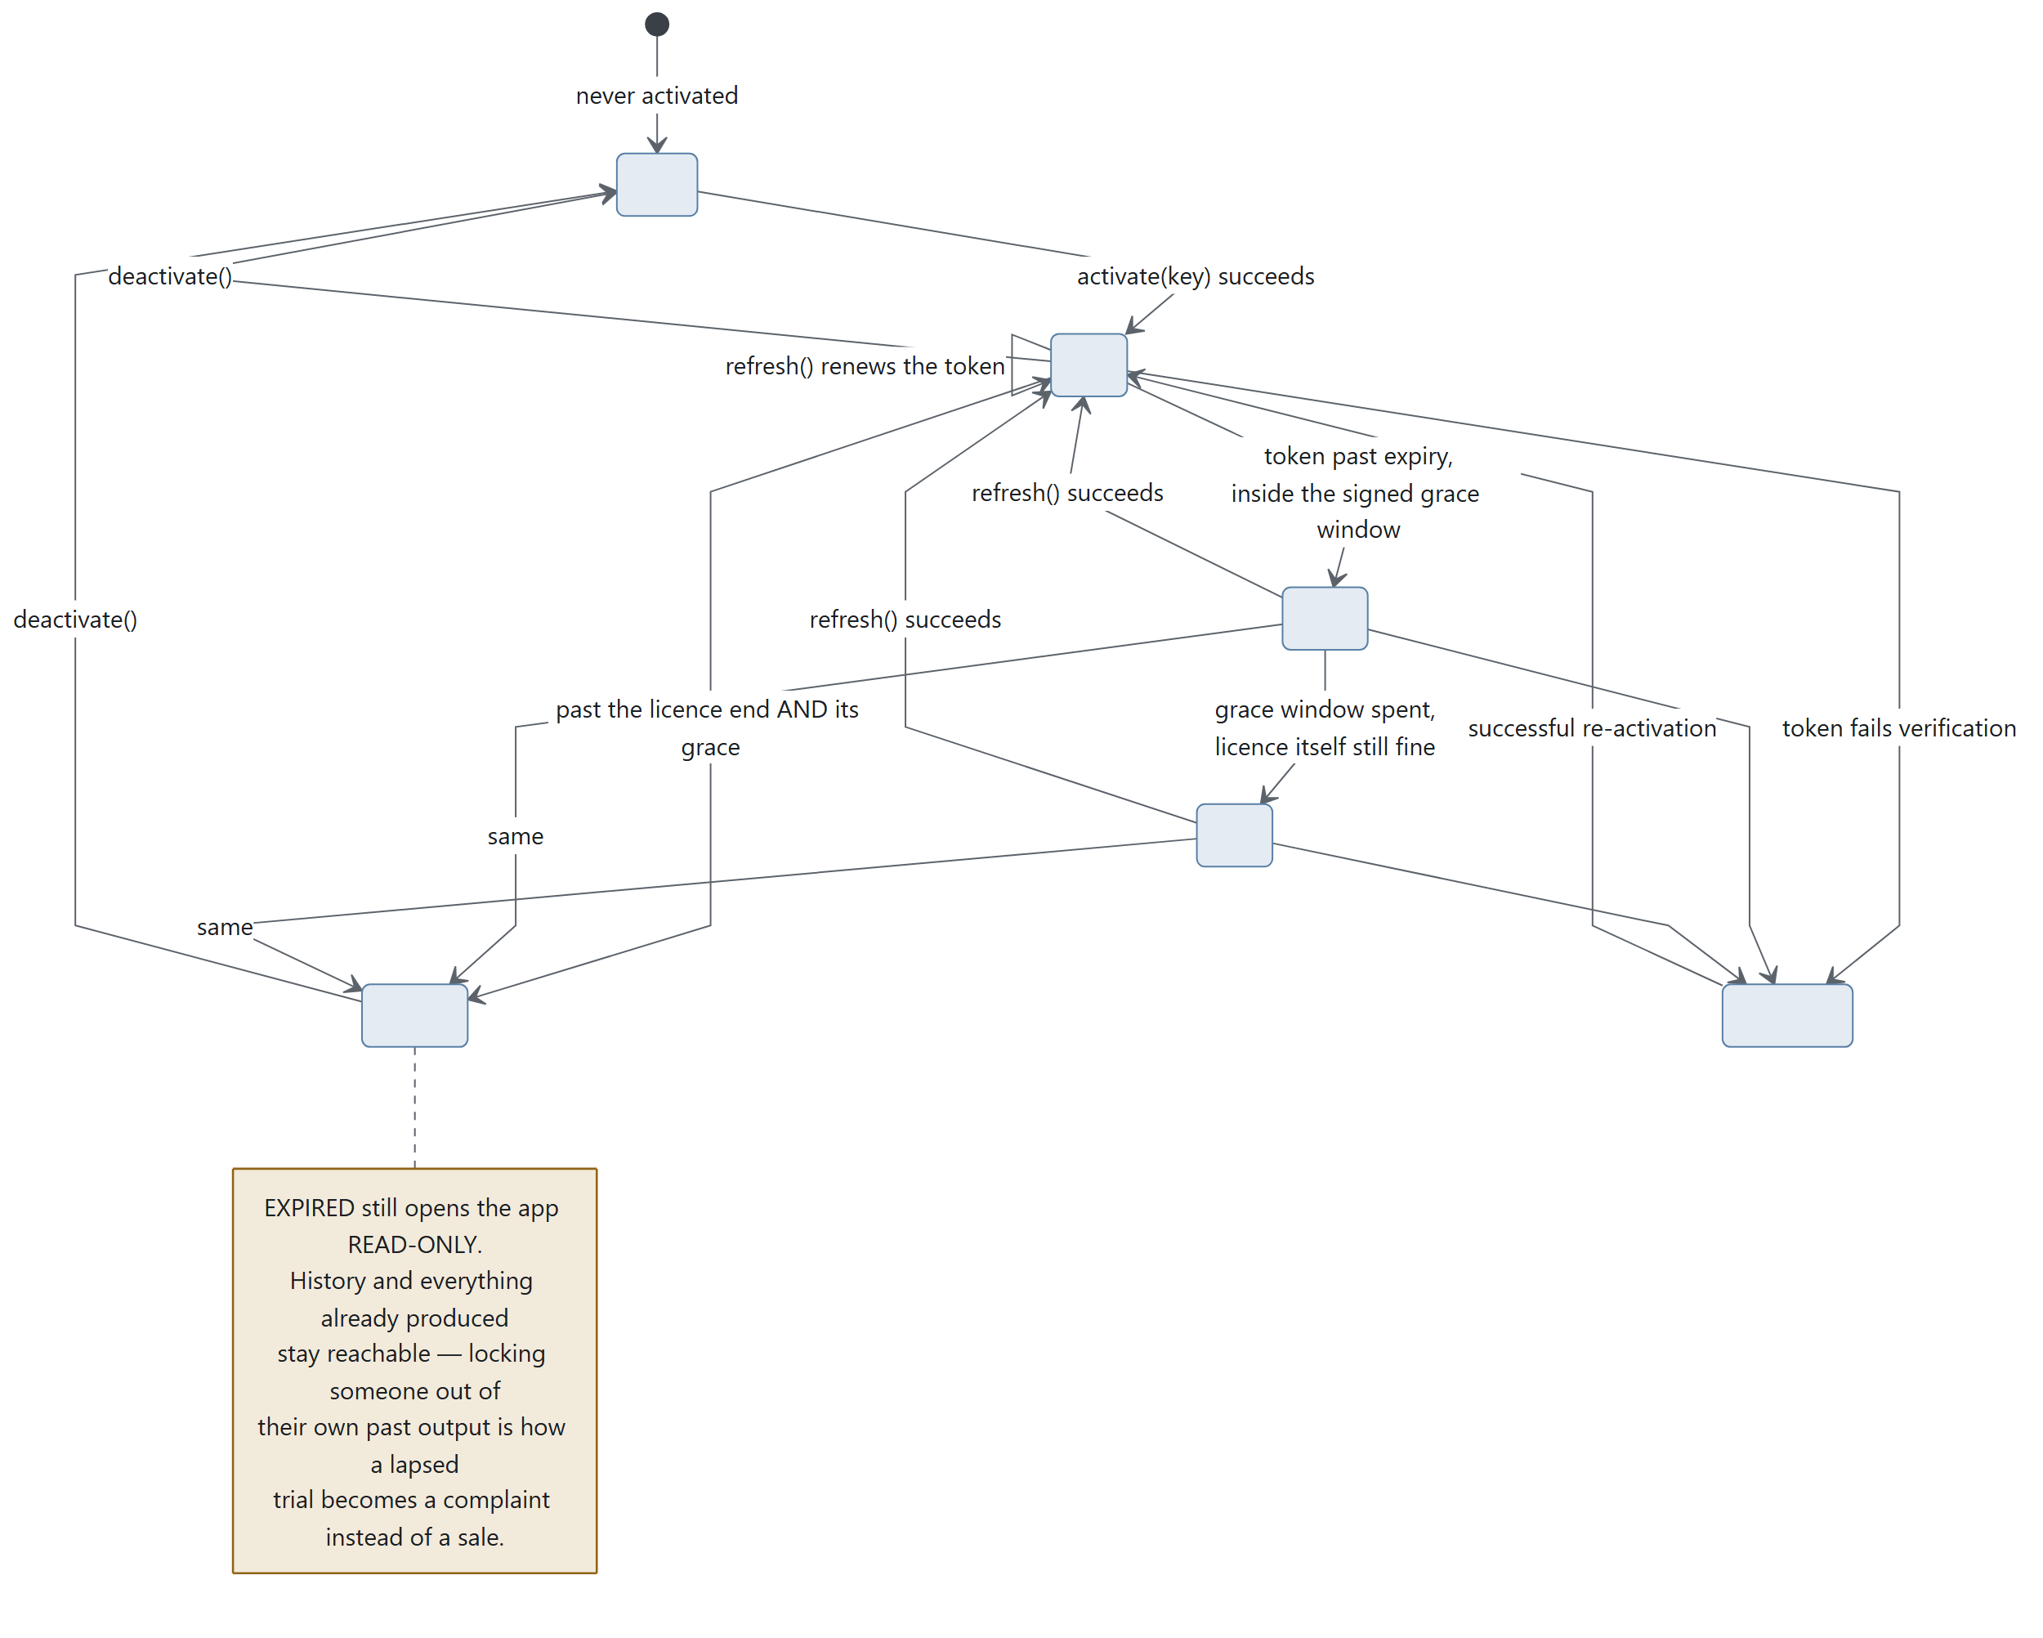
Diagram 5.1
LicenseState
Member | Meaning
status | none · valid · grace · stale · expired · tampered
usable() | May the customer start new work?
days_left() | Days until the licence ends, rounded up. Negative once it has
has(feature) | Entitlement check
message | The sentence to show

CLOCK_TOLERANCE = 1 day. clock_rolled_back(last_seen) compares against the stored high-water mark, advanced by store.touch_clock().

5.4 The authorisation flow — the important part
This is what replaced a design that went to the server on every plan with no offline fallback at all: up to 90 seconds against a cold host before the customer saw anything, and one flaky connection meant no work.
The trade it was making — live control in exchange for our availability becoming our customers' availability — is now paid for by a signed lease instead of a round trip, which is strictly better on both sides.
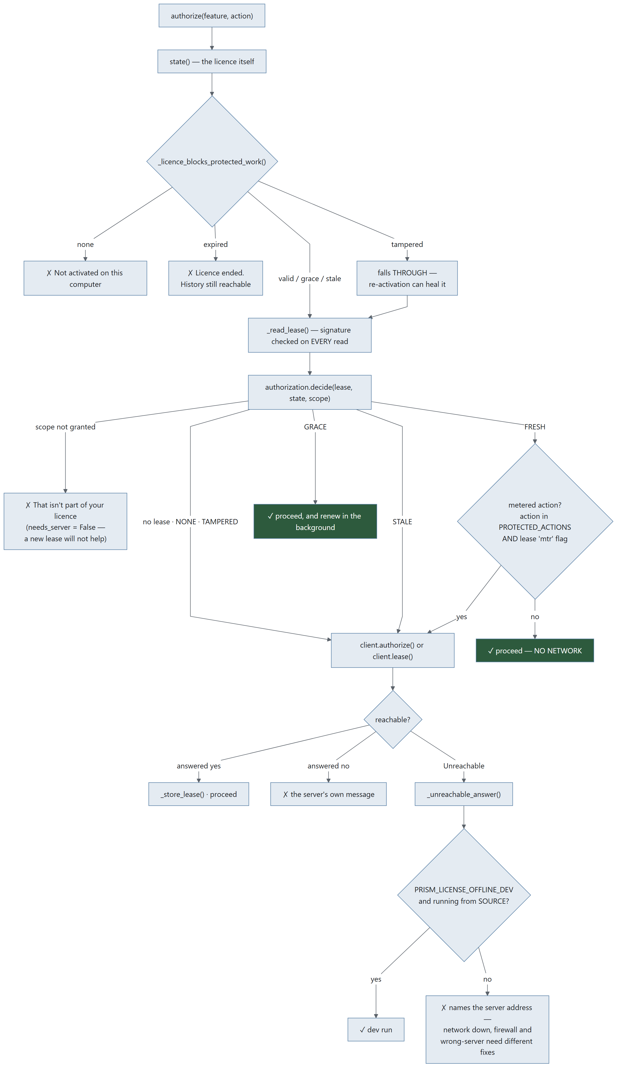
Diagram 5.2

The order, and why it is this order
- Local signed lease. Valid and in scope → proceed, no network.
- Missing, expired or out of scope → ask the backend.
- Backend re-validates licence, device, seat, revocation, entitlement, quota and client version, and signs a new lease.
- Cache it, and proceed.

What still always goes to the server
Metered actions on a metered licence — PROTECTED_ACTIONS = {'plan'}, and the lease's signed mtr flag.
A daily allowance can only be counted where the counter lives; a lease says what a client MAY do, never how much of it it has already done. Prism's own pipeline is browser automation against the customer's logged-in sessions and costs Alphakore nothing, so only planning — three Groq calls — is in that set.

Why stale is deliberately absent from the blocking list
A lease is normally the fresher evidence: the backend caps a lease's expiry at the licence's own hard stop, so a valid lease implies a valid licence at the moment it was issued.
none, expired and tampered are different — in each of them we cannot establish that the licence is alive at all, so a lease that says otherwise is either a clock being wound or a lease that was never ours.
Without _licence_blocks_protected_work, the fast path would happily authorise protected work on an expired licence for as long as a lease sat on disk — precisely the hole that "check the cache first" opens if the cache is checked instead of the licence rather than as well as.

Why tampered falls through
It can be healed by a successful re-activation. Refusing without trying would strand someone whose token was invalidated by a licence reissue.

The honest limit of the offline window
Inside GRACE, a metered licence can plan without the server counting it. That window is the backend-signed off claim (default one hour), so the exposure is bounded, per-licence, and adjustable without shipping an app.
A local counter would look like a fix and would not be one — anything this process counts, this process can be patched to forget.

When it is called
At the START of a run or add-on — never during one. A pipeline is tens of minutes of browser automation, and failing it part-way would discard real work for a reason the customer cannot act on.

5.5 The lease
licensing/lease.py + licensing/authorization.py
Claims (build_claims): kid · license_id · device_fp · scope · features · metered · jti · iat · ttl · off (offline window).
Scopes: SCOPE_CORE = "core" · SCOPE_WORKFLOW = "workflow" · SCOPE_GROK = "grok".
States — Lease.state(now):
State | Meaning | decide() verdict
FRESH | Inside TTL | ✓ proceed, no network
GRACE | Past TTL, inside the signed off window | ✓ proceed and renew in the background — this is the state that makes a flaky connection a non-event rather than an outage
STALE | Offline window spent | ✗ this is where offline operation stops
NONE | No lease cached | ✗ ask the server
TAMPERED | Fails verification | ✗ ask the server; clear() the cache

Lease.allows(scope) is scope membership only — NOT temporal. Callers must go through decide(), which combines both. That separation is deliberate: it is why an in-date lease that simply does not cover a feature returns needs_server=False — a new lease will not help unless the licence itself changes, so it is a definite no rather than a reason to go to the network.
server_reachable is what the caller has just observed, not a guess. It is False only after a request has actually failed.
That distinction is the whole point: an arbitrary network failure must not equal a licence failure, but neither may "I did not bother asking" become a permanent offline mode.
Throttling: RETRY_INTERVAL = 60 s. note_attempt() records a failure; may_retry() gates the next try.

5.6 Device fingerprint — one machine, one seat
licensing/device.py. SALT = b"PRISM-DEVICE-V1"; the identity is salted, hashed and truncated.
Three tiers, best first:
Tier | Source
TIER_PLATFORM | Linux: /etc/machine-id. macOS: IOPlatformUUID. Windows: registry MachineGuid
TIER_MAC | The MAC address
TIER_RANDOM | A random id persisted in ~/.prism

The tier is reported alongside the fingerprint so the server knows how much to trust it. reset_cache() is tests only — the fingerprint is stable for a process's lifetime.
_hostname() supplies a human label for the seat list, so a customer asking which five machines are using their seats gets names rather than hashes.

5.7 Where the key is stored
licensing/secretstore.py
Place | Constant | Notes
OS credential store | KEYRING | Service "Prism (Alphakore)", account "licence-key". Probed once — an import that fails, or a backend that is not there, must not be retried on every call
~/.prism/license.json | FILE | Fallback, 0600
Neither | ABSENT

store.save_key() prefers the keyring. forget_key() removes it from both places — "release this device" has to mean it.
store.write_json() is atomic and 0600. store.read_json() resolves every failure to the default — a missing, truncated or hand-edited file is not a crash.

5.8 Metering
licensing/meter.py — what the customer consumed, never what they wrote.
Function
record(kind, *, tool, stage, prompt_tokens, completion_tokens, ok, ms) | Buffer one event. kind ∈ plan · run · stage · groq · addon
drain() | Take everything buffered, leaving the buffer empty
restore(events) | Put them back after a failed send, so a flaky network loses nothing
pending() | Count
install_groq_meter(router_module) | Counts Groq tokens by wrapping the module's requests handle

MAX_BUFFERED = 2000. Thread-safe via a module lock.
licensing.report_usage(run_id) is fire-and-forget: never blocks, never raises.

5.9 Background renewal
MainWindow.LICENCE_REFRESH_MS = 10 * 60 * 1000 — every ten minutes, _tick_licence() renews the token and the lease off the UI thread, forever.
_repaint_licence() re-reads the cached licence and repaints. No network, never raises — it is safe to call from paint code.
refresh_licence_ui() repaints everything that depends on the licence: the banner, the rail's licence card (_plan_summary() → two lines: what you have, and whether it is ending), and every padlock.

5.10 Plans and features
plans.py is the single table the app and the licence server share.
ORDER = ('studio', 'works', 'complete')
FALLBACK = ('core',)
Function
features_for(plan_key) | What this plan includes
label(f) / blurb(f) / pitch(f) | What the paywall says
plan_of(features) | Best-guess plan name — display only
missing_from(plan_key) | The upsell list, in order

main.py::_paywall() is registered once via licensing.set_paywall_handler(), so the licensing package never has to import Qt. Anything not in the licence shows a padlock in the rail and opens the pitch rather than failing.
Known gap: plans.py feature names and blurbs are not in the translation catalogue — they render in English regardless of interface language.

5.11 Development and testing

Running without a licence server
PRISM_LICENSE_OFFLINE_DEV=1 PRISM_LICENSE_SERVER=http://127.0.0.1:9 python3 main.py
Both are honoured only from source — a frozen build ignores them, or they would be a total bypass.
PRISM_LICENSE_OFFLINE_DEV alone is not enough when a real server is reachable: it fires on a connection failure, and a server that answers "no" has not failed. Pointing at a dead port is what makes it apply.
Mint a local licence: python3 devtools/mint.py install --features …

Do NOT export PRISM_LICENSE_OFFLINE_DEV=1 to run the test suite
This is worth restating because the repo README used to say the opposite.
licensing._offline_dev() is read only inside _unreachable_answer() — i.e. after the HTTP call has already raised Unreachable. It changes the answer, never the round trip, so it cannot make a hanging test finish.
What it does do is open a production bypass underneath the revocation test: with the hatch open, a revoked licence's offline fallback is granted and test_h_a_revoked_licence_gets_no_lease_and_loses_its_cache fails on True is not false. That failure was read as known contamination for months.
tests/conftest.py now strips the variable per test, so the suite is insulated either way — but do not put it back in the invocation.

The self-test
licensing.selftest() verifies the committed test vector in licensing/testdata/. Called by main.py --selftest (via PRISM_SELFTEST), which also proves a packaged build is whole: every bundled resource present.

5.12 Threat model — what this does and does not stop
Stated plainly, because a maintainer needs to know which complaints are bugs and which are the design.
Attack | Stopped? | By what
Sharing a key across many machines | Yes | Seat counting on the device fingerprint
Editing license.json to extend the date | Yes | Ed25519 signature over the claims, verified every read
Copying ~/.prism to another machine | Yes | Claims are device-bound; verification fails
Winding the system clock back | Mostly | clock_rolled_back() against the stored high-water mark, CLOCK_TOLERANCE = 1 day
Pointing a release build at a fake server | Yes | PRISM_LICENSE_SERVER honoured from source only
Pointing a source checkout at a fake server | No | Deliberate — that is the dev hatch
Patching the Python to skip the gate | No | It is Python on the customer's machine. This design does not pretend otherwise
Exceeding a daily allowance while offline | Bounded, not stopped | The signed off window (default 1 hour). A local counter would look like a fix and would not be one

There is no offline fallback for a first authorisation. If the licence server cannot be reached and no lease covers the action, the answer is no. LICENSING.md argues why that trade is worth making.

