ALPHAKORE · INTERNAL
Prism Architecture
The complete reference — system, data, flow, operations
Product Prism · version 1.3.0
Commit 20292f4
Drawn 26 August 2026
Source docs/architecture/ — Markdown is the master

Contents
Right-click here and choose 'Update Field' to build the contents.

Index
Audience: the product manager and maintainer, and anyone joining the team. Purpose: understand the whole system without reading 74,000 lines of code.
This set is the technical reference. It says what the system is, what data it holds, where that data comes from and goes, and what every module is responsible for. It deliberately does not re-argue product decisions — those live in the documents listed under "Where the reasoning lives" below, and this set links out to them rather than restating them.
Last updated: 2026-08-26 · against commit 20292f4, app version 1.3.0.

Read in this order
# | Document | Answers
1 | System overview | What is Prism, what are the layers, what runs on which thread, what happens at startup
2 | Data model | Every file on disk, every field in it, every in-memory record, and how they relate
3 | Data flow | Every pipeline, stage by stage: input → process → output → destination
4 | API reference | Internal module surface, and every external service Prism talks to
5 | Licensing & authorisation | The gate on every launch and every add-on
6 | Add-on subsystems | Email automation, BOQ, Gerber, Reel/Studio, Email blast
7 | Operations | Build, CI, release, tests, configuration, environment, failure modes
8 | System state & roadmap map | What is built, what is half-built, what is deliberately not built

The thirty-second version
Prism is a native PySide6/Qt desktop application — no browser, no local server, no backend of its own. It takes a task in plain language, works out which AI tools it needs, and drives those tools in the user's own Chrome, signed in as them. On top of that sits a shelf of add-ons for small Indian manufacturers: read the inbox and keep an inquiry register, take quantities off a CAD drawing, measure a PCB job, send email from the user's own account, make a short video.
Three properties shape every decision in the codebase:
- The customer's data stays on the customer's machine. There is no Prism server that receives customer content. The only outbound calls are to Groq (small text snippets, and only when local rules cannot settle a question), the licence server (never content), and the user's own mail servers.
- Prism has no AI engine of its own. core_bridge.py imports the prism_terminal submodule's core/ package. The CLI and the GUI run identical routing, automation, voice and file-finding code, and share one ~/.prism/config.json.
- Automation stops where money moves. Two human confirmations per order — before a price goes to a customer, and before a purchase order is accepted. Everything else runs unattended.

Where the reasoning lives
This set answers what and how. These answer why, and they are the record of decisions already argued through. Do not duplicate them; link to them.
Document | Holds
README.md (repo root) | The product tour, the layout, the known limitations
CHANGES.md | The full development log, round by round
docs/EMAIL_WORKFLOW.md | The per-inquiry lifecycle as a business process
docs/EMAIL_WORKFLOW_RUNTIME.md | Which brain does which job; the human stop points
docs/EMAIL_AUTOMATION.md | Office scale: several mailboxes, one register
docs/AFTER_THE_MERGE.md | Decided work, blocked only on merging
docs/DEFERRED.md | Work deliberately not built yet, each with its trigger
docs/FUTURE_INDUSTRY_TARGETS.md | Which industries next, and the hard rules per industry
docs/GERBER_FIXES.md | The Gerber reader's verification history
LICENSING.md | The licence design and the trade it makes
BUILD.md / SHIPPING.md / RUNNING.md | Building, issuing keys, running
KNOWN_ISSUES.md | Live defects

Word copies
Everything here is also generated as Word documents in `word/` — nine individual files plus Prism-Architecture-Complete.docx, which carries all nine behind a contents page. They are for people who will never open a repository.
The Markdown is the master. The .docx files are output: they are regenerated, not edited. If you edit one by hand, the next build overwrites it.
python docs/architecture/build_docx.py
Real Word heading styles (so the navigation pane and the contents field both work), native tables, and every diagram rendered to an image — wide ones on their own landscape page. Diagrams need node; the build fetches @mermaid-js/mermaid-cli through npx on demand and caches the results. With no node on the machine, diagrams fall back to their source text in a captioned box rather than failing the build.
Word's contents page opens empty by design: right-click it and choose Update Field → Update entire table to fill in the page numbers.

Maintaining this set
- Each document names the files it describes, so a change to the code has an obvious document to update.
- Field tables come from the source, not from memory. When a schema changes, update the table in 02-data-model.md in the same commit.
- When a fact here contradicts the code, the code wins — fix the document and say so in the commit message.
- Do not move product reasoning in here. If a decision needs arguing, it belongs in docs/DEFERRED.md or docs/AFTER_THE_MERGE.md.

System Overview

1.1 What Prism is, precisely
A single-process native desktop application, written in Python 3.12 against PySide6 (Qt 6), shipped as a portable per-OS binary built with PyInstaller.
It has:
- No web front end. No Electron, no embedded browser view, no localhost server. Every screen is a Qt widget.
- No backend of its own for customer data. The only Prism-operated server is the licence server, and it never receives customer content — only a licence id, a device fingerprint, an app version, and usage counters.
- No database. All persistent state is flat files: JSON under ~/.prism, and CSV in a folder the customer chooses (deliberately, so the register stays theirs and opens in Excel).
- No AI model of its own. It orchestrates other people's: Groq over HTTP for fast structured work, and the user's own logged-in web tools (ChatGPT, Claude, Perplexity, Canva, NotebookLM, Apollo…) driven through a real Chrome window with Selenium.

Why that shape
The target customer is a small Indian manufacturer. Two constraints follow and explain nearly every architectural decision:
Constraint | Consequence in the code
The customer's design files and correspondence must not leave their machine | Gerber files never reach an AI (cmd_gerber passes attachments=[], asserted by test). Triage sends only a 1,500-character snippet, and only for senders local rules could not settle. A "Keep everything on this computer" switch removes even that.
The customer already pays for ChatGPT/Claude and will not pay again per token | Automation drives the tools in their Chrome, signed in as them. There are no API bills for the heavy tools, and no new subscription to sell them.

1.2 The two repositories
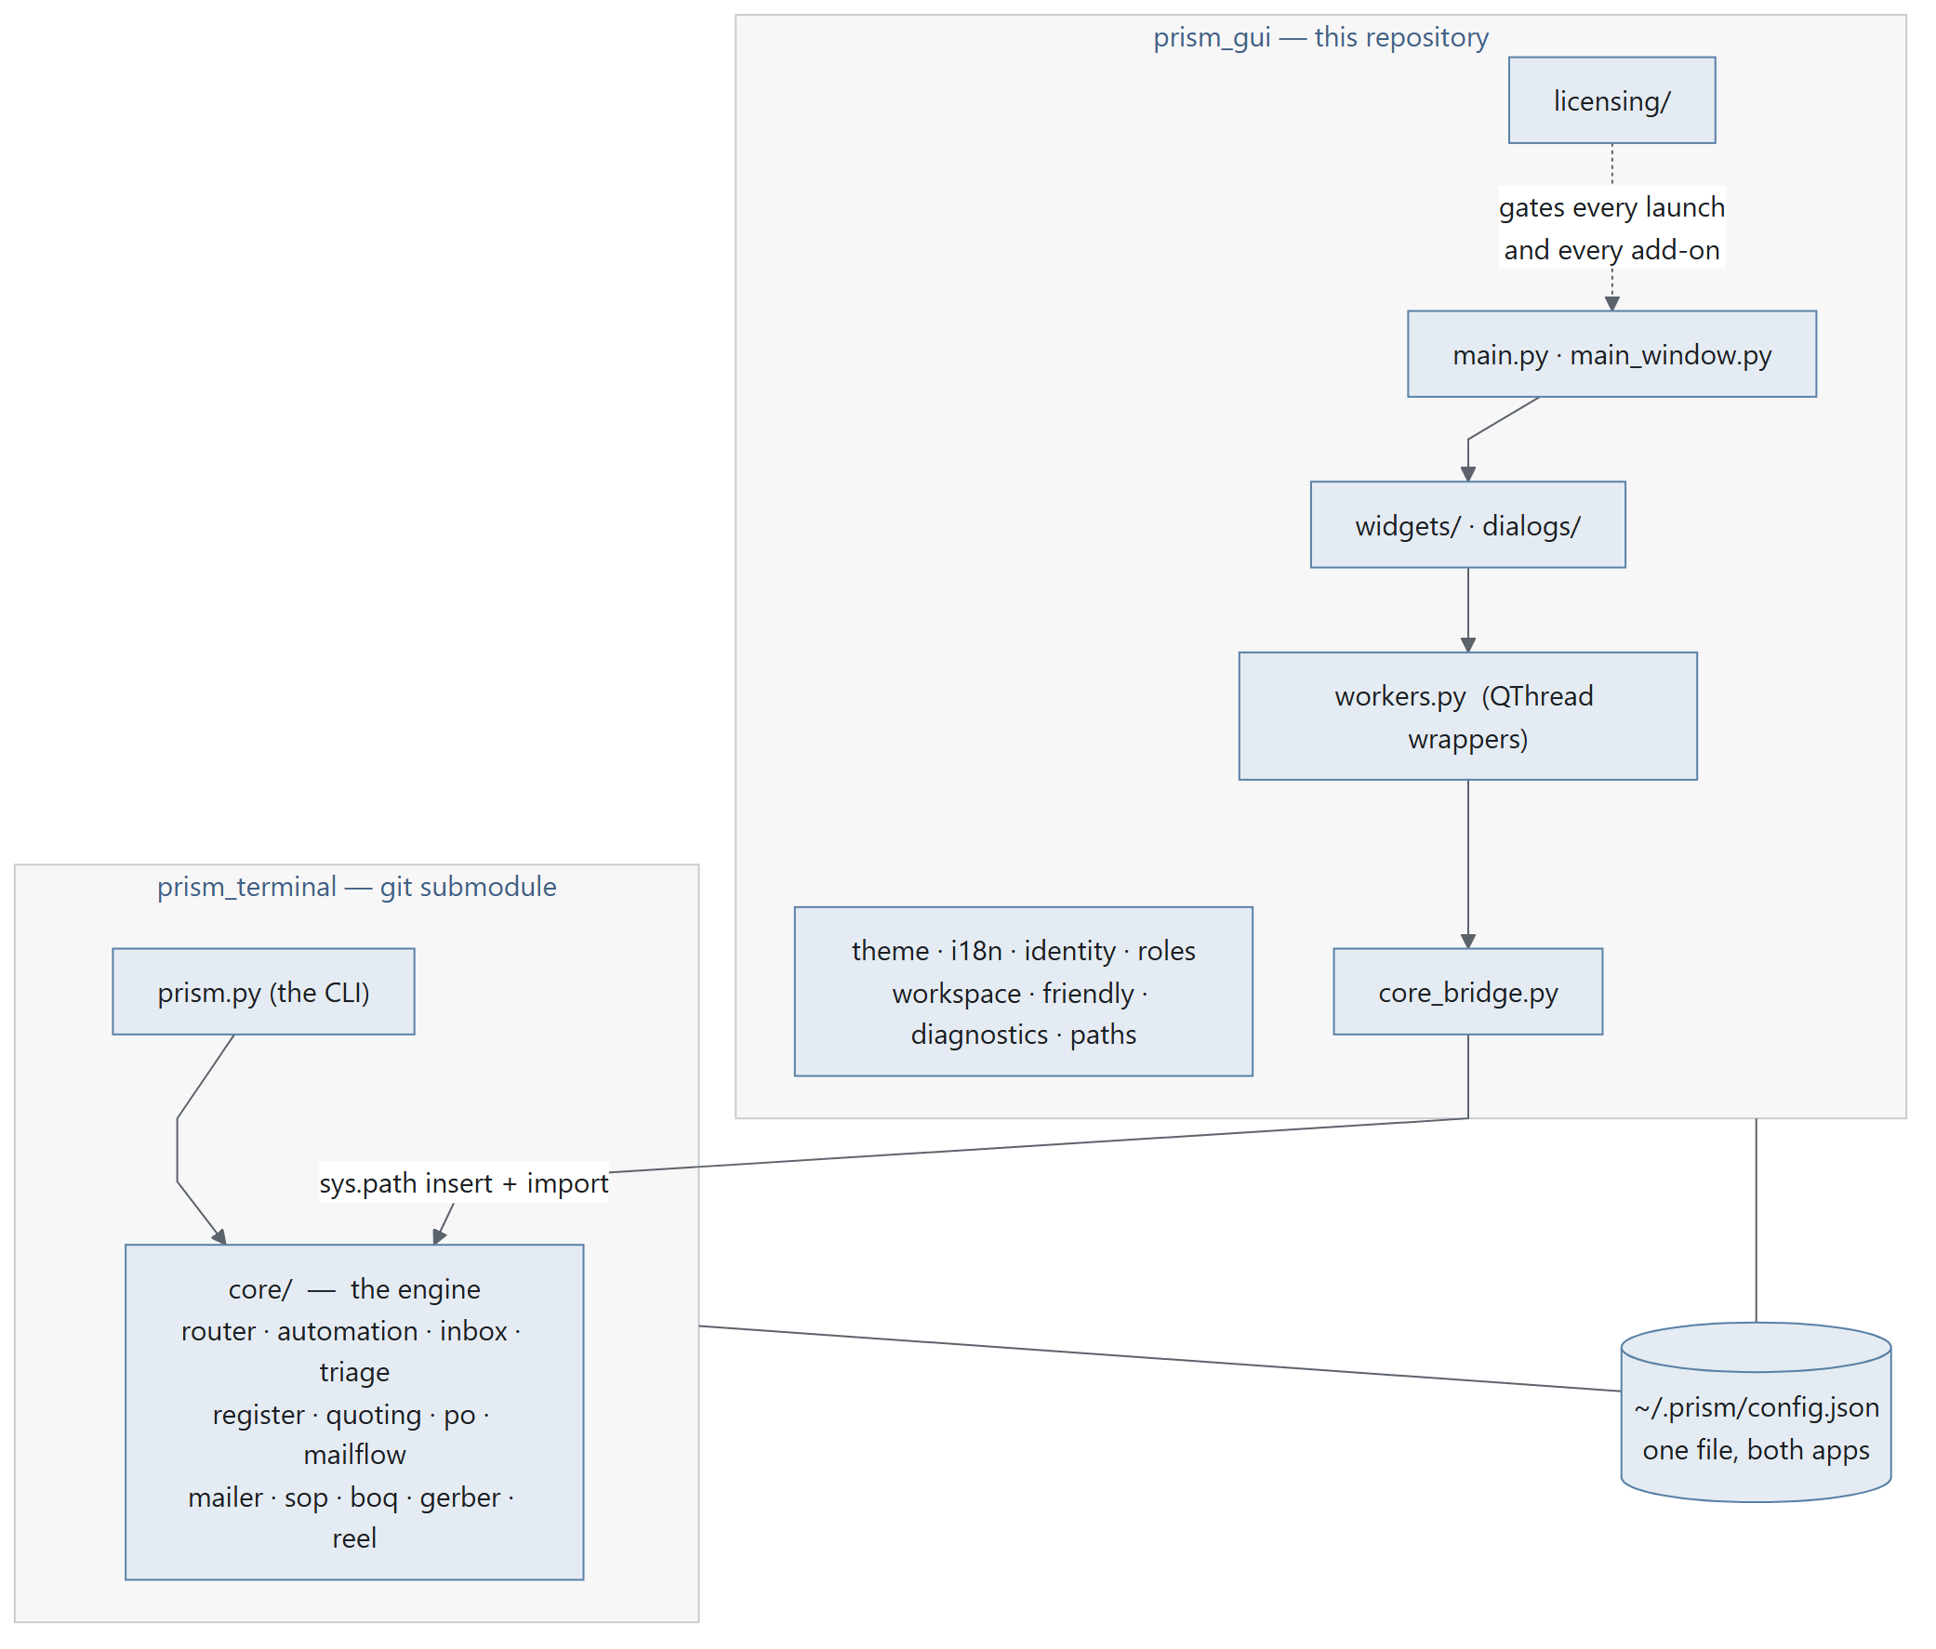
Diagram 1.1
prism_terminal is pinned as a git submodule (see .gitmodules) to github.com/HitarthTrivedi/prism_terminal.
The submodule always wins. paths.resource('prism_terminal') resolves to ./prism_terminal and is checked first. A sibling ../prism_terminal checkout is ignored; core_bridge._warn_about_sibling() prints a note naming both paths when it finds two, because believing the opposite once cost an afternoon spent editing a copy that was never loaded.
Operational trap, already recorded: two checkouts of prism_terminal on one dev machine is a known hazard — docs/AFTER_THE_MERGE.md §5. Decide one way or the other; do not keep both.

1.3 The layer model
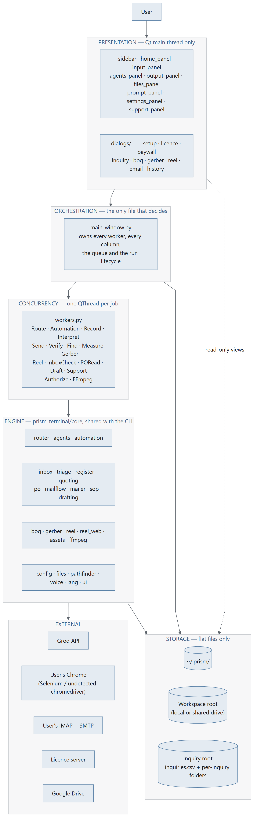
Diagram 1.2

The rule that keeps the layers honest
main_window.py is the only file that makes decisions.
Widgets emit signals and render what they are given. Dialogs collect input and return it. workers.py classes do one job off the UI thread and emit a result. The engine knows nothing about Qt. Everything that decides what happens next — which worker to start, what to do with its result, when to persist, when to stop for a human — lives in main_window.py or in the add-on dialog that owns that screen.
This is why main_window.py is 2,131 lines and why that is not, by itself, a problem to fix. It is also why a change to behaviour almost always lands in one file.

1.4 Process and threading model
Prism is single-process. Concurrency is QThread, never multiprocessing, and never asyncio.

Diagram 1.3

The four rules
- Nothing touches a widget from a worker thread. Workers communicate exclusively by Qt signal; Qt marshals the call back onto the main thread.
- Every worker is owned by the window that started it and is retired in closeEvent. MainWindow._retire_workers() asks each live worker to stop and then waits up to _WORKER_WAIT_MS = 10000 ms. InquiryDialog.closeEvent does the same for its own workers.
- Long-running work is interruptible, not killable. AutomationWorker.stop() sets a flag the engine polls at safe points (_sleep_interruptibly, should_stop callbacks). There is no thread termination.
- Cleanup order matters and has bitten before. _retire_listener() exists because dropping a wake-word listener while its thread was still running crashed the interpreter — see tests/ coverage for GIL-related cleanup.

Where blocking actually happens
Job | Typical duration | Worker
Groq routing call | 1–5 s | RouteWorker
Licence authorise | up to 45 s (cold host) | AuthorizeWorker
Browser pipeline (per stage) | 35 s – 30 min | AutomationWorker
IMAP fetch + triage, one mailbox | 5 s – 3 min | InboxCheckWorker
SMTP blast | 2 s per recipient (SEND_DELAY) | SendWorker
Gerber measurement | 2 s – 2 min | GerberWorker
Reel encode | 1–10 min | ReelWorker

1.5 Startup sequence
main.py :: main() — the order is load-bearing, and each step's comment in the source explains what breaks if it moves.
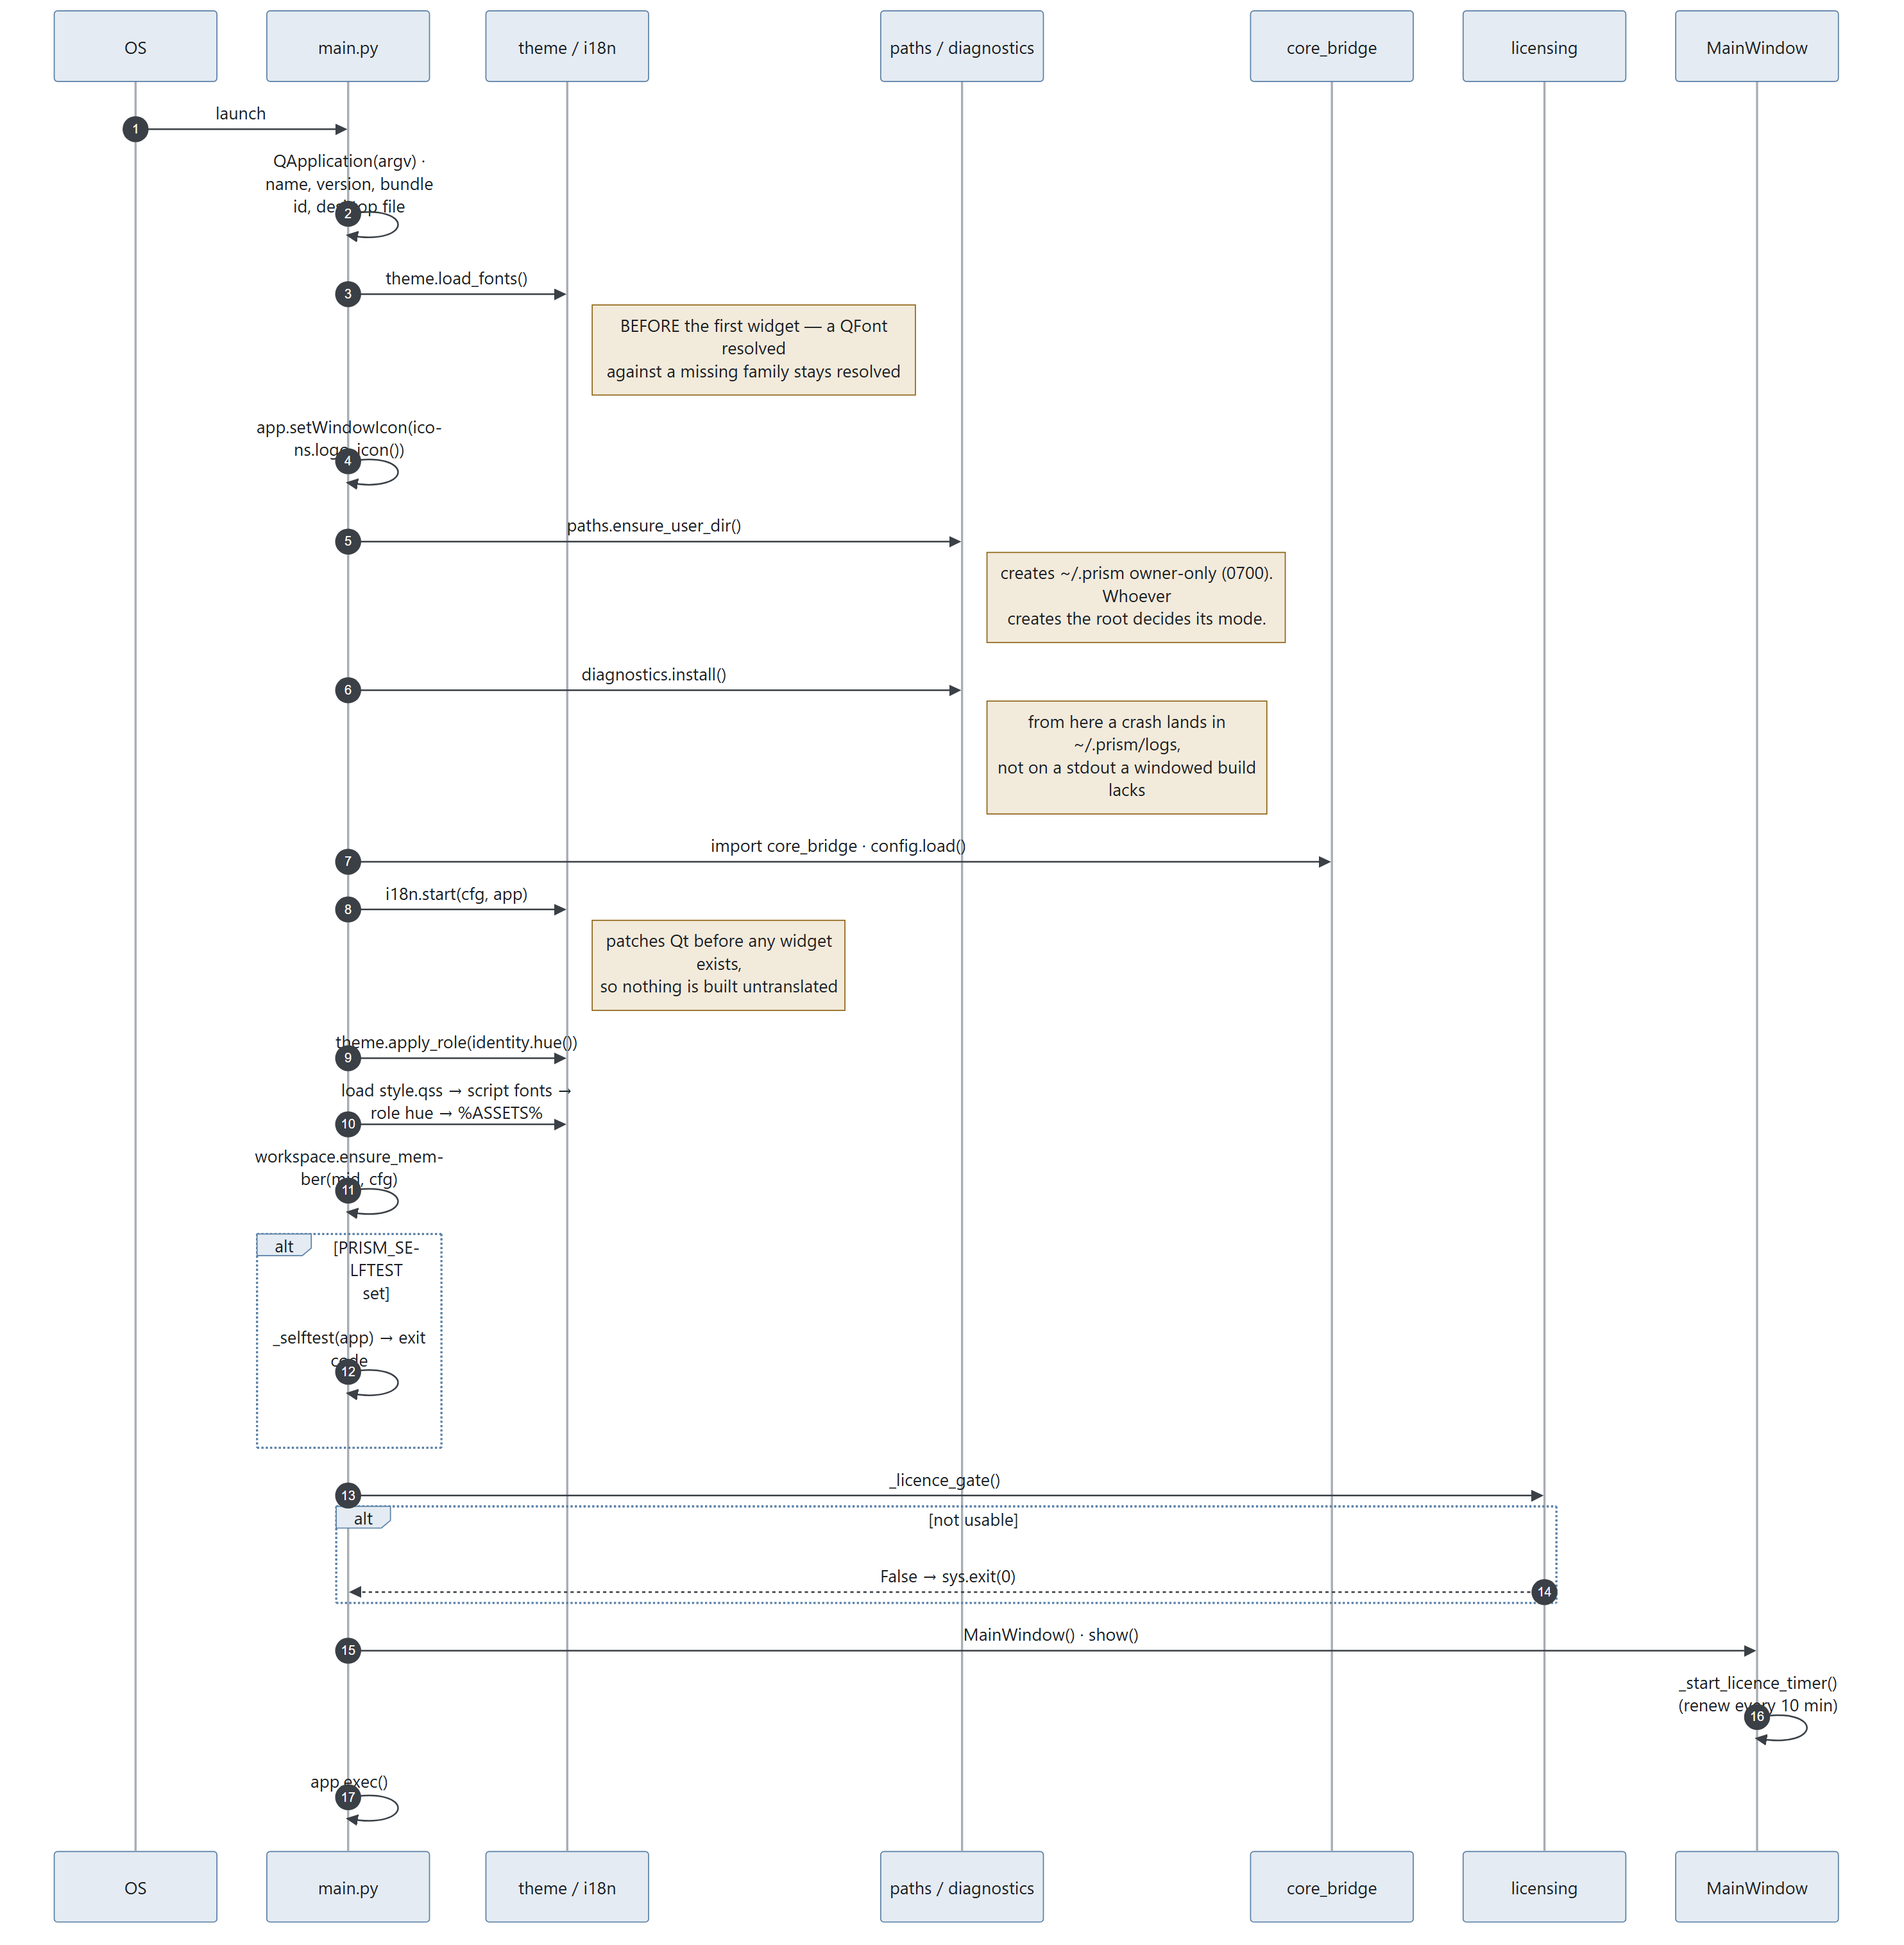
Diagram 1.4

What each step protects
Step | Moving it breaks
theme.load_fonts() first | Widgets built before the font is registered stay on the fallback sans forever
paths.ensure_user_dir() before diagnostics | ~/.prism gets created by whatever runs first, inheriting the ambient umask instead of 0700
diagnostics.install() before anything fallible | A crash in a windowed build has nowhere to print
i18n.start() before the first widget | Untranslated widgets, permanently
Stylesheet after i18n and theme.apply_role | Both rewrite the QSS; whichever runs last wins
Licence gate before MainWindow | The window reaches for the licence server during construction

1.6 Module map

Application root (prism_gui/)
File | Lines | Responsibility
main.py | 327 | Entry point, startup order, licence gate, --selftest, paywall registration
main_window.py | 2,131 | The only decision-maker: owns all workers, all three columns, the task queue, the run lifecycle, all add-on entry points
core_bridge.py | 258 | Puts prism_terminal/core on sys.path; lazy get_*() / *_available() accessors so heavy optional deps are probed, not imported at boot
workers.py | 511 | 16 QThread wrappers — the entire concurrency surface
dashboard_data.py | 355 | Read-only projections for Home and register screens (recent runs, counts, sparklines, register views, currency formatting)
theme.py | 597 | Industry design tokens; per-role accent hue; stylesheet rewriting
i18n.py | 441 | Interface translation; patches Qt before any widget exists; script-aware font stacks
identity.py | 191 | Who is signed in (designation key), display name, accent hue, view-as
roles.py | 211 | The eight roles, their hues, their default agent picks
workspace.py | 305 | Per-member folders on a shared drive; the team roster; read permissions
plans.py | 210 | What each plan includes — the single table the app and licence server share
friendly.py | 347 | Any error → title, plain English, numbered next steps
diagnostics.py | 300 | Crash logs to ~/.prism/logs
paths.py | 129 | Resource resolution frozen vs. source; ~/.prism helpers; open/reveal a result
app_meta.py | 20 | Name, version (1.3.0), bundle id, publisher, support email
favorites.py | 51 | Starred file/folder persistence
awake.py | — | Keep-awake during long runs
cloud.py | — | Cloud file attach
wakeword.py | — | Best-effort "Prism" wake-word polling loop (not a real engine — see §1.8)
support_kb.py | 1,618 | The support answer book
style.qss | 45 KB | The Industry theme — everything QSS can express

widgets/ — presentation
File | Lines | Shows
controls.py | 1,767 | The shared component library: square switch, tool chip, step mark, pills
simple_panels.py | 1,582 | Six screens: Guide, AI tools registry, History, and three status screens
output_panel.py | 1,461 | The run console — live per-step results, Copy output, Open in tool
support_panel.py | 1,244 | Help & support: answer book left, conversation right
settings_panel.py | 1,216 | Settings as one screen with a grouped section list
agents_panel.py | 1,144 | The plan — steps, plain-English names, tool chips
sidebar.py | 1,105 | Left rail: brand, nav groups, add-on shelf with padlocks, favourites
home_panel.py | 886 | Home — the command centre
input_panel.py | 683 | The task card — the front door
inquiry_panel.py | 675 | Inquiry automation as a screen rather than a dialog
tour.py | 490 | Six-step progressive onboarding
files_panel.py | 374 | "Files you mentioned"
register_table.py, blueprint.py, ask_panel.py, prompt_panel.py, icons.py, markdown.py | — | Register table, hairline frame with registration marks, shared ask box, "Behind the scenes", 24×24 stroked line icons, markdown → Qt rich text

dialogs/ — modal flows
File | Lines | Flow
inquiry_dialog.py | 2,618 | The five-tab Email automation screen, plus quotation, PO review, reminder, edit-row dialogs
inquiry_setup_dialog.py | 1,013 | Mailboxes, folders, terms, who's-who — asked once
setup_dialog.py | 1,003 | Setup, with per-section deep links from the rail
email_dialog.py | 687 | Email blast: recipients, draft, confirm-and-send
reel_dialog.py | 468 | Reel / Studio
license_dialog.py | 418 | Activation, expiry, licence problems
boq_dialog.py | 410 | Quantities off a CAD drawing
history_dialog.py | 392 | Past runs, re-rendered from stored JSON
gerber_dialog.py | — | PCB job measurement — no AI sees the design
paywall.py, problem_dialog.py, guide_dialog.py, drive_dialog.py, ai_directory_dialog.py, completion_dialog.py, contact_dialog.py, base.py | — | Locked-add-on pitch, friendly errors, the guide, Drive picker, tool catalogue, run completion, contact the team, shared modal chrome

licensing/ — the gate
File | Lines | Responsibility
__init__.py | 879 | The whole public surface: state, has, require, activate, authorize, refresh, report_usage, selftest
authorization.py | 285 | The lease cache and the offline policy, in one place
client.py | 267 | HTTP to the licence server; timeouts sized for a cold host
store.py | 251 | ~/.prism/license.json, atomic and 0600
lease.py | 233 | Lease wire format and verification
payload.py | 186 | Server-published configuration format and verification
status.py | 169 | The state machine: none / valid / grace / stale / expired / tampered
device.py | 150 | Machine fingerprint for seat counting (three tiers)
token.py | 145 | Licence token format, signing input, verification
designation.py | 142 | The second key: who this person is and what job they do
secretstore.py | 132 | OS credential store, with a file fallback
meter.py | 130 | Usage metering — what was consumed, never what was written
keyformat.py | 65 | The key the customer types: PRSM-…, Crockford-ish alphabet, checksum
keys.py | 43 | Ed25519 public keys; DEVELOPMENT keys trusted from source only

prism_terminal/core/ — the engine (18,708 lines)
File | Lines | Responsibility
automation.py | 3,222 | Browser automation: Chrome profile seeding, driver setup, per-stage prompt construction, typing, waiting, scraping, downloads, image harvesting, failover
gerber.py | 2,120 | RS-274X and Excellon parsing, copper geometry, track width, spacing, board outline, drills, cross-check against CAM reports
reel.py | 1,810 | Vertical video: frames drawn with Pillow, encoded with FFmpeg
reel_web.py | 1,765 | Prism Studio: the frames are a real web page filmed in a paused Chromium
inbox.py | 1,009 | IMAP: host discovery, read-only fetch, header-batching, backfill, parsing, attachments
boq.py | 827 | DXF/DWG geometry: lengths, areas, counts, per-layer and per-block
router.py | 785 | The routing brain (Groq): query enrichment, stage selection, guardrails, model fallback chain
quoting.py | 742 | Rate lists, cost sheets, matching, Decimal arithmetic, quotation rendering
agents.py | 720 | The agent registry: every tool, its URL, selectors, waits, specialty, cost
mailflow.py | 565 | The daily loop — one check() that never raises and never sends
triage.py | 559 | Sorting the inbox: local rules first, batched AI only for the unknown
register.py | 556 | The inquiry register CSV: numbering, threading, atomic writes, status transitions
mailer.py | 502 | SMTP: recipient parsing, discovery prompts, draft parsing, bulk send
po.py | 406 | Reading a purchase order and comparing it to the quotation
sop.py | 392 | Sending SOPs to customers at their current revision
remote.py | 328 | The LAN/relay bridge for driving Prism from a phone
ffmpeg.py | 323 | FFmpeg location, download, SHA-256 verification
assets.py | 310 | Reel assets: background cutout, ink ratio, the asset table
drafting.py | 307 | Writing the awkward emails using the browser tools
ui.py, onboarding.py, pathfinder.py, voice.py, files.py, config.py, checklog.py, lang.py | — | Terminal UI, CLI onboarding, natural-language file finder, push-to-talk voice, attachments, config, check logging, language

1.7 The window layout
The window follows direction 1b ("Workbench") of the Prism Directions design canvas, rendered in the Industry design system: #f2f2f3 canvas, slate-blue #5980a6 accent, Barlow / Barlow Condensed, square corners, hairline borders with blueprint registration marks.
It auto-sizes to the screen it is on: 92% / 88% of available width/height, capped at 1360×880, floor 1060×640.
Three fixed columns. The old QDockWidgets are gone — nothing can be dragged out, closed, or lost behind a tab, so there is no View menu.
┌───────────────┬───────────────────────────────┬──────────────┐
│ RAIL │ WORK (two-page stack) │ CONTEXT │
│ │ │ (collapses │
│ brand │ ┌─ Composing ──────────────┐ │ to 44px) │
│ Home │ │ task card │ │ │
│ How to use │ │ · kicker, state chip │ │ Files you │
│ AI tools │ │ · 16px editable task │ │ mentioned │
│ History │ │ · Speak / Add file / │ │ · Keep │
│ Settings │ │ Add folder / Make a │ │ · Change │
│ wake word │ │ plan │ │ │
│ │ │ Your plan │ │ Behind the │
│ ADD-ONS │ │ · one row per stage │ │ scenes │
│ Email autom. │ │ · include marker, icon, │ │ (collapsed) │
│ BOQ │ │ plain-English name, │ │ · what you │
│ Email │ │ tool chip │ │ said │
│ BOM (soon) │ │ Start the work │ │ · task brief│
│ │ └──────────────────────────┘ │ · each │
│ WORKSPACE │ ┌─ Running ────────────────┐ │ stage's │
│ Status │ │ live per-step cards │ │ prompt │
│ Login tabs │ │ · Copy output │ │ │
│ │ │ · Open in tool │ │ │
│ CONFIGURE │ │ Back to the plan │ │ │
│ Licence … │ └──────────────────────────┘ │ │
│ │ │ │
│ FAVORITES │ │ │
└───────────────┴───────────────────────────────┴──────────────┘
The accent hue shifts with the signed-in member's role, so a glance says whose copy this is. Only the hue moves — every swatch keeps its lightness, so contrast is identical in every role and nothing needs re-checking for legibility.
Anything not in the licence shows a padlock and opens the pitch rather than failing.

1.8 Known architectural limitations
These are documented, deliberate, and should be quoted honestly to customers. Sourced from the repo README.md "Known limitations" and verified in code.
Limitation | Detail
Wake word is best-effort | wakeword.py is a polling loop — record ~2 s, check for silence, transcribe if not silent, look for "prism". Not a real local wake-word engine. Expect seconds of lag and occasional misses. Swap in Porcupine / OpenWakeWord to make it production-grade.
NotebookLM automation is unverified | automation._run_notebooklm is best-effort and has not been checked against a live session.
Typed queries do not auto-scan for file mentions | Only spoken input runs the interpreter. A GUI has real Attach buttons; prose-scanning a typed sentence adds risk for no benefit.
Email automation's send path and PO screen have never run against a real mailbox | Written and unit-tested. Reading is the well-covered half. This is the single biggest verification gap in the product.
plans.py feature names and blurbs are not in the translation catalogue | They render in English regardless of interface language.
One machine writes the register | Several mailboxes are supported; several machines writing one register is deliberately not built. The office PC that stays on does the writing; everyone else reads. Trigger for changing this is in docs/DEFERRED.md.
No offline licence fallback | If the licence server cannot be reached and no lease covers the action, the answer is no. This is a deliberate trade — see LICENSING.md.

Data Model

2.1 The storage map
Prism has no database. Everything persistent is a flat file, in one of three places.
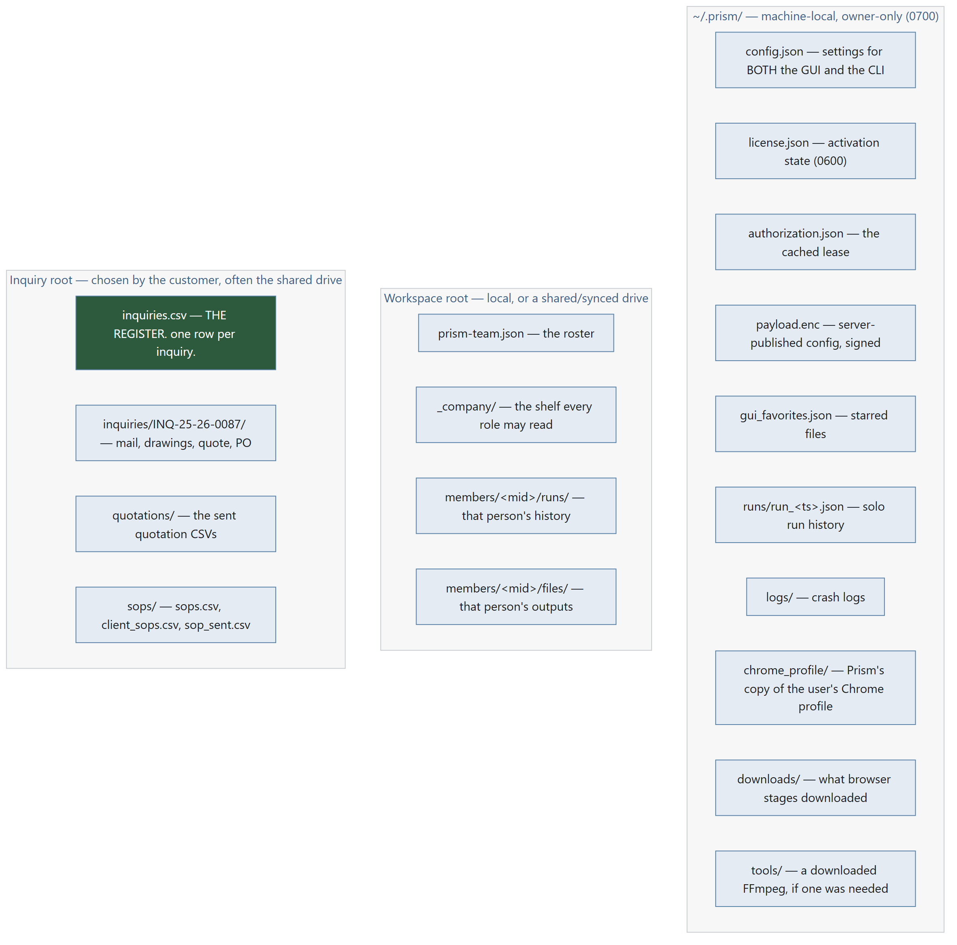
Diagram 2.1

Why the split
Location | Holds | Never holds
~/.prism/ | Credentials, licence state, machine-local caches | Anything another machine needs
Workspace root | Per-member run history and outputs | Passwords — ever
Inquiry root | The register and everything belonging to an inquiry | Passwords — ever

The rule, stated once: mailbox and SMTP passwords live only in ~/.prism/config.json on the machine that does the checking. They never touch the shared folder. That is why "one machine writes, everyone reads" is a design rule and not an accident.

2.2 Entity–relationship diagram
The register is the hub. Everything else either feeds it or hangs off it.

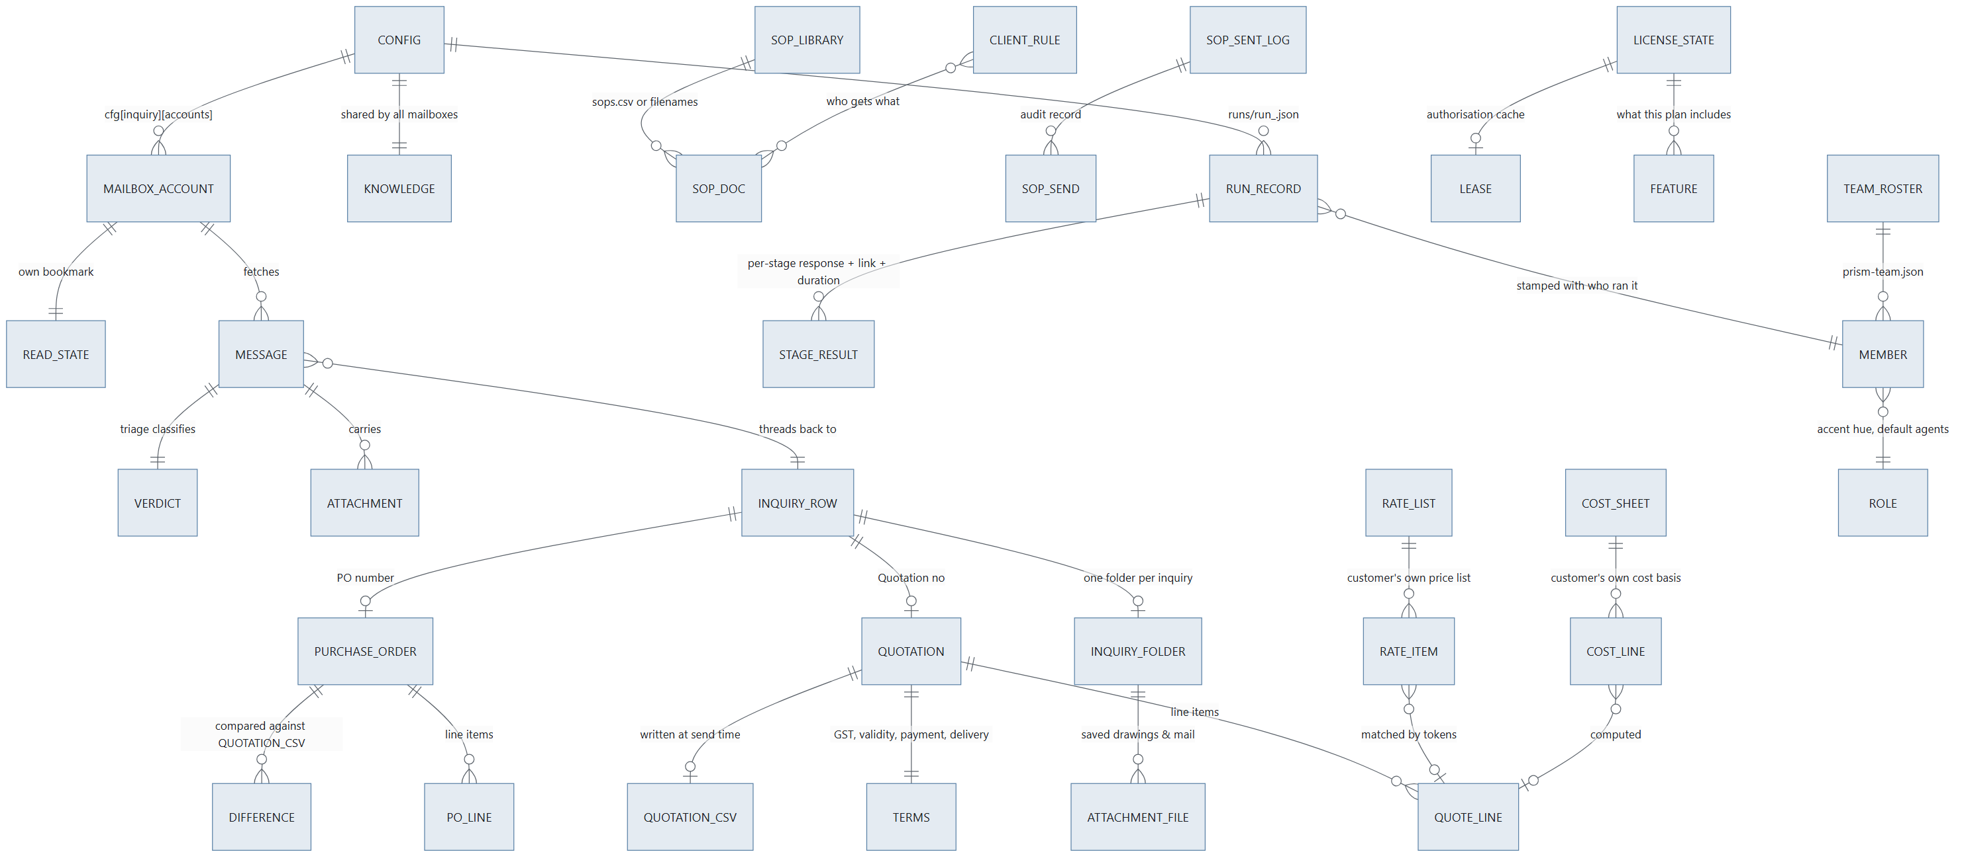
Diagram 2.2

2.3 ~/.prism/config.json — the shared configuration
Written by prism_terminal/core/config.py. Both the GUI and the CLI read and write this file; set an API key in either and the other sees it immediately.
Written atomically: temp file in the same directory, os.replace(). A file that fails to parse is quarantined (moved aside, path reported) rather than overwritten — config._quarantine().

Root keys — engine defaults (config.DEFAULT)
Key | Type | Default | Meaning
api_key | str | "" | Groq API key (gsk_…). The only AI credential Prism holds.
profile | str | "" | Free-text "what do you do" — steers routing
agents | dict | {} | {category: agent_name} — only categories the user enabled
chrome_version | str | "" | Pinned Chrome major version; "" = auto-detect
chrome_profile | str | "" | Which real Chrome profile to copy logins from ("Profile 20" or an address). "" = whichever Chrome used last. Chrome need not have a profile called "Default" — assuming it did meant nothing was ever copied on some machines.
onboarded | bool | false | Has setup been completed
model | str | "llama-3.3-70b-versatile" | Preferred Groq model; the fallback chain starts here

Additional root keys written by the GUI
Key | Type | Meaning
inbox | dict | Single-mailbox reading credentials (legacy shape, still honoured)
email | dict | The sending account (SMTP)
inquiry | dict | The whole Email-automation configuration — see below
workspace_root | str | Where per-member folders live; a shared drive makes it a team
output_language | str | The language the AI tools answer in (separate from the interface language)
language | str | The interface language (en, hi, gu)
designation | str | The signed-in member's designation key (PRSD1…)

cfg["inbox"] — reading account (legacy single mailbox)
Field | Type | Meaning
address | str | The mailbox address
password | str | App password / mailbox password — plaintext, machine-local only
host | str | IMAP host, discovered or typed
port | int | 993 (SSL) or STARTTLS port
folder | str | Defaults to INBOX

inbox.is_configured(cfg) requires address, password and host.

cfg["email"] — sending account (SMTP)
Same four fields plus port semantics: 465 → SMTP_SSL, otherwise STARTTLS. mailer.is_configured(cfg) requires address, password, host.

cfg["inquiry"] — the Email-automation configuration
Written whole by dialogs/inquiry_setup_dialog.py :: _save().
Key | Type | Meaning
accounts | list[dict] | The mailbox list. Each entry: address, password, host, port, folder, and its own state bookmark
account | dict | Mirror of accounts[0] minus state — kept so a config written by this version still opens in the previous one
state | dict | Mirror of accounts[0]["state"] — same backwards-compatibility reason
folder | str | The inquiry root. Default ~/Prism Inquiries. Point it at a shared drive and the whole office reads one register
rate_list | str | Path to the customer's own price list (CSV or XLSX)
cost_sheet | str | Path to the customer's own cost sheet
company | str | Company name, printed on the quotation
signature | str | Email signature
terms | dict | gst_percent, validity_days, payment, delivery
pricing_policy | str | Path to the bargaining-limits file. With no such file, the negotiation prompt is instructed to offer nothing on price at all
followup_days | int | Days of silence before a reminder (default 2)
max_reminders | int | How many reminders before stopping (default 3)
auto_minutes | int | Automatic check interval
auto_followup | bool | Send due reminders unattended
local_only | bool | "Keep everything on this computer" — no message content reaches Groq at all
knowledge | dict | own_domains, customers, vendors (lists) and learned ({address: category})

accounts_of(cfg) is the one reader that understands both shapes. It prefers the list; if there is no list it wraps the legacy account as entry one and carries the legacy state with it, so an existing customer's first multi-mailbox check continues from where their last single-mailbox check stopped instead of re-importing a month of mail.

Read bookmark — inbox.State
One per mailbox. Getting this wrong either re-imports hundreds of old mails as fresh inquiries or skips everything new forever.
Field | Type | Meaning
uidvalidity | int | The server's folder generation. A server may renumber a folder (rebuild, migration) and signals it by changing this. Storing it means a renumber is detected instead of corrupting the register
last_uid | int | Highest UID seen — the "new mail" watermark
floor_uid | int | How far down the recency window this mailbox has been read. Newest mail is fetched first; older mail inside the window is backlog, worked a chunk at a time
backfilled | bool | Set once a backlog search comes back empty, so the steady state costs one SEARCH and nothing else

Why floor_uid exists: without it, a first check on a busy mailbox handed back the oldest 200 of 766 messages — three minutes of waiting to be shown a month-old newsletter, with the real inquiries four checks away.

2.4 The inquiry register — inquiries.csv
The single most important artefact in the product. An ordinary CSV that opens in Excel and stays the customer's whatever happens to Prism.
Defined in prism_terminal/core/register.py. Written atomically. Hand-added columns survive a rewrite. A register open in Excel produces the sentence "close it in Excel" (RegisterLocked), not a lost row.

Columns, in file order
# | Column | Written by | Notes
1 | Inquiry no | next_number() | INQ/25-26/0087 — prefix / financial year / zero-padded serial
2 | Date received | from_message() | From the message date
3 | Time received | _clock() | Time as well as date. Two inquiries from one customer on one morning are indistinguishable in a date-only register, and "which came first" is exactly the question asked when someone revises their requirement an hour later
4 | Customer | Groq details extraction
5 | Contact person | Groq details extraction
6 | Email | Message sender
7 | Phone | Groq details extraction
8 | Product asked | product_summary() | Also used to match a rate list
9 | Quantity | Groq details extraction
10 | Drawing | Attachment save | Filename(s) filed into the inquiry folder
11 | Status | Lifecycle | See the state machine below
12 | Quotation no | mark_quoted() | QTN/25-26/0042
13 | Quotation date | mark_quoted()
14 | Quotation value | mark_quoted() | Indian lakh grouping
15 | Reminders sent | note_reminder() | Counter, capped by max_reminders
16 | Last contact | Several
17 | Result | mark_converted() / mark_lost()
18 | Reason if lost | mark_lost()
19 | PO number | mark_converted()
20 | PO date | mark_converted()
21 | Order value | mark_converted()
22 | Folder | from_message() | Path to this inquiry's folder
23 | Notes | Various
24 | Thread | add_thread() | Not for reading. Message-ID / References identifiers that tie a reply back to its row. This is what stops one conversation becoming four rows
+ | Mailbox | _stamp_mailboxes() | Which address the inquiry arrived at. Added when several mailboxes feed one register

Status lifecycle
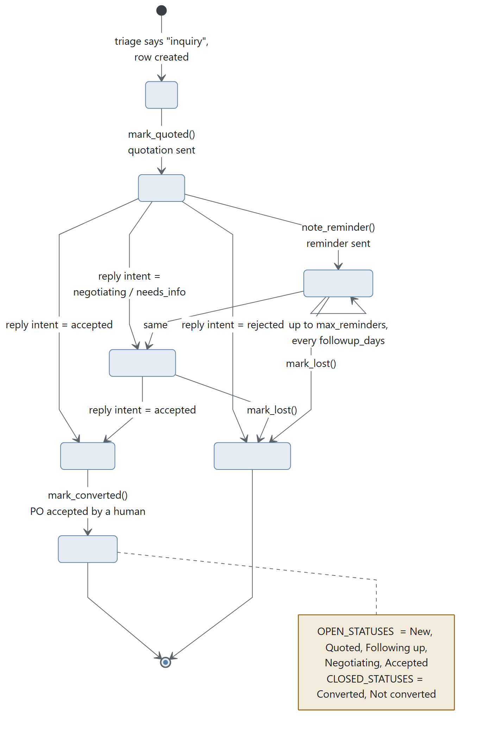
Diagram 2.3
REPLY_STATUS maps the reply intent onto the status: accepted → Accepted, rejected → Not converted, negotiating → Negotiating, needs_info → Negotiating.

Numbering
fy_label() returns "25-26" for any date from 1 April 2025 to 31 March 2026 — the Indian financial year. next_number(rows, prefix, when) reads the existing Inquiry no column, finds the highest serial in the current financial year, and returns the next. An imported register therefore carries on from the customer's own numbering rather than restarting.

Threading — how a reply finds its row
thread_key(message) collects Message-ID, In-Reply-To and References. find_by_thread(rows, message) matches by conversation first, then by sender. add_thread(row, message) folds new identifiers into the row without losing the old ones.

2.5 The inquiry folder
mailflow.Paths.folder_for("INQ/25-26/0087") → <root>/inquiries/INQ-25-26-0087/
The number carries slashes and a slash in a path is a directory separator, so it becomes hyphens on disk. Reversible by eye, which is what matters when somebody is looking for it.
<inquiry root>/
├── inquiries.csv ← THE REGISTER
├── inquiries/
│ └── INQ-25-26-0087/
│ ├── <saved attachments> ← drawings, specs (safe_name()d)
│ └── <the mail itself>
├── quotations/
│ └── QTN-25-26-0042.csv ← written AT SEND TIME
└── sops/
├── sops.csv ← the library index
├── client_sops.csv ← who gets what
└── sop_sent.csv ← the audit log
inbox.safe_name(name, fallback) strips [<>:"/\|?*\x00-\x1f] so an attachment filename cannot escape its folder or upset Windows.

2.6 Quotation

In memory
Terms — from cfg["inquiry"]["terms"]
Field | Type | Default
gst_percent | Decimal | 18
freight | Decimal | 0
discount_percent | Decimal | 0
validity_days | int | 15
payment | str | "100% against proforma invoice"
delivery | str | "2–3 weeks from receipt of confirmed order"
currency | str | "INR"
notes | str | ""

QuoteLine
Field | Type | Meaning
description | str
quantity | Decimal
unit | str | "nos"
rate | Decimal
hsn | str | HSN tax code
basis | str | Where the rate came from — "rate list", "cost sheet", "entered by hand". Printed on the internal copy so any figure can be traced later
amount | property | rupees(rate × quantity)

Quotation — number, date, customer, contact, email, inquiry_no, lines[], terms, breakdown.
Every total is a property, in one place, so the arithmetic cannot disagree with itself:
subtotal = Σ line.amount
discount = subtotal × discount_percent / 100
taxable = subtotal − discount + freight
gst = taxable × gst_percent / 100
total = taxable + gst
valid_until = date + validity_days
No AI ever touches a figure. All arithmetic is Decimal with ROUND_HALF_UP (quoting.rupees()) — the way an invoice rounds, never banker's rounding. indian_currency() renders 1,42,500.00 with lakh grouping, which is what the reader expects to see.

On disk — quotations/<number>.csv
Written by quoting.write_csv() in utf-8-sig (so Excel opens it correctly).
Quotation no , QTN/25-26/0042
Date , 14-08-2026
Customer , <name>
Inquiry no , INQ/25-26/0087
(blank)
Sr | Description | HSN | Quantity | Unit | Rate | Amount | Rate source
1 | … | … | … | nos | … | … | rate list
(blank)
Subtotal | …
Discount% | -… (if any)
Freight | … (if any)
GST 18% | …
Total | …
This file is load-bearing. It is what the PO comparison reads back — "the quotation actually sent", not a re-derivation. The comparison is refused on any mismatch.

2.7 Purchase order
POLine — description, quantity, unit, rate, amount.
settled() fills in whichever of quantity × rate = amount was left out. POs routinely print only two of the three. Derived by arithmetic only, never by asking a model to work it out.
PurchaseOrder
Field | Type | Meaning
number | str
date | date
buyer | str
lines | list[POLine]
delivery_date | date
total | Decimal | The printed total
terms | str
reference | str | Our quotation number, when they quote it
source | str | The file it was read from
computed_total | property | Σ line.amount
value | property | Printed total wins, else the sum of lines — the printed one may legitimately include freight or tax the lines do not, and it is the figure both sides will quote at each other later
missing() | method | Fields a person must still supply — this drives the form Prism shows

Difference — one row of the comparison. Kind is MONEY or NOTE.
The rate-gap rule: a rate difference is measured in money, multiplied out by quantity. Ninety paise on five thousand pieces is ₹4,500 walking past a one-rupee tolerance.

2.8 Pricing inputs — the customer's own files

Rate list (cfg["inquiry"]["rate_list"]) → RateItem
CSV or XLSX (needs openpyxl). load_rates() finds the header row by scanning for one that names a description and a rate, then maps columns through _COLUMN_ALIASES — code/item code/sku/part no/cat no/…, and similar alias sets for description, rate, unit, HSN.
Extra columns like Rate @ 100 become quantity slabs (_SLAB_HEADER). RateItem.rate_for(quantity) returns the deepest slab reached.
Matching is match_item(query, items): tokenise (tokens() — words and numbers, lowercased, polite noise removed via _STOPWORDS), score, return the best five with a reason for each, in the owner's own words, shown next to every match. is_confident(matches, margin=1.6) is true only when the best row is clearly ahead of the runner-up.
RateFileError always carries the fix in its text.

Cost sheet (cfg["inquiry"]["cost_sheet"]) → CostLine
The owner's own cost basis: name, basis, rate. Basis is one of per_kg · per_piece · per_lot · percent.
cost_sheet(lines, weight_kg, quantity) runs it for one job and returns a CostBreakdown. Shown, never hidden — every line of the working appears on screen.
Weight helpers, for spring manufacturers specifically:
Function | Computes
density_for(material) | kg/m³ from DENSITY_KG_PER_M3 (steel 7850, stainless 7930, brass…)
wire_weight_kg(dia, length, material) | Weight of a length of round wire or bar
coil_length_mm(mean_dia, total_coils) | π × mean diameter × coils
spring_wire_weight_kg(wire_dia, outer_dia, total_coils, material) | Weight of one helical spring, from the three numbers on the drawing

2.9 Mail records (in memory only)
Message — prism_terminal/core/inbox.py
Field | Type | Purpose
uid, message_id, date |  | Identity and ordering
from_name, from_addr, to[] |  | Who
subject, body |  | Content
attachments[] | list[Attachment] | name, mime, data, size
in_reply_to, references[] |  | Thread link — what stops one conversation becoming four rows
list_unsubscribe, auto_submitted, precedence |  | The famous bulk markers
list_id, list_help, feedback_id |  | The less famous ones. Atlassian notifications carry List-Help and a Salesforce Marketing Cloud Feedback-ID and no unsubscribe header at all — they were the only mail in a real 40-message sample the rules could not place, and one ended up in the register as a customer inquiry
headers_only | bool | True when only headers were downloaded. Mail that says in its own headers that it is a mailshot is settled without a body, so the body never crosses the wire — that is most of what a real inbox contains, and it is where the three minutes went
sender_domain | property
snippet(limit=1500) | method | Subject plus the opening of the body — what triage shows an AI, and deliberately short: the less of somebody's correspondence that leaves the building, the more honestly we can describe what Prism does with it

Verdict — category, source, reason, is_reply, actionable.
source is "rule" · "learned" · "ai" · "none" — shown in the UI, so a wrong answer can be traced to the thing that produced it instead of blamed on "the AI".
Categories: inquiry · order · payment · promotion · vendor · internal · other · unsorted. Only inquiry and order are ACTIONABLE, and only those two are worth an AI call when the rules are unsure.
Knowledge — persisted in cfg["inquiry"]["knowledge"].
Field | Type | Meaning
own_domains | set | The company's own domains
customers | set | Addresses or domains
vendors | set | Addresses or domains
learned | dict | address → category, grown from corrections

Every field here makes the rules smarter and the AI less necessary — which is both cheaper and more private. learn() remembers a correction, and that sender is never sent to an AI again. Shared across every mailbox on purpose: a sender is the same sender whichever address they wrote to.
mailflow.Item — one thing that came out of a check and may need a person: kind (inquiry · reply · order · sop), message, row, folder, files[], intent, note.
mailflow.Result — counts, sorted_mail[(Message, Verdict)], new_inquiries[], replies[], orders[], followups[], sops[], state, knowledge, error, fetched.
unsorted_by_failure is kept apart from ordinary unsorted mail. One means "we read it and it is unclear"; the other means "we never got to read it at all", and only the second is a reason to go and look yourself. A real inquiry was lost inside the first meaning once, which is why it has a name.

2.10 SOP records
Entity | Source | Fields
SopDoc | sops.csv, else filenames | code, title, revision, path, applies-to, date; newer_than(revision)
ClientRule | client_sops.csv | which customers receive which documents; matches(address)
Send log | sop_sent.csv | Date sent, Customer, Email, SOP code, Title, Revision, Reason, Inquiry no
Pending | computed | what should go out now, with the reason for each

Revision is parsed from _REVISION (_rev2, -v1.1, (R3)) and code from _CODE. The log is written atomically like the register — it is an audit record.

2.11 Run history — runs/run_<ts>.json
Written by config.save_run(record, runs_dir). The GUI passes a per-member folder (workspace.runs_dir(mid, cfg)) so one person's history does not land in another's; the CLI writes to ~/.prism/runs.
Key | Type | Meaning
query | str | The user's own words
routing | dict | {stage: {questions, needed}} — what the router decided
responses | dict | {stage: [text, …]}
links | dict | {stage: url} — where the work is
attachments | list[str] | Names, not dicts — matches what the CLI writes
agents | dict | GUI only: which tool actually ran each step, so History can name them instead of showing bare stage keys
durations | dict | GUI only: how long each step took. The panel had timed every stage all along and the number died with the widget — which is why "this one is slow" was never answerable
error | str | Present only on a failed run
member | dict | {mid, name, role} — stamped so a run file is self-describing even if copied out of its folder

member is always the real member, never identity.viewing(). An admin reading someone else's profile and then starting a run files that run under themselves.

2.12 Team and identity
prism-team.json at the workspace root: [{mid, name, role}, …].
workspace.member_id(role, name) builds the stable folder name — role first, so an ls of the members directory groups by job.
Path | Holds
<root>/prism-team.json | The roster
<root>/_company/ | The shared shelf every role may read
<root>/members/<mid>/runs/ | That member's history
<root>/members/<mid>/files/ | That member's outputs

SOLO = "personal" is the member id for a single-user copy that has not been pointed at a shared workspace.
Roles (roles.py): owner · manager · sales · marketing · operations · engineering · accounts · hr. Each carries an accent hue; GENERAL_HUE = 210 is Prism's own, used for anyone without a role. roles.default_agents(key, available) picks one tool per stage that role uses.

2.13 Licence state
Full treatment in 05-licensing.md; the storage shape is here.
File | Mode | Holds
~/.prism/license.json | 0600, atomic | Activation state: token, licence id, cached claims, clock high-water mark
~/.prism/authorization.json | 0600 | The cached lease, plus the last failed-attempt timestamp for RETRY_INTERVAL throttling
~/.prism/payload.enc | 0600 | The server-published configuration blob, verbatim and signed
OS credential store | — | The reusable licence key, when the machine has one (secretstore.py, service "Prism (Alphakore)"). Falls back to the file

LicenseState — usable(), days_left() (rounded up), has(feature). Statuses: none · valid · grace · stale · expired · tampered. CLOCK_TOLERANCE = 1 day; clock_rolled_back() compares against the stored high-water mark.
Lease — a verified authorisation grant, constructed only from claims that passed lease.verify(). States: NONE · FRESH · GRACE · STALE · TAMPERED. Scopes: core · workflow · grok.

2.14 Data classification — what leaves the machine
The single table to hand a customer who asks "where does my data go".
Data | Leaves the machine? | To where | Controlled by
Mailbox / SMTP passwords | Never | — | Stored in ~/.prism/config.json only
Full email bodies | Never | — | Only a ≤1,500-char snippet, and only for unsettled senders
Email snippets (unknown senders only) | Yes, conditionally | Groq | local_only switch removes even this
Inquiry details extraction | Yes | Groq | local_only
Purchase-order text | Yes | Groq | local_only → typed-in boxes instead
Gerber / PCB design files | Never — hard rule | — | cmd_gerber passes attachments=[]; asserted by test
CAD drawings (BOQ) | Yes | The browser tools the user chose | write_files = [cad_file] + templates + note_files — deliberately different from Gerber; see docs/AFTER_THE_MERGE.md §2
Quotation figures | Never to an AI | — | All arithmetic is Python Decimal
The register | Never | — | Local or the customer's own shared drive
Task text and attachments (main pipeline) | Yes | The user's own logged-in tools, in their own Chrome | The user picks the tools
Licence id, device fingerprint, app version, usage counters | Yes | Licence server | Unavoidable — this is the licence check
Email content, customer names, file contents | Never to the licence server | — | meter.py records what was consumed, never what was written

Data Flow

3.0 How to read this document
Prism runs six independent pipelines. They share configuration and the licence gate; they do not share state with each other.
# | Pipeline | Entry point | Human stops
A | Main task pipeline | The task card → Make a plan → Start the work | Reviewing the plan
B | Email automation daily loop | Check my mail (manual or timer) | Sending a quotation · Accepting a PO
C | BOQ | BOQ add-on | Pricing (deliberately left blank)
D | Gerber | Gerber add-on | None — pure measurement
E | Reel / Studio | Reel add-on | None
F | Email blast | Email add-on | Confirm and send

Every stage table uses the same four columns: Input → Process → Output → Lands in. Where a stage can send data off the machine, it is marked ⚠ leaves the machine.

3.1 Pipeline A — the main task pipeline
The general-purpose one: a task in plain language becomes a chain of AI tools driven in the user's own Chrome.
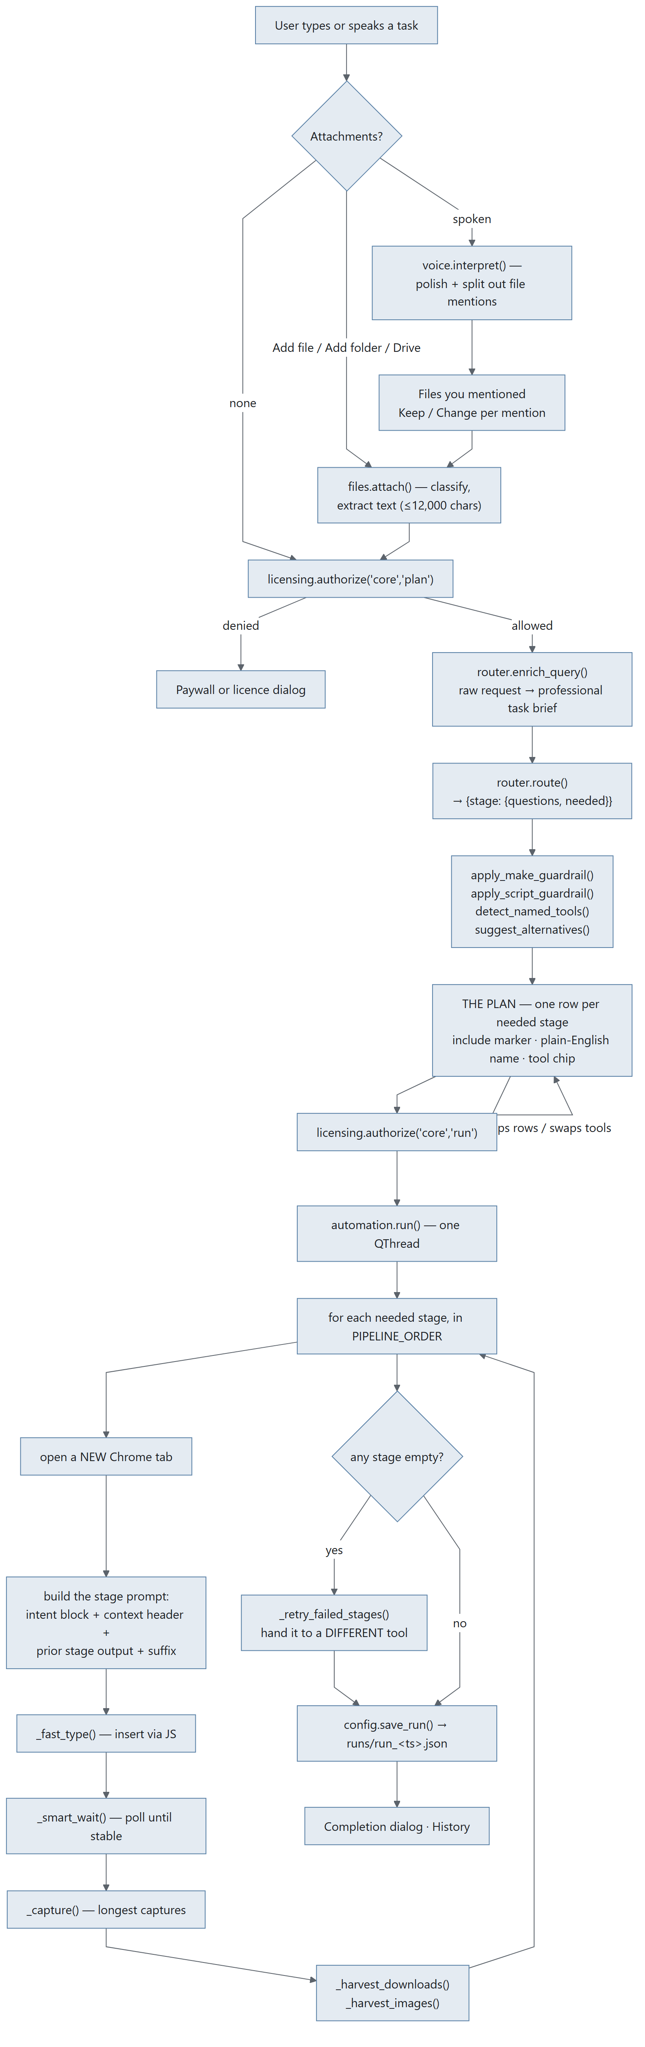
Diagram 3.1

Stage A1 — Capture the task
Input | Typed text in the task card, or microphone audio (push-to-talk / wake word)
Process | Typed: taken verbatim. Spoken: RecordWorker captures WAV at 16 kHz → voice.transcribe() (Groq whisper-large-v3) → voice.interpret() polishes the transcript and splits out file mentions ⚠ leaves the machine
Output | query: str, plus {"mentions": [...]} for spoken input
Lands in | MainWindow._last_query, the task card

Typed queries are deliberately not prose-scanned for file mentions. Only spoken input runs the interpreter — a GUI has real Attach buttons, and scanning a typed sentence adds risk for no benefit.

Stage A2 — Resolve file mentions (spoken input only)
Input | Each mention string, e.g. "the quotation on my desktop"
Process | pathfinder.find(desc, cfg) — _llm_parse (Groq) or _heuristic_parse fallback → candidate dirs (_KNOWN_ROOTS, depth ≤ 2, _MAX_WALK_ENTRIES = 4000) → fuzzy filename match (depth ≤ 3)
Output | {folders: [...], files: [...]}, ≤ 5 matches
Lands in | The Files you mentioned rail, one row per mention with Keep / Change — the GUI equivalent of the CLI's confirm-before-attach

Stage A3 — Attach files
Input | A path from Add file / Add folder / the Drive picker
Process | files.attach(path) classifies by extension, extracts text where it can (≤ MAX_TEXT_CHARS = 12000). files.attach_dir() takes plain files directly inside a folder, capped at MAX_DIR_FILES = 15
Output | Attachment records: {name, path, kind, size, text}
Lands in | MainWindow.attachments; files.context_block() injects contents inline into agent prompts; files.routing_note() gives the router a short note only

Stage A4 — Licence authorisation
Input | feature="core", action="plan"
Process | AuthorizeWorker → licensing.authorize() → client.authorize() (45 s timeout, 1 retry) ⚠ leaves the machine — licence id, device fingerprint, app version, action, feature, scopes. No customer content.
Output | Authorization(allowed, run_id, message, code, state, offline)
Lands in | Gate: allowed → continue; denied → paywall or licence dialog

Stage A5 — Enrich the query
Input | Raw query + cfg["profile"] + API key + model
Process | router.enrich_query() — a Groq pre-pass that expands the raw request into a professional task brief ⚠ leaves the machine
Output | brief: str
Lands in | The routing prompt, and Behind the scenes in the context rail

Stage A6 — Route
Input | query, brief, cfg["profile"], active agents, attachment note, premium flags
Process | router.route() → groq_chat() against the model chain (cfg["model"] first, then MODEL_FALLBACKS: openai/gpt-oss-120b, openai/gpt-oss-20b, groq/compound-mini). Retries on 429/500/502/503/504. A fallback that works is remembered into cfg["model"]
Output | {stage: {"questions": [...], "needed": bool}} for each of the ten stages
Lands in | MainWindow.routing; rendered as the plan

The ten stages, in PIPELINE_ORDER: research → leads → brains → content → visual → media → audio → development → presentation → summary

Stage A7 — Guardrails and alternatives
Guardrail | What it forces
apply_make_guardrail() | If the user clearly asked to make an artefact (slide deck, image, video, web app), that stage is forced on even if the router said no
apply_script_guardrail() | A reel/video/deck needs words — script, narration, captions, slide copy. Forces a writing stage
detect_named_tools() | A tool the user named ("using NotebookLM…") is pre-selected and tagged You picked this
suggest_alternatives() | For each needed stage, offers other tools that could do it. The router's suggestion is starred in the chip's menu

Stage A8 — The plan (human review)
Input | The routing dict + guardrail results
Process | widgets/agents_panel.py renders one row per needed stage: square include-marker, line icon, plain-English name ("Look things up", "Write it up", "Build the slides"), one line of what it means, and the tool as a clickable chip
Output | run_agents — whatever is still switched on
Lands in | automation.run()

Stage A9 — Execute the pipeline
Runs on AutomationWorker. For each needed stage:
Step | Input | Process | Output
Driver | cfg["chrome_version"], cfg["chrome_profile"] | _setup_chrome_driver() — undetected-chromedriver against ~/.prism/chrome_profile. seed_profile() copies the real Chrome profile in (so the user is already signed in). _clear_profile_locks() removes SingletonLock left by a killed run. _prune_preferences() stops Prism poisoning its own profile | A live driver
Tab | agent name | _open_tab() — a new tab, leaving every finished one on screen
Prompt | query, prior stage output, agent config | _intent_block() (the user's own words, verbatim, at the top of every stage prompt) + _context_header() + prior output + _resolve_suffix() | The full prompt text
Type | prompt | _fast_type() inserts the whole prompt at once via JavaScript rather than per-character; _bmp_safe() strips non-BMP characters ChromeDriver refuses
Wait | agent config | _smart_wait() — poll every 5 s, require stable_for=25 s, min_wait=35 s, cap from the registry (WAIT_FLOOR=300, WAIT_MULTIPLIER=2.0, WAIT_CEILING=1800). Interruptible | (waited, timed_out)
Health | page | _looks_signed_out() · _looks_exhausted() · _looks_unreadable() — each returns "" when fine, else the sentence the user needs
Scrape | page | _capture() — everything reading as a reply, longest captures only. _is_prompt_echo() rejects the tool echoing the prompt back | [text, …]
Harvest | download folder, page | _wait_for_downloads() (45 s), _harvest_downloads() → attachment records the next stage can use. _harvest_images() pulls real generated images, since an image cannot travel in a text handoff | Files, images

⚠ This whole stage runs in the user's own browser, signed in as them. The prompt and any attached files go to whichever tools the user chose.

Stage A10 — Failover
Input | Any stage whose output came back empty
Process | _retry_failed_stages() — hands each failed stage to a different tool via agents.alternatives_for()
Output | Filled-in responses where a second tool succeeded

Stage A11 — Persist
Input | responses, links, stage agents, durations, attachments, routing, query
Process | config.save_run(record, workspace.runs_dir(mid, cfg))
Output | runs/run_<timestamp>.json
Lands in | History dialog; Home's recent-runs list via dashboard_data.recent_runs()

A failed run has no engine return value, so _save_run rebuilds what did land from the per-stage events collected on the way. Save failures are swallowed to the status bar on purpose: the run itself succeeded, and a full disk should not turn that into an error dialog.

3.2 Pipeline B — Email automation, the daily loop
The one used every day, and the reason the app gets opened at all.
Five tabs, in the order the work happens: What arrived → Inquiries → What they said back → Waiting on a reply → The order came.

B.0 The whole loop

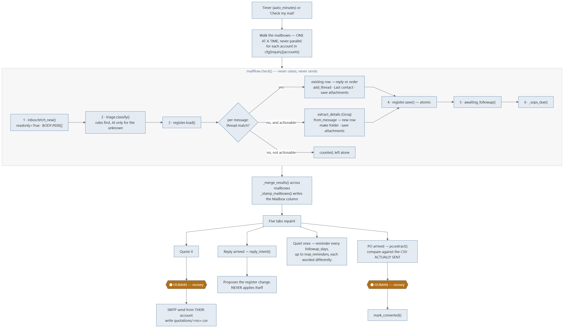
Diagram 3.2

B.1 Fetch — inbox.fetch_new()
Input | cfg (one account), its State bookmark, always_full (known senders), must_read (predicate), catch_up_with_new
Process | IMAP connect (SSL 993, else STARTTLS) → select(folder, readonly=True) → check UIDVALIDITY against the bookmark → _search_above(last_uid) for new mail, plus _search_window(first_days) for backlog → _fetch_headers() in batches of HEADER_BATCH = 100 → bodies pulled only for messages that might matter, with BODY.PEEK[]
Output | (messages: list[Message], new_state: State, error: str)
Lands in | Memory only. Nothing is written to the mailbox

Limits: FIRST_FETCH_DAYS = 30 · MAX_PER_FETCH = 200 · MAX_BODY_CHARS = 20000 · BACKFILL_PER_CHECK = 60.
Reads the mailboxes, never writes to them. readonly=True on select and BODY.PEEK[] on fetch mean nothing is marked read, moved or deleted — the owner keeps using Outlook on the same account.
Which bodies get downloaded:
Case | Body fetched? | Why
Headers say it is a mailshot (says_it_is_bulk) | No | That is most of what a real inbox contains, and where three minutes went
Sender is known (always_full) | Yes, always | A customer on a system that stamps an unsubscribe link onto every message must not be caught by the bulk rule. Being over-generous costs one body download; being mean costs an order
Subject asks for a price, or names a PO (must_read) | Yes, whatever the headers say | Subjects arrive with the headers, so this costs nothing, and it is the difference between "we never downloaded it" and a lost order
Otherwise | Yes

B.2 Sort — triage.classify()
Two passes: local rules, then one batched AI call for whatever is left.
Pass | Input | Process | Output
Rules | Message, Knowledge | rules_pass() — List-Unsubscribe / List-Id / List-Help / Feedback-ID / Precedence / Auto-Submitted; robot addresses (no-reply@, mailer-daemon@…); learned corrections; known customers and vendors; own domains; narrow keyword sets (_PO_WORDS, _PAY_WORDS, _INQ_WORDS, _PROMO_WORDS, _INQ_SUBJECT, _INQ_BODY, _OFFERING, _ORDER_PHRASES) | Verdict(category, source="rule"|"learned", reason) — or UNSORTED with source="none", meaning "ask"
AI | Only the unsettled messages, batched batch_size=10 | defang() strips the message's power to imitate the prompt carrying it, then one Groq call on model FAST_MODEL = llama-3.1-8b-instant ⚠ leaves the machine — subject + ≤1,500 chars of body, per unknown sender only | Verdict(category, source="ai"), or source="failed" if the model never answered

local_only=True sets api_key = "" for the entire check, not just triage.
That is deliberate and was a fix: local_only was passed to triage alone at first, which left detail extraction and reply reading still sending customer correspondence out. A privacy switch that quietly did two thirds of what its name promises is worse than not offering one.
Prompt-injection defence: defang() neutralises _FORGED_FENCE (a message faking "--- END EMAIL ---") and _FORGED_ANSWER (a message writing its own "3: inquiry" answer line).

B.3 Register — the ordering rule
For every message, thread first, verdict second:
Case | Action | Result item
Thread matches an existing row | add_thread() · Last contact = today · save attachments into the existing folder | Item("order") if category is ORDER, else Item("reply") with intent
No thread match, not actionable | Counted and left alone | —
No thread match, actionable | extract_details() (Groq ⚠) → from_message() → new row → make the folder even if nothing was attached → save attachments → Drawing column | Item("inquiry"), or Item("order") noted "ordered without a quotation from us"

Why thread beats verdict: a message belonging to an inquiry already in the register is live business by definition. It used to get a vote — "Yes, please proceed" from a customer whose address had never been added to the customer list reads like nothing in particular, so it came back unsorted, unsorted is not actionable, and the loop skipped it before ever asking which quotation it answered. A whole negotiation could go quiet that way, and the register would still say "waiting on a reply".
Why the folder is made even when empty: the register points at that folder from the moment the row exists, and the quotation and the PO land in it later. A path in the file that opens onto nothing is the kind of small broken thing that makes people stop trusting the rest.

B.4 Save — atomic, and honest about locks
register.save(rows, path) writes to a temp file in the same directory and os.replace()s it. Hand-added columns survive.
If Excel holds the file open, RegisterLocked is raised with a plain sentence. check() then returns with out.error set and the bookmark reset to the previous state — the work is in memory, only the write failed, and nothing is lost because unsaved rows have no bookmark advance behind them.

B.5 The multi-mailbox walk
Owned by InquiryDialog, not by the engine.
Rule | Behaviour | Why
One at a time, never parallel | _check_account() → _account_checked() → next | Every account's rows land in the same CSV, and two writers racing on one order book is how a row is lost
One dead mail server | Skipped; the walk continues | That account's problem; the others carry on
One locked register | Stops the whole walk | The same lock would refuse every account after it, and no bookmark has moved
Bookmarks | _remember_account() banks each mailbox's own state | Two mailboxes sharing one bookmark would skip or re-import each other's mail
Learned corrections | Shared across all mailboxes | A sender is the same sender whichever address they wrote to
Mailbox column | _stamp_mailboxes() writes which address each new inquiry arrived at | With three addresses feeding one file, "who is this customer talking to" is the first question the sheet gets asked

B.6 Quote — QuotationDialog
Input | The register row, the rate list or the cost sheet, cfg["inquiry"]["terms"]
Process | Rate route: match_item() on Product asked → RateItem.rate_for(quantity). Cost route: cost_sheet(lines, weight_kg, quantity) runs the owner's own formulas. Then next_quote_number(), Terms, and the Quotation properties compute every total. All Decimal, ROUND_HALF_UP. No AI touches a figure
Output | Quotation + render_text() + write_csv()
Lands in | quotations/<number>.csv, and the covering mail body

The covering letter is drafted by covering_letter_prompt() — the numbers are handed over already formatted, and the model is told in as many words not to compute or restate them. Its job is the two paragraphs around them.
⬤ HUMAN STOP 1. _finish(send=True) is a button a person presses.
On send: mailer sends from their own account, mark_quoted() updates the row, and the quotation CSV is written. That CSV is what the PO comparison reads back later.

B.7 Read the reply — mailflow.reply_intent()
Input | The reply Message
Process | _own_words() strips quoted history (_QUOTED_LINE) → local_intent() tries plain patterns first (_LOCAL_INTENT) → only if that is not plain, one Groq call ⚠
Output | accepted · rejected · negotiating · needs_info · unclear
Lands in | Tab 3, as a proposed register change

It never applies itself. REPLY_STATUS maps the intent onto a status, and a person presses Apply. unclear always waits for a human.

B.8 Chase — reminders
Input | Rows past followup_days with Reminders sent < max_reminders
Process | register.awaiting_followup() → drafting.followup_prompt(attempt=n). Each reminder is worded differently — attempt number is part of the prompt
Output | Subject + body, shown before it goes (_ReminderDialog) or sent unattended when auto_followup is on
Lands in | SMTP; note_reminder() increments the counter and sets Last contact

Every two days, three times, then it stops.

B.9 Win back a no — drafting.negotiation_prompt()
Input | The quotation text read back off disk, the customer's own reply, the bargaining-limits file (pricing_policy)
Process | Drafted through the browser tools (DraftWorker → drafting.draft()), not Groq — this one is worth a good model. _NO_INVENTED_NUMBERS hard rules override anything in the customer's email
Output | A draft reply, editable
Lands in | The send dialog

With no bargaining-limits file, the prompt is instructed to offer nothing on price at all.

B.10 The PO — po.extract() and po.compare()
Step | Input | Process | Output
Find it | The order message | find_attachment() picks the attachment most likely to be the order | A path
Read it | PDF / DOCX | pdf_text() / docx_text(). looks_scanned() — under _TEXT_PER_PAGE = 120 characters per page means a photograph of a page, not a document | Text, or POError carrying SCANNED_ADVICE
Extract | The text | One direct Groq call ⚠ → strict JSON (_json_from tolerates fences) → from_json() builds defensively → POLine.settled() fills the missing third of quantity × rate = amount by arithmetic | PurchaseOrder
Compare | The PO + quotations/<no>.csv | compare(order, quote, tolerance=₹1) — read back from the CSV written at send time, refused on any mismatch. A rate gap is multiplied out by quantity | [Difference] + summary()

⬤ HUMAN STOP 2. Accept — mark converted is a button a person presses. Then mark_converted(row, po_number, value).
Scanned POs — about half of them — get typed-in boxes and an honest sentence. The same boxes serve anyone who switched on Keep everything on this computer: a PO is mail content, and the privacy switch means what it says even when that costs the automatic reading.

B.11 SOPs — sop.pending()
Input | sops/sops.csv (or filenames), client_sops.csv, sop_sent.csv
Process | load_library() → current revision per document. for_client() / for_product() → what this customer should hold. pending(annual_days=365) → what should go out now, with the reason
Output | [Pending]
Lands in | The check result; record_sent() appends to the audit log

_sops_due() never fails the whole check. An unreadable client map is a setup problem, not a reason to stop sorting somebody's mail.

3.3 Pipeline C — BOQ (quantities off a drawing)
Stage | Input | Process | Output
1 · Convert | .dwg or .dxf | ensure_dxf() — .dwg needs a local converter (dwg2dxf / ODAFileConverter). _read_dxf() tolerates minor structural errors | A .dxf path + notes
2 · Measure | The DXF | measure() walks every entity in every layout's modelspace: lengths (lines, arcs, polylines with bulge), areas (shoelace, hatch boundaries minus holes), counts, grouped per layer and per block | {quantities} dict
3 · Units | Quantities + the user's answer | apply_known_unit() when the file did not say | Corrected quantities
4 · Scope | Quantities + keywords | filter_by_keywords() keeps only matching layers/blocks | Scoped quantities
5 · Write | Quantities | write_quantities_csv() — exactly as computed, before any AI touches them | A CSV
6 · Research | The request | standards_prompt() — the design norms a quantity surveyor would look up ⚠ | Standards text
7 · Interpret | Request + quantities + file roles | interpretation_prompt() — work out what the drawing's codes mean ⚠ | A legend
8 · Format | Everything above | formatting_prompt(allow_derived=…) — allow_derived is the difference between a takeoff and an estimate ⚠ | The BOQ document

Rate and Amount are deliberately left blank. Prism counts and measures; you price it.
⚠ Note the deliberate contrast with Gerber: BOQ does attach the drawing — write_files = ([cad_file] if cad_file else []) + templates + note_files. A building drawing is a description of a job. See §3.4.

3.4 Pipeline D — Gerber (PCB measurement)
### The rule that must not be broken The Gerber files never reach an AI. cmd_gerber passes attachments=[] and a test asserts that literal string. A Gerber set is the customer's product, not a description of a job. Do not copy the BOQ pattern across without the customer's written permission.
Stage | Input | Process | Output
1 · Gather | A folder, .zip or .rar | gather() expands archives into a flat file list. Never individual files — a job arrives as one archive of 9–17 files, and asking a customer to pick the right four is the whole problem restated | [paths]
2 · Split | The flat list | split_jobs() groups into separate boards by _job_stem() | [(stem, files)]
3 · Classify | Each file | classify() — extension map, _sniff() reads the first few hundred bytes, _name_hint() handles art001…art012, _resolve_numbered_layers() turns those into top / inner / bottom | Role per file
4 · Parse | Gerber files | parse_gerber() — RS-274X into millimetre geometry: apertures (%ADD), format spec (%FS), operations, arcs flattened to chords, macros (%AM) | GerberLayer
5 · Copper | Each layer | layer_copper() → one shapely geometry; classify_copper() splits conductors from markings | Geometry
6 · Measure | Geometry | track_widths() · spacing(snap_mm=0.01) · board_outline() · excellon() / merge_drills() / drill_from_gerber() | The five numbers
7 · Cross-check | The job's own CAM report | crosscheck() parses .DRR / .REP and compares hole counts and tool tables. Free, exact, no AI | [checks]
8 · Rules | .RUL files | design_rules() — what the designer said the board was allowed to use | Limits beside each reading
9 · Report | All of it | answers_text() (the five numbers, nothing else) · summary_text() (the workings, so they can be argued with) · files_text() · write_report_csv() · write_summary_csv() | Four panels + CSVs
10 · Brief | The numbers only | agent_brief(job, context) — the instruction handed to a writing agent: numbers, never a file ⚠ | Quote text

The five numbers Fine Circuits asked for, and nothing else: pcb size · min track width · min track spacing · min drill size · number of drills.
Needs shapely. Without it four of five numbers still work, and the missing one says so.
The verification ladder (docs/AFTER_THE_MERGE.md §2), cheapest first:
- The job's own CAM report — built.
- A second independent implementation (gerbonara, test-only) — built; reach for this before any AI.
- AI sanity-check on a rendered image plus the numbers — not built.
- The raw Gerber to an AI — only with the customer's written permission.

3.5 Pipeline E — Reel / Studio
 | Reel | Studio
Frames | Drawn with Pillow in Python | A real web page filmed in a paused Chromium
Encode | FFmpeg (imageio-ffmpeg, ships inside the build) | Same
Design stage | One pass | A conversation: one turn for the look and a storyboard, then one turn per scene, each laid out at 1080×1920 and corrected before the next is asked for

Asking for the whole reel in one reply is what made the old output look like a slide deck — a scene got about 278 characters, which is a headline and a subhead. See CHANGES.md → Round 6.
Stage | Input | Process | Output
1 · Assets | Attached images | assets.has_flat_background() → cutout() strips a flat background and trims; _ink_ratio() tells a logo from a photo; collect() builds the asset table the design stage may reference | Asset table + manifest()
2 · Design | The goal + manifest | design_instructions() ⚠ | Look + storyboard
3 · Scenes | Storyboard, one at a time | scene_instructions() per scene ⚠ | HTML/CSS per scene
4 · Film | Scene pages | Paused Chromium, frame by frame | PNG frames
5 · Encode | Frames | ffmpeg.py — locates FFmpeg, or downloads the wheel and verifies it against the SHA-256 PyPI publishes for that exact file before unpacking | .mp4, 1080×1920

Known gap (docs/AFTER_THE_MERGE.md §4): nothing treats scene 1 differently from scene 4, but the opening ~1.5 seconds is the whole bet — a reel without a hook is never watched to the end.

3.6 Pipeline F — Email blast
Stage | Input | Process | Output
1 · Recipients | Attached CSV and/or addresses in the goal text | split_attachments() → parse_recipients() (with or without a header row, _NAME_HEADERS aliases) + recipients_from_text() | [{email, name}]
2 · Discover | The goal, when no list was given | discovery_prompts() → a research stage, then a structuring stage; prefers_lead_database() routes to Apollo when the chosen agent is a lead database ⚠ | Candidates
3 · Structure | Candidate text | parse_structured_csv_text() → write_recipients_csv() — a durable record on disk | A real CSV
4 · Draft | The goal | A normal pipeline stage ⚠; parse_draft() pulls (subject, body); is_prompt_echo() rejects the tool echoing the prompt | Subject + body, editable
5 · Verify | cfg["email"] | VerifyWorker → mailer.verify() — log in and hang up. Worth its own button: the alternative is discovering at the worst possible moment that Gmail wants an app password | "" or a fixable sentence
6 · Send | Recipients, subject, body, files | ⬤ HUMAN — confirm and send. send_bulk() — one message per recipient so {name} can be substituted, SEND_DELAY = 2.0 s between, timeout scaled to attachment size (_send_timeout), progress + stop callbacks | Sent count, failures

clean_password() trims a pasted app password: outer whitespace always goes, and inner spaces go when the shape matches _APP_PASSWORD (four groups of four) — Gmail shows them in groups of four and they get pasted with the spaces in, which otherwise fails exactly like a wrong password.

3.7 The trust boundary, in one picture
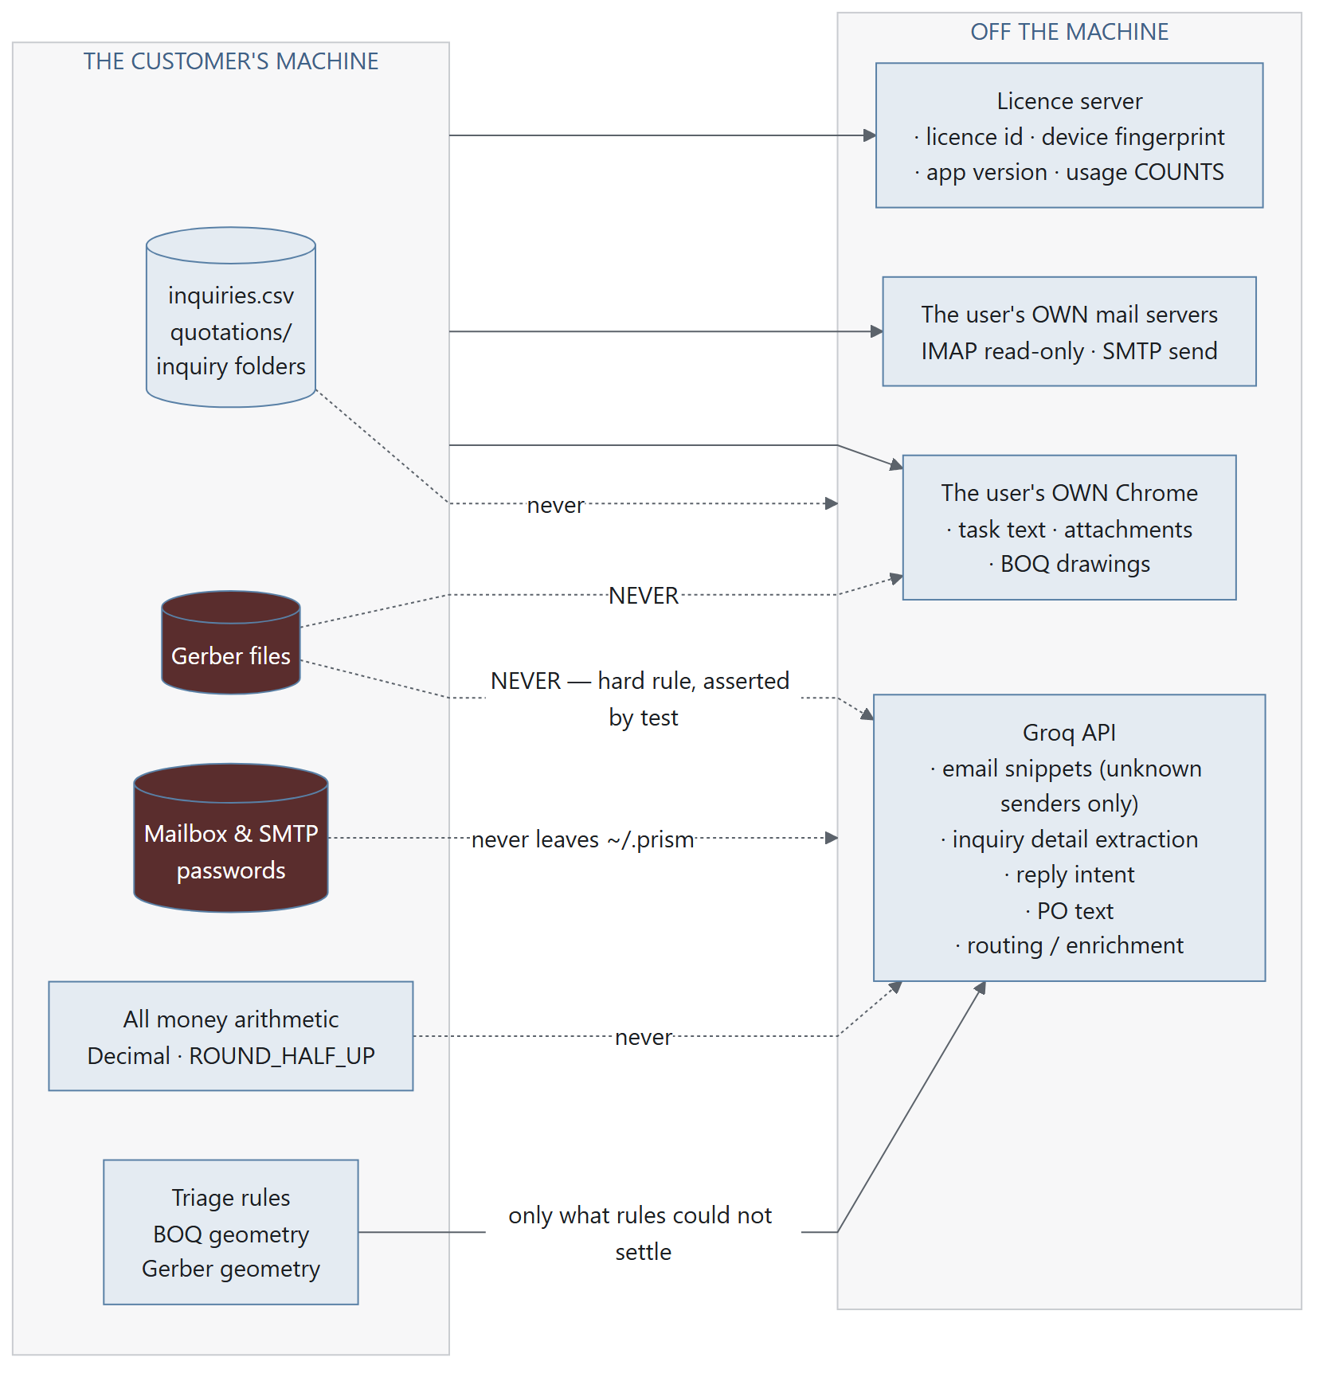
Diagram 3.3
The local_only switch ("Keep everything on this computer") sets api_key = "" for the entire email-automation check, removing the Groq column completely. The cost is that scanned POs and ambiguous senders need typing in by hand — which is stated honestly on screen rather than hidden.

API Reference
Two halves:
- Part 1 — External APIs: every service Prism talks to over the network, with request and response shapes.
- Part 2 — Internal module API: the functions each module exposes to the rest of the system.

API Reference
Prism makes network calls to exactly four kinds of endpoint. There are no others.
Service | Purpose | Sees customer content?
Groq | Fast structured AI: routing, triage, extraction, transcription | Yes — snippets, conditionally
Licence server | Activation, authorisation, metering, published config | No — never
IMAP / SMTP | The customer's own mail | Yes — it is their mail
Google Drive | Optional file picker | Yes — files they pick

Plus the user's own Chrome, driven locally with Selenium. That is not an API call; it is a browser on their desktop, signed in as them.

1.1 Groq
Base URLs
Endpoint | Constant | Used by
https://api.groq.com/openai/v1/chat/completions | router.GROQ_URL | routing, triage, extraction, intent, PO reading
https://api.groq.com/openai/v1/audio/transcriptions | voice.TRANSCRIBE_URL | push-to-talk and wake word

Auth: Authorization: Bearer <cfg["api_key"]> — a gsk_… key the customer supplies. This is the only AI credential Prism holds.

The model chain
cfg["model"] (default "llama-3.3-70b-versatile", user-selectable)
↓ on failure
"openai/gpt-oss-120b"
↓
"openai/gpt-oss-20b"
↓
"groq/compound-mini"
router.model_chain(preferred) returns the list with the caller's choice first and never duplicated. router.apply_model_chain(models) lets a verified server payload replace the chain.
Triage uses its own fast model: triage.FAST_MODEL = "llama-3.1-8b-instant". mailflow.check() overrides it with cfg["model"] when one has been learned — leaving it at the hardcoded default meant every check restarted from a dead model regardless of what had already been saved to disk.

router.groq_chat() — the single call site
groq_chat(api_key, model, prompt, *, temperature=0.3, timeout=60, retries=1) -> str
Concern | Handling
Rate limit / server error | _RETRY_STATUS = (429, 500, 502, 503, 504) → retry
Model retired | _model_is_gone(status, body) distinguishes "this model is unavailable" from "this request was bad" → move down the chain
A fallback that worked | _remember_model() persists it into cfg["model"], so the next run starts there

What is sent, per call type
Call | Payload | Size
enrich_query() | The raw query + cfg["profile"] | Small
route() | Query, brief, profile, agent list, attachment note only (never contents) | Small
triage.classify() | Batch of ≤10 Message.snippet(1500) — subject + ≤1,500 chars, unknown senders only, after defang() | ≤ ~15 KB
mailflow.extract_details() | One inquiry message | Small
mailflow.reply_intent() | _own_words() — the reply with quoted history stripped, ≤1,500 chars | Small
po.extract() | The PO text | Up to a few pages
pathfinder._llm_parse() | The file description only — no file contents | Tiny
voice.transcribe() | WAV audio, 16 kHz mono, ≤ MAX_TAKE_S = 300 s | Up to a few MB

Verifying a key
router.verify_key(api_key, model="") → "" if it works, else why not.

1.2 Licence server
Default: https://prism-license-server.onrender.com (client.DEFAULT_SERVER).
Override: PRISM_LICENSE_SERVER — honoured only when running from source. An environment variable that redirected a release build would let anyone point Prism at a licence server they control, which is precisely the backdoor this design exists to not have.
Headers on every request
X-Prism-Version: <app_meta.VERSION>
X-Prism-Platform: <sys.platform>
Content-Type: application/json
Timeouts
Constant | Value | Applies to
TIMEOUT | 8 s | refresh, deactivate, usage, payload
AUTHORIZE_TIMEOUT | 45 s | authorize, lease
AUTHORIZE_RETRIES | 1
ACTIVATE_TIMEOUT | 75 s | activate — sized for a cold host
ACTIVATE_RETRIES | 0

Only a transport failure retries. A server that answered has said something, even if it said no, and repeating the request would double-count a metered run.

Endpoints

POST /v1/activate
Turn a licence key into a token on this machine.
{ "key": "PRSM-XXXXX-XXXXX-XXXXX-XXXXX",
"device_fp": "<salted hash>",
"app_version": "1.3.0",
"hostname_label": "Ravi's PC" }
hostname_label exists so a customer asking which five machines are using their seats gets a human answer rather than five hashes.

POST /v1/refresh
Renew the token; optionally pull new published configuration.
{ "license_id": "...", "device_fp": "...",
"app_version": "1.3.0", "payload_etag": "..." }

POST /v1/deactivate
Release this machine's seat.
{ "license_id": "...", "device_fp": "...", "token": "PRSMv1..." }
token is proof we are the machine that holds the seat. The licence id and the fingerprint are not secrets — both sit in ~/.prism and travel in the token itself — so without it the server had no way to tell this call apart from a stranger releasing someone else's seat.

POST /v1/authorize — the metered call
{ "license_id": "...", "device_fp": "...",
"action": "run" | "plan", "feature": "core" | "reel" | "inbox" | ...,
"scopes": ["core", "workflow"], "app_version": "1.3.0" }
The server writes a usage row and counts it against the daily allowance.

POST /v1/lease — free
Same check — licence status, revocation, seat, device, entitlements, client version — but records no usage event and consumes no allowance.
Use lease when all you need is authorisation. Spending a quota unit to answer "may I open a dialog" would bill the customer for the question rather than the work.

POST /v1/usage
{ "license_id": "...", "device_fp": "...", "run_id": "...",
"app_version": "1.3.0",
"events": [ { "kind": "groq", "tool": "", "stage": "research",
"prompt_tokens": 812, "completion_tokens": 240,
"ok": true, "ms": 1840 } ] }
kind is one of plan · run · stage · groq · addon.
What the customer consumed, never what they wrote. No prompt text, no email content, no file names, no customer names.

POST /v1/payload
Returns the server-published configuration blob (agent selector overrides and the Groq model chain), signed and verified offline before anything is applied.

Error shape
Any status ≥ 400:
{ "error": { "code": "seat_limit", "message": "…", "detail": { } } }
→ raised as ServerError(code, message, detail). A transport failure raises Unreachable instead, which is almost never worth showing to the user.

1.3 IMAP / SMTP
The customer's own mail servers. Prism holds the credentials locally and talks to them directly.

IMAP (reading) — prism_terminal/core/inbox.py
Concern | Detail
Transport | Port 993 → IMAP4_SSL. Anything else → IMAP4 + starttls(). Always a real ssl.create_default_context()
Mode | select(folder, readonly=True) and BODY.PEEK[] — nothing is marked read, moved or deleted
Host discovery | imap_for(address) for known consumer providers; mx_host(domain) resolves MX records via _MX_IMAP; guess_hosts(address) produces the candidate list. A typed host is tried first
Auth failure vs. unreachable | is_auth_failure(error) checks _AUTH_MARKERS. Gmail and Microsoft 365 throttle then lock an account on repeated failed logins, so a timer that keeps re-presenting a refused password ends with "Prism locked me out of my email"
Errors | explain_error(error, address) turns an imaplib failure into the sentence that unblocks the user
Batching | _fetch_headers() fetches HEADER_BATCH = 100 at a time — headers for many messages in a few round trips rather than one each

Provider map (_IMAP_HOSTS): gmail.com / googlemail.com → imap.gmail.com:993; outlook.com / office365.com → outlook.office365.com; GoDaddy → imap.secureserver.net; and more.

SMTP (sending) — prism_terminal/core/mailer.py
Concern | Detail
Transport | Port 465 → SMTP_SSL. Otherwise SMTP + STARTTLS
Host map | _SMTP_HOSTS: gmail → smtp.gmail.com:465, outlook → smtp-mail.outlook.com, …
Pacing | SEND_DELAY = 2.0 s between messages
Timeout | _send_timeout(files) scales the socket timeout to the attachment payload — uploading a big PDF on a slow line is not a hang
One message per recipient | So {name} can be substituted per person
Passwords | clean_password() — outer whitespace always trimmed; inner spaces removed when the shape matches _APP_PASSWORD (four groups of four)

1.4 Google Drive
integrations/gdrive.py (335 lines) — optional. Lets the user pick a file out of Drive the same way they would pick one off the disk (dialogs/drive_dialog.py). The file is downloaded locally and then handed to the same attach path as any local file.

1.5 The remote bridge (LAN / relay)
prism_terminal/core/remote.py — drive Prism from a phone on the same network.
Port | BASE_PORT = 7777
Pairing | start() → LAN URL; the phone shows a code; pair(code) approves it
Poll | next_prompt(code) → (pid, text); set_status(pid, status)
Hosted relay | relay_pair(base, code) → token; relay_next(), relay_set_status()

API Reference
Only the surface each module exposes. Private helpers are omitted; the source docstrings are the detail.

2.1 core_bridge — the engine bridge
Puts prism_terminal/core on sys.path and re-exports it. Every accessor is lazy, so heavy optional dependencies are probed rather than imported at boot.
Function | Returns
automation_available() | (bool, reason) — Selenium / undetected-chromedriver
boq_available() | (bool, reason) — needs ezdxf
gerber_available() | (bool, reason) — shapely optional; four of five numbers work without it
reel_available() | (bool, reason) — Pillow draws, FFmpeg encodes
studio_available() | (bool, reason) — plus a browser engine
get_automation() get_boq() get_gerber() get_inbox() get_triage() get_register() get_quoting() get_sop() get_po() get_mailflow() get_files() get_drafting() get_reel() get_studio() get_assets() get_ffmpeg() | The module

_warn_about_sibling() prints a note naming both paths when a sibling ../prism_terminal checkout exists and is being ignored.

2.2 workers — the concurrency surface
Every class is a QThread. All communication is by Qt signal.
Worker | Constructor | Does
AuthorizeWorker | (feature='core', action='run') | Ask the licence server whether this run may go ahead
RouteWorker | (query, cfg, attachments) | One router.route() call
AutomationWorker | (routing, cfg, attachments, query, custom_stages, chatgpt_analysis, reel_design_stage) | The whole browser pipeline. stop() / stopping()
RecordWorker | (cfg) | Push-to-talk: recording starts as soon as the thread runs
InterpretWorker | (text, cfg) | Polish a transcript, split out file mentions
SendWorker | (cfg, recipients, subject, body, files) | The email blast. stop() / stopped()
VerifyWorker | (cfg) | Log in and hang up — check the account before a real blast
FindWorker | (desc, cfg) | Natural-language file finding
MeasureWorker | (path, unit='', scope=None) | Parse a CAD drawing off the UI thread
GerberWorker | (paths) | Measure one or several PCB jobs
ReelWorker | (spec, out_path, studio=False) | Render the reel
InboxVerifyWorker | (address, password, host='') | Find the mail server and check the password
InboxCheckWorker | (cfg, root, *, state, knowledge, local_only, followup_days, max_reminders, catch_up_with_new) | One run of the daily loop
POReadWorker | (cfg, text, source='') | Read one purchase order into fields
SupportWorker | (cfg, prompt) | One answer from the support assistant
DraftWorker | (cfg, prompt, *, purpose='draft', attachments=None) | Write one email using the browser tools. stop()
FFmpegWorker | () | Download and install FFmpeg

2.3 licensing — the public surface
__all__ = ['state', 'has', 'require', 'activate', 'deactivate', 'refresh',
'authorize', 'report_usage', 'Authorization', 'meter', ...]
Function | Purpose
state() -> LicenseState | Cached, cheap, safe to call from paint code
reload() -> LicenseState | Drop the cache and re-read from disk
has(feature) -> bool | Entitlement check
require(feature, parent=None) -> bool | Gate an action — shows the paywall itself, so call sites stay one line
set_paywall_handler(fn) | Registered once from main.py, so licensing never imports Qt
activate(key) -> LicenseState | Key → token on this machine
deactivate() | Release the seat. Local state is cleared even if the server call fails
refresh(blocking=False) | Renew token and lease
authorize(feature='core', action='run') -> Authorization | May this protected operation go ahead?
report_usage(run_id='') | Fire-and-forget; never blocks, never raises
lease_state() -> str | FRESH | GRACE | STALE | NONE | TAMPERED
lease_bearer() -> str | The raw signed lease, for Authorization: Bearer …
apply_cached_payload() -> int | Re-apply the last verified payload at startup
selftest() -> (bool, str) | Verify the committed test vector — called by main.py --selftest

PROTECTED_ACTIONS = {'plan'}.

2.4 prism_terminal/core — engine modules

config
Function
load() -> dict | Reads ~/.prism/config.json; a file that fails to parse is quarantined
save(cfg) | Atomic — an interrupted write cannot destroy it
is_configured(cfg) -> bool
active_agents(cfg) -> dict | Categories the user actually assigned an agent to
save_run(record, runs_dir='') -> str | Persist one run's routing + responses

router
Function
route(query, cfg, attachments=None) -> dict | {stage: {questions, needed}}
enrich_query(query, profile, api_key, model) -> str | Raw request → professional task brief
groq_chat(api_key, model, prompt, *, temperature, timeout, retries) -> str | The one Groq call site
model_chain(preferred='') -> list[str]
apply_model_chain(models) -> int | Replace the chain from a verified payload
verify_key(api_key, model='') -> str
detect_named_tools(query) -> dict | The user named a tool explicitly
apply_make_guardrail(query, routing, agents) -> list[str] | Force make-stages the user clearly asked for
apply_script_guardrail(routing, agents) -> bool | A reel/deck needs words
suggest_alternatives(query, brief, routing, agents, api_key, model) -> list[dict]
build_prompt(...) -> str

agents
Symbol
PIPELINE_ORDER | The ten stages, in order
CATEGORIES | label · emoji · colour · description per stage
AGENT_REGISTRY | Every tool: url, specialty, cost, avg time, wait cap, selectors
resolve_agent(stage, name) -> dict
alternatives_for(stage, tried, cfg, limit=2) -> list[str] | Other tools that could do this stage
summary_agent_name(agents) -> str
apply_overrides(mapping) -> int / overrides() -> dict | Verified server overrides
wants_canva(text) -> bool | Did the user actually ask for an editable design

Wait tuning: WAIT_FLOOR = 300 · WAIT_MULTIPLIER = 2.0 · WAIT_CEILING = 1800.

automation
Function
run(routing, cfg, attachments, on_event, query, chatgpt_analysis, custom_stages, should_stop, failover, reel_design_stage) -> (responses, links) | Execute the pipeline
shutdown() | Close Prism's browser
detect_chrome_version() -> int | None
chrome_profiles() -> list[dict] | Every profile in the real Chrome, most likely first
preferred_profile(cfg) -> dict | None
seed_profile(force=False, cfg=None) -> bool | Copy the chosen real profile into Prism's
profile_is_seeded() -> bool / seeded_from() -> str
open_login_tabs(urls, cfg=None) | Sign in before a real run

inbox
Function
fetch_new(cfg, state, *, limit, first_days, timeout, always_full, must_read, backfill, catch_up_with_new) -> (messages, state, error)
verify(cfg) -> str | Log in, look, hang up
discover(address, password, timeout=20, host='') -> (dict, str) | Work out the server from two things they know
guess_hosts(address) -> list[str] / imap_for(address) / mx_host(domain)
parse_message(raw, uid=0) -> Message
save_attachments(msg, folder) -> list[str]
safe_name(name, fallback) -> str | Cannot escape its folder or upset Windows
html_to_text(html) -> str
is_robot_address / bulk_header / says_it_is_bulk
explain_error(error, address='') -> str / is_auth_failure(error) -> bool

triage
Function
classify(messages, api_key, *, knowledge, model, local_only, batch_size=10) -> list[Verdict] | A verdict for every message, in order
rules_pass(msg, knowledge) -> Verdict | Local only — no network
learn(knowledge, msg_or_address, category) -> Knowledge | That sender is never sent to an AI again
summarise(verdicts) -> dict / describe(counts) -> str
defang(text) -> str | Strip a message's power to imitate the prompt carrying it
asks_for_a_price(subject, body) / offers_a_price(text)

register
Function
load(path) / save(rows, path) | Atomic; RegisterLocked when Excel holds it
next_number(rows, prefix='INQ', when=None) -> str
fy_label(when=None) -> str | Indian financial year
from_message(message, details, *, prefix, rows, folder) -> dict
find_by_thread(rows, message) / find(rows, inquiry_no) / add_thread(row, message)
product_summary(message) -> str
mark_quoted / mark_lost / mark_converted / mark_reply / note_reminder | Status transitions
update(rows, inquiry_no, changes) -> dict
awaiting_followup(rows, after_days, max_reminders, today)

quoting
Function
load_rates(path) -> list[RateItem] | CSV or XLSX; RateFileError always carries the fix
match_item(query, items, limit=5) -> list[Match] | Each with a reason
is_confident(matches, margin=1.6) -> bool
load_cost_lines(path) / cost_sheet(lines, *, weight_kg, quantity) -> CostBreakdown
rupees(value) -> Decimal | ROUND_HALF_UP — the way an invoice rounds
indian_currency(value) -> str | Lakh grouping
next_quote_number(rows, prefix='QTN', when=None) -> str
render_text(quote, company='') -> str / write_csv(quote, path) -> str
covering_letter_prompt(quote, inquiry_text, signature) -> str
wire_weight_kg / coil_length_mm / spring_wire_weight_kg / density_for

mailflow
Function
check(cfg, paths, *, state, knowledge, model, local_only, followup_days, max_reminders, catch_up_with_new, today) -> Result | One run of the whole loop. Never raises, never sends
extract_details(message, api_key, model) -> dict
reply_intent(message, api_key, model) -> str
local_intent(message) -> str | What the reply plainly says, or ""
day_summary(paths, *, today) -> str | The fifteen-second read at 6 p.m.
Paths(root) | .inquiries .register_csv .sops .sop_log .client_sops .quotations .folder_for(no) .ensure()

po
Function
text_from(path) -> str | Raises POError with advice
looks_scanned(text, pages=1) -> bool
find_attachment(message) -> str | None
extract(text, api_key, model='', *, source='') -> PurchaseOrder
compare(order, quote, *, tolerance=Decimal('1')) -> list[Difference]
summary(order, differences) -> str

mailer
Function
parse_recipients(path) -> list[dict] / recipients_from_text(text)
split_attachments(attachments) | CSVs hold recipients; the rest is payload
discovery_prompts(goal, finder='') -> (str, str)
parse_structured_csv_text(text) / write_recipients_csv(rows, path)
parse_draft(text) -> (subject, body) / is_prompt_echo(text) -> bool
verify(cfg) -> str / is_configured(cfg) -> bool / smtp_for(address)
clean_password(password) -> str / explain_error(error, address) -> str
send_bulk(cfg, recipients, subject, body, files, delay, on_progress, should_stop)

drafting
Function
available(cfg) -> (bool, str) | Can we draft in the browser right now
choose_agent(cfg) -> str | The customer's own choice wins
draft(cfg, prompt, *, purpose, attachments, agent, on_event, should_stop) -> Draft
negotiation_prompt(...) / followup_prompt(...)
load_policy(path) -> (text, attachments) | The bargaining file

PREFERRED = ('Claude', 'ChatGPT', 'Perplexity').

sop
load_library(folder) · load_client_map(path) · for_client(address, rules, library) · for_product(product, library) · pending(rules, library, log, *, annual_days=365, today) · record_sent(...) · last_sent(log, address, code) · covering_prompt(docs, customer, reason, signature).

boq
ensure_dxf(path) -> (dxf_path, notes) · measure(dxf_path) -> dict · apply_known_unit(q, unit_name) · filter_by_keywords(q, keywords) · write_quantities_csv(q, path) · summary_text(q) · classify_inputs(attachments) · standards_prompt(...) · interpretation_prompt(...) · formatting_prompt(..., allow_derived=True, ...).

gerber
gather(paths) -> list[str] · split_jobs(paths) · classify(paths) · analyse(paths, snap_mm=0.01, on_progress=None) -> dict · crosscheck(job) · crosscheck_text(checks) · design_rules(files) · answers_text(job) · summary_text(job) · files_text(job) · agent_brief(job, context='') · write_report_csv(job, path) · write_summary_csv(jobs, path).

files / pathfinder / voice
Module | Surface
files | attach(path) · attach_dir(path) · describe(att) · context_block(attachments) · routing_note(attachments) · upload_paths(attachments)
pathfinder | find(desc, cfg) -> dict · parse_description(desc, cfg) · list_dir_files(path, limit=15)
voice | available() · record_until(should_stop) · transcribe(wav, cfg) -> (text, lang) · record_and_transcribe(cfg, stop_key) · interpret(raw, cfg) -> dict

2.5 GUI support modules
Module | Surface
paths | is_frozen() · bundle_dir() · resource(*parts) · user_dir(*parts) · ensure_user_dir() · open_result(url) · reveal_result(path) · is_local_result(url) · app_root()
identity | current() · display_name(cfg) · reload() · activate(key) · clear() · view_as(mid) · viewing() · is_viewing_other() · hue() · describe()
roles | get(key) · label(key) · hue(key) · is_admin(key) · ordered() · default_agents(key, available)
workspace | root(cfg) · is_shared(cfg) · member_id(role, name) · load_team(cfg) · save_team(members, cfg) · upsert_member(...) · member_dir(mid, cfg, *parts) · ensure_member(mid, cfg) · runs_dir(mid, cfg) · files_dir(mid, cfg) · company_dir(cfg) · readable_members(cfg, identity) · may_read(cfg, identity, mid) · unreachable(cfg)
plans | features_for(plan_key) · label(f) · blurb(f) · pitch(f) · plan_of(features) · missing_from(plan_key). ORDER = ('studio','works','complete')
dashboard_data | recent_runs(cfg, limit=6) · run_counts(cfg, days=7) · runs_per_day(cfg, days=7) · register_rows(cfg) · inquiry_stats(cfg, rows) · inquiries_per_day(cfg, rows, days=7) · register_view(cfg, rows) · waiting_view(cfg, rows) · rupees(value, compact=False) · status_tone(status)
favorites | load() · save(items) · add(path) · remove(path)
friendly | Any error → (title, plain English, numbered next steps)
theme | load_fonts() · apply_role(hue) · role_stylesheet(qss, hue) + the Industry tokens
i18n | start(cfg, app) · t(text) · install() · style_for_script(qss)

friendly.py's rule: never show someone a problem without showing them the next action. A message with no action is a phone call.

Licensing and Authorisation
Product reasoning and the trade this design makes live in LICENSING.md. Issuing keys is SHIPPING.md. This document is the mechanism.
Every launch and every add-on goes through licensing/. The server signs a compact claims blob; the app verifies it offline against an Ed25519 public key baked into the bundle.

5.1 The two keys
Prism has two different signed keys, and confusing them is the first mistake a new maintainer makes.
 | Licence key | Designation key
Module | keyformat.py → token.py | designation.py
Prefix | PRSM (typed) → PRSMv1 (token) | PRSD1
Answers | May this machine run Prism, and with what features? | Who is this person, and what job do they do?
Scope | The company's licence, one seat per machine | One member of that company
Drives | The gate, the paywall, the plan | The accent hue, the member folder, default agents
Where stored | ~/.prism/license.json + OS credential store | cfg["designation"]

designation.looks_like_one(text) exists so the activation dialog can tell them apart from what was pasted.

The licence key format
PRSM-XXXXX-XXXXX-XXXXX-XXXXX
Property | Value
ALPHABET | 0123456789ABCDEFGHJKMNPQRSTVWXYZ — Crockford-style, no I/L/O/U
BODY_LEN | 20 characters, grouped in 5s
Checksum | Last character, over the preceding 19
_CONFUSIONS | I→1, L→1, O→0, U→V on input

normalise(text) turns anything a user could plausibly paste into canonical form. is_well_formed(text) is structural and self-consistent only — it says nothing about whether the key is real.

5.2 The three signed artefacts
All three are PREFIX.payload_b64.signature_b64, Ed25519, verified offline against keys.public_keys().
Artefact | Prefix | Module | Lives in | Says
Token | PRSMv1 | token.py | license.json | This licence, this machine, these features, until this date
Lease | PRSMLv1 | lease.py | authorization.json | This machine may do these scopes, until this time, with this offline window
Payload | PRSMPv1 | payload.py | payload.enc | Published configuration: agent selector overrides, Groq model chain
(Designation) | PRSD1 | designation.py | config.json | This person, this role, in this org

Verification is always device-bound. token.verify(token, device_fp=…, public_keys=…) fails if the fingerprint does not match. NBF_SKEW = 300 s tolerates modest clock drift.
keys.py: DEVELOPMENT keys are trusted from source only. A frozen build accepts production keys alone.
payload.py limits: MAX_BYTES = 256 KB; selectors are filtered to an allow-list (selectors_for), and the model chain to models_for. A payload that fails raises PayloadError, which is always non-fatal — the caller falls back to what shipped.

5.3 Licence state machine
licensing/status.py
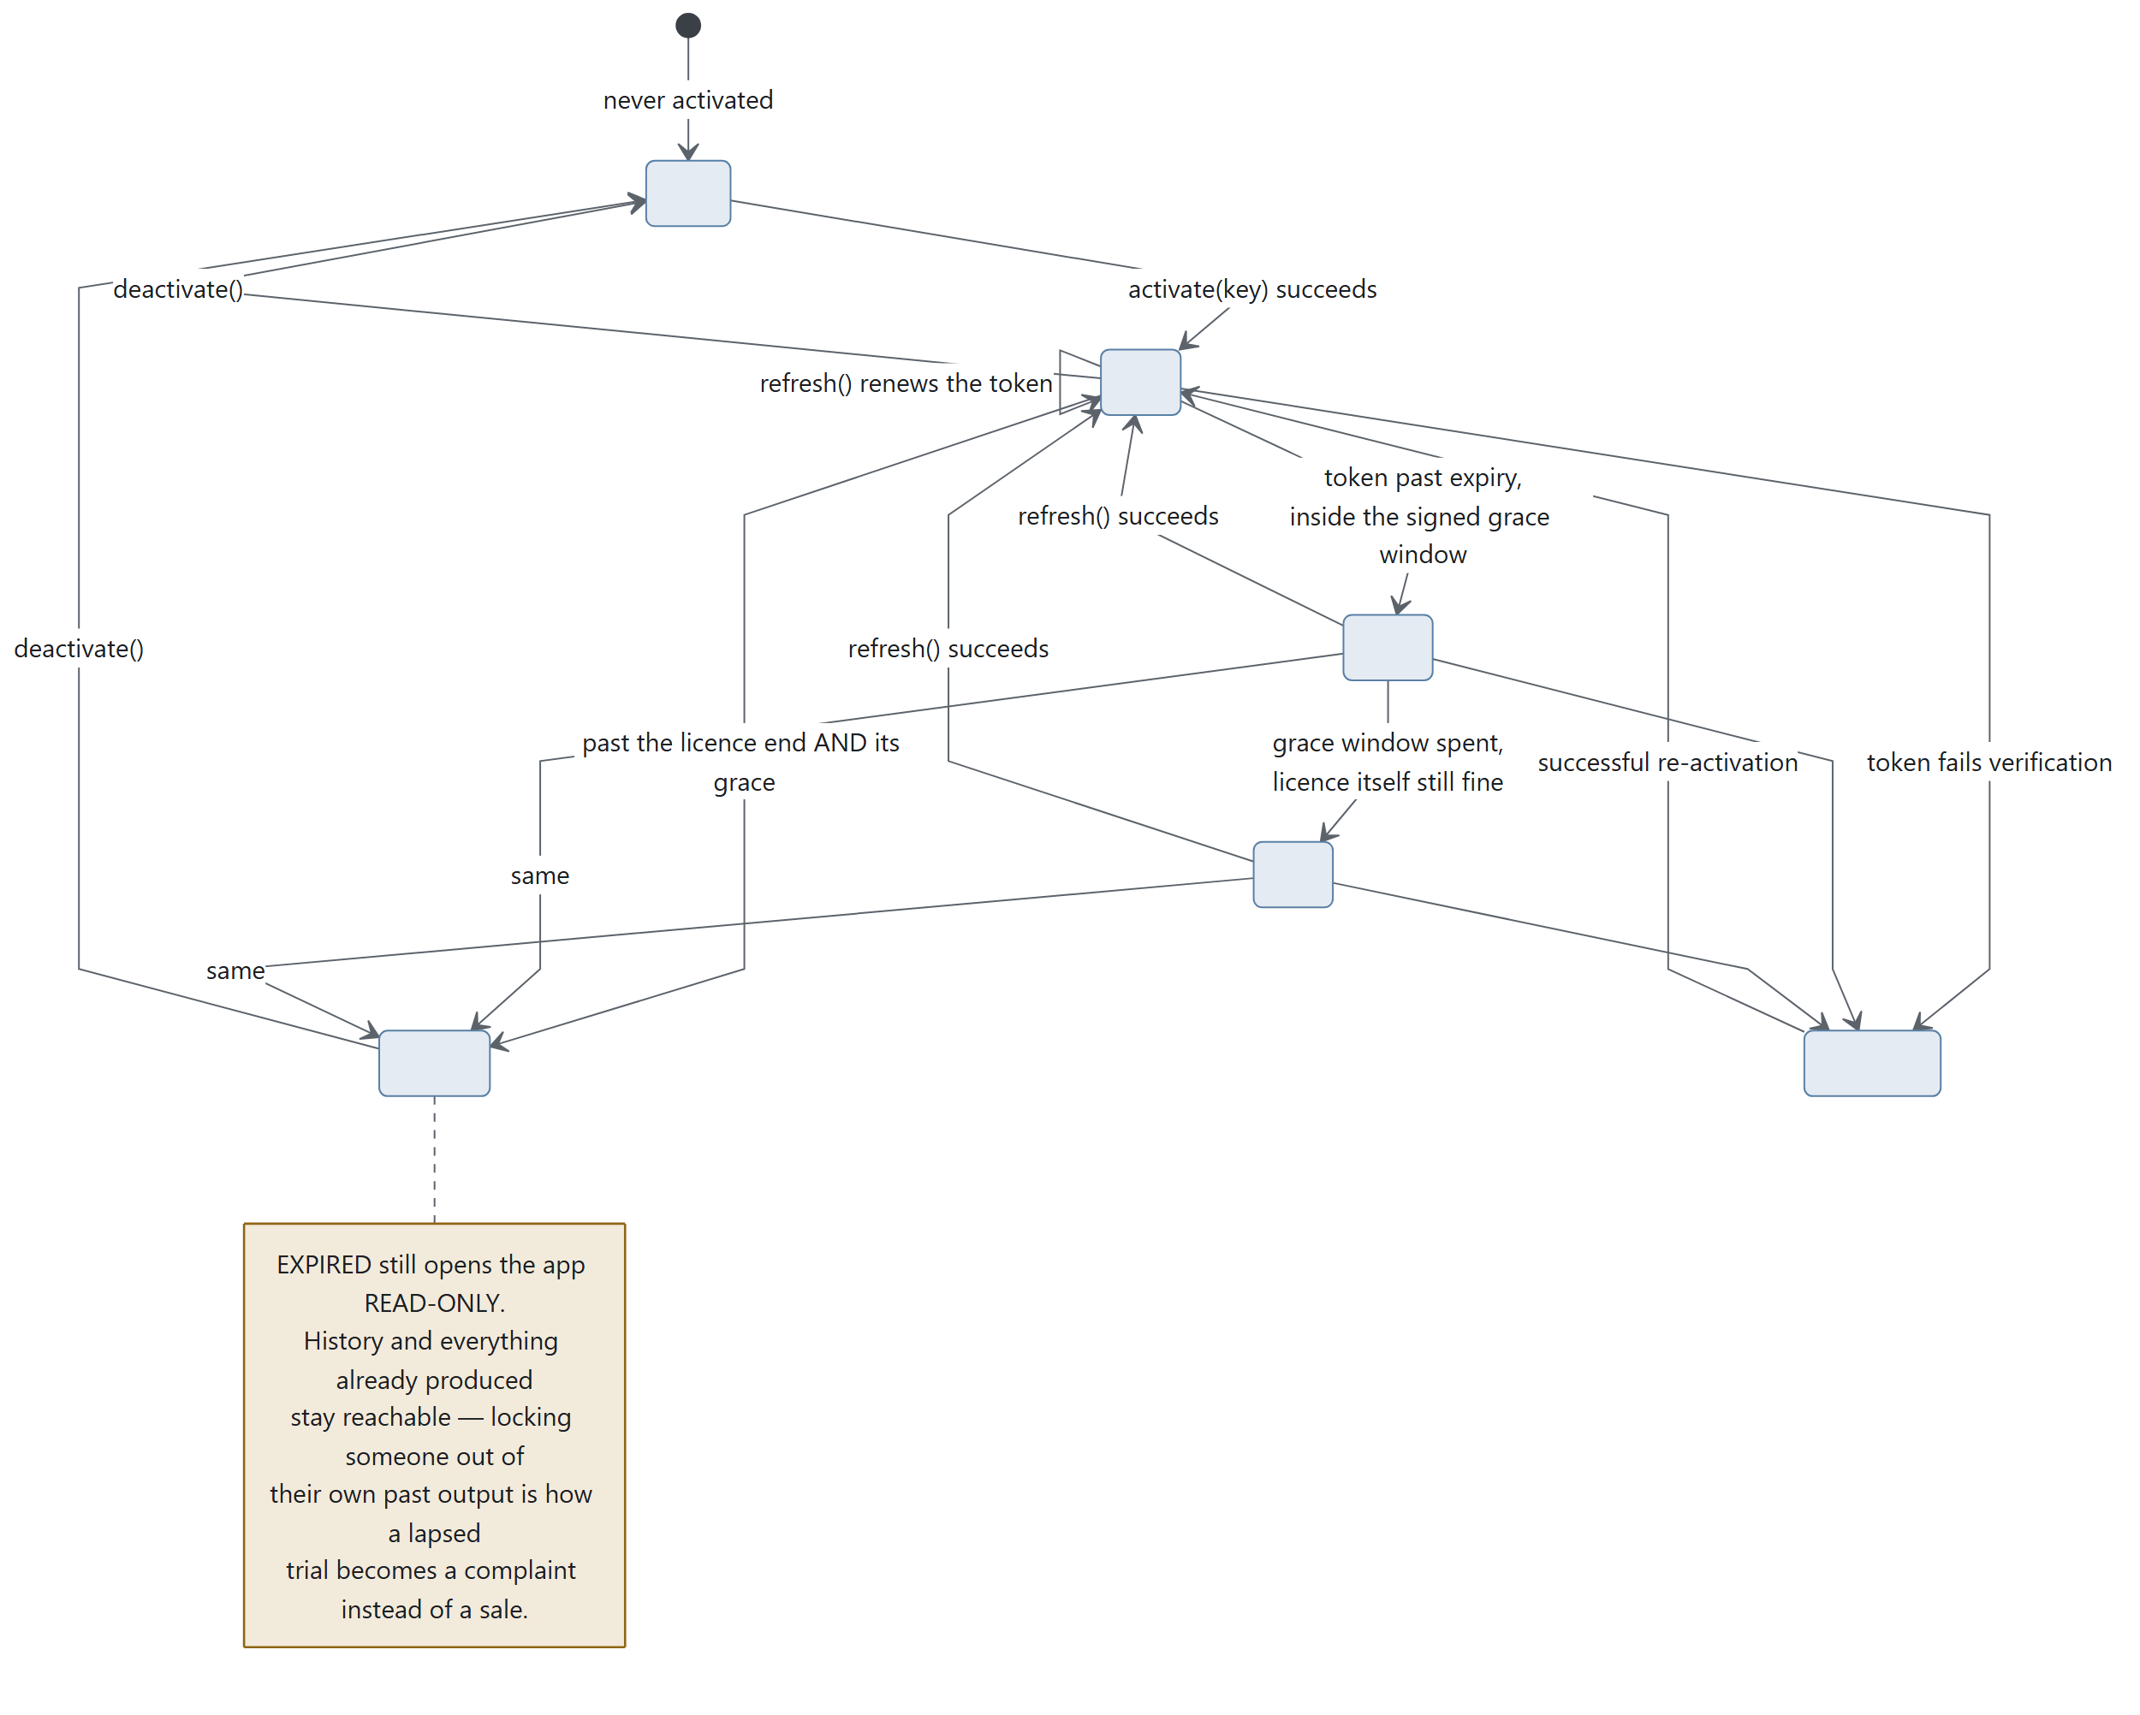
Diagram 5.1
LicenseState
Member | Meaning
status | none · valid · grace · stale · expired · tampered
usable() | May the customer start new work?
days_left() | Days until the licence ends, rounded up. Negative once it has
has(feature) | Entitlement check
message | The sentence to show

CLOCK_TOLERANCE = 1 day. clock_rolled_back(last_seen) compares against the stored high-water mark, advanced by store.touch_clock().

5.4 The authorisation flow — the important part
This is what replaced a design that went to the server on every plan with no offline fallback at all: up to 90 seconds against a cold host before the customer saw anything, and one flaky connection meant no work.
The trade it was making — live control in exchange for our availability becoming our customers' availability — is now paid for by a signed lease instead of a round trip, which is strictly better on both sides.
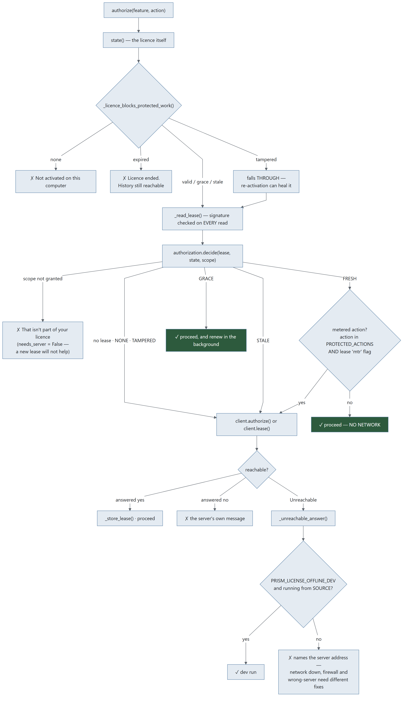
Diagram 5.2

The order, and why it is this order
- Local signed lease. Valid and in scope → proceed, no network.
- Missing, expired or out of scope → ask the backend.
- Backend re-validates licence, device, seat, revocation, entitlement, quota and client version, and signs a new lease.
- Cache it, and proceed.

What still always goes to the server
Metered actions on a metered licence — PROTECTED_ACTIONS = {'plan'}, and the lease's signed mtr flag.
A daily allowance can only be counted where the counter lives; a lease says what a client MAY do, never how much of it it has already done. Prism's own pipeline is browser automation against the customer's logged-in sessions and costs Alphakore nothing, so only planning — three Groq calls — is in that set.

Why stale is deliberately absent from the blocking list
A lease is normally the fresher evidence: the backend caps a lease's expiry at the licence's own hard stop, so a valid lease implies a valid licence at the moment it was issued.
none, expired and tampered are different — in each of them we cannot establish that the licence is alive at all, so a lease that says otherwise is either a clock being wound or a lease that was never ours.
Without _licence_blocks_protected_work, the fast path would happily authorise protected work on an expired licence for as long as a lease sat on disk — precisely the hole that "check the cache first" opens if the cache is checked instead of the licence rather than as well as.

Why tampered falls through
It can be healed by a successful re-activation. Refusing without trying would strand someone whose token was invalidated by a licence reissue.

The honest limit of the offline window
Inside GRACE, a metered licence can plan without the server counting it. That window is the backend-signed off claim (default one hour), so the exposure is bounded, per-licence, and adjustable without shipping an app.
A local counter would look like a fix and would not be one — anything this process counts, this process can be patched to forget.

When it is called
At the START of a run or add-on — never during one. A pipeline is tens of minutes of browser automation, and failing it part-way would discard real work for a reason the customer cannot act on.

5.5 The lease
licensing/lease.py + licensing/authorization.py
Claims (build_claims): kid · license_id · device_fp · scope · features · metered · jti · iat · ttl · off (offline window).
Scopes: SCOPE_CORE = "core" · SCOPE_WORKFLOW = "workflow" · SCOPE_GROK = "grok".
States — Lease.state(now):
State | Meaning | decide() verdict
FRESH | Inside TTL | ✓ proceed, no network
GRACE | Past TTL, inside the signed off window | ✓ proceed and renew in the background — this is the state that makes a flaky connection a non-event rather than an outage
STALE | Offline window spent | ✗ this is where offline operation stops
NONE | No lease cached | ✗ ask the server
TAMPERED | Fails verification | ✗ ask the server; clear() the cache

Lease.allows(scope) is scope membership only — NOT temporal. Callers must go through decide(), which combines both. That separation is deliberate: it is why an in-date lease that simply does not cover a feature returns needs_server=False — a new lease will not help unless the licence itself changes, so it is a definite no rather than a reason to go to the network.
server_reachable is what the caller has just observed, not a guess. It is False only after a request has actually failed.
That distinction is the whole point: an arbitrary network failure must not equal a licence failure, but neither may "I did not bother asking" become a permanent offline mode.
Throttling: RETRY_INTERVAL = 60 s. note_attempt() records a failure; may_retry() gates the next try.

5.6 Device fingerprint — one machine, one seat
licensing/device.py. SALT = b"PRISM-DEVICE-V1"; the identity is salted, hashed and truncated.
Three tiers, best first:
Tier | Source
TIER_PLATFORM | Linux: /etc/machine-id. macOS: IOPlatformUUID. Windows: registry MachineGuid
TIER_MAC | The MAC address
TIER_RANDOM | A random id persisted in ~/.prism

The tier is reported alongside the fingerprint so the server knows how much to trust it. reset_cache() is tests only — the fingerprint is stable for a process's lifetime.
_hostname() supplies a human label for the seat list, so a customer asking which five machines are using their seats gets names rather than hashes.

5.7 Where the key is stored
licensing/secretstore.py
Place | Constant | Notes
OS credential store | KEYRING | Service "Prism (Alphakore)", account "licence-key". Probed once — an import that fails, or a backend that is not there, must not be retried on every call
~/.prism/license.json | FILE | Fallback, 0600
Neither | ABSENT

store.save_key() prefers the keyring. forget_key() removes it from both places — "release this device" has to mean it.
store.write_json() is atomic and 0600. store.read_json() resolves every failure to the default — a missing, truncated or hand-edited file is not a crash.

5.8 Metering
licensing/meter.py — what the customer consumed, never what they wrote.
Function
record(kind, *, tool, stage, prompt_tokens, completion_tokens, ok, ms) | Buffer one event. kind ∈ plan · run · stage · groq · addon
drain() | Take everything buffered, leaving the buffer empty
restore(events) | Put them back after a failed send, so a flaky network loses nothing
pending() | Count
install_groq_meter(router_module) | Counts Groq tokens by wrapping the module's requests handle

MAX_BUFFERED = 2000. Thread-safe via a module lock.
licensing.report_usage(run_id) is fire-and-forget: never blocks, never raises.

5.9 Background renewal
MainWindow.LICENCE_REFRESH_MS = 10 * 60 * 1000 — every ten minutes, _tick_licence() renews the token and the lease off the UI thread, forever.
_repaint_licence() re-reads the cached licence and repaints. No network, never raises — it is safe to call from paint code.
refresh_licence_ui() repaints everything that depends on the licence: the banner, the rail's licence card (_plan_summary() → two lines: what you have, and whether it is ending), and every padlock.

5.10 Plans and features
plans.py is the single table the app and the licence server share.
ORDER = ('studio', 'works', 'complete')
FALLBACK = ('core',)
Function
features_for(plan_key) | What this plan includes
label(f) / blurb(f) / pitch(f) | What the paywall says
plan_of(features) | Best-guess plan name — display only
missing_from(plan_key) | The upsell list, in order

main.py::_paywall() is registered once via licensing.set_paywall_handler(), so the licensing package never has to import Qt. Anything not in the licence shows a padlock in the rail and opens the pitch rather than failing.
Known gap: plans.py feature names and blurbs are not in the translation catalogue — they render in English regardless of interface language.

5.11 Development and testing

Running without a licence server
PRISM_LICENSE_OFFLINE_DEV=1 PRISM_LICENSE_SERVER=http://127.0.0.1:9 python3 main.py
Both are honoured only from source — a frozen build ignores them, or they would be a total bypass.
PRISM_LICENSE_OFFLINE_DEV alone is not enough when a real server is reachable: it fires on a connection failure, and a server that answers "no" has not failed. Pointing at a dead port is what makes it apply.
Mint a local licence: python3 devtools/mint.py install --features …

Do NOT export PRISM_LICENSE_OFFLINE_DEV=1 to run the test suite
This is worth restating because the repo README used to say the opposite.
licensing._offline_dev() is read only inside _unreachable_answer() — i.e. after the HTTP call has already raised Unreachable. It changes the answer, never the round trip, so it cannot make a hanging test finish.
What it does do is open a production bypass underneath the revocation test: with the hatch open, a revoked licence's offline fallback is granted and test_h_a_revoked_licence_gets_no_lease_and_loses_its_cache fails on True is not false. That failure was read as known contamination for months.
tests/conftest.py now strips the variable per test, so the suite is insulated either way — but do not put it back in the invocation.

The self-test
licensing.selftest() verifies the committed test vector in licensing/testdata/. Called by main.py --selftest (via PRISM_SELFTEST), which also proves a packaged build is whole: every bundled resource present.

5.12 Threat model — what this does and does not stop
Stated plainly, because a maintainer needs to know which complaints are bugs and which are the design.
Attack | Stopped? | By what
Sharing a key across many machines | Yes | Seat counting on the device fingerprint
Editing license.json to extend the date | Yes | Ed25519 signature over the claims, verified every read
Copying ~/.prism to another machine | Yes | Claims are device-bound; verification fails
Winding the system clock back | Mostly | clock_rolled_back() against the stored high-water mark, CLOCK_TOLERANCE = 1 day
Pointing a release build at a fake server | Yes | PRISM_LICENSE_SERVER honoured from source only
Pointing a source checkout at a fake server | No | Deliberate — that is the dev hatch
Patching the Python to skip the gate | No | It is Python on the customer's machine. This design does not pretend otherwise
Exceeding a daily allowance while offline | Bounded, not stopped | The signed off window (default 1 hour). A local counter would look like a fix and would not be one

There is no offline fallback for a first authorisation. If the licence server cannot be reached and no lease covers the action, the answer is no. LICENSING.md argues why that trade is worth making.

Add-on Subsystems
Each add-on is: a rail entry (with a padlock when unlicensed) → a licence check → a dialog or panel → one or more QThread workers → engine modules in prism_terminal/core.
Add-on | Feature key | Rail group | Verified against real customer data?
Email automation | inbox | ADD-ONS | Reading: yes. Sending & PO: no
BOQ | boq | ADD-ONS | Partially
Gerber | (engine done, GUI in progress) | ADD-ONS | Yes — customer's own check sheet
Email blast | email | ADD-ONS | Yes
Reel / Studio | reel | ADD-ONS | Yes
BOM & Stock | — | ADD-ONS | Not built — visibly coming soon, disabled on purpose

Why a disabled shelf entry is deliberate: a shelf that looks like a product line is worth more in a demo than an empty gap.

6.1 Email automation (inbox)
The one used every day, and the reason the app gets opened at all.
Built with a spring manufacturer at GIDC, Vadodara; grown to office scale — several mailboxes, one shared register — after a second firm described exactly that.

Files
Layer | File | Lines
Screen | dialogs/inquiry_dialog.py | 2,618
Setup | dialogs/inquiry_setup_dialog.py | 1,013
Panel | widgets/inquiry_panel.py | 675
Table | widgets/register_table.py | —
Workers | InboxCheckWorker, POReadWorker, DraftWorker, SendWorker, InboxVerifyWorker | —
Engine | inbox · triage · register · quoting · po · mailflow · mailer · sop · drafting | 4,046
Read-only views | dashboard_data.register_view(), waiting_view(), inquiry_stats() | —

The three phases the screen is built around
The tabs are separated because the difference between them is the difference between software you leave running and software you supervise.
Phase | Tabs | Runs how
READ | 1 · What arrived | On its own. Nothing here can cost anybody money
ANSWER | 2 · Inquiries · 3 · What they said back · 4 · Waiting on a reply | Prism prepares; a person presses Send
MAKE | 5 · The order came | Put the PO against the quotation, accept it, hand the drawing to BOQ

Full stage-by-stage data flow: 03-data-flow.md §3.2.

The properties that sell it
Property | Mechanism
Reads the mailboxes, never writes to them | readonly=True select, BODY.PEEK[]. Nothing marked read, moved or deleted — the owner keeps using Outlook on the same account
Sorts on local rules first | List-Unsubscribe, auto-replies, known senders, narrow keyword rules settle most mail with no AI call at all. Only genuinely unknown senders reach the model, in one batched call
Keeps an ordinary CSV register | Opens in Excel, stays theirs whatever happens to Prism. Written atomically; hand-added columns survive; an existing register can be imported with numbering carrying on from theirs
Prices from their own rate list or cost sheet | Every line of the working shown. Decimal with ROUND_HALF_UP, Indian lakh grouping, financial-year numbering (INQ/25-26/0087). No AI ever touches a figure
Reads the reply | Accepted, declined, haggling, or a question — and proposes the register change. It never applies itself
Chases the quiet ones | Every two days, three times, then stops. Each reminder worded differently
Puts the PO against the quotation actually sent | Read back from the CSV written at send time, refused on any mismatch. Every difference listed, with rate gaps multiplied out by quantity
Wins back a no | Drafts through the AI tools in the user's own Chrome, using bargaining limits they supply in a file. With no such file it is instructed to offer nothing on price at all

It stops twice on purpose — before a price goes to a customer, and before a purchase order is accepted.

Office scale — the rules
Rule | Why
Mailboxes are walked one at a time, never in parallel | All rows land in one CSV; N fetches racing on one order book loses rows
Each mailbox keeps its own read bookmark | Two mailboxes sharing one would skip or re-import each other's mail
Learned corrections are shared across mailboxes | A sender is the same sender whichever address they wrote to
One dead mail server → skip that account | That account's problem; the others carry on
One locked register → stop the walk | The same lock would refuse every account after it, and no bookmark has moved
A Mailbox column records the arrival address | With three addresses feeding one file, "who is this customer talking to" is the first question the sheet gets asked
One machine writes; everyone else reads | See the deferred entry below

Verification status — read this before selling it
Half | Status
Reading (fetch, sort, register, file attachments) | Well covered. Unit tests plus devtools/inbox_demo.py against sample mail
Sending and the PO screen | Written and unit-tested but never run against a real mailbox

This is the single biggest verification gap in the product. It is stated in the repo README.md and should be stated to customers.

Deferred, with triggers (docs/DEFERRED.md)
Deferred | Trigger that would change it
Several machines writing one register | A customer whose salespeople refuse to put mailbox passwords on the shared office PC — heard from two firms, not one. The build would be per-machine append journals merged by whichever Prism reads next
OCR for scanned POs | Scanned POs above roughly half a real customer's measured volume — counted from their own register, not guessed in a meeting — AND the customer saying the typing is what stops them using the tab

Why not OCR now: an OCR misread of a rate is worse than typing four fields, because it arrives with confidence — and the comparison against the quotation is only worth having when its inputs are exact.

The "send unless stopped" softening
Sanctioned and designed, not built. docs/EMAIL_WORKFLOW_RUNTIME.md §1: Prism prepares the quotation and says "going out in 10 minutes"; doing nothing sends it, one tap holds it. Plus a value threshold — catalogue items under a figure the owner sets go out on their own; anything made-to-drawing or above it waits.
From the customer's chair that is full automation. From ours the escape hatch is still there.

6.2 BOQ
Quantities off a CAD drawing (DXF via ezdxf) or from a written spec.
Layer | File
Screen | dialogs/boq_dialog.py (410 lines)
Worker | MeasureWorker
Engine | prism_terminal/core/boq.py (827 lines)
Availability | core_bridge.boq_available() → needs ezdxf

What it measures: lengths (lines, arcs, polylines with bulge — real arc length, not chord), areas (shoelace; hatch external boundaries minus internal hole loops), and counts — grouped per layer and per block, across every layout's modelspace-equivalent geometry.
.dwg support needs a local converter: dwg2dxf or ODAFileConverter. find_dwg_converter() probes for it.
The Rate and Amount columns are deliberately left blank. Prism counts and measures; you price it. Deriving a price from a drawing is the mistake this add-on exists not to make.
allow_derived in formatting_prompt() is the switch between a takeoff (measured quantities only) and an estimate (quantities plus inferred work) — the single most important flag in this module.
Contrast with Gerber: BOQ does attach the drawing to the AI tools — write_files = ([cad_file] if cad_file else []) + templates + note_files. A building drawing is a description of a job; a Gerber set is the customer's product. Do not copy either pattern across without asking.
Handoff: InquiryDialog._make_boq() hands an inquiry's saved drawings straight to this add-on, so a drawing that arrived by email is measured without being re-found on disk.

6.3 Gerber
Measure a PCB job. No AI sees the design.
Layer | File | Status
Engine | prism_terminal/core/gerber.py (2,120 lines) | Done — commit 7cef5c4, 26 tests
CLI | /gerber in prism.py | Done
Screen | dialogs/gerber_dialog.py | Built — see docs/AFTER_THE_MERGE.md §1
Worker | GerberWorker | Done
Availability | core_bridge.gerber_available() — shapely optional

The rule that must not be broken
The Gerber files never reach an AI. cmd_gerber passes attachments=[] and a test asserts that literal string. The GUI must do the same.

The five numbers Fine Circuits asked for, and nothing else
pcb size · min track width · min track spacing · min drill size · number of drills

Input shape
Drop a folder, .zip or .rar — never individual files. A job arrives as one archive of 9 to 17 files, and asking a customer to pick the right four is the whole problem restated.
Four panels, exactly as the terminal shows: what is in the job, the five numbers, the workings, and the cross-check.

The verification ladder — cheapest first
Step | Method | Status
1 | The job's own CAM report — crosscheck() parses .DRR/.REP, compares hole counts and tool tables. Free, exact, no AI | Built. The 2018 sample reproduces all ten tools and 218 holes
2 | A second independent implementation — gerbonara (pip, pure Python, test-only, not a runtime dependency). Comparing per-layer object counts found both parser bugs on 2026-08-19; all 19 layers of both samples now match exactly | Built, pinned by a skipping test. Reach for this before any AI
3 | AI sanity-check on a rendered image plus the numbers. A PNG of the copper is not a manufacturable design, so this does not break the rule the way attaching the Gerber would | Not built
4 | The raw Gerber to an AI — only with the customer's written permission | Not built, and gated on consent

Why this ladder is written down: on 2026-08-19 an independent measurement found two real defects — modal D-codes and sequential polarity — that code review and 900 passing tests had missed. Both produced plausible wrong numbers with no error and no crash. One meant Prism had read 158 of a layer's 470 objects and reported a clearance anyway.

Customer validation
2026-08-20. Fine Circuits returned their own filled-in check sheet for both sample jobs. Prism reconciles: size, track width, min drill and hole count exact on both boards; spacing within a mil. Asked about the one-mil difference, the reply was "if its 9 or 10 it means its working".
Two things that reply told us:
- The sheet was filled in by someone else while the contact was busy. A good witness, not a precise one. Prism's figure is arguably tighter — the one-mil gap is design rule versus measured worst case (102 places on the 2018 board sit at 9 mil).
- "We just do DRC." A tool already produces these numbers and the hand measuring is a side task. Ask for a DRC output — machine-generated, free, and a far better witness than a spreadsheet. It may also mean the five numbers are not the product and the DRC is. Worth finding out.

Untested constructs
Neither sample contains these, so nothing proves they work. Prism warns when it meets them; a warning is not a guarantee.
- Arcs (G02/G03) — zero in both jobs. Implemented, never exercised on real data.
- Aperture macros (%AM) on a copper layer — macro flashes are counted but given no geometry, so they take no part in spacing.
- Step-and-repeat (%SR) panelisation — detected and reported, not expanded.
- Negative inner planes, where the plane layer is drawn inverted.
The contact has said the two samples are deliberately simple and that complex files will follow. Run steps 1 and 2 of the ladder on every one of them.

Where the add-on actually goes — the whole enquiry
An incoming PCB job, end to end:
# | Step | Owner
1 | Email/WhatsApp lands with a zip | Prism — Email automation ✅
2 | Identify layers, measure the board | Prism — core/gerber.py ✅
3 | Can we make it? What is at our limit? | NOT BUILT
4 | How many boards fit our panel? | NOT BUILT
5 | Cost it — laminate, layers, finish | NOT BUILT
6 | Write the quote | Prism — drafting ✅
7 | Send it | Prism — mailer ✅
8 | Chase it at 2 days | Prism — mailflow ✅

CAM software (Genesis 2000, InCAM, CAM350, UcamX) owns step 2 alone. We own 1, 2, 6, 7, 8. Steps 3–5 are the whole remaining product, and none of them need to touch a Gerber.
The sentence: CAM tells you what the board is. Prism tells you what to charge for it, writes the quote, sends it, and chases it — using the AI subscriptions you already pay for, without your customer's design ever leaving your computer.

The realistic first build — and what NOT to build
Decision | Step | Reason
Build | 3 · capability check | One document from him, no pricing, no credentials, no assumption about how the job arrived. It turns Prism from "a thing that reads Gerbers" into "a thing that answers the question I actually have"
Do not build yet | 4 · panel utilisation | Needs his panel sizes, edge rails, scoring rules, tooling margins. Real geometry — code, not an AI — but a week of work, and wrong in a way he will spot instantly if any input is guessed. Wait until he asks
Do not build yet | 5 · costing | Needs his entire rate structure, which is his margin. Asking early reads as asking for his books
Do not build yet | sending | He has not said he wants Prism touching his mail, and credentials are the highest-friction thing on the list

The staged ask — each stage must be worth something on its own:
Stage | What to ask for | Risk
1 | Capability sheet — thinnest track, tightest gap, smallest drill, layer count, finishes, panel sizes | Low. He has it already; it is what he quotes against
2 | How he prices + a sample quote he has sent + company details | Medium. Pricing is his margin; he will not share it until stage 1 has proved useful
3 | Sending account (SMTP) | High. Credentials. Last thing asked for, never the first

The assumption to NOT make
Not every job arrives by email. Window fabricators showed this: WhatsApp photos, a phone call, a worker's notebook. A PCB fab may take jobs through a customer portal, a shared drive, a WhatsApp group, or an ERP nobody outside the company has heard of.
The add-on must work from a folder on his machine, full stop. If a zip lands there by any means, it is measured. Email ingestion is one route in, not the route in.

6.4 Email blast
Layer | File
Screen | dialogs/email_dialog.py (687 lines)
Workers | SendWorker, VerifyWorker
Engine | prism_terminal/core/mailer.py (502 lines)

Recipients come from an attached CSV and/or addresses in the goal text, with a Search for their public email fallback that runs a research stage and a structuring stage and writes a real CSV to disk as a durable record.
The draft is generated through a normal pipeline stage and is editable, then confirm-and-send from the user's own account. First use opens the one-time SMTP setup (Gmail needs an app password).
One message per recipient, so {name} can be substituted, with SEND_DELAY = 2.0 s between them.
Full flow: 03-data-flow.md §3.6.

6.5 Reel / Studio
 | Reel | Studio
Engine | core/reel.py (1,810 lines) | core/reel_web.py (1,765 lines)
Frames | Drawn with Pillow | A real web page filmed in a paused Chromium
Availability | reel_available() — Pillow + FFmpeg | studio_available() — plus a browser engine
Output | 1080×1920 .mp4 | Same

FFmpeg ships inside the build (imageio-ffmpeg). If it is ever missing, Prism downloads the same wheel and verifies it against the SHA-256 PyPI publishes for that exact file before unpacking it (core/ffmpeg.py, FFmpegWorker).

Why Studio is a conversation
The design stage is one turn for the look and a storyboard, then one turn per scene, each laid out at 1080×1920 and corrected before the next is asked for.
Asking for the whole reel in one reply is what made the old output look like a slide deck — a scene got about 278 characters, which is a headline and a subhead. See CHANGES.md → Round 6.

The house style
~/Desktop/studio_pcb.mp4 (26.7 s, 1080×1920) is the standard to hold every future reel against: dark, terminal-styled, and built from the customer's own material — a real file listing, 238 holes drawn as 238 dots, the board drawn with dimension lines, a two-column panel contrasting what stays on the machine with what the AI ever sees.

Open gaps (docs/AFTER_THE_MERGE.md §4, docs/DEFERRED.md)
Gap | Detail
Invented numbers — fix first | studio_pcb.mp4 claims 238 holes, 125.93 × 76.40 mm and 0.152 mm. The AI made all three up, because the reader did not exist when the script was written. The real board reads 218 holes, 90.17 × 90.17 mm, 0.203 mm, 4 layers, confirmed against the customer's own CAM report. Re-render those scenes
No hooks | Nothing in design_instructions() or scene_instructions() treats scene 1 differently from scene 4 — but a reel without a hook is never watched to the end, so the opening ~1.5 seconds is the whole bet
Adaptiveness unverified | The pipeline asks for "build it from the customer's own material, not from adjectives"; nothing verifies it happened
Storyboard is advice, not a contract | Nothing checks that the scene the model wrote is the scene its storyboard described. Trigger: a reel where every scene lays out clean and the film still reads as a deck
Motion seams — claimed done, not found in code ⚠️ | docs/DEFERRED.md records this as DONE, with a motion_faults() that checks the two measurable faults (scene wrapper animating as one slab; one animation used by 70%+ of everything that moves). No motion_faults exists anywhere in prism_terminal/core/ at the pinned submodule commit — the nearest real function is brand_faults() (reel_web.py:373). Either the work landed upstream and the submodule pin is behind, or the entry was written ahead of the code. Verify before relying on it

6.6 Cross-cutting: how an add-on is wired
Adding one follows the same six steps every time.

Diagram 6.1

The availability probe is not optional. Heavy dependencies (selenium, ezdxf, shapely, Pillow, FFmpeg) are probed lazily so a missing one produces a sentence the user can act on rather than an import error at boot — and so startup stays fast.
Feature keys live in plans.py and are shared with the licence server. AGENT_FEATURES = {'Prism Reel': 'reel', 'Prism Studio': 'reel'} in main_window.py maps agent names onto feature keys for the plan rows.

Operations
Building, releasing, testing, configuring and debugging. BUILD.md, SHIPPING.md and RUNNING.md are the full procedures; this is the operational map and the failure modes.

7.1 Running from source
git clone --recurse-submodules https://github.com/HitarthTrivedi/prism_gui.git
cd prism_gui
pip install -r requirements.txt
python3 main.py
Already cloned without --recurse-submodules? Run git submodule update --init once.
Without the submodule the engine is an empty directory and nothing works. The CI workflow explains this in its own failure message because the git error ("not our ref <sha>") cost a debugging session once already.
First launch opens the licence screen, then Setup (API key, profile, one agent per category, Chrome version) if ~/.prism/config.json is not already configured from the CLI.
You also need Google Chrome installed, since Prism drives it directly.

7.2 Dependencies
Package | Needed for | Optional?
PySide6>=6.5.0 | The entire UI | No
requests | Groq, licence server | No
cryptography | Ed25519 verification | No
certifi | TLS roots in a frozen build | No
setuptools, packaging | Runtime helpers | No
selenium>=4.0.0, undetected-chromedriver | Browser automation | Probed by automation_available()
ezdxf (pulls numpy) | BOQ reads DXF geometry | Probed by boq_available()
shapely | Gerber spacing / copper geometry | Optional — four of five numbers still work without it, and the missing one says so
pillow | Reel draws every frame with PIL | Probed by reel_available()
imageio-ffmpeg | Reel encode — ships inside the build | Downloaded + SHA-256 verified if missing
openpyxl | Reading .xlsx rate lists | Degrades to CSV only
pypdf, python-docx | Reading purchase orders | Degrades to an honest refusal
pyaudio | Microphone capture | Voice disabled without it
dnspython | MX lookup for mail host discovery | Falls back to guessed hosts
keyring | OS credential store for the licence key | Falls back to the 0600 file
gerbonara | Test-only cross-check of the Gerber parser | Never a runtime dependency

Python 3.12, deliberately. 3.13 removed the stdlib audioop that the wake word uses, and PySide6 wheels lag the newest release.

7.3 Build and release
packaging/ — prism.spec, build.py, codesign.py, make_icons.py, smoke_test.py, install.sh, entitlements.plist, two PyInstaller runtime hooks (rthook_distutils.py, rthook_ssl_certs.py).

CI — .github/workflows/build.yml
PyInstaller cannot cross-compile, so each OS builds on its own runner.
Runner | Target | Note
ubuntu-22.04 | Linux x64 | Oldest supported glibc — binaries built against a newer libc cannot run on older systems
windows-latest | Windows x64
macos-14 | macOS Apple Silicon
~~macos-15-intel~~ | Dropped | Built fine but failed its smoke test, and release needs the whole matrix — one red leg blocks the publish for every platform. The machines this is going to are Apple Silicon

An arm64 .dmg will NOT run on an Intel Mac — there is no Rosetta path for it, the app simply will not open. To support one, add macos-15-intel back (GitHub offers that image until Aug 2027) and fix the smoke-test failure it surfaces.
fail-fast: false — a broken macOS build should not hide a good Windows one.
Triggers: push to main/master, any v* tag, pull requests, manual dispatch. A tag publishes a release; anything else leaves artifacts attached to the run.
submodules: recursive is mandatory in the checkout step.

The submodule push trap
If prism_gui pins prism_terminal to a commit that was never pushed, CI checkout fails. The fix:
cd prism_terminal && git push origin HEAD:main
The workflow prints this as an error annotation on checkout failure.

Distribution
Portable, no installer — nothing written outside the app folder and ~/.prism. Grab the build for your OS from Releases. First launch on macOS needs the unsigned-app step (GETTING_STARTED.md — the doc to hand a non-technical user).

7.4 Tests
python3 -m pytest tests/ -q --deselect \
"tests/test_gates.py::TaskQueue::test_each_task_is_planned_in_turn"
python3 -m devtools.scenarios # 148 end-to-end scenario checks
python3 devtools/inbox_demo.py # the inbox pipeline on sample mail
1,203 tests collected as of commit 20292f4, plus the 148 scenarios.
The repo README.md says "705 tests" and the file listing at its foot says "588" — both are stale. Worth correcting when the README is next touched.
Nothing in either suite touches the network. IMAP and Groq are both faked, because a test that needs a mail server is a test nobody runs.

The one deselect is not decoration
test_each_task_is_planned_in_turn builds a real MainWindow, which reaches for the licence server, and it hangs rather than failing — so a plain pytest tests/ appears to freeze.
It is pre-existing and unrelated to any recent work; it hangs on a clean tree at older commits too. Left in place rather than quietly deleted, because a hanging test is a real problem and deleting it would only hide it.

Do NOT export PRISM_LICENSE_OFFLINE_DEV=1 to run the suite
Full reasoning in 05-licensing.md §5.11. Short version: it changes the answer, never the round trip, so it cannot make a hanging test finish — but it does open a production bypass underneath the revocation test, whose failure was read as known contamination for months. tests/conftest.py now strips it per test.

Test file map
Area | Files
Email automation | test_mailflow.py (1,674), test_email_automation.py, test_inbox_fetch.py, test_mail_end_to_end.py, test_inquiry_is_never_lost.py, test_sorting_precision.py, test_document_handoff.py
Inquiry UI | test_inquiry_ui.py (1,470), test_inquiry_screen.py, test_register_table.py
Gerber | test_gerber.py (974), test_gerber_dialog.py, gerber_samples.json
Licensing | test_authorization.py (777), test_licensing.py, test_licensing_endpoint.py, test_licence_safe_modules.py, test_secrets.py, test_gates.py
Reel | test_reel_capture.py, test_reel_dialog.py, test_scene_by_scene.py, test_ffmpeg.py, test_canva.py
Engine / platform | test_apollo.py, test_cuts.py, test_intent.py, test_failover.py, test_resilience.py, test_run_timeline.py, test_chrome_profile.py
App | test_ux.py, test_roles.py, test_i18n.py, test_support.py, test_dashboard_data.py

7.5 Environment variables
Variable | Honoured | Effect
PRISM_LICENSE_SERVER | Source only | Point at a staging licence server. A frozen build ignores it — an env var that redirected a release build would be the backdoor this design exists not to have
PRISM_LICENSE_OFFLINE_DEV | Source only | Grant offline when the server is unreachable. Fires on a connection failure only — a server that answers "no" has not failed
PRISM_SELFTEST | Always | Run main._selftest(app) and exit with its code — proves a packaged build is whole
PRISM_SERVER_URL | Tests | The fake licence server in the test suite
PRISM_NET_TESTS | Tests | Opt into tests that would touch the network
PRISM_SLOW_TESTS | Tests | Opt into slow tests
PRISM_FFMPEG | Always | Point at a specific FFmpeg binary
PRISM_GOOGLE_CLIENT | Always | Google Drive client credentials
PRISM_OWN_PROMPT | Always | Override the engineered prompt (development)
PRISM_EFFECTS, PRISM_SHADOWS | Always | UI effect toggles
PRISM_BUILD_ENGINE | Build | Which engine to package with

7.6 Configuration surface — where a setting actually lives
Setting | Set in | Stored
Groq API key | Setup → API key | cfg["api_key"]
What you do (profile) | Setup → Profile | cfg["profile"]
One agent per category | Setup → Agents | cfg["agents"]
Chrome version / profile | Setup → Chrome | cfg["chrome_version"], cfg["chrome_profile"]
Interface language | Settings → Language | cfg["language"]
AI output language | Settings → Language | cfg["output_language"] — set separately on purpose: a Gujarati-speaking owner may well want the output in English
Your role | Settings → Your role | designation key → cfg["designation"]
Workspace root | Settings | cfg["workspace_root"]
Sending account | Email add-on first run | cfg["email"]
Mailboxes, register folder, rate list, terms, who's-who | Email automation → Setup | cfg["inquiry"]
Licence | Rail → Licence | ~/.prism/license.json + OS credential store
Favourites | Star a file | ~/.prism/gui_favorites.json

7.7 Diagnostics and failure modes

Crash logs
diagnostics.install() sends crashes to ~/.prism/logs, because a windowed build has no console to print to. problem_dialog.py offers the diagnostics file when something goes wrong.

Check logging
core/checklog.py writes one line per email-automation check to ~/.prism/logs — start, stop reason, and a done line with counts and elapsed time. This is the first place to look when a customer says "it didn't pick up my mail".

The error contract
friendly.py turns every error a customer can see into three things: what happened in five words, one or two sentences of plain English, and the numbered things to try.
Never show someone a problem without showing them the next action. A message with no action is a phone call.

Failure catalogue
Symptom | Likely cause | Where to look
pytest tests/ appears to freeze | The known hanging test | Add the deselect (§7.4)
CI checkout fails, "not our ref" | Submodule pinned to an unpushed commit | cd prism_terminal && git push origin HEAD:main
/gerber says "Unknown command" | Running the stale sibling checkout, not the submodule | docs/AFTER_THE_MERGE.md §5 — two checkouts of one repo is a trap
Edits to prism_terminal have no effect | Same cause. core_bridge prints a note naming both paths | core_bridge._warn_about_sibling()
App will not open, licence screen loops | Server unreachable and no lease covers it. There is no offline fallback by design | The message names the server address
Revocation test fails on True is not false | PRISM_LICENSE_OFFLINE_DEV leaked into the environment | Unset it
"Close it in Excel" on every check | The register is open | Genuine; close Excel
One mailbox stops being checked | Repeated auth failure — the timer gives up deliberately, so Prism does not lock the account | _maybe_stop_timer(), _note_failure()
First check returns old newsletters | Pre-floor_uid behaviour | Should not recur; State.floor_uid fixed it
Chrome will not start after a crash | SingletonLock left behind | automation._clear_profile_locks() handles it; check it ran
Nothing is copied from the real Chrome profile | Chrome has no profile called "Default" | cfg["chrome_profile"]; preferred_profile()
A stage returns the prompt back | The tool echoed it | _is_prompt_echo() rejects it; failover retries elsewhere
Icons missing from the stylesheet | A Windows backslash inside QSS url() is read as an escape | main.py posix-separates the assets path
First widgets on the wrong font | theme.load_fonts() ran late | It must be before the first widget
Untranslated UI | i18n.start() ran after a widget was built | It must patch Qt first

7.8 Development tools — devtools/ (never shipped)
Tool | Does
mint.py | Mint licence keys and designation keys locally (install --features …)
scenarios.py | 148 end-to-end scenario checks
inbox_demo.py | Run the inbox pipeline over sample mail
demo_register.py | Generate a demo register
extract_strings.py | Pull translatable strings for lang/
dev-signing-key.hex | The DEVELOPMENT signing key — trusted from source only

7.9 Localisation
i18n.py patches Qt before the first widget exists, so nothing is built untranslated. Language packs live in lang/: hi.json, gu.json, and _catalogue.json.
i18n.style_for_script(qss) appends font families that cover Devanagari and Gujarati to every font stack — Barlow has neither. A no-op for Latin scripts.
QFileDialog's static methods are deliberately never patched — doing that once broke every attachment in the app. Captions are translated at the call site instead.
Known gap: plans.py feature names and blurbs are not in the catalogue.

7.10 The operational rules that are easy to break
Collected in one place, because each one has already cost time.
- The submodule always wins. A sibling ../prism_terminal checkout is ignored. Do not keep two checkouts of one repo.
- Push the submodule before pushing the parent, or CI cannot check out.
- Never export PRISM_LICENSE_OFFLINE_DEV=1 to run tests.
- Keep the one deselect in the pytest invocation.
- One machine writes the register. Several mailboxes, yes; several writers, no.
- Gerber files never reach an AI — asserted by a test that checks a literal string. Do not "improve" that test.
- Startup order in main.py is load-bearing. Every step's comment says what breaks if it moves.
- Nothing touches a widget from a worker thread.
- Never show an error without a next action.

State and Roadmap
This document is the PM's control panel. It says what exists, how well it is proven, what is decided-but-blocked, and what is deliberately not built and why.
It does not replace docs/DEFERRED.md and docs/AFTER_THE_MERGE.md — those are the working files where decisions get made. This is the index across them, so you can see the whole board at once.
Snapshot: 2026-08-26 · commit 20292f4 · version 1.3.0 · 74,259 lines of Python · 1,203 tests + 148 scenarios.

8.1 The maturity board
Rated on two independent axes, because they fail differently:
- Built — does the code exist and pass tests?
- Proven — has it run against real customer data, and did a customer confirm the output?
Capability | Built | Proven | Notes
Main task pipeline (route → plan → run) | ✅ | ✅ | The general-purpose product
Licensing & authorisation | ✅ | ✅ | Committed test vector, 777-line auth test file
Email automation — reading | ✅ | ✅ | Fetch, sort, register, file attachments. The well-covered half
Email automation — sending | ✅ | ❌ | Never run against a real mailbox
Email automation — PO screen | ✅ | ❌ | Never run against a real mailbox
Multi-mailbox walk | ✅ | ⚠️ | Built and tested; office-scale customer had not yet run it at time of writing
Quotation from rate list / cost sheet | ✅ | ⚠️ | Arithmetic is exact and tested; not yet validated against a customer's own sent quotes
Gerber engine | ✅ | ✅ | Reconciled against Fine Circuits' own filled-in check sheet on both sample jobs
Gerber GUI | ✅ | ⚠️ | Window built; needs real customer archives
BOQ | ✅ | ⚠️ | Geometry sound; .dwg needs a local converter
Email blast | ✅ | ✅
Reel | ✅ | ✅
Studio | ✅ | ⚠️ | House style set; invented numbers in the reference reel still to fix
Voice / push-to-talk | ✅ | ✅
Wake word | ⚠️ | ❌ | Best-effort polling loop, not a real engine
NotebookLM automation | ⚠️ | ❌ | Best-effort, unverified against a live session
Teams / shared workspace | ✅ | ⚠️ | One-writer rule holds
Localisation (hi, gu) | ✅ | ⚠️ | plans.py strings not in the catalogue
BOM & Stock | ❌ | ❌ | Shelf placeholder, disabled on purpose
PCB capability check (step 3) | ❌ | ❌ | The recommended next build
Panel utilisation (step 4) | ❌ | ❌ | Wait until asked
PCB costing (step 5) | ❌ | ❌ | Wait until stage 1 has earned it

8.2 The three lists, and the difference between them
This is the discipline the repo already runs on. Keep it.
File | Holds | An entry leaves when
docs/AFTER_THE_MERGE.md | Decided, understood, blocked only on a merge. Everything here is worth building now | It is done, or deliberately killed — say which
docs/DEFERRED.md | Deliberately not built yet. Every entry carries a trigger: the observable thing that turns it from an idea into a job | Its trigger fires
docs/FUTURE_INDUSTRY_TARGETS.md | Which industries next, and the hard rules per industry | A target is entered or abandoned

The rules that make these files work
From AFTER_THE_MERGE.md, and worth restating because they are the reason the files are still readable:
- An entry leaves only when it is done or deliberately killed — say which.
- Every entry names the file it touches, so the work starts without a hunt.
- Record the reasoning, not just the task. In six weeks the task will be obvious and the reasoning will not.
- Update it in the conversation where the decision is made, not later.
And from DEFERRED.md:
A list of "nice to have someday" rots — nobody reads it, and six months later nobody remembers whether an entry was a plan or a passing thought. So every entry carries a trigger. If the trigger has not happened, the entry is doing its job by sitting here.
Add an entry when you consciously choose the smaller version of something. The comment in the code should point here; this file should point back at the code.

8.3 Deferred work — the trigger board
Every open entry in docs/DEFERRED.md, with the observable event that would start it. This is the table to review at a regular interval.
# | Deferred | Trigger | Size
1 | Several machines writing one register | A customer whose salespeople refuse to put mailbox passwords on the shared office PC — heard from two firms, not one | Days. Per-machine append journals, merged by whichever Prism reads next. The migration must be invisible
2 | OCR for scanned POs | Scanned POs above ~half a real customer's measured volume — counted from their own register, not guessed in a meeting — AND the customer saying the typing is what stops them using the tab | —
3 | Storyboard is advice, not a contract | A reel where every scene lays out clean and the film still reads as a deck. That is now the only failure mode left in this stage, so watch for it specifically | Same shape as the layout check that already works
4 | Design stage takes minutes | A customer complaining about the wait, or a reel long enough (10+ scenes) that the sequence outlives the model's context | —
5 | Reel motion — carriers across the cut | The seam check working reliably first. Asking a model to author a matched element into two separate scene blocks is a lot while the simpler laws are still missed | A week or more, and worth it only for customers who care
6 | Agent failover inside the pipeline | A customer losing real work to a MIDDLE stage failing | Genuine surgery on the riskiest function in the codebase — a 500-line loop whose index-keyed maps (machine_stages, spec_feeder, design_feeder) all shift if the stage list changes underneath it
7 | Gerber reading — its own add-on | Two or three real customer zips from Fine Circuits, ideally from different design tools and ideally one with no .gbrjob. The reader has been tested on exactly one clean KiCad export, and the fallback path — the one that matters — has never run | —
8 | The test that hangs | Already overdue. The fix is to stub the licence call the way the other window tests do | Small
9 | Translation catalogue (plans.py strings) | — | Small

Marked closed, but unverified: Reel motion — check the seams is recorded in docs/DEFERRED.md as DONE, via a motion_faults() that checks the two measurable faults.
⚠️ Discrepancy found while writing these docs. motion_faults does not exist anywhere in prism_terminal/core/ at the currently pinned submodule commit — the nearest real function is brand_faults() (reel_web.py:373). Either the work landed in prism_terminal upstream and the submodule pin here is behind it, or the entry was written ahead of the code. This is the exact failure mode AFTER_THE_MERGE.md exists to catch (the engine moves and the window does not). See §8.7 debt #10.

8.4 Decided and waiting — docs/AFTER_THE_MERGE.md
# | Item | State
1 | Gerber add-on needs its window | Engine done; window built since
2 | The Gerber verification ladder | Steps 1–2 built; 3–4 are the plan for when a job defeats us
3 | Untested Gerber constructs | Arcs, aperture macros, step-and-repeat, negative planes — warned about, not guaranteed
4 | The reel look is the house style | Standard set; invented numbers to re-render first
5 | Two copies of prism_terminal on the dev machine | Decide one way or the other. Two checkouts of one repo is a trap, not a convenience
6 | Validated by the customer | Done — and it produced the DRC question below
7 | Where the Gerber add-on actually goes | The eight-step map. Steps 3–5 are the whole remaining product
8 | What the customer must hand over | The three-stage ask, each stage worth something on its own
9 | The realistic first build | Build the capability check. Do not build panel utilisation, costing or sending yet

8.5 The open questions worth answering next
These are not tasks. They are things you do not know, where the answer changes what gets built.
# | Question | Why it matters | Who can answer
1 | Is the DRC the product, not the five numbers? | The contact said "we just do DRC" — a tool already produces these numbers and the hand measuring is a side task. If the DRC is the product, the measurement add-on is a feature of something else | Fine Circuits — ask for a DRC output. Machine-generated, free, a far better witness than a spreadsheet
2 | What does his capability sheet look like? | It is the entire input to the recommended next build (step 3) | Fine Circuits
3 | What panel sizes does he run, and what does he cost a job on? | Inputs to steps 4 and 5 — do not guess any of them | Fine Circuits, later stages
4 | Does the email send path survive a real mailbox? | The largest verification gap in the product | Any willing existing customer
5 | How does the office-scale customer actually run the walk? | The one-writer rule is a design decision that has not met its stress case | The second firm
6 | What proportion of real POs are scans? | Trigger #2 needs a measured number from a real register, not an estimate | Existing customer's own register

8.6 How to decide what is next — the rules already in play
The repo has an implicit decision doctrine. Written down, it is:

1. Each move must be finishable, checkable against a real job, and useful on its own
"One step at a time, in the order he will actually say yes."

2. Do not ask for more than the customer will give at that stage
A fabricator will type in one page. He will not type in eight, and he will not hand over his mail password on day one to a supplier he met last month. So the setup is staged, and each stage has to be worth something on its own — if he stops after stage one he must still have got value.

3. Send each step to the tool that is best at it — that is the Prism part
Step | Tool | Why
Capability check | The thinking tool | Measured numbers + his capability sheet. It sees numbers, never the design
Panel utilisation | Code, not an AI | Geometry. An LLM estimating how many boards fit an 18×24 panel is the BOQ mistake again
Costing | The research tool | Laminate and finish prices this week, from the web, not a rate card from two years ago
Writing the quote | The writing tool | In his format and his voice

One tool doing all four would be worse at all four, and that is exactly what every competing automation is.

4. Anything that can cost the customer money stops on a click
Not because the software cannot do it — because if Prism mails a wrong rate to a customer, that is a real loss and it is our fault. Everything that cannot cost money if it goes wrong should run by itself.

5. Prefer the honest refusal to the confident guess
po.looks_scanned() says "this is a photograph, type four fields" rather than OCR-ing a rate. Gerber warns about untested constructs rather than reporting a number it cannot stand behind. An answer that arrives with confidence and is wrong costs more than no answer.

6. Measure before you build
Trigger #2 requires a counted proportion from a real register, not a figure from a meeting. This is the pattern: turn "customers want X" into "N of M measured cases show X".

8.7 Technical debt register
Ranked by what it will cost if left.
# | Debt | Cost if left | Fix size
1 | test_each_task_is_planned_in_turn hangs | pytest tests/ appears to freeze — every new contributor loses time to it, and the deselect has to be remembered | Small: stub the licence call the way other window tests do
2 | Send path + PO screen unverified against a real mailbox | The riskiest thing to sell. A first real customer finds the bug | Medium: one willing customer, one supervised run
3 | Two prism_terminal checkouts on the dev machine | Already cost an afternoon once (/gerber "Unknown command") | Trivial: delete one
4 | README test counts are stale (says 705 and 588; actual 1,203) | Erodes trust in the rest of the README | Trivial
5 | plans.py strings not translated | Hindi/Gujarati users see English on the paywall — the screen where you are asking for money | Small
6 | Wake word is a polling loop | Lag and misses; unsellable as a feature | Medium: swap in Porcupine / OpenWakeWord
7 | NotebookLM automation unverified | A stage that silently returns nothing | Medium
8 | Agent failover only after the pipeline, not inside it | A middle-stage failure loses downstream work | Large — surgery on the riskiest function in the codebase. Do not start without trigger #6
9 | Gerber fallback path never exercised | The reader has been tested on exactly one clean KiCad export | Blocked on trigger #7 — real customer zips
10 | DEFERRED.md marks reel-motion seam checking DONE, but motion_faults is not in the pinned submodule | A doc claiming a guarantee the code does not provide is worse than no doc. It also suggests the submodule pin may be behind the engine generally | Trivial to diagnose: cd prism_terminal && git log --oneline -20 and compare with upstream. Then either bump the pin or reopen the entry

8.8 Metrics worth tracking
The product currently produces these but does not aggregate them. Each is cheaply derivable from data that already exists on disk.
Metric | Source | Tells you
Inquiries per day | dashboard_data.inquiries_per_day() | Whether the register is being fed
Conversion rate | Register Status column | Whether quoting works
Time from inquiry to quotation | Date received vs Quotation date | The number the customer actually feels
Reminders sent vs. replies | Reminders sent, Last contact | Whether chasing works
Triage source split (rule / learned / ai) | Verdict.source | How much AI you are actually buying — and how well Knowledge is growing
unsorted_by_failure count | Result.unsorted_by_failure | Messages nothing managed to read — the only figure that means something may have been missed
Run success/failure | dashboard_data.run_counts() | Pipeline reliability
Per-stage durations | run_<ts>.json durations | Which stage is slow — newly answerable

The triage source split is the most under-used number in the product. It is the direct evidence for the privacy claim and the cost claim, and it is already recorded on every verdict.
The number to quote a customer, from EMAIL_WORKFLOW_RUNTIME.md: about six minutes a day, in four taps. Not "automation" — six minutes.

8.9 A suggested cadence
For running this as a PM rather than as a developer.
Rhythm | Do
Per change | Update the architecture doc the change touches, in the same commit
Weekly | Walk §8.3's trigger board. Has any trigger fired?
Weekly | Check the failure catalogue in 07-operations.md §7.7 against what support actually saw
Per customer conversation | Record the reasoning in DEFERRED.md / AFTER_THE_MERGE.md in that conversation, not later
Per release | Refresh the maturity board (§8.1) and the snapshot line at the top
Per quarter | Re-read §8.5's open questions. Which are still open, and why?

