基于双向链表的index结构—读测试
在前面写成功的基础上，我们分析了读的过程，目前来看最终会调用系统自带的generic_file_buffered_read以及我们提供的episode_readpage和系统自带的block_read_full_page。

static int episode_readpage(struct file *file, struct page *page)
{
return block_read_full_page(page,episode_get_block);
}

从上面可以看出，我们实际并没有修改 block_read_full_page，只是提供了get_block这个函数的实例。目前，我们只是使用缓冲读的方式读取幕文件。

1. 使用自带的缓冲读方式进行测试
测试程序：
#define _GNU_SOURCE
#include <fcntl.h>
#include <stdio.h>
#include <stdlib.h>
#include <unistd.h>
#include <malloc.h>
#include <malloc.h>
#include <string.h>

void main()
{
char *name = "/mnt/episode/idx1.txt";

int fd;
int loopnum = 3;
for (int i = 0; i < loopnum; i++)
{
printf("loopnum = %d\n", i);
fd = open(name, O_CREAT |O_RDONLY, 0600);//这里一定要改了。
if (fd < 0)
{
printf("open file failed!");
exit(1);
}
int32_t size = 0;
char buf[1024];
char buf1[] = "abdc123", buf2[] = "qwertyui", buf3[] = "qazwsxedcvfr4321";
int32_t len1 = sizeof(buf1) - 1, len2 = sizeof(buf2) - 1, len3 = sizeof(buf3) - 1;

lseek(fd, 0, SEEK_SET);
if ((size = read(fd, buf, 1024)) < 0)
{
perror("read:");
exit(1);
}
else
printf("bytes read from file:%d\n", size);
if (close(fd) < 0)
{
perror("close:");
exit(1);
}
else
printf("Close hello.c\n");
}
exit(0);
}

结果：
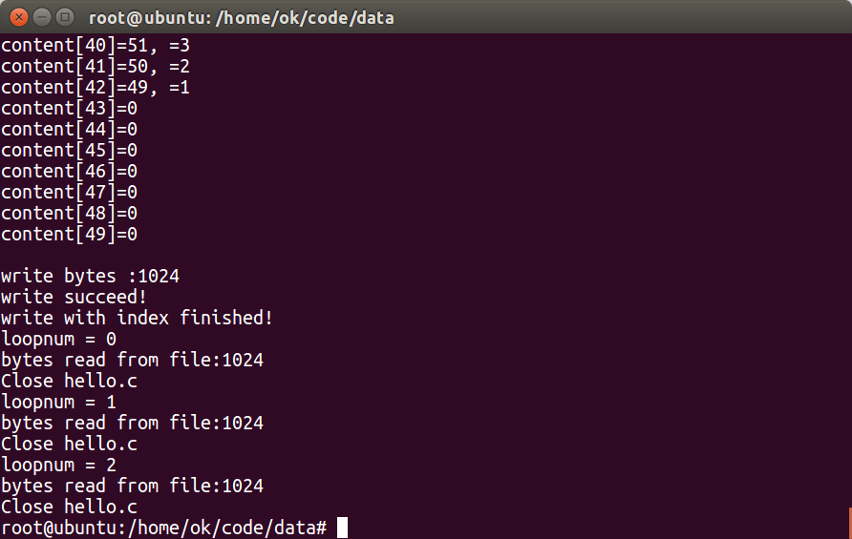

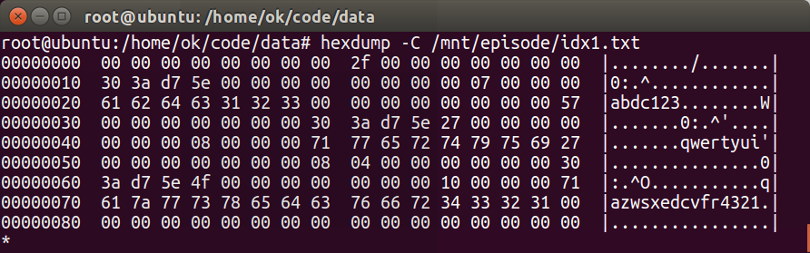
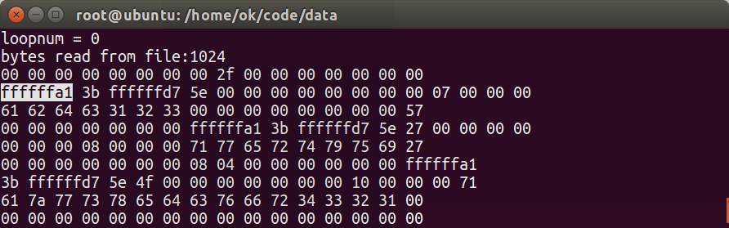
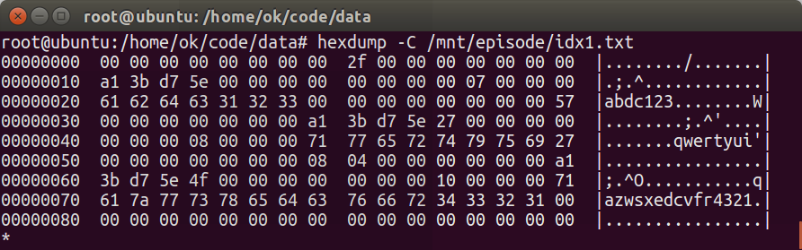
可以发现，我们读出来的和文件内容是一致的。之所以显示不一样，是因为我们按照字节打印，它是当作有符号来打印的，对于大于0x80的，会用0xffffff作为前缀。原因是对于有符号的16进制数，如负数(-1)为0xff。然后到printf中以十六进制输出，由于printf中的格式化字符串%x要求输出数据类型为无符号16进制整数，且%x对应数据类型为unsigned int，因此首先进行有符号扩展（从8位变成了32位），从signed char(0xff即8位-1)到signed int(0xffffffff，即32位的-1),再做无符号扩展，从signed int到unsigned int(0xffffffff，即32位的无符号数ffffffff)。

2. 修改generic_file_buffered_read为episode_file_buffered_read
在file.c增加三个函数：
static ssize_t episode_file_read_iter(struct kiocb *iocb, struct iov_iter *iter)
{
size_t count = iov_iter_count(iter);//获取要读到的遍历器指向的用户空间缓冲区的长度，即iov_inter中的count字段,//linux/uio.h中
ssize_t retval = 0;

if (!count)
goto out; /* skip atime */
//init_sync_kiocb中对ki_flags进行了赋值。iocb.ki_flags = iocb_flags(filp)
//暂不支持DIRECT，只使用缓存
if (iocb->ki_flags & IOCB_DIRECT) {//如果文件打开方式中用了DIRECT标记
retval = -1;
goto out;
}

retval = episode_file_buffered_read(iocb, iter, retval);//7.我们一般采用这种方式读取数据到用户态的缓冲区
out:
return retval;
}

/**
* episode_file_buffered_read - episode file read routine
* @iocb: the iocb to read，iocb是和filp绑定的，
* @iter: data destination，与用户态的一块buf绑定
* @written: already copied
*
* This is a generic file read routine, and uses the
* mapping->a_ops->readpage() function for the actual low-level stuff.
*
* This is really ugly. But the goto's actually try to clarify some
* of the logic when it comes to error handling etc.
*/
static ssize_t episode_file_buffered_read(struct kiocb *iocb,
struct iov_iter *iter, ssize_t written)
{
struct file *filp = iocb->ki_filp;//从iocb中拿到文件指针，
struct address_space *mapping = filp->f_mapping;//获得文件对应的address_space对象，其实就是inode对应的address_space对象。
struct inode *inode = mapping->host;//该address_space 对象mapping对应的inode
struct file_ra_state *ra = &filp->f_ra;//文件预读相关的
loff_t *ppos = &iocb->ki_pos; //long long 类型
pgoff_t index; //unsigned long类型，该页描述结构在地址空间radix树page_tree中的对象索引号即页号, 表示该页在vm_file中的偏移页数
pgoff_t last_index;
pgoff_t prev_index;
unsigned long offset; /* offset into pagecache page */
unsigned int prev_offset;
int error = 0;

if (unlikely(*ppos >= inode->i_sb->s_maxbytes))
return 0;
iov_iter_truncate(iter, inode->i_sb->s_maxbytes);

index = *ppos >> PAGE_SHIFT;
prev_index = ra->prev_pos >> PAGE_SHIFT;
prev_offset = ra->prev_pos & (PAGE_SIZE-1);
last_index = (*ppos + iter->count + PAGE_SIZE-1) >> PAGE_SHIFT;
offset = *ppos & ~PAGE_MASK;

for (;;) {
struct page *page;
pgoff_t end_index;
loff_t isize;
unsigned long nr, ret;

cond_resched();
find_page:
if (fatal_signal_pending(current)) {
error = -EINTR;
goto out;
}

page = find_get_page(mapping, index);
if (!page) {
if (iocb->ki_flags & IOCB_NOWAIT)
goto would_block;
page_cache_sync_readahead(mapping,
ra, filp,
index, last_index - index);
page = find_get_page(mapping, index);
if (unlikely(page == NULL))
goto no_cached_page;
}
if (PageReadahead(page)) {
page_cache_async_readahead(mapping,
ra, filp, page,
index, last_index - index);
}
if (!PageUptodate(page)) {
if (iocb->ki_flags & IOCB_NOWAIT) {
put_page(page);
goto would_block;
}

/*
* See comment in do_read_cache_page on why
* wait_on_page_locked is used to avoid unnecessarily
* serialisations and why it's safe.
*/
error = wait_on_page_locked_killable(page);
if (unlikely(error))
goto readpage_error;
if (PageUptodate(page))
goto page_ok;

if (inode->i_blkbits == PAGE_SHIFT ||
!mapping->a_ops->is_partially_uptodate)
goto page_not_up_to_date;
/* pipes can't handle partially uptodate pages */
if (unlikely(iter->type & ITER_PIPE))
goto page_not_up_to_date;
if (!trylock_page(page))
goto page_not_up_to_date;
/* Did it get truncated before we got the lock? */
if (!page->mapping)
goto page_not_up_to_date_locked;
if (!mapping->a_ops->is_partially_uptodate(page,
offset, iter->count))
goto page_not_up_to_date_locked;
unlock_page(page);
}
page_ok:
/*
* i_size must be checked after we know the page is Uptodate.
*
* Checking i_size after the check allows us to calculate
* the correct value for "nr", which means the zero-filled
* part of the page is not copied back to userspace (unless
* another truncate extends the file - this is desired though).
*/

isize = i_size_read(inode);
end_index = (isize - 1) >> PAGE_SHIFT;
if (unlikely(!isize || index > end_index)) {
put_page(page);
goto out;
}

/* nr is the maximum number of bytes to copy from this page */
nr = PAGE_SIZE;
if (index == end_index) {
nr = ((isize - 1) & ~PAGE_MASK) + 1;
if (nr <= offset) {
put_page(page);
goto out;
}
}
nr = nr - offset;

/* If users can be writing to this page using arbitrary
* virtual addresses, take care about potential aliasing
* before reading the page on the kernel side.
*/
if (mapping_writably_mapped(mapping))
flush_dcache_page(page);

/*
* When a sequential read accesses a page several times,
* only mark it as accessed the first time.
*/
if (prev_index != index || offset != prev_offset)
mark_page_accessed(page);
prev_index = index;

/*
* Ok, we have the page, and it's up-to-date, so
* now we can copy it to user space...
*/

ret = copy_page_to_iter(page, offset, nr, iter);
offset += ret;
index += offset >> PAGE_SHIFT;
offset &= ~PAGE_MASK;
prev_offset = offset;

put_page(page);
written += ret;
if (!iov_iter_count(iter))
goto out;
if (ret < nr) {
error = -EFAULT;
goto out;
}
continue;

page_not_up_to_date:
/* Get exclusive access to the page ... */
error = lock_page_killable(page);
if (unlikely(error))
goto readpage_error;

page_not_up_to_date_locked:
/* Did it get truncated before we got the lock? */
if (!page->mapping) {
unlock_page(page);
put_page(page);
continue;
}

/* Did somebody else fill it already? */
if (PageUptodate(page)) {
unlock_page(page);
goto page_ok;
}

readpage:
/*
* A previous I/O error may have been due to temporary
* failures, eg. multipath errors.
* PG_error will be set again if readpage fails.
*/
ClearPageError(page);
/* Start the actual read. The read will unlock the page. */
error = mapping->a_ops->readpage(filp, page); //8. 调用episode的readpage（）函数

if (unlikely(error)) {
if (error == AOP_TRUNCATED_PAGE) {
put_page(page);
error = 0;
goto find_page;
}
goto readpage_error;
}

if (!PageUptodate(page)) {
error = lock_page_killable(page);
if (unlikely(error))
goto readpage_error;
if (!PageUptodate(page)) {
if (page->mapping == NULL) {
/*
* invalidate_mapping_pages got it
*/
unlock_page(page);
put_page(page);
goto find_page;
}
unlock_page(page);
shrink_readahead_size_eio(filp, ra);
error = -EIO;
goto readpage_error;
}
unlock_page(page);
}

goto page_ok;

readpage_error:
/* UHHUH! A synchronous read error occurred. Report it */
put_page(page);
goto out;

no_cached_page:
/*
* Ok, it wasn't cached, so we need to create a new
* page..
*/
page = page_cache_alloc(mapping);
if (!page) {
error = -ENOMEM;
goto out;
}
error = add_to_page_cache_lru(page, mapping, index,
mapping_gfp_constraint(mapping, GFP_KERNEL));
if (error) {
put_page(page);
if (error == -EEXIST) {
error = 0;
goto find_page;
}
goto out;
}
goto readpage;
}

would_block:
error = -EAGAIN;
out:
ra->prev_pos = prev_index;
ra->prev_pos <<= PAGE_SHIFT;
ra->prev_pos |= prev_offset;

*ppos = ((loff_t)index << PAGE_SHIFT) + offset;
file_accessed(filp);
return written ? written : error;
}

/*
* CD/DVDs are error prone. When a medium error occurs, the driver may fail
* a _large_ part of the i/o request. Imagine the worst scenario:
*
* ---R__________________________________________B__________
* ^ reading here ^ bad block(assume 4k)
*
* read(R) => miss => readahead(R...B) => media error => frustrating retries
* => failing the whole request => read(R) => read(R+1) =>
* readahead(R+1...B+1) => bang => read(R+2) => read(R+3) =>
* readahead(R+3...B+2) => bang => read(R+3) => read(R+4) =>
* readahead(R+4...B+3) => bang => read(R+4) => read(R+5) => ......
*
* It is going insane. Fix it by quickly scaling down the readahead size.
*/
static void shrink_readahead_size_eio(struct file *filp,
struct file_ra_state *ra)
{
ra->ra_pages /= 4;
}

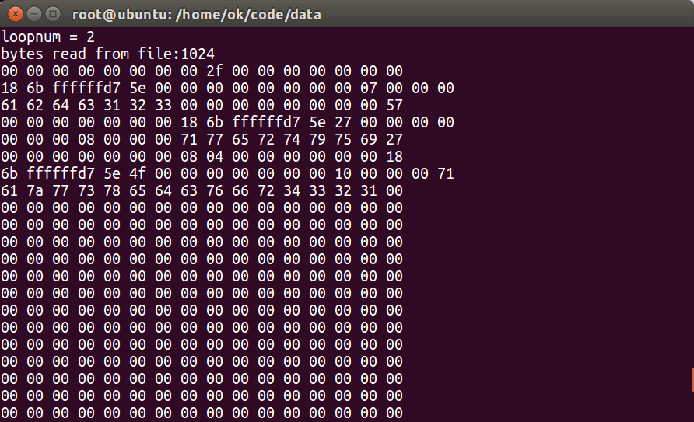

3. 修改episode_file_buffered_read内部实现，实现数据解封装
static ssize_t episode_file_buffered_read(struct kiocb *iocb,
struct iov_iter *iter, ssize_t written)
{
struct file *filp = iocb->ki_filp; //从iocb中拿到文件指针，
struct address_space *mapping = filp->f_mapping; //获得文件对应的address_space对象，其实就是inode对应的address_space对象。
struct inode *inode = mapping->host; //该address_space 对象mapping对应的inode
struct file_ra_state *ra = &filp->f_ra; //文件预读相关的
loff_t *ppos = &iocb->ki_pos; //long long 类型
pgoff_t index; //unsigned long类型，该页描述结构在地址空间radix树page_tree中的对象索引号即页号, 表示该页在vm_file中的偏移页数
pgoff_t last_index;
pgoff_t prev_index;
unsigned long offset; /* offset into pagecache page */
unsigned int prev_offset;
int error = 0;
char * buff;
char *buff2;
unsigned int curPos = 0,curPos2 = 0;//buff和buff2中的游标
uint64_t prev,next,cur,base;
uint32_t time,recLen,recNum = 0;

int i;

if (unlikely(*ppos >= inode->i_sb->s_maxbytes)) //超出最大文件长度
return 0;
iov_iter_truncate(iter, inode->i_sb->s_maxbytes); //什么也没做。目的是确认iter->count是个正常的值，不会超长

index = *ppos >> PAGE_SHIFT; //计算ppos对应的位置应该在本文件的第几个页缓存中。相当于*ppos/4096,注意，这里的页缓存编号从0开始
prev_index = ra->prev_pos >> PAGE_SHIFT; //上次预读的起始页面id
prev_offset = ra->prev_pos & (PAGE_SIZE - 1); //上次预读的页内偏移量
//上面这两个变量可能会连同本次读的page一起用于更高层次的函数，判断使用哪种预读策略。注意：预读指的是从磁盘上预先读取数据放到缓存中，别搞错了
last_index = (*ppos + iter->count + PAGE_SIZE - 1) >> PAGE_SHIFT; //计算这次读，会涉及到的最后一个页的id
offset = *ppos & ~PAGE_MASK; //和index配合，ppos所在页面的偏移量。个人认为，有了index+offset可以确定读的起始位置，last_index确定要读到的结束页面
//至于预读干啥用，还不清楚啊，
//若PAGE_SIZE为4096，则PAGE_MASK为4095，二进制为000000000000000000000000111111111111

for (;;)
{
struct page *page;
pgoff_t end_index;
loff_t isize;
unsigned long nr, ret;

cond_resched();
find_page:
if (fatal_signal_pending(current))
{
error = -EINTR;
goto out;
}

page = find_get_page(mapping, index); /*在radix树中查找相应的page*/
if (!page)
{
/* 如果没有找到page，内存中没有将数据,先进行预读，从磁盘上预读一定量的数据到页缓存中 */
if (iocb->ki_flags & IOCB_NOWAIT) //阻塞
goto would_block;
//发出一个同步预读请求。预读机制很大程度上能够保证数据已经进入缓存
page_cache_sync_readahead(mapping, ra, filp, index, last_index - index);
page = find_get_page(mapping, index); //再次查找需要的页是否已经在内存缓存中
if (unlikely(page == NULL)) //如果还是没有找到，则跳到no_cached_page，直接进行读取操作
goto no_cached_page;
}
//
if (PageReadahead(page))
{ //判断page是否设置了PageReadahead标记，如果设置了，说明这次读的数据是上次读的后续，两次读是顺序的，因此可以进一步多读一些，此时则内核会采用更加激进的异步预读。
//既然已经在缓存中找到了page，为啥还需要进一步异步预读呢？
page_cache_async_readahead(mapping, ra, filp, page, index, last_index - index);
}
if (!PageUptodate(page))
{ //检查page是否是最新的
//这里是处理页不是最新的逻辑
if (iocb->ki_flags & IOCB_NOWAIT)
{
put_page(page);
goto would_block;
}

/*
* See comment in do_read_cache_page on why
* wait_on_page_locked is used to avoid unnecessarily
* serialisations and why it's safe.
*/
error = wait_on_page_locked_killable(page);
//wait_on_page_locked_killable 的阻塞一般发生在 do_page_fault 里, 也就是在应用程序访问虚拟内存时发生的, 众所周知, do_page_fault 是在用户空间进程访问没有实际物理内存的虚拟内存时, 产生了缺页中断, 然后陷入到内核空间执行的函数.
//https://blog.csdn.net/qkhhyga2016/article/details/79540119
if (unlikely(error)) //error不是0，则if成立
goto readpage_error;
if (PageUptodate(page)) //现在是最新的页了
goto page_ok;
//页仍然不是最新的
if (inode->i_blkbits == PAGE_SHIFT ||
!mapping->a_ops->is_partially_uptodate) //我们没有设定这个函数
goto page_not_up_to_date;
/* pipes can't handle partially uptodate pages */
if (unlikely(iter->type & ITER_PIPE))
goto page_not_up_to_date;
if (!trylock_page(page))
goto page_not_up_to_date;
/* Did it get truncated before we got the lock? */
if (!page->mapping)
goto page_not_up_to_date_locked;
if (!mapping->a_ops->is_partially_uptodate(page,
offset, iter->count))
goto page_not_up_to_date_locked;
unlock_page(page);
}
page_ok: /* 数据内容是最新的 */
/*下面这段代码是在page中的内容ok的情况下将page中的内容拷贝到用户空间去，主要的逻辑分为检查参数是否合法进性拷贝操作*/
/*合法性检查*/
isize = i_size_read(inode);
end_index = (isize - 1) >> PAGE_SHIFT;
// printk("end_index:%d,index:%d,isize:%ld， unlikely(!isize || index > end_index)：%d,(!isize || index > end_index):%d,unlikely(0):%d,unlikely(1):%d,likely(1):%d,likely(2):%d,likely(0):%d\n",end_index,index,isize,unlikely(!isize || index > end_index),(!isize || index > end_index),unlikely(0),unlikely(1),likely(1),likely(2),likely(0));
if (unlikely(!isize || index > end_index))
{ //unlikely(true) =true; unlikely(false)=false;
printk("I am here!!!!!!!\n"); //这句不会执行
put_page(page);
goto out;
}

/* nr是能从本page中copy的最大字节数，显然就是Page_size了 */
nr = PAGE_SIZE;
if (index == end_index)
{ //最后一個页面，此时还没有写满，是有可能的。
nr = ((isize - 1) & ~PAGE_MASK) + 1; //最后一个页里面所含有的字节数
if (nr <= offset)
{ //出错了
put_page(page);
goto out;
}
}
nr = nr - offset; //要读取的字节数？

/* If users can be writing to this page using arbitrary
* virtual addresses, take care about potential aliasing
* before reading the page on the kernel side.
*/
if (mapping_writably_mapped(mapping))
flush_dcache_page(page);

/*
* When a sequential read accesses a page several times,
* only mark it as accessed the first time.
*/
if (prev_index != index || offset != prev_offset)
mark_page_accessed(page);
prev_index = index;

/*
* 到此为止，我们已经拿到了所需要的pages，并且它们都是最新的,下一步，就可以把这些pages从内核空间复制到用户空间了。
*/
printk("iter->nsegs:%u,iter->count:%u,iov_base:%p,offset:%d,nr:%d",iter->nr_segs,iter->count,iter->iov->iov_base,offset,nr);
printk("before copy page to iter, offset:%u, nr:%u",offset, nr);
//ret = copy_page_to_iter(page, offset, nr, iter);//如果后面的逻辑能处理好，是否是先将page中的内容复制到buff中，然后读取buff进行处理，结果放到buff2中，然后复制到iter中？
printk("after copy page to iter, offset:%u, nr:%u, ret:%u",offset, nr, ret);
//将页缓存中的内容copy到用户态的缓冲区(iter的iov指针对象），如果修改这边，则需要重新定义copy_page_to_iter()，然后不是一次将多个页面直接copy过来，
//而是按照记录的粒度在内核态内部进行处理，但是涉及到page重组等问题，其实可能更麻烦。比较容易处理的方式，是在episode_file_read_iter中
//对返回的iter和iovec进行处理。我们暂时就采用这种方式。
printk("iter->nsegs:%u,iter->count:%u,iov_base:%p,offset:%d,nr:%d",iter->nr_segs,iter->count,iter->iov->iov_base,offset,nr);
buff = (char*)kmalloc(4096,GFP_KERNEL);
memset(buff,0,4096);
memcpy_from_page(buff, page,offset,nr);
for( i=0;i<120;i++) printk("buff[%d]:%d",i,buff[i]);
//从buff中去掉index信息，放到buff2中
buff2 = (char*) kmalloc(4096,GFP_KERNEL);
memset(buff2,0,4096);
curPos =0;
while(curPos < 4096){
memcpy(&prev,buff+curPos,sizeof(prev));
memcpy(&next,buff+curPos+sizeof(prev),sizeof(next));
memcpy(&time,buff+curPos+sizeof(prev)+sizeof(next),sizeof(time));
memcpy(&cur,buff+curPos+sizeof(prev)+sizeof(next)+sizeof(time),sizeof(cur));
memcpy(&recLen,buff+curPos+sizeof(prev)+sizeof(next)+sizeof(time)+sizeof(cur),sizeof(recLen));
printk("prev:%ul, next:%ul, time:%u, cur:%ul, recLen:%u, buff+curPos:%p",prev,next,time,cur, recLen,buff+curPos);
memcpy(buff2+curPos2, buff+curPos+sizeof(prev)+sizeof(next)+sizeof(time)+sizeof(cur), sizeof(recLen)+recLen);
curPos2 = curPos2 + sizeof(recLen) +recLen;
recNum ++;
if(recNum == 1){
base = cur;
}
if(next - base > 4096) break;
curPos = curPos +sizeof(prev)+sizeof(next)+sizeof(time)+sizeof(cur) +sizeof(recLen) + recLen;
if(curPos != next - base - sizeof(prev)) {
curPos = next- base - sizeof(prev);
}
}
printk("curPos2:%u",curPos2);
for( i=0;i<curPos2;){
printk("buff2[%d]: %02x %02x %02x %02x %02x %02x %02x %02x %02x %02x %02x %02x %02x %02x %02x %02x",
i,buff2[i],buff2[i+1],buff2[i+2],buff2[i+3],buff2[i+4],buff2[i+5],buff2[i+6],buff2[i+7],buff2[i+8],buff2[i+9],buff2[i+10],buff2[i+11],buff2[i+12],buff2[i+13],buff2[i+14],buff2[i+15]);
i =i+16;
}
memcpy_to_page(page,offset,buff2,nr);
ret = copy_page_to_iter(page, offset, nr, iter);
offset += ret;
printk("offset:%u",offset);
index += offset >> PAGE_SHIFT;
offset &= ~PAGE_MASK;
prev_offset = offset;
printk("after copy page to iter and update, offset:%u, nr:%u, index:%u",offset, nr, index);
put_page(page);
written += ret;
if (!iov_iter_count(iter))
goto out;
if (ret < nr)
{
error = -EFAULT;
goto out;
}
continue;

page_not_up_to_date:
/* Get exclusive access to the page ... */
error = lock_page_killable(page);
if (unlikely(error))
goto readpage_error;

page_not_up_to_date_locked:
/* Did it get truncated before we got the lock? */
if (!page->mapping)
{
unlock_page(page);
put_page(page);
continue;
}

/* Did somebody else fill it already? */
if (PageUptodate(page))
{
unlock_page(page);
goto page_ok;
}

readpage:
/*
* A previous I/O error may have been due to temporary
* failures, eg. multipath errors.
* PG_error will be set again if readpage fails.
*/
ClearPageError(page);
/* Start the actual read. The read will unlock the page. */
error = mapping->a_ops->readpage(filp, page); //8. 调用episode的readpage（）函数

if (unlikely(error))
{
if (error == AOP_TRUNCATED_PAGE)
{
put_page(page);
error = 0;
goto find_page;
}
goto readpage_error;
}

if (!PageUptodate(page))
{
error = lock_page_killable(page);
if (unlikely(error))
goto readpage_error;
if (!PageUptodate(page))
{
if (page->mapping == NULL)
{
/*
* invalidate_mapping_pages got it
*/
unlock_page(page);
put_page(page);
goto find_page;
}
unlock_page(page);
shrink_readahead_size_eio(filp, ra);
error = -EIO;
goto readpage_error;
}
unlock_page(page);
}

goto page_ok;

readpage_error:
/* UHHUH! A synchronous read error occurred. Report it */
put_page(page);
goto out;

no_cached_page:
/*
* Ok, it wasn't cached, so we need to create a new
* page..
*/
page = page_cache_alloc(mapping); //在缓存中申请一个页
if (!page)
{ //内存分配失败
error = -ENOMEM;
goto out;
}
error = add_to_page_cache_lru(page, mapping, index,
mapping_gfp_constraint(mapping, GFP_KERNEL)); //将新申请的页挂到缓存区的链表（LRU表)中
if (error)
{
put_page(page); //释放页
if (error == -EEXIST)
{ //如果在将新页挂到链表时发现这个page已经存在了（其他操作已经挂上去了），则这个不用挂了，直接返回到find_page
error = 0;
goto find_page;
}
goto out;
}
goto readpage; //挂链完成，下面就可以读page的内容啦
}

would_block:
error = -EAGAIN;
out:
ra->prev_pos = prev_index;
ra->prev_pos <<= PAGE_SHIFT;
ra->prev_pos |= prev_offset;

*ppos = ((loff_t)index << PAGE_SHIFT) + offset;
file_accessed(filp);
return written ? written : error;
}

这里之给出了主要函数，其他辅助函数没有给出。主要思路是：在得到了要读取的页面page之后，将之复制到临时缓冲区buff中，然后再申请一个临时缓冲区buff2。通过遍历buff，将解码后的数据放到buff2中，然后将buff2的内容放到iov_iter中。iov_iter会最终将解码后的数据返回给用户。

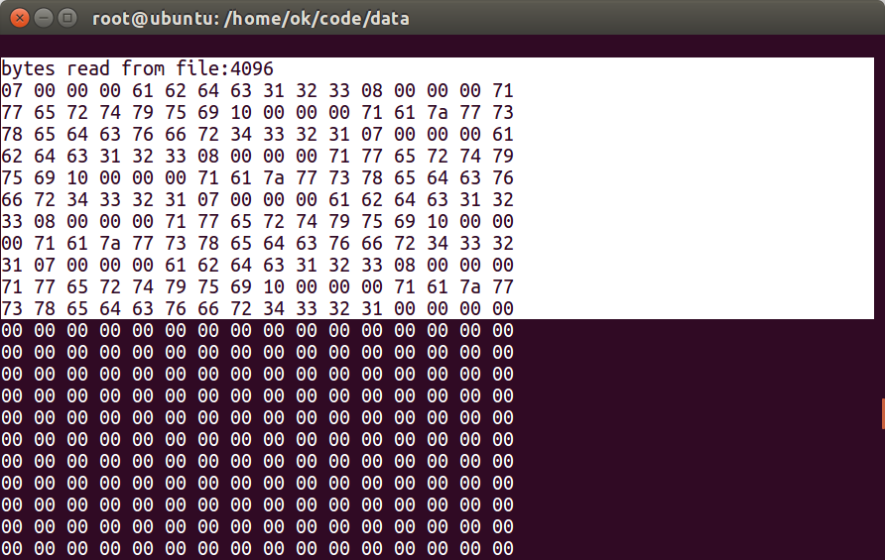
上述结果为按照4096的缓冲区读取的。但是引入另外一个问题:文件内容发生了变化！！！
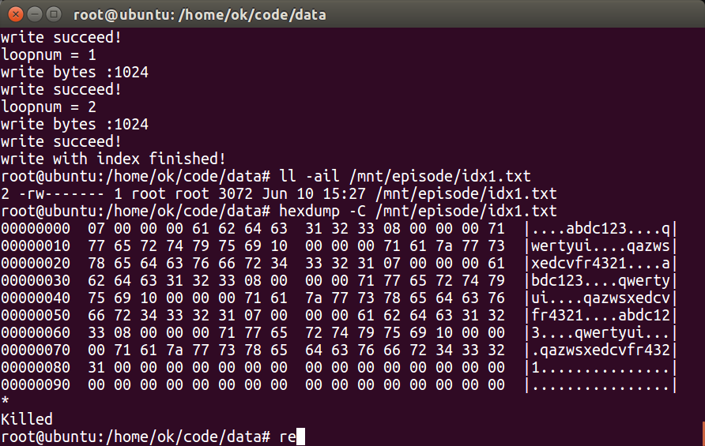
下面测试一下按照1024的缓冲区进行读取。

