Write 最终测试：
static ssize_t episode_direct_write(struct file *filp, const char __user *buf, size_t len, loff_t *ppos)
{
//构造新的buff，然后遍历buf，创建新的记录，填充到buff中。jsc 0510
/*******************************************************************
* Prev next timestamp offset len data
* 8 8 4 8 4 k
* ****************************************************************/
char * buff = NULL, *buff2=NULL;
__u32 pos = 0;//buf内的偏移量
// __u32 dataSizeinRec = 0;//buf内当前数据记录的数据段长度
__u32 tmp= 0;
__u32 bufLen = len,writeLen=0;//buf的长度
__u32 timestamp = 0;//时间戳
__u64 position=0;//与prev、next类型一致,nextPosition用于buff2中记录next字段的位置
__u64 prev = 0,next = 0,offset = 0;//在文件中，当前记录的前一个记录的起始位置、next字段起始位置，以及当前记录的数据段位置
char lenSeg[4]={0},time[sizeof(timestamp)]={0};//用于记录长度和时间的临时变量
__u32 recLen=0,lastRecLen=0,recNum=0,additionalLen=0,totalNeedforBuff2=0;//lastRecLen记录上一条数据的长度，用途是用于确定最后一条数据的next字段的起始位置
char * ptr8;
int i,testcount=0;
__u64 tmpLen;
__u64 curPos,basePos;
__u64 lastRecPos = 0;
int retnum = 0;
//读取inode中的上一条记录的位置，jsc 0510
struct episode_inode * raw_inode;
struct inode * inode = file_inode(filp);
struct episode_inode_info *episode_inode = episode_i(inode);
struct kiocb kiocb;
struct iov_iter iter;
ssize_t ret;
struct iovec iov;

if(!inode){
printk("The inode got from the filp %s is null!\n",filp->f_path.dentry->d_iname);
}
if(!episode_inode){
printk("The episode_inode got from the inode is null!\n");
}
additionalLen = sizeof(prev)+sizeof(next)+sizeof(offset)+sizeof(time);
printk("I am here! and the user buf size is %d\n" ,len);
lastRecPos = episode_inode->i_lastrecordpos;
tmpLen = i_lastrecordpos(inode);
curPos = inode->i_size;//文件游标位置,也是这次写操作的base
basePos = curPos;
printk("The last data record position: %ld\t tmpLen=%lld\n current postion:%ld\n",lastRecPos,tmpLen,curPos);
if(len%512 != 0)
{
printk("user buf len %lu mod 512!=0, now return -1! \n",len);
return -1;
}
printk("len=%d\n",len);
//这里，后续可以先读取一遍buf，得到具体的record数量n，因为对于每条record，扩展需要添加的字节数是固定的，8+8+8+4=28字节，则比原来需要增加28n字节，然后将len+28n向上取512的整数倍，即为buff的长度
//buff =(char *) kmalloc((1+len/512)*512, GFP_KERNEL);//buff存储的内容和buf一样，只不过是内核态的空间
buff = (char*)kmalloc(len,GFP_KERNEL);
//printk("ater kmalloc, buff:");
// for(i=0;i<1024;i++) printk("buff[%d]=%u",i,buff[i]<0?(255+buff[i]):buff[i]);
memset(buff,0,len);
// printk("ater memset, buff:");
//for(i=0;i<1024;i++) printk("buff[%d]=%u",i,buff[i]<0?(255+buff[i]):buff[i]);
if(!buff)
{
printk("kmalloc failed for the buff!\n");
}
printk("buff size %d\n",sizeof(buff));
//给buff赋值
retnum = copy_from_user(buff,buf,1024);
//printk("ater copy from user, buff:");
//for(i=0; i<len; i++) printk("buff[%d]=%d, ",i,buff[i]);
printk(" I am here 3! retnum=%d for the function copy_from_user(). pos=%d, bufLen=%d\n",retnum,pos,bufLen);
//遍历buff，获取记录数，并确定要扩展的长度，最终确定buff2有多长
pos=0;
while(pos<bufLen-1){
memcpy(&recLen,&buff[pos],sizeof(recLen));
if(recLen == 0){
break;
}
pos = pos+recLen+sizeof(recLen);
recNum++;
}
totalNeedforBuff2 = pos+recNum*additionalLen;
if(totalNeedforBuff2%512!=0){
totalNeedforBuff2 = (1+(int)totalNeedforBuff2/512)*512;
}
//因为当前版本中，对于buff2长度超过buf的时候，没法处理（因为要把buff2的内容通过copy to user赋值给buf，就会出现溢出），所以，这里加判断，是否会溢出，溢出则返回。
if(totalNeedforBuff2 > len) {
printk("Not enough space for index extention in the buf!!!");
return -1;
}
printk("total need for buff2 is %ld, and there are %d records in buf, real data in buf is %d!\n",totalNeedforBuff2,recNum,pos);
buff2 = (char *)kmalloc(len, GFP_KERNEL);
memset(buff2,0,len);
// printk("size of buff2:%d\n",sizeof(buff2));
pos = 0;
//这里bufLen=0,是有问题的
while(pos < bufLen-1){ //遍历buf中的每一条记录，进行扩充，形成新的结构，然后放到buff中。
// mid_char(&lenSeg[0], buf, 4, pos);//获取buf中一条记录的长度字段
// printk("Address of reLen : %x, buff:%x\n",&recLen,buff);
memcpy(&recLen,&buff[pos],sizeof(recLen));
printk(" I am here 4! and recLen=%d\n",recLen);
if(recLen == 0) {
printk("Reach the end of the records in buff!");
//Todo 设定本buff2中最后一条数据的next指向为下一个buff2的第8字节
next = basePos+len+sizeof(next);
printk("next=%ul\n",next);
// memcpy(&buff2[curPos-lastRecLen - sizeof(recLen)-sizeof(timestamp)-sizeof(offset)-sizeof(next)],&next,sizeof(next));
memcpy(&buff2[lastRecPos-basePos+sizeof(prev)],&next,sizeof(next));
break;//跳出while，也就是buf中已经没有新记录了。
}
//构造索引结构和索引信息
//prev,next,timestamp,offset,len,data
prev = lastRecPos;
next = curPos+sizeof(prev)+sizeof(next)+sizeof(timestamp)+sizeof(offset)+sizeof(recLen)+recLen+sizeof(prev);
// nextPosition =
timestamp = getCurrentTime();
offset = curPos;
//printk("Current time: %d, prev=%ld, next=%ld,recLen=%d,offset=%ld, and prev position=%ld\n",timestamp,prev,next,recLen,offset,position);
memcpy(&buff2[position],&prev,sizeof(prev));
printk("prev segment:");
for(i=0;i<sizeof(prev);i++) printk("buff2[%d]=%ud",position+i,buff2[position+i]<0 ? (255+buff2[position+i]):buff2[position+i]);
position = position +sizeof(prev);
memcpy(&buff2[position],&next,sizeof(next));
printk("next segment:");
for(i=0;i<sizeof(next);i++) printk("buff2[%d]=%ud",position+i,buff2[position+i]<0 ? (255+buff2[position+i]):buff2[position+i]);
position = position +sizeof(next);
memcpy(&buff2[position],&timestamp,sizeof(timestamp));
printk("timestamp segment:");
for(i=0;i<sizeof(timestamp);i++) printk("buff2[%d]=%ud",position+i,buff2[position+i]<0 ? (255+buff2[position+i]):buff2[position+i]);
position = position +sizeof(timestamp);
memcpy(&buff2[position],&curPos,sizeof(curPos));
printk("offset segment:");
for(i=0;i<sizeof(offset);i++) printk("buff2[%d]=%ud",position+i,buff2[position+i]<0 ? (255+buff2[position+i]):buff2[position+i]);
position = position +sizeof(curPos);
//ptr8 = NULL;
/*
memcpy(&buff[position],lenSeg,sizeof(dataSizeinRec));
position = position +4;
memcpy(&buff[position],&buf[4],len-4);
position = position +len-4;
*/
//copy buf中该数据记录到buff中,替换上面的两次memcpy()调用
memcpy(&buff2[position],&buff[pos],sizeof(recLen)+recLen);
printk("recLen segment:");
for(i=0;i<sizeof(recLen);i++) printk("buff2[%d]=%ud",position+i,buff2[position+i]<0 ? (255+buff2[position+i]):buff2[position+i]);
printk("data segment:");
for(i=0;i<recLen; i++) printk("buff2[%d]=%c",position+i+sizeof(recLen),buff2[position+i+sizeof(recLen)]);
position = position+recLen+sizeof(recLen);
lastRecPos = curPos;
curPos =curPos+ sizeof(prev)+sizeof(next)+sizeof(timestamp)+sizeof(offset)+sizeof(recLen)+recLen;
printk("The start position of the next extended record is %ld\n",curPos);
pos = pos+sizeof(recLen)+recLen;
lastRecLen = recLen;
recLen = 0;
printk("current pos:%d\n",pos);
}
//Todo 增加最后一条数据的处理机制，指向本buf结束后的下一个位置。

printk("After extending,data size in buff2 is %d, data in buff2 are:\n",position);
for(i=0;i<position;i++){
if(buff2[i]<123 && buff2[i]>96) printk("buff2[%d]=%u, =%c",i,buff2[i]<0? (255+buff2[i]):buff2[i],buff2[i]);
else if(buff2[i]<91 && buff2[i]>64) printk("buff2[%d]=%u, =%c",i,buff2[i]<0? (255+buff2[i]):buff2[i],buff2[i]);
else if(buff2[i]<58 && buff2[i]>47) printk("buff2[%d]=%u, =%c",i,buff2[i]<0? (255+buff2[i]):buff2[i],buff2[i]);
else printk("buff2[%d]=%u,",i,buff2[i]<0? (255+buff2[i]):buff2[i]);
}
printk("\n");
retnum = clear_user(buf,len);//这里不敢把len改成其他长度，所以这里是有坑的！！！因为buf是用户态的，我们最多清理len长度。如果清理过长，会不会出问题？
printk("bytes can not be cleared in the user buf is %d/%d\n",retnum,len);
//retnum = copy_to_user(buf,buff2,totalNeedforBuff2);
retnum = copy_to_user(buf,buff2,len);//这里按照buff2的实际长度给用户态buf赋值。totalNeedforBuff2如果和len不相等，不知道会不会有问题。最好是len长一些。
printk("bytes cannot be copied to user space is retnum=%d for the function copty_to_user()\n",retnum);
//再次将buf中的内容copy到buff中，测试buf中是否有内容
/* printk("pos = %d\n",pos);
memset(buff,0,(1+len/512)*512);//和前面一致，要进行清零
for(i=0;i<(1+len/512)*512;i++) {
if(buff[i]==0) testcount++;
}
printk("after the memset, there are %d zeroes!\n",testcount);
retnum = copy_from_user(buff,buf,len);
printk("bytes cannot be copied to kernel space is %d/%d for the function copty_from_user()\n",retnum,len);
testcount = 0;
for(i=0;i<len;i++) {
if(buff[i]==0) testcount++;
printk("buff[%d]=%u",i,buff[i]<0? (255+buff[i]):buff[i]);
}
printk("after the copy_from_user, there are %d zeroes!\n",testcount);
*/
//修改buf，jsc
/* if(len<totalNeedforBuff2) writeLen = totalNeedforBuff2;
else writeLen = len;*/
writeLen = len;

// struct iovec iov = { .iov_base = (void __user *)buf, .iov_len = len };
iov.iov_base = (void __user *)buf;
//iov.iov_len = position+1;//此时buff的长度应为512整数倍。但这里的position+1却不一定，所以这里填写什么需要确认一下
//iov.iov_len = len;
iov.iov_len = writeLen; //这里也要进行修改

init_kiocb(&kiocb, filp);
kiocb.ki_pos = *ppos;
//iov_iter_init(&iter, WRITE, &iov, 1, len);//
iov_iter_init(&iter, WRITE, &iov, 1, writeLen);//
ret = generic_file_write_iter(&kiocb, &iter);

BUG_ON(ret == -EIOCBQUEUED);
if (ret > 0){
*ppos = kiocb.ki_pos;
//最后一条的写入位置，即offset需要保留到inode中。
episode_inode->i_lastrecordpos = offset;//这个不知道能不能写回？
}
kfree(buff);
kfree(buff2);
return ret;
}

就目前的实现来说，我们假定用户态的buf留有足够的空间容纳扩展buf中原来的数据。也就是说buf中的数据经过扩展后，buf还能存得下。

在用户态的writeIdx.c中设定memalign(512,512*2)的情况下，输出：
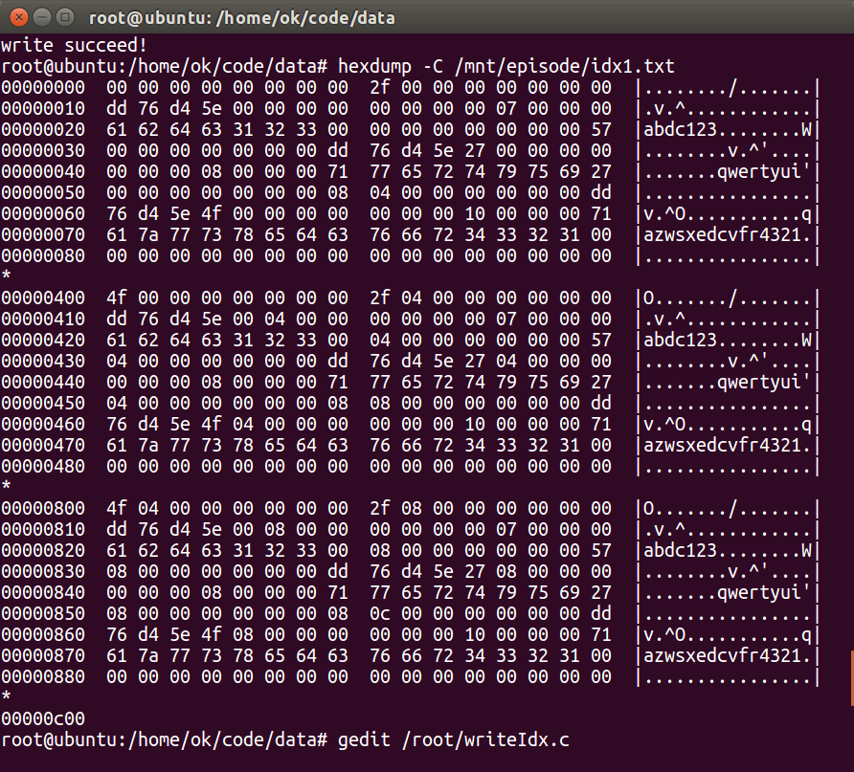
下面我们调整为memalign(512,3*512)的情况下，输出：
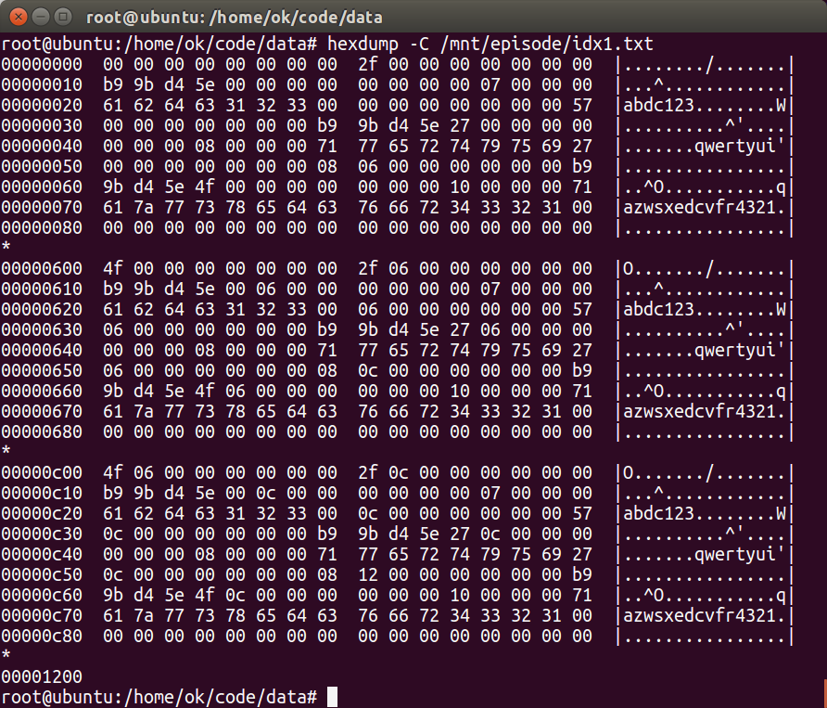
下面我们调整为memalign(512,512)的情况下，执行到insmod出错。这应该是memalign造成的，只要memalign的参数第一个是2的整数幂，第二个参数是第一个整数倍（大于1）即可。

