**Lab Exercise 11– Terraform AWS Provider Configuration**

**Name- Zuhair Ahmad**

**SAP ID- 500119134**

**Batch- 1**

## Exercise Steps:

**Step 1: Create a New Directory:**

Create a new directory for your Terraform configuration:

## “Terraform-Demo”

**Step 2: Create Terraform Configuration File (main.tf):**

Create a file named main.tf with the following content:

terraform { required_providers { aws = {

source = "hashicorp/aws" version = "5.30.0"

}

}

}

provider "aws" {

}

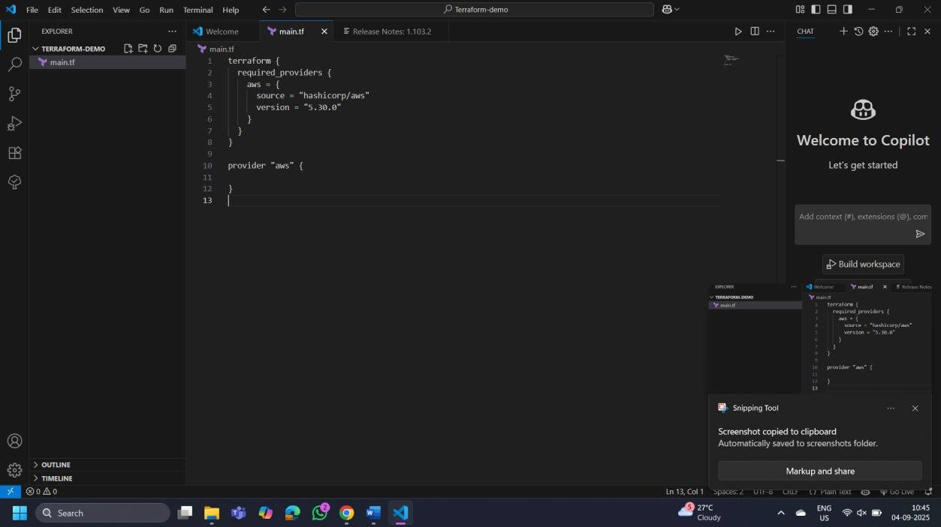

## Step 3: Initialize Terraform:

Run the following command to initialize your Terraform working directory:

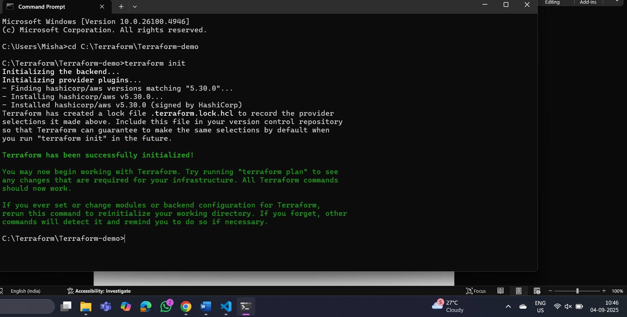

**terraform init**