**Lab Exercise 12– Terraform IAM User Setting**

**Name- Zuhair Ahmad**

**SAP ID- 500119134**

**Batch- 1**

## Prerequisites: Terraform Installed: Make sure you have Terraform installed on your machine. Follow the official installation guide if needed.

AWS Credentials: Ensure you have AWS credentials (Access Key ID and Secret Access Key) configured. You can set them up using the AWS CLI or by setting environment variables.

## Exercise Steps:

**Step 1: Create a New Directory:**

Create a new directory for your Terraform configuration:

## “Terraform-Demo”

**Step 2: Create Terraform Configuration File (main.tf):**

Create a file named main.tf with the following content:

terraform { required_providers { aws = {

source = "hashicorp/aws" version = "5.31.0"

}

}

}

provider "aws" {

region = "ap-south-1"

access_key = "your IAM access key" secret_key = "your secret access key"

}

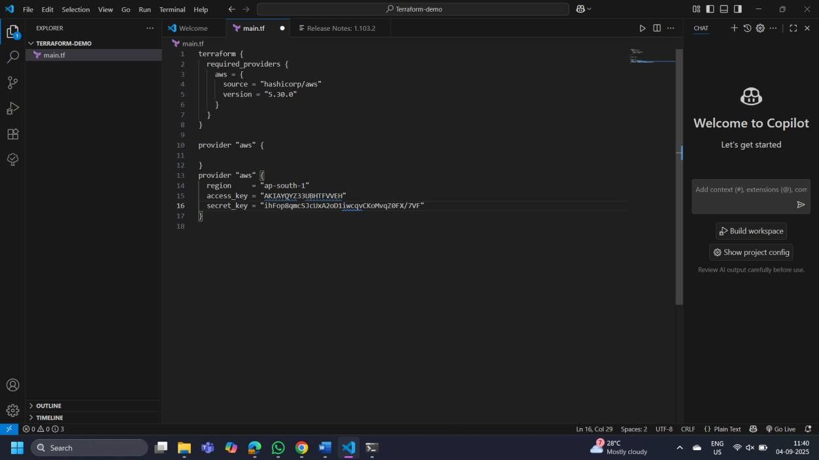

This script defines an AWS provider and provisions an EC2 instance.

## Step 3: Initialize Terraform:

Run the following command to initialize your Terraform working directory:

terraform init

