**Lab Exercise 14–Provisioning an S3 Bucket on AWS**

**Name- Zuhair Ahmad**

**SAP ID- 500119134**

**Batch- 1**

## Exercise Steps:

**Step 1: Create a New Directory:**

Create a new directory to store your Terraform configuration:

mkdir Terraform-S3-Demo cd Terraform-S3-Demo

## Step 2: Create the Terraform Configuration File (main.tf):

Create a file named main.tf with the following content:

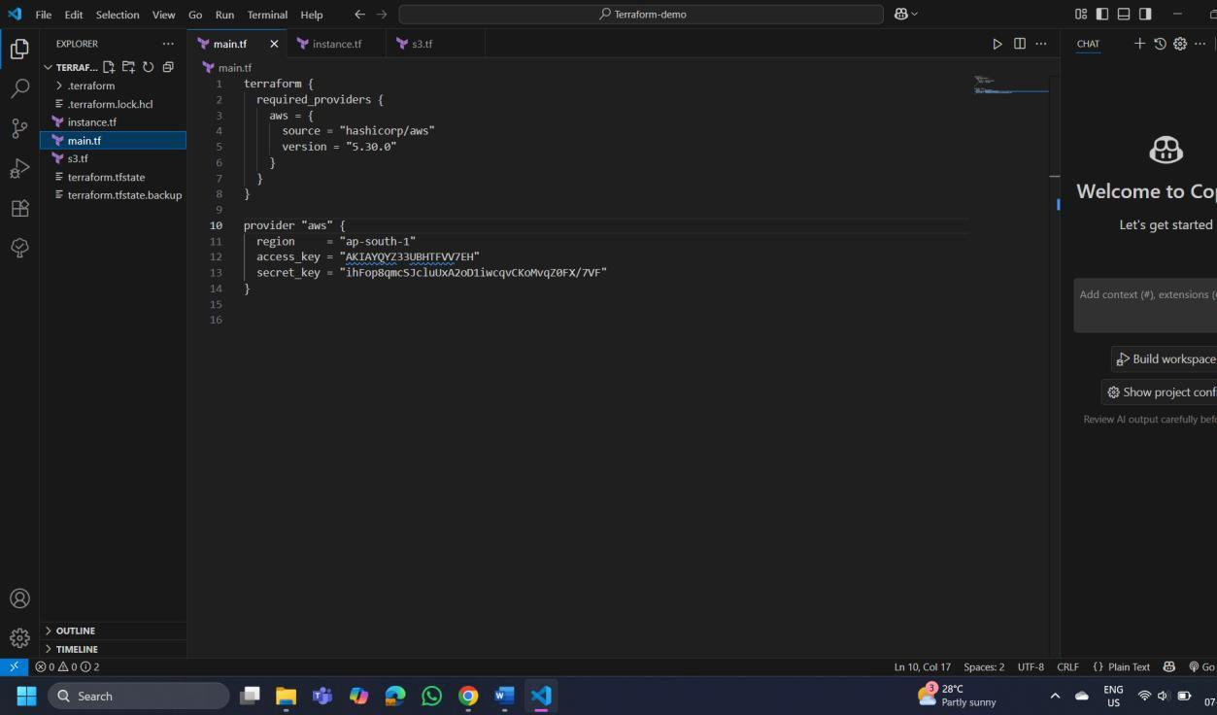

This file sets up the Terraform AWS provider.

## Step 3: Create a Terraform Configuration File for the S3 Bucket (s3.tf):

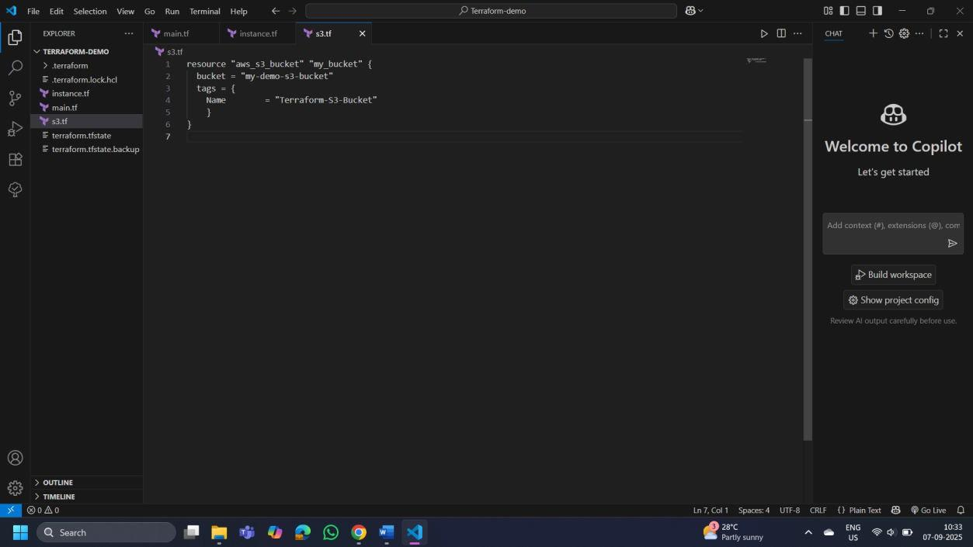

This file provisions an S3 bucket with a unique name using a random string suffix.

## Step 4: Initialize Terraform:

Run the following command to initialize your Terraform working directory:

terraform init

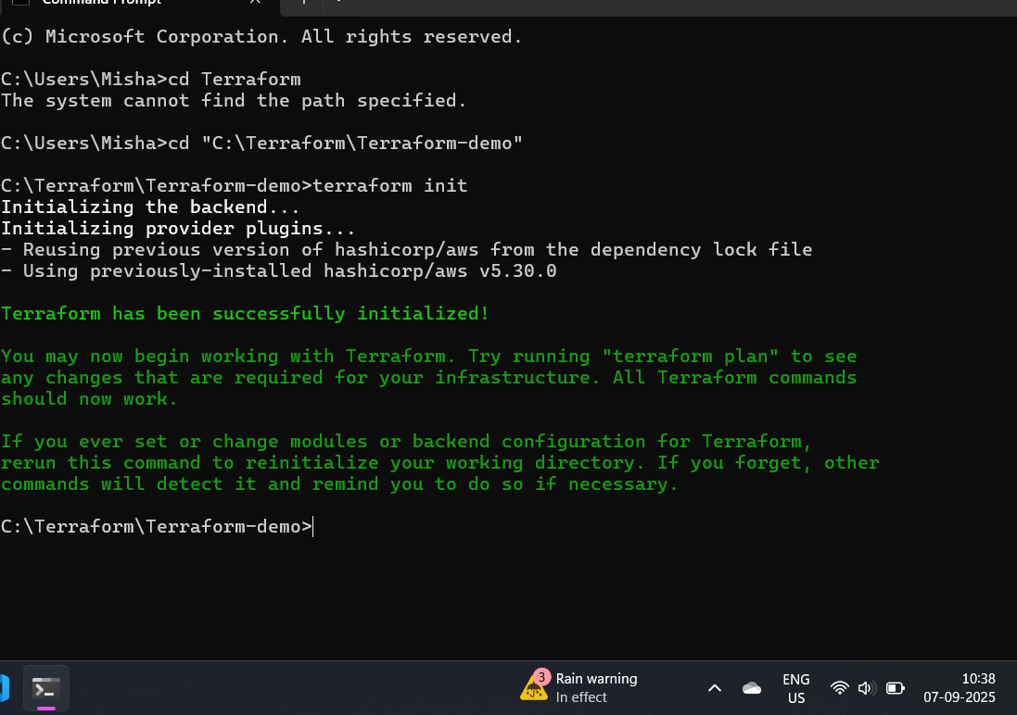

## Step 5: Review the Plan:

Preview the changes Terraform will make:

terraform plan

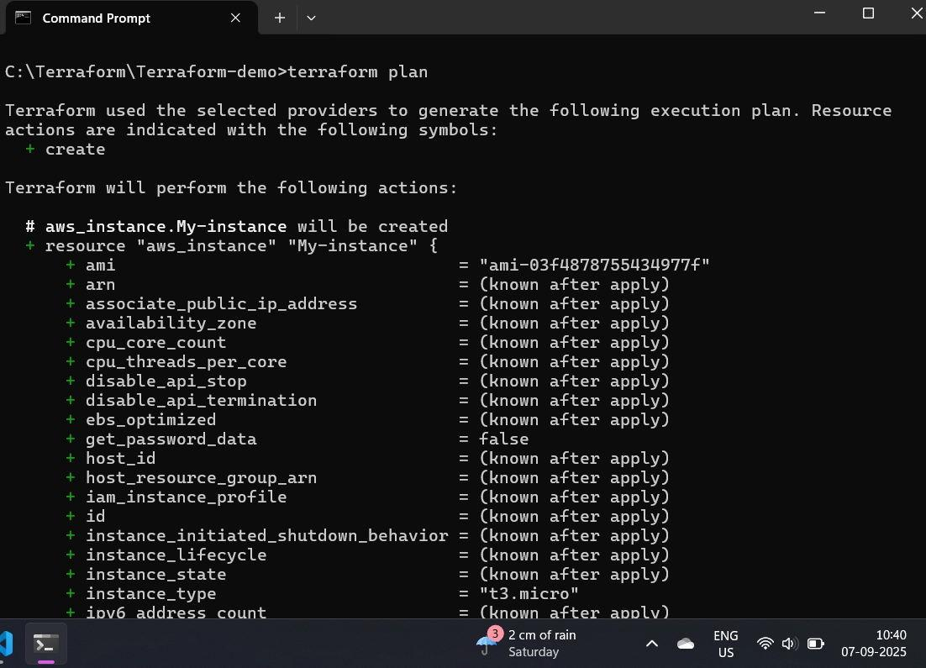

## Step 6: Apply the Changes:

Create the resources:

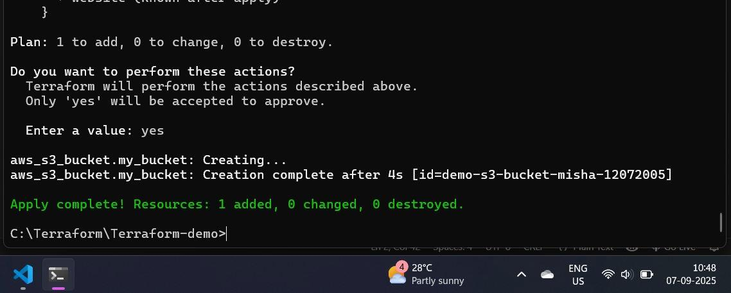

terraform apply

When prompted, type yes to confirm.

## Step 7: Verify Resources:

1. Log in to your AWS Management Console.
2. Navigate to the **S3** dashboard.
3. Verify that the S3 bucket has been created with the specified configuration.

## Step 8: Cleanup Resources:

To remove the resources created, run the following command:

terraform destroy

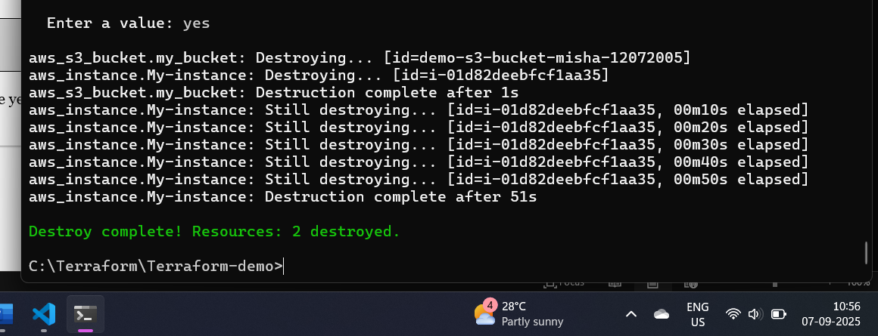

When prompted, type yes to confirm.