# Lab Exercise 16– Terraform Variables with Command Line Arguments

**Name- Zuhair Ahmad**

**SAP ID- 500119134**

**Batch- 1**

**Objective:**

Learn how to pass values to Terraform variables using command line arguments.

# Steps:

1. **Create a Terraform Directory:**

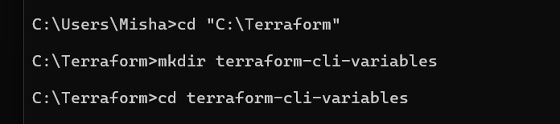

**mkdir terraform-cli-variables cd terraform-cli-variables**

1. **Create Terraform Configuration Files:**
   * Create a file named main.tf:

# instance.tf

resource "aws_instance" "example" {

ami

= var.ami

instance_type = var.instance_type

}

* + Create a file named variables.tf:

# variables.tf

**variable "ami" { description = "AMI ID"**

**default = " ami-08718895af4dfa033"**

**}**

**variable "instance_type" { description = "EC2 Instance Type" default = "t2.micro"**

**}**

# Use Command Line Arguments:

* + Open a terminal and navigate to your Terraform project directory.
  + Run the terraform init command:

**terraform init**

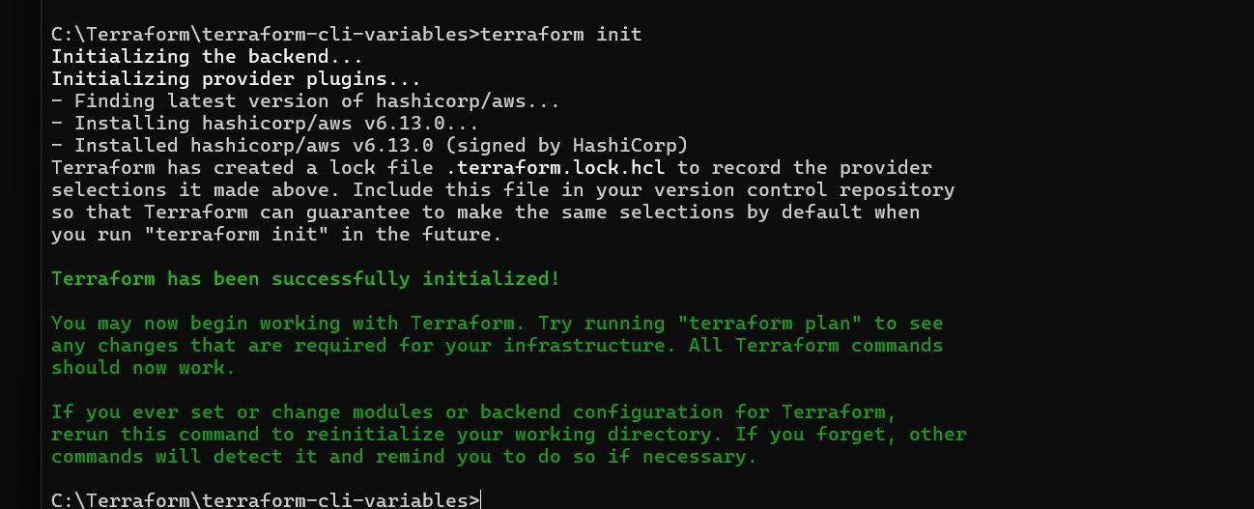

* + Run the terraform apply command with command line arguments to set variable values:

**terraform plan -var=”ami=ami-0522ab6e1ddcc7055” -var=”instance_type=t3.micro”**

* + Adjust the values based on your preferences.

# Test and Verify:

* + Observe how the command line arguments dynamically set the variable values during the apply process.
  + Access the AWS Management Console or use the AWS CLI to verify the creation of resources in the specified region.

# Clean Up:

After testing, you can clean up resources:

**terraform destroy**

Confirm the destruction by typing yes.