**Lab Exercise 18- Scanning IaC Templates for Vulnerabilities**

**Name- Zuhair Ahmad**

**SAP ID- 500119134**

**Batch- 1**

## Objective

* Learn how to scan Infrastructure as Code (IaC) templates for security vulnerabilities.
* Use open-source IaC security tools to detect misconfigurations.
* Understand common risks such as public access, unencrypted resources, and insecure network rules.

## Step 1: Create an Insecure IaC Template

Create a file named main.tf with the following Terraform code:

provider "aws" { region = "us-east-1"

}

resource "aws_s3_bucket" "insecure_bucket" { bucket = "my-insecure-bucket-lab"

acl = "public-read"

}

resource "aws_security_group" "insecure_sg" { name = "insecure-sg"

description = "Allow all inbound traffic" ingress {

from_port = 0

to_port = 65535 protocol = "tcp" cidr_blocks = ["0.0.0.0/0"]

}

}

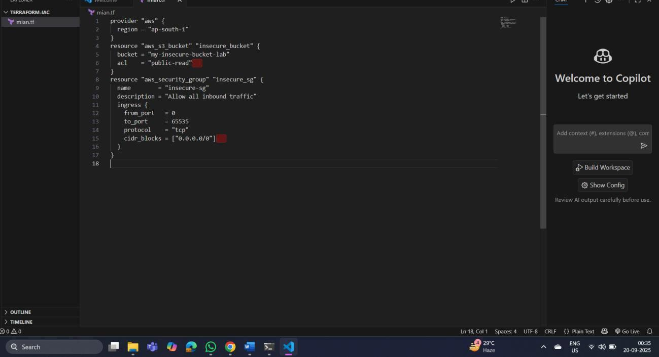

## Step 2: Scan the Template with Checkov

Run Checkov on the current directory:

checkov -d .

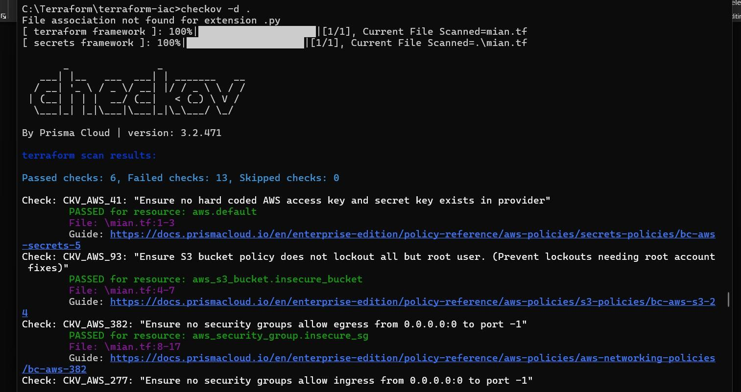

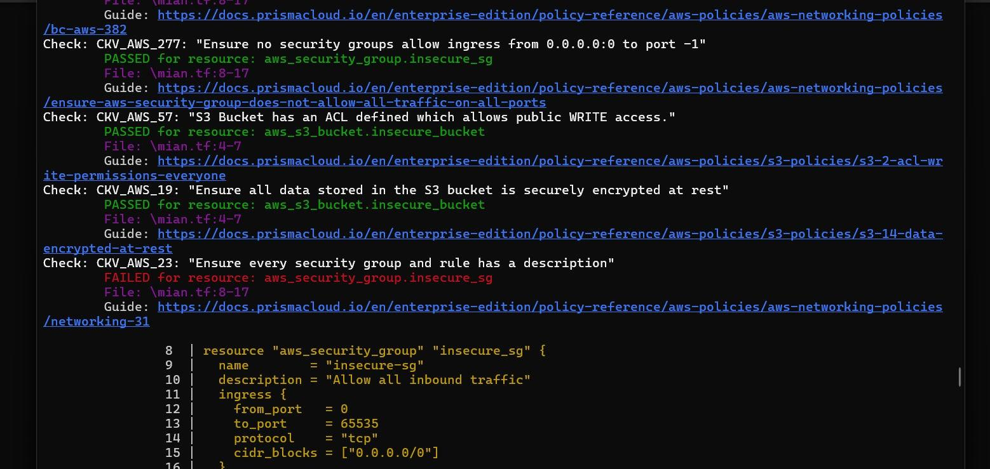

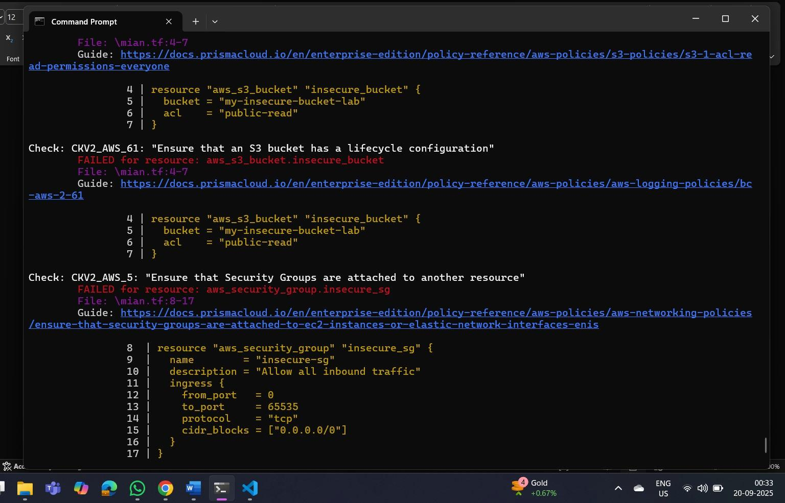

## Expected Findings:

* Public S3 bucket access (public-read)
* Security group open to all inbound traffic

## Expected Findings:

* Warns about S3 bucket without encryption
* Flags open Security Group rules

## Step 4: Review the Report

Example output (Checkov):

Check: CKV_AWS_20: "S3 Bucket allows public read access" FAILED for resource: aws_s3_bucket.insecure_bucket

Check: CKV_AWS_260: "Security group allows ingress from 0.0.0.0/0"

FAILED for resource: aws_security_group.insecure_sg

## Step 5: Apply Fixes (Optional)

Modify the IaC template to:

* + Set S3 bucket ACL to private
  + Enable encryption (AES256)
  + Restrict Security Group to specific IP ranges

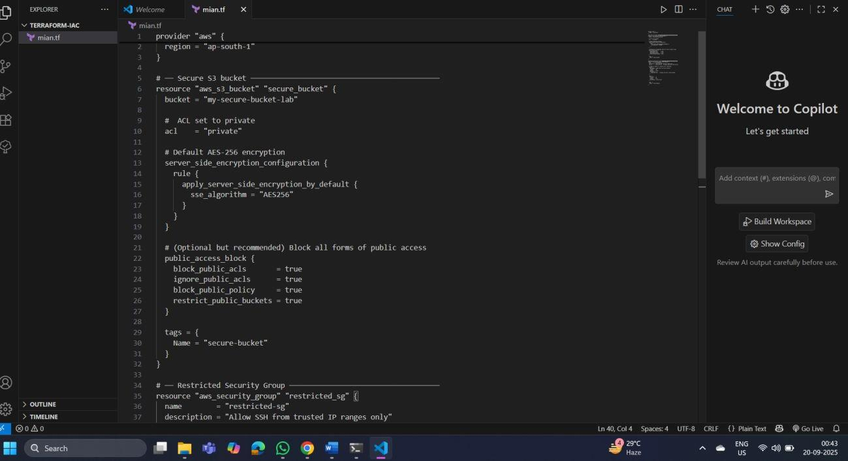

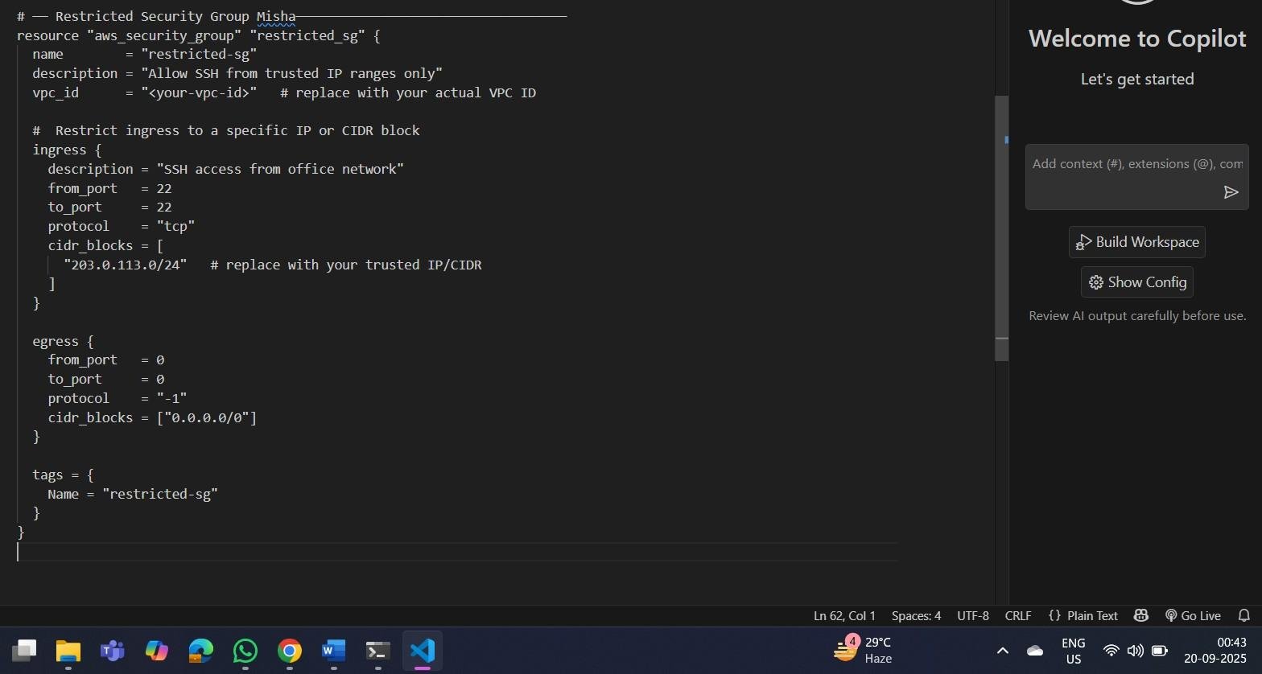

## Step 6: Rescan the Template

Run the scan again:

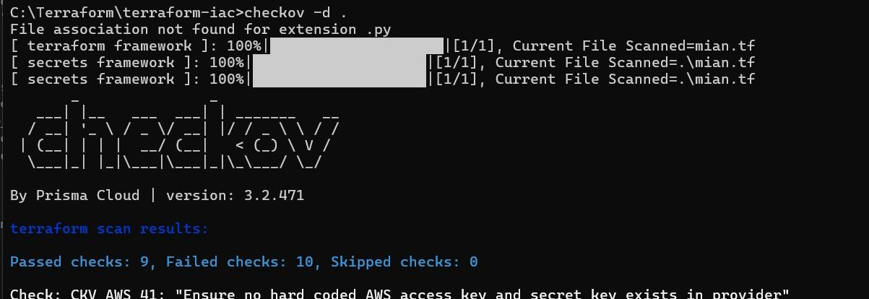

checkov -d .

Now the findings should be **resolved or reduced**.

## Step 7: Document Findingss

Create a simple findings log:

**Before** the securing, terraform scan results

**Passed** checks: **6**, **Failed** checks: **13**, Skipped checks: 0

**After** securing- terraform scan results:

**Passed** checks: **9**, Failed checks: **10**, Skipped checks: The number of failed test checks reduced,.