**Lab Exercise 5- Generate and Use SSH Key with Git and GitHub**

**Name: Zuhair Ahmad**

**Sap ID: 500119134**

**Batch: 1**

**Objective:**  
To learn how to generate an SSH key, add it to GitHub, and use it to securely connect and push code without repeatedly entering a password.

**Prerequisites**

* Git installed on your local machine
* GitHub account
* Basic understanding of Git commands

**Step 1 – Check for Existing SSH Keys**

Run:

ls -al ~/.ssh

Look for files like id_rsa and id_rsa.pub. If they exist, you may already have an SSH key.

**Step 2 – Generate a New SSH Key**

Run:

ssh-keygen -t rsa -b 4096 -C "your_email@example.com"

* **-t rsa** → key type
* **-b 4096** → key length
* **-C** → comment (your GitHub email)

When prompted:

* Press **Enter** to save in the default location: /home/user/.ssh/id_rsa (Linux/Mac) or C:\Users\<username>\.ssh\id_rsa (Windows)
* Optionally, set a passphrase for extra security.

**Step 3 – Start the SSH Agent**

eval "$(ssh-agent -s)"

**Step 4 – Add SSH Key to the Agent**

ssh-add ~/.ssh/id_rsa

**Step 5 – Add SSH Key to GitHub**

1. Copy the public key:

cat ~/.ssh/id_rsa.pub

1. Log in to GitHub → **Settings** → **SSH and GPG Keys** → **New SSH key**.
2. Paste the key and save.

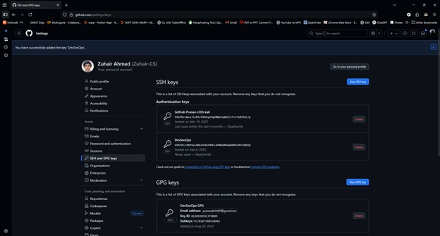

**Step 6 – Test SSH Connection**

ssh -T git@github.com

Expected output:

Hi <username>! You've successfully authenticated, but GitHub does not provide shell access.

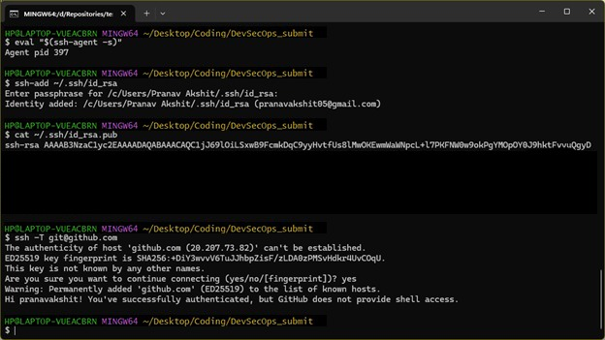

**Step 7 – Use SSH to Clone a Repository**

git clone git@github.com:<username>/<repository>.git

Now you can pull and push without entering your username/password.

**Use Case**

**Scenario:**  
An organization’s developers often need to push code to GitHub multiple times a day. Using SSH keys eliminates the need to repeatedly enter credentials, while maintaining secure, encrypted communication between the developer’s machine and GitHub.

**Table – HTTPS vs SSH for GitHub**

| **Feature** | **HTTPS** | **SSH** |
| --- | --- | --- |
| Authentication | Username & password / token | SSH key pair |
| Convenience | Requires login each session | No password once key is added |
| Security | Encrypted, but password-based auth | Encrypted, key-based authentication |
| Best For | Occasional access | Frequent development work |