

**DevSecOps: Integrating Security in   
DevOps Practices**

**Submitted by: Submitted to:**

Abhinav Rawat Dr. Hitesh Sharma  
500120490  
Batch 2 DevOps

**Lab Exercise 1 – Working With Git Revert**

1. **Lab Exercise: Git Revert**

Command:   
1. git init git-revert-lab  
2. Cd git-revert-lab

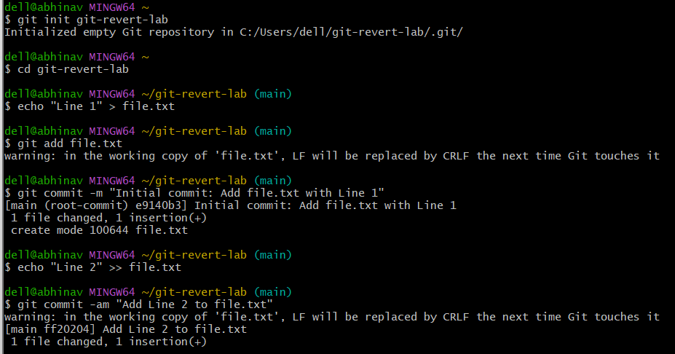  
3. Echo “Line 1” > file.txt  
4. Git add file.txt  
5. Git commit -m “Initial commit: Add file.txt with Line 1”

  
6. Echo “Line 2” >> file.txt  
7. Git commit -am “Add file.txt with Line 2”

  
8. Echo “Line 3” >> file.txt  
9. Git commit -am “Add Line 3 to file.txt”  
10. Git log --oneline  
  
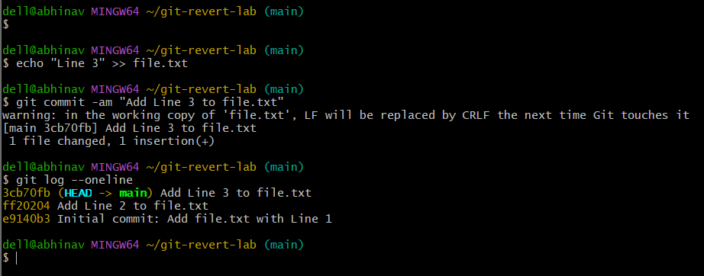

1. **Revert the last Commit**

Commands:  
1. Git revert HEAD

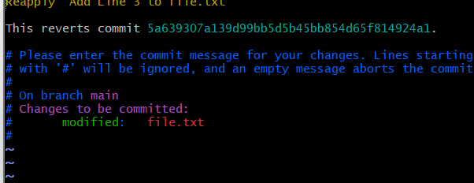

1. Cat file.txt  
     
   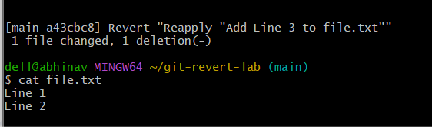
2. Git log –oneline

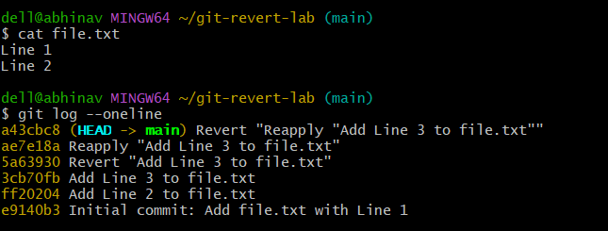

1. **Handle Merge Conflicts During Revert**

Commands

1. Echo “Conflict Line” >> file.txt
2. Git commit -am “Add Conflict Line”

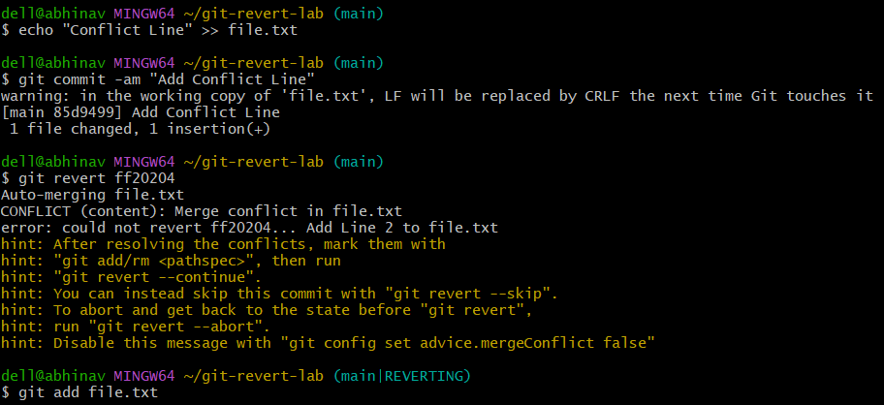

1. Git revert 8b2a1c



1. Git add file.txt
2. Git revert -- continue

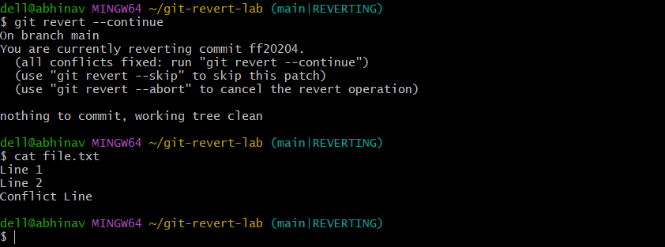

**Lab Exercise 2 – Working with Git Reset**

Lab Exercise: Git Reset

Commands:

1. Git init git-reset-lab

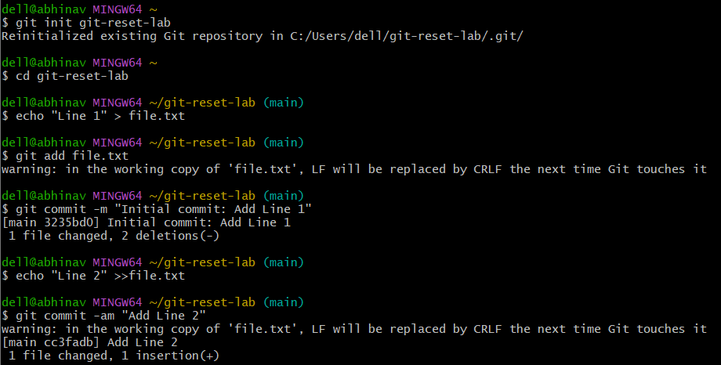

1. Cd git -reset-lab
2. Echo “Line 1” >file.txt



1. Git add file.txt
2. Git commit -m “Initial commit: Add Line 1”



1. Echo “Line 2” >> file.txt
2. Git commit -am “Add Line 2”



1. Git log –oneline

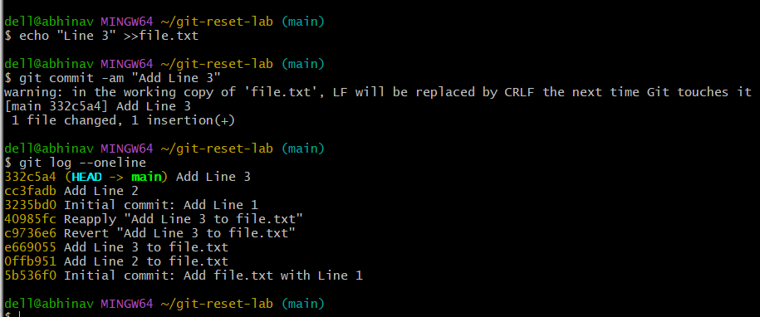

**Use Git Reset –Soft**

Commands:

1. git reset –soft HEAD~1
2. Git log –oneline

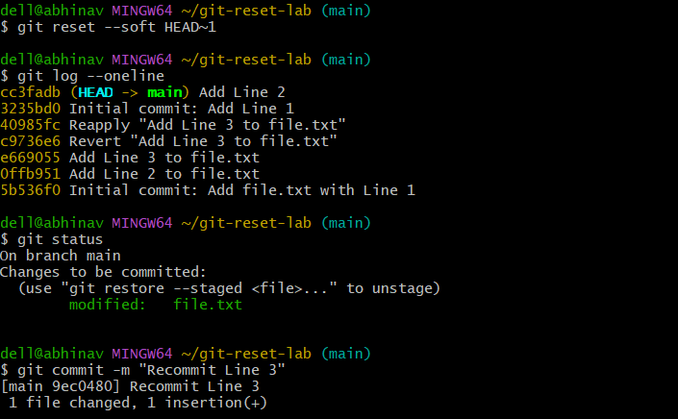

1. Git status
2. Git commit -m “Reconnect Line 3”



**Use git reset –mixed**

Commands:

1. Git reset –mixed HEAD~1
2. Git log –oneline

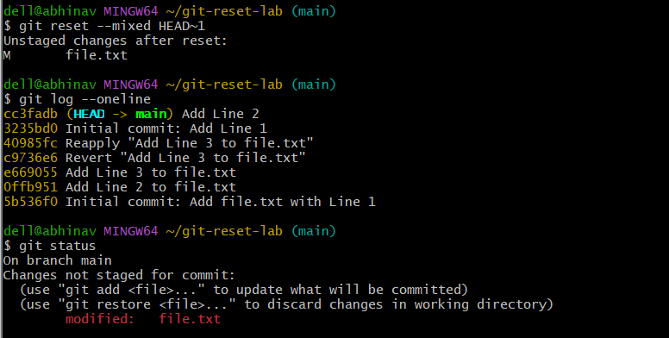

1. Git status



1. Git add file.txt

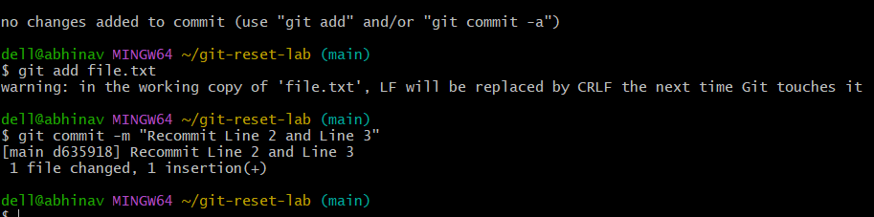

1. Git commit -m “Reconnect Line 2 and Line 3”



**Use Git Reset –Hard**

Commands

1. git reset – hard HEAD~1
2. git log –online
3. cat file.txt

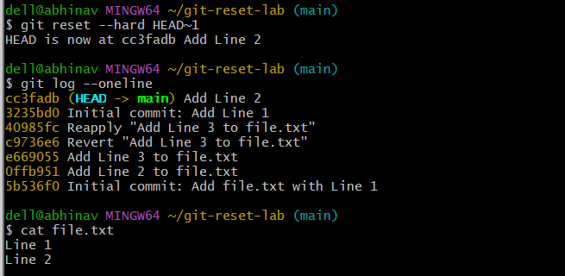

**Use Git Reset with a Commit Hash  
Commands:**

1. echo “Line 2 ”>> file.txt
2. Git commit -am “Add Line 2”
3. Echo “Line 3” >> file.txt
4. Git commit -am “Add Line 3”
5. Git log –oneline
6. Git reset –hard <commit-dhash>

**Lab Exercise 3 – Working with Git Rebase**

Commands:

1. git init git-rebase-lab
2. cd git-rebase-lab
3. echo “Line 1 from main branch” > file.txt

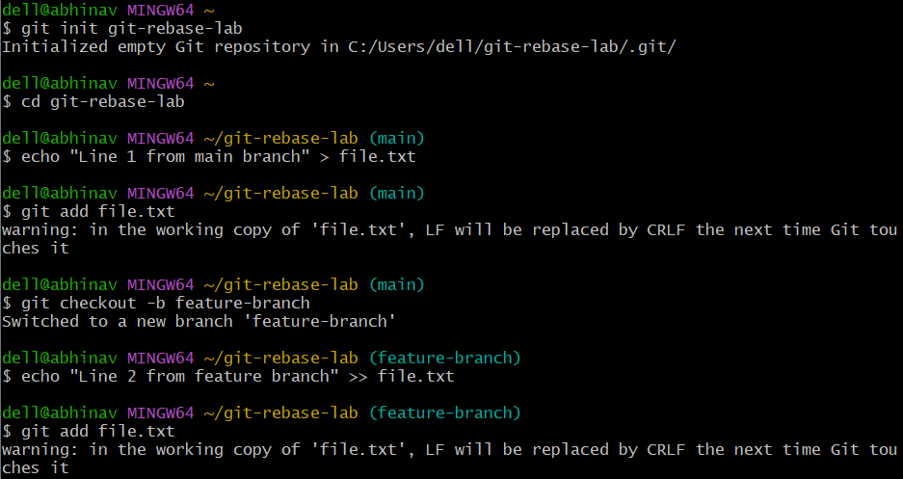

1. git add file.txt
2. git checkout -b feature-branch
3. echo “Line 2 from feature branch” >> file.txt



1. git add file.txt
2. git commit -m “Add Line 2 from feature branch”



1. git checkout main
2. echo “Line 3 from main branch” >> file.txt

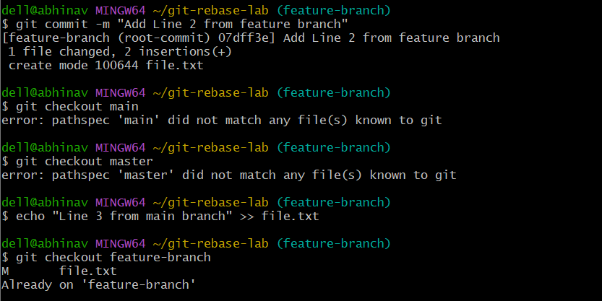

1. git add file.txt
2. git commit -m “Add Line 3 from main branch”



**Rebase Feature Branch Onto Main**

**Commands:**

* 1. git checkout feature-branch
  2. git rebase main



* 1. git log –oneline
  2. git log –oneline –graph
  3. cat file.txt

