**Lab Exercise 18- Scanning IaC Templates for Vulnerabilities**

**Step 1: Create an Insecure IaC Template**

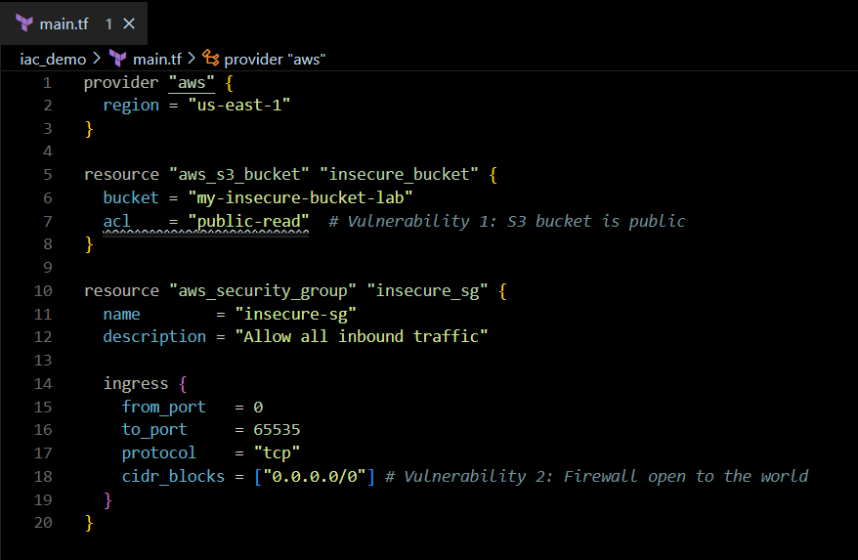

**Step 2: Scan the Template with Checkov**

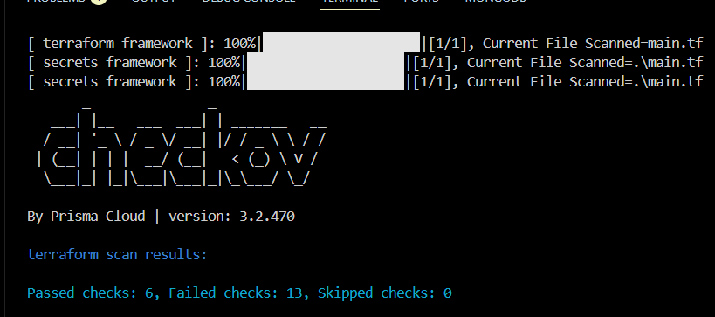

**Expected Findings:**

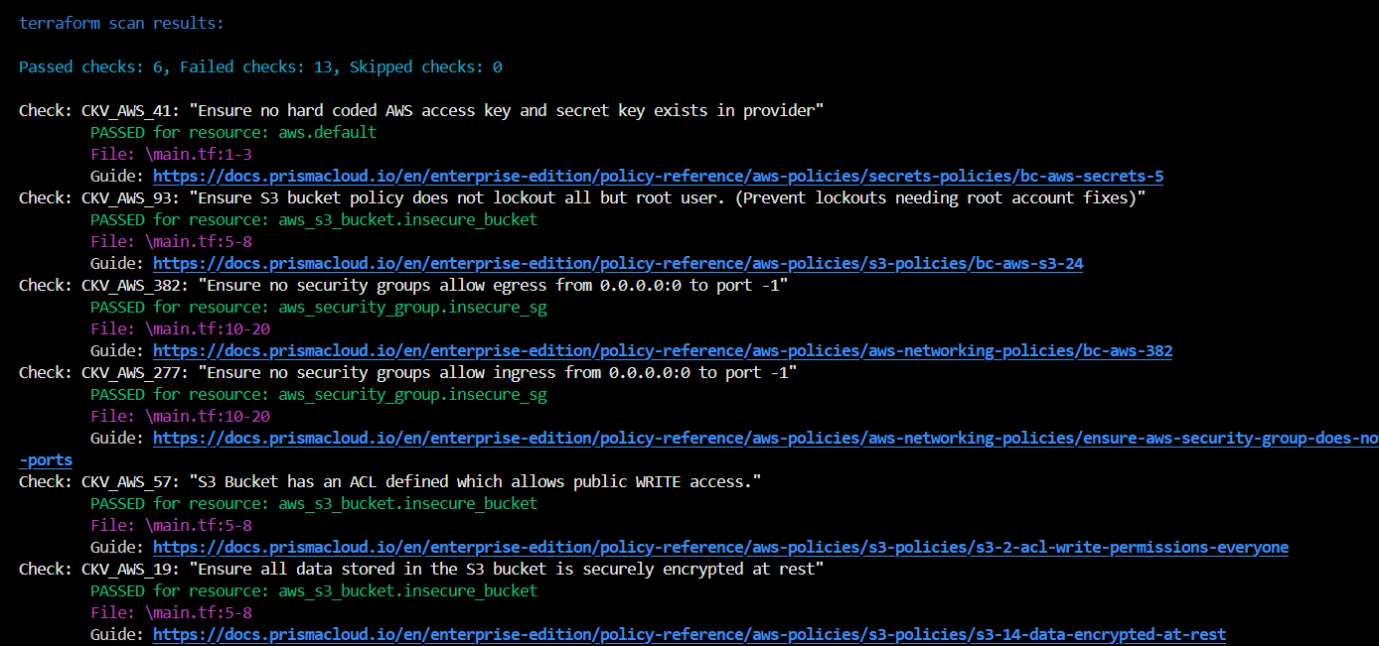

**Step 4: Review the Report**



Check: CKV_AWS_260: "Security group allows ingress from 0.0.0.0/0"

  

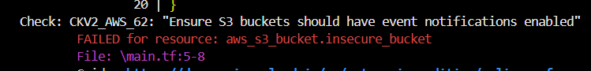 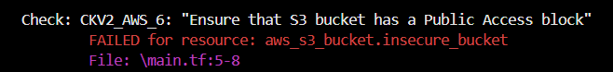 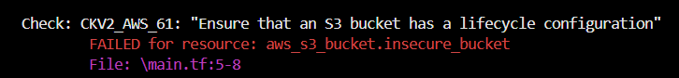 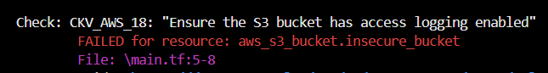 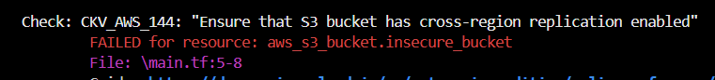

Check: CKV_AWS_20: "S3 Bucket allows public read access"

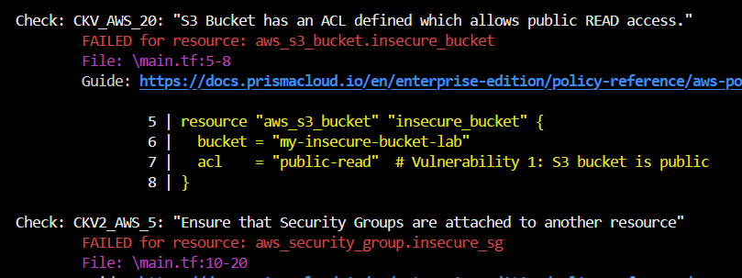

**Step 5: Apply Fixes (Optional)**

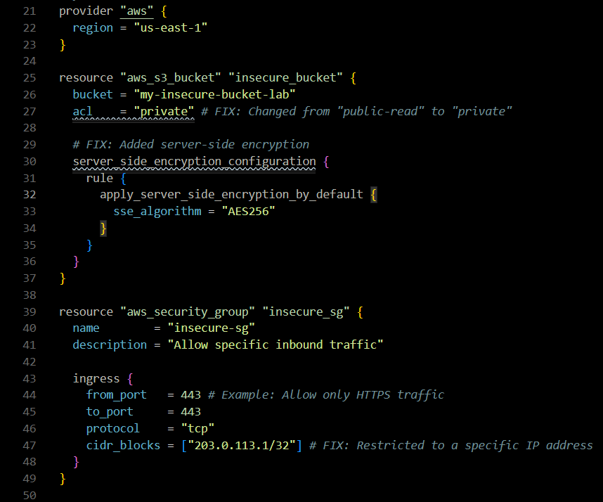

**Step 6: Rescan the Template**

