**Lab Exercise 2– Terraform AWS Provider Configuration**

**Prerequisites: Terraform Installed: Make sure you have Terraform installed on your machine. Follow the official installation guide if needed.**

**Exercise Steps:**

**Step 1: Create a New Directory:**

Create a new directory for your Terraform configuration:

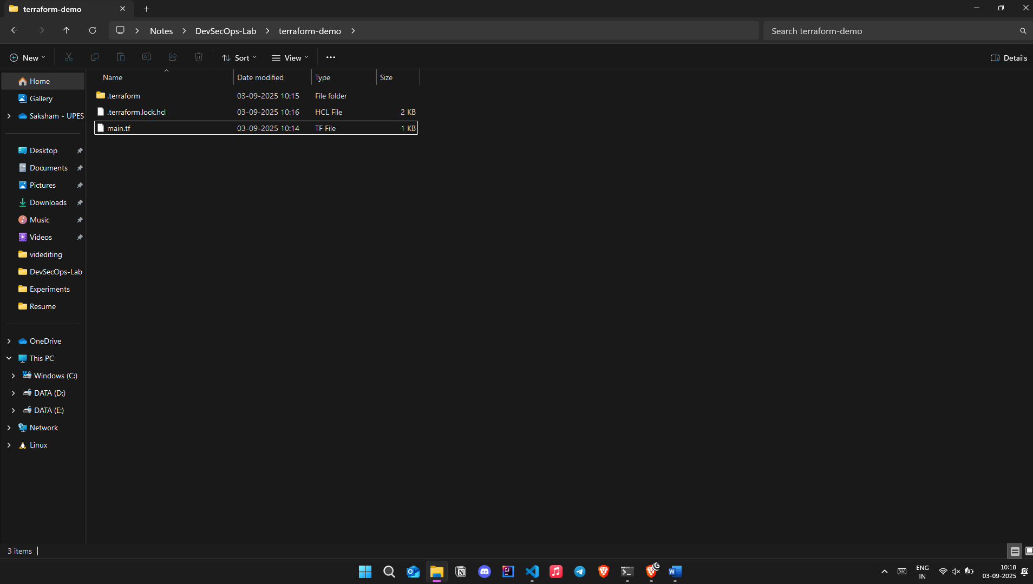

“**Terraform-Demo”**

**Step 2: Create Terraform Configuration File (main.tf):**

Create a file named main.tf with the following content:

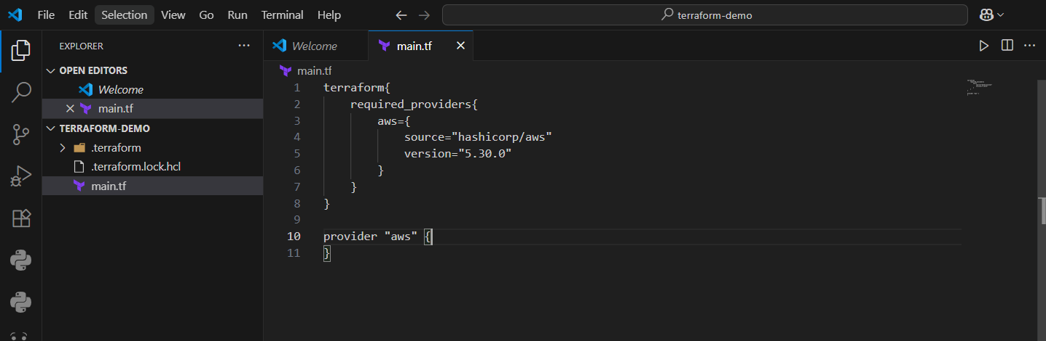

**Step 3: Initialize Terraform:**

Run the following command to initialize your Terraform working directory:

**terraform init**

