

School of Computer Science, UPES, Dehradun.

Lab 9

DevSecOps Lab

B.TECH. - V Semester

**Submitted to:**

Dr. Hitesh Kumar Sharma

**Submitted by:**

Name: Ishika Mehrotra

Batch: Devops B1

Sap Id: 500124411

Roll No.: R2142230281

**Objective: To set up poll SCM configuration in Jenkins for automating build triggering and optimizing resource usage on Jenkins servers**

**Step 1:** **Log in to the Jenkins CI tool and set up poll SCM configuration**

1. In the Jenkins dashboard, click on **New Item**

1. Select the **Freestyle project** while creating a Jenkins job, provide a custom job name, and click on **OK**

1. Now, in the Configure page, navigate to **Source Code Management** from the left navigation bar, select **Git**, and then provide the Git repository URL

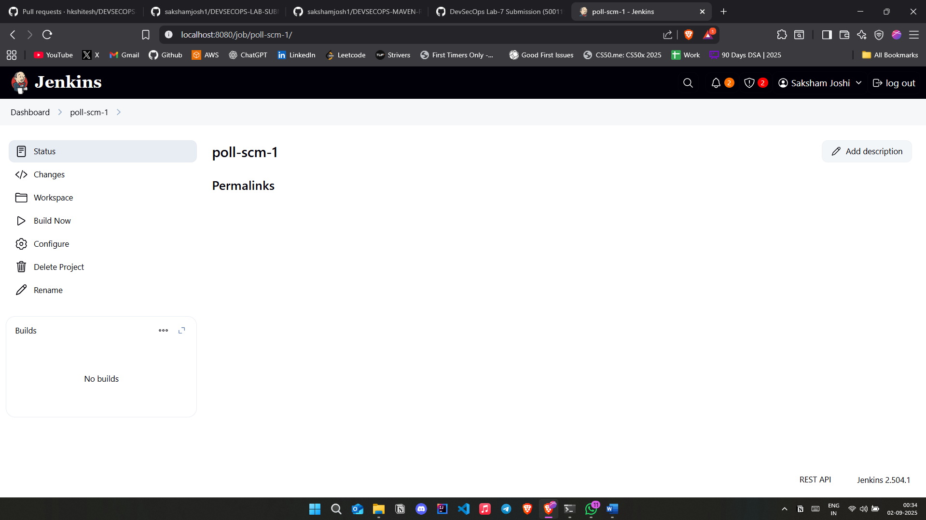

1. Now, navigate to **Build Environment**, click on **Poll SCM**, provide **H/2\*\*\*\*** under the **Schedule** section, and then click on **Save**

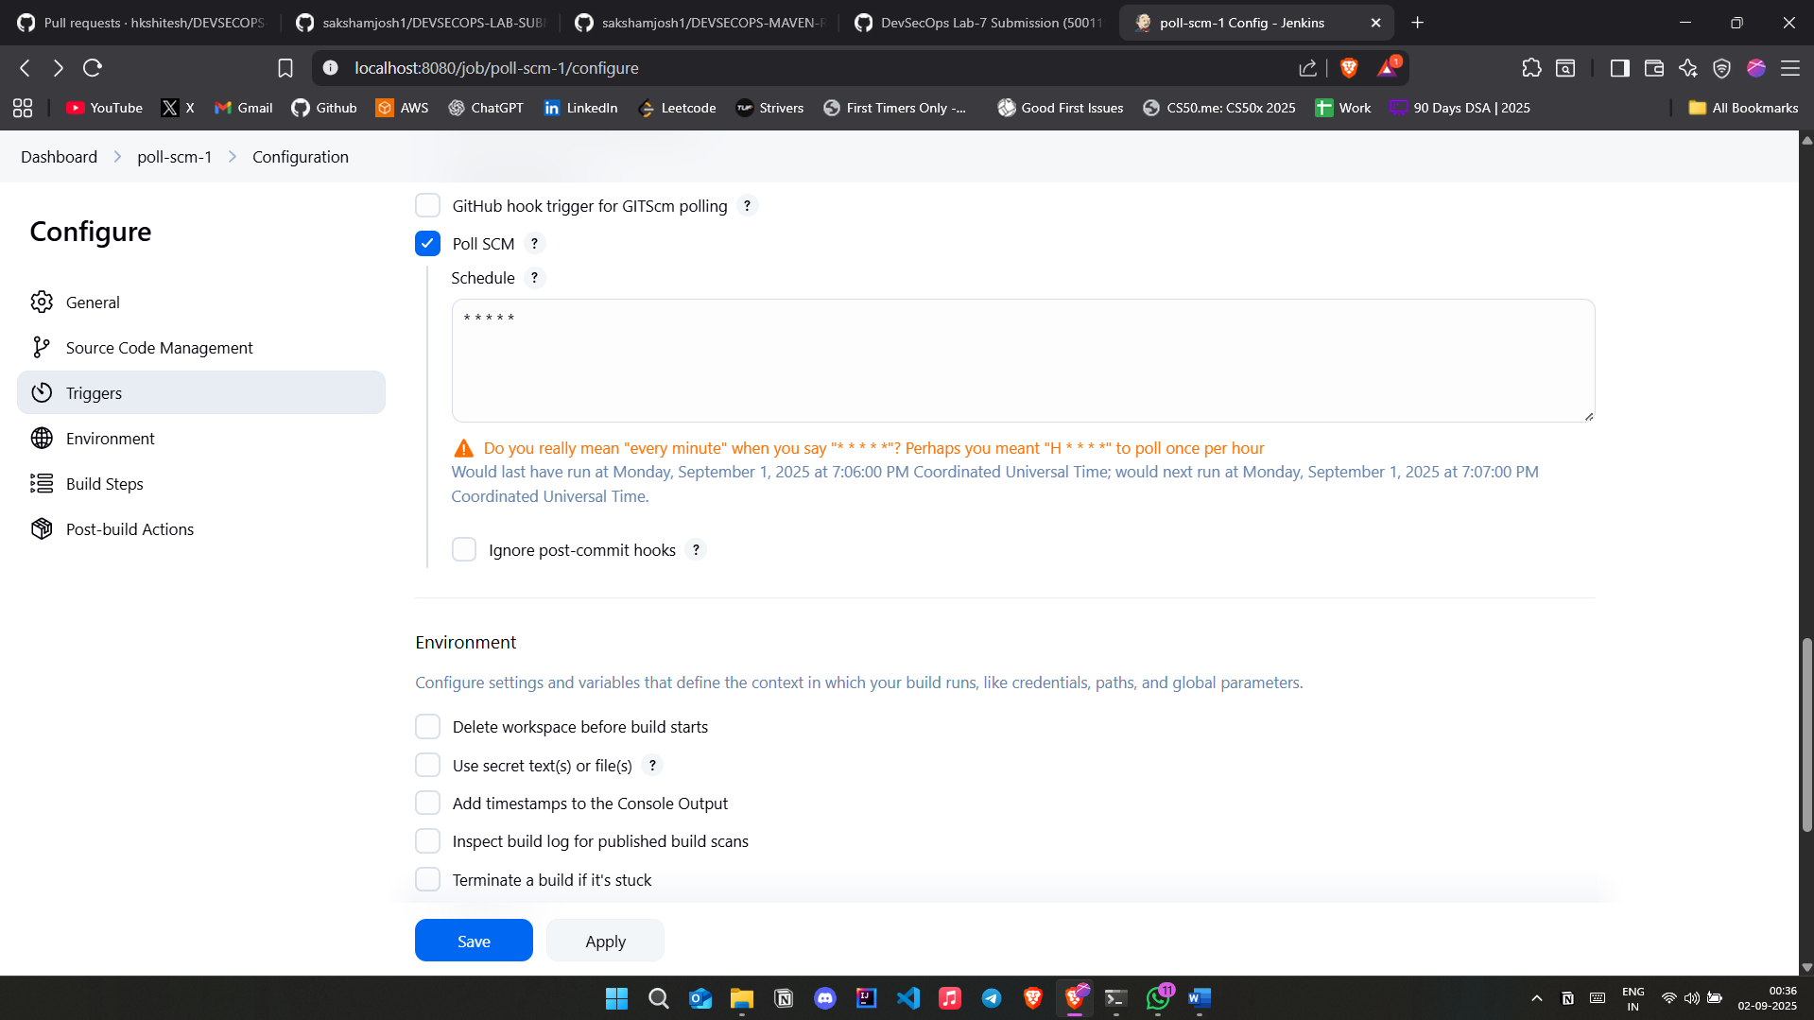

1. Then, click on **Build Now** to configure a build, and you will be able to view the successful build in the **Console output** section.



