**Lab Exercise 7**

**Integrating Maven with Jenkins**

**Objective:** To install the Maven plugin in Jenkins for smooth integration and automation of Maven-based build processes within the Jenkins environment

**Tools required:** Git, GitHub, and Jenkins

**Prerequisites:** None

Steps to be followed:

1. Install the Maven plugin
2. Set up Global Tool Configuration
3. Fork a sample repository
4. Integrate Maven with Jenkins

**Step 1:** **Install the Maven plugin**

1. Open the browser, go to the Jenkins Dashboard by typing **localhost:8080** in your browser, provide the credentials, and click the **Sign in** button

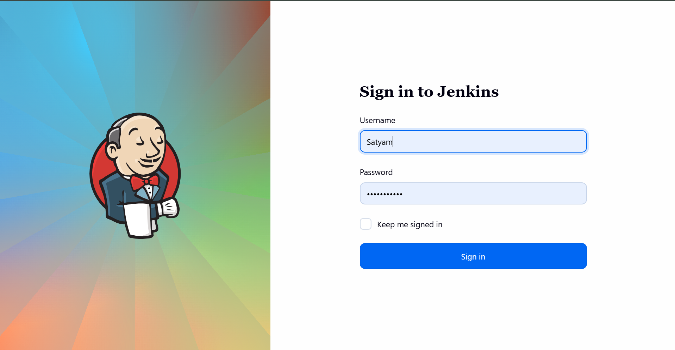

1. Click on the **Manage Jenkins** option as shown in the screenshot below:

1. Click on the **Plugins** option as shown in the screenshot below:

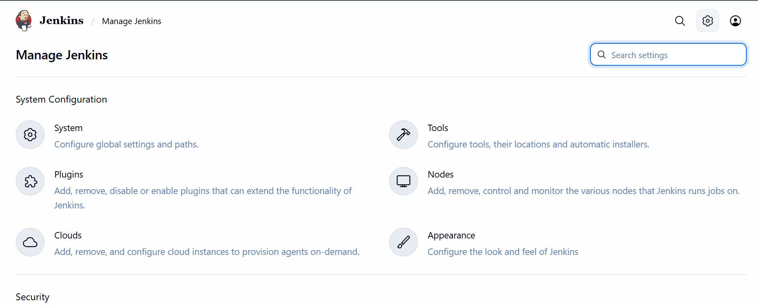

1. Click on **Installed plugins** to verify whether the **Maven Integration plugin** has been installed

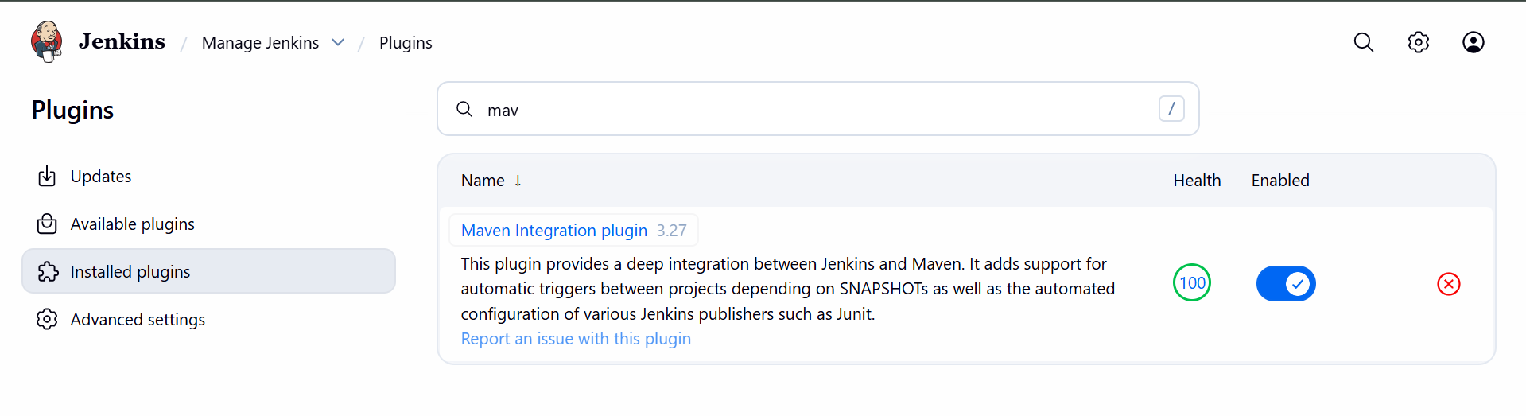

1. Use the following command to check the Maven version:

**mvn -version**

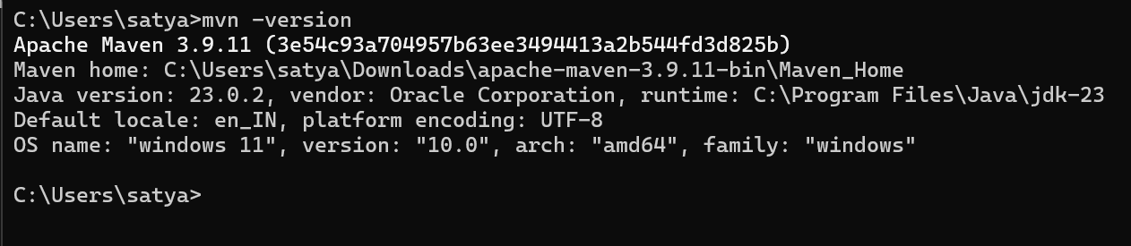

**Step 2: Set up Global Tool Configuration**

1. Go to the Jenkins Dashboard, click on **Manage Jenkins**, and then select **Tools** from the list of options

1. To configure Maven, click on the **Maven installations** button in the Maven section and enter a **Name** and **MAVEN_HOME** path

