**Lab Exercise 11**

**Terraform AWS Provider Configuration**

**Objective:** Initializing terraform working directory

**Prerequisites:** Terraform Installed: Make sure you have Terraform installed on your machine. Follow the official installation guide if needed.

Exercise Steps:

Step 1: Create a New Directory:

Create a new directory for your Terraform configuration:

“Terraform-Demo”

Step 2: Create Terraform Configuration File (main.tf):

Create a file named main.tf with the following content:

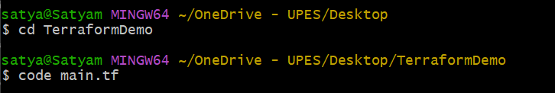

terraform {

  required_providers {

    aws = {

      source = "hashicorp/aws"

      version = "5.30.0"

    }

  }

}

provider "aws" {

  }

**Step 3: Initialize Terraform:**

Run the following command to initialize your Terraform working directory:

**terraform init**

