**Lab Exercise 9**

**Setting up Poll SCM Configuration in Jenkins**

**Objective:** To set up poll SCM configuration in Jenkins for automating build triggering and optimizing resource usage on Jenkins servers

**Tools required:** Jenkins

**Prerequisites:** You need to have a Jenkins up and running.

**Step 1:** **Log in to the Jenkins CI tool and set up poll SCM configuration**

1. Log in to Jenkins using the credentials

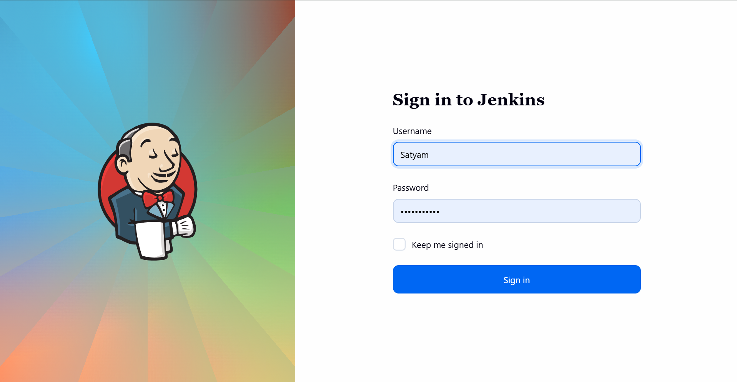

1. In the Jenkins dashboard, click on **New Item**

1. Select the **Maven Project** while creating a Jenkins job, provide a custom job name, and click on **OK**

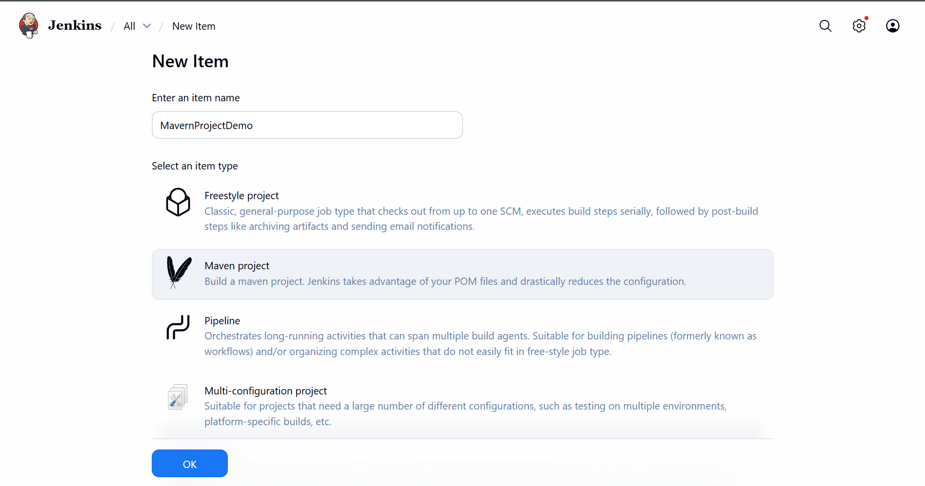

1. Now, in the Configure page, navigate to **Source Code Management** from the left navigation bar, select **Git**, and then provide the Git repository URL

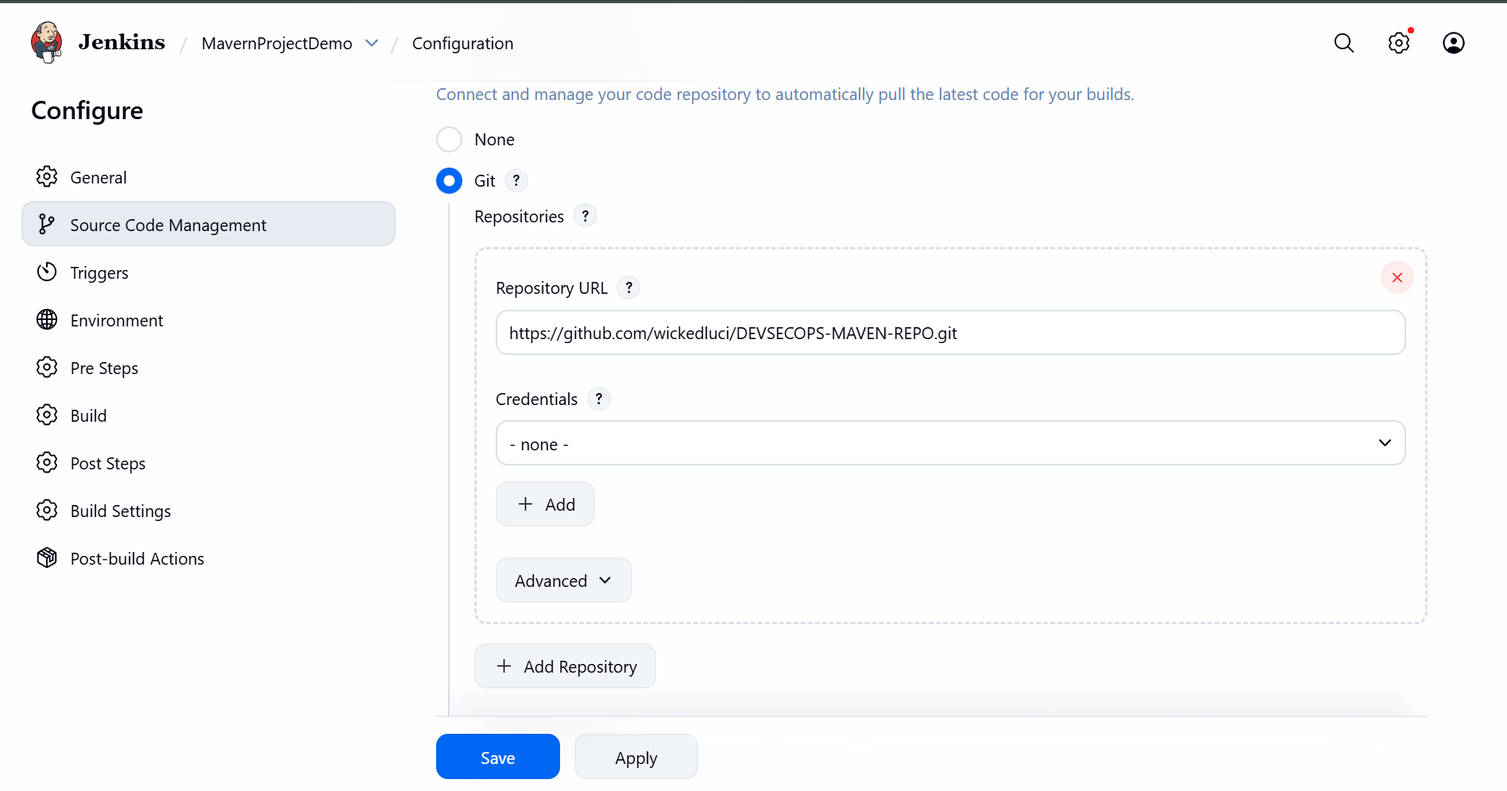

1. **Note:** Here, the repository URL is[**https://github.com/wickedluci/DEVSECOPS-MAVEN-REPO.git**](https://github.com/wickedluci/DEVSECOPS-MAVEN-REPO.git) **.**
2. Now, navigate to **Build Environment**, click on **Poll SCM**, provide **H/2\*\*\*\*** under the **Schedule** section, and then click on **Save**

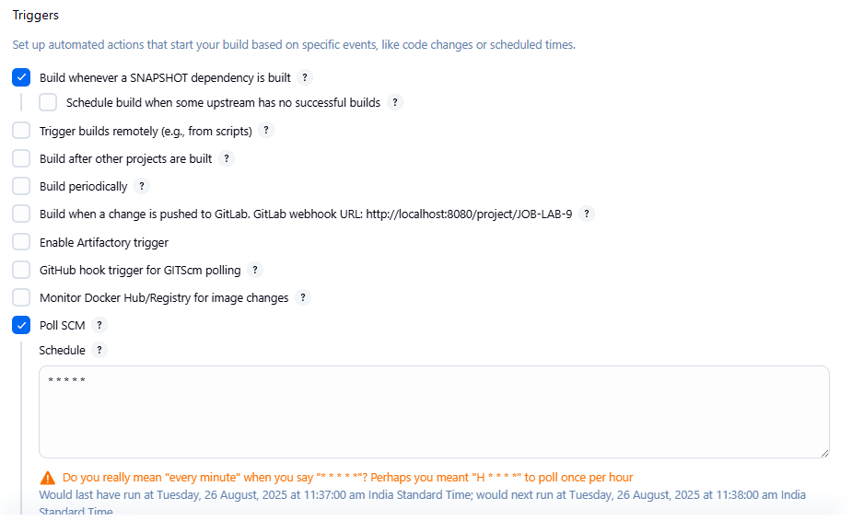

1. Then, automatic build will be trigger within a minute, and you will be able to view the successful build in the **Console output** section.

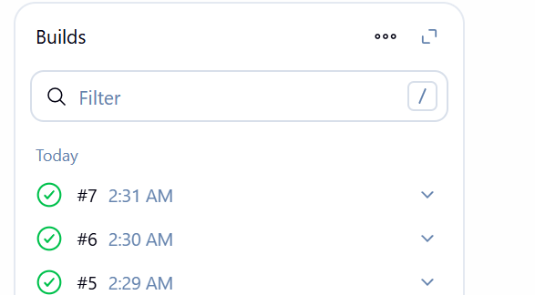

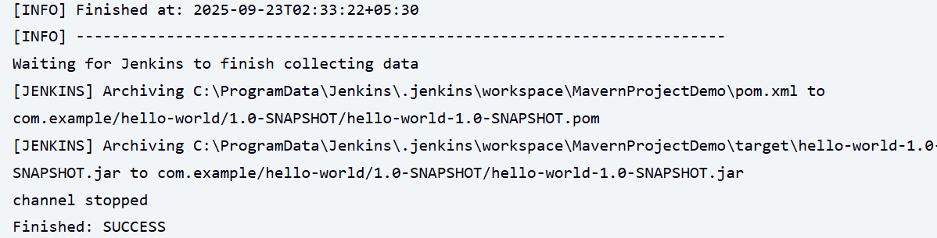

You can see that the build is configured successfully.

By following these steps, you have successfully set up poll SCM configuration in Jenkins for automating build triggering and optimizing resource usage on Jenkins servers.