**Lab Exercise 20**

**Creating a Pipeline Script**

Click on the **New Item** option as shown in the screenshot below:

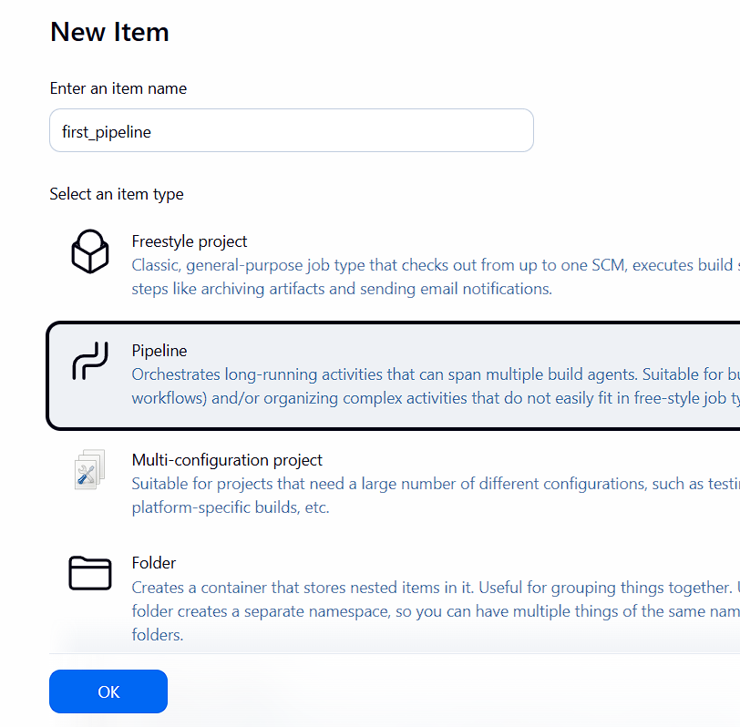

1. Enter a desired name for the project, select **Pipeline**, and then click on **OK** as shown in the screenshot below: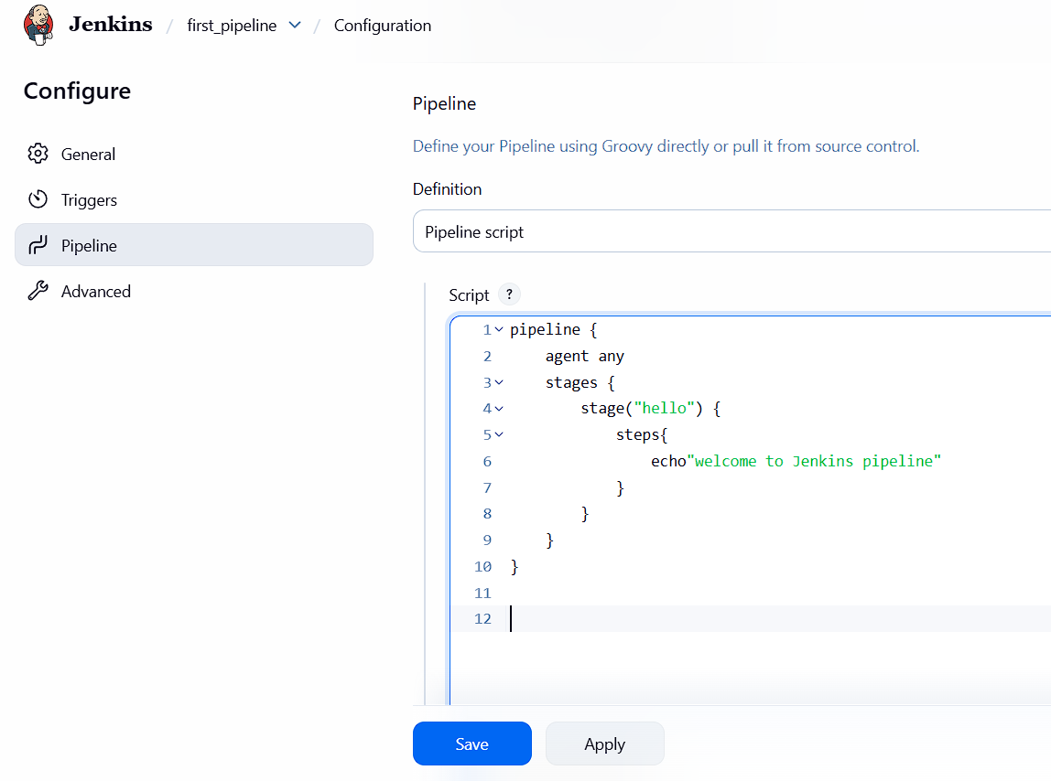

Enter the following pipeline script in the script editor and click on **Save** as shown in the screenshot below:

**pipeline {**

**agent any**

**stages {**

**stage("hello") {**

**steps{**

**echo"welcome to Jenkins pipeline"**

**}**

**}**

**}**

**}**

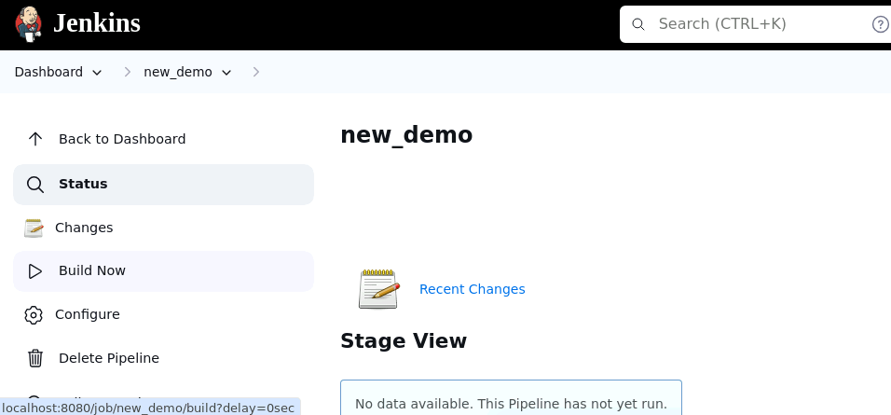

1. Hover over the milliseconds number next to the build stage name as shown in the screenshot below:

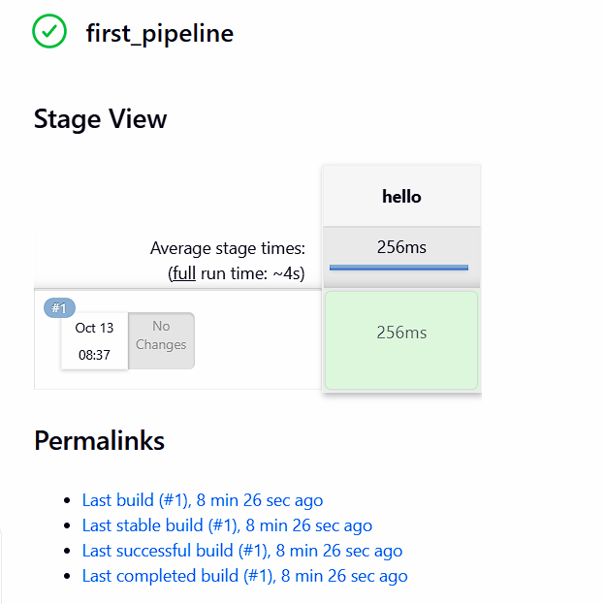

|  |
| --- |
| **Note:** Ensure that you hover the cursor over the milliseconds number without clicking on it |

1. Click on **Logs** as shown in the screenshot below:

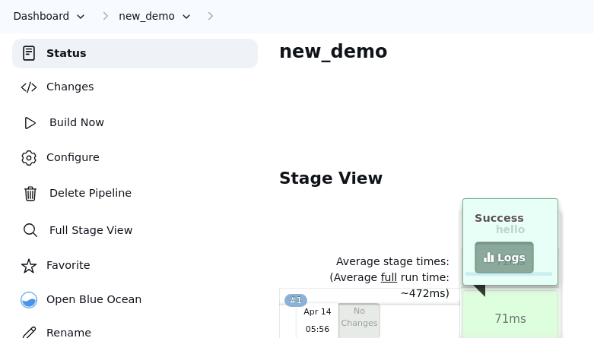

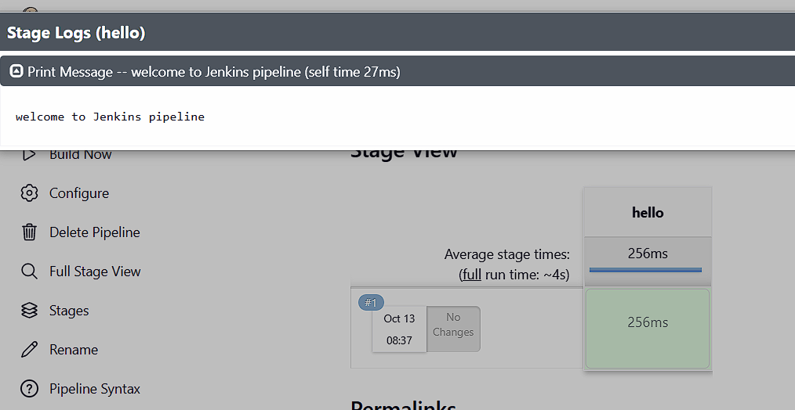

By following these steps, you have successfully created a pipeline script for automating build processes in Jenkins.

**Creating pipeline for maven project**

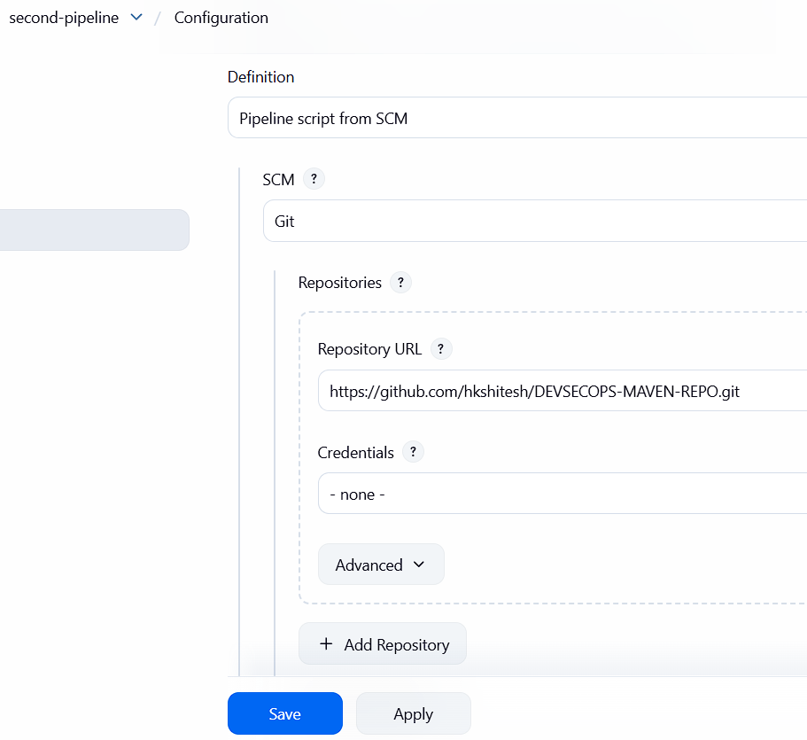

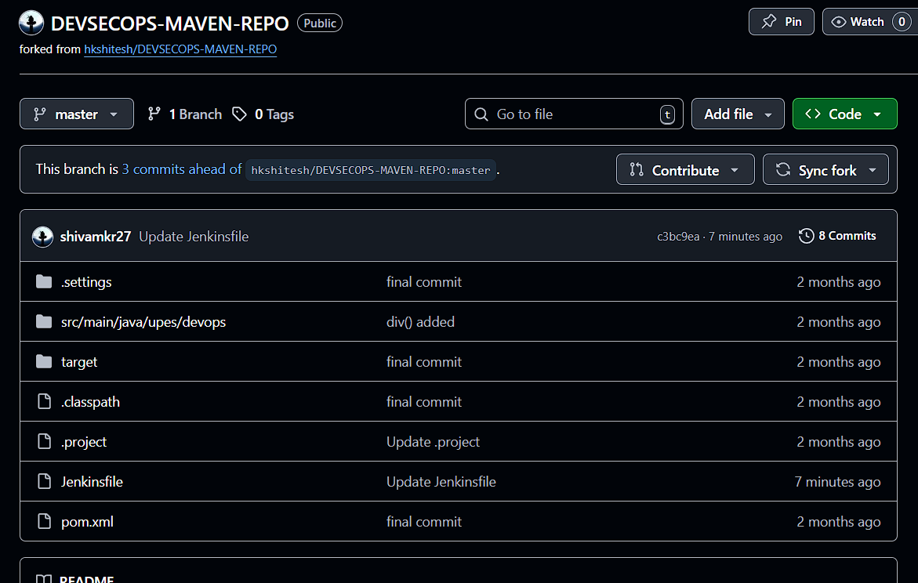

pipeline

{

agent any

tools

{

maven 'maven'

}

stages

{

stage('Welcome Stage')

{

steps

{

echo 'Welcome to Jenkins Pipeline'

}

}

stage('Clean Stage')

{

steps

{

bat 'mvn clean'

}

}

stage('Clean Success Stage')

{

steps

{

echo 'clean success'

}

}

stage('Build & Install Stage')

{

steps

{

bat 'mvn install'

}

}

stage('Build Success')

{

steps

{

echo 'Build successful'

}

}

stage('Final Success')

{

steps

{

echo 'Final successful'

}

}

}

}

