WORKING WITH DATA

ONLINE vs OFFLINE Mode of Learning

horizontal line

# Contents

1. Introduction
2. Research Methodology
3. Demographic view of Survey Participants
4. Financial Analysis
5. Effects of Online learning
6. Effects on Examination
7. Employment Issues
8. Conclusion
9. Responses and Questionnaire



Introduction

This report summarises the findings of a survey performed in April-May 2021 to investigate participants' learning mode preferences.

Given the current situation, which is a pandemic, there was a necessity to shift from the traditional style of learning to an online one. Though e-learning has been in use for a few years, its breadth has expanded significantly in the last year and a half. Some people prefer e-learning over conventional offline learning, while others prefer the polar opposite.

What will be the style of learning after the lockdown is lifted? Will we continue to use the usual offline mode, or will we have the opportunity to select a different mode? So we conducted this poll, which received over 1000 responses, to understand about people's learning preferences. Furthermore, it aided in the investigation of the impact of online mode on learner performance and the issues related with this style of learning.

The purpose was to gain a thorough understanding of the learners' perspectives on this subject and, as a result, to determine which form of learning would be most advantageous in the future. It was also useful to learn about the necessary improvements that must be made if we are to continue with the online service.

Research Methodology

The survey's goal was to collect data from university students, thus a form with the needed questions was sent via various social media channels.

The impact on money, education, and grades; issues experienced during online contact and assessment. The form includes employment-related questions to guarantee that the data is assessed on all conceivable versions to get reliable results.

We got 1,024 answers from students from various states and universities, each of which used a different e-learning platform. This helped to guarantee that the results were not based just on the advantages and disadvantages of a particular digital platform.

In answer to each question, the evaluated data is shown statistically as well as visually. Important information discovered during the analysis are provided, along with any appropriate references.

Demographic view of Survey Participants

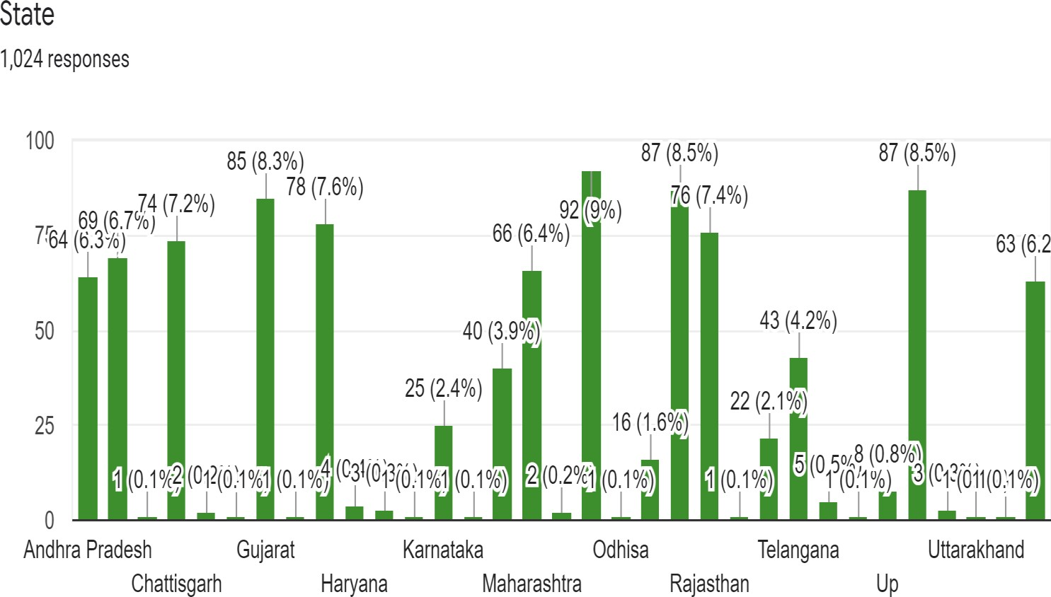

In this section, we attempted to present a demographic overview of survey respondents in March 2021. A kind of shape. A Google form was distributed to pupils, and they were requested to answer the questions on the form. Based on 1,024 replies, this summary was created. A brief demographic analysis of the 1,024 participants in the report revealed that 6.3 percent are from Andhra Pradesh, 6.9 percent are from Bihar, 7.2 percent are from Chhattisgarh, 8.3 percent are from Gujarat, 7.6 percent are from Haryana, 2.4 percent are from Karnataka, 3.9 percent are from Madhya Pradesh, 6.4 percent are from Maharashtra, 9 percent are from New Delhi, and 1.6 percent are from Odisha.

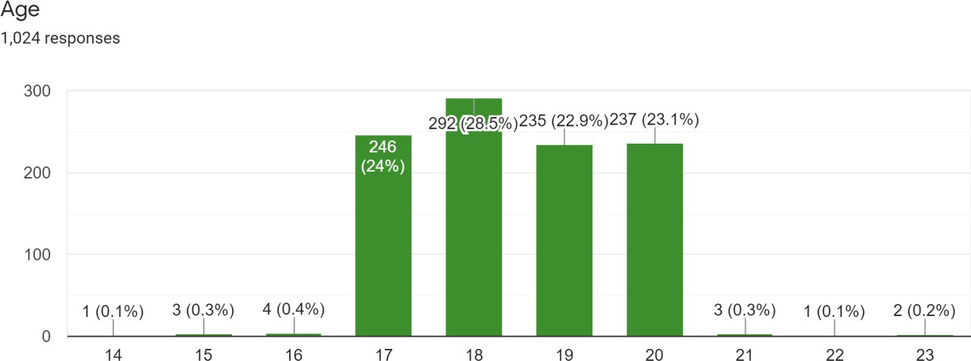

In terms of age: 24% were aged around 17, 28.5 % were found to be of age 18,22.9% were found 19, and 23.1% were found to be 20 years old. These were the age groups the held the majority of the responses from the participants.

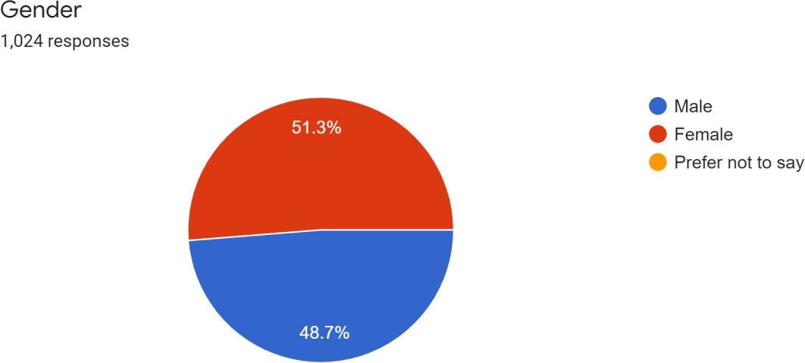

Males possessed more replies than females in terms of gender and responses. According to their educational background, the majority of the respondents were pursuing a Bachelor of Technology and were either in their first or second year.

Financial Analysis

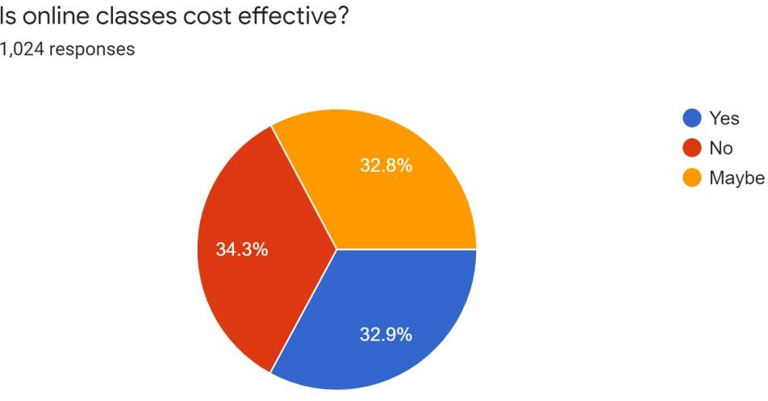

|  |  |  |
| --- | --- | --- |
| S.No. | Response Chosen | No. of Responses |
| 1. | Yes, it is cost-effective. | 337 |
| 2. | No, it isn’t cost-effective. | 351 |
| 3. | Maybe | 336 |

Online vs. offline learning has a significant financial impact, whether it is institutions or parents on the opposite side of the table.

Parents are dissatisfied with the money they pay to institutions for various services that children do not receive owing to the covid scenario.

There is no question that institutions are making a lot of money here since there is no need for power, sanitization, water, and other things. Not only are these expenses being avoided, but money is also being saved from the salaries of staff who are no longer needed.

Parents had no problems with student academics during offline courses since they were receiving sufficient assistance in school, but in online settings, in addition to school costs, they must also provide for a reliable internet connection and a tutor to advise them.

Main Message:

* Profit for institutions.
* Parents and students are highly disappointed due to high fees.

Effects of Online learning

The online approach offers both benefits and drawbacks. One of the benefits is that it can accommodate practically everyone's schedule. Working or studying from home allows people to better manage their schedules by reducing travel time. It also gives us the option of recording the information so that we can examine it later if a person is unable to accommodate the classes into their schedule.

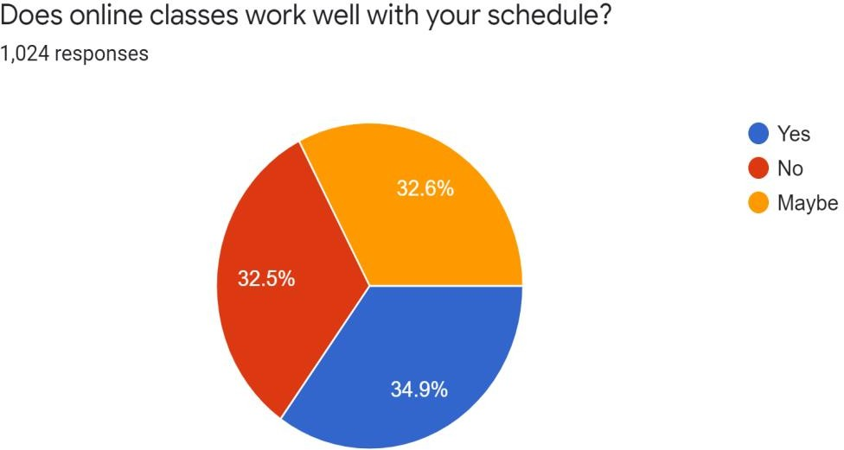

|  |  |  |
| --- | --- | --- |
| S.No. | Response Chosen | No. of Responses |
| 1. | Yes, it works well with my schedule. | 357 |
| 2. | No, it doesn’t work with my schedule. | 333 |
| 3. | Maybe | 334 |

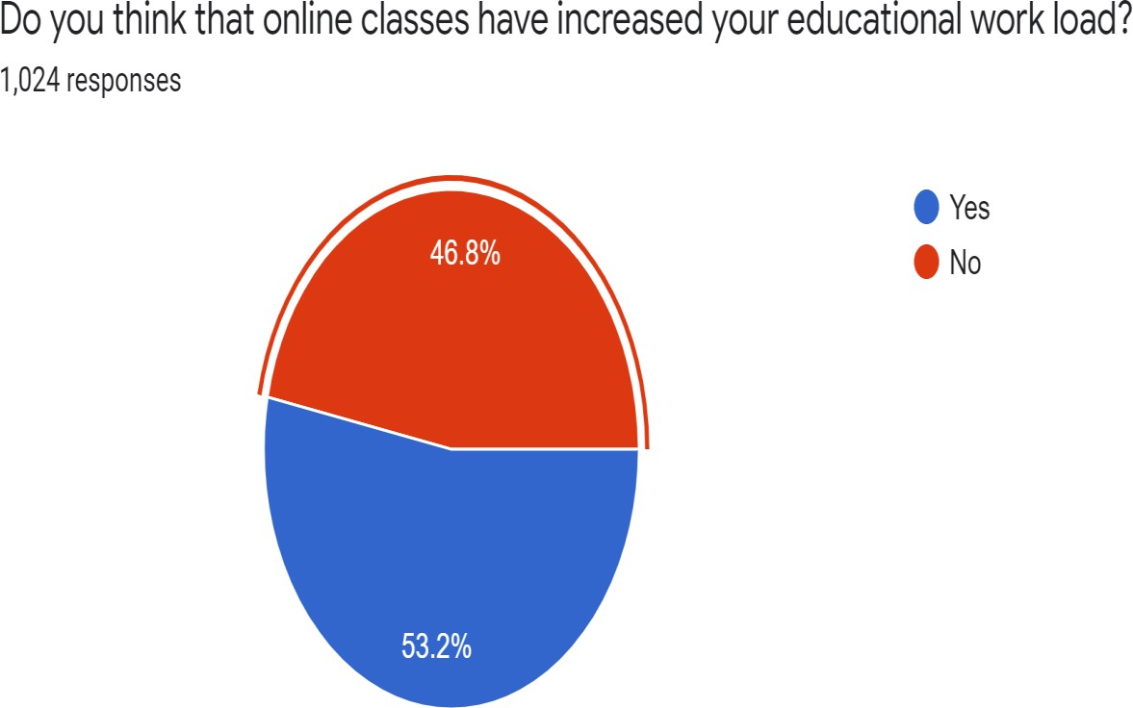

The offline mode used to have set hours of classes, and most of us were used to it, however the duration of courses changes greatly in online mode. Learners' screen usage has grown significantly, which adds to their stress.

|  |  |  |
| --- | --- | --- |
| S.No. | Response Chosen | No. of Responses |
| 1. | Yes, it increased the workload. | 545 |
| 2. | No, it didn’t increase the workload. | 479 |

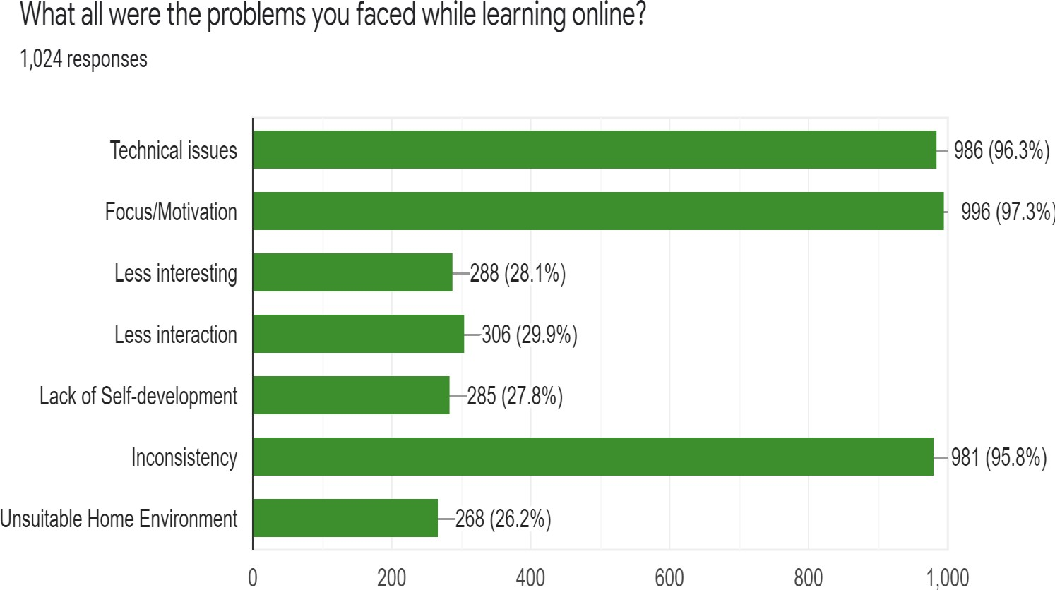

While learning online, students face a variety of challenges. Some people experience technological difficulties, which is by far the most prevalent problem. Studying alone in a room rather than in a class with familiar faces results in a loss of motivation/focus owing to less interaction with the other students.

Furthermore, some students experience difficulties as a result of inadequate family circumstances.

|  |  |  |
| --- | --- | --- |
| S.No. | Response Chosen | No. of Responses |
| 1. | Technical issues | 986 |
| 2. | Lack of focus/motivation | 996 |
| 3. | Less Interesting | 288 |
| 4. | Less Interaction | 306 |
| 5. | Lack of Self-development | 285 |
| 6. | Inconsistency | 981 |
| 7. | Unsuitable Home Environment | 268 |

Main Message:

* Most of the participants are satisfied with the changes in their schedules.
* Educational workload has increased due to change in the mode of learning.
* Learners lack focus and motivation due to the online mode. Also, they face many issues due to technical problems.

Effects on Examination

The project's primary goal is to give the objective, functionality, and behavior of the online examination. In this section, we attempted to estimate how online tests influenced students' academic life in terms of grades and regular academic schedules. And how happy are they with this new way of learning?

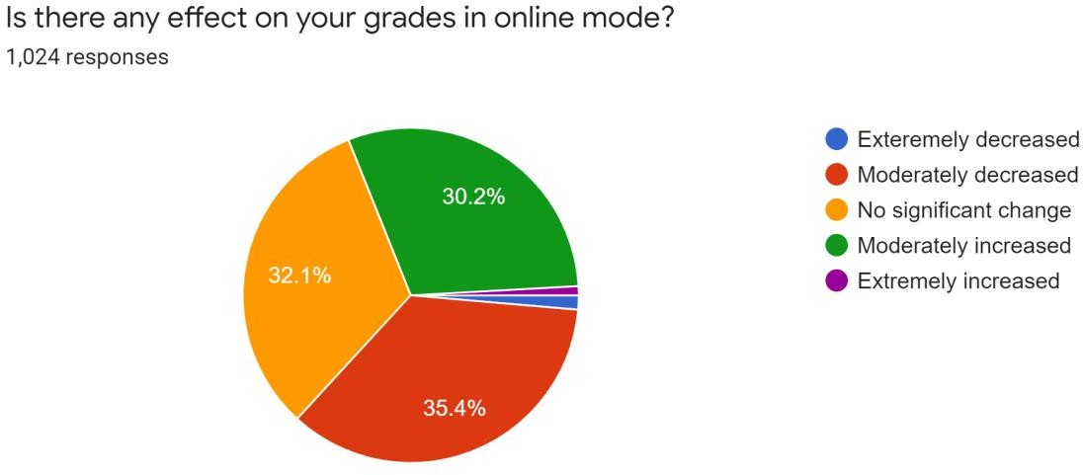

|  |  |  |
| --- | --- | --- |
| S.No. | Response Chosen | No. of Responses |
| 1. | Extremely Decreased | 14 |
| 2. | Moderately Decreased | 363 |
| 3. | No significant change | 329 |
| 4. | Moderately Increased | 309 |
| 5. | Extremely Increased | 9 |

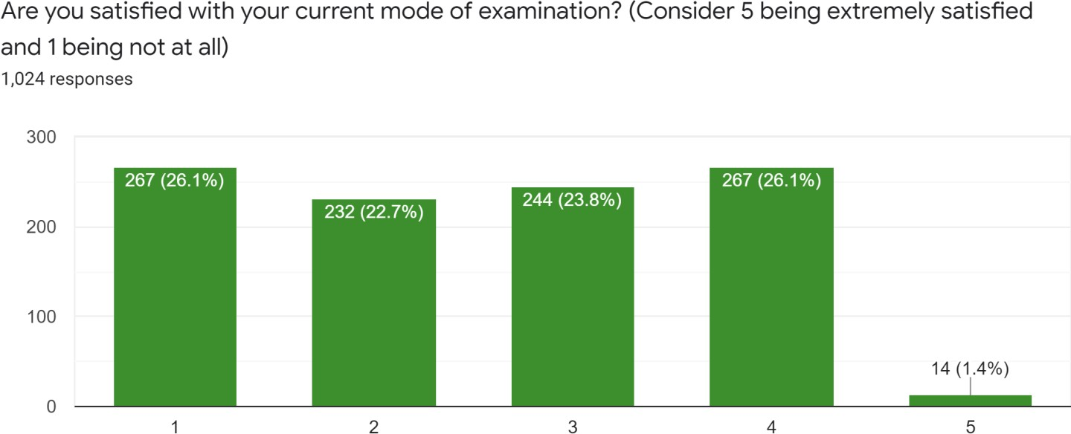

|  |  |  |
| --- | --- | --- |
| S.No. | Response Chosen | No. of Responses |
| 1. | Extremely Dissatisfied | 14 |
| 2. | Moderately Dissatisfied | 363 |
| 3. | Just Satisfied | 329 |
| 4. | Moderately Satisfied | 309 |
| 5. | Extremely Satisfied | 9 |

Main Message:

* The online examination takes less time as compared to the offline examination.
* Susceptible to Cheating.
* Sitting long hours in front of the system causes health issues.

Employment Issues

The education sector is one of the largest in India, and the epidemic has a significant impact on it.

All classes have switched from offline to online mode, which has had a significant impact on employment ratios, whether it is employees who have been dismissed because there is no work in schools for them or transportation service providers who have lost their jobs since there is no demand.

Not only employees and teachers, but even graduate students, have been affected by this issue, since many organizations are not employing new interns owing to their poor financial circumstances.

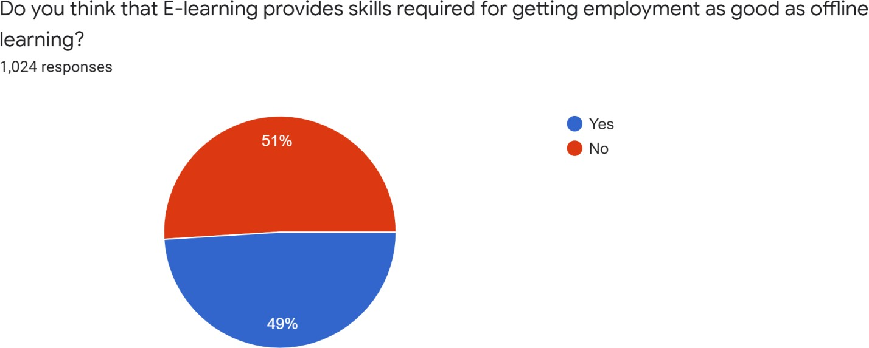

|  |  |  |
| --- | --- | --- |
| S.No. | Response Chosen | No. of Responses |
| 1. | Yes, it provides skills for getting employment. | 502 |
| 2. | No, it doesn’t. | 522 |

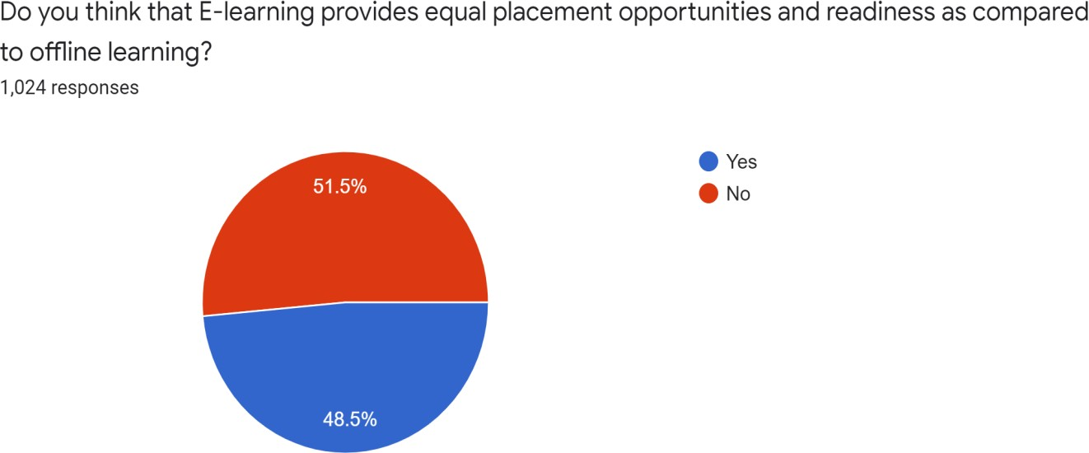

|  |  |  |
| --- | --- | --- |
| S.No. | Response Chosen | No. of Responses |
| 1. | Yes, it provides equal placement opportunities. | 497 |
| 2. | No, it doesn’t. | 527 |

Main Message:

* Workers are losing their jobs.
* Graduating students are facing problem in placements

Conclusion

Homeroom education is critical for energising and stimulating synergistic learning. Understudy fundamental thinking abilities are improved through study hall training. Homeroom reading allows students to participate in actual dialogues where they may more likely utilise their fundamental intuition abilities to voice opinions or participate in a debate.

Traditional offline learning is now unquestionably a more appealing option. However, owing to the epidemic, online schooling is becoming increasingly important.

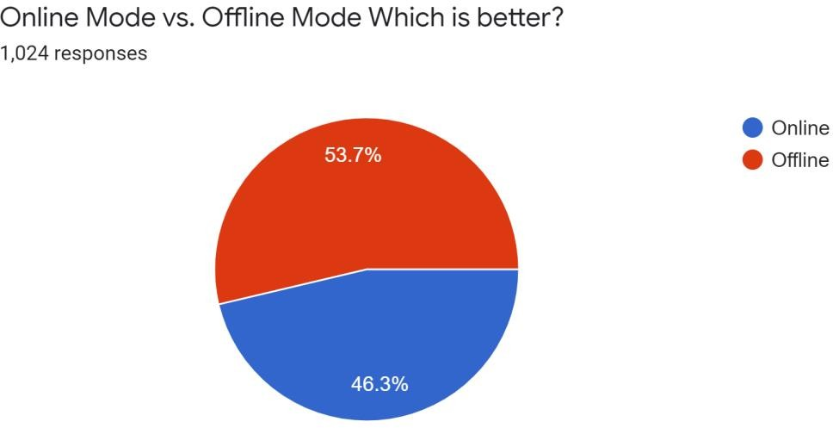

|  |  |  |
| --- | --- | --- |
| S.No. | Response Chosen | No. of Responses |
| 1. | Online mode is better. | 474 |
| 2. | Offline mode is better. | 550 |

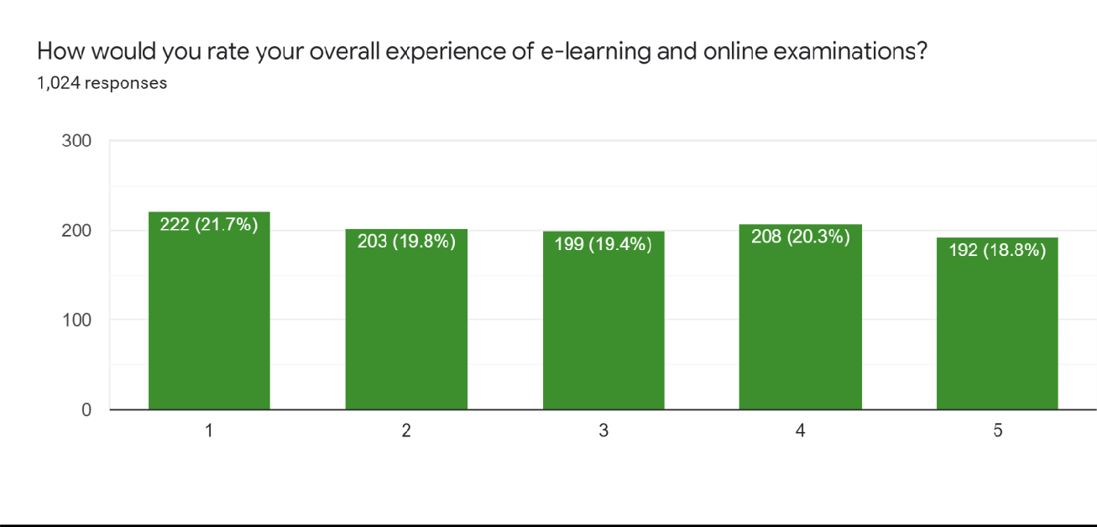

|  |  |  |
| --- | --- | --- |
| S.No. | Response Chosen | No. of Responses |
| 1. | Extremely Dissatisfied | 222 |
| 2. | Moderately Dissatisfied | 203 |
| 3. | Just Satisfied | 199 |
| 4. | Moderately Satisfied | 208 |
| 5. | Extremely Satisfied | 192 |

Main Message:

* Learners prefer the offline mode of learning.
* The Online mode isn’t unworthy but requires few significant changes.

Responses and Questionnaire

Link for the questionnaire: <https://forms.gle/XYCzKF6YuHPSaW5W9>

Link for the responses sheet: <https://drive.google.com/file/d/1BhekVcCNkG_5QXwqpj2LNAqGMs5-1nA4/view?usp=sharing>