**Unix Assignment**

**Hitendra Singh Pal**

**Id: 200604**

**Task1**

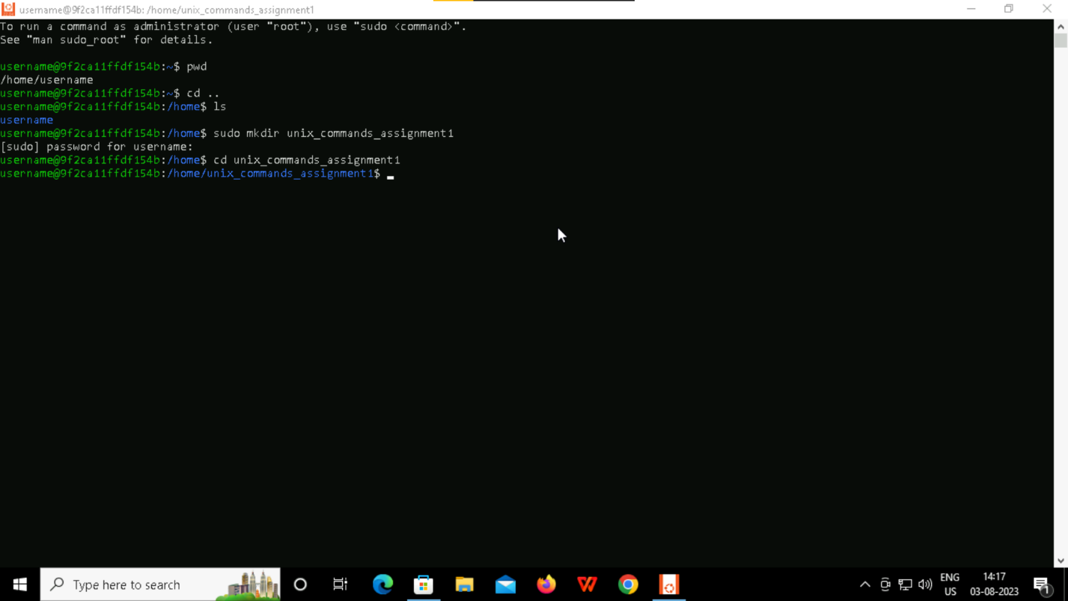

**Task2**

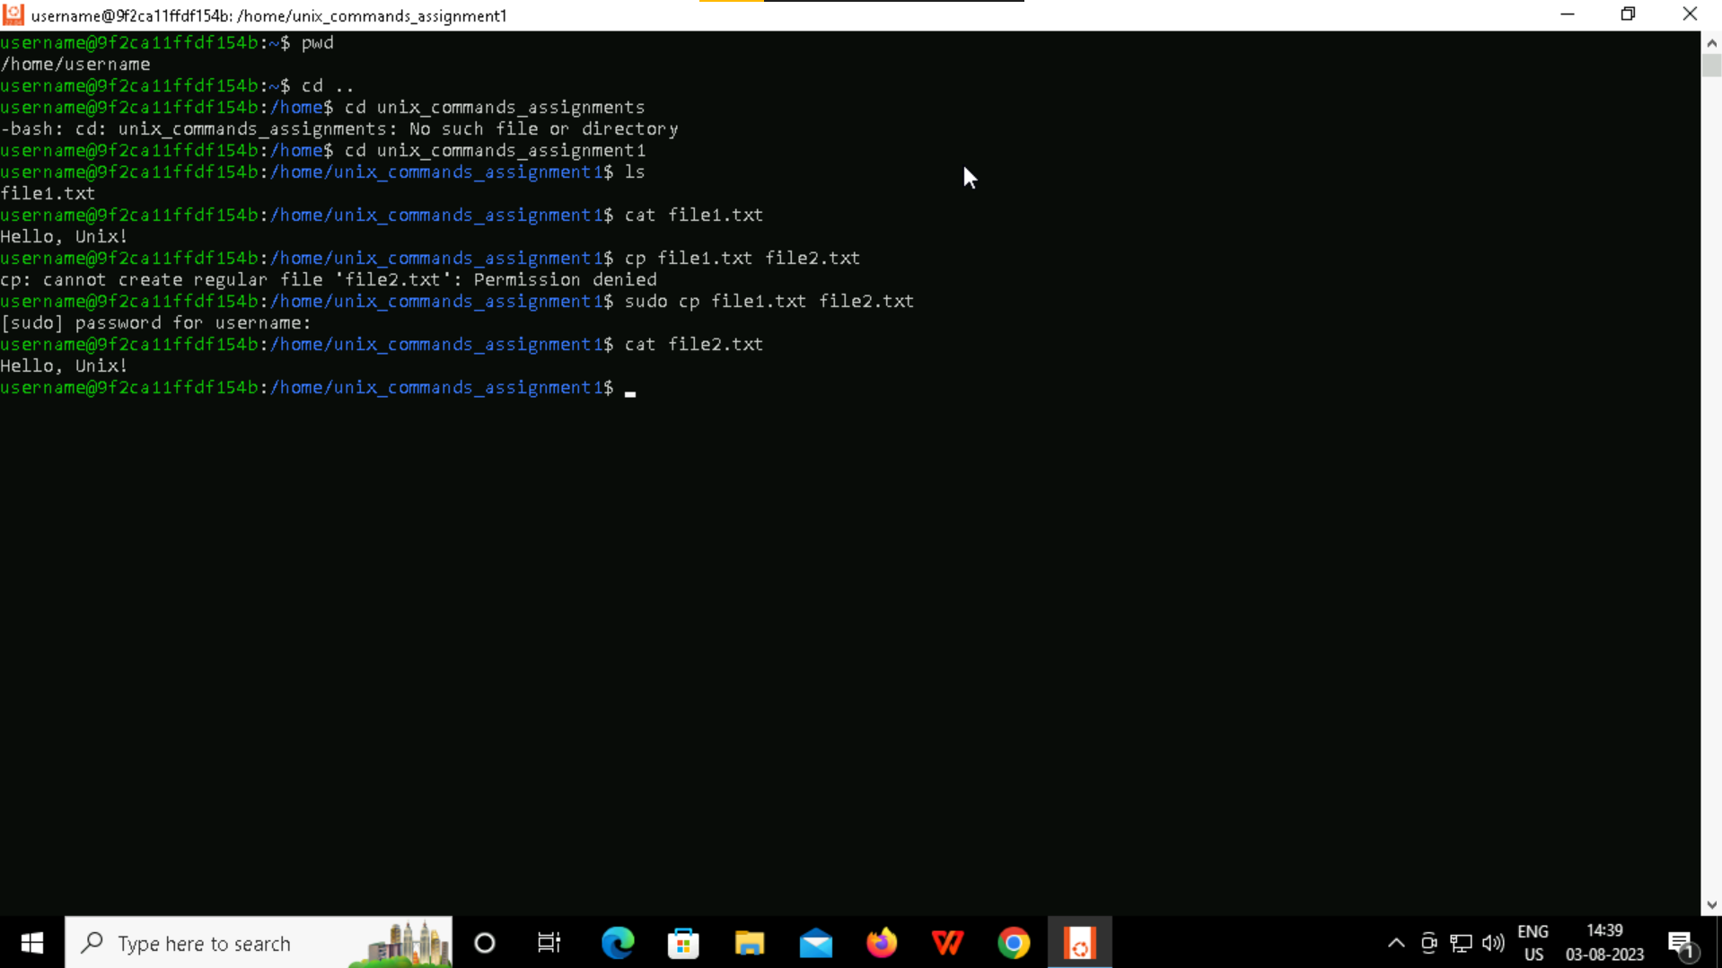

**Task3**

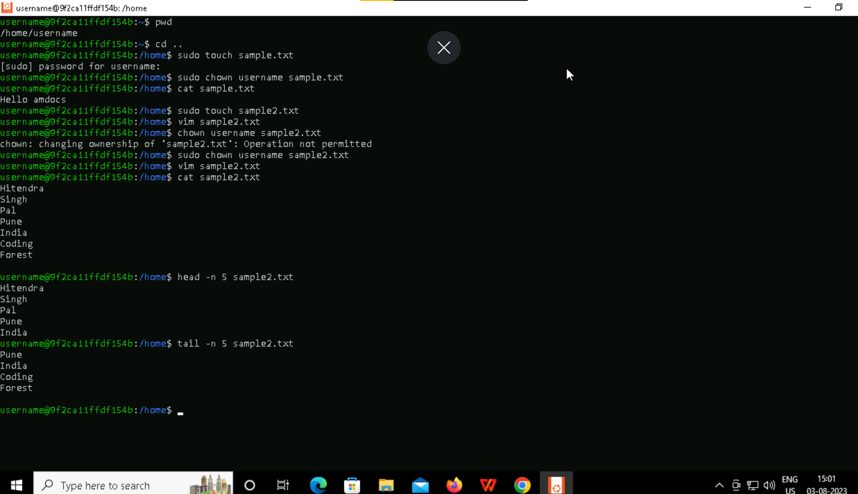

**Task4**

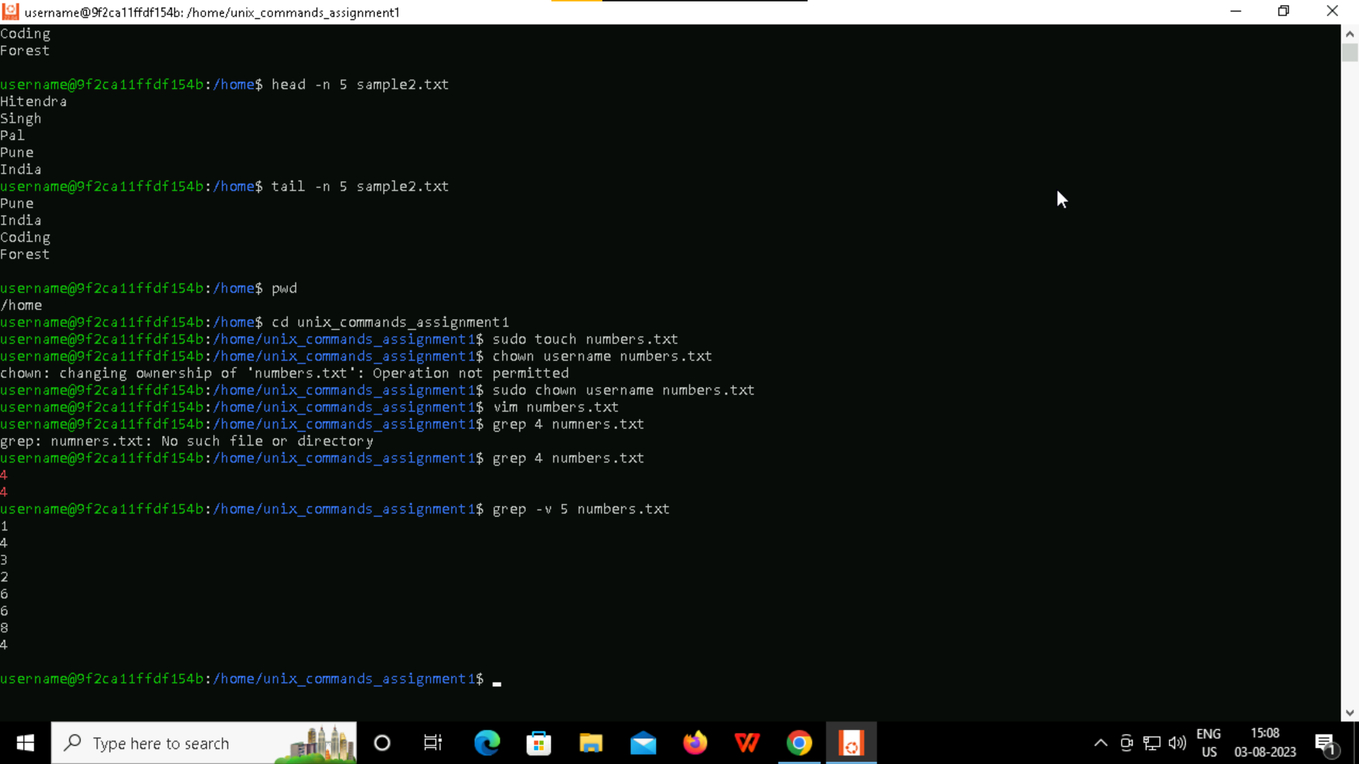

**Task5**

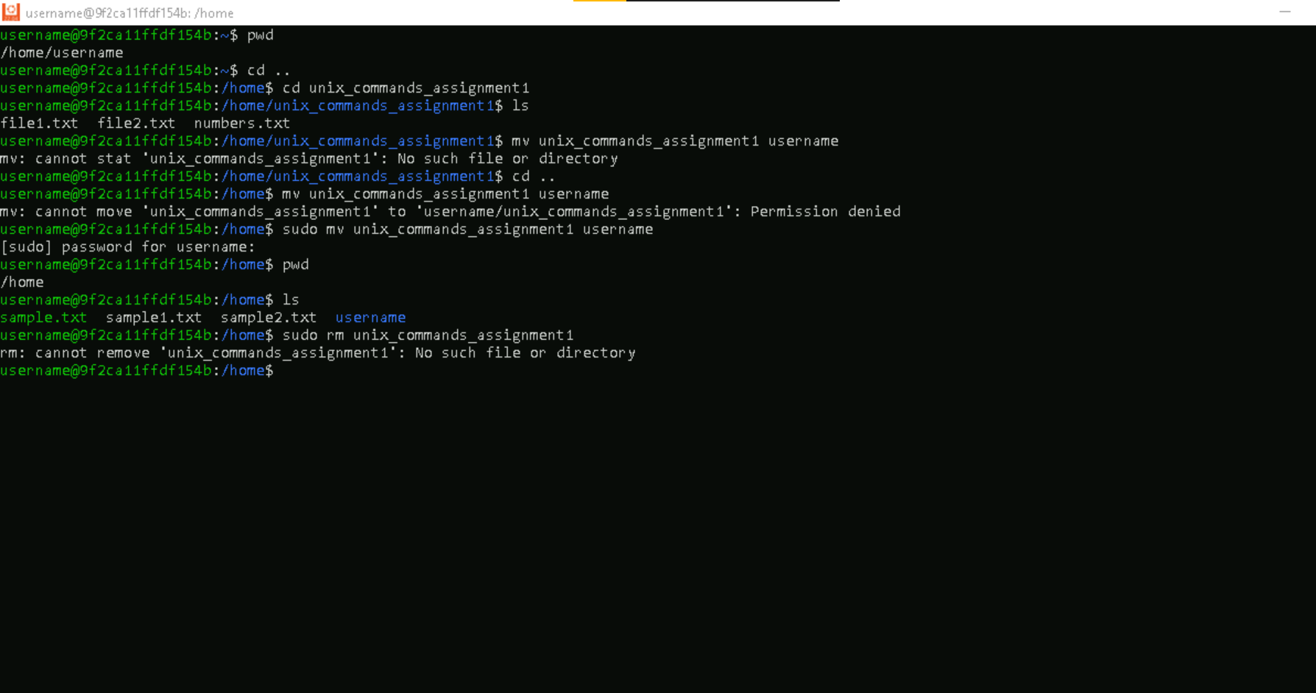

**Summary:**

**Overall experience was great. Got an opportunity to learn a lot about unix architecture and commands. Looking forward to learn more in incoming classes.**