Hastavāṇī: A Privacy-Preserving, Browser-Based System for Recognising American and Indian Sign Language Letters, Digits and Sentences from Webcam Landmarks
[Author Name(s)]
[Department, Institution, City, Country]
[email@institution]
Draft notes for the authors (delete before submission): text in [square brackets] must be filled in. Every number in this draft is a measured result from the project (see Description.md); do not round them up. Items marked [verify] are bibliographic details to confirm against the original source. Format: re-flow into your target venue's template (e.g. IEEE two-column) once the content is final.
Abstract—Sign language recognition systems are usually server- or GPU-dependent and are often evaluated on test sets that share signers or recording sessions with their training data, which overstates real-world accuracy. We present Hastavāṇī, a complete web application that recognises American Sign Language (ASL) and Indian Sign Language (ISL) fingerspelling, the digits 0–9 and a catalog of 101 everyday sentences per language from an ordinary webcam, running entirely inside the browser with no video leaving the device. All modules operate on MediaPipe hand and body-pose landmarks rather than pixels. Letters are classified by small multilayer perceptrons; digits by rotation- and scale-invariant geometric rules; sentences by dynamic time warping (DTW) nearest-neighbour matching on body-relative hand and arm features with idle-segment trimming. For ASL sentences, for which no suitable repeated-sentence dataset exists, reference sequences are synthesised by chaining isolated-sign clips from WLASL. Replacing an image CNN with a landmark classifier raised ASL letter accuracy on photos from an unseen source from 53.2% to 82.3% (93.0% top-3). The digit reader reaches 97% on 872 real photographs. For ISL sentences, a cross-setup protocol that never matches a signer against their own recordings reveals that leave-one-out accuracy (31.7% top-1) substantially overstates performance on new signers (10.8%); features tuned on the honest protocol raise new-signer accuracy to 17.2% top-1 and 31.3% top-3 against a 1% chance level. Word-chained ASL sentence references reach 76.8% top-1 on held-out signers in a synthetic setting. We further introduce on-device personalisation in which users' own confirmed recordings become references. We report negative results and evaluation pitfalls alongside the system, as lessons for building deployable, honestly evaluated sign language tools.
Index Terms—sign language recognition, American Sign Language, Indian Sign Language, MediaPipe, hand landmarks, dynamic time warping, fingerspelling, web application, privacy, evaluation methodology.

I. Introduction
Sign languages are the primary means of communication for millions of Deaf and hard-of-hearing people, yet very few hearing people can read them. Automatic sign language recognition (SLR) could support learners, families and everyday interactions, but most published systems are research prototypes: they require a GPU or a remote server, specialised cameras or controlled studio conditions, and they are frequently evaluated on data splits in which the same signer, session or even near-identical video frames appear in both training and test sets. Such evaluations report high accuracy that does not transfer to a new person using an ordinary webcam.
This work set out to build a sign language tool that a person can actually use: one that opens in a web browser, works on a CPU-only laptop, never uploads video, and covers more than the alphabet. Along the way, we repeatedly found that models with excellent in-distribution scores failed in realistic conditions, and that the most effective improvements came from changing the input representation and the evaluation protocol rather than from larger models.
The resulting system, Hastavāṇī (Sanskrit hasta, "hand", and vāṇī, "voice"), recognises ASL and ISL letters, digits and sentences in real time in the browser, speaks the result aloud and keeps a per-user history. The contributions of this paper are:
- A complete, client-only SLR web application for two sign languages, in which all recognition runs in TypeScript on MediaPipe landmarks, with no machine-learning runtime and no server.
- An empirical comparison showing that, for ASL fingerspelling, a 63-dimensional landmark multilayer perceptron generalises to an unseen photo source far better than ImageNet-pretrained image CNNs (82.3% vs. 53.2% top-1).
- A training-free, rule-based digit recogniser based on finger extension, thumb position and thumb–fingertip contact, reaching 97% on 872 real photographs.
- A small-data sentence recogniser based on DTW nearest-neighbour matching with body-relative hand and arm features and idle-segment trimming, evaluated with a cross-setup protocol that exposes the optimism of leave-one-out testing.
- A method for building ASL sentence references without sentence-level data, by chaining isolated-sign clips (WLASL) in ASL gloss order.
- On-device personalisation, in which a user's confirmed recordings are added as references, and a documented set of negative results and evaluation pitfalls (data leakage in frame-derived datasets, same-signer leakage in sentence evaluation).
The rest of the paper is organised as follows. Section II reviews related work, Section III gives an overview of the system and Section IV describes the datasets. Section V presents the methods, Section VI the experimental protocols and Section VII the results. Section VIII discusses the findings, Section IX limitations and ethical considerations, and Section X concludes.

II. Related Work

A. Landmark-based hand analysis
MediaPipe Hands [1] detects up to two hands and regresses 21 three-dimensional landmarks per hand in real time on commodity hardware, and BlazePose [2] provides 33 body landmarks. Because landmarks abstract away appearance (background, lighting, skin tone), they have become a common input for lightweight gesture and fingerspelling classifiers. We use both models through the MediaPipe Tasks API in the browser and in Python.

B. Fingerspelling and isolated sign recognition
Image-based fingerspelling classifiers are often trained on Sign Language MNIST [3], a 28×28 grayscale dataset of 24 static ASL letters. Larger isolated-sign corpora such as WLASL [4] (2,000 glosses) and MS-ASL [5] support word-level recognition with deep video models. For ISL, Ekbote and Joshi [6] recognised numerals with ANN and SVM classifiers. Transfer learning from ImageNet backbones such as MobileNetV2 [7] is a standard way to train image classifiers on small datasets; we evaluate this approach and find that it does not generalise across photo sources for our task.

C. Sentence-level and continuous recognition
Continuous SLR and sign language translation are typically addressed with sequence models trained on large corpora such as How2Sign [8]. These require data volumes that are not available for a fixed catalog of everyday ISL sentences: ISL-CSLTR [9] provides roughly five to seven recordings per sentence. For very small data, template matching with dynamic time warping (DTW) [10], which aligns two sequences that differ in speed, remains a strong baseline, and we adopt it here.

D. Evaluation practice
A recurring problem in SLR is evaluation leakage: random splits of frame-derived datasets place near-duplicate frames in both training and test sets, and signer-dependent splits measure memorisation of a person's signing style rather than generalisation. Our evaluation therefore uses cross-source, temporal, cross-setup and held-out-signer protocols (Section VI), and reports the realistic numbers.

III. System Overview
Fig. 1 shows the architecture. All recognition runs in the browser. Webcam frames are processed by the MediaPipe HandLandmarker (up to two hands) and, on the sentence page only, by the PoseLandmarker lite model. Three recognisers consume the landmarks: a letter MLP with confidence gating and temporal voting, a rule-based digit reader, and a DTW sentence matcher that compares a whole recorded clip against a bank of reference sequences, optionally extended with the user's own recordings. Results are displayed, spoken with the Web Speech API and stored in a per-user history. Offline, Python scripts extract landmarks from the datasets, train or tune the recognisers and export static files: JSON weights for the MLPs, and a float32 binary reference bank with a JSON index for the sentence matcher. Because every feature function exists twice (Python for training, TypeScript for the browser), every port was verified numerically (Section VI-E).
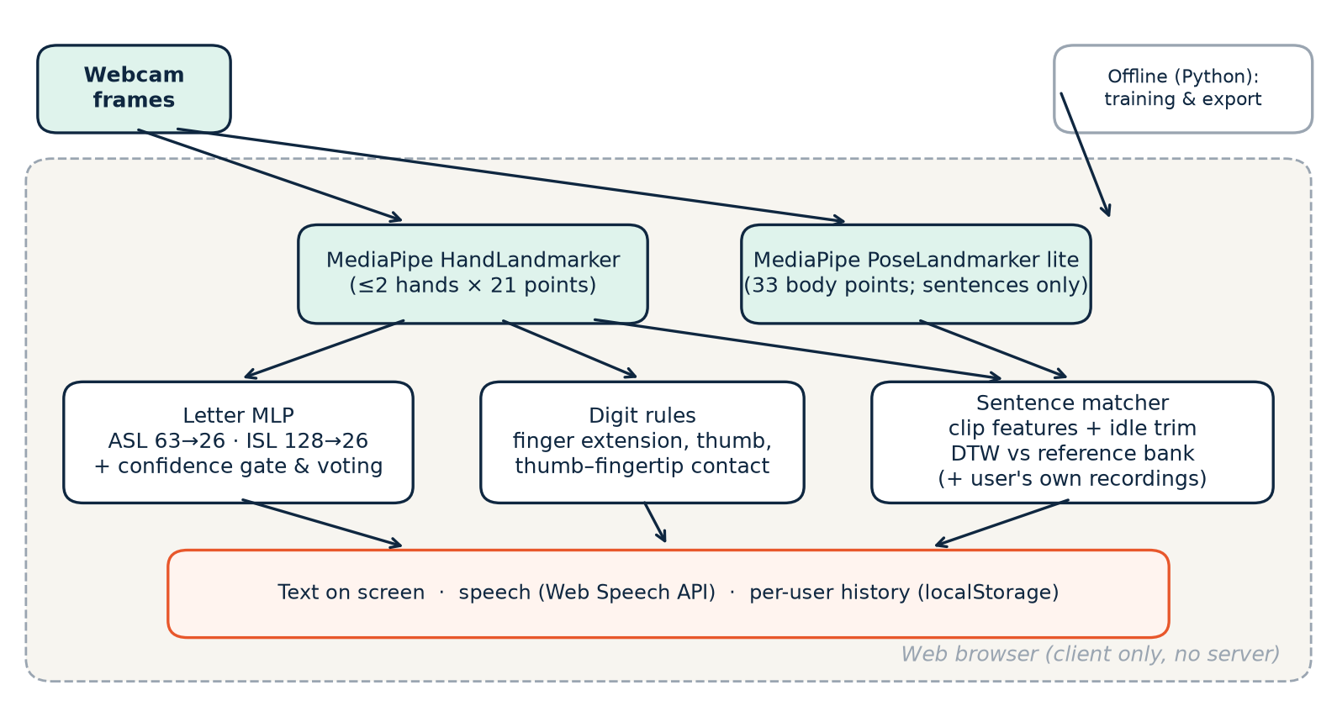
Fig. 1. System architecture. Everything inside the dashed box runs client-side in the web browser; no video or landmarks are sent to a server.

IV. Datasets
Table I lists the datasets used. Two observations shaped the methods. First, the ISL alphabet photos are consecutive frames of one continuous recording per letter by a single signer: the mean absolute pixel difference between images of the same class is only about 2–15 (out of 255), even for frames hundreds apart. Second, no public ASL dataset records a fixed set of sentences several times. How2Sign contains roughly one recording per sentence, ASL-Homework-RGBD is access-restricted, ASLLRP utterances are mostly unique, and RWTH-BOSTON-104 uses monochrome cameras that are unsuitable for MediaPipe. This motivated the word-chaining approach of Section V-D.
TABLE I. Datasets used in this work
Dataset | Used for | Size used | Notes
Sign Language MNIST [3] | ASL letters, baseline v1 | 24 classes, 28×28 grayscale | Controlled, tightly cropped
Marxulia ASL alphabets v03 | ASL letters (train) | 10,873 photos; 8,514 with a hand | Varied real photos
EitanG98 asl_letters | ASL letters: train split; validation split = cross-source test | 720 val. photos; 672 with a hand | Different photographer and camera; never trained on
Hemg ISL dataset | ISL letters; digit validation | 31,945 letter images (26 classes) | One signer, continuous recording per letter
ISL-CSLTR [9] | ISL sentences | 687 videos, 101 sentences | 492 at 1920×1080 (camera), 195 at 240×320 (phone)
WLASL [4] | ASL sentence references | 140 glosses, 1,050 clips (of 11,980) | ~6 signers per gloss; non-commercial licence

V. Methodology

A. Fingerspelling (letters)

1) ASL: from images to landmarks
The ASL letter recogniser went through four versions (Table II, Fig. 2):
- v1. A CNN trained on Sign Language MNIST reached 99.8% on its own test set but was unusable on a live webcam.
- v2. An ImageNet-pretrained MobileNetV2 (96×96 RGB input; frozen backbone, then top ~30 layers fine-tuned; spatial-attention head) was trained on hand-cropped Marxulia photos. From-scratch CNNs had failed to train at all: the loss stayed at ln 26 across six ablations.
- v3. The same network trained on Marxulia plus the EitanG98 training split, with heavier colour and geometric augmentation.
- v4 (final). A landmark MLP. The 21 hand landmarks p₁…p₂₁ (MediaPipe normalised coordinates) are translated so that the wrist p₁ is at the origin and scaled by the hand's largest planar extent:
x = vec( (pᵢ − p₁) / ( maxⱼ ‖(pⱼ − p₁)ₓᵧ‖₂ + ε ) ), i = 1…21, x ∈ ℝ⁶³ (1)
The classifier is Dense(256)–BatchNorm–ReLU–Dropout(0.3)–Dense(128)–BatchNorm–ReLU–Dropout(0.3)–Dense(26, softmax), about 52 k parameters. It is trained on 6,557 landmark samples, each with seven augmented copies: random horizontal mirroring, in-plane rotation (σ = 0.15 rad), anisotropic scaling (σ = 0.08) and Gaussian jitter (σ = 0.004). Training uses Adam (learning rate 10⁻³), batch size 128, up to 60 epochs, early stopping on validation accuracy (patience 8) and learning-rate halving on plateau (patience 3).

2) ISL: two-hand landmarks
An image CNN trained on the ISL photos reached 100% test accuracy under a random 80/10/10 split. We identified this as leakage caused by the near-duplicate frames described in Section IV. The final ISL model therefore uses two-hand landmarks: 15,733 samples (every second frame), of which 59.7% contain both hands. Hands are ordered by wrist x-coordinate. All present landmarks are centred on their joint centroid and divided by the maximum planar distance to it, and two hand-presence flags are appended, giving 128 features. The MLP is Dense(384)–BN–ReLU–Dropout–Dense(192)–BN–ReLU–Dropout–Dense(26). To reduce leakage, it is evaluated with a temporal split within each letter's recording: the first 70% of frames for training, 72–80% for validation and the last 18% for testing.

3) Real-time decoding
At run time a prediction is accepted only if its softmax confidence is at least 0.60. A letter is locked in when it wins at least 5 of the last 8 accepted predictions. The lock is released only after 10 consecutive low-confidence or no-hand frames; this hysteresis eliminated repeated insertions of a held letter (e.g. "HHHH") that a single-frame reset had caused. Locked letters are appended to a word buffer and spoken, with each letter repeated at most once every 2 s.

B. Digits
Public digit datasets did not match the numeral charts taught by the application, so we built a training-free recogniser instead. For each of the four fingers it computes an extension score e_f ∈ [0, 1] from the proximal-interphalangeal joint angle and a tip-to-base distance ratio. It also computes a thumb-abduction score and four thumb–fingertip contact scores (thumb-tip-to-fingertip distance relative to hand size). Each score is a logistic function of its measurement, with midpoints of 135° (joint angle), 1.6 (distance ratio), 0.68 (thumb) and 0.42 (contact). Each digit is defined by a template over these scores; for example, 6–9 are distinguished by which fingertip the thumb touches. Template agreement yields a probability for each digit. Because the features are ratios and angles, they are invariant to hand scale, position and in-plane rotation. ASL and ISL share the handshapes for most digits, so one reader serves both languages. As an optional personalisation step, users may record samples of each digit; once at least 30 exist, a k-nearest-neighbour vote (k = 7) over the user's landmark vectors is blended with the rules.

C. ISL sentences: body-relative DTW matching

1) Sequence extraction
Each ISL-CSLTR video is sampled at about 12.5 frames/s (one frame per 80 ms, at most 90 frames). For every sampled frame we extract up to two hands and the body pose. A body is detected in every frame, but only 31% of frames contain two detected hands, and about 85% of clips lose a hand in at least one mid-clip frame.

2) Clip features
A whole clip is converted to a sequence of feature vectors as follows. Let s_L and s_R be the pose shoulder points in pixel coordinates. The body reference frame is fixed per clip, with origin o = median_t((s_L + s_R)/2) and scale σ = median_t ‖s_L − s_R‖₂. Using pixel coordinates and clip-level medians makes the features independent of image aspect ratio, camera distance and per-frame pose noise. Each kept frame t is described by:
- Hand shape (2 × 20): the positions of the five fingertips and five middle joints relative to the wrist, divided by the palm length (wrist to middle-finger knuckle), weighted by w_shape/3.
- Presence flags (2).
- Hand location (2 × 2): each palm centre relative to the body frame, (c − o)/σ, weighted by w_loc.
- Arm pose (2 × 2 × 2): pose elbows and wrists relative to the body frame, weighted by w_arm. These are available even when the hand detector loses a hand.
Hands and arms are ordered by wrist x-coordinate, and every reference clip is stored together with its horizontal mirror to accommodate left-handed signing. The frame weights were tuned on the cross-setup protocol (Section VI-C): w_shape = 2, w_loc = 0.5, w_arm = 8. A frame is kept if a hand or a body is detected in it.

3) Idle-segment trimming
Recordings begin and end with the hands resting in the lap, and the length of these idle segments varies widely. Let y_t be the higher of the two pose wrists, measured downward in body-frame units: y_t = min(wrist_L,y, wrist_R,y) − o_y, divided by σ. We keep only the frames between the first and the last frame with y_t < τ, using τ = 0.4 shoulder-widths below the shoulder line.

4) Matching
A query sequence a (length T₁) is compared with each reference b (length T₂) by DTW with squared-Euclidean frame cost, restricted to a Sakoe–Chiba band of relative width β = 0.2 around the diagonal:
D(i, j) = ‖aᵢ − bⱼ‖² + min{ D(i−1, j−1), D(i−1, j), D(i, j−1) }, |j − i·T₂/T₁| ≤ β·T₂ (2)
d(a, b) = D(T₁, T₂) / (T₁ + T₂) (3)
The score of a sentence is the minimum distance over its references (a per-class 1-nearest-neighbour rule), and sentences are returned in ranked order. For display, the distances are converted to a confidence with a softmax over −3·(d − d_min)/d_min. The final ISL bank contains 1,374 sequences (687 clips plus their mirrors) and occupies 7.9 MB.

5) Rejected alternatives
A two-layer bidirectional GRU (about 250 k parameters, masking, 14× augmentation) reached 97% training accuracy but only 15.2% top-1 on held-out videos, i.e. it memorised the roughly five examples per class. Fixed-length resampling with Euclidean k-NN scored about 18%. On the cross-setup protocol, the following gave no gain: interpolating hand detection gaps, velocity features, removing depth, L1 or per-frame Euclidean costs, late fusion of per-channel DTW distances, per-clip centring, temporal smoothing and mean-of-k class aggregation.

D. ASL sentences from chained word clips
We defined 101 everyday ASL sentences, including the ISL catalog's sentences wherever ASL has the words, and wrote each in ASL gloss order (for example, "What is your phone number?" becomes YOUR PHONE NUMBER WHAT), using only the 140 glosses available in WLASL. Landmarks for all 1,050 WLASL clips of these glosses were extracted with the same settings as for ISL. Each word clip is featurised independently, with its own body frame and idle trim, which removes the rest pose before and after the sign. A sentence reference is then the concatenation of one random clip per gloss in gloss order. The bank contains seven random chains per sentence plus their mirrors (1,414 sequences, 31 MB). For ASL we keep the earlier feature variant (v2, 140 dimensions per frame). It retains the full joint-normalised two-hand coordinates (126) together with location and arm features (w_loc = 1, w_arm = 2, τ = 0.6). With the compact v3 shape features, accuracy fell to at most 59% top-1, because ASL signs are distinguished mainly by handshape and the relative position of the two hands. Each bank stores its feature recipe, so the browser featurises a query in the same way as the bank it is matched against.

E. On-device personalisation
Because inter-signer variation dominates sentence errors (Section VII-C), users can add their own recordings as references. After each result, the user either confirms it or selects the correct sentence. The recording's feature sequence is then stored in browser localStorage, keyed by language and feature recipe, and up to the 60 most recent recordings are matched alongside the bank. No data leaves the device.

F. Implementation
The application is a multi-page Vite site written in TypeScript with Tailwind CSS. MLP forward passes (with batch normalisation folded into the dense layers) and DTW are implemented in plain TypeScript; removing TensorFlow.js reduced the translator bundle from about 1 MB to 164 kB. Hands are tracked on every frame. On the sentence page, the pose model runs only on the 80 ms sampling ticks, and the hand-detection threshold is set to 0.3 to match offline extraction. The application also provides speech output, an alphabet guide, a signing calculator and practice game, light and dark themes, client-side sign-in and a per-user activity history (Figs. 5–6).

VI. Experimental Setup
All experiments ran on a laptop CPU (Intel Core i7-1255U, 10 cores, no GPU) using Python 3.11, TensorFlow/Keras and NumPy. Sentence evaluation used a Numba-parallel DTW, which reduced a full 687-video leave-one-out run from 17.7 minutes (pure Python) to about 13 seconds.

A. Letters
Cross-source (ASL). The EitanG98 validation split, from a different photographer, camera and background, is never used for training. We evaluate on its 672 images in which a hand is detected and report top-1 and top-3 accuracy. Temporal split (ISL). As described in Section V-A2.

B. Digits
We assembled 872 real photographs whose signs match the taught charts: Hemg ISL classes verified to match, and ASL letter photographs that share a digit handshape (O = 0, V/U = 2, B = 4, W = 6, F = 9). The rule thresholds were tuned on the same set.

C. ISL sentences
Leave-one-out (LOO). Each of the 687 videos is matched against all others (and their mirrors), excluding itself and its own mirror. Other takes by the same signer therefore remain in the bank. Cross-setup. ISL-CSLTR contains two recording setups with different people: phone (240×320) and camera (1920×1080). Queries from one setup are matched only against references from the other, in both directions, and we report the mean of the two directions. This is the closest available proxy for a new signer on a new camera, because the corpus has no signer identifiers.

D. ASL sentences
Held-out signers. In each of three seeds, 30% of WLASL signers are excluded from the references. Queries are chained clips by those held-out signers (five per sentence where every gloss is available; about 66 sentences are covered per seed). Hard queries. The same protocol, with 10–25% cut from the edges of each word, a random speed change of 0.7–1.4× and landmark jitter. Whole-clip. Detection is run over the joined reference video of each sentence, which includes the rest pose between words, and the clip is classified exactly as in the browser.

E. Implementation parity
Each TypeScript port was compared with its Python reference on real data. ISL letter MLP: maximum probability difference 6×10⁻⁸. Sentence features (both versions, including the no-body fallback path): maximum absolute difference 3.8×10⁻⁶. DTW distances: maximum relative difference 1.8×10⁻⁷ on 16 real clips against the shipped banks. Personalisation: a clip not in the bank, taught under a different label, was returned with that label in 7 of 7 cases. End-to-end flows were tested in headless Chrome with a virtual camera.

VII. Results

A. Letters
TABLE II. ASL letter recognition: same-source vs. cross-source top-1 accuracy
Model | Input | Same-source | Cross-source (unseen camera)
v1 CNN (Sign Language MNIST) | 28×28 gray image | 99.8% | unusable live
v2 MobileNetV2 | 96×96 RGB crop | 88.9% | 27.2%
v3 MobileNetV2, two sources | 96×96 RGB crop | 73.0% | 53.2%
v4 landmark MLP (ours) | 63 landmark features | 91.8% | 82.3% (top-3 93.0%)

Table II shows the central result for letters. Same-source accuracy was a poor predictor of real performance: v2 lost 62 percentage points on photos from a different source, and its confusion matrix was close to random. Combining two sources (v3) helped but remained weak. The landmark MLP, with about 52 k parameters and no image input at all, generalised best: 82.3% top-1 and 93.0% top-3 on the unseen source. Counting the 48 images without a detected hand as errors, the figures are 76.8% and 86.8%. The ISL landmark model reached 100% on the temporal split; because all data come from a single signer in a single session, we do not regard this as an estimate of real-world accuracy.
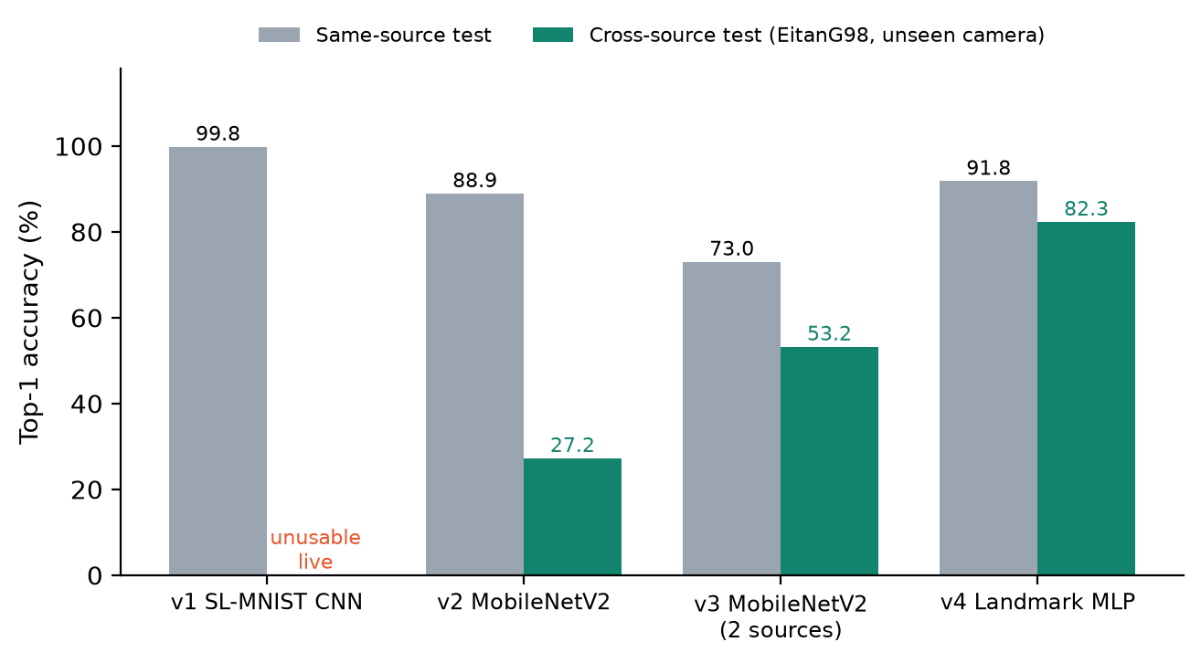
Fig. 2. ASL letter accuracy across model versions. High same-source accuracy did not predict accuracy on an unseen camera; landmark features did.

B. Digits
TABLE III. Rule-based digit recognition on 872 real photographs
Digit | 0 | 1 | 2 | 3 | 4 | 5 | 6 | 7 | 8 | 9 | All
Accuracy | 83% | 100% | 95% | 100% | 97% | 100% | 97% | n/a | n/a | 90% | 97%

The digit reader reaches 97% overall without any training (Table III). The weakest digits are 0 (83%, n = 23) and 9 (90%, n = 29). Digits 7 and 8 could not be validated because no matching photographs were available; they use the same thumb-contact mechanism as 6 and 9. Since the thresholds were tuned on this set, real-world accuracy may be slightly lower.

C. ISL sentences
TABLE IV. ISL sentence recognition (101 classes; chance ≈ 1%)
Method | Protocol | Top-1 | Top-3 | Top-5
Bidirectional GRU | 99 held-out videos | 15.2% | 23.2% | 29.3%
Fixed-length k-NN | LOO | ~18% | ~28% | ~33%
DTW v1 (hand shape only) | LOO | 24.5% | 35.4% | 41.3%
+ Sakoe–Chiba band (β = 0.2) | LOO | 25.0% | 36.7% | 42.5%
+ body-relative location and arms | LOO | 28.0% | 39.7% | 45.6%
+ idle trimming = DTW v2 | LOO | 31.7% | 47.9% | 53.7%
DTW v2 | Cross-setup | 10.8% | 18.2% | 24.2%
DTW v3 (ours, deployed) | Cross-setup | 17.2% | 31.3% | 36.9%
DTW v3 | LOO | 27.7% | 44.3% | 52.3%

Table IV and Fig. 3 summarise the sentence experiments. Under LOO, DTW outperformed the GRU, and each addition (band constraint, body-relative location and arm features, idle trimming) improved accuracy, reaching 31.7% top-1. The cross-setup protocol, however, showed that this figure depended heavily on the same signer's other takes being in the bank: on new signers, DTW v2 achieved only 10.8%. Two further observations show how strongly signers differ. The two phone recordings of each sentence are by two different people in the same room and with the same phone, yet matching one against the other gives just 6.8% top-1. Within the camera setup, where signers repeat sentences, LOO gives 35.2% top-1 and 64.6% top-5.
Tuning the features on the cross-setup protocol produced DTW v3: coarser hand-shape features, much heavier arm weighting and stricter trimming. On new signers, v3 improves top-1 from 10.8% to 17.2% (+59% relative) and top-3 from 18.2% to 31.3%, at the cost of some same-signer accuracy (LOO 31.7% → 27.7%). Per direction, v3 obtains 17.9/32.3/37.4% (phone queries, camera references) and 16.5/30.3/36.4% (camera queries, phone references) top-1/3/5. Idle trimming was the single most important component: removing it halves cross-setup top-1 (10.8% → 5.7%).
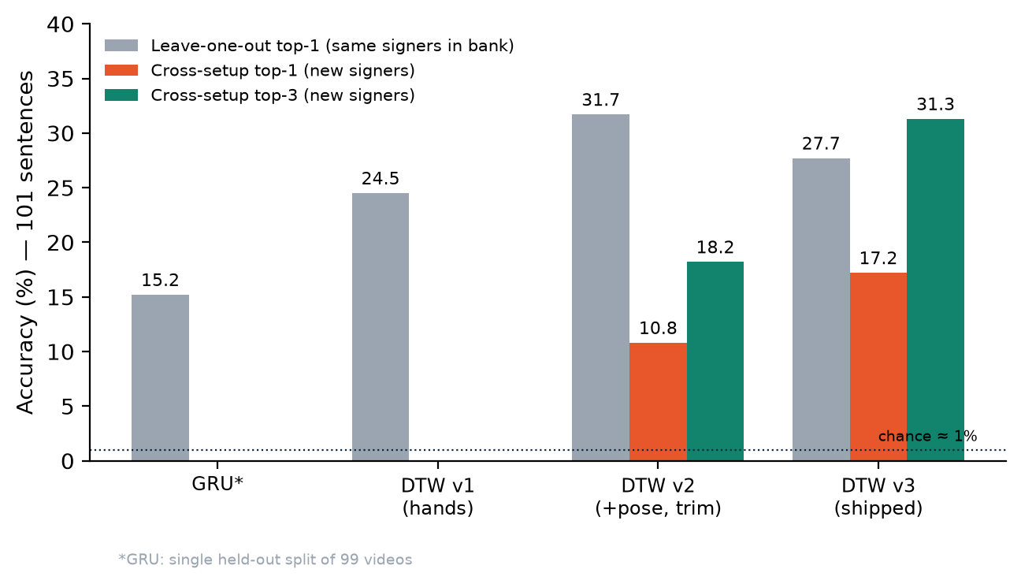
Fig. 3. ISL sentence accuracy. Leave-one-out (same signers in the bank) overstates accuracy on new signers; features tuned on the cross-setup protocol (v3) trade some same-signer accuracy for substantially better new-signer accuracy.

D. ASL sentences
TABLE V. ASL sentence recognition with word-chained references (101 classes)
Test | Top-1 | Top-3 | Top-5
Held-out signers, 10 refs/sentence | 76.8% | 90.5% | 94.0%
Held-out signers, 7 refs/sentence (deployed) | 77.9% | 87.3% | 90.4%
Held-out signers, 5 / 3 refs/sentence | 73.1% / 65.8% | 86.4% / 80.2% | 90.3% / 86.1%
Hard queries (edge cuts, 0.7–1.4× speed, jitter) | 77.3% | 90.3% | 93.7%
Whole-clip, browser-style | 69.3% | 87.1% | 91.1%
v3 compact features instead of v2 | ≤59% | — | —

Word-chained references achieve high accuracy on held-out signers (Table V, Fig. 4). Accuracy saturates at around seven references per sentence, which we deploy to keep the bank at 31 MB. The method is robust to cut word edges and speed changes, and whole-clip classification, despite the rest pose between words, still yields 69.3% top-1. All of these tests are synthetic, however: the queries are themselves chained isolated signs. Fluent signing blends adjacent signs (co-articulation), so live accuracy is expected to be lower. Measuring it requires recordings of real continuous ASL sentences, which were not available.
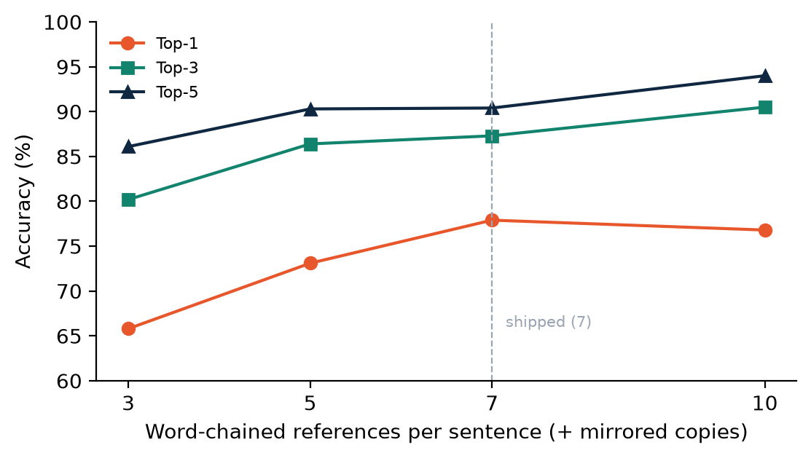
Fig. 4. ASL sentence accuracy on held-out signers as a function of the number of word-chained references per sentence.

E. Application
Figs. 5 and 6 show the translator and the sentence builder. The translator recognises a held ASL "L" with full confidence and appends it to the word buffer. The sentence builder shows the best match, the next three candidates and the personalisation controls. The application runs on a CPU-only laptop at interactive rates; the only network downloads are the MediaPipe models (cached after the first visit) and the static reference banks (7.9 MB for ISL and 31 MB for ASL, loaded on first use).
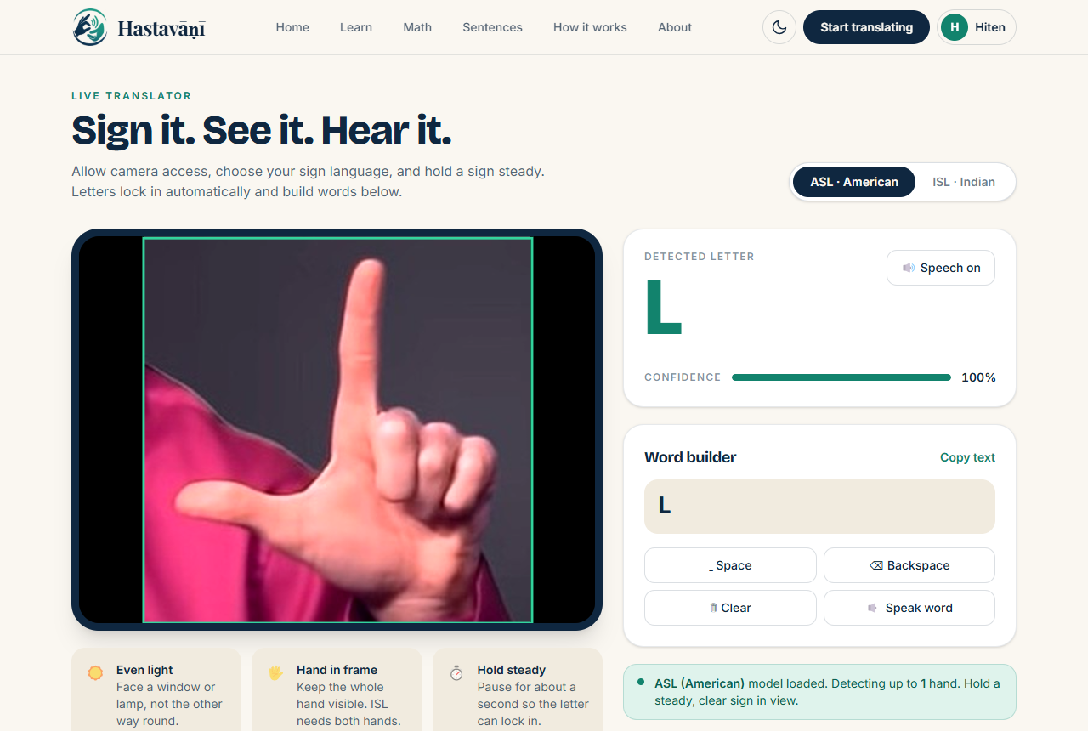
Fig. 5. Live translator: an ASL "L" (static image supplied through a virtual camera) is detected with 100% confidence and added to the word builder.
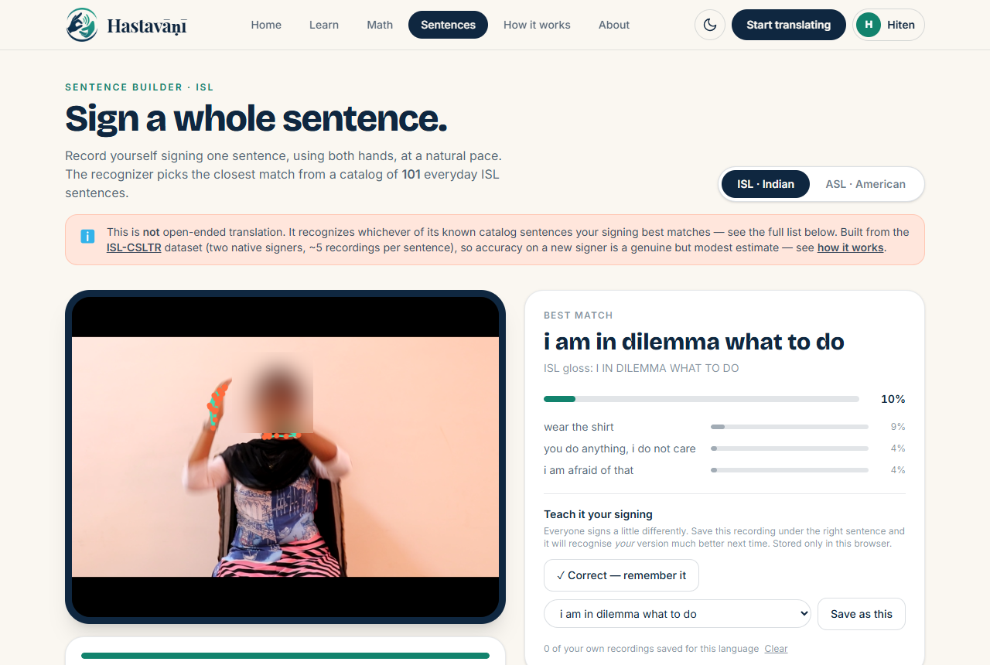
Fig. 6. Sentence builder interface with ranked results and the "Teach it your signing" controls. The input here is a dataset clip looped through a virtual camera and is shown for layout only (the face is blurred); the displayed match is not an accuracy example.

VIII. Discussion
In-distribution accuracy is not real-world accuracy. This held throughout the project: 99.8% on Sign Language MNIST was unusable on a live webcam; 88.9% same-source accuracy became 27.2% on another source; and 31.7% LOO sentence accuracy became 10.8% for new signers. In each case, a more realistic test both revealed the problem and showed which direction of improvement was worthwhile.
Representation matters more than capacity. A 52 k-parameter MLP on hand landmarks outperformed fine-tuned MobileNetV2 models on an unseen source by 29 percentage points, while running in plain JavaScript on every frame. Landmarks remove background, lighting and skin tone, which is exactly the variation that defeated the image models.
Leakage hides in frame-derived data. The 100% ISL result came from near-duplicate video frames that a random split placed on both sides. Checking within-class pixel similarity is a simple diagnostic that we recommend for any dataset extracted from video.
With about five examples per class, matching beats training. DTW outperformed a GRU by 9 points top-1 because it does not need to generalise beyond the stored examples. The quality of its distance metric, rather than any model capacity, then determines accuracy.
Body context and trimming matter for sentences. Where the hands are relative to the body (face versus chest) and how the arms move carry information that is shared across signers, whereas fine hand shape is largely signer-specific. Removing the variable-length idle segments was critical. For ASL isolated signs the opposite holds: handshape dominates. The best feature recipe therefore depends on the language and vocabulary, and the system stores the recipe with each bank.
Inter-signer variation motivates personalisation. When two people signing the same sentence in the same room match each other only 6.8% of the time, no amount of tuning on two signers' data will produce a reliable recogniser for a third. Letting each user contribute their own references is a pragmatic, privacy-preserving response. Quantifying its benefit requires a dataset with signer identifiers and repeated takes per signer.

IX. Limitations and Ethical Considerations
- ISL letters come from one signer in one session, and accuracy on other people is unmeasured. The dataset's alphabet also differs from the official ISLRTC chart for several letters.
- ASL J and Z involve motion and are approximated from single frames.
- Digits 7 and 8 were not validated, and the digit thresholds were tuned on the evaluation set.
- ISL sentences reach only 17.2% top-1 for new signers. The cross-setup protocol is a proxy, because the corpus lacks signer identifiers.
- ASL sentences are evaluated only on synthetic chains of isolated signs. The glosses were written by the authors and should be reviewed by Deaf ASL signers.
- Scope. The vocabulary is a fixed catalog, with no open translation and no facial grammar (non-manual markers). The gain from personalisation is not yet measured.
- Deployment. Sign-in is implemented client-side for demonstration only. User data (history, personal samples) remains in the browser.
- Licensing and consent. WLASL is licensed for non-commercial academic use, and its clips originate from third-party websites. The ISL numeral chart is reproduced from [6]. Republication permissions should be confirmed.
- Intended use. The system is a learning and practice aid and does not replace human interpreters. Development should involve Deaf communities, whose language and data these are.

X. Conclusion and Future Work
We presented Hastavāṇī, a browser-only system that recognises ASL and ISL letters, digits and everyday sentences from webcam landmarks without uploading video. Landmark features made ASL fingerspelling robust to an unseen camera (82.3% top-1, 93.0% top-3). A training-free geometric reader recognises digits at 97%. Body-relative DTW matching with idle trimming, tuned on an honest cross-setup protocol, raises new-signer ISL sentence accuracy to 17.2% top-1 and 31.3% top-3 among 101 classes. Chaining isolated-sign clips provides ASL sentence references where no sentence data exist. Equally important are the evaluation lessons: frame-level leakage and same-signer leakage can each inflate reported accuracy several-fold.
Future work includes:
- Collecting a multi-signer sentence corpus with signer identifiers, to measure signer-independent and personalised accuracy properly.
- Learning a metric embedding of pose sequences from large corpora (e.g. contrastive training on How2Sign) for use with DTW or k-NN.
- Continuous recognition with CTC-style models.
- Adding facial landmarks for non-manual grammar, and motion-aware recognition of J and Z.
- Conducting a user study with Deaf signers.

Acknowledgment
[Acknowledge supervisors, institution and funding here.] The authors thank the creators of the MediaPipe, ISL-CSLTR, WLASL, Sign Language MNIST, Marxulia, EitanG98 and Hemg datasets and tools for making their work openly available.

References
[1] F. Zhang, V. Bazarevsky, A. Vakunov, A. Tkachenka, G. Sung, C.-L. Chang, and M. Grundmann, "MediaPipe Hands: On-device real-time hand tracking," arXiv:2006.10214, 2020.
[2] V. Bazarevsky, I. Grishchenko, K. Raveendran, T. Zhu, F. Zhang, and M. Grundmann, "BlazePose: On-device real-time body pose tracking," arXiv:2006.10204, 2020.
[3] tecperson (datamunge), "Sign Language MNIST," Kaggle dataset. [Online]. Available: https://www.kaggle.com/datasets/datamunge/sign-language-mnist
[4] D. Li, C. Rodriguez, X. Yu, and H. Li, "Word-level deep sign language recognition from video: A new large-scale dataset and methods comparison," in Proc. IEEE/CVF WACV, 2020, pp. 1459–1469.
[5] H. R. Vaezi Joze and O. Koller, "MS-ASL: A large-scale data set and benchmark for understanding American Sign Language," in Proc. BMVC, 2019.
[6] J. Ekbote and M. Joshi, "Indian sign language recognition using ANN and SVM classifiers," in Proc. Int. Conf. Innovations in Information, Embedded and Communication Systems (ICIIECS), 2017. [verify]
[7] M. Sandler, A. Howard, M. Zhu, A. Zhmoginov, and L.-C. Chen, "MobileNetV2: Inverted residuals and linear bottlenecks," in Proc. IEEE/CVF CVPR, 2018, pp. 4510–4520.
[8] A. Duarte, S. Palaskar, L. Ventura, D. Ghadiyaram, K. DeHaan, F. Metze, J. Torres, and X. Giro-i-Nieto, "How2Sign: A large-scale multimodal dataset for continuous American Sign Language," in Proc. IEEE/CVF CVPR, 2021.
[9] R. Elakkiya and B. Natarajan, "ISL-CSLTR: Indian Sign Language dataset for continuous sign language translation and recognition," Mendeley Data, v1, 2021, doi:10.17632/kcmpdxky7p.1. [verify]
[10] H. Sakoe and S. Chiba, "Dynamic programming algorithm optimization for spoken word recognition," IEEE Trans. Acoust., Speech, Signal Process., vol. 26, no. 1, pp. 43–49, 1978.
[11] Marxulia, "asl_sign_languages_alphabets_v03," Hugging Face dataset. [Online]. Available: https://huggingface.co/datasets/Marxulia/asl_sign_languages_alphabets_v03
[12] EitanG98, "asl_letters," Hugging Face dataset. [Online]. Available: https://huggingface.co/datasets/EitanG98/asl_letters
[13] Hemg, "Indian_sign_language_dataset," Hugging Face dataset. [Online]. Available: https://huggingface.co/datasets/Hemg/Indian_sign_language_dataset
[14] [Add: the "Gesture Recognition in Sign Language Translation" paper whose pipeline the first prototype reproduced — full citation from your copy.]

Appendix A. Hyperparameters
TABLE VI. Key hyperparameters of the deployed system
Component | Setting
MediaPipe hand detection confidence | 0.3 (offline extraction and sentence page); 0.5 (letter and digit pages)
ASL letter MLP | 63 → 256 → 128 → 26, BN + ReLU + dropout 0.3; Adam 1e-3; batch 128; ≤60 epochs; 7 augmented copies
ISL letter MLP | 128 → 384 → 192 → 26; same training setup; 6 augmented copies; temporal split 70/8/18
Letter decoding | confidence ≥ 0.60; majority 5 of last 8; unlock after 10 misses; speech cooldown 2 s
Digit rules | logistic midpoints: angle 135°, ratio 1.6, thumb 0.68, contact 0.42; personal k-NN k = 7 (≥30 samples)
Sentence sampling | 80 ms per frame (~12.5 fps), ≤90 frames, ≤7.5 s recording
ISL sentence features (v3) | 54-D: shape 40 (× 2/3), flags 2, location 4 (× 0.5), arms 8 (× 8); trim τ = 0.4
ASL sentence features (v2) | 140-D: joint-normalised hands 126 + flags 2, location 4 (× 1), arms 8 (× 2); trim τ = 0.6
DTW | squared Euclidean cost; Sakoe–Chiba band 0.2; normalised by T₁ + T₂; per-class 1-NN
Reference banks | ISL 1,374 sequences (7.9 MB); ASL 1,414 sequences, 7 chains per sentence + mirrors (31 MB)
Personalisation | newest 60 recordings per language and feature recipe, in localStorage

Appendix B. Reproducibility
All code, scripts and the chronological engineering log are included with the project (README.md, Description.md). The main scripts are listed below; all are run from the repository root with Python 3.11.
- ASL letters: landmarks_asl.py → train_asl_landmarks.py → export_asl_landmarks.py
- ISL letters: landmarks_isl.py → train_isl_landmarks.py
- Digits (validation set): numbers/extract_digit_validation.py
- ISL sentences: sentences/extract_landmarks.py → sentences/extract_pose.py → sentences/export_dtw_bank.py. Evaluation: eval_dtw_pose.py (LOO), eval_cross.py (cross-setup), dtw_lab.py (Numba harness).
- ASL sentences: asl_sentences/extract_words.py → asl_sentences/build_bank.py (eval | export). Additional tests: eval_hard.py, eval_clips.py.
- Parity checks: sentences/check_pose_parity.py with webapp/scripts/check-pose-parity.mts; webapp/scripts/check-personal.mts.
- Web application: cd webapp && npm install && npm run build (static site in webapp/dist).

