Experiment 6

Aim: Implement a classification problem based on logistic regression

Software used : Google Collab

Program Code and Output:

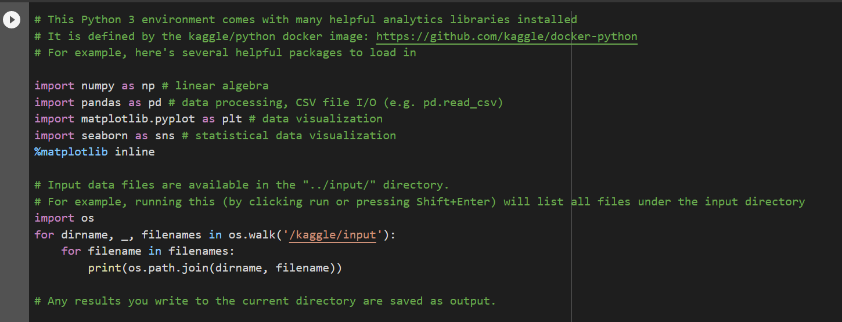





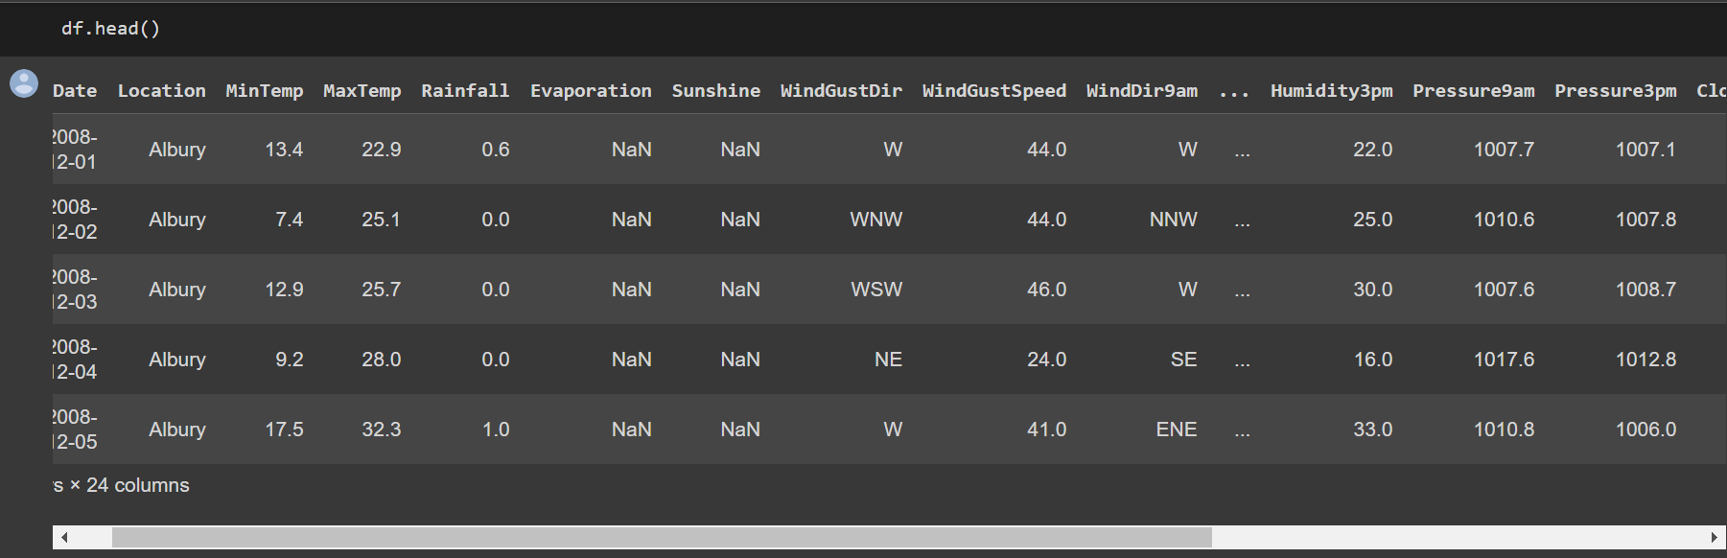

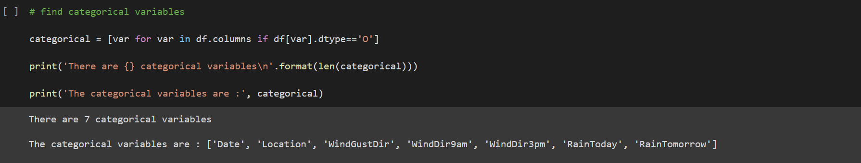

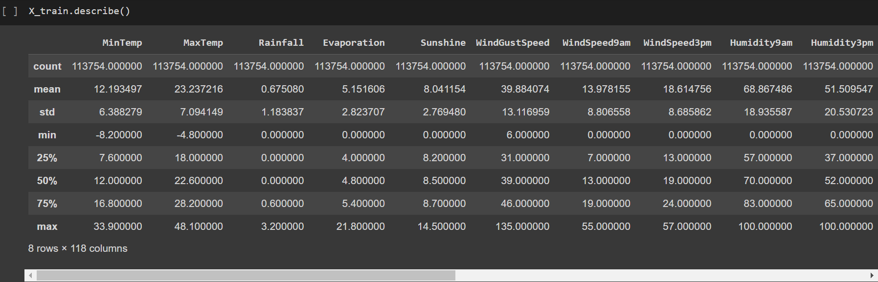

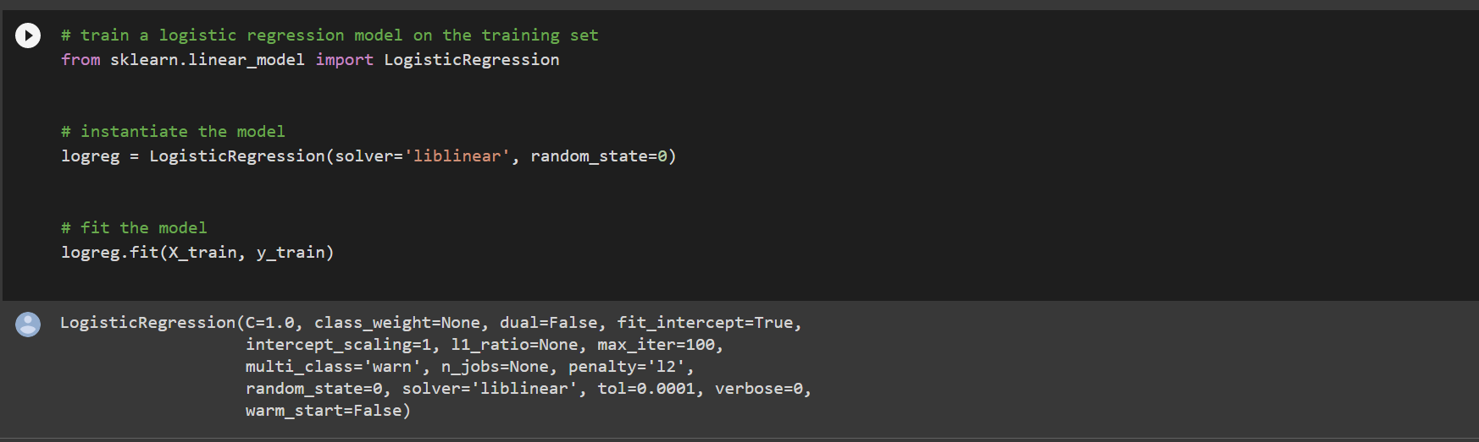



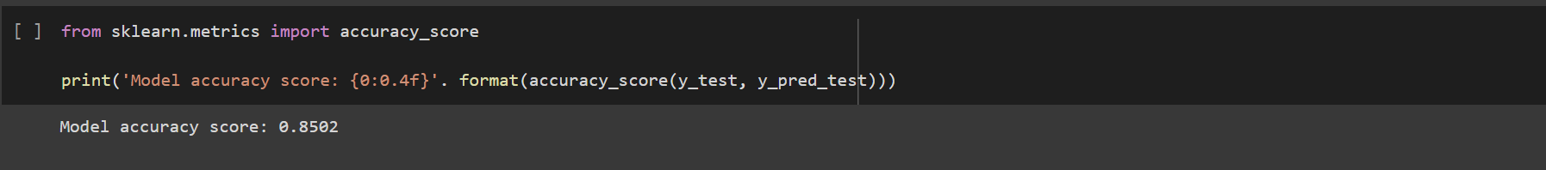

Conclusion: Classification problem based on logistic regression is solved and evaluated.