wPractical File

On

**Natural Language Processing with Deep Learning**

Submitted to

Department of in Artificial Intelligence

Amity School of Engineering and Technology



In partial fulfilment of the requirements for the award of the degree of

**Bachelor of Technology**

**(Artificial Intelligence)**

By

**SRISHTI SINGH**

**(A023119820035)**

Under the guidance of

**Prof. (Dr.) Archana Singh**

DEPARTMENT OF IN ARTIFICIAL INTELLIGENCE

AMITY SCHOOL OF ENGINEERING AND TECHNOLOGY

AMITY UNIVERSITY, UTTAR PRADESH

**table of contents**

|  |  |  |  |  |  |
| --- | --- | --- | --- | --- | --- |
| **Exp.**  **No.** | **Name of Experiment** | **Date of Allotment**  **of experiment** | **Date**  **of**  **Evaluation** | **Remarks** | **Signature**  **of**  **Faculty** |
| 1 | To perform classification with word vectors. | 18/07/2023 | 01/08/2023 |  |  |
| 2 | To implement Neural Network Bigram Model. | 01/08/2023 | 08/08/2023 |  |  |
| 3 | Implementation of word2vec using NumPy. | 08/08/2023 | 22/08/2023 |  |  |
| 4 | Implementation of word2vec using tensorflow. | 22/08/2023 | 29/08/2023 |  |  |
| 5 | To implement GLOVE using numpy gradient descent. | 29/08/2023 | 05/09/2023 |  |  |
| 6 | To implement GLOVE using Alternative Least Squares. | 05/09/2023 | 12/09/2023 |  |  |
| 7 | Visualizing data with analogies with t-SNE. | 12/09/2023 | 19/09/2023 |  |  |
| 8 | To visualize the data analogies using embedding projectors. | 19/09/2023 | 26/09/2023 |  |  |
| 9 | Implement GloVe using tensorflow gradient descent. | 26/09/2023 | 03/10/2023 |  |  |
| 10 | To perform point wise Mutual Information. | 03/10/2023 | 10/10/2023 |  |  |
| 11 | Implement Recursive Neural Tensor Network using tensorflow. | 10/10/2023 | 17/10/2023 |  |  |

Experiment 1

Aim: Perform Classification with word vectors

Software used: Jupyter Notebook

Dataset: <http://qwone.com/~jason/20Newsgroups/>

Output:

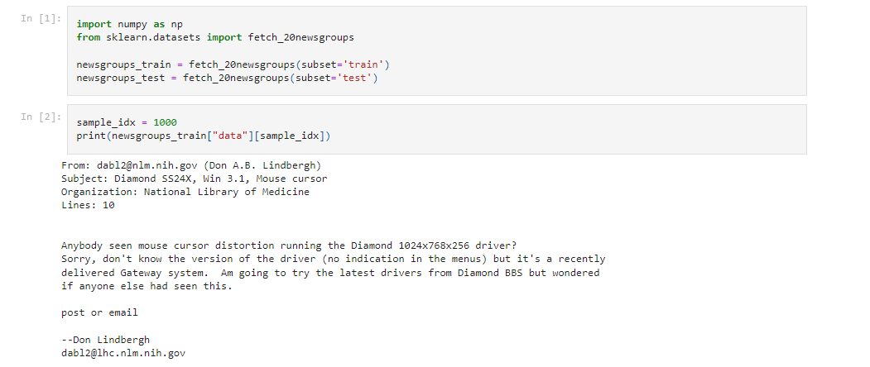

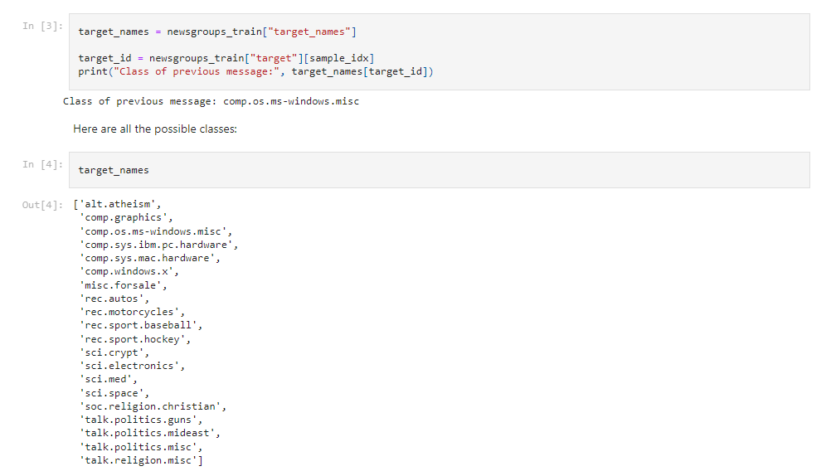

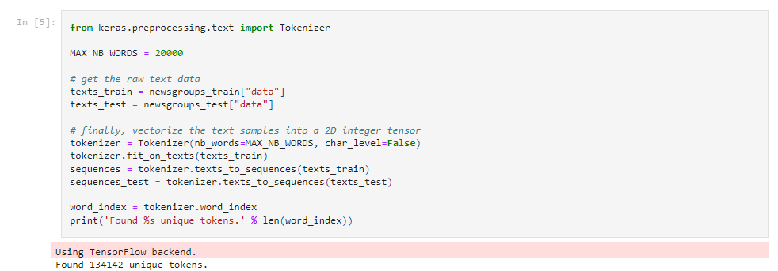

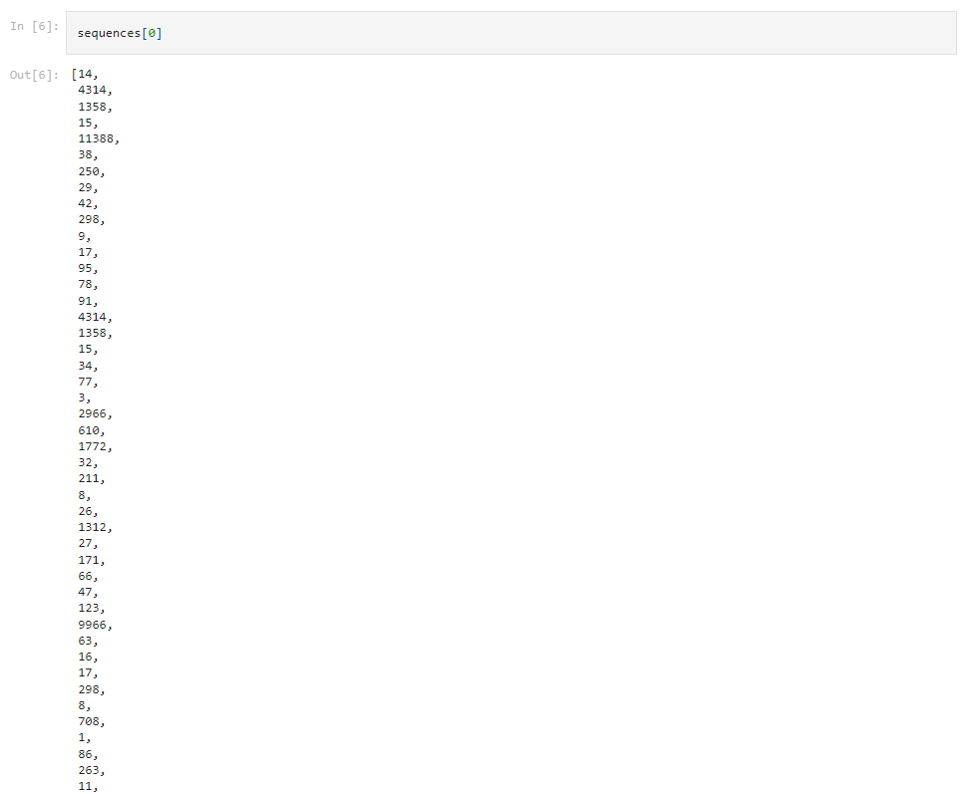

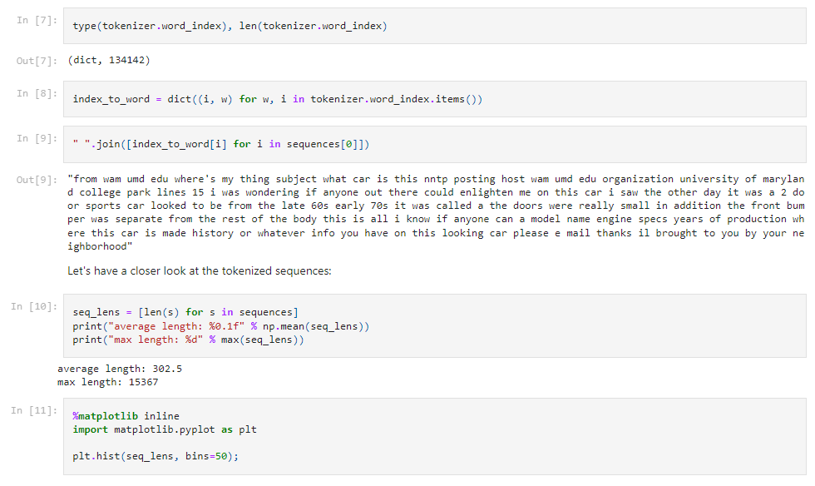

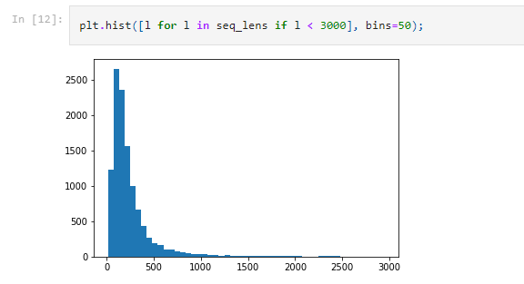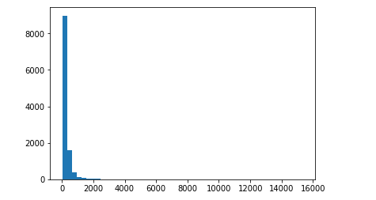



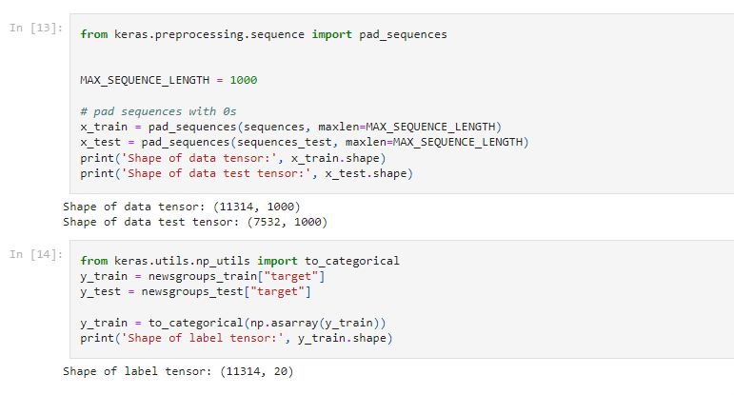

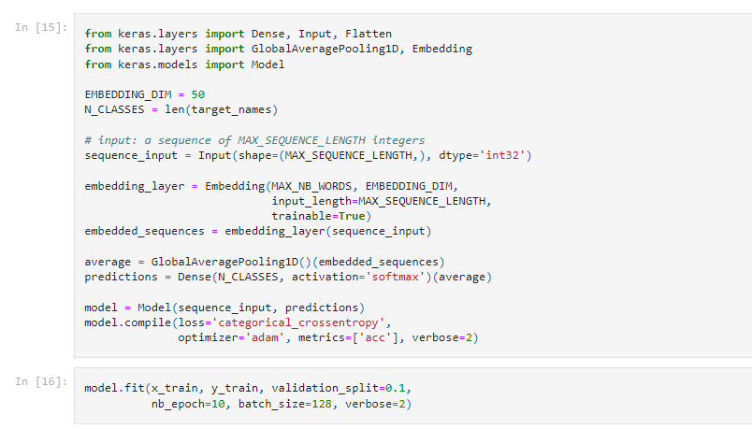

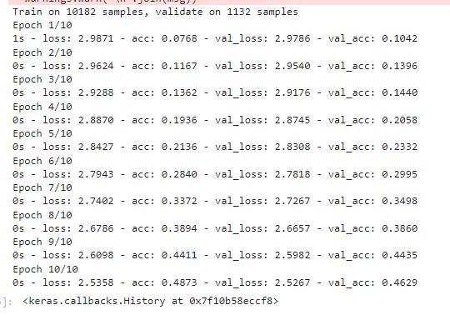

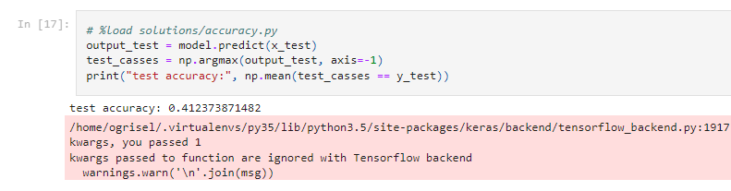

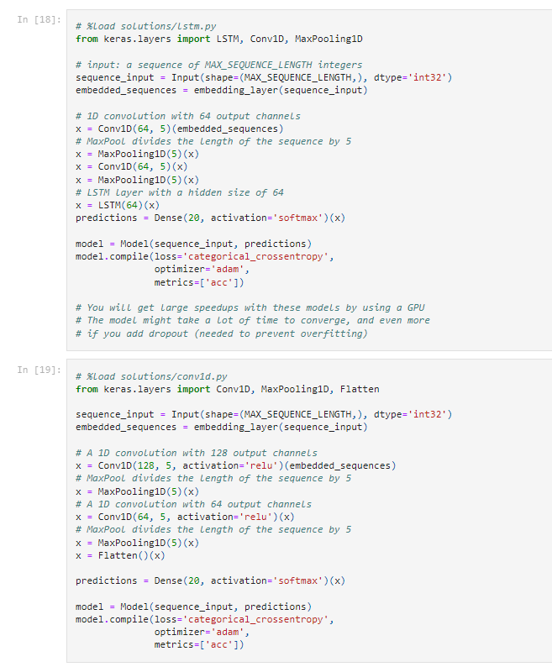

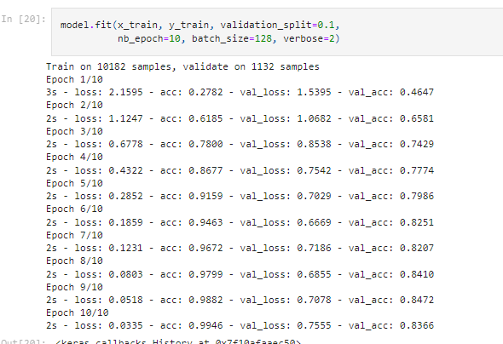

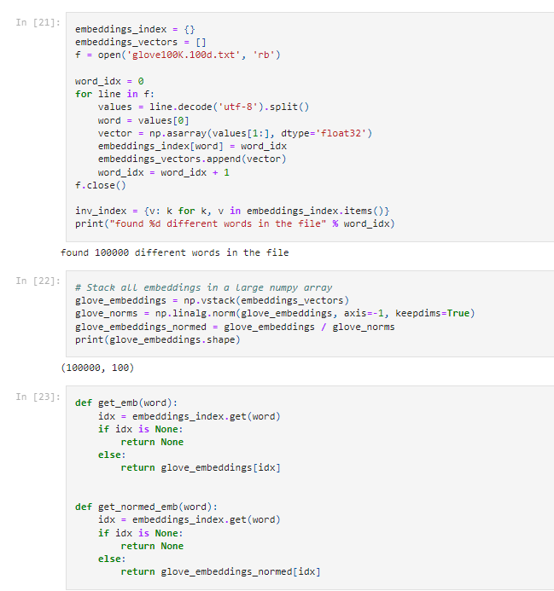

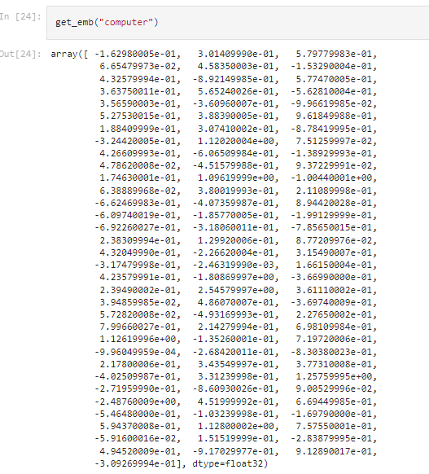

Conclusion: Implementation was successful.

Experiment 2

Aim: Implement Neural Network Bigram Model.

Software used: Google Colab

Output:

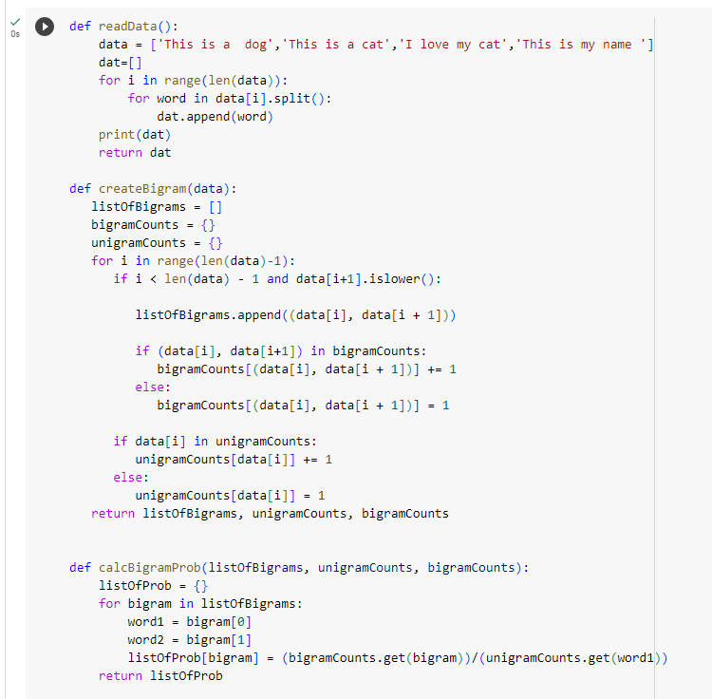

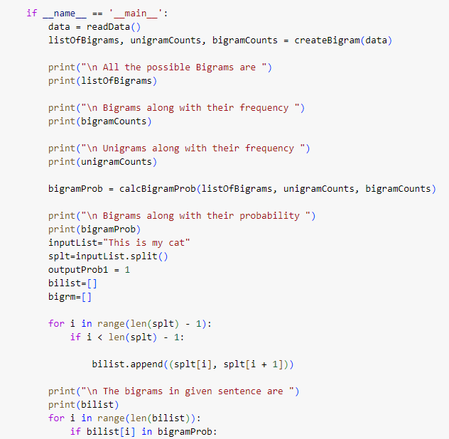

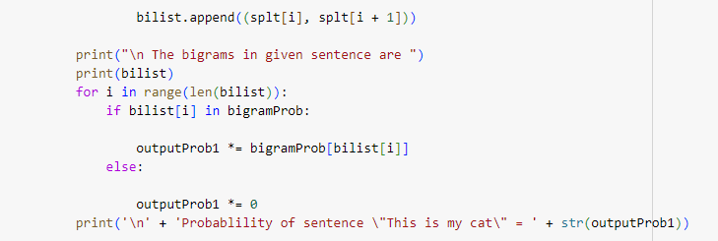

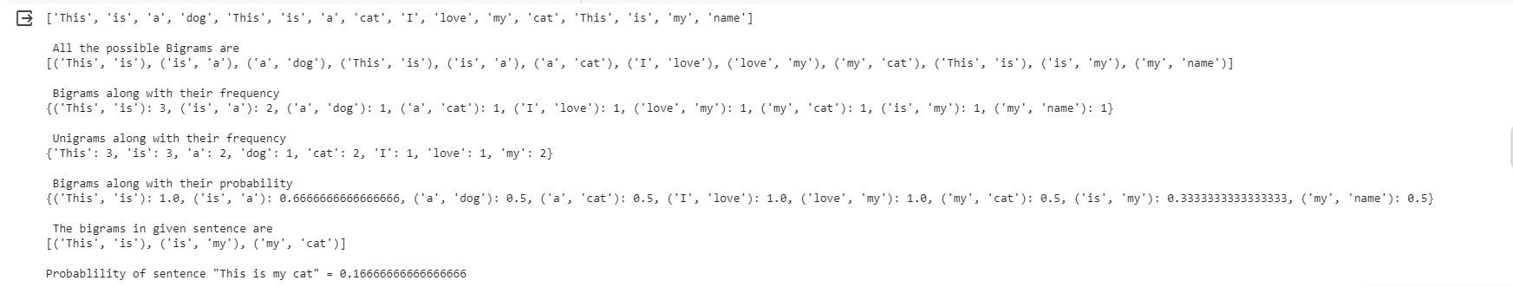

Conclusion: Implementation was successful.

Experiment 3

Aim: Implementation of word2vec using numpy.

Software used: Google Colab, Jupyter Notebook

Output:

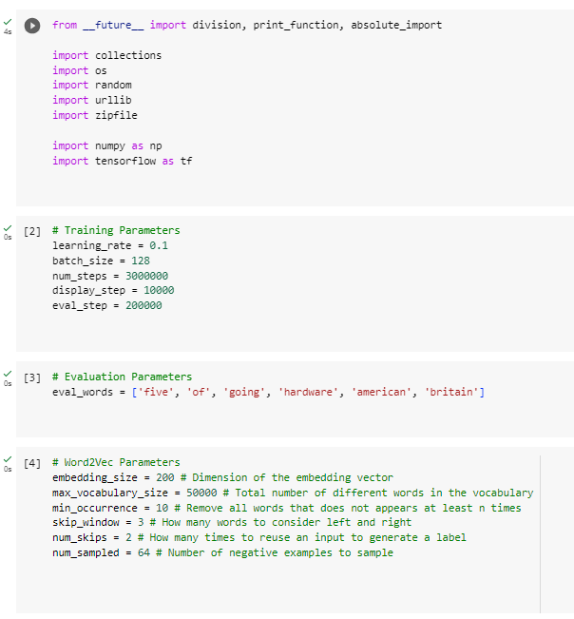

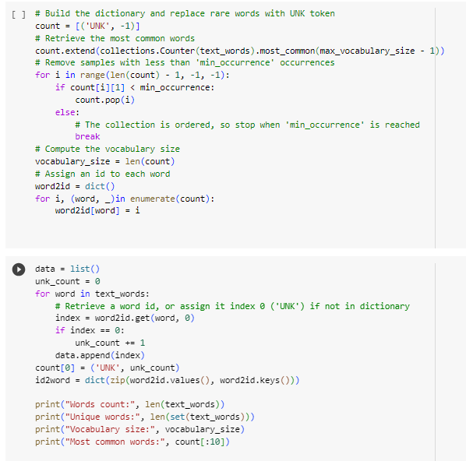\



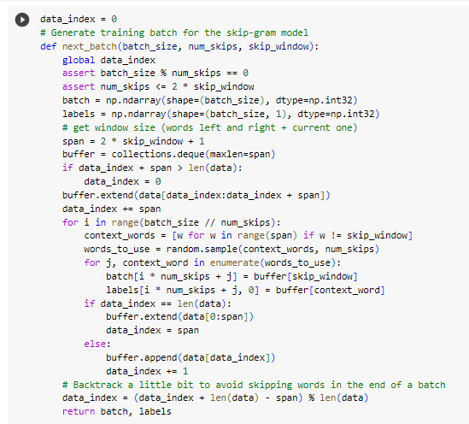

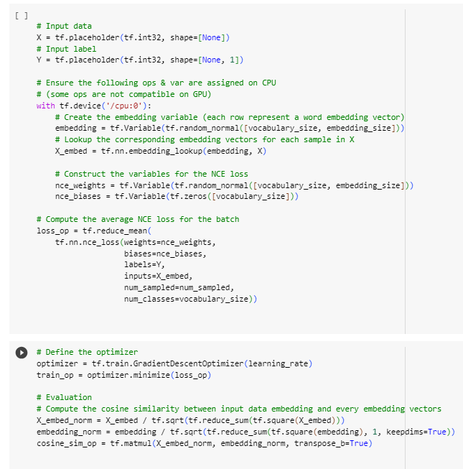



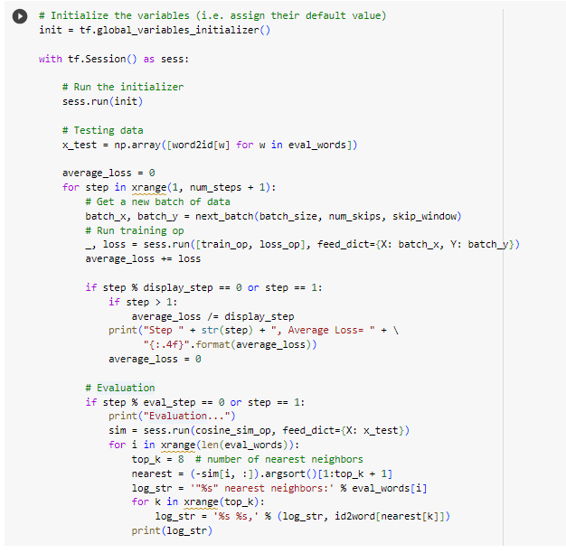

Conclusion: Implementation was successful.

Experiment 4

Aim: Implementation of word2vec using tensorflow.

Software used: Google Colab

Output:

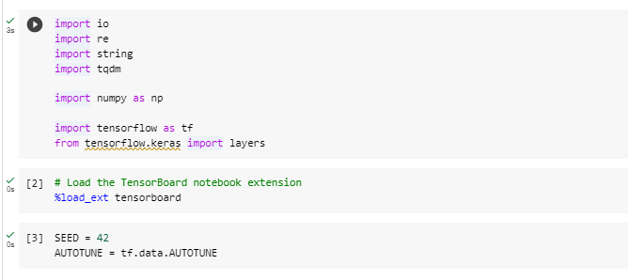

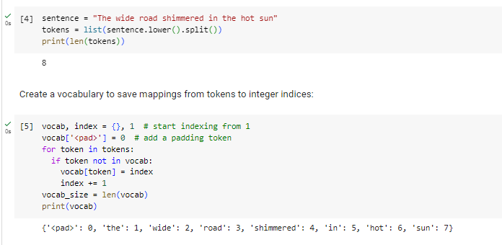

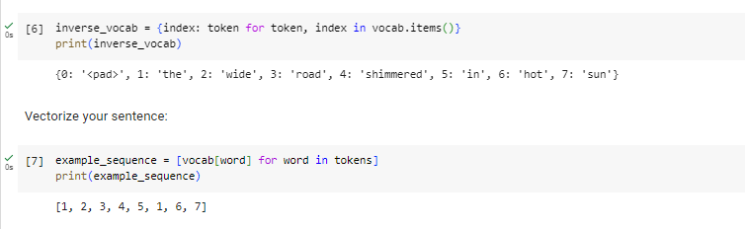

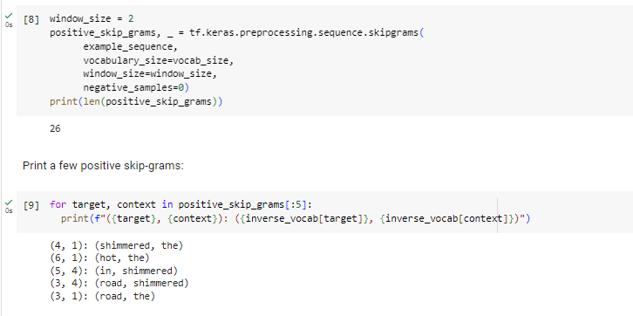

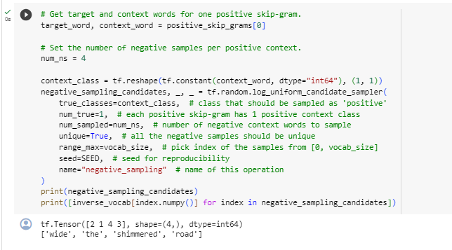

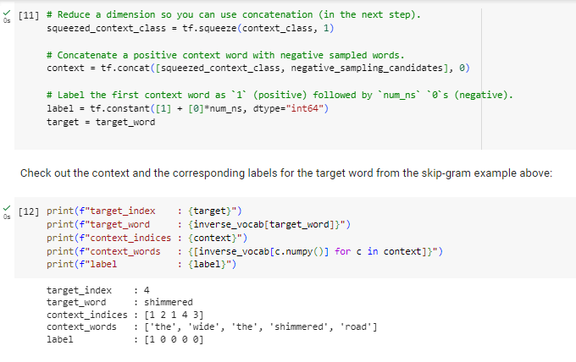

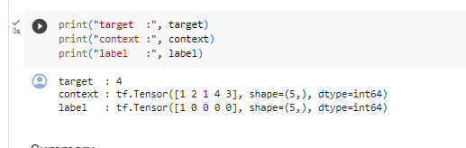

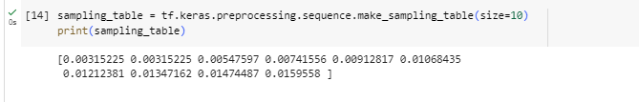

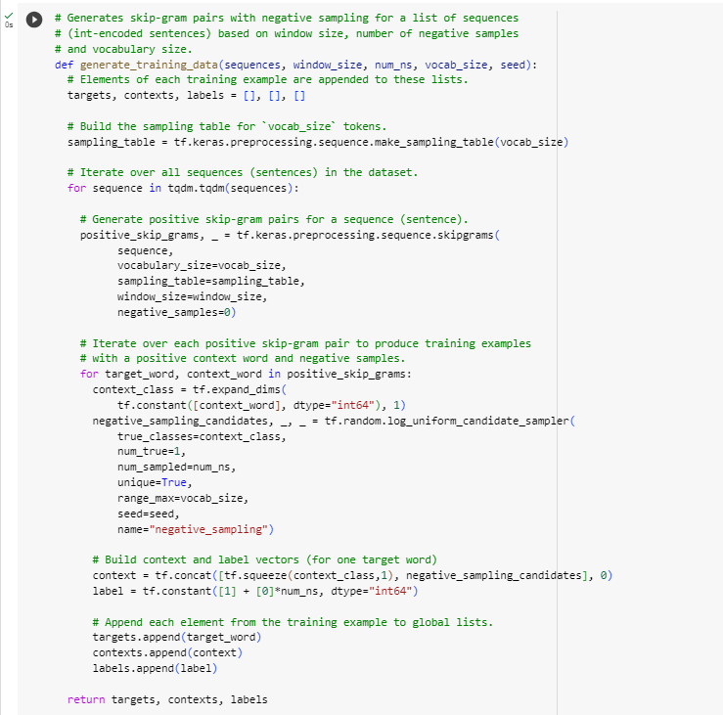

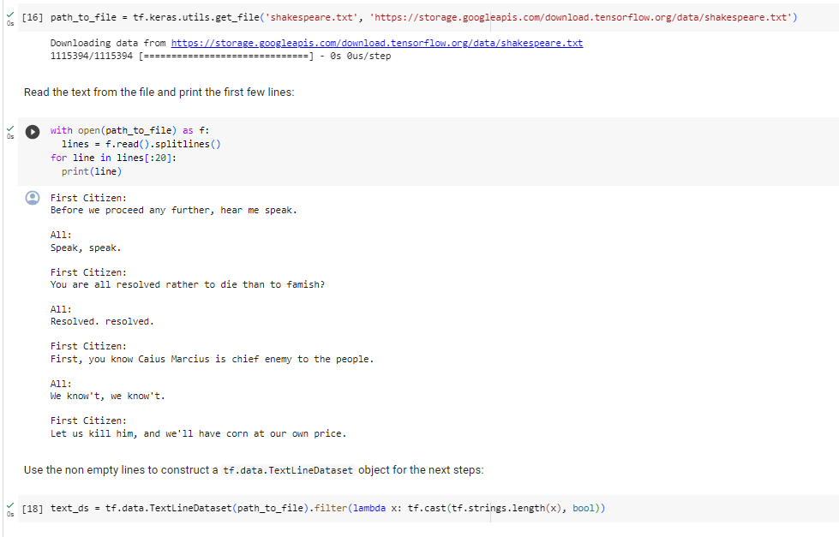

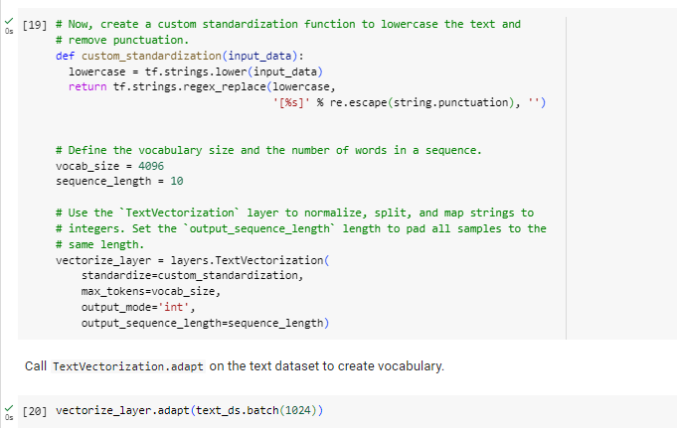

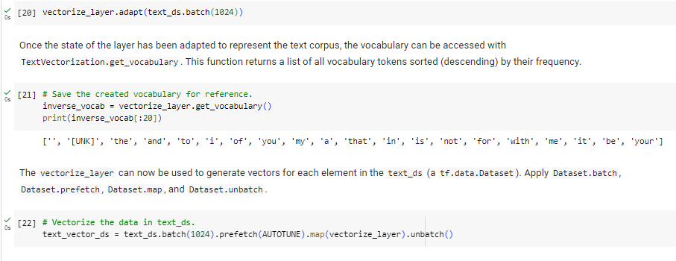

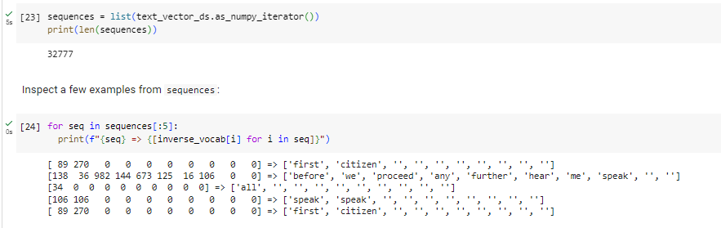

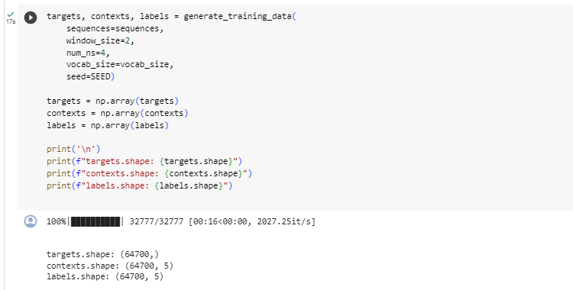

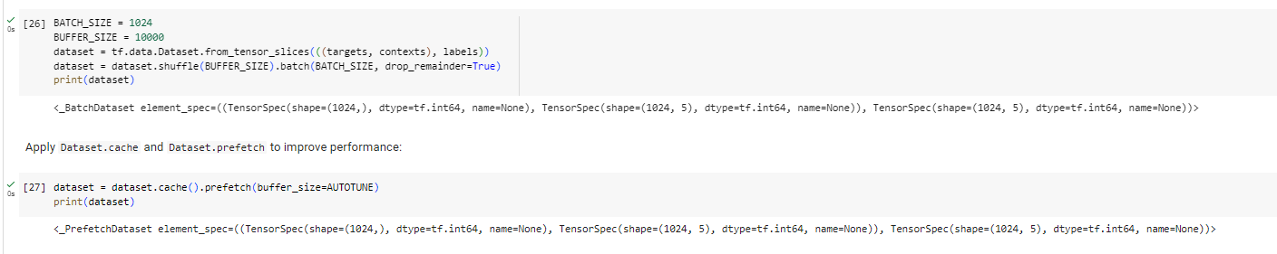

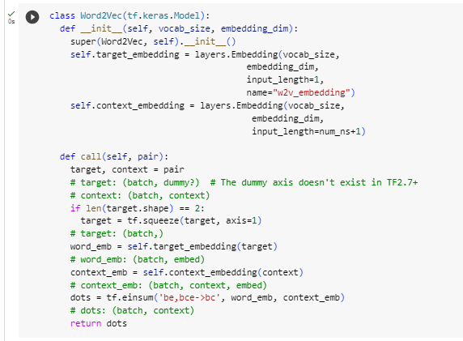

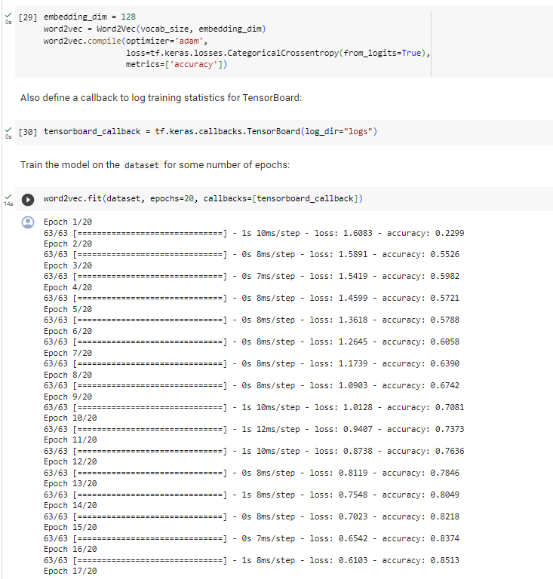

CONCLUSION: Implementation was successful.

Experiment 5

Aim: Implement GloVe using numpy gradient descent.

Software used: Google Colab, Jupyter Notebook

Output:

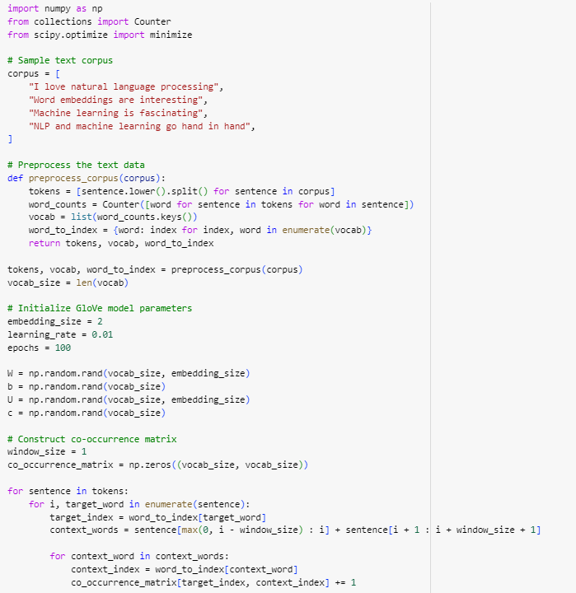

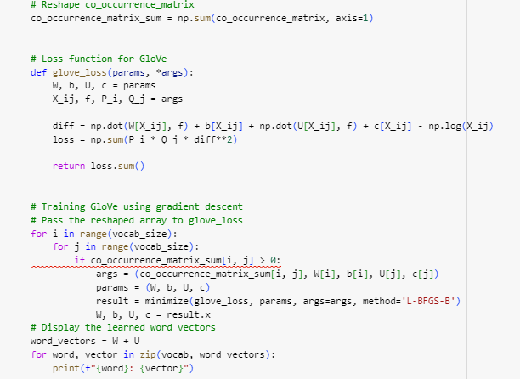

CONCLUSION: Implementation was successful.

Experiment 9

Aim: Implement GloVe using tensorflow gradient descent.

Software used: Google Colab, Jupyter Notebook

Output:

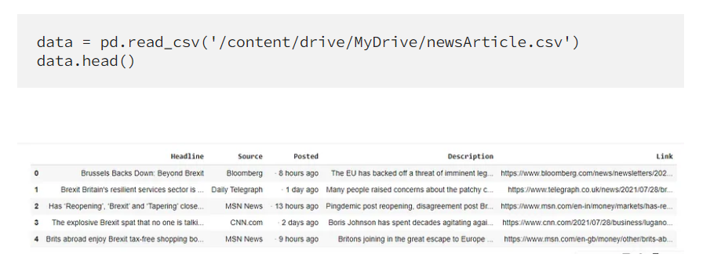

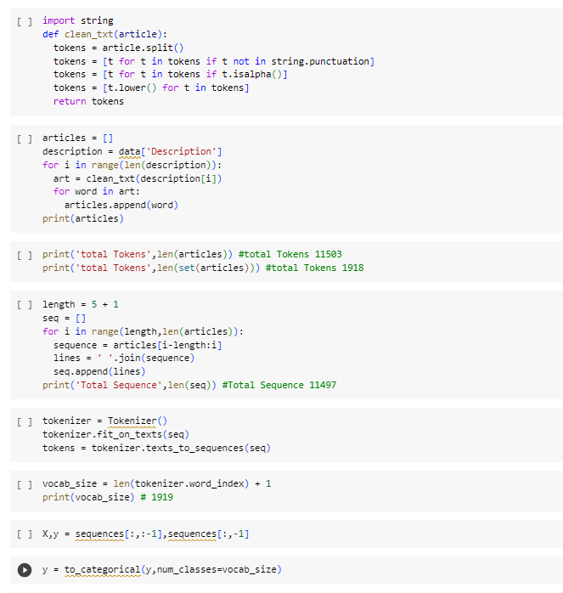



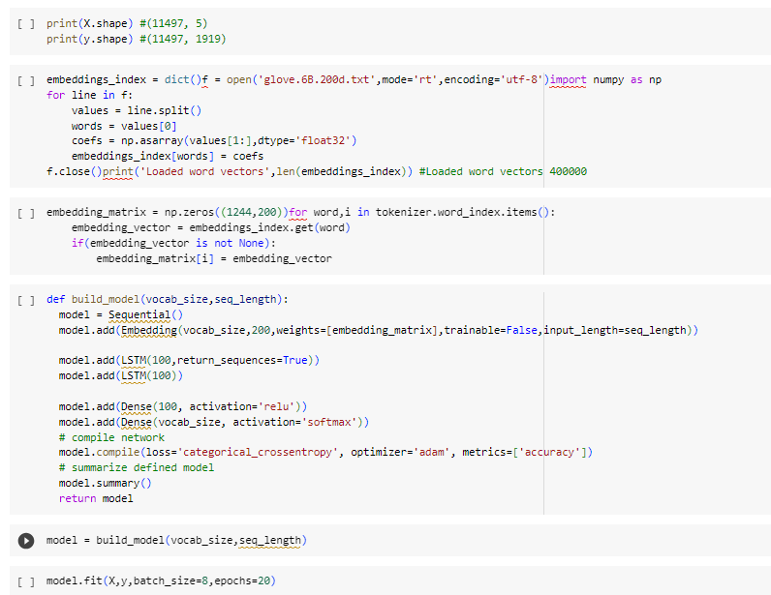

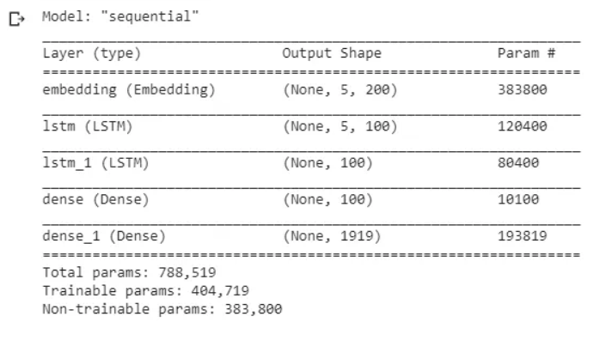

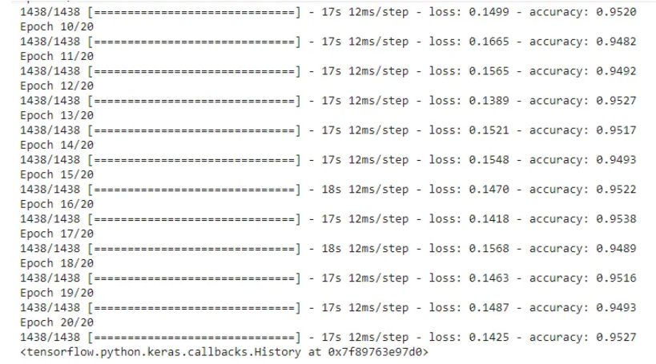

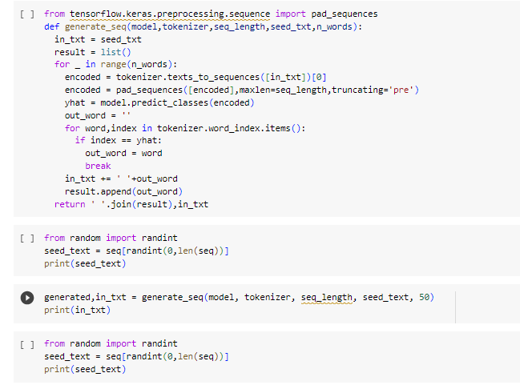

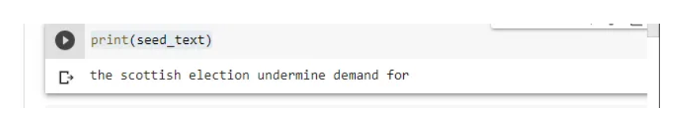

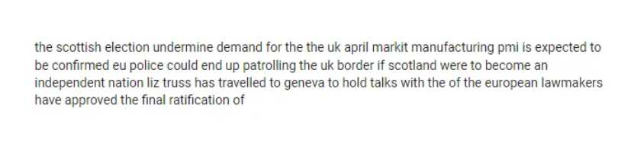

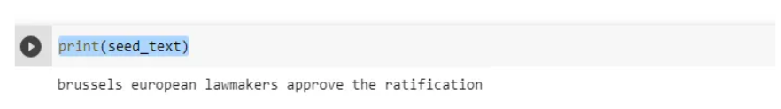

CONCLUSION: Implementation was successful.

Experiment 7

Aim: Visualizing data with analogies with t-SNE.

Software used: Google Colab

Output:

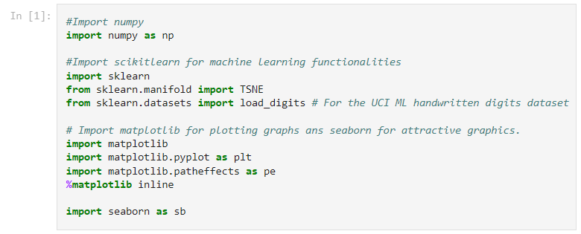

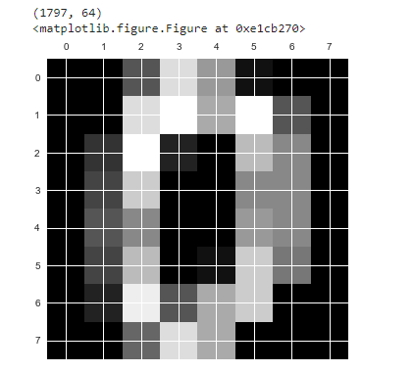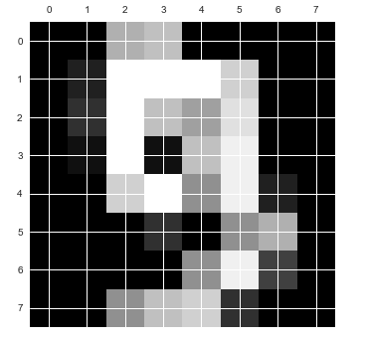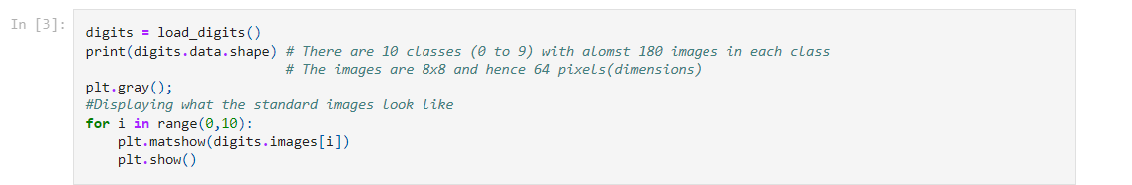

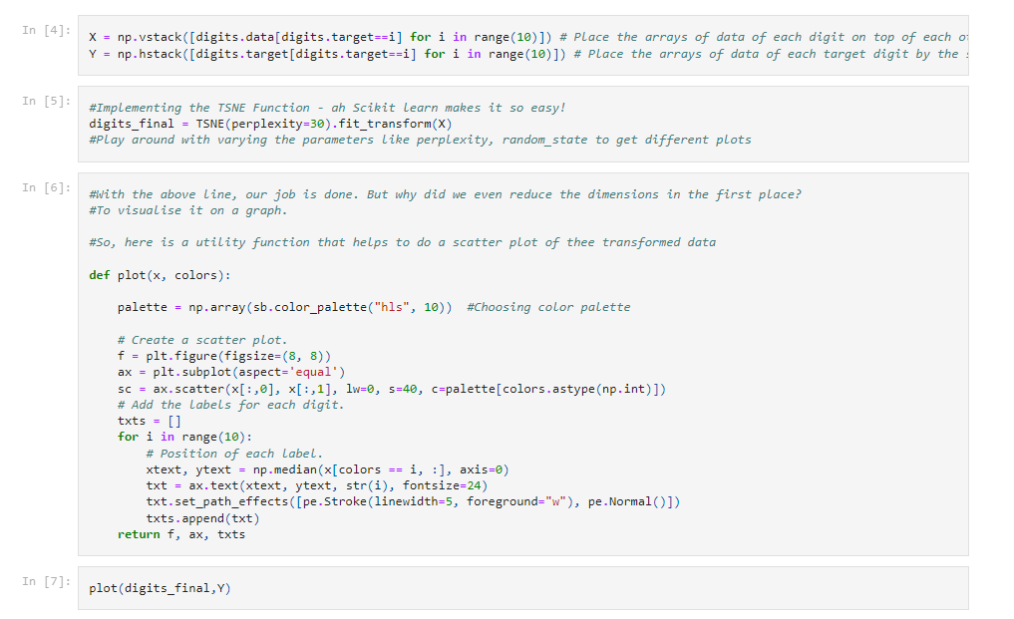

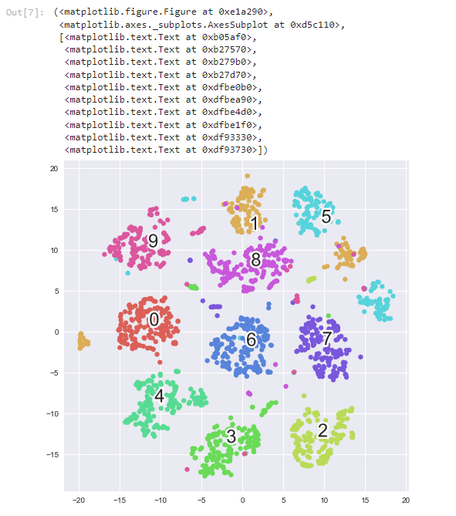

CONCLUSION: Implementation was successful.

Experiment 8

Aim: Visualizing country analogies using embedding projectors.

Software used: Google Colab, Jupyter Notebook

Output:

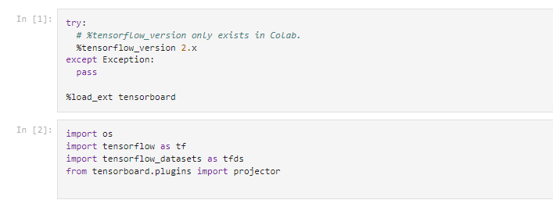

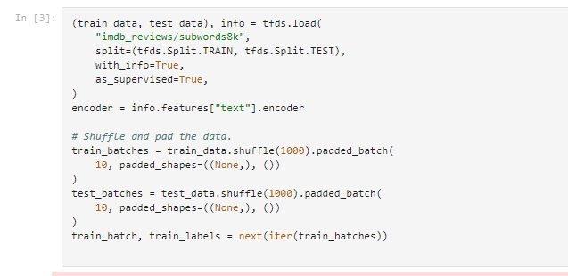

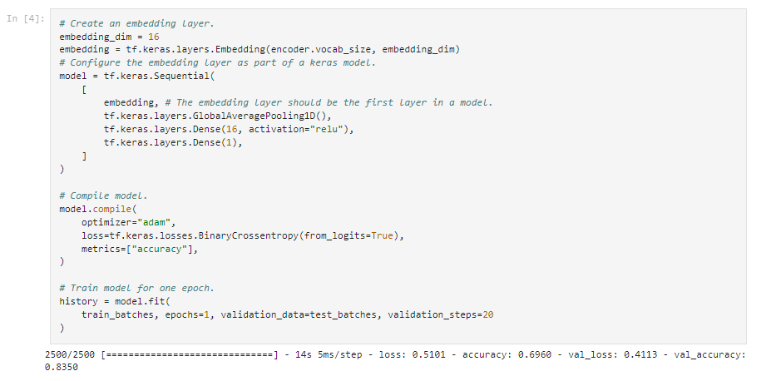

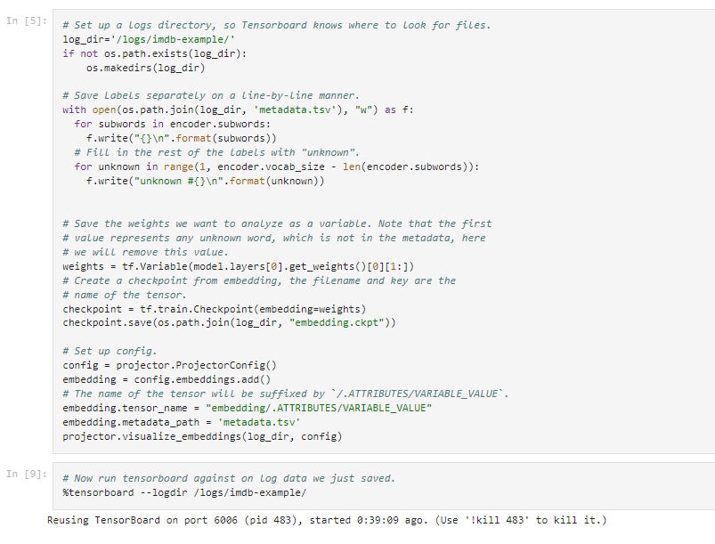

CONCLUSION: Implementation was successful.

Experiment 6

Aim: Implement GloVe using Alternating Least Squares

Software used: Google Colab, Jupyter Notebook

Output:

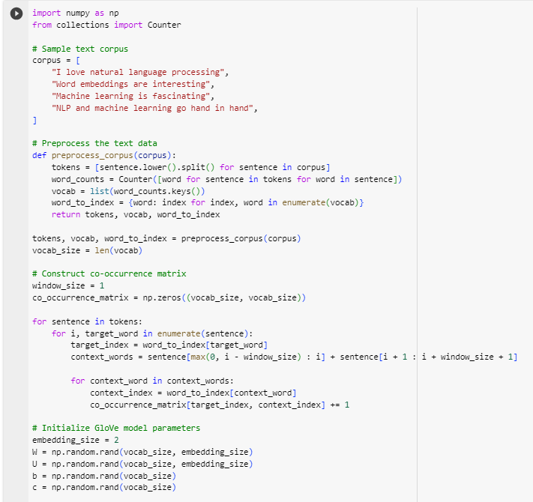

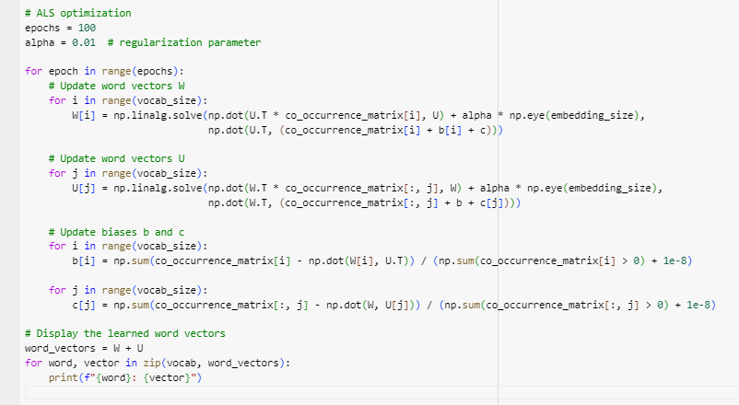

CONCLUSION: Implementation was successful.

Experiment 10

Aim: Perform Pointwise Mutual Information.

Software used: Google Colab, Jupyter Notebook

Output:

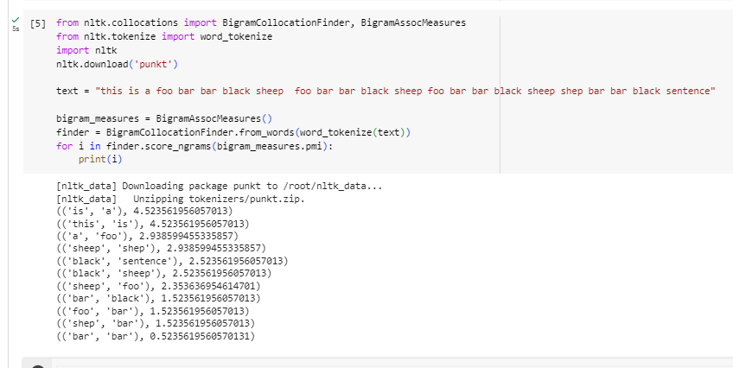

CONCLUSION: Implementation was successful.

Experiment 11

Aim: Implement Recursive Neural Tensor Network using tensorflow.

Software used: Google Colab, Jupyter Notebook

Output:

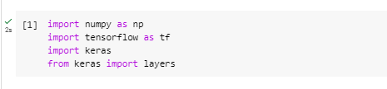

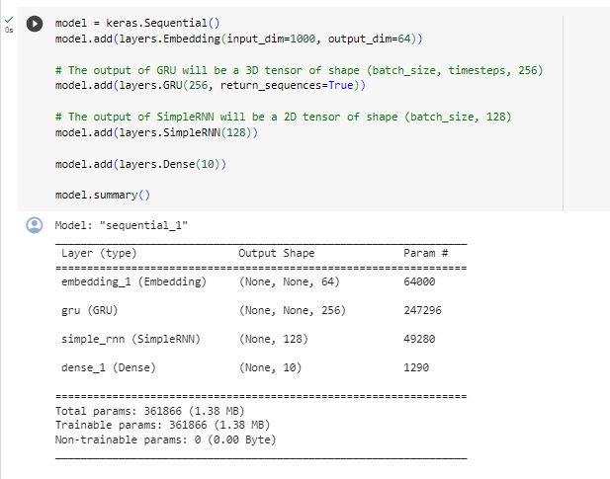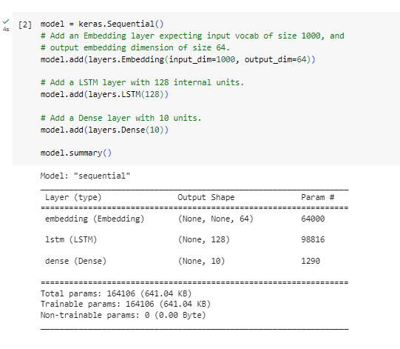

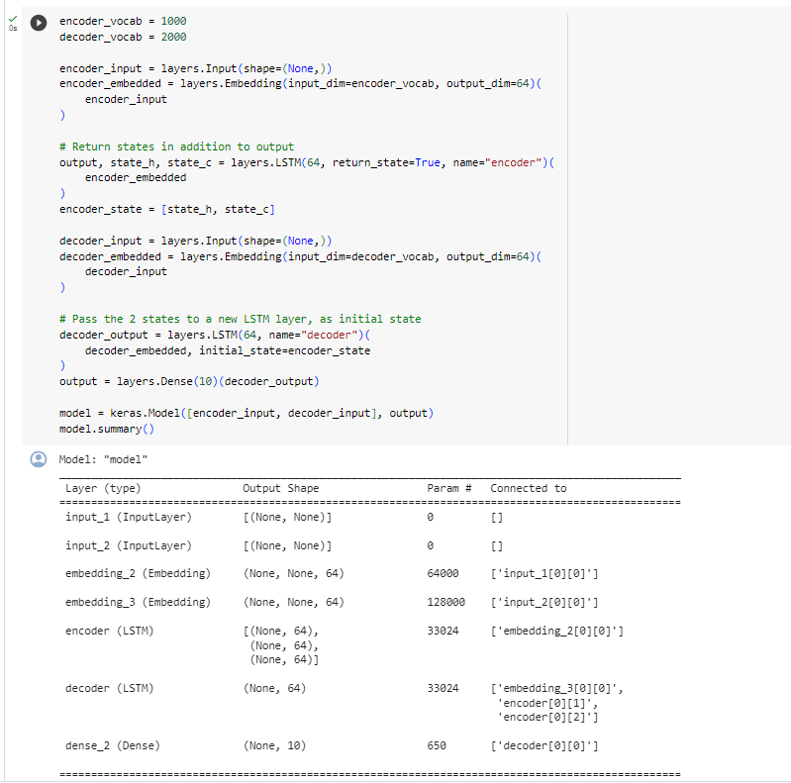

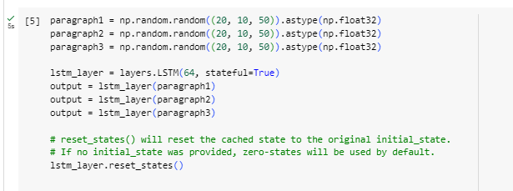

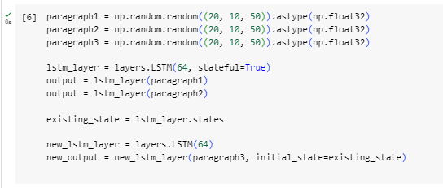

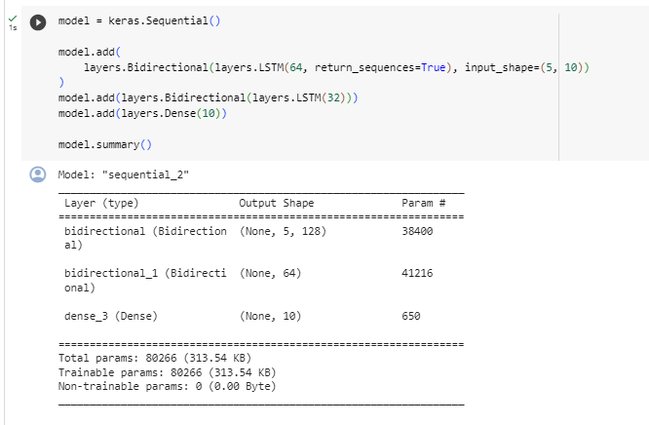

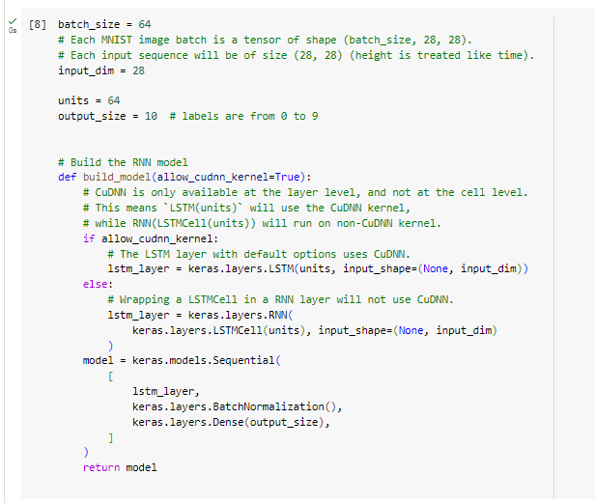

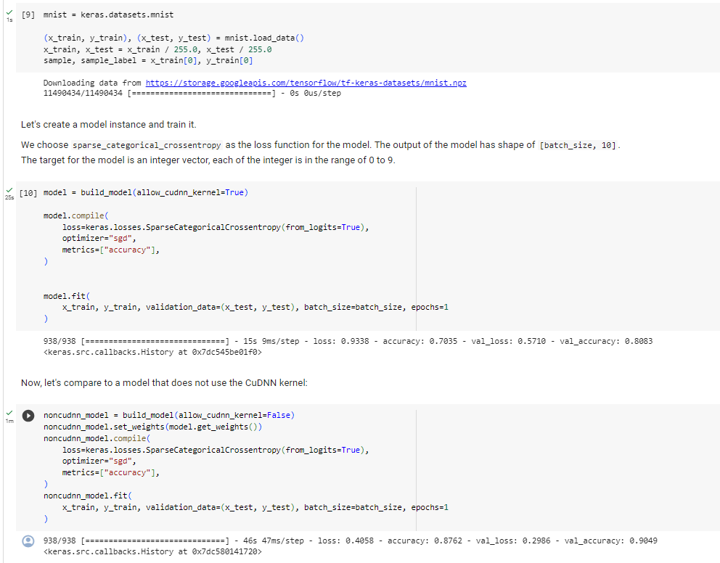

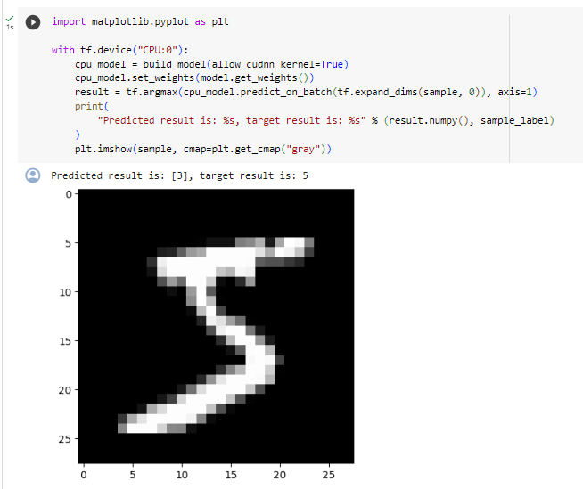

CONCLUSION: Implementation was successful.