E-COMMERCE SALES ANALYTICS
Dashboard & Data Report

Table of Contents
1. Introduction 3
2. About the Dataset 3
3. The Data Model 4
4. Key Metrics Tracked 4
5. Dashboard Overview 4
6. Visual Deep-Dive: Profit by Country 6
7. Visual Deep-Dive: Profit by Product Category 7
8. Getting the Most From the Dashboard 8
9. Conclusion 8

1. Introduction
This report documents the E-commerce Sales Analytics Power BI dashboard — the data it is built on and how each visual on the page turns that data into insight. It is intended as a companion reference for anyone reviewing, presenting, or extending the dashboard.
The report is organized in two parts: the first explains the underlying dataset and data model, and the second walks through the dashboard itself — its layout, its visuals, and how to use them.

2. About the Dataset
The dashboard is built on order-level e-commerce transaction data, modeled across five connected tables so that every sale can be traced back to the customer who bought it and the product that was sold.

2.1 Data Grain
Each row in the core sales table represents one order line item, not one order. A single order containing three products contributes three rows — which keeps product- and country-level totals accurate when the dashboard aggregates profit, sales, or quantity.

2.2 Tables in the Model
Table | Role | Description
order_items | Fact table | One row per order line; the source of every sales, profit, and quantity figure the dashboard reports.
customer_master | Dimension | Buyer details, including the customer's country — used to break profit down by market.
product_catalog | Dimension | Product details, including the product category — used to break profit down by category.
Consolidated analytics table | Consolidated table | A pre-joined, order-level view (ecommerce_sales_customer_analytics_150k) combining customer, product, and order data for reporting; its name indicates roughly 150,000 underlying records.
Dataset statistics | Supporting table | Standalone reference data supporting the model; not directly joined to order_items.

Note on figures
This report describes the structure and purpose of the data and dashboard rather than reproducing live totals. For current sales, profit, or quantity figures, refer to the dashboard itself.

3. The Data Model
order_items sits at the center of the model. It is linked to customer_master, product_catalog, and a consolidated analytics table used for reporting — the same relationship pattern the dashboard's charts query directly to break profit and sales down by country and by category. Dataset statistics sits apart from these joins as a standalone supporting table.

3.1 How the Tables Connect
- order_items ↔ customer_master — joins each order line to the customer who placed it, enabling country-level analysis.
- order_items ↔ product_catalog — joins each order line to the product sold, enabling category-level analysis.
- order_items ↔ Consolidated analytics table — joins to the pre-joined, order-level view used for streamlined reporting.
- Dataset statistics sits alongside the core model as a standalone supporting table, not directly joined to order_items.

4. Key Metrics Tracked
Four measures, all derived from order_items, underpin every chart and card in the dashboard:
Metric | Definition
Gross Sales | Total revenue generated before any discounts, returns, or deductions.
Net Sales | Revenue after discounts and returns — a truer view of realized sales.
Profit | What remains after costs are subtracted from sales; the dashboard's headline measure.
Quantity | Total units sold across all order line items.

5. Dashboard Overview
The report is a single, interactive page designed for at-a-glance monitoring rather than multi-tab navigation. Every visual on the page responds to the same country filter, so KPI cards and charts always stay in sync.

5.1 Layout
Dashboard Area | Visual Type | Purpose
Title banner | Text box | Identifies the report as “E-commerce Sales Analytics” across the full page width.
Left panel | Pie chart | Shows profit share by customer country.
Right panel | Bar chart | Ranks profit by product category.
Bottom-left strip | KPI cards | Surfaces total Profit, Quantity, Net Sales, and Gross Sales.
Bottom-right strip | Slicer | Lets the viewer filter the whole page by country.

5.2 Design Principles
- One page, built for quick scanning — no tabs to click through.
- KPI cards surface totals first, before any chart is read.
- Two charts break performance down by geography and by category.
- A single country slicer filters every visual on the page at once.

6. Visual Deep-Dive: Profit by Country
Visual types: Pie Chart + Country Slicer
The pie chart splits total profit by customer_country, with each slice labeled by its percent of the whole — an immediate read on which markets contribute the most profit.
The country slicer beside it lets a viewer click one or more countries and instantly filter every other visual on the page — the pie chart, the bar chart, and the KPI cards — to that selection.
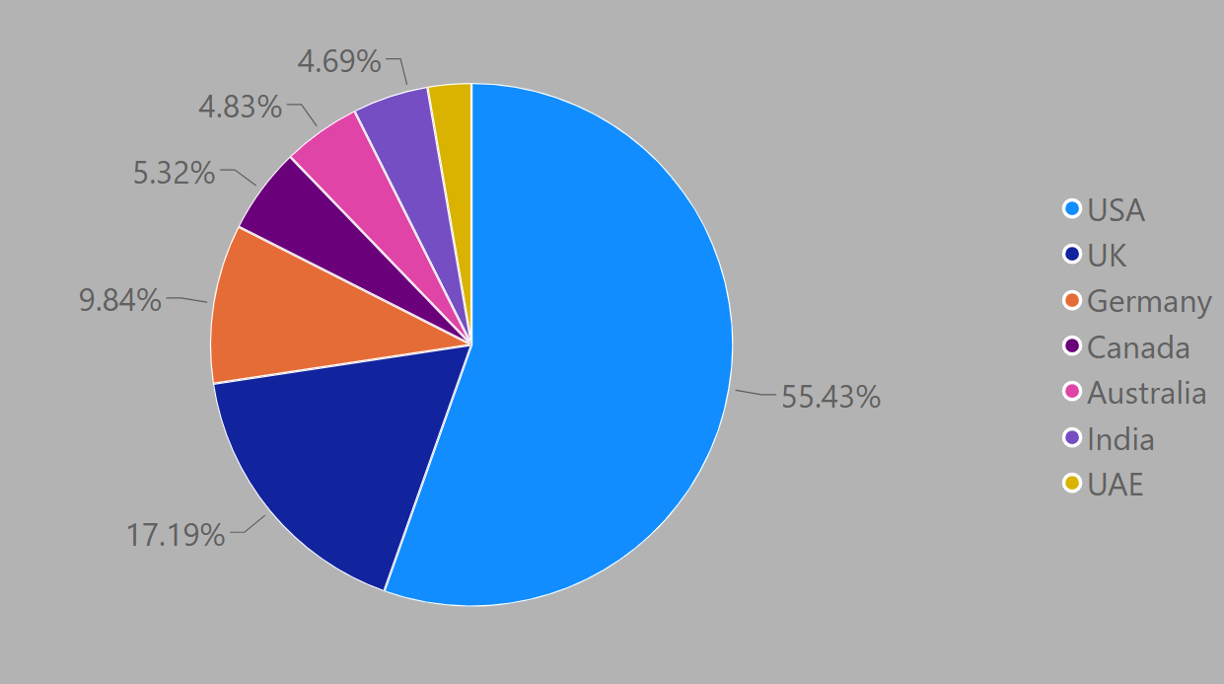
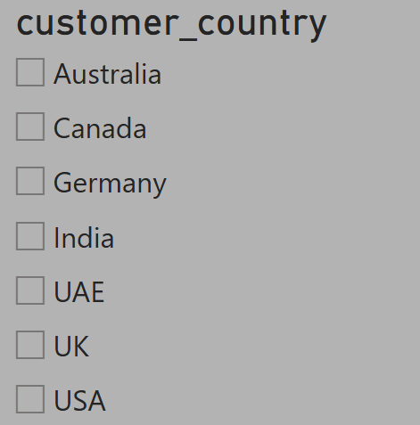
Why it matters
Regional profit concentration is often uneven. This pairing lets a reviewer isolate a single country and see its full performance story on the same page.

7. Visual Deep-Dive: Profit by Product Category
Visual types: Bar Chart + KPI Summary Cards
The bar chart ranks every product_category by total profit, sorted highest to lowest — making it easy to spot which categories drive the business and which lag behind.
Four KPI cards along the bottom surface the headline totals — Profit, Quantity, Net Sales, and Gross Sales — so the top-line numbers are visible before drilling into any chart.
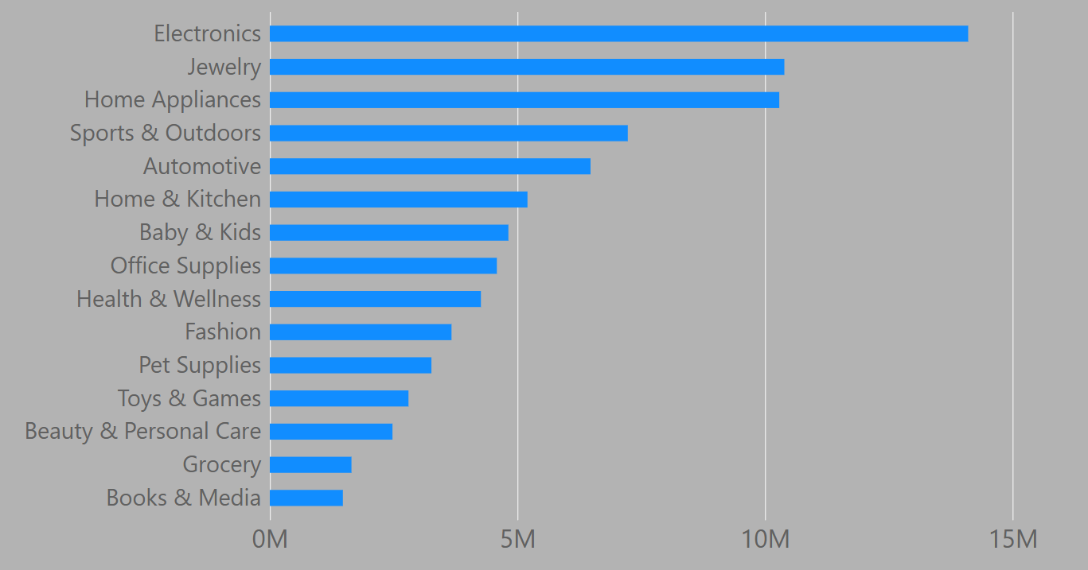
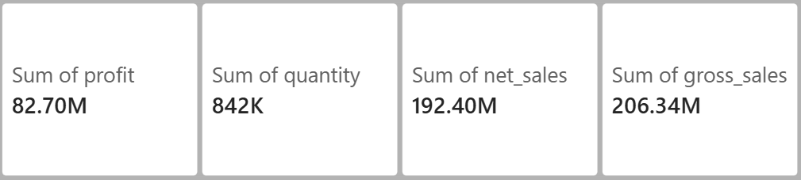
Why it matters
Because every card and chart shares the same slicer, the totals update together — there is never a mismatch between the headline numbers and the chart detail.

8. Getting the Most From the Dashboard

8.1 Spot Top Markets Fast
Use the country pie chart to find where profit is concentrated before planning regional campaigns.

8.2 Filter, Don't Guess
Click the country slicer to see one market's full picture — profit, sales, and category mix together.

8.3 Compare Categories
The bar chart's ranking highlights which product categories to double down on, and which to review.

8.4 Trust the Totals
Because everything shares one filter, the KPI cards and charts always tell a consistent story.

9. Conclusion
The E-commerce Sales Analytics dashboard combines a compact, well-joined data model with a focused, single-page layout. The data model keeps every order line traceable to its customer and product, while the dashboard's shared filtering ensures that whatever story the KPI cards tell, the charts tell the same story in more detail.
Used together — the country view, the category view, and the KPI totals — the dashboard gives a fast, reliable read on where profit is coming from and where it is going.

