Lab 3: System Design
for
ServiceHub
Student Name | Hitesh Sosa
Roll Number | CE159
Team Member | Rahul Solanki — CE156
Lab No. | Lab 3 — System Design

Aim
To design the system architecture for the ServiceHub application using UML diagrams — Use Case, Class, Activity, and Sequence diagrams — and to document the REST API for each core data entity of the system.

1. Use Case Diagram
The use case diagram identifies the three actors of the system — Customer, Service Provider, and Admin — and the core interactions each actor has with the ServiceHub, including an «include» relationship (Book Service to Payment) and an «extend» relationship (Rate & Review extending Book Service).
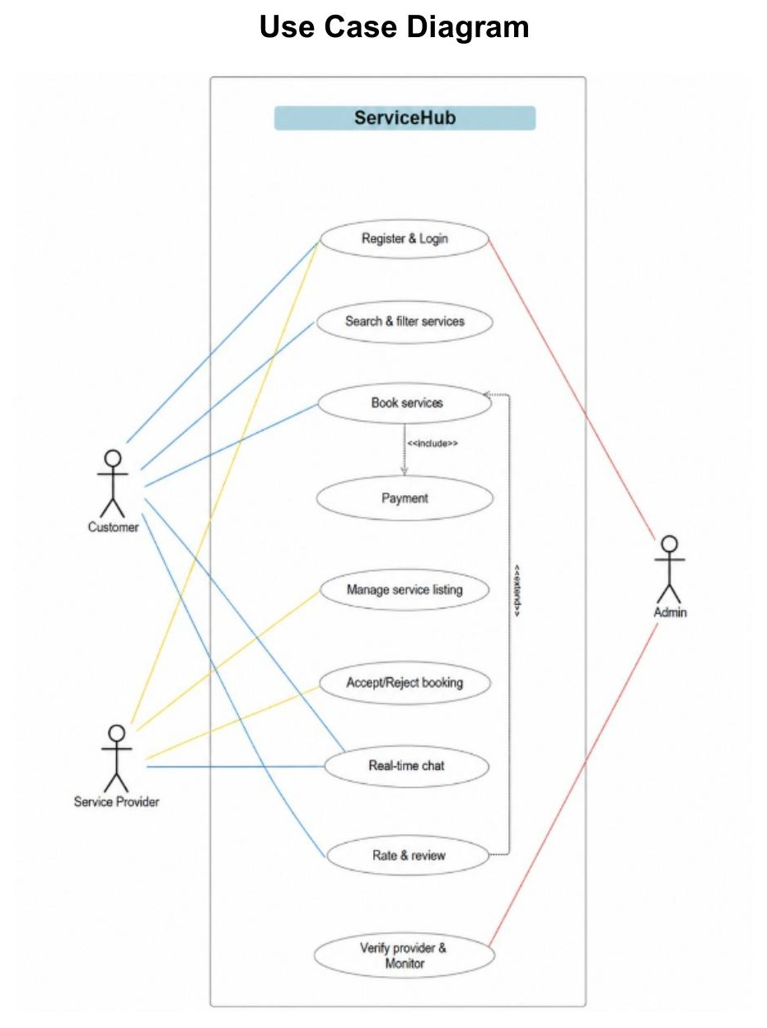
Figure 1: Use Case Diagram for ServiceHub

2. Class Diagram
The class diagram models User as a base class with Customer, Provider, and Admin as subclasses (inheritance). Provider is associated with Service and Booking; Booking composes Payment (shown with a filled diamond, since a Payment record cannot exist independently of its Booking) and associates with Review and ChatMessage.
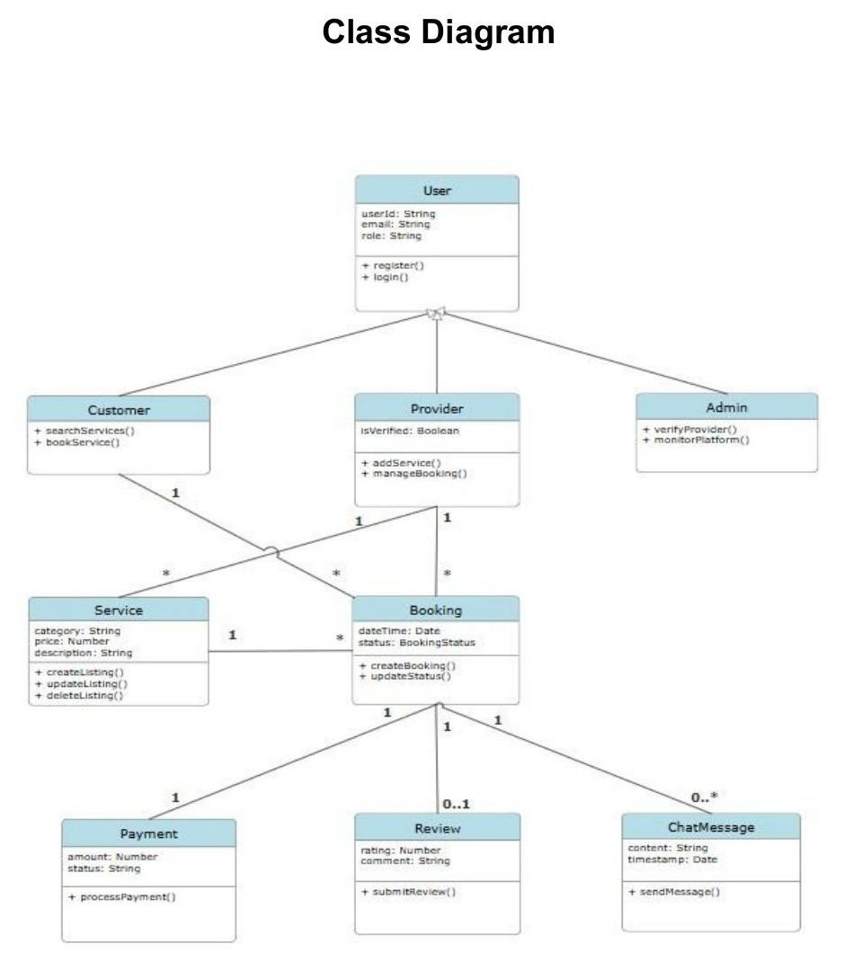
Figure 2: Class Diagram for ServiceHub

3. Activity Diagrams
Activity diagrams are provided for the two major workflow modules of the system: Book Service & Payment, and Provider Verification.

3.1 Activity Diagram — Book Service & Payment
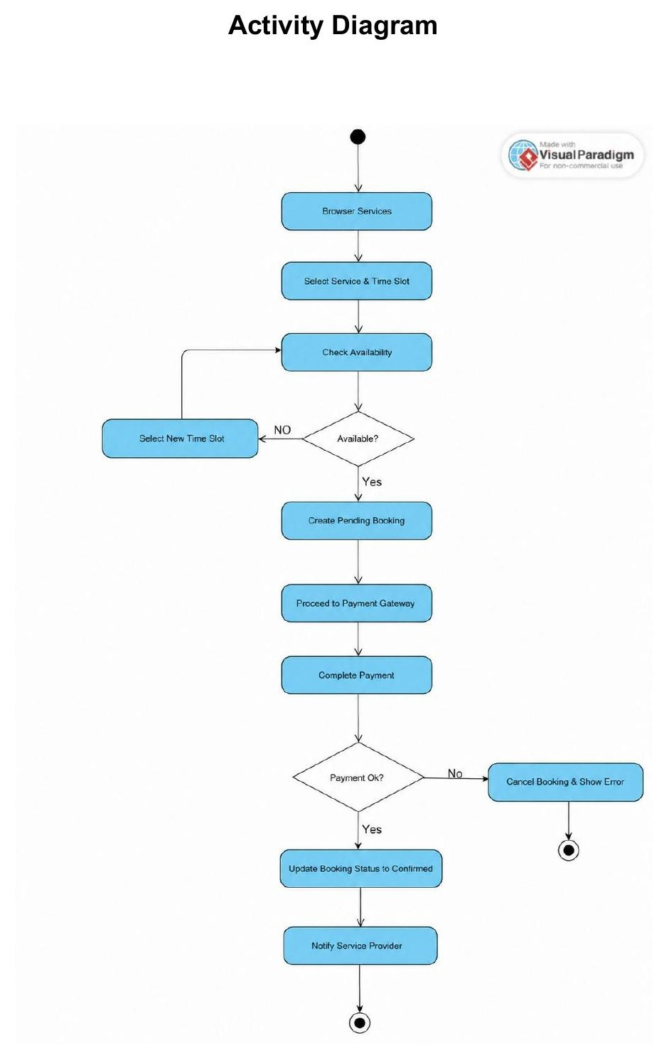
Figure 3: Activity Diagram — Book Service & Payment

3.2 Activity Diagram — Provider Registration & Verification
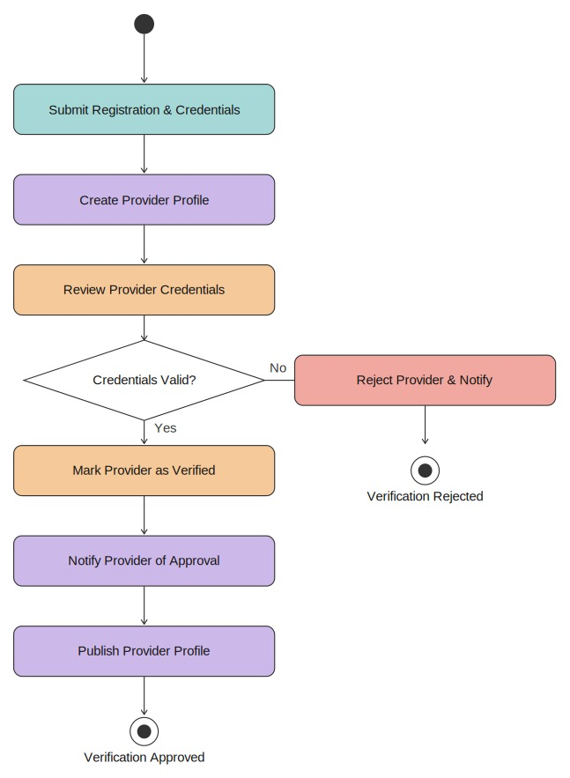
Figure 4: Activity Diagram — Provider Registration & Verification

4. Sequence Diagrams
Sequence diagrams are provided for the same two major modules, showing the message flow between Customer/Provider, the Frontend, backend microservices, the Payment Gateway, Notification Service, and the Database.
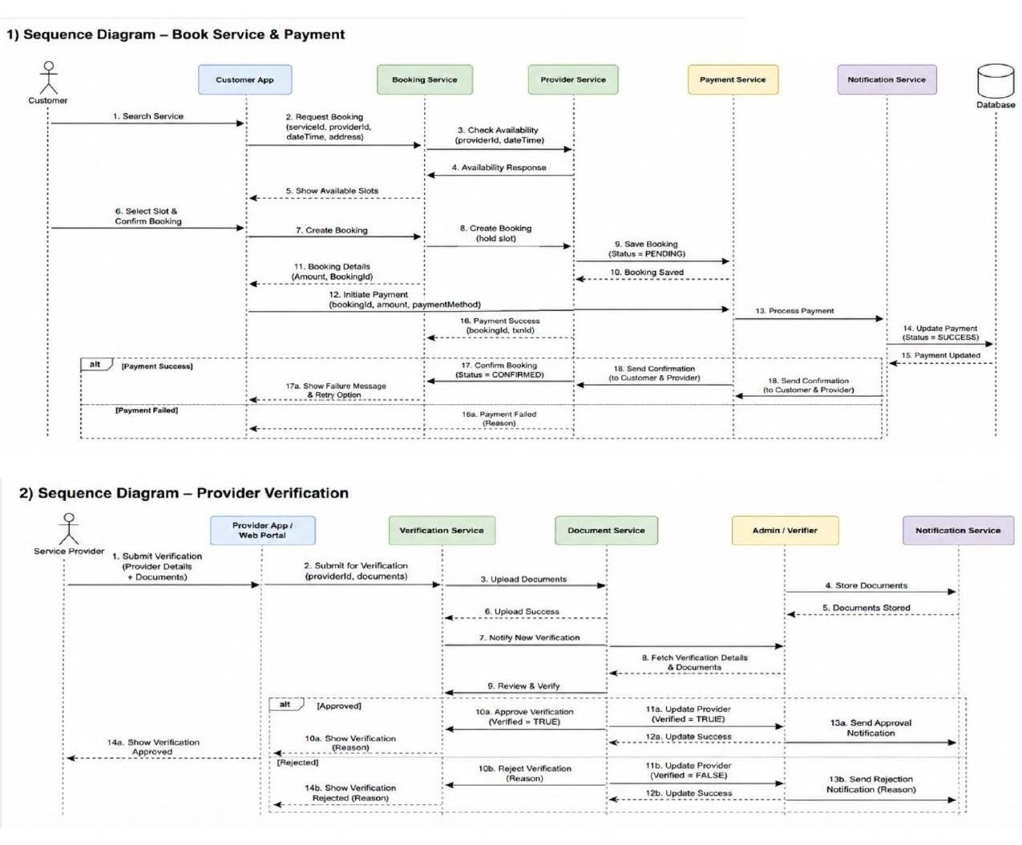
Figure 5: Sequence Diagrams — Book Service & Payment (top), Provider Verification (bottom)

5. REST API Documentation
Base URL: http://localhost:5000/api | Data Format: JSON | Authentication: JWT (Bearer token, required for all endpoints except register/login)

5.1 API Summary
Entity | Method | Endpoint | Description
User / Auth | POST | /api/auth/register | Register a new user as Customer or Provider
User / Auth | POST | /api/auth/login | Authenticate user and issue a JWT
User | GET | /api/users/:id | Retrieve a user's profile
User | PUT | /api/users/:id | Update a user's profile details
User | DELETE | /api/users/:id | Deactivate/delete a user account
Service | GET | /api/services | Retrieve all services (supports search & filter query params)
Service | GET | /api/services/:id | Retrieve one service listing by ID
Service | POST | /api/services | Create a new service listing (Provider only)
Service | PUT | /api/services/:id | Update an existing service listing (incl. availability)
Service | DELETE | /api/services/:id | Delete a service listing
Booking | GET | /api/bookings | Retrieve bookings for the logged-in Customer or Provider
Booking | GET | /api/bookings/:id | Retrieve one booking by ID
Booking | POST | /api/bookings | Create a new booking request
Booking | PUT | /api/bookings/:id | Update booking status (accept, reject, confirm, cancel)
Booking | DELETE | /api/bookings/:id | Cancel/delete a booking before it is confirmed
Payment | POST | /api/payments | Initiate and process payment for a confirmed booking
Payment | GET | /api/payments/:id | Retrieve payment details (incl. transaction ID) for a booking
Review | GET | /api/reviews/:providerId | Retrieve all reviews for a provider
Review | POST | /api/reviews | Submit a rating and review after a completed booking
Review | PUT | /api/reviews/:id | Edit a review the customer previously submitted
Review | DELETE | /api/reviews/:id | Delete a customer's own review
ChatMessage | GET | /api/chat/:bookingId | Retrieve chat history for a booking
ChatMessage | POST | /api/chat/:bookingId | Send a new chat message linked to a booking
Admin | GET | /api/admin/providers | Retrieve unverified provider profiles (?verified=false)
Admin | PUT | /api/admin/providers/:id/verify | Approve or reject a provider's verification status

5.2 Detailed Endpoint Reference
1. Register User
Method | POST
URL | /api/auth/register
Description | Registers a new Customer or Provider account
Request Body | {"name":"Hitesh Sosa","email":"hitesh@mail.com","password":"******","role":"Customer"}
Sample Response | {"message":"User registered successfully","userId":"64f1a2..."}
2. Login
Method | POST
URL | /api/auth/login
Description | Authenticates a user and returns a JWT
Request Body | {"email":"hitesh@mail.com","password":"******"}
Sample Response | {"token":"eyJhbGciOi...","role":"Customer"}
3. Get All Services
Method | GET
URL | /api/services?category=Plumbing&rating=4
Description | Returns all services, filterable by category and rating
Request Body | None
Sample Response | [{"serviceId":"S101","category":"Plumbing","price":500,"rating":4.5}]
4. Create Service Listing
Method | POST
URL | /api/services
Description | Creates a new service listing (Provider only)
Request Body | {"category":"Electrician","price":600,"description":"Home wiring repair","availability":true}
Sample Response | {"message":"Service listed successfully","serviceId":"S102"}
5. Update Service Listing
Method | PUT
URL | /api/services/:id
Description | Updates an existing service listing, including availability
Request Body | {"price":650,"availability":false}
Sample Response | {"message":"Service updated successfully"}
6. Delete Service Listing
Method | DELETE
URL | /api/services/:id
Description | Deletes a service listing
Request Body | None
Sample Response | {"message":"Service deleted successfully"}
7. Create Booking
Method | POST
URL | /api/bookings
Description | Creates a new booking request for a service
Request Body | {"serviceId":"S101","providerId":"P55","dateTime":"2026-08-20T10:00:00Z","address":"12 MG Road, Ahmedabad"}
Sample Response | {"message":"Booking created","bookingId":"B900","status":"Pending"}
8. Update Booking Status
Method | PUT
URL | /api/bookings/:id
Description | Provider accepts/rejects, or system confirms/cancels a booking
Request Body | {"status":"Confirmed"}
Sample Response | {"message":"Booking status updated","status":"Confirmed"}
9. Cancel Booking
Method | DELETE
URL | /api/bookings/:id
Description | Cancels a booking before it is confirmed by the provider
Request Body | None
Sample Response | {"message":"Booking cancelled successfully"}
10. Process Payment
Method | POST
URL | /api/payments
Description | Initiates and processes payment for a confirmed booking
Request Body | {"bookingId":"B900","amount":500,"method":"card"}
Sample Response | {"message":"Payment successful","paymentId":"PAY55","status":"Success","txnId":"TXN88231"}
11. Submit Review
Method | POST
URL | /api/reviews
Description | Submits a rating and review after a booking is completed
Request Body | {"bookingId":"B900","rating":5,"comment":"Great service!"}
Sample Response | {"message":"Review submitted successfully"}
12. Edit Review
Method | PUT
URL | /api/reviews/:id
Description | Edits a review the customer previously submitted
Request Body | {"rating":4,"comment":"Updated comment"}
Sample Response | {"message":"Review updated successfully"}
13. Send Chat Message
Method | POST
URL | /api/chat/:bookingId
Description | Sends a new chat message linked to a booking
Request Body | {"senderId":"U10","content":"I will arrive by 4 PM"}
Sample Response | {"message":"Message sent","messageId":"MSG77"}
14. Verify Provider (Admin)
Method | PUT
URL | /api/admin/providers/:id/verify
Description | Admin approves or rejects a provider's verification
Request Body | {"isVerified":true}
Sample Response | {"message":"Provider verification updated","isVerified":true}

5.3 Status Codes
Code | Meaning
200 | OK
201 | Created
400 | Bad Request
401 | Unauthorized (invalid/missing JWT)
404 | Not Found
500 | Internal Server Error

5.4 Validation Rules
Field | Rule
email | Required, must be a valid email format
password | Required, minimum 8 characters
role | Required, one of "Customer" or "Provider"
price | Required, must be a positive number
rating | Required, range 1–5
dateTime | Required, must be a future date/time
address | Required for bookings, minimum 10 characters
availability | Boolean, defaults to true when a service is created

