Lab 4: Database Design
MongoDB Database Design & Implementation for
ServiceHub

Prepared by
Group Name: ServiceHub Developers
Hitesh Sosa | CE159 | 24ceucs152@ddu.ac.in Rahul Solanki | CE156 | 24ceucs147@ddu.ac.in

Course: MEAN/MERN Stack Web Application Development Date: August 16, 2026
100 Points

Aim
To design and implement the MongoDB database for the ServiceHub project by creating collections, inserting sample data, and performing CRUD operations.

Part A – Database Design

Review of Approved SRS and System Design
The database design presented in this lab is based on the approved Software Requirements Specification (SRS) for ServiceHub (formerly referred to as “LocalConnect” during the proposal stage). The SRS defines three user roles — Customer, Provider, and Admin — and seven core functional areas: authentication, service listing, search and filtering, booking management, real-time chat, rating and review, and admin verification. These functional requirements (F1–F8) and the Appendix A Data Dictionary of the SRS were used as the primary inputs for identifying entities, attributes, and relationships in this design.
Since the project uses MongoDB (a document/NoSQL database) as mandated by the design constraints in Section 2.3 of the SRS, the design below models the data as collections of documents rather than normalized relational tables. Relationships between entities are implemented using referenced ObjectIds (normalization) rather than embedding, since collections such as Booking, Review, and ChatMessage are updated independently and grow unbounded over time — a pattern for which references scale better than embedded sub-documents.

Finalized ER Diagram (Chen Notation)
The diagram below follows standard Chen ER notation: rectangles represent entities, diamonds represent relationships, and ellipses represent attributes. Key attributes are underlined, and a double-outlined ellipse denotes a multivalued attribute.
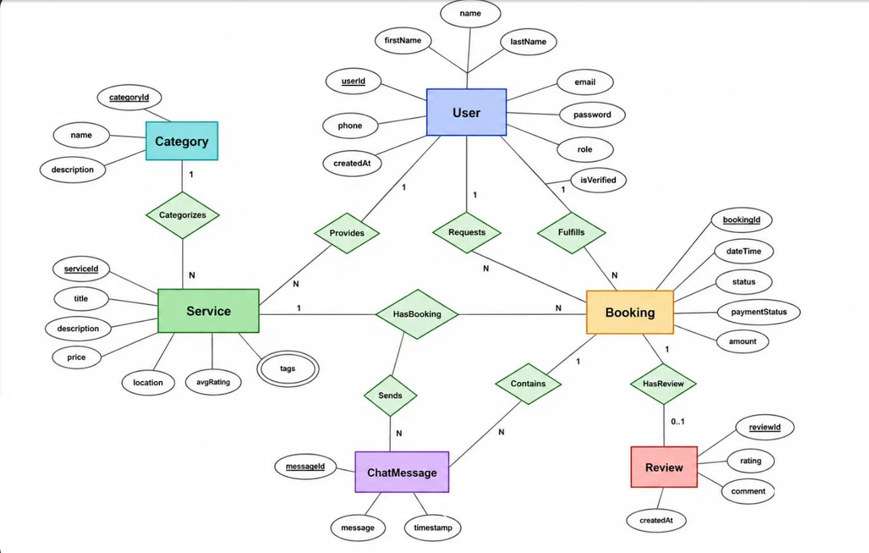
Figure 1: Finalized Entity–Relationship (ER) Diagram for ServiceHub (Chen Notation)

Legend and Cardinality Notation
Symbol | Meaning | Symbol | Meaning
Rectangle | Entity (Strong) | 1 | One
Diamond | Relationship | N | Many
Ellipse | Attribute | 0..1 | Zero or One
Underlined ellipse | Key Attribute
Double-outlined ellipse | Multivalued Attribute

Design Notes
    - User, Category, Service and Booking are the four core entities, each with its own key attribute.

    - User participates in the Booking relationship set twice, in two distinct roles. This is modelled as two separate named relationships, Requests (customer role) and Fulfills (provider role), rather than one ambiguous relationship.
    - Booking connects to Review and ChatMessage through the HasReview and Contains relationships respectively; a Booking may have zero or one Review (0..1) and many ChatMessages (N).
    - A direct User–Review relationship was intentionally omitted: the reviewing customer and provider are already derivable through Booking, so a separate edge would be a redundant relationship.
    - name (User) is modelled as a composite attribute of firstName and lastName; tags (Service) is modelled as a multivalued attribute, since a service may be tagged with several keywords for search (F3).

Entities and Relationships Summary

Relationship | Participating Entities | Cardinality | Type
Categorizes | Category → Service | 1 : N | Regular
Provides | User → Service | 1 : N | Regular
Requests | User → Booking | 1 : N | Regular (customer role)
Fulfills | User → Booking | 1 : N | Regular (provider role)
HasBooking | Service → Booking | 1 : N | Regular
Sends | User → ChatMessage | 1 : N | Regular
Contains | Booking → ChatMessage | 1 : N | Regular
HasReview | Booking → Review | 1 : 0..1 | Regular

Part B – MongoDB Database Creation
This section documents the creation of the ServiceHub MongoDB database, the six collections derived from the ER diagram in Part A, schema validation rules, sample seed data, and a set of representative CRUD queries. All commands below were written for and executed in the mongosh shell (MongoDB v7.0) connected to a local/Atlas cluster named servicehub.

Database and Collection Setup
The database is created implicitly on first write. Switch to it as follows:

// Switch to (create) the ServiceHub database use servicehub
The six collections corresponding to the entities in the ER diagram are created with JSON Schema validation so that MongoDB enforces the structure defined during design:

Collection: users
db.createCollection("users", { validator: { $jsonSchema: { bsonType: "object",
required: ["name", "email", "password", "role"], properties: {
name: { bsonType: "string" },
email: { bsonType: "string", pattern: "^.+@.+\\..+$" }, password: { bsonType: "string" },
role: { enum: ["Customer", "Provider", "Admin"] }, isVerified: { bsonType: "bool" },
phone: { bsonType: "string" }, createdAt: { bsonType: "date" }
}
}}
});
db.users.createIndex({ email: 1 }, { unique: true });

Collection: categories
db.createCollection("categories", { validator: { $jsonSchema: { bsonType: "object",
required: ["name"], properties: {
name: { bsonType: "string" }, description: { bsonType: "string" }
}
}}
});

Collection: services
db.createCollection("services", { validator: { $jsonSchema: { bsonType: "object",
required: ["providerId", "title", "category", "price"], properties: {
providerId: { bsonType: "objectId" }, title: { bsonType: "string" }, description: { bsonType: "string" }, category: { bsonType: "string" },

price: { bsonType: "number", minimum: 0 },
avgRating: { bsonType: "number", minimum: 0, maximum: 5 }, location: { bsonType: "string" }
}
}}
});
db.services.createIndex({ category: 1 });

Collection: bookings
db.createCollection("bookings", { validator: { $jsonSchema: { bsonType: "object",
required: ["customerId", "providerId", "serviceId", "dateTime", "status"], properties: {
customerId: { bsonType: "objectId" }, providerId: { bsonType: "objectId" }, serviceId: { bsonType: "objectId" }, dateTime: { bsonType: "date" },
status: { enum: ["Pending", "Confirmed", "Completed", "Cancelled"] }, paymentStatus: { bsonType: "string" },
amount: { bsonType: "number" }
}
}}
});

Collection: reviews
db.createCollection("reviews", { validator: { $jsonSchema: { bsonType: "object",
required: ["bookingId", "customerId", "providerId", "rating"], properties: {
bookingId: { bsonType: "objectId" }, customerId: { bsonType: "objectId" }, providerId: { bsonType: "objectId" },
rating: { bsonType: "int", minimum: 1, maximum: 5 }, comment: { bsonType: "string" },
createdAt: { bsonType: "date" }
}
}}
});

Collection: chatmessages
db.createCollection("chatmessages", { validator: { $jsonSchema: { bsonType: "object",
required: ["bookingId", "senderId", "message"], properties: {
bookingId: { bsonType: "objectId" }, senderId: { bsonType: "objectId" }, message: { bsonType: "string" }, timestamp: { bsonType: "date" }
}
}}
});

Confirming the collections were created:

show collections categories
users services

bookings reviews chatmessages

Sample Data Insertion
Representative sample documents were inserted into each collection to test the schema and support the query demonstrations in section B.3.

Insert Users
db.users.insertMany([
{ _id: ObjectId("66aa10000000000000000001"),
name: "Ankit Patel", email: "ankit.patel@example.com", password: "$2b$10$hashPlaceholder1", role: "Customer",
isVerified: true, phone: "9876543210", createdAt: new Date("2026-07-01") },
{ _id: ObjectId("66aa10000000000000000002"),
name: "Rakesh Mehta", email: "rakesh.mehta@example.com", password: "$2b$10$hashPlaceholder2", role: "Provider",
isVerified: true, phone: "9898989898", createdAt: new Date("2026-07-02") },
{ _id: ObjectId("66aa10000000000000000003"),
name: "Priya Shah", email: "priya.shah@example.com", password: "$2b$10$hashPlaceholder3", role: "Provider",
isVerified: false, phone: "9765432109", createdAt: new Date("2026-07-03") },
{ _id: ObjectId("66aa10000000000000000004"),
name: "Admin User", email: "admin@servicehub.com", password: "$2b$10$hashPlaceholder4", role: "Admin",
isVerified: true, phone: "9000000000", createdAt: new Date("2026-06-15") }
]);
{
acknowledged: true, insertedIds: {
'0': ObjectId('66aa10000000000000000001'),
'1': ObjectId('66aa10000000000000000002'),
'2': ObjectId('66aa10000000000000000003'),
'3': ObjectId('66aa10000000000000000004')
}
}

Insert Categories
db.categories.insertMany([
{ _id: ObjectId("66aa20000000000000000001"), name: "Plumbing", description: "Pipe fitting, leak repair and bathroom installation" },
{ _id: ObjectId("66aa20000000000000000002"), name: "Electrician", description: "Wiring, appliance repair and electrical installation" }
]);

Insert Services
db.services.insertMany([
{ _id: ObjectId("66aa30000000000000000001"),
providerId: ObjectId("66aa10000000000000000002"),
title: "Bathroom Pipe Repair", description: "Fix leaking pipes and fittings", category: "Plumbing", price: 500, avgRating: 4.5, location: "Ahmedabad" },
{ _id: ObjectId("66aa30000000000000000002"),
providerId: ObjectId("66aa10000000000000000003"),
title: "Home Wiring Fix", description: "Repair faulty home wiring", category: "Electrician", price: 800, avgRating: 4.0, location: "Ahmedabad" }
]);

Insert Bookings
db.bookings.insertMany([
{ _id: ObjectId("66aa40000000000000000001"),
customerId: ObjectId("66aa10000000000000000001"), providerId: ObjectId("66aa10000000000000000002"),

serviceId: ObjectId("66aa30000000000000000001"), dateTime: new Date("2026-08-10T10:00:00Z"),
status: "Completed", paymentStatus: "Paid", amount: 500 },
{ _id: ObjectId("66aa40000000000000000002"),
customerId: ObjectId("66aa10000000000000000001"), providerId: ObjectId("66aa10000000000000000003"), serviceId: ObjectId("66aa30000000000000000002"), dateTime: new Date("2026-08-18T14:00:00Z"),
status: "Pending", paymentStatus: "Pending", amount: 800 }
]);

Insert Review
db.reviews.insertOne({
bookingId: ObjectId("66aa40000000000000000001"), customerId: ObjectId("66aa10000000000000000001"), providerId: ObjectId("66aa10000000000000000002"), rating: 5, comment: "Excellent and timely service!", createdAt: new Date("2026-08-10T16:00:00Z")
});

Insert Chat Messages
db.chatmessages.insertMany([
{ bookingId: ObjectId("66aa40000000000000000001"), senderId: ObjectId("66aa10000000000000000001"), message: "Hi, are you available today?", timestamp: new Date("2026-08-10T09:00:00Z") },
{ bookingId: ObjectId("66aa40000000000000000001"), senderId: ObjectId("66aa10000000000000000002"), message: "Yes, I can come by 4 PM.",
timestamp: new Date("2026-08-10T09:05:00Z") }
]);

Practicing Basic Queries (CRUD Operations)

Create – Add a new Service
db.services.insertOne({
providerId: ObjectId("66aa10000000000000000003"),
title: "Ceiling Fan Installation", description: "Install and balance ceiling fans", category: "Electrician", price: 350, avgRating: 0, location: "Ahmedabad"
});
{
acknowledged: true,
insertedId: ObjectId('66aa30000000000000000003')
}

Read – Find all verified Providers
db.users.find({ role: "Provider", isVerified: true }, { name: 1, email: 1, _id: 0 }); [ { name: 'Rakesh Mehta', email: 'rakesh.mehta@example.com' } ]

Read – Search & filter Services by category and price
db.services.find(
{ category: "Electrician", price: { $lte: 800 } }
).sort({ price: 1 }); [
{ _id: ObjectId('66aa30000000000000000003'),
title: 'Ceiling Fan Installation', price: 350, category: 'Electrician', ... },
{ _id: ObjectId('66aa30000000000000000002'),
title: 'Home Wiring Fix', price: 800, category: 'Electrician', ... }
]

Update – Confirm a pending booking
db.bookings.updateOne(
{ _id: ObjectId("66aa40000000000000000002") },
{ $set: { status: "Confirmed" } }
);
{
acknowledged: true, matchedCount: 1, modifiedCount: 1, upsertedCount: 0
}

Update – Verify a Provider (Admin action, F7)
db.users.updateOne(
{ _id: ObjectId("66aa10000000000000000003") },
{ $set: { isVerified: true } }
);

Delete – Remove a chat message
db.chatmessages.deleteOne({
message: "Hi, are you available today?"
});
{ acknowledged: true, deletedCount: 1 }

Aggregation – Join Bookings with Service and Customer details
This satisfies F4 (Booking Management) by producing a consolidated view for the Provider Dashboard, using
$lookup to reference across the users and services collections instead of embedding duplicate data:

db.bookings.aggregate([
{ $match: { status: "Completed" } },
{ $lookup: {
from: "services", localField: "serviceId", foreignField: "_id", as: "service" } },
{ $lookup: {
from: "users", localField: "customerId", foreignField: "_id", as: "customer" } },
{ $unwind: "$service" },
{ $unwind: "$customer" },
{ $project: {
"service.title": 1, "customer.name": 1,
amount: 1, status: 1, dateTime: 1 } }
]); [
{ _id: ObjectId('66aa40000000000000000001'),
amount: 500, status: 'Completed', dateTime: ISODate('2026-08-10T10:00:00Z'),
service: { title: 'Bathroom Pipe Repair' }, customer: { name: 'Ankit Patel' } }
]

Aggregation – Average rating per Provider
db.reviews.aggregate([
{ $group: {
_id: "$providerId",
avgRating: { $avg: "$rating" }, totalReviews: { $sum: 1 } } }
]); [
{ _id: ObjectId('66aa10000000000000000002'),
avgRating: 5, totalReviews: 1 }
]

Summary of Query Types Practiced

CRUD  Type | MongoDB Operator(s) Used | Related Requirement
Create | insertOne, insertMany | F2 (Service Listing), F4 (Booking)
Read | find, sort, $lte, projection | F3 (Search & Filter)
Update | updateOne, $set | F4 (Booking status), F7 (Verification)
Delete | deleteOne | F5 (Chat cleanup)
Aggregate | $lookup, $unwind, $group, $avg | F4, F6 (Rating aggregation)

Conclusion
The ServiceHub database was designed directly from the approved SRS, translating the six core entities and their relationships into a finalized ER diagram. This design was then implemented in MongoDB as six schema-validated collections, seeded with representative sample data, and verified using Create, Read, Update, Delete, and Aggregation queries covering the platform’s key functional requirements (F2–F7). The referenced (non-embedded) relationship pattern chosen here will allow the Booking, Review, and Chat collections to scale independently as the application grows, consistent with the Adaptability requirement (Section 4.3.3) of the SRS.

