INDEX

S.No. Title Page No.

- Introduction 1-2

- Backend 3-5

- Frontend 6-52

- Folder Structure 6-7
- Package.json 8-9
- Public/index.html 10-11
- src/App.js 12-13
- src/apiKeys.js 14
- Src/App.css 15-36
- Src/index.js 37-38
- Src/currentLocation.js 39-45
- Src/forcast.js 46-50
- Src/index.css 51

- Live Demo 52-54

INTRODUCTION

Welcome to our Weather Website, your trusted source for comprehensive and up-to-the-minute weather information. We understand the importance of weather in our daily lives, whether you're planning a weekend getaway, a business trip, or just your daily commute. Our website is designed to provide you with everything you need to stay informed and make well-informed decisions.
Real-Time Weather Updates: Our website offers real-time weather updates, ensuring that you're always aware of the current conditions. Whether it's sunny skies, pouring rain, or a winter storm, you'll know what to expect at a glance.
Accurate Forecasts: Planning ahead? Our accurate weather forecasts provide you with a detailed outlook for the next several days. You can confidently plan outdoor activities, travel, or even your wardrobe based on our predictions.
Interactive Maps: Explore weather patterns with our interactive maps. Track storms, view temperature variations, and understand wind directions. Our maps make it easy to grasp complex weather data.
Local and Global Coverage: Whether you're interested in the weather outside your window or conditions at your dream vacation destination, we've got you covered. Our website provides both local and global weather information, ensuring you're prepared wherever you go.
Weather-Related Insights: We offer more than just temperature and precipitation data. Dive into weather-related insights, including air quality, UV indexes, and pollen counts. Stay informed about environmental factors that affect your health and well-being.
Customized Alerts: Sign up for personalized weather alerts. Get notifications for severe weather conditions, ensuring you're always aware of potential storms, hurricanes, or other emergencies in your area.
User-Friendly Interface: Our user-friendly interface makes navigating our website a breeze. Whether you're tech-savvy or a casual user, you'll find our website easy to use and visually appealing.
Mobile Accessibility: Access our weather information on the go with our mobile-friendly website. Check the weather from your smartphone or tablet, ensuring you're prepared wherever you are.
Stay Informed, Stay Safe: At our Weather Website, we believe that staying informed about the weather is essential for your safety and convenience. Whether it's for your daily commute or planning a special event, we're here to provide you with the weather information you need.

Backend Part
The backend of a Weather Website is responsible for handling various tasks that ensure the website provides accurate and up-to-date weather information to users. Here are the key backend activities of a Weather Website:
Data Retrieval: The backend regularly fetches weather data from reliable sources such as meteorological agencies, weather APIs (e.g., OpenWeatherMap, Weather.com), or satellites. This data includes information like temperature, humidity, wind speed, and more.
Data Parsing: Once the data is retrieved, the backend parses it to extract relevant information. This involves converting raw data into a structured format that can be used to generate weather forecasts and reports.
Data Storage: Weather data is typically stored in a database. The backend manages this data, ensuring it is organized, updated, and readily accessible for various purposes. Historical weather data may also be stored for reference.
Forecast Generation: Using the collected data and historical patterns, the backend generates weather forecasts. This can include short-term (daily) and long-term (weekly) forecasts, as well as specialized forecasts like storm warnings.
API Integration: Many Weather Websites offer APIs to allow developers and other services to access their weather data. The backend handles these API requests, providing data in a standardized format (e.g., JSON) for external use.
User Management: For websites that offer user-specific features like personalized alerts and location-based forecasts, the backend manages user accounts, authentication, and preferences.
Alerts and Notifications: The backend monitors weather conditions and sends alerts to users when significant changes or severe weather events are detected. This can include email alerts, push notifications, or SMS messages.
Geolocation Services: To provide location-based weather information, the backend may use geolocation services to determine a user's approximate location based on their IP address or device GPS coordinates.
Security: Weather data is sensitive, and the backend must implement security measures to protect it from unauthorized access and data breaches. This includes encryption, access controls, and regular security audits.
Load Balancing and Scalability: Weather Websites often experience fluctuations in traffic due to changing weather conditions. The backend should be designed to handle spikes in traffic efficiently, ensuring the website remains responsive during high-demand periods.
Performance Optimization: Optimizing the backend for speed and efficiency is crucial to deliver real-time weather updates. This includes database indexing, caching, and minimizing latency in data retrieval and delivery.
Maintenance and Updates: Regular maintenance and updates are essential to keep the backend infrastructure and data sources up to date. This ensures the accuracy and reliability of the weather information provided.

Frontend part
Folder structure :-
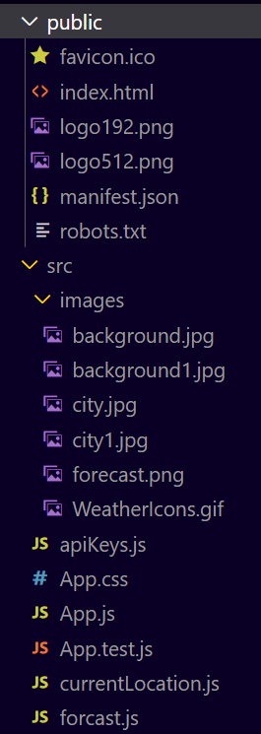
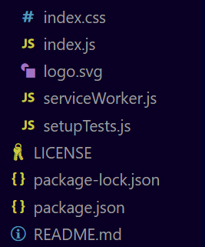

Package.json:-
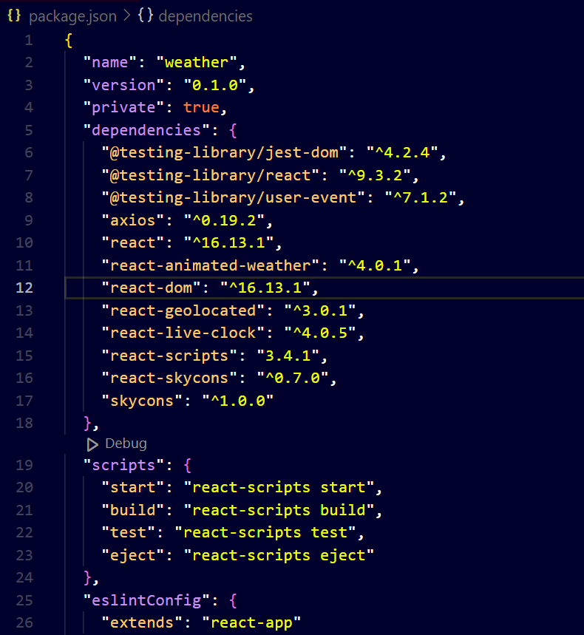
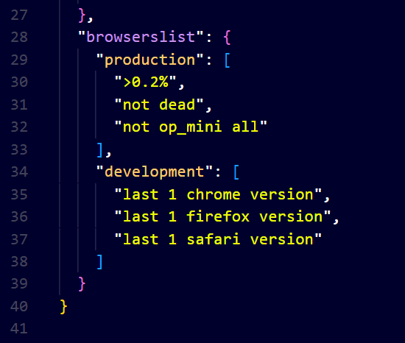

Public/index.html
Description :- This HTML template represents the foundation of a web application built using React.js. It includes essential metadata, such as character encoding, viewport settings, and theme color, to ensure proper rendering on various devices. Additionally, it integrates Google Analytics for tracking user interactions. The main content div, identified by the "root" id, serves as the entry point for the React application. This template emphasizes the importance of JavaScript for running the app and provides a brief description for users who need to enable JavaScript for it to function.
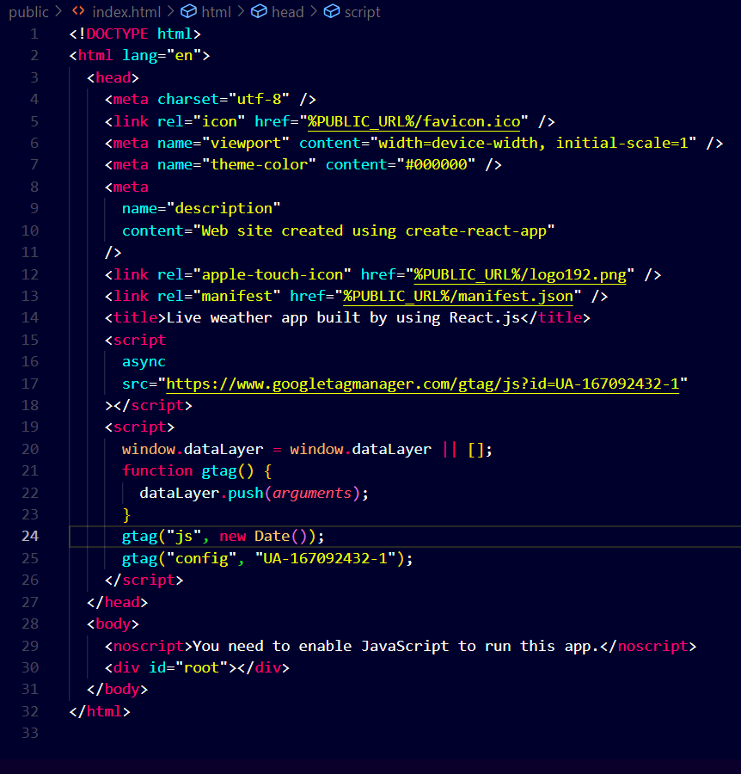

src/App.js
Description :- This React application, represented by the code provided, is designed to display the current location using the "CurrentLocation" component. It offers a straightforward user interface within a container, providing location-related information. The footer section includes links to download the source code, details about the developer (Bhawana Sharma), and acknowledgment to HTML HINTS for their support. This application serves as a practical example of how to integrate location-based features into a web application using React.
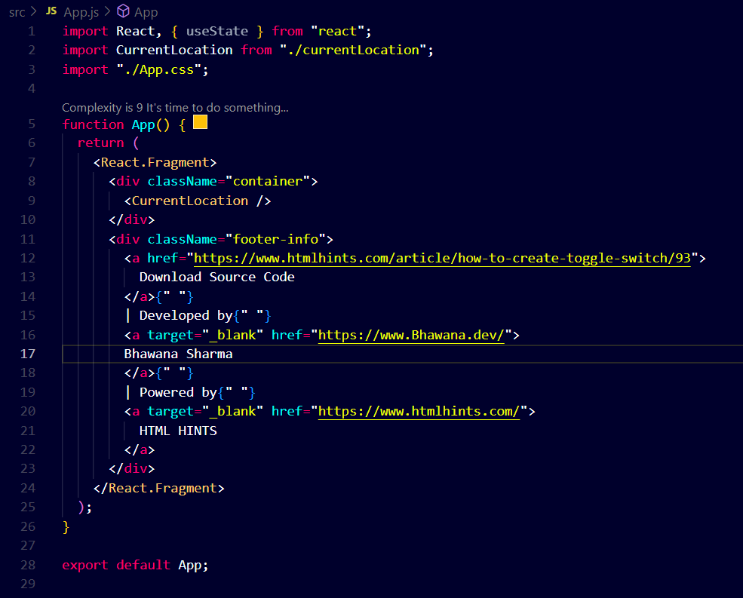

src/ apiKeys.js
Description :- This JavaScript module configuration is meant for accessing weather data from the OpenWeatherMap API. To utilize this module, users must sign up for a free API key on the OpenWeatherMap website. Once obtained, this key can be added to the "key" field within the module, allowing developers to make API requests and retrieve weather-related information. This simple configuration facilitates the integration of weather data into various applications and services.
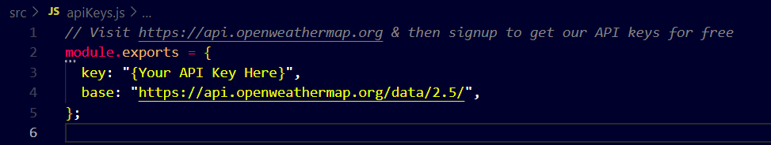

Src/App.css

Description :- This CSS code is a comprehensive reset and styling for web elements, followed by styling specific to an index page. It sets the baseline styling for various HTML elements and defines specific styles for the layout, fonts, background images, and responsiveness of the page. The code includes media queries to ensure the website's adaptability to different screen sizes. It creates a visually appealing and responsive weather website, featuring dynamic elements for displaying weather information. The code also includes styling for search functionality and attribution links.
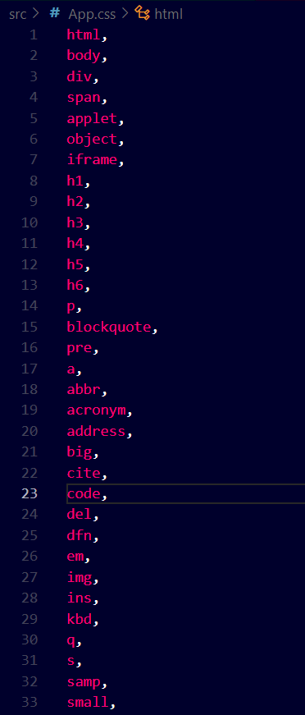
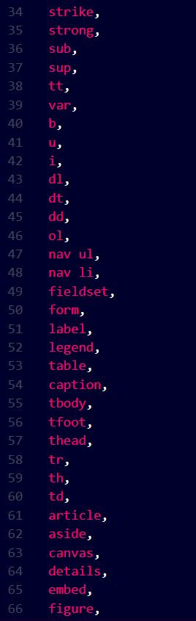
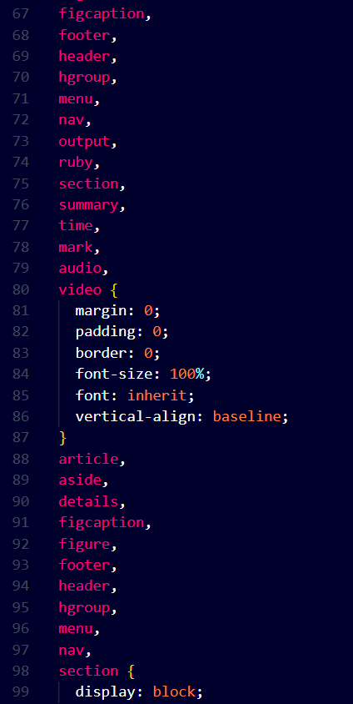
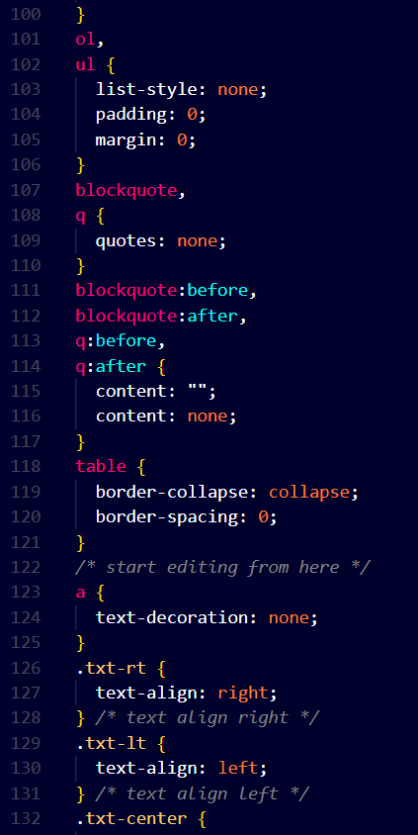
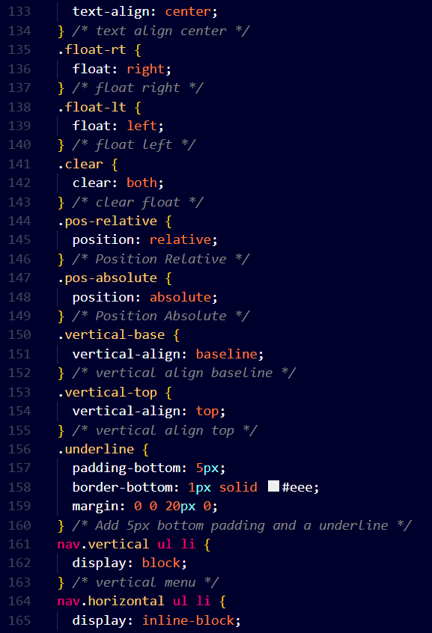
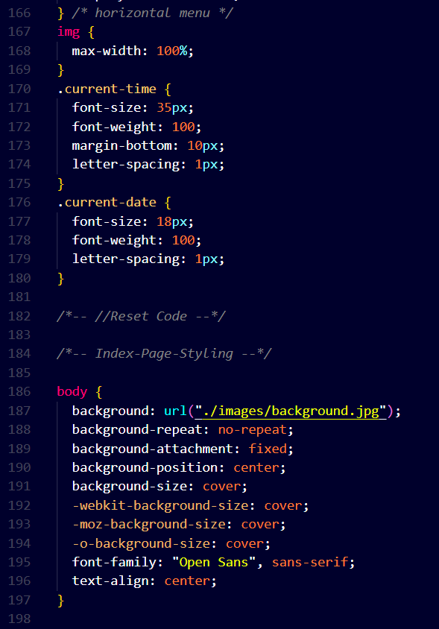
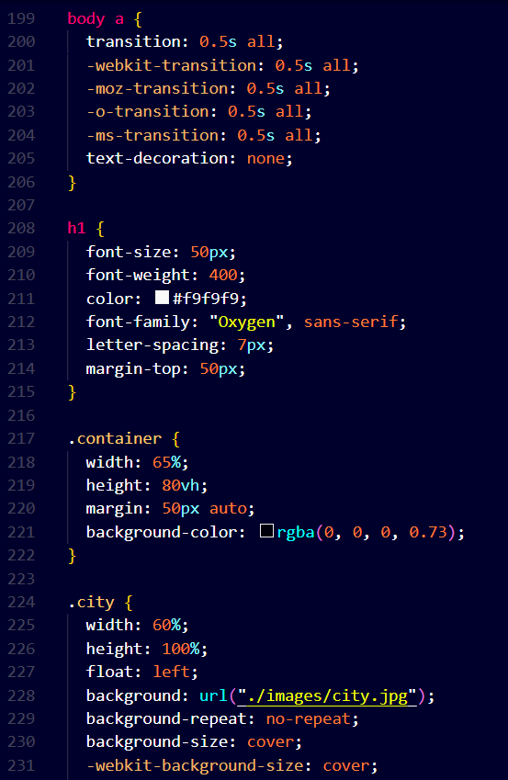
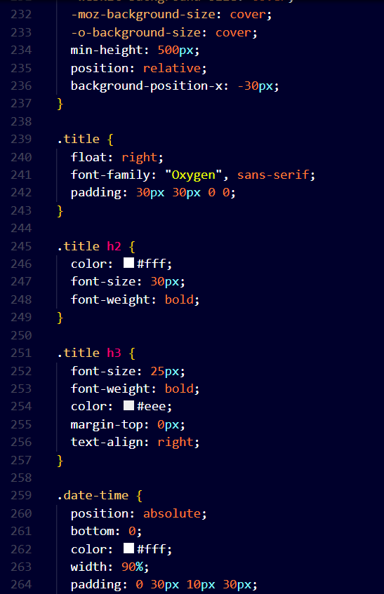
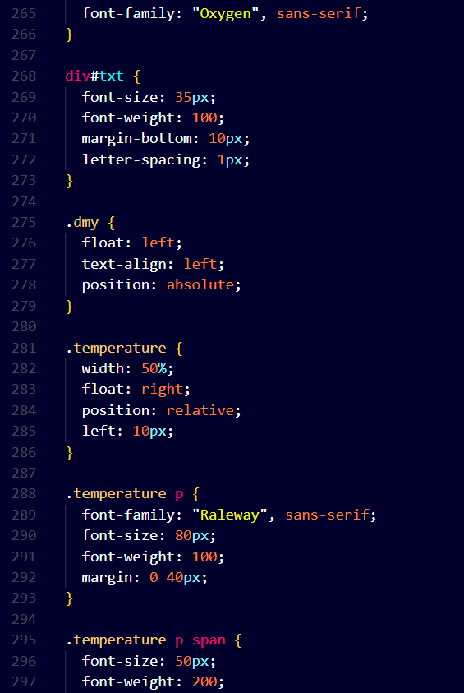
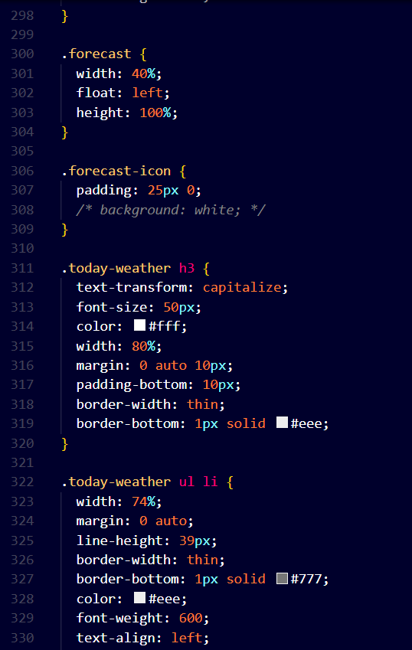
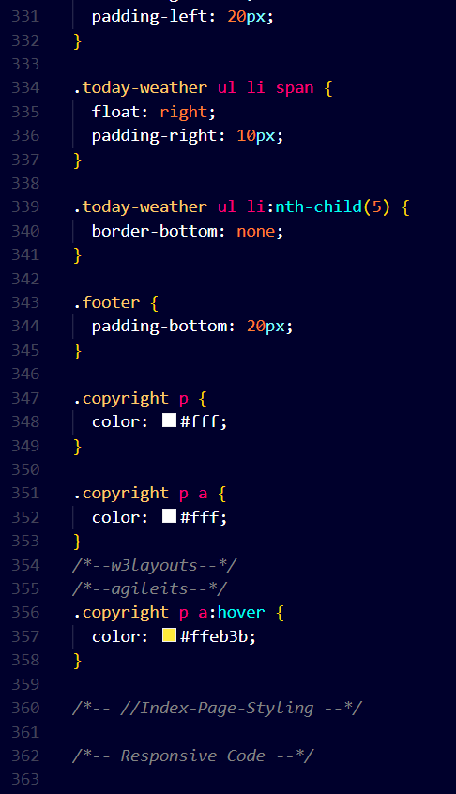
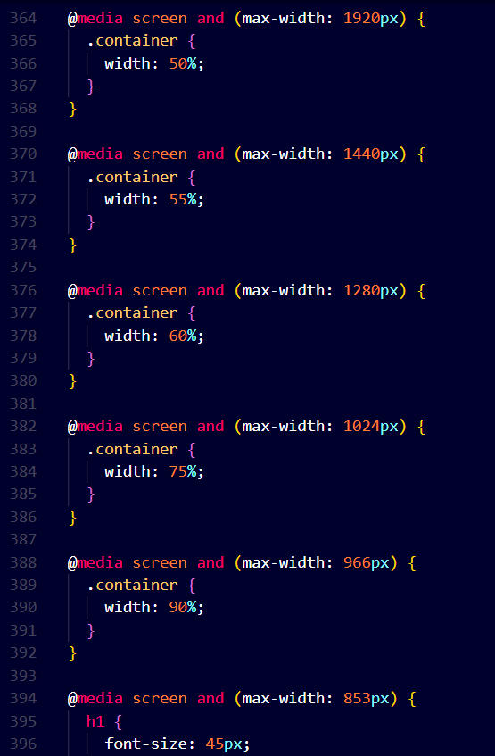
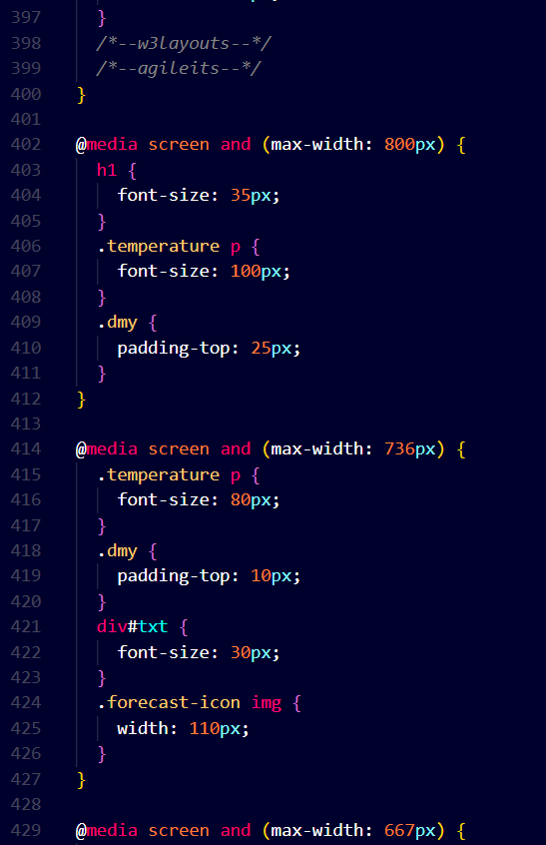
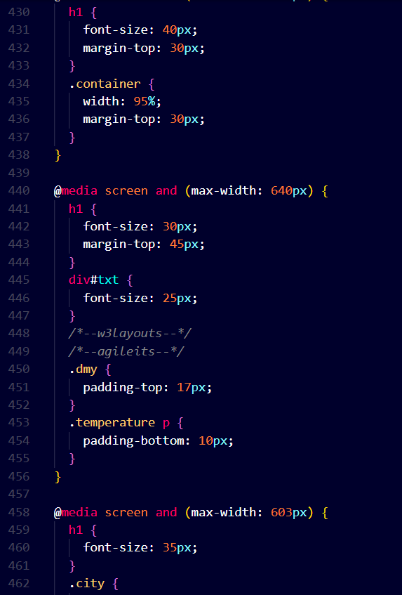
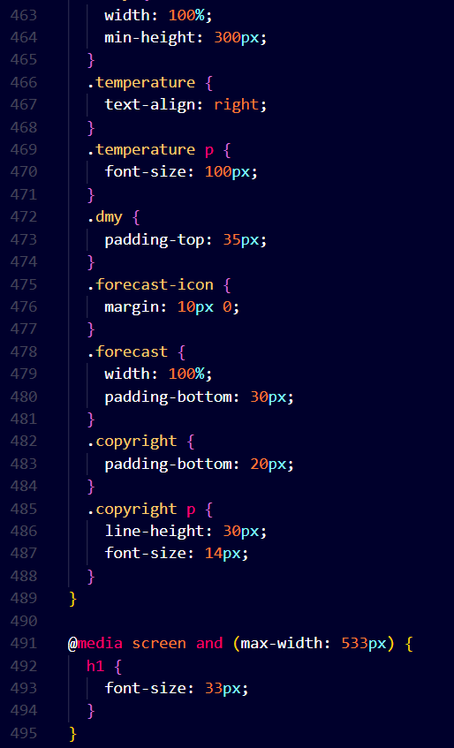
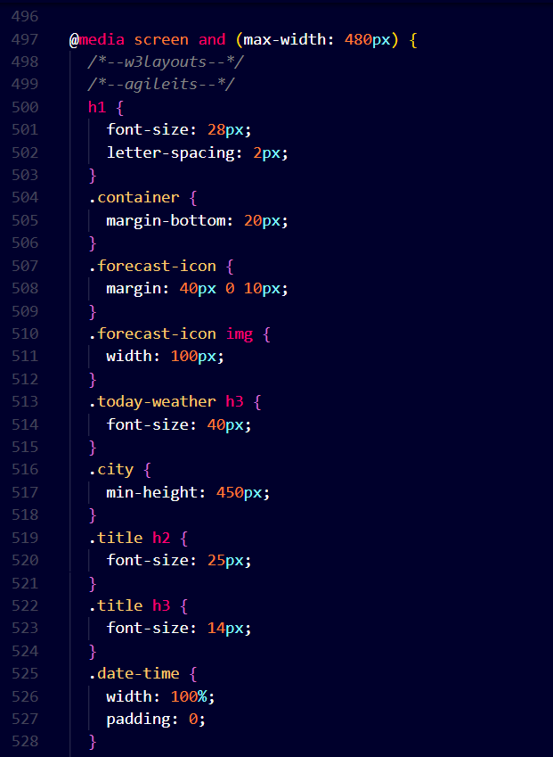
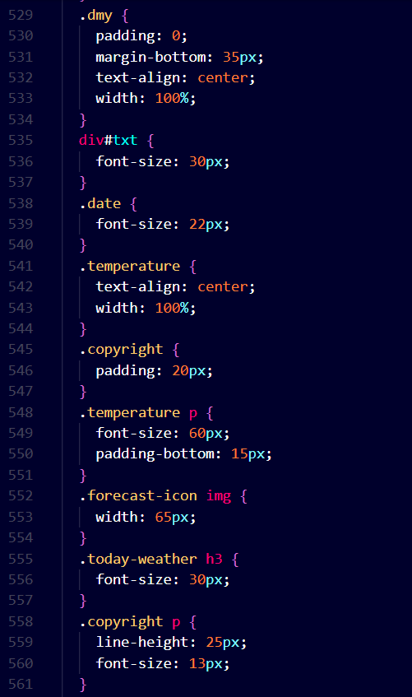
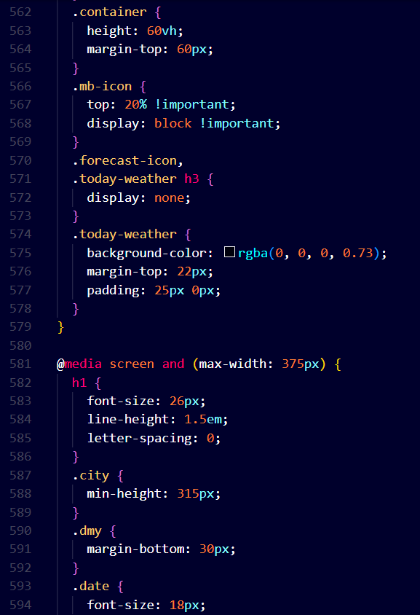
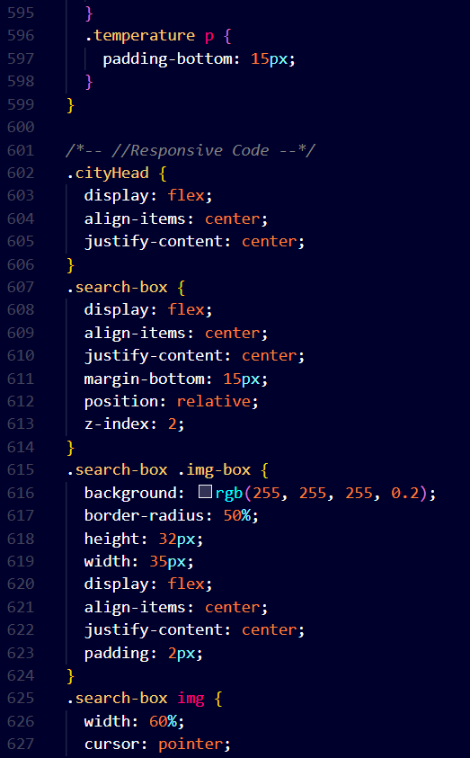
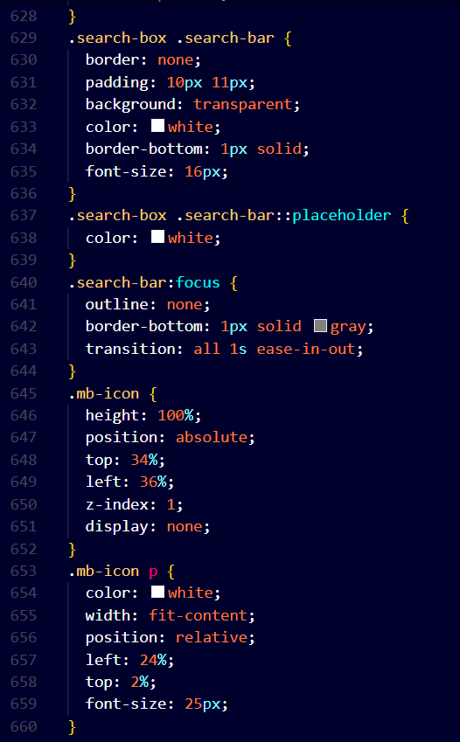
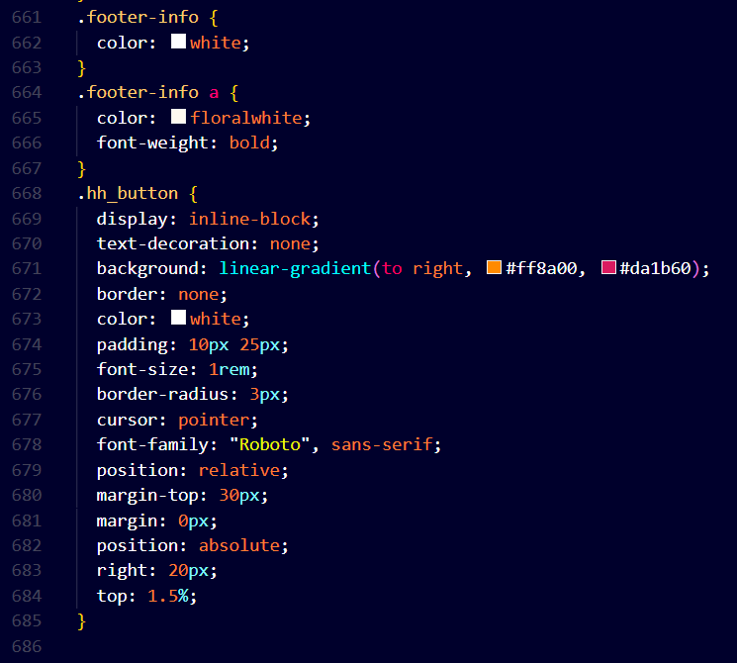

Src/index.js

Description :- The provided code snippet is an entry point for a React application. It uses ReactDOM.createRoot() to create a root-level element in the HTML document where the React application will be rendered. The application is wrapped within multiple components to enable certain features and context. It imports the App component, which is likely the main component of the application. It also imports CSS styles from various libraries like Bootstrap, Remixicon, and Slick Carousel to style the application. The BrowserRouter component from the react-router-dom library is used to enable routing functionality. Additionally, the AuthContextProvider is used to provide authentication-related context to components within the application. The entire application is rendered within the React.StrictMode, which helps catch potential issues during development. Overall, this code sets up the foundation for rendering the React application with necessary styles, routing, and context management.
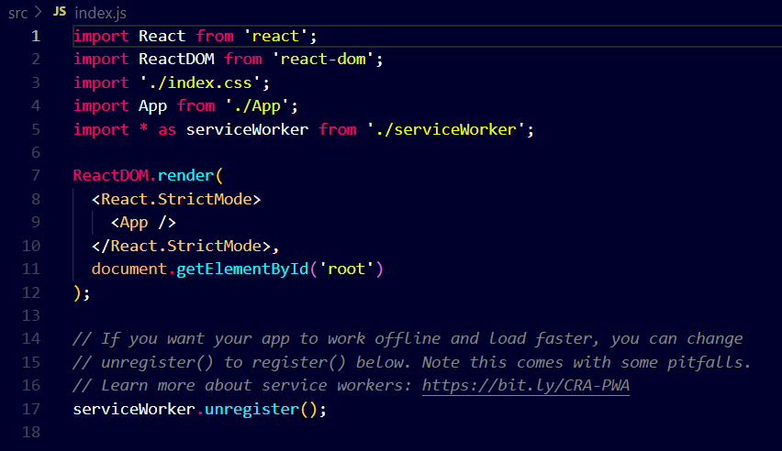

Src/ currentLocation.js

Description :- This React.js component, named "Weather," is a dynamic weather display application. It uses the OpenWeatherMap API to fetch real-time weather data based on the user's location. The component provides information such as city, country, temperature in both Celsius and Fahrenheit, humidity, weather conditions, and an animated weather icon representing the current conditions. It also displays the date and time. The component is designed to be responsive, ensuring a seamless user experience across different devices and screen sizes. Additionally, it includes a loading screen with a location detection message while fetching data. Overall, this component offers an engaging and informative weather experience for users.
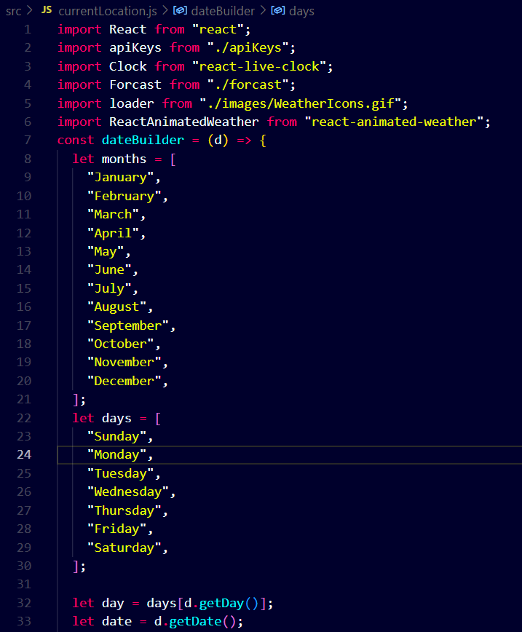
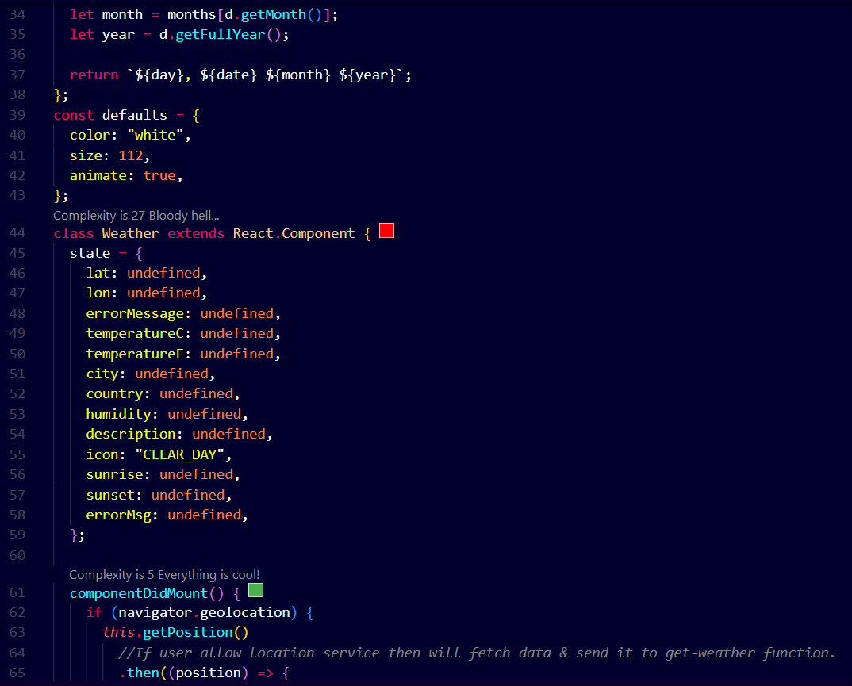
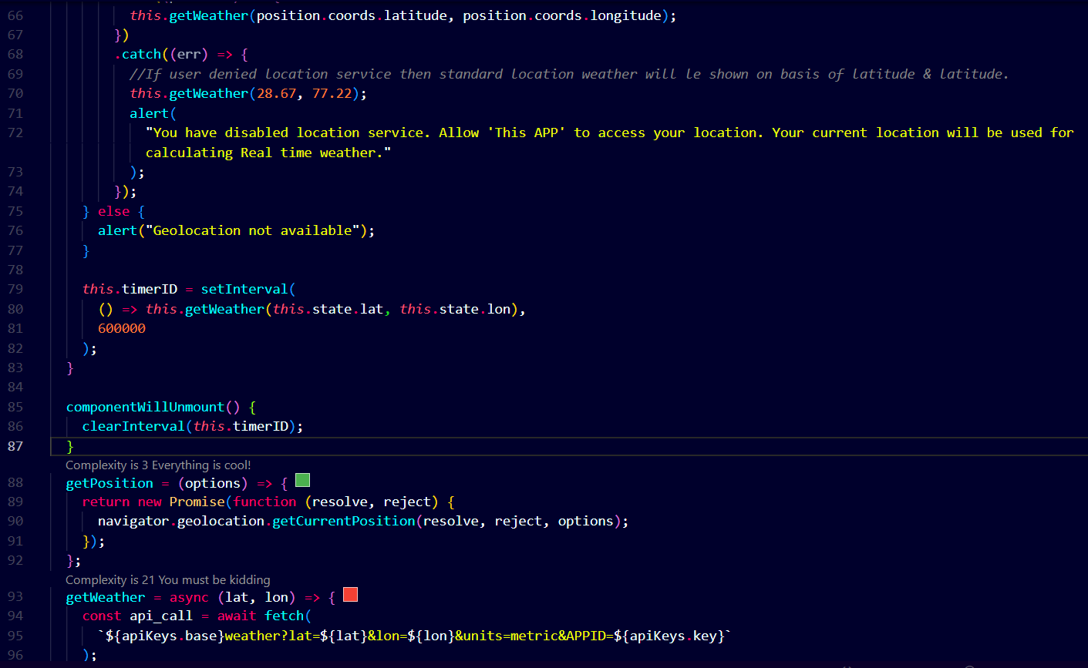
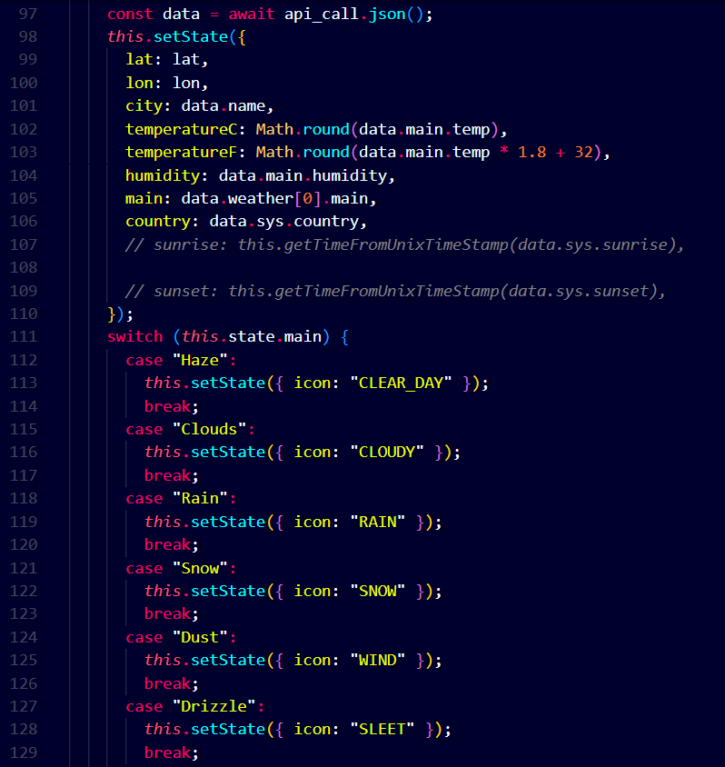
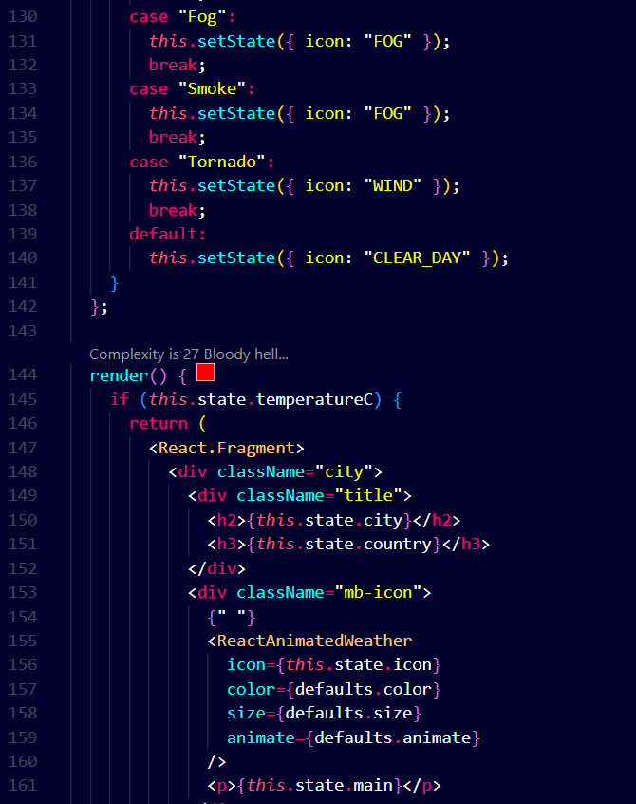
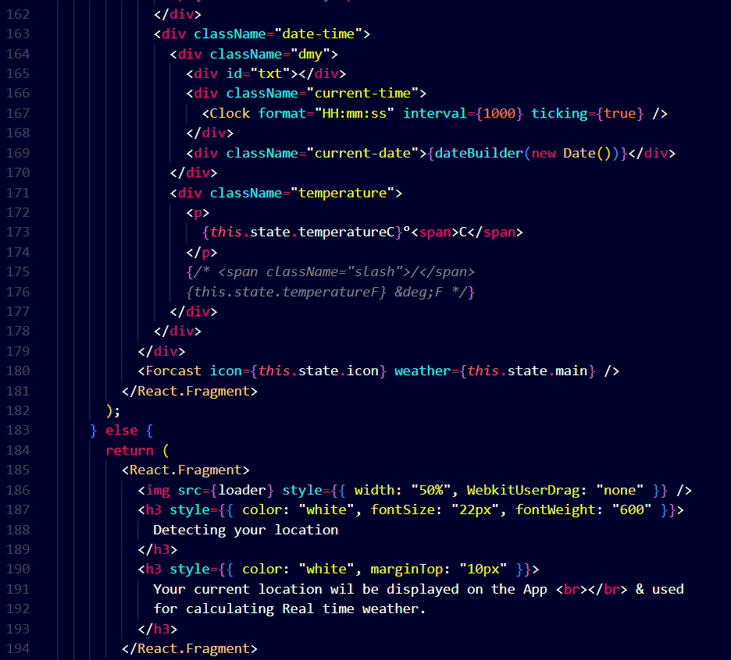
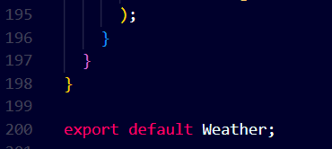

Src/ forcast.js

Description :-
These two React components, "Weather" and "Forecast," together form a dynamic weather display application. The "Weather" component provides real-time weather data based on the user's location, utilizing the OpenWeatherMap API. It offers information such as city, country, temperature in both Celsius and Fahrenheit, humidity, weather conditions, and an animated weather icon representing the current weather. Additionally, it displays the date and time and is designed to be responsive.

The "Forecast" component complements the "Weather" component by allowing users to search for weather information for different cities. It provides similar weather data, including temperature, humidity, visibility, and wind speed, along with a search feature to look up weather conditions for specific locations.

Together, these components offer an engaging and informative weather experience for users, both for their current location and for cities they may want to explore.
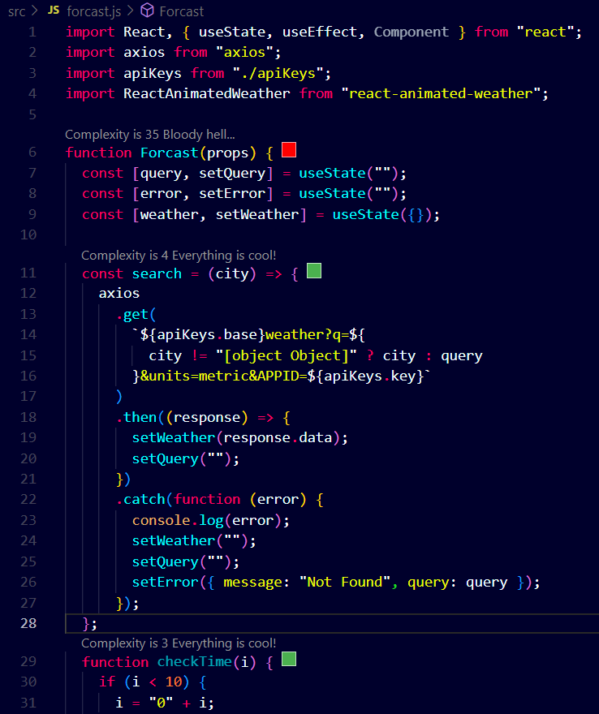
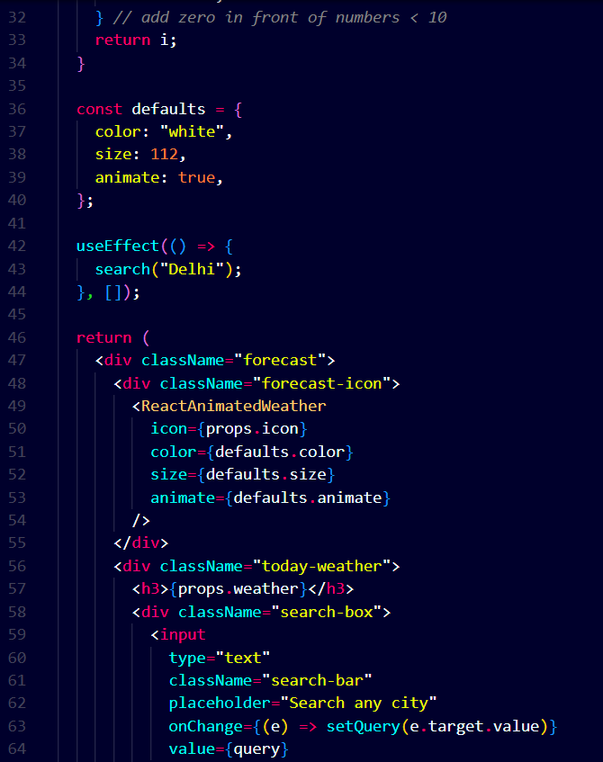
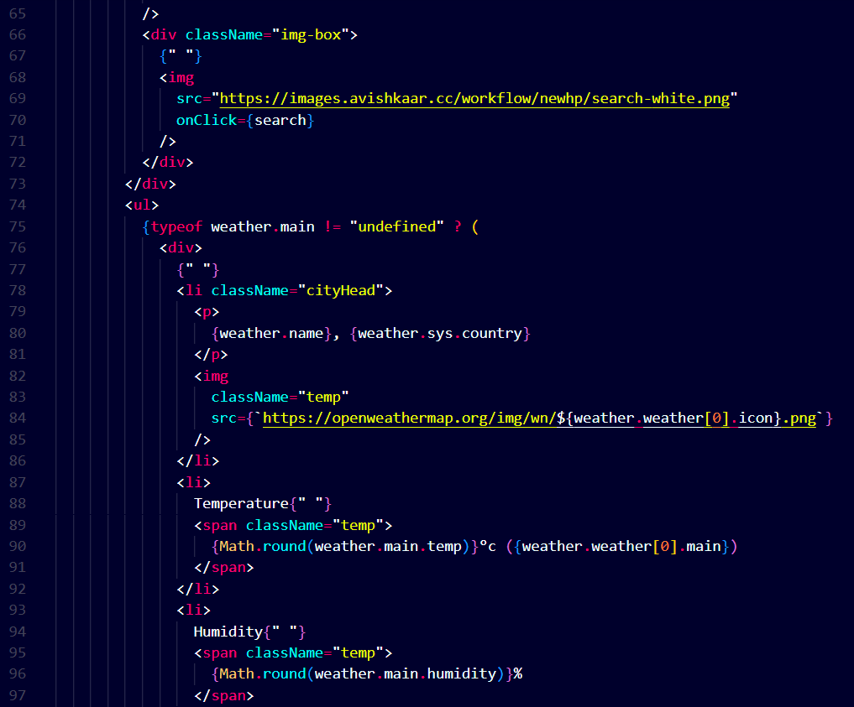
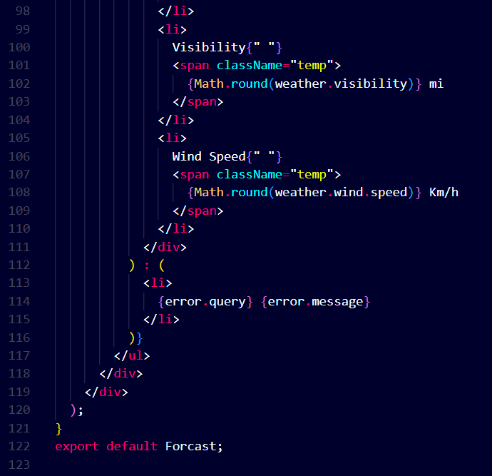

Src/index.css

Description :- This CSS code snippet defines some fundamental styles for a web page's body and code elements. It sets the margin to zero, ensuring there is no extra space around the page content. The chosen font for the body text is a system font stack, designed for optimal readability across different operating systems. Additionally, it employs font-smoothing techniques to enhance the text's appearance, both on Apple devices and in Mozilla Firefox. For code elements, a specific monospace font stack is used, ensuring code snippets display in a clear and consistent manner, suitable for programming and technical content.
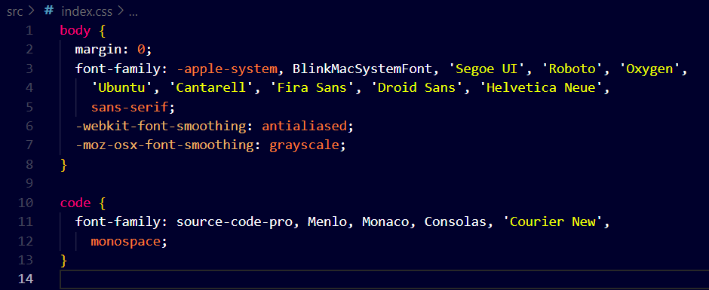

Home Page :

