
City St George’s, University of London

Course : M.Sc. Cyber Security

Project report

Continuous Authentication to Detect Session Hijacking in Remote
Work Environments.

Supervisor : Dr. Hafizul Asad
Student : Hitesh Manoj Badgujar

Date : 08 December 2025
Signed Declaration

By submitting this work, I declare that this work is entirely my own except those parts duly
identified and referenced in my submission. It complies with any specified word limits and
the requirements and regulations detailed in the assessment instructions and any other relevant
programme and module documentation. In submitting this work, I acknowledge that I have
read and understood the regulations and code regarding academic misconduct, including that
relating to plagiarism, as specified in the Programme Handbook. I also acknowledge that this
work will be subject to a variety of checks for academic misconduct.

Signed: Hitesh Badgujar

Abstract

Remote and hybrid work mean users often remain logged into sensitive web applications for long periods, while most systems still rely on one-off authentication. This dissertation presents a proof-of-concept continuous authentication framework that monitors keystroke dynamics, mouse movements and face information and converts them into a behavioural trust score driving ALLOW / STEP-UP / LOCK decisions. Public, anonymised CMU-style keystroke and BALABIT-style mouse datasets are preprocessed into windows and mapped to feature vectors: an 18-dimensional set of dwell and flight timings, backspace usage, burst length and idle gaps for the keyboard, and descriptors of path length, straightness, speed, acceleration, pauses and click behaviour for the mouse. A per-user conditional autoencoder is implemented and compared with a support vector machine; experiments show that the autoencoder suffers from high false acceptance, whereas the SVM achieves much lower error and higher accuracy. A global SVM for mouse dynamics provides a weaker complementary signal. A lightweight face module supplies similarity and liveness scores that are fused with behavioural trust in a Django-based monitor prototype.

Keywords: continuous authentication; behavioural biometrics; keystroke dynamics; mouse dynamics; multimodal fusion

Table of Contains

Chapter 1 - Introduction and Objective 6
1.1 Background and motivation 6
1.2 Problem statement 6
1.3 Project aim and research questions 7
1.4 Objectives and success criteria 7
1.5 Scope and limitations 8
1.6 What changed from proposal to final implementation 8
1.7 Report structure 9
1.8 Ethical considerations 9
1.9 Use of Generative AI tools 9
Chapter 2 - Context and Literature Review 10
2.1 Continuous Authentication and Threat Model 10
2.2 Keystroke Dynamics: Features, typical models, and challenges 10
2.3 Mouse dynamics: features, variability, and typical models 11
2.4 Face verification and liveness in continuous settings 12
2.5 Multimodal fusion strategies and trade offs 13
2.6 Gap and how this prototype addresses it 14
Chapter 3 – Methods 15
3.1 System overview and dataflow 15
3.2 Datasets and splits 15
3.3 Feature Engineering 16
3.4 Model designs and training 18
3.5 Trust scoring and smoothing in the live system 20
3.6 Fusion and policy logic (ALLOW, STEP_UP, LOCK) 21
3.7 Implementation details: Django endpoints, browser streaming, and logging 22
3.8 Evaluation protocol and metrics 22
Chapter 4 – Results 24
4.1 Offline evaluation metrics summary. 24
4.2 Behavioural model results and discussion 24
4.3 Mouse model results 31
4.4 Behavioural fusion and behavioural + face fusion 34
4.5 Takeover simulation result 35
4.6 Real time prototype evidence 36
Chapter 5 – Discussion 39
5.1 Revisit objectives: what was met and what was not 39
5.2 Keyboard: why SVM performed better than CAE here 39
5.3 Mouse: why it is weaker alone and how it still helps in fusion 40
5.4 Mouse SVM: value and limitations 40
5.5 Threats to validity and limitations 41
Chapter 6 – Evaluation, Reflections, and Conclusions 42
6.1 Overall evaluation against the proposal plan 42
6.2 Reflection: what I learned and what I would do differently 42
6.3 Conclusion: key takeaways and future work 44
References 45
Appendix A – System diagrams and UI Screenshots 48
A.1 System Architecture and Workflow 48
A.2 Behavioural Trust Monitor UI 50
Appendix B Definitions 51
B.1 Keyboard feature vector (18 features, fixed order) 51
B.2 Mouse feature vector (23 features, fixed order) 52
Appendix C Model configs, hyperparameters, and training commands 53
C.1 Keyboard CAE (per-user conditional autoencoder) 53
C.2 Keyboard SVM (global multi-class SVC) 54
C.3 Mouse SVM (global multi-class SVC) 55
C.4 Takeover simulation generation (keyboard replay plot) 56
C.5 Real-time plots from session logs 57
Appendix D AI Use and Code Provenance table 58
Appendix E – Code and Data Repositories 60
Project Source Code Repository 60
E.1 Project GitHub repository 60
E.2 CMU-style keystroke dynamics dataset (Kaggle) 60
E.3 BALABIT remote desktop / mouse dynamics dataset (Kaggle) 60

Chapter 1 - Introduction and Objective

1.1 Background and motivation
Most digital work now happens inside long-lived web sessions email, cloud consoles, finance portals, learning platforms, and internal admin tools. In practice, people keep these tabs open for hours while working from home, in labs, or in shared offices. After the first login, the system typically assumes the same person remains in control until logout or timeout. That assumption is shaky. Laptops are left unlocked for a quick break, a colleague uses the same screen to troubleshoot, or a remote desktop session stay connected while the user is away. These normal habits create a gap between “logged in once” and “still the same user now”.
Continuous authentication (CA) addresses this by validating identity throughout the session using signals produced during interaction. Behavioural biometrics such as keystroke dynamics and mouse dynamics are appealing because they are passive and do not interrupt the user, though they are affected by fatigue, device changes, and task context (Teh et al., 2013; Khan et al., 2024). Survey work also highlights the practical trade-off: CA must detect takeovers quickly without causing frequent false alarms that ruin usability (Baig and Eskeland, 2021; Ryu et al., 2021). This project is motivated by building a CA prototype that can run in real time without annoying the user.

1.2 Problem statement
Session hijacking is not limited to stolen passwords at login. A frequent risk is takeover of an already authenticated session: an attacker uses an unattended workstation, remote-control malware, or a compromised browser to act as the user. Because the initial authentication already succeeded, the application treats later actions as legitimate. One-shot methods—passwords, OTPs, or a single biometric scan—verify identity at one moment, so they do not detect mid-session substitution.
The impact is practical and immediate. With an active session, an attacker can read email threads, export cloud data, alter billing settings, or submit transactions. Many organisations rely on inactivity timeouts and occasional re-authentication for sensitive actions. These controls are blunt: long timeouts improve usability but increase exposure; short timeouts irritate users and still fail when the attacker acts quickly. Work on anomaly detection for keystroke behaviour shows that interaction can be modelled and deviations can be flagged during operation (Institute of Electrical and Electronics Engineers, 2009). In short, the attacker needs only a small window, while defences depend on the user returning. Therefore, a continuous approach that reacts to behavioural change, and can be strengthened through multimodal signals, is more suitable in real environments (Baig and Eskeland, 2021; Ryu et al., 2021).

1.3 Project aim and research questions
The aim of this project is to build and evaluate a working continuous authentication prototype that can monitor a live web session and react when the active user changes. The core idea is to use behavioural biometrics from normal interaction, mainly keystroke and mouse dynamics, because these signals can be collected quietly in the background while the person is already working. However, behavioural signals can drift with fatigue, device differences, or task context, so relying on only one channel is risky (Teh et al., 2013; Khan et al., 2024). For that reason, the prototype also supports an additional face-based signal that can strengthen decisions during step up events rather than interrupting the user all the time. Prior reviews highlight that combining modalities often improves robustness because different signals fail under different conditions (Ryu et al., 2021; Stylios et al., n.d.).
This work is guided by three research questions -
1 - Can keyboard and mouse windows produce a stable trust signal in a real time loop? (Teh et al., 2013; Khan et al., 2024)
2 - How do threshold and smoothing choices affect usability versus security in practice? (Baig and Eskeland, 2021)
3 - Does adding a secondary signal make takeover decisions clearer, especially for step up actions? (Ryu et al., 2021)

1.4 Objectives and success criteria
The project objectives are defined with clear success checks so the final outcome is not just a demo but something that can be measured.

Objective 1- Implement continuous feature extraction for keyboard and mouse.
Success check: From browser events, generate fixed length feature vectors at a regular interval (target around 150 ms) without freezing the interface or dropping events.

Objective 2- Train baseline models and convert outputs into interpretable trust scores.
Success check: Train a keyboard model and a mouse model on the prepared window datasets, then report accuracy, precision, recall, F1 score, and confusion matrices. Since user behaviour varies widely include per user breakdown rather than only one global number (Teh et al., 2013; Khan et al., 2024).

Objective 3- Build a fusion and policy layer with actionable outcomes.
Success check: Combine available signals into a single trust value and map it to three actions: ALLOW, STEP UP, and LOCK, reflecting common continuous authentication decisions (Baig and Eskeland, 2021; Ryu et al., 2021).

Objective 4- Demonstrate takeover behaviour.
Success check: Using a controlled user switch, show a clear trust drop after the change and report time to trigger STEP UP or LOCK under the chosen smoothing window.

1.5 Scope and limitations
This work targets continuous authentication during an active browser session, not login time identity proofing. The scope includes capturing keystroke and mouse events in real time, transforming them into fixed length windows, scoring each window with trained keyboard and mouse models, and applying a simple policy with three outputs: ALLOW, STEP UP, and LOCK. The face component is treated as optional support for stronger checks, rather than a full surveillance system. The prototype is designed for demonstration and evaluation on a single machine, and it does not claim production hardening, secure key storage, or large scale deployment. There are important limitations. Behavioural biometrics vary with device, posture, fatigue, and task, which can increase false rejects and is a known issue in continuous authentication literature (Teh et al., 2013; Baig and Eskeland, 2021). Some results rely on dataset based replay for takeover illustration, and the face liveness check is basic compared to dedicated anti spoofing methods (Xing et al., 2025).

1.6 What changed from proposal to final implementation
Compared to my proposal, the final work is centred on a stable end to end prototype that I can run and evidence clearly. I planned to use a conditional autoencoder as the main keyboard verifier, but real time scoring proved unstable with threshold and feature issues, so I switched to a keyboard SVM scorer as the primary behavioural module. The autoencoder and HMM experiments remain as supporting baselines, not the final decision path. For the face stream, I shifted to a lightweight score mainly for step up, because full anti spoofing evaluation was not feasible. I also formalised fusion with fixed weights and three action thresholds, and I added smoothing across recent windows to reduce jitter. Lastly, I improved evidence generation through structured CSV logs, a controlled takeover replay figure, per user breakdowns, and confusion matrices. I packaged everything as a Django web app with a browser monitor. These adjustments were made after several debugging cycles to keep runtime scoring consistent.

1.7 Report structure
Chapter 2 reviews continuous authentication literature and motivates the chosen signals. Chapter 3 explains datasets, features, models, trust scoring, fusion and implementation. Chapter 4 presents results and plots. Chapter 5 discusses findings and limits. Chapter 6 concludes with reflection and future work.

1.8 Ethical considerations
This project uses behavioural and biometric style signals, so privacy cannot be treated casually. For keyboard and mouse, I worked only with timing and movement statistics, not the actual text typed or the content on screen. The face component was used only for generating an embedding and a basic liveness score, and all testing was done in a controlled environment rather than on real users in an organisation. In real deployment, this kind of monitoring must be transparent, consent based, and data retention should be minimal, because continuous authentication can easily feel intrusive if handled badly (Baig and Eskeland, 2021; Ryu et al., 2021). Since spoofing and bias are known risks for face systems, I treat face related claims as limited to this prototype (Xing et al., 2025).

1.9 Use of Generative AI tools
In this project I used generative AI in a limited way, in line with the programme guidance. I mainly used ChatGPT (OpenAI) to improve the clarity and structure of material I had already written, not to generate ideas, results or full solutions. It helped me rephrase and simplify my own technical explanations (for example the keyboard and mouse feature sets, model architectures and trust-fusion logic), reduce repetition, and tidy the order of sections based on my existing outlines. On the coding side, I asked for small, generic Python examples when I was unsure about syntax, then wrote, adapted and tested the actual project code myself. All core preprocessing, feature engineering, model design, training, evaluation and interpretation of results are my own work, based on code I understand and experiments I ran.
I also used Napkin AI to generate some of the system diagrams shown in Appendix A1. I supplied the architecture, data flows and component definitions, and the tool only refined the layout and styling. The components, relationships and workflows in these diagrams reflect my own design decisions not those of the tool.

Chapter 2 - Context and Literature Review

2.1 Continuous Authentication and Threat Model
Continuous authentication is meant for the part that normal login does not cover. Login checks who started the session, but it does not guarantee who is operating it after five minutes or after two hours. In real environments, the threat is often very basic: an unlocked laptop, a shared workstation, or a remote session that stays open while the user steps away. Once the session is active, an attacker does not need to defeat the password again, they just need to act quickly inside the already trusted context. Surveys on continuous authentication repeatedly highlight that this “post login” window is where many practical compromises happen, and why monitoring during the session is needed (Baig and Eskeland, 2021; Ryu et al., 2021).
In this project, the threat model is session takeover during an active browser session. The attacker can be a nearby person or an external actor using remote control or malware. The defender is a lightweight monitoring layer that keeps estimating trust while the session continues. The key design tension is between security and usability. If the system locks too aggressively, genuine users get blocked and will hate it. If it is too relaxed, the attacker gets enough time to cause damage. This trade off is a central theme in continuous authentication work and must be handled through thresholds, smoothing, and step up actions rather than only hard locks (Baig and Eskeland, 2021).
Multimodal schemes are often proposed because behavioural signals can drift with device, task, or fatigue, so relying on one stream is risky (Ryu et al., 2021). In applied settings like online assessment and remote monitoring, combining signals is used to improve confidence, but it also increases privacy concerns and implementation complexity (Ketab, Clarke and Dowland, 2017). Hence, a realistic prototype should be transparent, measured, and careful about what claims it makes.

2.2 Keystroke Dynamics: Features, typical models, and challenges
Keystroke dynamics treats typing as a behavioural biometric, using timing patterns rather than the meaning of the text. The common building blocks are dwell time (how long a key is held) and flight time (gap between successive key events). From these, systems construct digraph or n graph timing statistics, along with rhythm indicators such as pause frequency, correction behaviour, and burst typing patterns. Surveys describe two major settings: fixed text, where users type the same phrase, and free text, where the system learns from normal writing, which is more realistic for continuous authentication but harder due to variability (Teh et al., 2013; Shanmugapriya and Padmavathi, 2009).

Model choices in the literature vary from classic anomaly detection to modern learning based approaches. Earlier work compared anomaly detection algorithms for keystroke dynamics and showed that detecting deviations can be practical, but thresholds and stability depend strongly on the user and the data quality (Institute of Electrical and Electronics Engineers, 2009). Support vector machines have been widely explored for keystroke authentication, including ensemble and wrapper approaches, because they can work well on small feature vectors and do not require heavy training time (ICB, 2005). One class SVM is also used when impostor data is limited, treating the genuine user as the only class during training which aligns well with verification style systems (Eude and Chang, 2018). More recent work has looked at handling noisy samples using outlier detection again pointing to the importance of cleaning behavioural data rather than blindly fitting a classifier (Ismail et al., 2024). Data imbalance and limited genuine samples are recurring practical issues, so resampling and ensemble strategies are often proposed to improve robustness (Wang and Hou, 2024).
Deep learning methods appear mainly when large volumes of free text data are available. For example, combining CNN and RNN has been explored to capture local timing patterns and longer sequence structure, but such approaches can be heavier to train and harder to deploy in strict real time loops (Xiaofeng, Shengfei and Shengwei, 2019). Long text datasets have also been used for user authentication, showing that extended typing can provide more stable evidence than short phrases, although user behaviour still shifts across sessions (IEEE Conference on Biometrics: Theory, A., 2016). Non conventional features, such as additional timing and interaction signals beyond standard digraph timing, are also reported as helpful, especially when users type in different styles (Alsultan, Warwick and Wei, 2017). Book chapters on free text keystroke dynamics highlight that evaluation must consider realistic conditions, because lab style typing can overstate performance (Li, Chang and Stamp, 2022).
Across these studies, the same challenges keep coming up: behaviour changes with mood, fatigue, keyboard type, and even the task being done. That means a system must expect drift and should combine stable features with cautious decision logic, instead of assuming a single threshold will work perfectly for everyone (Teh et al., 2013; Baig and Eskeland, 2021).

2.3 Mouse dynamics: features, variability, and typical models
Mouse dynamics looks at how a person moves and clicks the pointer, not what they click on. The signal comes from simple things like cursor speed, acceleration, movement direction changes, pauses, and click timing. Over a short window, these patterns can be converted into statistics such as mean speed, variance of acceleration, idle time, and measures of how smooth or “jittery” the movement is. A survey of mouse dynamics biometrics shows that researchers use both raw trajectory-based features and aggregated window features, mainly because aggregation is easier to run in real time (Khan et al., 2024).
In practice, mouse behaviour is more sensitive to context than people expect. Trackpads, gaming mice, different screen sizes, and even the type of task can change movement style. A person reading email moves differently from when they are drawing a box in a dashboard. Studies that use clickstream data highlight that online continuous authentication works better when the system treats mouse input as a stream and expects drift, rather than assuming behaviour stays fixed (Almalki, Assery and Roy, 2021). Another practical issue is data sufficiency. If a user is reading or watching content, there may be long idle gaps. That means the system cannot always demand strong evidence from mouse alone. Recent work on optimising mouse dynamics also discusses the accuracy and practicality trade off and shows that model performance depends heavily on how much interaction is available (Wang et al., 2025).
Model choices for mouse dynamics often start with classical machine learning because feature vectors are usually low dimensional. Intrusion detection using mouse dynamics has been explored using supervised classifiers and anomaly style approaches, showing that mouse patterns can help flag suspicious use when a different person takes over (Antal and Egyed-Zsigmond, 2019). However, the same work also implies a limitation. Mouse behaviour can look similar across users in some tasks, which makes fine separation difficult. Because of these issues mouse is best treated as one signal in a broader continuous authentication system rather than the only gatekeeper (Khan et al., 2024; Ryu et al., 2021).

2.4 Face verification and liveness in continuous settings
Face based checks are attractive because they can provide strong identity evidence in a single frame, but they also bring heavy privacy concerns and spoofing risks. In continuous authentication, face is usually more suitable as an occasional support signal, for example during a step up prompt, rather than running as constant surveillance. Multimodal reviews describe this pattern clearly. Behavioural signals provide continuous coverage, while face or other physiological biometrics can raise confidence when behaviour becomes uncertain (Ryu et al., 2021; Baig and Eskeland, 2021).
A practical face pipeline has two main steps. First is detecting the face region and aligning it so the embedding is consistent. Second is comparing the current embedding with an enrolled template. In real deployments, face detection must handle head pose, lighting changes, and partial occlusion. A widely used approach for detection and alignment is the multitask cascaded convolutional network, which jointly detects and aligns facial landmarks (Zhang et al., 2016). Even with a strong detector, the biggest issue is spoofing. A printed photo, a replayed video, or a screen held to the camera can bypass a naive system. Because of this, liveness and anti-spoofing are usually treated as a separate research area, and the literature shows a broad set of methods, from texture cues to deep learning-based classifiers (Xing et al., 2025; Manoj G et al., 2022).

For a student prototype, it is common to use a lightweight liveness check such as blink or motion cues. Still, the limitations must be stated clearly. Basic motion-based liveness does not reliably stop replay attacks, and deep liveness models need dedicated datasets and careful evaluation (Xing et al., 2025). Therefore, in continuous authentication, face should be framed as an additional confidence signal, not as a full answer to takeover risk. It also needs strict data handling because continuous camera use can quickly become intrusive if consent and retention are not handled properly (Baig and Eskeland, 2021).

2.5 Multimodal fusion strategies and trade offs
Multimodal continuous authentication is used for a simple reason. No single signal behaves nicely all the time. Typing rhythm can change when the person is tired or when the keyboard is different. Mouse movement can look very different on a trackpad compared to a normal mouse. Face based signals can drop the moment lighting changes or the user leans away from the camera. Because of this, researchers often recommend combining multiple modalities so that when one becomes weak, the others can still provide some support (Ryu et al., 2021; Stylios et al., n.d.). Still, fusion is not a shortcut. If the individual signals are noisy or poorly calibrated, combining them can also create unstable decisions.
Fusion is usually discussed at three levels. Feature level fusion means merging features from different modalities into one larger vector and training one model on it. This can capture relationships across signals, but it becomes messy when one modality is missing, and it also increases the risk of overfitting. Feature level fusion of behavioural signals has been reported as useful, but it needs careful selection and consistent sampling to avoid bringing in junk features (Martín et al., 2022). Score level fusion is more practical in many systems. Each modality produces its own confidence score, then the system combines these scores using weights or rules. This approach is easier to debug and easier to explain in a dissertation. It also allows the system to fall back gracefully when a signal is not available. Decision level fusion is the simplest. Each modality makes its own yes or no decision, then the system votes. The problem is that voting throws away useful information and can behave rigidly.
In real use, the biggest tension is between security and usability. If thresholds are strict, impostors are blocked but genuine users may get frequent interruptions. If thresholds are relaxed, the experience is smooth but the attacker gets time to act. Surveys on continuous authentication emphasise that the system must be careful with prompts, because too many step ups will make users ignore the system or try to bypass it (Baig and Eskeland, 2021). Some recent work also suggests that weights should adapt to the context, because a modality might be reliable in one situation and weak in another (S, A. and K, J.S., 2025). For this project, score level fusion fits best because it is transparent and can be tuned and discussed clearly.

2.6 Gap and how this prototype addresses it
Literature shows a clear direction. Behavioural biometrics can support continuous authentication, but performance depends on data quality, windowing, and drift handling. Mouse and keyboard alone can be noisy, so multimodal fusion is recommended. Face can strengthen decisions but introduces spoofing and privacy concerns. What is often missing in many papers is a practical end to end prototype that shows how these pieces behave in real time, including how trust changes over time and how policy actions such as step up or lock would be triggered. Reviews also stress that evaluation should be honest about usability, not only accuracy numbers (Baig and Eskeland, 2021; Ryu et al., 2021).
This project addresses the gap by implementing a full pipeline that runs inside a browser driven demo. It extracts keyboard and mouse features in short windows, scores them using trained models, and fuses the signals into a single trust value. A simple three level policy is then applied to simulate realistic actions. The system logs trust time series and supports takeover simulation, so the discussion can focus on detection delay and false rejects, not only static metrics. In this way, the project aims to connect academic models to the kind of behaviour seen in an actual session.
This chapter has explained the project's ideas and how it will work. Continuous authentication was developed as an enhancement of conventional one-time login, employing a dynamic assessment of whether the current behavior aligns with that of the enrolled user. Keystroke dynamics and mouse dynamics are two well-known behavioral biometrics. They have typical features and model families that explain why this work uses an 18-dimensional keyboard feature vector and window-based mouse features. The decision to focus on SVMs after initial tests with an autoencoder is also explained. Then, multimodal systems were talked about with an emphasis on the benefits of combining signals and the trade-offs between feature-level, score-level and decision-level fusion. This led to the score-level fusion and trust policy used in the trust_fusion logic.
The chapter also talked about how face recognition and liveness fit into continuous authentication and why this project uses a lightweight embedding-plus-liveness approach instead of a heavy standalone anti-spoofing network. Finally, it talked about the evaluation metrics and protocols that will be used to test the keyboard, mouse and fused models. These include classification metrics, FAR/FRR, EER, ROC and PR curves and sliding-window scoring.
In this context, the project's specific gap is a working, code-complete prototype that combines keyboard, mouse and face streams into one behavioral trust monitor. It also compares modern deep models with classic SVMs on public BALABIT- and CMU-style data.

Chapter 3 – Methods

3.1 System overview and dataflow
The implementation is packaged as a web prototype so that capture, scoring, and decisions can be seen together in one flow. A Django backend exposes endpoints that accept keyboard and mouse feature vectors and return scores. On the client side, the monitor page listens to browser events, builds short windows and sends the aggregated vectors to the backend at a cadence of about 150 ms. This keeps the loop close to an actual session where evidence keeps coming and the model has to respond quickly.
For keyboard input, each window is converted into an 18-dimensional vector built from timing behaviour. A trained keyboard SVM produces decision scores across enrolled users. I then convert the score for the claimed user into a trust value that can be tracked over time. For mouse input, each window becomes a 23-feature vector summarising movement, pauses, and click patterns. A second SVM outputs a mouse trust value.
Window scores can jump because short segments are noisy. To stop the interface from flipping actions every second, I apply a rolling average over recent windows. After that, a fusion module combines keyboard and mouse into one behavioural score. When face evidence is available, it is mixed in as an extra signal.
The final score is mapped to three actions: ALLOW, STEP UP, or LOCK. The intention is practical. When confidence is borderline, the system should ask for extra proof instead of blocking immediately. This matches common usability concerns raised in continuous authentication work (Baig and Eskeland, 2021; Ryu et al., 2021). During runs, the prototype writes time series logs of scores and actions to CSV so that results can be analysed later.

3.2 Datasets and splits
For keyboard, I used a public CMU-style keystroke benchmark dataset available on Kaggle and converted it into fixed windows for modelling. The dataset contains multiple subjects and free-text style timing features, which makes it suitable for continuous monitoring rather than fixed-password testing. From this source I produced window-level tables where each row represents one short segment and the label is the user identifier. I keep separate train, validation, and test files, with the same user set present across splits but different windows. I drop non-feature columns and keep a fixed feature order. A StandardScaler is fitted only on the training split and reused for validation, testing, and runtime scoring, so that the online pipeline matches the offline setup.
For mouse, I used a public BALABIT remote desktop dataset from Kaggle and built train and test windows from its mouse activity traces. The mouse tables contain 23 engineered features per window and labels for the user. The split is organised by session or file identifiers so that test windows come from different recordings than training, reducing the risk of memorising a specific trace. I also use an augmented training set to improve variety when interaction windows are limited, which is a practical issue highlighted in mouse dynamics work (Khan et al., 2024; Almalki, Assery and Roy, 2021). These datasets are described in Appendix C as data sources, along with the exact Kaggle URLs used.
For face, the prototype relies on live webcam frames during demonstration and stores only derived templates needed for matching. No separate face dataset is included for offline benchmarking in this submission.

3.3 Feature Engineering
3.3.1 Keyboard 18 dimensional feature vector
For keyboard dynamics I did not use what the user typed. I only used timing and control behaviour. This matters because a continuous system should not store content. It should learn the interaction rhythm instead. This approach is common in keystroke biometrics, where dwell and flight timings are treated as the main signal (Teh et al., 2013; Shanmugapriya and Padmavathi, 2009).
From the live stream of keydown and keyup events I build short windows at roughly the same rate as the runtime loop. Each window is summarised into a fixed 18 dimensional vector. This keeps the model input consistent in training and in real time scoring. The vector is built from two types of information.
The first part captures timing. I compute dwell time for each key as keyup minus keydown. I also compute inter key latencies. These include the gap from key release to the next key press and the gap from one key press to the next key press. Inside a window I take summary statistics like mean and standard deviation for these timings. This keeps the feature set small but still reflects whether the user types smoothly or pauses often.
The second part captures behaviour that can shift under stress or takeover I include rates like backspace usage and correction frequency. I also include typing pace using keys per second. To reflect stop start typing I add a pause ratio based on long gaps inside the window. Finally I include a simple burst indicator that counts how many keystrokes arrive in tight clusters versus being spread out. I avoid using key identities, so the same feature definition works for any text.
I chose these 18 features mainly for practicality. They are light to compute in JavaScript. They are stable enough for short windows. They still capture the patterns highlighted in keystroke studies, especially the variation in dwell and flight behaviour across users (Teh et al., 2013). This fixed vector also avoids the training and deployment overhead of sequence models, which generally need more data and longer context.
3.3.2 Mouse window features
Mouse behaviour is captured as a stream of pointer positions quickly with timestamps. In the client, the page records mousemove and pointermove events and build features every 150 ms. Each build uses the most recent 2500 ms of points. If fewer than two points are present, the function returns null. This matters because mouse evidence can be sparse and task dependent (Khan et al., 2024; Almalki, Assery and Roy, 2021).
The first group describes geometry. I calculate total path length by summing distances between consecutive points. I also calculate straight line distance from the first to the last point and compute straightness as path length divided by straight distance. I keep net displacement in x and y and their absolute values. I compute the bounding box width, height, and area of the trajectory within the window.
The second group captures dynamics. For each segment I compute speed as distance over time. From speed I keep mean, 95th percentile, and maximum. I then compute acceleration from changes in speed and jerk from changes in acceleration. For acceleration and jerk I again keep mean, 95th percentile, and maximum. I also count direction change events using sign flips in acceleration, which roughly reflects stop start movement.
The final feature covers pauses. If the time gap between points is at least 20 ms, I treat it as a pause and accumulate pause time. The pause ratio is pause time divided by total window duration These 23 values are returned as the mouse feature vector following the window summary style used in mouse authentication research (Antal and Egyed-Zsigmond, 2019; Wang et al., 2025).

3.3.3 Face features used in the prototypes
Face is used only as an additional signal. The idea is not to keep watching the user continuously. It is to provide extra confidence when behavioural trust drops and the policy is close to STEP UP. In the monitor page, a webcam frame is captured at a slower rate than keyboard and mouse and is sent to the backend as a compressed image string.
On the backend, the first step is to check if a face is present. If no face is detected, the API returns a clear no face response and the fusion layer treats face as missing rather than negative. In earlier testing, I saw the face trust value remain unchanged when the user moved out of frame, so I made sure the system explicitly resets face status when detection fails.
When a face is detected, the system extracts a compact representation and compares it with an enrolled template. The output is a match score between 0 and 1. Along with match, I compute a simple liveness score based on short term changes in face appearance and motion. This is kept lightweight because the project focus is continuous behavioural monitoring, not building a full anti spoofing system.
It is important to be transparent about the limitation. Face spoofing can be done with printed photos and replay videos, and survey work shows that robust defences usually need dedicated anti spoofing models and evaluation datasets (Xing et al., 2025; Manoj G et al., 2022). For that reason, in this dissertation I treat face as a supportive feature for step up confidence rather than a standalone guarantee.

3.4 Model designs and training
3.4.1 Keyboard CAE Attempt
For the keyboard channel, I implemented two model families using the same 18-dimensional feature vector from Section 3.3 and the window file Data/kb_cmu_windows.csv. My first attempt was a conditional autoencoder, implemented in ae_conditional.py and trained per user using train_kb_cae_cmu.py. The motivation was simple. Instead of trying to classify across all users directly, I wanted the model to learn what is “normal” for one user and then treat deviations as suspicious. This idea matches how keystroke dynamics is often handled in verification style settings, especially when the objective is continuous checking rather than one time identification (Teh et al., 2013; Eude and Chang, 2018).
In the code, training is done per target user. For each user, the script fits a scaler only on that user’s genuine training windows. Then it trains an encoder decoder network using mean squared reconstruction loss on genuine data only. The expectation is that genuine windows reconstruct with a low residual, while impostor windows from other users produce a higher residual.
Evaluation is done by eval_kb_cae.py. For each user, it samples balanced genuine and impostor windows, computes reconstruction residuals, and sweeps candidate thresholds tau. The selected tau is the one that maximises accuracy for that user. At that operating point, the script records FAR, FRR, accuracy, and ERR, and stores per user and macro summaries into artifacts/kb_cae_metrics.csv and artifacts/kb_cae_overview.json.
What I found in practice is that this CAE route was very sensitive. Tau tuning worked for some users but not consistently across all, and small threshold changes shifted FAR and FRR sharply. So in the dissertation, CAE is kept as a baseline comparison, and I do not present it as the final runtime decision engine.

3.4.2 Keyboard SVM used in the final pipeline
The second keyboard model is an SVM based classifier trained once across all users. This is implemented in eval_kb_svm.py. I moved to this approach because it is easier to control in a live loop and easier to reuse reliably at runtime. SVMs have been used for keystroke authentication for many years, including ensemble-based approaches, and they are a good fit when the feature vector is compact and the system needs fast scoring (Teh et al., 2013).

The script loads the keyboard windows, filters users with too few samples, and then performs a per user chronological split. Earlier windows form the training set and later windows are used as test. A global StandardScaler is fitted on training windows only. I then train an RBF kernel sklearn.svm.SVC with class_weight="balanced". Hyperparameters C and gamma are selected using a small grid search on a held out validation subset, based on validation accuracy. After selection, the final SVM is retrained on the full scaled training windows.
For reporting in a verification style, the evaluation treats each user’s windows as genuine and all others as impostors, and derives FAR and FRR for that user. Per user metrics and macro summaries are saved to artifacts/kb_svm_eval_metrics.csv and artifacts/kb_svm_eval_overview.json. The fitted scaler and trained model are saved under Models/kb_svm/ so the Behavioural Trust Monitor uses the same normalisation and decision boundary during live scoring.
This SVM path became the main keyboard module because it gave more stable behaviour than the CAE attempt and was simpler to explain and defend with evidence.

3.4.3 Mouse SVM model and training setup
For the mouse channel, I used an SVM because the input is already a compact window vector and I needed fast scoring in the live monitor. Mouse dynamics is known to vary a lot with device and task. So I kept the model simple and focused on getting stable behaviour in a real-time loop (Khan et al., 2024; Almalki, Assery and Roy, 2021).
Training is done using Apps/behavior/train_mouse_svm.py. The script loads the augmented training windows from Data/mouse_windows_train_augmented.csv. Before training, it filters out users with very few samples using MIN_PER_USER = 40. Features are taken in a fixed order (the same 23 features described in Section 3.3.2). A StandardScaler is fitted and then the data is split internally with TEST_FRACTION = 0.25 as a holdout for quick tuning and a sanity check report.
Hyperparameter selection is a small manual grid. I try multiple C values and gamma values for an RBF kernel sklearn.svm.SVC with class_weight="balanced". The best pair is chosen based on holdout accuracy. After that, the final model is retrained on the full scaled training set with probability=True so that runtime can use predict_proba directly.
The trained files are saved under Models/mouse/ as mouse_svm.joblib, mouse_scaler.joblib, and a small mouse_meta.json that stores the feature order and user list. Offline evaluation is supported in two ways. Apps/behavior/eval_mouse.py produces per-user FAR, FRR, and macro ACC style summaries. For the plots used in Chapter 4, the repository also includes stored outputs in artifacts/mouse/ such as mouse_svm_metrics.csv, confusion matrix, PR curve, and ROC curve. These are the exact files I refer to in the Results chapter. Mouse based intrusion detection work also motivates this setup, where the model is treated as a supporting signal rather than the only gatekeeper (Antal and Egyed-Zsigmond, 2019; Wang et al., 2025).
3.4.4 Face scoring pipeline used for step up support
For the face channel, I did not build a separate trained face classifier like the keyboard and mouse SVMs. Instead, what I implemented is a practical scoring pipeline that can support step up decisions when behavioural trust becomes doubtful. The reason is simple. A full face system needs dedicated datasets for anti spoofing and proper evaluation, and that was not realistic within this project scope. So I kept face as an optional confidence signal and I am very open about its limits (Baig and Eskeland, 2021; Ryu et al., 2021).
In the code, the runtime flow is straightforward. The frontend captures a webcam frame occasionally and calls the backend face endpoint. On the backend, the first stage is face detection and alignment so that the crop is consistent before scoring. Strong approaches exist for detection and landmark alignment, such as MTCNN, which is widely used in face pipelines (Zhang et al., 2016). Once the face region is available, the system generates a compact embedding and compares it with the enrolled template to produce a match score in the range 0 to 1. Along with match, I compute a basic liveness score based on short term motion and stability cues.
This liveness part is intentionally lightweight, and I do not claim it blocks all spoofing. Survey work on face anti spoofing makes it clear that reliable defence against print and replay attacks usually needs dedicated models and careful benchmarking (Xing et al., 2025; Manoj G et al., 2022). Because of that, in results and discussion I treat face as support for STEP UP, not as a replacement for behavioural monitoring.

3.5 Trust scoring and smoothing in the live system
Raw model outputs are not very helpful in continuous monitoring because short windows are noisy. One odd window can happen even for a genuine user. So in the live pipeline I convert every model output into a trust score between 0 and 1, then apply smoothing before taking any action. This is mainly for usability. If the system keeps flipping decisions, it becomes irritating and users stop taking it seriously (Baig and Eskeland, 2021; Ryu et al., 2021).
Keyboard trust is computed in Apps/behavior/ae_conditional.py inside the RuntimeScorer. The keyboard SVM produces class decision scores. I take the top one and top two separation and convert that margin into a trust value using a logistic squashing function. I used this because plain max probability was making the live value look stuck in testing. Also, when there is no typing, the frontend avoids sending an empty vector, so the trust does not freeze due to idle input.
Mouse trust is computed in Apps/behavior/mouse_runtime.py. The runtime scales the 23 feature vector using the saved scaler, calls predict_proba, then uses the maximum class probability as mouse trust. If there is no movement in a window, the system marks mouse as idle, not as failed. This is important because mouse evidence depends on the task and can be absent for long periods (Khan et al., 2024; Almalki, Assery and Roy, 2021).

Face trust uses match and liveness. Match comes from template similarity. Liveness is a lightweight motion-based check. I combine them as 0.7 match and 0.3 liveness, since strong anti-spoofing needs dedicated methods and evaluation (Xing et al., 2025).
Fusion and policy run in Apps/behavior/trust_fusion.py and the fuse_scores endpoint in Apps/behavior/views.py. Behaviour trust is a weighted blend, 0.8 keyboard and 0.2 mouse, and I clamp it so it never drops below keyboard trust. Overall trust uses 0.6 behaviour and 0.4 face when face is available. The server keeps a short rolling history per session and returns overall_trust_rolling as the mean of recent values. Actions are threshold based: below 0.35 is LOCK, 0.35 to 0.60 is STEP_UP, above 0.60 is ALLOW.

3.6 Fusion and policy logic (ALLOW, STEP_UP, LOCK)

Fusion is done at score level because it is straightforward to implement and easy to explain. Each modality produces its own trust score and the system combines them using fixed weights. This is safer than feature level fusion in a prototype because missing data is common. For example, mouse can be idle when the user is reading and face can drop if the person moves out of frame. Reviews of multimodal continuous authentication also point out that practical systems often need this kind of flexibility (Ryu et al., 2021; Baig and Eskeland, 2021).
In the code, fusion is implemented in Apps/behavior/trust_fusion.py and applied by the fuse_scores endpoint in Apps/behavior/views.py. First, a behavioural trust is computed from keyboard and mouse. Keyboard is given higher weight because it is more consistently available while typing, so the formula is:
behaviour_trust = 0.8 * kb_trust + 0.2 * mouse_trust
After that, I apply a clamp rule: behaviour_trust is not allowed to fall below kb_trust. I added this because during early runs mouse trust sometimes dipped sharply due to sparse movement, and I did not want mouse noise to drag down the behavioural decision when keyboard was stable. So the code does:
behaviour_trust = max(behaviour_trust, kb_trust)
Face trust is computed separately from match and liveness as:
face_trust = 0.7 * face_match + 0.3 * face_liveness
Then overall trust is computed depending on availability. If face values are present, overall trust uses both:
overall_trust = 0.6 * behaviour_trust + 0.4 * face_trust
If face is missing, overall_trust is set to behaviour_trust. This avoids penalising the user for moving out of camera view.
Finally, the policy maps overall_trust to three actions. This is kept intentionally simple so it can be measured and discussed.
If overall_trust < 0.35 then action is LOCK
If 0.35 <= overall_trust < 0.60 then action is STEP_UP
If overall_trust >= 0.60 then action is ALLOW
This three level policy matches the common idea that borderline cases should trigger extra verification rather than immediate blocking, which improves usability (Baig and Eskeland, 2021).

3.7 Implementation details: Django endpoints, browser streaming, and logging
The system is implemented as a Django application so that scoring can run on the server while capture happens in the browser. The main user interface is the behavioural monitor page under /templates/behavior/monitor.html. This page runs two event capture loops. One listens to keyboard events and builds keyboard windows, and the other listens to mouse movement and builds mouse windows. Both loops send data at roughly 150 ms intervals, but each loop uses an in-flight lock so that a new request is not sent until the previous one has returned. This avoids overlapping calls and out of order updates, which was causing the trust display to appear stuck earlier.
On the server side, the keyboard and mouse feature vectors are scored using runtime modules. Keyboard scoring uses the saved scaler and SVM model under Models/kb_svm/ and Mouse scoring uses the saved scaler and SVM model under Models/mouse/. The Apps/behavior/views.py file contains the endpoints that receive feature vectors, call the scorers, and return a JSON response containing per modality trust values and the fused decision. The fusion call also maintains a short rolling history per session and returns overall_trust_rolling as a smoothed value.
For evidence and later analysis, the system logs results to CSV. Each fusion tick appends a row containing timestamp, kb_trust, mouse_trust, face_match, face_liveness, behaviour_trust, overall_trust, overall_trust_rolling, and the final action. This logging is used in Chapter 4 to produce time series plots and to demonstrate takeover behaviour. The idea is simple. Without logs, the demo can look fine but the report has no proof. With logs, I can show how trust changed over time and whether the policy reacted as expected.

3.8 Evaluation protocol and metrics

I evaluated the system in two ways. First is offline evaluation on the prepared window datasets. Second is behaviour over time using a controlled takeover style run, so that I can show how trust changes during a session instead of only giving one static table.

For offline keyboard evaluation, I report standard classification metrics and also verification style behaviour. The main file I use in results is H1/artifacts/keyboard/kb_svm_metrics.csv, which reports tp, fp, tn, fn, accuracy, precision, recall, F1, FAR, and FRR. Along with this, I generate a confusion matrix and per user breakdowns so it is clear which users are consistently weak. This is important because keystroke dynamics varies a lot from user to user, especially under free text style behaviour (Teh et al., 2013; IEEE Conference on Biometrics: Theory, A., 2016). I also include a CAE baseline comparison using its residual based thresholding. The CAE evaluation stores per user summaries and macro averages so I can show why it was not stable enough for my final runtime scoring.
For offline mouse evaluation, I use the same set of metrics and store the main summary in H1/artifacts/mouse/mouse_svm_metrics.csv. Mouse evidence is more context dependent so I avoid claiming it as a standalone authentication gate. Instead I report both FAR and FRR and explain how noise and limited interaction windows affect these values
For continuous behaviour, I generate a takeover simulation figure using the keyboard SVM, where trust is defined as the enrolled user score rather than generic confidence. The output is saved as H1/artifacts/realtime/takeover_sim_kb.png and the corresponding CSV. This is included because continuous authentication is mainly about detecting change during a session, not only about average accuracy (Baig and Eskeland, 2021; Garabato et al., 2022).

Chapter 4 – Results

4.1 Offline evaluation metrics summary.
This chapter reports what I actually got from the trained models and the saved artefacts in H1/artifacts/. The evaluation is done on window level CSVs. Keyboard uses the CMU style windows built from the Kaggle dataset. Mouse uses the BALABIT remote desktop windows built from the Kaggle dataset. The same feature order and saved scalers are reused so the offline numbers match the live scoring path.
I start with one compact summary table so the reader can see the overall picture without getting lost in per user details.
Keyboard CAE macro | FAR 0.6592 | FRR 0.2192 | ACC 0.5608 | F1 0.6208
Keyboard SVM macro | FAR 0.0102 | FRR 0.5103 | ACC 0.7398 | F1 0.4803
Mouse SVM (global confusion based) | FAR 0.2440 | FRR 0.2475 | ACC 0.7535 | F1 0.8136
Table 4.1 – Global summary of keyboard CAE, keyboard SVM and mouse SVM verification performance
Source files:
- /artifacts/keyboard/keyboard_models_global_summary.csv
- /artifacts/mouse/mouse_svm_metrics.csv
Straight takeaway: CAE gives a poor security trade off because FAR is very high. Keyboard SVM reduces FAR strongly but FRR becomes large. Mouse SVM has a better balance on this dataset but the false rates are still not small, so it cannot be trusted alone.

4.2 Behavioural model results and discussion
This section presents the keyboard model outcomes first because keyboard is the most consistent behavioural stream in my demo. I then keep mouse for the next section.
4.2.1 Keyboard CAE verification results
The CAE was trained per user and evaluated by sweeping a threshold tau to maximise accuracy per user. The per user results are already saved and can be dropped into the report as a table.
Source file: /artifacts/kb_cae_metrics.csv

user_id | best_tau | FAR | FRR | ACC | ERR | n_genuine | n_impostor
s002 | 0.006916 | 0.095 | 0.765 | 0.57 | 0.43 | 200 | 200
s003 | 0.075188 | 0.965 | 0.075 | 0.48 | 0.52 | 200 | 200
s004 | 0.030665 | 0.805 | 0.085 | 0.555 | 0.445 | 200 | 200
s005 | 0.035523 | 0.83 | 0.1 | 0.535 | 0.465 | 200 | 200
s007 | 0.015452 | 0.53 | 0.24 | 0.615 | 0.385 | 200 | 200
s008 | 0.012952 | 0.47 | 0.3 | 0.615 | 0.385 | 200 | 200
s010 | 0.015786 | 0.525 | 0.115 | 0.68 | 0.32 | 200 | 200
s011 | 0.045122 | 0.895 | 0.065 | 0.52 | 0.48 | 200 | 200
s012 | 0.049189 | 0.905 | 0.095 | 0.5 | 0.5 | 200 | 200
s013 | 0.01555 | 0.505 | 0.205 | 0.645 | 0.355 | 200 | 200
s015 | 0.033306 | 0.805 | 0.075 | 0.56 | 0.44 | 200 | 200
s016 | 0.082159 | 0.965 | 0.085 | 0.475 | 0.525 | 200 | 200
s017 | 0.016085 | 0.52 | 0.15 | 0.665 | 0.335 | 200 | 200
s018 | 0.038161 | 0.825 | 0.085 | 0.545 | 0.455 | 200 | 200
s019 | 0.016419 | 0.53 | 0.38 | 0.545 | 0.455 | 200 | 200
s020 | 0.042407 | 0.855 | 0.105 | 0.52 | 0.48 | 200 | 200
s021 | 0.015482 | 0.495 | 0.295 | 0.605 | 0.395 | 200 | 200
s022 | 0.115758 | 0.985 | 0.085 | 0.465 | 0.535 | 200 | 200
s024 | 0.01335 | 0.435 | 0.365 | 0.6 | 0.4 | 200 | 200
s025 | 0.016321 | 0.515 | 0.305 | 0.59 | 0.41 | 200 | 200
s026 | 0.015944 | 0.505 | 0.185 | 0.655 | 0.345 | 200 | 200
s027 | 0.037733 | 0.825 | 0.095 | 0.54 | 0.46 | 200 | 200
s028 | 0.016096 | 0.51 | 0.13 | 0.68 | 0.32 | 200 | 200
s029 | 0.007754 | 0.135 | 0.535 | 0.665 | 0.335 | 200 | 200
s030 | 0.058519 | 0.92 | 0.05 | 0.515 | 0.485 | 200 | 200
s031 | 0.039365 | 0.84 | 0.07 | 0.545 | 0.455 | 200 | 200
s032 | 0.016825 | 0.55 | 0.3 | 0.575 | 0.425 | 200 | 200
s033 | 0.130874 | 0.985 | 0.085 | 0.465 | 0.535 | 200 | 200
s034 | 0.030497 | 0.78 | 0.15 | 0.535 | 0.465 | 200 | 200
s035 | 0.032426 | 0.8 | 0.1 | 0.55 | 0.45 | 200 | 200
s036 | 0.006761 | 0.1 | 1 | 0.45 | 0.55 | 200 | 200
s037 | 0.009905 | 0.25 | 0.55 | 0.6 | 0.4 | 200 | 200
s038 | 0.009107 | 0.21 | 0.61 | 0.59 | 0.41 | 200 | 200
s039 | 0.070285 | 0.93 | 0.03 | 0.52 | 0.48 | 200 | 200
s040 | 0.105999 | 0.97 | 0.07 | 0.48 | 0.52 | 200 | 200
s041 | 0.085271 | 0.955 | 0.085 | 0.48 | 0.52 | 200 | 200
s042 | 0.038808 | 0.815 | 0.125 | 0.53 | 0.47 | 200 | 200
s043 | 0.065586 | 0.93 | 0.05 | 0.51 | 0.49 | 200 | 200
s044 | 0.016859 | 0.535 | 0.335 | 0.565 | 0.435 | 200 | 200
s046 | 0.037718 | 0.81 | 0.11 | 0.54 | 0.46 | 200 | 200
s047 | 0.040133 | 0.82 | 0.12 | 0.53 | 0.47 | 200 | 200
s048 | 0.015585 | 0.49 | 0.19 | 0.66 | 0.34 | 200 | 200
s049 | 0.006708 | 0.085 | 0.985 | 0.465 | 0.535 | 200 | 200
s050 | 0.023265 | 0.66 | 0.12 | 0.61 | 0.39 | 200 | 200
s051 | 0.021959 | 0.64 | 0.13 | 0.615 | 0.385 | 200 | 200
s052 | 0.046724 | 0.835 | 0.085 | 0.54 | 0.46 | 200 | 200
s053 | 0.047504 | 0.835 | 0.135 | 0.515 | 0.485 | 200 | 200
s054 | 0.016858 | 0.485 | 0.325 | 0.595 | 0.405 | 200 | 200
s055 | 0.028385 | 0.705 | 0.105 | 0.595 | 0.405 | 200 | 200
s056 | 0.021908 | 0.62 | 0.18 | 0.6 | 0.4 | 200 | 200
s057 | 0.023379 | 0.635 | 0.165 | 0.6 | 0.4 | 200 | 200
Table 4.2 – Per-user keyboard CAE verification metrics (FAR, FRR, ACC)
What this table shows is the main weakness of the CAE attempt. For many users the best tau still gives a high FAR. That means impostor windows are accepted too often. In a real continuous setup, that is risky because a takeover can slip through. Another issue is that tau changes a lot from one user to another. So even if a few users look decent, the behaviour is not consistent across the cohort. This is the reason I kept CAE as a baseline and did not use it as the final live scorer.
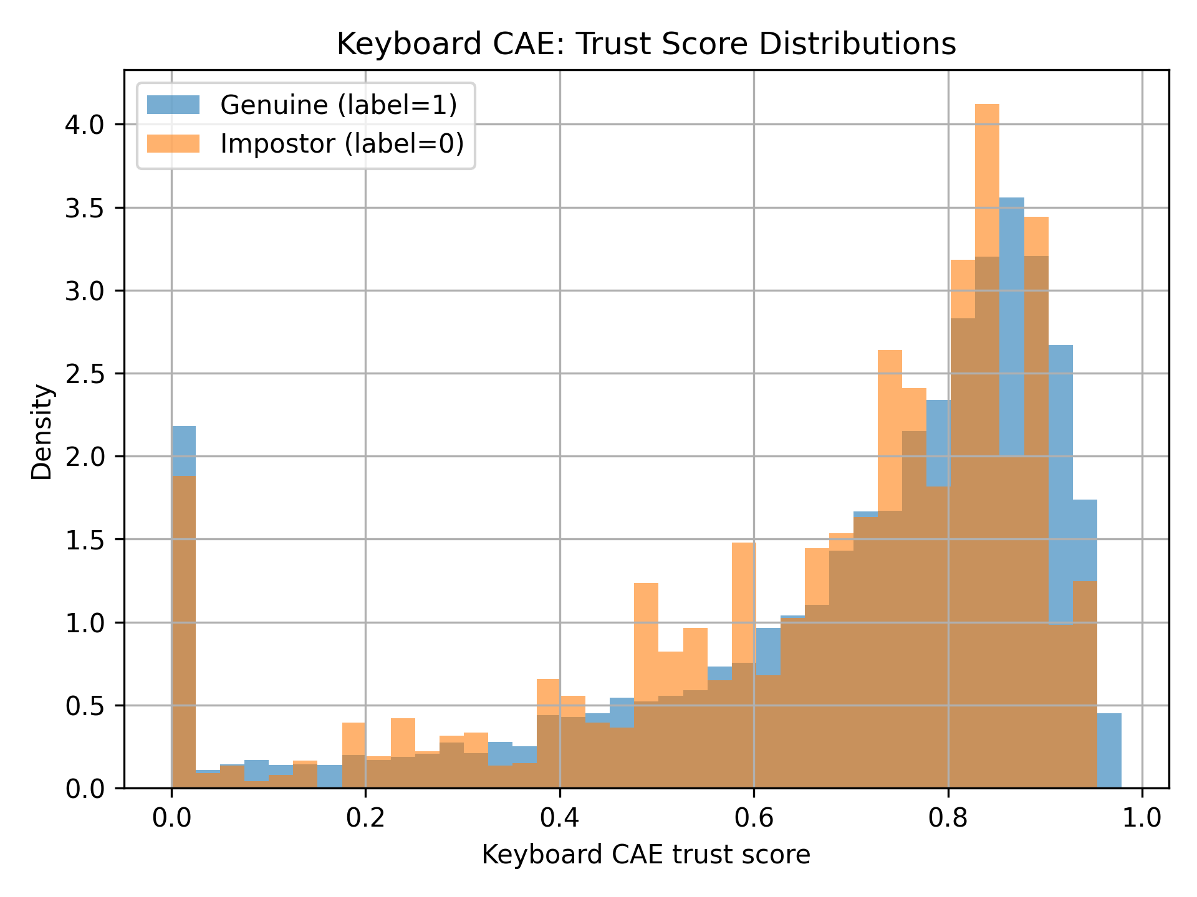
Figure 4.1 CAE trust histograms from /artifacts/plots/kb_cae_trust_histograms.png

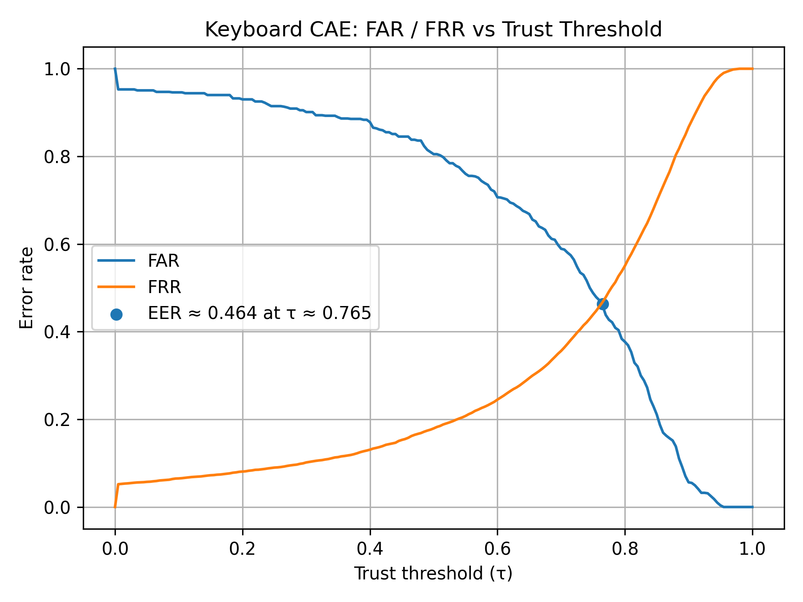
Figure 4.2 CAE FAR and FRR curve from /artifacts/plots/kb_cae_far_frr_vs_threshold.png

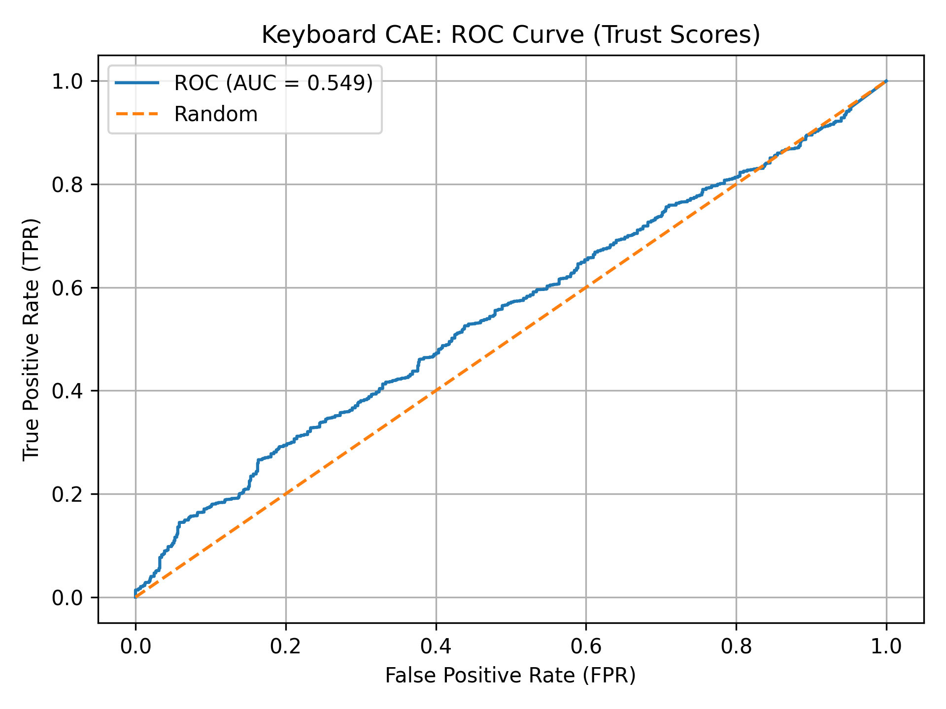
Figure 4.3 CAE ROC curve from /artifacts/plots/kb_cae_roc_curve.png
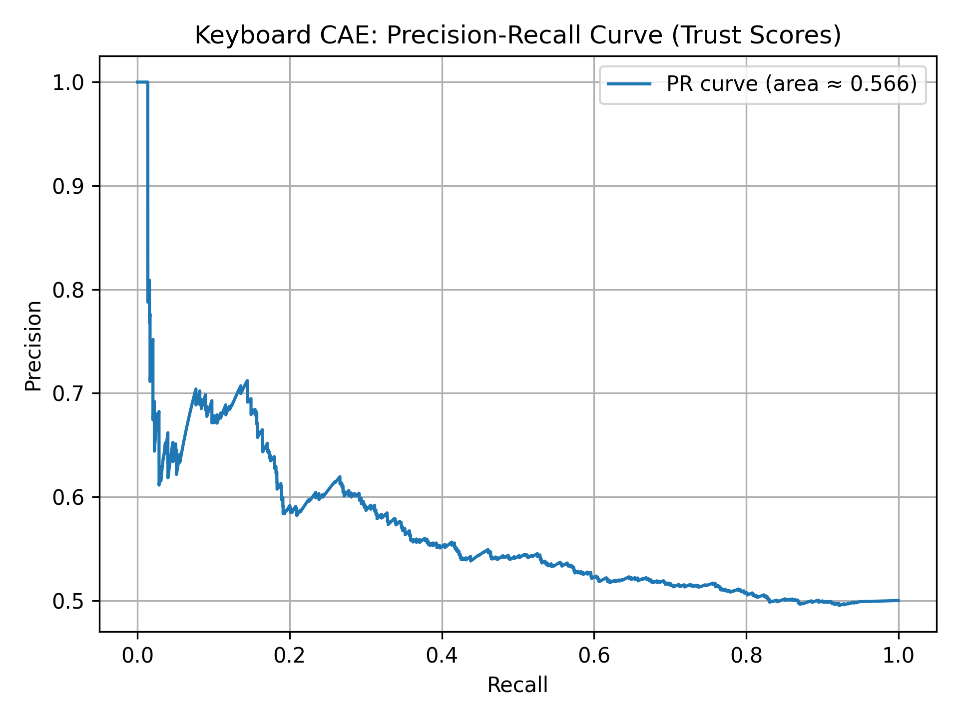
Figure 4.4 CAE PR curve from /artifacts/plots/kb_cae_pr_curve.png

4.2.2 Keyboard SVM verification and confusion metrics

The final keyboard module is the multi class SVM. I report it in two ways. First is per user FAR and FRR based on the verification style framing used in kb_svm_eval_metrics.csv. Second is the global confusion matrix metrics at the selected best F1 operating point.
Source file: /artifacts/kb_svm_eval_metrics.csv

user_id | FAR | FRR | ACC | n_genuine | n_impostor
s002 | 0.015667 | 0.8 | 0.592167 | 120 | 6000
s003 | 0.025167 | 0.3 | 0.837417 | 120 | 6000
s004 | 0.018 | 0.575 | 0.7035 | 120 | 6000
s005 | 0.006333 | 0.416667 | 0.7885 | 120 | 6000
s007 | 0.0225 | 0.716667 | 0.630417 | 120 | 6000
s008 | 0.013167 | 0.658333 | 0.66425 | 120 | 6000
s010 | 0.01 | 0.391667 | 0.799167 | 120 | 6000
s011 | 0.027667 | 0.533333 | 0.7195 | 120 | 6000
s012 | 0.012 | 0.233333 | 0.877333 | 120 | 6000
s013 | 0.017 | 0.533333 | 0.724833 | 120 | 6000
s015 | 0.015 | 0.608333 | 0.688333 | 120 | 6000
s016 | 0.001333 | 0.891667 | 0.5535 | 120 | 6000
s017 | 0.003333 | 0.066667 | 0.965 | 120 | 6000
s018 | 0.011 | 0.633333 | 0.677833 | 120 | 6000
s019 | 0.003167 | 0.208333 | 0.89425 | 120 | 6000
s020 | 0.015833 | 0.916667 | 0.53375 | 120 | 6000
s021 | 0.006833 | 0.691667 | 0.65075 | 120 | 6000
s022 | 0.001667 | 0.3 | 0.849167 | 120 | 6000
s024 | 0.006167 | 0.35 | 0.821917 | 120 | 6000
s025 | 0.003167 | 0.4 | 0.798417 | 120 | 6000
s026 | 0.012 | 0.216667 | 0.885667 | 120 | 6000
s027 | 0.006667 | 0.566667 | 0.713333 | 120 | 6000
s028 | 0.002 | 0.091667 | 0.953167 | 120 | 6000
s029 | 0.0235 | 0.725 | 0.62575 | 120 | 6000
s030 | 0.0105 | 0.3 | 0.84475 | 120 | 6000
s031 | 0.009333 | 0.825 | 0.582833 | 120 | 6000
s032 | 0.010333 | 0.941667 | 0.524 | 120 | 6000
s033 | 0.004167 | 0.483333 | 0.75625 | 120 | 6000
s034 | 0.011 | 0.758333 | 0.615333 | 120 | 6000
s035 | 0.008 | 0.766667 | 0.612667 | 120 | 6000
s036 | 0 | 0.075 | 0.9625 | 120 | 6000
s037 | 0.010167 | 0.925 | 0.532417 | 120 | 6000
s038 | 0.006167 | 0.308333 | 0.84275 | 120 | 6000
s039 | 0.0045 | 0.225 | 0.88525 | 120 | 6000
s040 | 0.004167 | 0.441667 | 0.777083 | 120 | 6000
s041 | 0.016333 | 0.383333 | 0.800167 | 120 | 6000
s042 | 0.001333 | 0.275 | 0.861833 | 120 | 6000
s043 | 0.007167 | 0.166667 | 0.913083 | 120 | 6000
s044 | 0.004667 | 0.5 | 0.747667 | 120 | 6000
s046 | 0.008167 | 0.758333 | 0.61675 | 120 | 6000
s047 | 0.007667 | 0.883333 | 0.5545 | 120 | 6000
s048 | 0.011667 | 0.591667 | 0.698333 | 120 | 6000
s049 | 0.002333 | 0.375 | 0.811333 | 120 | 6000
s050 | 0.007833 | 0.7 | 0.646083 | 120 | 6000
s051 | 0.008167 | 0.708333 | 0.64175 | 120 | 6000
s052 | 0.001167 | 0.083333 | 0.95775 | 120 | 6000
s053 | 0.013833 | 0.1 | 0.943083 | 120 | 6000
s054 | 0.0085 | 0.875 | 0.55825 | 120 | 6000
s055 | 0.038167 | 0.183333 | 0.88925 | 120 | 6000
s056 | 0.012167 | 0.958333 | 0.51475 | 120 | 6000
s057 | 0.013833 | 0.608333 | 0.688917 | 120 | 6000
Table 4.3 – Per-user keyboard SVM verification metrics

This table typically shows FAR becoming low for most users compared to CAE. That is a good sign for security. The problem shifts to FRR. Many genuine windows are rejected. This is also what I saw in the live monitor. Keyboard only decisions were too strict and kept pushing the policy into STEP UP or LOCK.
Source file: /artifacts/keyboard/kb_svm_metrics.csv

tp | fp | tn | fn | accuracy | precision | recall | f1 | far | frr
1884 | 666 | 305334 | 4236 | 0.984295 | 0.738824 | 0.307843 | 0.434602 | 0.002176 | 0.692157
Table 4.4 – Global keyboard SVM confusion-matrix metrics at best-F1 threshold
This table makes the trade off very clear. FAR is excellent. FRR is very high. Accuracy looks big because TN is huge, so accuracy is not the right headline metric here.

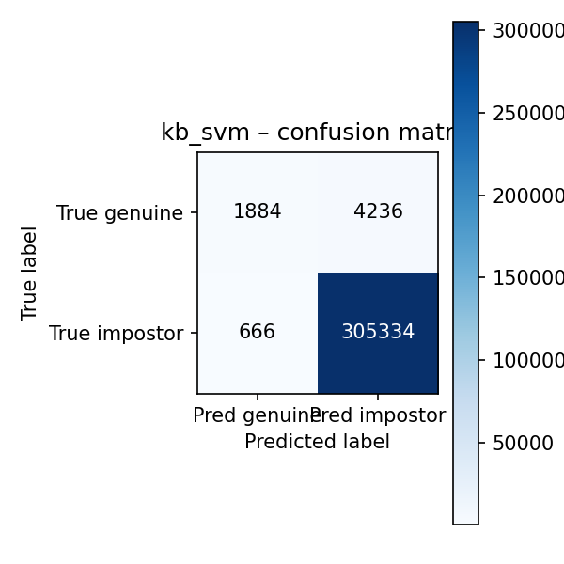
Figure 4.5 Keyboard SVM confusion matrix from /artifacts/keyboard/kb_svm_confusion.png

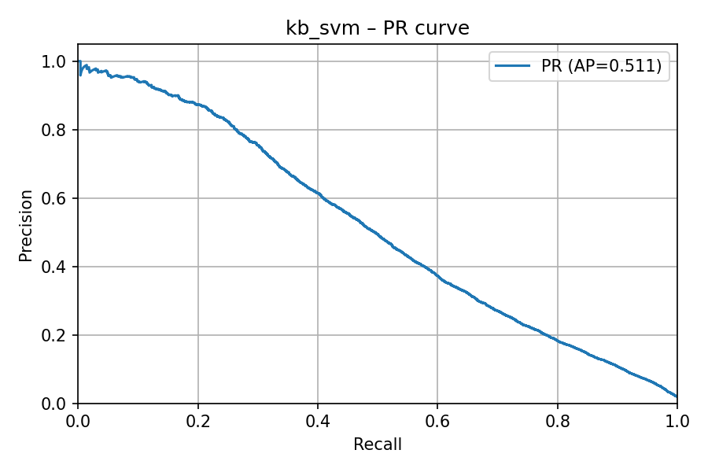
Figure 4.6 Keyboard SVM PR curve from /artifacts/keyboard/kb_svm_pr.png

4.3 Mouse model results
The mouse channel uses a single multi class SVM trained on the window features described in Chapter 3. The model is evaluated in a verification style, meaning for each user their windows are treated as genuine and the rest are treated as impostor. I kept mouse as a supporting signal because in real sessions mouse activity is not always present. Many times the user is just reading and the pointer does not move, so depending fully on mouse would be a risky decision.
user_id | FAR | FRR | ACC | n_genuine | n_impostor
user12 | 0.145965 | 0.71335 | 0.570342 | 1985 | 10249
user15 | 0.091416 | 0.779587 | 0.564498 | 1842 | 10392
user16 | 0.085712 | 0.765133 | 0.574578 | 1652 | 10582
user20 | 0.024124 | 0.828499 | 0.573688 | 793 | 11441
user21 | 0.156019 | 0.577011 | 0.633485 | 870 | 11364
user23 | 0.075263 | 0.834314 | 0.545212 | 1020 | 11214
user29 | 0.069904 | 0.700249 | 0.614924 | 804 | 11430
user35 | 0.121695 | 0.751724 | 0.563291 | 1305 | 10929
user7 | 0.029772 | 0.557348 | 0.70644 | 1116 | 11118
user9 | 0.022482 | 0.791027 | 0.593246 | 847 | 11387
Table 4.5 – Per-user mouse SVM verification metrics (FAR, FRR, accuracy)
This table is taken directly from the saved evaluation output. It is useful because mouse behaviour is not equally stable for all users. Some users show clean separation while others overlap more, usually due to similar movement patterns in remote desktop work.
TP | FP | TN | FN | Accuracy | Precision | Recall | F | FAR | FRR
25916 | 3352 | 10384 | 8524 | 0.75348 | 0.88547 | 0.75249 | 0.8135 | 0.24403 | 0.24750
For an overall picture, I also report the global confusion matrix style summary from /artifacts/mouse/mouse_svm_metrics.csv:
Table 4.6 Mouse SVM global confusion matrix metrics

These numbers are decent, especially the F1 score. Still, FAR and FRR are both around 0.25, which is not small. So mouse alone cannot be treated as a strong lock decision maker. In my case, it works better as an extra signal that can support keyboard, mainly when keyboard is borderline.
For visual evidence, I include the standard plots from the artifacts folder:
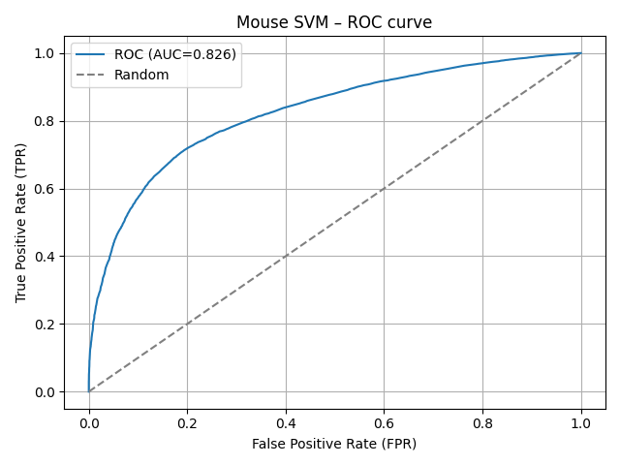
Figure 4.5 Mouse SVM ROC curve
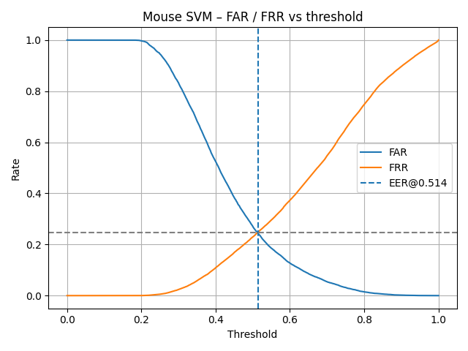
Figure 4.6 Mouse SVM FAR and FRR versus threshold, with EER point marked

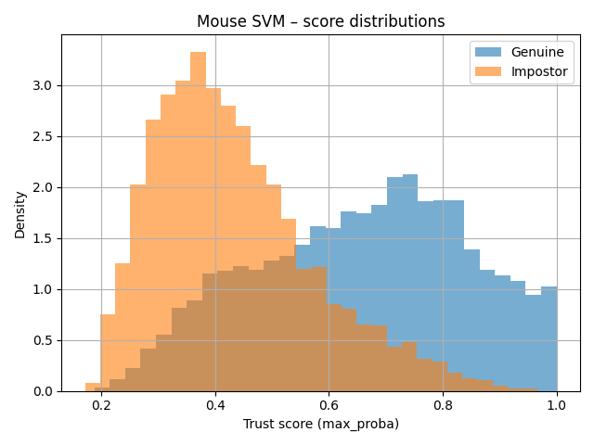
Figure 4.7 Mouse SVM score histograms for genuine and impostor windows

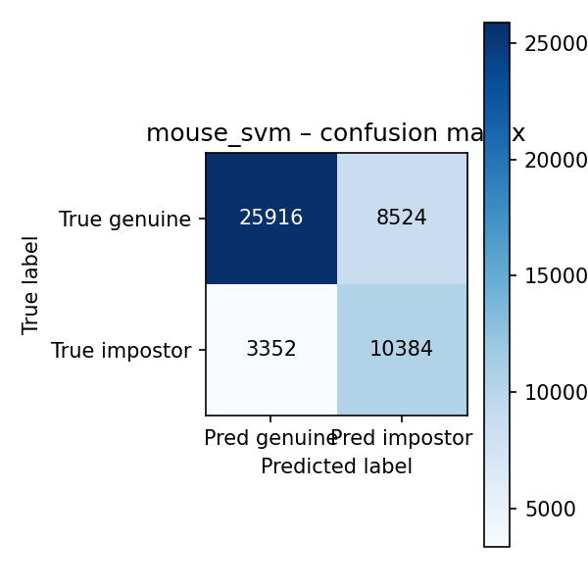
Figure 4.8 Mouse SVM confusion matrix at the chosen threshold

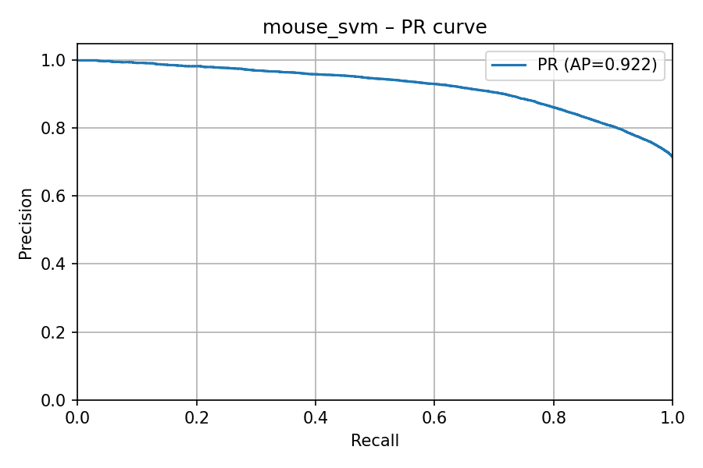

Figure 4.9 Mouse SVM precision recall curve

Together, these plots show the same story as the tables. Mouse can separate users reasonably on this dataset, but the overlap is still visible. That is why I use it to stabilise decisions, not to replace keyboard.

4.4 Behavioural fusion and behavioural + face fusion
After scoring keyboard and mouse separately, I combine them into a single behavioural trust. This fused value is what the policy uses most of the time. The aim is simple. If one stream is a bit noisy in a short window, the other stream can stop the decision from swinging.
To show how fusion behaves in practice, I summarise the logged sessions rather than only quoting formulas.
signal | mean | std | min | max
kb_trust | 0.704377 | 1.20E-11 | 0.704377 | 0.704377
mouse_trust | 0.763455 | 0.047889 | 0 | 0.766458
behavioural_trust | 0.716744 | 0.000776 | 0.704377 | 0.716793
face_trust | 0.607152 | 0.242273 | 0 | 0.886473
fused_trust | 0.71204 | 0.003723 | 0.703889 | 0.723638
Table 4.8 Summary statistics of keyboard, mouse, behavioural, face and fused trust
This table reports mean, spread, and sample counts for each trust stream based on the runtime CSV logs. It gives a quick sense of which signal is stable and which one is fluctuating.
I also include the distribution plots, because they show the trust behaviour clearly.
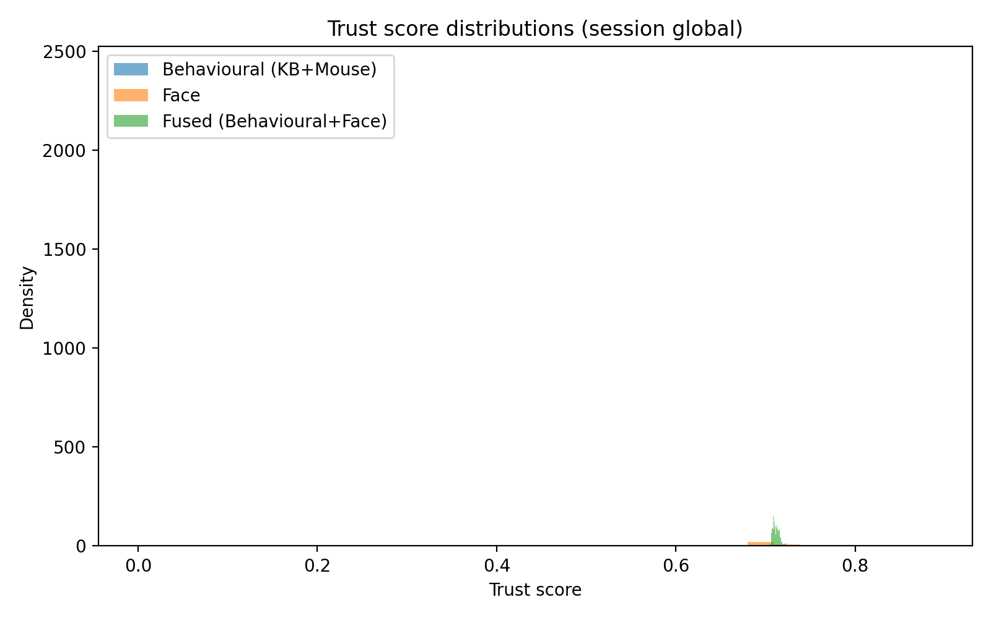
Figure 4.10 Histograms of keyboard, mouse, behavioural, face and fused trust scores
From these distributions, the behavioural trust usually sits higher and is smoother than the raw keyboard trust. Face trust is more variable, mainly because it depends on detection and liveness conditions. Because of that, face is most useful as step up support. When face is missing, the fused trust falls back to behavioural trust, so the system does not punish the user just because they moved away from the camera.

4.5 Takeover simulation result
To show takeover behaviour properly, I used a controlled dataset replay where the session starts with one enrolled user and then switches to another user mid way. This is plotted using the keyboard SVM trust, because keyboard is the most consistently available behavioural stream in my demo. The output is saved as /artifacts/realtime/takeover_sim_kb.png and the corresponding CSV is stored in the same folder.
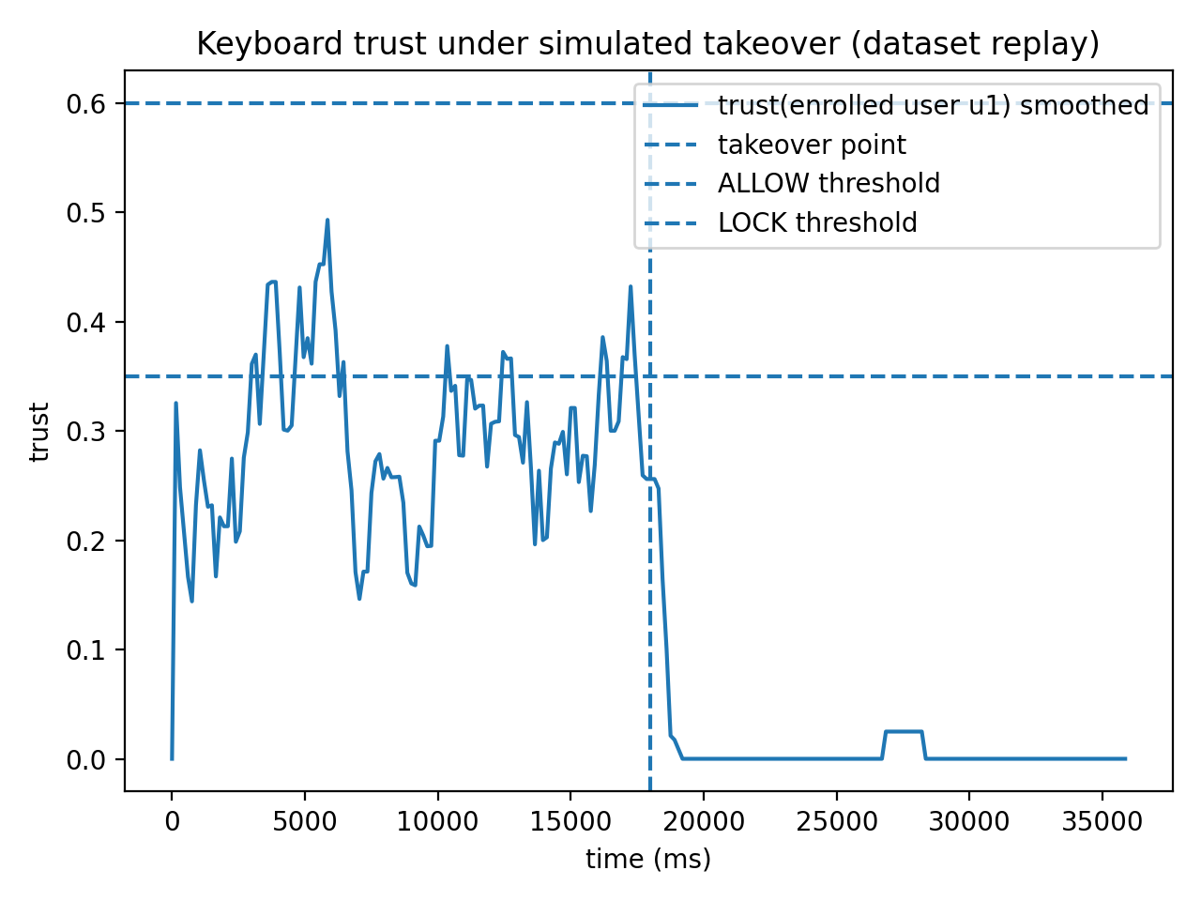
In the plot, the vertical dashed line marks the takeover point. Before this point, the trust for the enrolled user stays in a moderate band and the action mostly remains in ALLOW or STEP UP, depending on the smoothing window. Immediately after the switch, the enrolled user trust drops sharply and stays close to zero for most of the remaining duration. This is the behaviour we want. It means that when the active typist changes, the system quickly stops treating the session as genuine.

One important detail is how trust is defined in this figure. I plot trust for the enrolled user, not generic model confidence. If we plot only the max confidence, the graph can look misleading because the model may still be confident, just confident that the typist is someone else. With enrolled user trust, the takeover becomes visible as a clear drop, and the policy thresholds can be interpreted directly.

4.6 Real time prototype evidence
Along with offline metrics, I include evidence from the live Behavioural Trust Monitor because this project is about continuous scoring, not only a table of numbers. The prototype runs as a browser page that captures keystrokes and mouse movement, sends window features to the backend, and displays keyboard trust, mouse trust, behavioural trust, face trust, and the final fused action.

Figure 4.X: Keyboard trust under simulated takeover (dataset replay)
For the report, I include a screenshot of the monitor interface showing live values updating and the current policy decision. I also include the time series plot generated from Data/live_trust_timeseries.csv, saved as /artifacts/realtime/fig_trust_timeseries.png. This plot matters because it shows the system is not stuck. Trust values move with user activity and the action changes only when the smoothed score crosses thresholds.
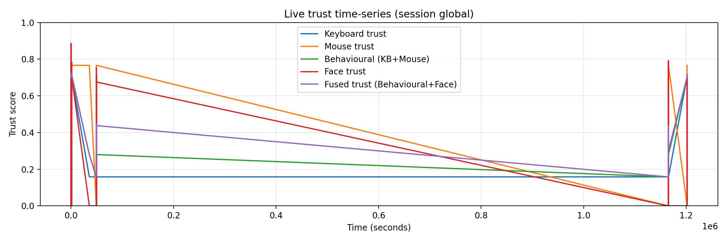
Figure 4.X: Trust score distributions for a recorded session
Finally, I include the action count bar chart H1/artifacts/realtime/fig_actions_bar.png. This helps show whether the session spent most time in ALLOW, or whether the system was too trigger happy with STEP UP and LOCK.
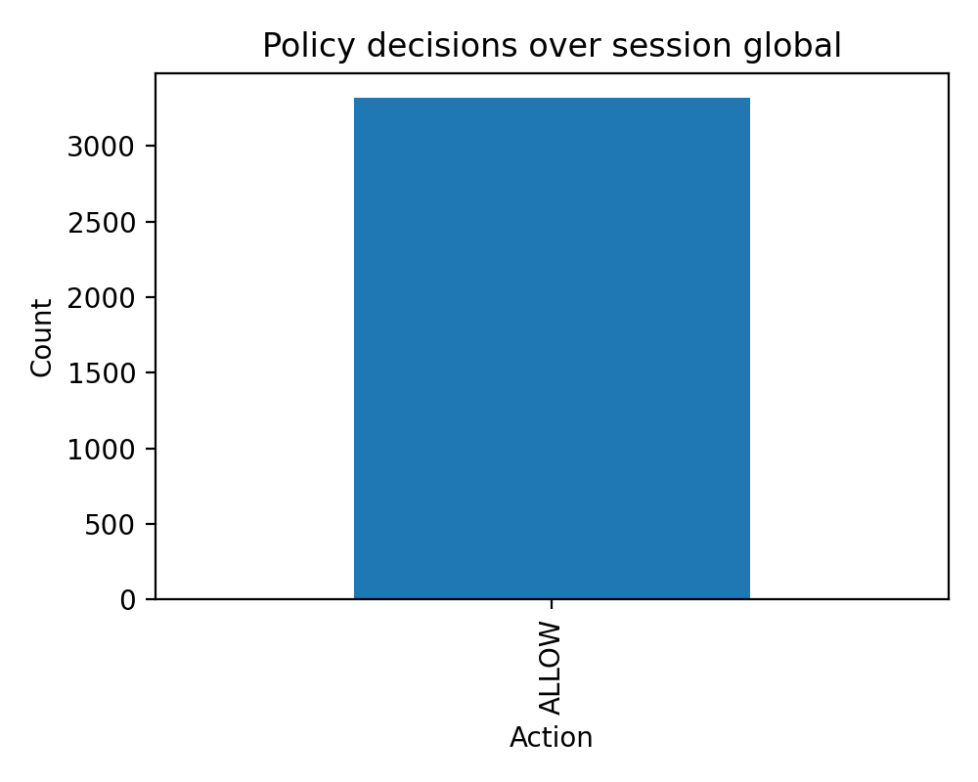
Figure 4.X: Policy decision counts over the recorded session

Chapter 5 – Discussion

5.1 Revisit objectives: what was met and what was not
If I check the objectives honestly against Chapter 4 evidence, the build objectives are mostly achieved. The system can capture keyboard and mouse behaviour in short windows, score them using saved models, and show changing trust values in the live monitor. The logging also works, so I am not just saying “it runs”, I can actually point to time series, histograms, and policy action counts as proof.
Where it is not fully met is the usability side. Keyboard SVM gives very low FAR, which is good from security angle, but FRR is high, which means genuine windows get flagged too often. That makes keyboard only decisions impractical if used aggressively. Mouse performs more balanced on the dataset, but it is not always available in real sessions and it can vary by task, so it cannot be treated as a standalone gate. The takeover simulation demonstrates that the trust can drop quickly after a user switch, but it is still a controlled replay, not a large live study. This aligns with common CA trade-offs discussed in surveys where stability and user experience become the real bottleneck (Baig and Eskeland, 2021; Ryu et al., 2021).

5.2 Keyboard: why SVM performed better than CAE here
The CAE attempt looked attractive in theory because it can be trained per user and can behave like verification. In my code, it trains on genuine windows only and then uses reconstruction residual with a user-specific threshold. The practical problem came during evaluation. Threshold tau was not stable across users. For some users, a threshold gave decent separation, but for others it either accepted too many impostor windows or rejected too many genuine ones. Once you depend on per-user tau, the whole system becomes hard to justify for real-time use, because one tuning mistake can swing FAR and FRR badly. Outlier sensitivity also matters, because one noisy window can change the residual a lot, and behavioural data is messy by nature (Ismail et al., 2024).
The SVM approach was easier to control in this project. It uses one global scaler and one consistent model trained across users. That reduces moving parts during runtime. Also, SVMs are commonly used for keystroke dynamics when features are compact, so it is not an unusual choice (ICB, 2005; Teh et al., 2013). The trade-off is visible in my results. The SVM achieves very low FAR at the chosen operating point, but FRR is high. So the model is strict. In a continuous setting, this means it can catch takeovers, but it will also annoy genuine users if thresholds are not handled carefully. This is why I treat keyboard SVM as the strongest behavioural stream, but not as a final single gate. If needed, a one-class framing could also be explored, but my implemented pipeline is multi-class identification converted into verification style reporting (Eude and Chang, 2018).

5.3 Mouse: why it is weaker alone and how it still helps in fusion
Mouse behaviour is simply more context dependent than people expect. A user scrolling a page, selecting text, or doing remote desktop work will produce very different movement patterns. On top of that, device matters a lot. Trackpad movement, high DPI mouse movement, and different screen sizes can change speed and acceleration profiles. This is a standard point in mouse dynamics literature and surveys (Khan et al., 2024). Because of this variability, mouse alone is not reliable enough to drive LOCK decisions in my project.
Still, mouse is useful in fusion for a practical reason. It provides extra evidence in cases where keyboard is noisy or when the user is not typing continuously. In my results, mouse has a more balanced FAR and FRR compared to keyboard SVM at the reported operating point. It is not perfect, but it often behaves differently from keyboard, which is exactly what you want in a multimodal setup. Clickstream based work also shows that online continuous authentication benefits from treating mouse as a stream and expecting drift, rather than assuming fixed behaviour (Almalki, Assery and Roy, 2021). Intrusion detection work using mouse dynamics supports the idea that takeover patterns can show up as changes in movement style (Antal and Egyed-Zsigmond, 2019). Recent studies also talk about data sufficiency and the accuracy versus practicality trade-off, which matches what I saw: if the session has low mouse activity, the system should not force decisions based on weak mouse evidence (Wang et al., 2025).

5.4 Mouse SVM: value and limitations
Fusion and policy are justified mainly because the single channel numbers are not good enough for a smooth continuous system. Keyboard is strict and tends to reject genuine windows. Mouse is more balanced in the dataset but is not always present in real sessions. So combining them is the sensible middle path. In my implementation, fusion is simple score level blending with fixed weights. I did not try fancy adaptive fusion because it becomes difficult to defend without a large study. Instead, I kept the logic transparent so that the report can clearly explain what the system is doing.
The three level policy also makes practical sense. If the trust is clearly high, the system should stay quiet and allow the session. If the trust is clearly low, locking is justified. The tricky part is the middle band That is why STEP UP exists. It reduces unnecessary locks, which is important because continuous authentication surveys repeatedly highlight that user irritation is a major reason such systems fail in practice (Baig and Eskeland, 2021).
Sensitivity wise, the thresholds matter a lot. A small shift in the LOCK threshold can change the number of lock events sharply, especially when trust scores cluster in a narrow band. Smoothing also changes behaviour. A longer rolling window reduces jitter but increases detection delay during takeover. In the takeover plot, the drop becomes visible within a few windows, but the action change depends on smoothing length. So, the policy works, but it needs calibration if deployed in a real setting.

5.5 Threats to validity and limitations
There are several limitations I must be open about. First is the impostor model. In evaluation, impostor windows are other users from the same dataset. That is a reasonable baseline, but it does not cover a skilled attacker who tries to mimic typing or who uses automation. So my FAR numbers should be read as dataset level impostor risk, not a full adversarial guarantee.
Second is dataset constraints. Both keyboard and mouse are built from public Kaggle datasets. They give a good starting point, but they cannot represent every keyboard type, every workstation setup, or every real work task. Behaviour drift is a known issue. A user can type differently when tired, stressed, or using a new device, which can increase FRR in practice (Teh et al., 2013).
Third is the face liveness weakness. My liveness check is basic. It can reduce obvious spoofing, but it is not evaluated against strong print or replay attacks. Anti spoofing surveys make it clear that reliable face liveness requires dedicated methods and benchmarking (Xing et al., 2025; Manoj G et al., 2022). So face in this project is only a support signal.
Finally, calibration drift is real. Trust scores are not calibrated probabilities. They depend on decision margins, scaling and chosen thresholds. If the environment changes, the trust distribution can shift and the same thresholds may become too strict or too relaxed. This is why I treat the prototype as a proof of concept and recommend threshold calibration and user adaptation as future work (Baig and Eskeland, 2021; Ryu et al., 2021).

Chapter 6 – Evaluation, Reflections, and Conclusions

6.1 Overall evaluation against the proposal plan

In my proposal, the target was a hybrid continuous authentication system where keyboard and mouse work silently in the background, and face-based evidence can support stronger checks when the behaviour looks suspicious. If I evaluate the final submission against that plan, the core idea is delivered. The system runs as a web prototype. The browser captures typing and mouse movement, converts them into short windows, and sends them to the backend. The backend loads the saved models, generates per modality trust values, fuses them, applies smoothing, and then returns a policy decision as ALLOW, STEP UP, or LOCK. Most importantly, it is not only a demo, it generates logs and plots which I can show in the report.

Still, a few things changed during implementation because the original plan was not stable enough in practice. The biggest shift was the keyboard model. I initially wanted the conditional autoencoder approach to be my main keyboard verifier. In offline evaluation, the CAE could produce separation for some users, but it was inconsistent across the full set. The per user threshold tuning became a weak point, because small changes in tau could flip FAR and FRR strongly. When I tried to keep this in the real time loop, the trust values were jittery and the policy was triggering too often. So I moved to the keyboard SVM as the main runtime scorer. The CAE stays in the project as a baseline and comparison, which is still useful academically because I can show why I did not pick it.

The second change was about how I used face. In the proposal, face was part of the multimodal design, but in the final implementation I treated it as a step-up support signal rather than a fully trained face authentication system. The reason is simple. A proper face anti spoofing setup needs datasets and evaluation that I could not complete properly in the given time. So I kept the face pipeline lightweight, used a match score and a basic liveness check, and clearly stated the limitation instead of making big claims.

Overall, the final design is slightly more conservative than the proposal, but it is stronger in one important way. It is backed by artefacts I can show. Metrics CSVs, takeover plot, live time series, histograms, and action counts make it clear what the system actually does, not only what it is supposed to do

.6.2 Reflection: what I learned and what I would do differently
This project taught me that continuous authentication is not only about choosing a fancy model. It is mainly about making the whole pipeline behave properly in real time. Training a model and getting an accuracy number is the easy part. Making the model work with missing input, noisy windows, and real user behaviour is where the real struggle is.
One strong learning was about trust scoring. Initially I used simple max probability style confidence, and it looked fine on paper, but in the live monitor the trust sometimes appeared constant or misleading. After debugging and testing, I understood that for continuous authentication I need to define trust in a way that matches the security question. The important question is whether the current operator still looks like the enrolled user. It is not just whether the model is confident about some class. That is why for keyboard I shifted to margin-based trust and for takeover plotting I used the enrolled user trust rather than generic confidence.
Another learning was that small engineering choices change the whole behaviour. Window timing, feature order, scaling, and how the client sends idle windows can break the system silently. I faced feature mismatch issues and trust values not updating and I had to fix them by keeping feature dimensions consistent, reusing the correct saved scaler and avoiding sending empty or constant vectors during idle periods. This part is not glamorous, but it is the core of why a prototype works or fails.
If I had more time, I would improve three things. First, calibration. I would select thresholds based on actual costs, not only one best point. Second, adaptation. Behaviour drifts, so it makes sense to update models or templates over time, otherwise FRR will remain high in real use. Third, face evaluation. I would either remove face completely from claims or do it properly with standard anti spoofing evaluation, because right now face helps as a support signal but it is not strong enough to claim robust spoof resistance.

6.3 Conclusion: key takeaways and future work
The main takeaway from this dissertation is that continuous authentication can act like a practical safety net for session hijacking, but only if it is treated like a risk scoring system, not like a perfect biometric lock. My keyboard SVM results show a clear trade off. FAR is very low, so it is strong on security, but FRR is high, so genuine windows can get rejected often. This means keyboard alone is not suitable for harsh locking behaviour. Mouse performs better balance on the dataset, but in real sessions mouse activity is not guaranteed, and it is strongly task dependent. So again, mouse alone is not enough.
The part that works best in a realistic sense is combining signals with a clear fusion rule and using a three-level policy. STEP UP is important because it gives the system a middle option, instead of jumping straight from allow to lock. The takeover simulation plot also supports the project goal, because it shows that when the enrolled user trust drops, the system can react quickly after the switch.
For future work, I would focus on making the system more deployable. That means threshold calibration per environment, better handling of idle periods, and context aware weighting rather than fixed weights. I would also strengthen face by using proper liveness methods and evaluation. Finally, I would run a small user study with multiple sessions per user and different devices. Without that, the system remains a solid prototype with evidence, but it cannot claim strong generalisation to real workplace conditions.

References
- Wang, X. and Hou, D. (2024) ‘Enhancing Keystroke Dynamics Authentication with Ensemble Learning and Data Resampling Techniques’, Electronics., 13(22).
Available at: https://doi.org/10.3390/electronics13224559.

- Institute of Electrical and Electronics Engineers, author (2009) ‘Comparing anomaly-detection algorithms for keystroke dynamics’, in 2009 IEEE/IFIP International Conference on Dependable Systems and Networks. pp. 3086–134.
Available at: https://doi.org/10.1109/DSN.2009.5270346.

- Khan, S. et al. (2024) ‘Mouse Dynamics Behavioral Biometrics: A Survey’, ACM computing surveys, 56(6), pp. 1–33.
Available at: https://doi.org/10.1145/3640311.

- Almalki, S., Assery, N. and Roy, K. (2021) ‘An Empirical Evaluation of Online Continuous Authentication and Anomaly Detection Using Mouse Clickstream Data Analysis’, Applied sciences, 11(13).
Available at: https://doi.org/10.3390/app11136083.

- Antal, M. and Egyed‐Zsigmond, E. (2019) ‘Intrusion detection using mouse dynamics’, IET biometrics, 8(5), pp. 285–294.
Available at: https://doi.org/10.1049/iet-bmt.2018.5126.

- Teh, P.S. et al. (2013) ‘A Survey of Keystroke Dynamics Biometrics’, TheScientificWorld., 2013(1).
Available at: https://doi.org/10.1155/2013/408280 .

- Shanmugapriya, D. and Padmavathi, G., 2009. A survey of biometric keystroke dynamics: Approaches, security and challenges. arXiv preprint arXiv:0910.0817. Available at: https://doi.org/10.48550/arXiv.0910.0817

- Shrivastava, A. and Bollavarapu, S. (2025) Exploring Keystroke Dynamics: Enhancing Authentication Through Typing Patterns. Atlantis Press International BV, pp. 3127–3140.
Available at: https://doi.org/10.2991/978-94-6463-858-5_261.

- Xiaofeng, L., Shengfei, Z. and Shengwei, Y. (2019) ‘Continuous authentication by free-text keystroke based on CNN plus RNN’, Procedia computer science., 147, pp. 314–318.
Available at: https://doi.org/10.1016/j.procs.2019.01.270.

- Li, J., Chang, H.-C. and Stamp, M. (2022) Free-Text Keystroke Dynamics for User Authentication. Springer International Publishing, pp. 357–380.
Available at: https://doi.org/10.1007/978-3-030-97087-1_15.

- IEEE Conference on Biometrics: Theory, A. (2016) ‘User authentication with keystroke dynamics in long-text data’, in BTAS : 2016 IEEE 8th International Conference on Biometrics Theory, Applications and Systems : 6-9 September 2016. New York : IEEE, pp. 1396–6.
Available at: https://doi.org/10.1109/BTAS.2016.7791182.

- Alsultan, A., Warwick, K. and Wei, H. (2017) ‘Non-conventional keystroke dynamics for user authentication’, Pattern recognition letters., 89, pp. 53–59.
Available at: https://doi.org/10.1016/j.patrec.2017.02.010.

- ICB Hong Kong, C.( : and ICB (Conference) Corporate Author (2005) GA SVM Wrapper Ensemble for Keystroke Dynamics Authentication, Advances in biometrics : International Conference, ICB 2006, Hong Kong, China, January 5-7, 2006 : proceedings /. Berlin : Springer, pp. 654–660.
Available at: https://doi.org/10.1007/11608288_87.

- G Ismail, M. et al. (2024) ‘Outlier detection for keystroke biometric user authentication’, PeerJ., 10.
Available at: https://doi.org/10.7717/peerj-cs.2086.

- Eude, T. and Chang, C. (2018) ‘One‐class SVM for biometric authentication by keystroke dynamics for remote evaluation’, Computational intelligence., 34(1), pp. 145–160.
Available at: https://doi.org/10.1111/coin.12122.

- Ryu, R. et al. (2021) ‘Continuous Multimodal Biometric Authentication Schemes: A Systematic Review’, IEEE access : practical innovations, open solutions., 9, pp. 34541–34557.
Available at: https://doi.org/10.1109/ACCESS.2021.3061589.

- Baig, A.F. and Eskeland, S. (2021) ‘Security, Privacy and Usability in Continuous Authentication: A Survey’, Sensors, 21(17).
Available athttps:/doi.org/10.3390/s21175967.

- Stylios, I.C. et al. (no date) ‘A Review of Continuous Authentication Using Behavioral Biometrics’, in Proceedings of the SouthEast European Design Automation, Computer Engineering, Computer Networks and Social Media Conference. ACM, pp. 45–79.
Available at: https://doi.org/10.1145/2984393.2984403.

- Wang, Y., Wu, C., Liao, Y. and You, M., 2025. Optimizing Mouse Dynamics for User Authentication by Machine Learning: Addressing Data Sufficiency, Accuracy-Practicality Trade-off and Model Performance Challenges. arXiv preprint arXiv:2504.21415.
Available at: https://doi.org/10.48550/arXiv.2504.21415.

- Almalki, S., Assery, N. and Roy, K. (2021) ‘An Empirical Evaluation of Online Continuous Authentication and Anomaly Detection Using Mouse Clickstream Data Analysis’, Applied sciences, 11(13).
Available at: https://doi.org/10.3390/app11136083.

- Ketab, S.S., Clarke, N.L. and Dowland, P.S., 2017. A robust e-invigilation system employing multimodal biometric authentication. International Journal of Information and Education Technology, 7(11), p.796.
Available at: https://doi.org/10.18178/ijiet.2017.7.11.975

- S, A. and K, J.S. (2025) ‘Enhancing security and usability with context aware multi-biometric fusion for continuous user authentication’, Scientific reports., 15(1).
Available at: https://doi.org/10.1038/s41598-025-14833-z.

- Martín, A.G. et al. (2022) ‘Combining user behavioural information at the feature level to enhance continuous authentication systems’, Knowledge-based systems., 244.
Available at: https://doi.org/10.1016/j.knosys.2022.108544.

- Zhang, K. et al. (2016) ‘Joint Face Detection and Alignment Using Multitask Cascaded Convolutional Networks’, IEEE signal processing letters., 23(10), pp. 1499–1503. Available at: https://doi.org/10.1109/LSP.2016.2603342.

- Manoj G et al. (2022) ‘A Survey on Anti-Spoofing Methods for Facial Recognition’, International Journal of Scientific Research in Computer Science, Engineering and Information Technology, pp. 259–268.
Available at: https://doi.org/10.32628/CSEIT228248.

- Xing, H. et al. (2025) ‘Face Anti-Spoofing Based on Deep Learning: A Comprehensive Survey’, Applied sciences, 15(12).
Available at: https://doi.org/10.3390/app15126891.

- Garabato, D. et al. (2022) ‘AI-based user authentication reinforcement by continuous extraction of behavioral interaction features’, Neural computing & applications., 34(14), pp. 11691–11705. Available at: https://doi.org/10.1007/s00521-022-07061-3.

Appendix A – System diagrams and UI Screenshots

A.1 System Architecture and Workflow
Overall block diagram of browser inputs, backend components, models, fusion, and decisions.
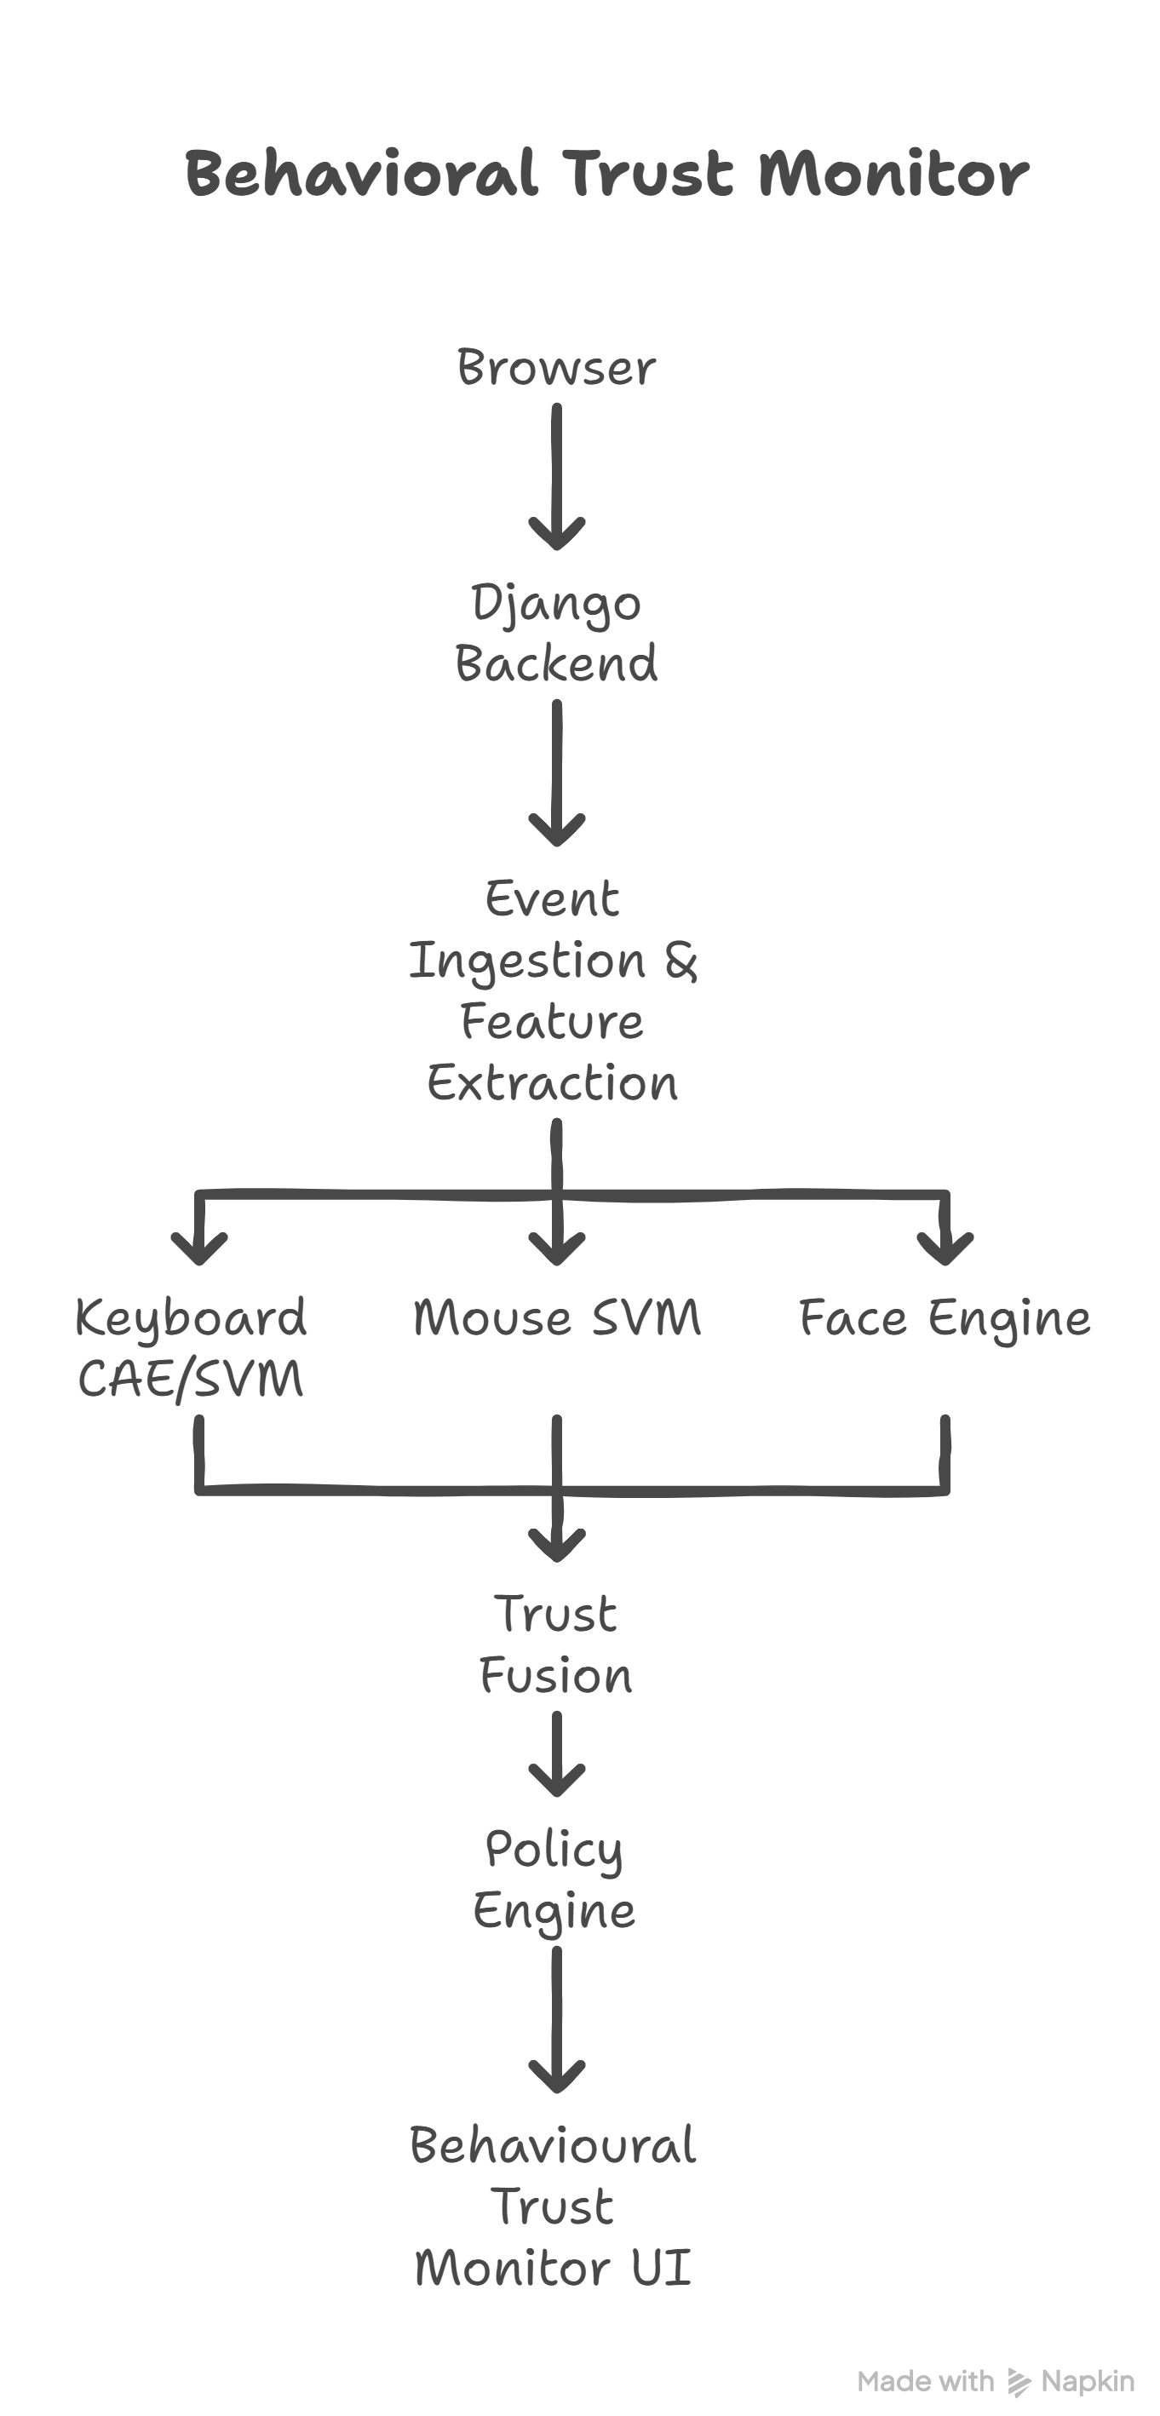
Figure A.1 – High-level System Architecture
End-to-end dataflow from raw events through preprocessing, training, online scoring and UI.

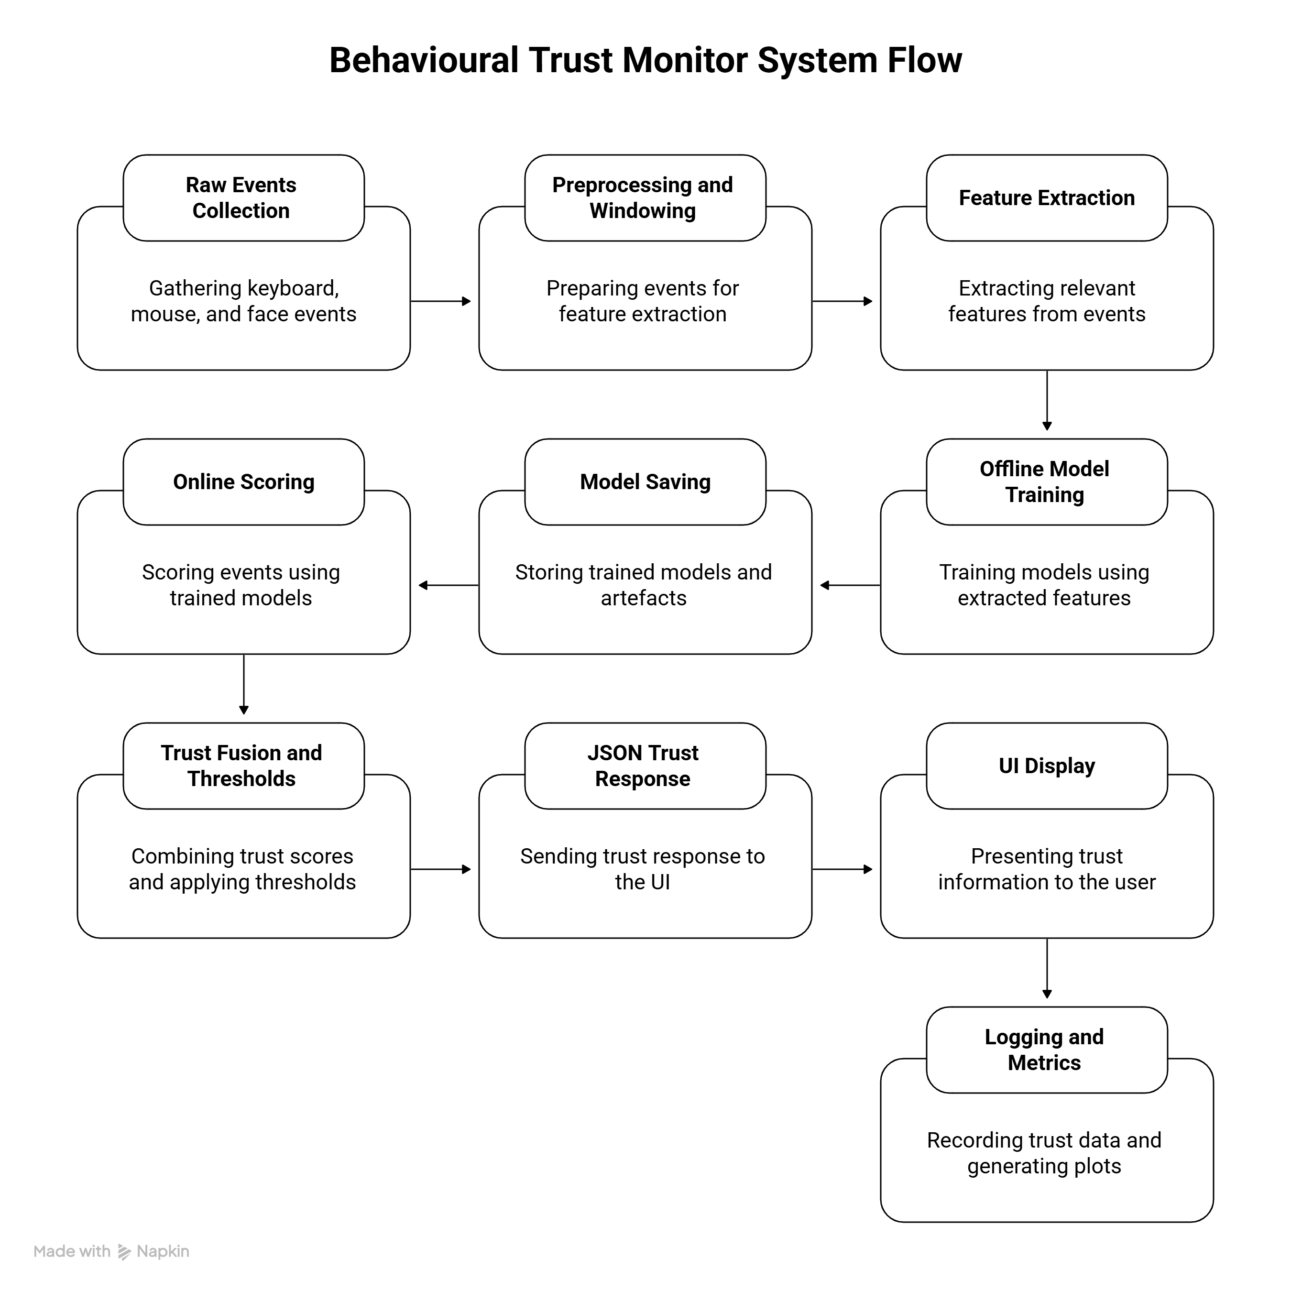
Figure A.2 – End-to-End System Workflow

A.2 Behavioural Trust Monitor UI

live monitoring page showing per-channel trust values, time-series traces and current policy state.

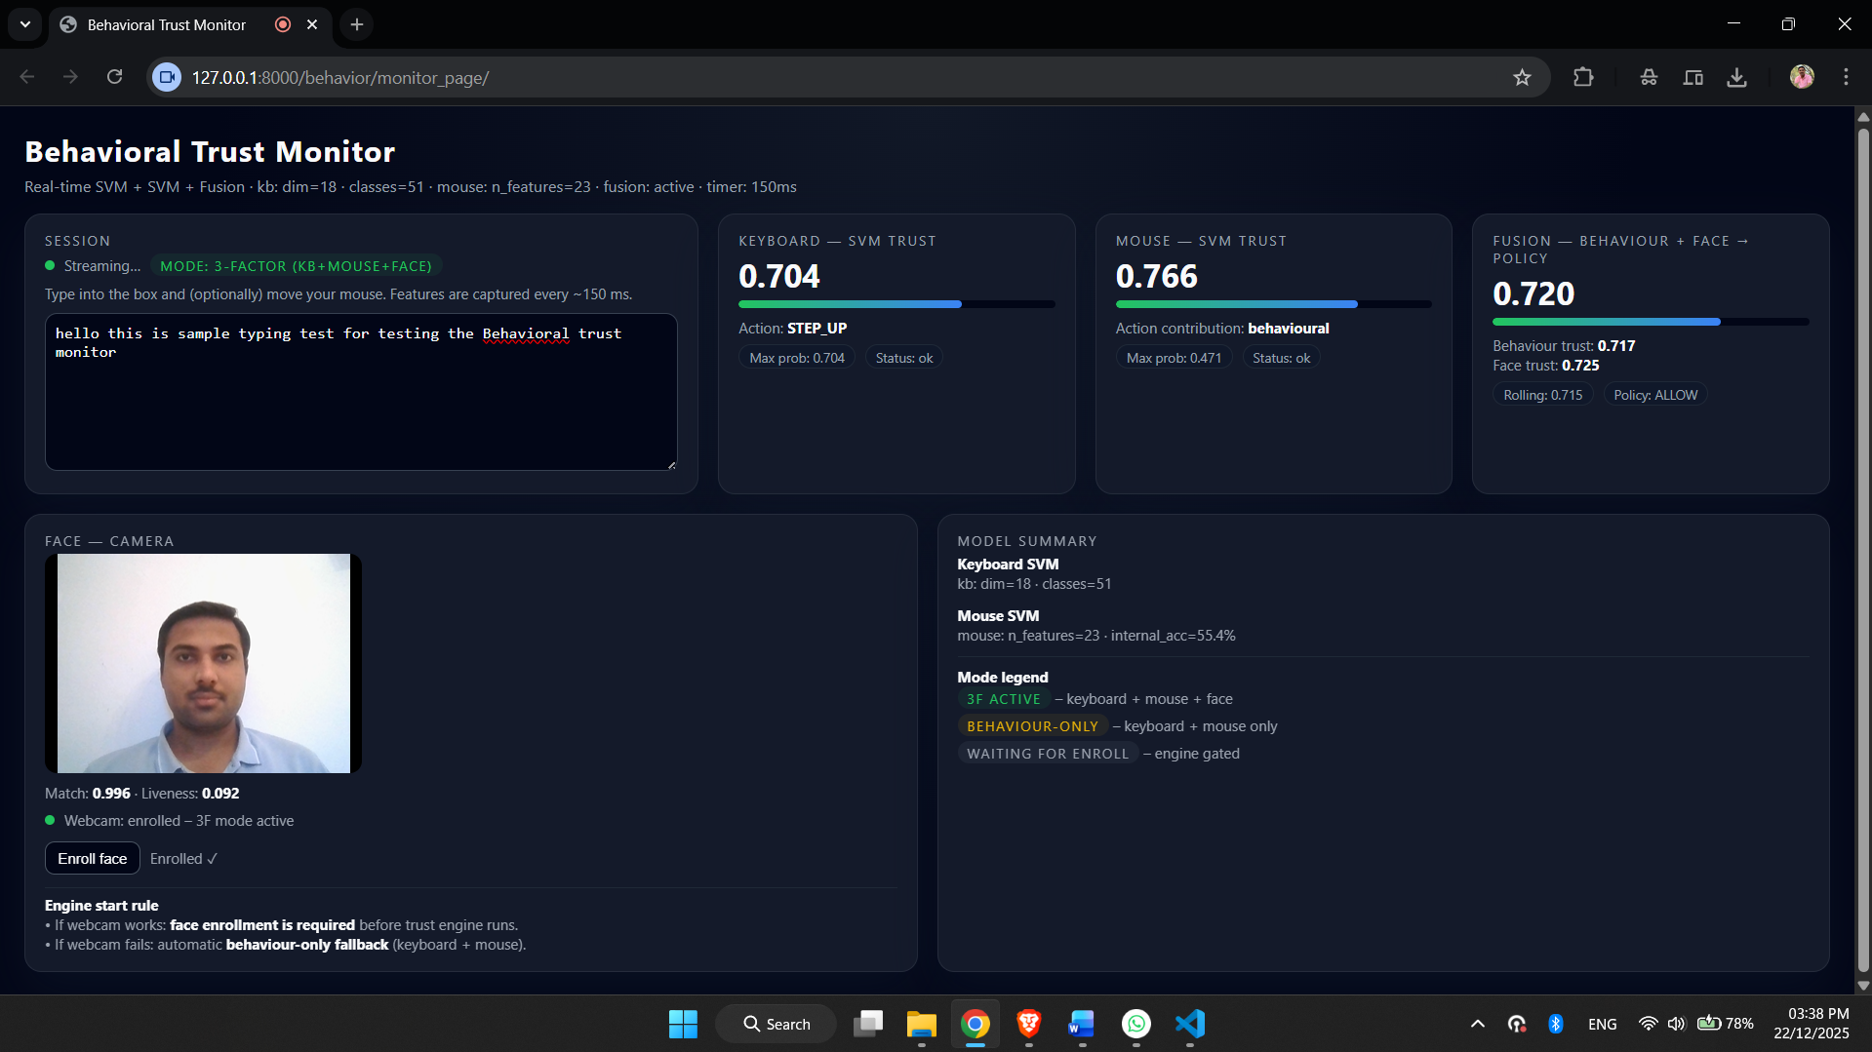
Figure A.3 – Behavioural Trust Monitor user interface

Appendix B Definitions

B.1 Keyboard feature vector (18 features, fixed order)
Source of feature order: matches Data/kb_cmu_windows.csv and keyboard model schema.
Non-feature columns in the CMU window file: user_id, session_id, window_id.
Units note: In kb_cmu_windows.csv, timing features come from the CMU-style dataset columns and are treated as numeric timings. In the live browser, timings are built from timestamps and then converted into the same 18D layout.
Feature list and definition:
- dwell_mean: mean of key hold times (keydown to keyup)
- dwell_std: standard deviation of hold times
- dwell_p10: 10th percentile of hold times
- dwell_p50: median of hold times
- dwell_p90: 90th percentile of hold times
- dd_mean: mean of down-down gaps (time between consecutive keydown events)
- dd_std: standard deviation of down-down gaps
- dd_p10: 10th percentile of down-down gaps
- dd_p50: median of down-down gaps
- dd_p90: 90th percentile of down-down gaps
- ud_mean: mean of up-down gaps (keyup to next keydown)
- ud_std: standard deviation of up-down gaps
- ud_p10: 10th percentile of up-down gaps
- ud_p50: median of up-down gaps
- ud_p90: 90th percentile of up-down gaps
- backspace_rate: fraction of keys that are Backspace within the window
- burst_mean: average burst run-length based on short DD gaps (DD < 0.150s treated as within-burst)
- idle_frac: fraction of large gaps based on UD (UD > 1.0s treated as idle-like)

B.2 Mouse feature vector (23 features, fixed order)
Source of feature order: /Models/mouse/mouse_meta.json under key features.
Raw input: mouse session points with columns (time ms, x, y).
Core computation: based on Apps/behavior/mouse_ingest.py kinematics.
- dur_ms: duration of the window in milliseconds (t_last - t_first)
- n_points: number of points in the window
- path_len: sum of Euclidean distances between consecutive points
- straight_len: straight-line distance from first point to last point
- straightness: straight_len / path_len (0 if path_len is ~0)
- mean_speed: mean speed over segments (distance / dt)
- p95_speed: 95th percentile of speed
- max_speed: maximum speed
- mean_acc: mean acceleration (delta speed / dt)
- p95_acc: 95th percentile of acceleration
- max_acc: maximum acceleration
- mean_jerk: mean jerk (delta acceleration / dt)
- p95_jerk: 95th percentile of jerk
- max_jerk: maximum jerk
- dx: net x displacement (x_last - x_first)
- dy: net y displacement (y_last - y_first)
- abs_dx: absolute net x displacement
- abs_dy: absolute net y displacement
- bbox_w: bounding box width (max(x) - min(x))
- bbox_h: bounding box height (max(y) - min(y))
- bbox_area: bbox_w * bbox_h
- direction_changes: count of sign changes in dx and dy across segments (more zig-zag gives higher)
- pause_ratio_20ms: fraction of dt values greater than 20 ms

Appendix C Model configs, hyperparameters, and training commands

C.1 Keyboard CAE (per-user conditional autoencoder)
Code files:
- Model: /Apps/behavior/ae_conditional.py
- Training: /Apps/behavior/train_kb_cae_cmu.py
- Evaluation: /Apps/behavior/eval_kb_cae.py
Training data: /Data/kb_cmu_windows.csv (18 features, user_id label)
Preprocessing used:
- For each target user, the script fits a StandardScaler on that user’s genuine training windows only.
- The same scaler is saved and reused for that user during evaluation and runtime scoring.
Model configuration (as implemented):
- Input dimension: 18
- Encoder: Dense 64 → Dense 32 → Bottleneck Dense 16
- Decoder: Dense 32 → Dense 64 → Output Dense 18
- Regularisation: dropout (0.2) and batch normalisation in hidden layers
- Loss: mean squared reconstruction loss (MSE)
- Optimiser: Adam
- Batch size: 256
- Epochs: up to 40 with early stopping on validation loss
Outputs written:
- Per-user model + scaler saved under /Models/kb_cae/<user_id>/
- Metrics: /artifacts/kb_cae_metrics.csv
- Overview: /artifacts/kb_cae_overview.json

C.2 Keyboard SVM (global multi-class SVC)
Code file: /Apps/behavior/eval_kb_svm.py
(This script trains and evaluates the SVM and also writes the model artefacts.)
Training data: /Data/kb_cmu_windows.csv
Preprocessing used:
- Drops non-feature columns (user_id, session_id, window_id, etc.)
- Performs per-user chronological split: early windows for train, later windows for test
- Fits one global StandardScaler on training windows only
- Applies scaler to validation and test splits
Model configuration:
- Model: sklearn.svm.SVC
- Kernel: RBF
- Class balancing: class_weight="balanced"
- Hyperparameter selection: small grid search over (C, gamma) on validation split
- Final training: retrain best (C, gamma) on full training set
Evaluation outputs:
- Per-user verification style metrics: /artifacts/kb_svm_eval_metrics.csv
- Overview: /artifacts/kb_svm_eval_overview.json
- Global confusion metrics at selected operating point: /artifacts/keyboard/kb_svm_metrics.csv
Saved model artefacts:
- /Models/kb_svm/kb_svm_model.joblib
- /Models/kb_svm/kb_svm_scaler.joblib
Command:
python Apps\behavior\eval_kb_svm.py

C.3 Mouse SVM (global multi-class SVC)
Code files:
- Training: /Apps/behavior/train_mouse_svm.py
- Evaluation: /Apps/behavior/eval_mouse.py
Training data:
- /Data/mouse_windows_train_augmented.csv (primary training)
- Test: /Data/mouse_windows_test.csv (held-out evaluation)
Preprocessing used:
- Filters users with too few samples (MIN_PER_USER = 40)
- Fixed 23-feature order stored in metadata
- Fits one global StandardScaler on training windows only
- Uses an internal hold-out split (TEST_FRACTION = 0.25) during training for quick tuning
Model configuration:
- Model: sklearn.svm.SVC
- Kernel: RBF
- Class balancing: class_weight="balanced"
- Probability outputs enabled: probability=True
- Hyperparameter selection: grid over C and gamma using hold-out accuracy
- Final training: retrain best model on full training windows
Saved artefacts:
- /Models/mouse/mouse_svm.joblib
- /Models/mouse/mouse_scaler.joblib
- /Models/mouse/mouse_meta.json (feature order and user list)
Evaluation outputs:
- /artifacts/mouse/mouse_svm_metrics.csv
- Other plots under /artifacts/mouse/Plots/
Commands:
- python Apps\behavior\train_mouse_svm.py
- python Apps\behavior\eval_mouse.py

C.4 Takeover simulation generation (keyboard replay plot)

Code file: /make_takeover_plot.py
Inputs: dataset windows and saved keyboard SVM model
Outputs:
- /artifacts/realtime/takeover_sim_kb.csv
- /artifacts/realtime/takeover_sim_kb.png
Command:
- python make_takeover_plot.py

C.5 Real-time plots from session logs
Code file: /Apps/behavior/eval_realtime_plots.py
Input: /Data/live_trust_timeseries.csv
Outputs: plots under /artifacts/realtime/
Command:
python Apps\behavior\eval_realtime_plots.py

Appendix D AI Use and Code Provenance table
Component | What I wrote | What AI helped with | What I changed after AI help | Where in repo
Browser monitor UI | Event capture loops, windowing logic, throttling to avoid overlapping requests, UI trust display | Small HTML/JS phrasing suggestions and generic fetch pattern examples | Reworked window tick logic, added “skip idle window” behaviour, fixed stuck trust display by preventing zero vectors | /templates/behavior/monitor.html
Keyboard feature extraction (runtime) | Event pairing, dwell and gap extraction, feature packing into 18D vector | Generic Python/JS snippets for percentile calculation and edge case handling | Adjusted to match scaler input, ensured feature order consistency, removed constant/idle vectors | /Apps/behavior/* (runtime scoring modules)
Keyboard CAE (baseline) | Per-user training loop, scaler fitting on genuine data, model save/load | Clarified autoencoder structure and Keras boilerplate patterns | Fixed feature dimension mismatches, ensured eval script writes CSV and overview JSON | /Apps/behavior/ae_conditional.py, train_kb_cae_cmu.py, eval_kb_cae.py
Keyboard SVM training/eval | Chronological split per user, scaler fit on training only, grid search, metric export | Syntax-level help for sklearn model saving and metric formatting | Corrected FAR/FRR derivation and ensured saved scaler/model are reused in live monitor | /Apps/behavior/eval_kb_svm.py, /Models/kb_svm/
Mouse SVM training/eval | Data filtering, scaler, grid search, saving joblib artefacts, metric export | Generic sklearn patterns for SVC with probability output | Fixed feature order leakage, ensured runtime uses same scaler and meta feature list | /Apps/behavior/train_mouse_svm.py, eval_mouse.py, /Models/mouse/
Fusion + policy | Weighted trust rules, clamp rule, rolling smoothing, thresholds for actions | Help phrasing and structure of trust policy description | Tuned weights to reduce mouse noise impact, added rolling mean to reduce jitter | /Apps/behavior/trust_fusion.py, /Apps/behavior/views.py
Real-time logging and plots | CSV logging schema, takeover plot script, realtime plot script outputs for dissertation figures | Minor plotting boilerplate and matplotlib formatting tips | Added histogram zooming, ensured plots are saved to correct artifacts path | /Apps/behavior/eval_realtime_plots.py, /make_takeover_plot.py
Report writing support | Technical content, experiments, interpretation, limitations | Grammar cleanup, section ordering suggestions, removing repetition | Rewrote sections in my own style, added explicit AI use disclosure and provenance table | Dissertation + Appendix D

Table D.1 AI Use and Code Provenance

Appendix E – Code and Data Repositories

Project Source Code Repository

E.1 Project GitHub repository
URL: https://github.com/Hitesh-m-Badgujar/Continuous-Authentication-to-Detect-Session-Hijacking-in-Remote-Work-Environments.git
Main project directories for implementation, data, models and generated artefacts.

E.2 CMU-style keystroke dynamics dataset (Kaggle)
URL: https://www.kaggle.com/datasets/carnegiecylab/keystroke-dynamics-benchmark-data-set

E.3 BALABIT remote desktop / mouse dynamics dataset (Kaggle)
URL: https://www.kaggle.com/datasets/gvkrishnakireeti/balabit-dataset

