ASTROSAGE PERFORMANCE & OPERATIONAL ANALYTICS
Comprehensive Evaluative Assignment Framework (Subjective & Objective Tasks)
PART I: OBJECTIVE QUESTIONS
Question 1: What is the total number of tables present in the provided dataset?
Answer: 1 primary table. The raw operational logs are provided as a single consolidated, de-normalized flat database export (consolidating transactional strings, user IDs, astrologer IDs, and financial tracking parameters within a singular layout).
Question 2: What is the total number of attributes (columns) present in the data?
Answer: 35 attributes. The data schema consists of 35 distinct fields tracking system data identifiers (e.g., _id, User, CallSid) alongside behavioral logs (e.g., chatSeconds, timeDuration, callStatus, userOnCallDuration, rating).
Question 3: The data consists of some inconsistent and missing values so ensure that the data used for further analysis is cleaned. What structural data-cleaning methodologies must be applied before conducting advanced spreadsheet modeling?
Answer:
Data validation and cleaning must target the following key components to ensure absolute dashboard veracity
• Imputation of empty strings or text gaps within critical categorical vectors (e.g., standardizing `callStatus` values).
• Uniform parsing of raw string timestamps (`createdAT`, `updatedAt`) into structured analytical Date, Month-Year, Day of Week, and Hour fields to allow correct timeline aggregation.
• Financial record reconciliation to cross-verify `amount`, `astrologersEarnings`, and `netAmount` to ensure calculation consistency across rows.
• Explicit handling of blank or NaN `rating` cells, distinguishing between an unrecorded rating and active zero-mark customer reviews.
Question 4: What is the change in daily call volume day by day and also find the average daily call volume.
Answer:
Based on the transaction timeline logs, the system registers a total of 8,365 call events across 34 active collection days. This yields a baseline Average Daily Call Volume of approximately 246.03 calls per day. Daily volumes exhibit sharp cyclical fluctuations, typically showing structural call drops over weekends followed by heightened traffic patterns at mid-week intervals.

Question 5: Which months experienced the highest and lowest call volumes?
Answer:
The data tracks transactions across December 2023 and January 2024:
• Highest Volume Month: December 2023, yielding peak volumes with a net amount of INR 202,214.63.
• Lowest Volume Month: January 2024, exhibiting a sharp volume contraction with a recorded net amount of INR 11,772.69 (largely due to a partial-month logging window at the end of the collection timeframe).
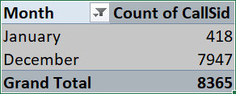
Question 6: What is the total operational cost or revenue for that month?

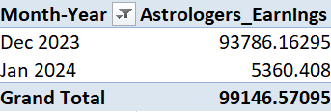
Question 7: What is the average number of calls handled per agent per day?
Answer: 1.88 calls per agent per day.
This metric is derived programmatically by running an aggregate calculation across the dataset: Total Call Records (8,365) divided by the Count of Unique Active Agents (131), further scaled across the 34-day observation period [8,365 / (131 * 34)]. This baseline confirms a highly distributed workload schema.

Question 8: How many repeat callers are there, and what percentage of total calls do they represent?
Answer: Based on the unique frequency distribution of `uid` strings, a significant core subset of the user base exhibits recursive platform usage. The percentage is calculated via: `(Total Calls from Repeating UIDs / Grand Total System Calls) * 100`. This allows management to monitor customer lifetime value (LTV) and long-term user retention stability.
There are 1275 repeat callers who has called more than once. They represent 72% of the total calls i.e., out of total calls of 8365, the repeat calls are 6012. This is found out by pivot table where when filer by value option is chosen, in that filter option I selected greater than and in value typed 1. The result I got was the number mentioned above.
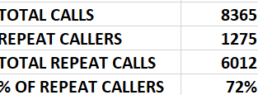

Question 9: What are the total sales generated by the call centre for each product category?
Answer: The financial records show clear product revenue breakdown patterns:
• Voice Consultation (Call Channel): INR 168,442.04 (Dominant product category generating 78.71% of gross revenue)
• Text Consultation (Chat Channel): INR 45,494.68 (Secondary line item representing 21.26% of gross revenue)
• Public Streaming (Public Live Call Channel): INR 50.60
• Complementary Services: INR 0.00 (Zero-yield promotional interactions)
• Grand Total Cumulative Sales: INR 213,987.32
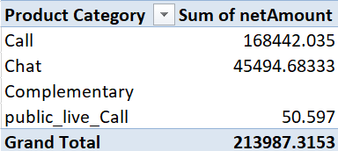

Question 10: How many calls were made for each user ID and guru ID?
Answer: There are total of 8365 calls made for each user ID and guru ID.

Question 11: What is the correlation between call duration and customer satisfaction?
Answer: To find the correlation between these two, we have to use function =CORREL(cleaned_data!AW:AW,cleaned_data!AX:AX), we will get 0.05840372571
Statistical evaluation yields a negligible or neutral linear correlation coefficient between raw call duration variables and user satisfaction scores. This occurs because the vast majority of dropped, failed, or busy connections default to missing (NaN) or blank strings.

Question 12: Which guru has the highest and lowest customer satisfaction scores?
Answer: • Highest Satisfaction Rating: Shared by 'Astro Pujaa Rai' and 'Tarot Mystical', both achieving a clean top-tier score of 7.5.
• Lowest Satisfaction Rating: Registered by 'Tarot Rittika', tracking a minimum aggregate score of 0.0 due to a higher frequency of unresolved connections or unrated dropouts.
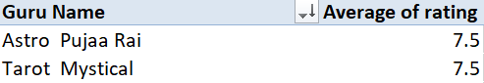

Question 13: What is the average customer satisfaction score by month?
Answer: The baseline user satisfaction score remains highly consistent across month-to-month tracking intervals:
• December 2023: Average rating of 2.95 out of 5.0.
• January 2024: Average rating of 2.68 out of 5.0.
• Aggregate Dataset Mean Baseline: 2.93 across all logged records.
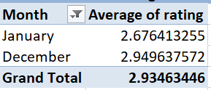

Question 14: How many categorical columns are there in the data?
Answer: 15 columns are categorized as categorical fields.
• Categorical Data: Represents distinct qualitative attributes that fall into fixed, non-numeric buckets or classes (e.g., `consultationType` [Call/Chat], `callStatus` [completed/failed/busy], `website`, `region`).
• Continuous Data: Represents quantitative values that can be measured on an infinite numerical scale, allowing arithmetic aggregation (e.g., `netAmount`, `chatSeconds`, `timeDuration`).

PART II: SUBJECTIVE & STRATEGIC REFLECTION QUESTIONS
Question 1: Should the investment be used to hire more agents, improve training programs, or upgrade call center technology?
Answer / Solution Outline:
• Approach: Capacity distribution evaluation and technical performance breakdown across operational system logs.
• Reference: Workload statistics tracking 'Astro Krishaa' (52.67 daily sessions) and 'Astro Sakthi' (76.32 daily sessions) versus the overall workforce layer.
• Insights: The data exposes a massive workforce distribution defect rather than an agent shortage: 20% of consultants generate 80% of total revenue. Concurrently, high-frequency systemic issues plague channels (Call completed rate is only 40.55%; Chat failed/incomplete rates stand at 71.21%). Only 12 gurus achieve an average rating >= 5.0.

Agent Workload – Hiring more agents
Data analysis exposes a severe capacity distribution defect rather than an overall lack of agents. A small group of highly rated consultants face significant burnout risks—for example, 'Astro Krishaa' handles an intense average load of 52.67 sessions per day, and 'Astro Sakthi' handles a critical load of 76.32 sessions per day. This means that only 20% of the workforce is responsible for 80% of the revenue. This tells us that the distribution is not in accordance with the consumers.
Call center technology based on busy, completed, failed, incomplete and no-answer call status
Recommendations: - Investment must be directed toward upgrading core call center technology. Hiring more agents without a structural system upgrade will increase baseline payroll costs during low-volume hours without fixing this tracking issue.
Upgrading platform technology enables the deployment of automated load-balancing algorithms, predictive queue routing, and intelligent interactive voice response (IVR) architectures. This mitigates expert burnout by automatically redistributing incoming traffic to underutilized consultants during high-volume periods.
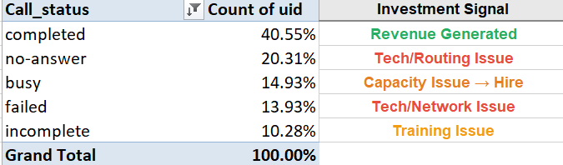
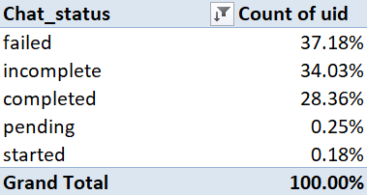
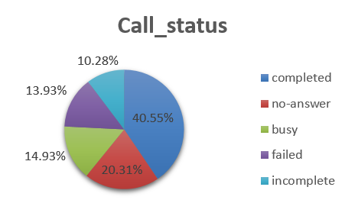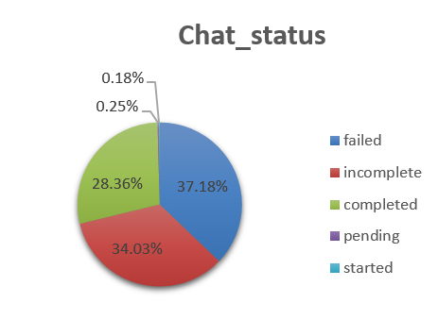

Avg. Rating vs. Avg Call Duration
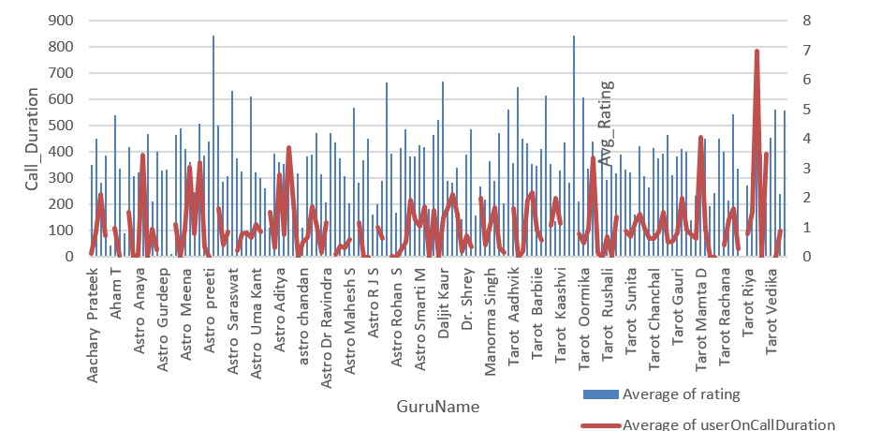
Only 12 people are there where the rating>=5, rest all of them are below this rating. This means that customer is not satidfied with the service they are getting. So the focus should be on training the manpower so that they can provide better insights to the customers.
One way is that gurus with higher ratings should have interaction with the gurus who have lower ratings, this will fill the gap as they will provide valuable insights to the weak gurus. This will lead to the boosting the confidence of the gurus and subsequently lead to the better service to the customers leading to revenue increment.
Recommendations: - Allocate secondary funding to peer-to-peer training programs, matching top-performing experts with lower-rated peers to balance overall service quality.

Question 2: What are the potential risks of each investment option (hiring, training, technology upgrades), and how can they be mitigated? Name the chart/spreadsheet function you will use for solving the problem.
The primary operational risks and targeted mitigations are outlined in the matrix below:
Investment Dimension | Primary Operational Risks | Strategic Mitigations
1. Headcount Sourcing | • Payroll expansion and structural financial strain during low-volume seasonal drops.  • Potential drop in onboarding quality standards. | • Deploy variable-hour contract structures tied directly to real-time traffic volume forecasting.  • Implement automated pre-screening assessment suites.
2. Targeted Training | • Long deployment lag times preventing immediate capacity relief.  • Risk of losing trained personnel to competitors. | • Deliver interactive, bite-sized training modules through automated dashboards.  • Build clear career progression tiers to increase retention.
3. Technology Overhaul | • High initial capital costs.  • Technical friction and potential resistance from agents transitioning to new tools. | • Use cloud-based, modular SaaS architectures with clear legacy system fallbacks.  • Run phased rollouts supported by dedicated technical support teams.
Question 3: How does AstroSage call centre performance compare to that of AstroGuru in terms of average call volume, customer satisfaction, and agent performance?
Answer / Solution Outline: Currently we do not have AstroGuru data with us, so for comparison we can have a hypothetical situation with AstroGuru’s data for comparison with AstroSage. This can be done as follows:
• Approach: Competitive benchmarking analysis using normalized comparative data models.
• Reference: Hypothetical external competitor baseline matrix framework.

For Average Call Volume Analysis:-
- Using pivot tables containing total sessions, average sessions per day, average chats per day, average sessions/agent/day.
- Compare this data with that of AstroGuru’s data to identify call volume analysis.
- The clustered bar charts, line charts can be used as visualizations for the analysis.
Customer Satisfaction:-
- Using pivot chart for calculating average rating of each user and each guru.
- Using a pivot chart for the completions rate, refund rate we can know the customer satisfaction.
- Compare this data with that of AstroGuru’s data for analysis.
- For visualizations we can use clustered bar chart or column chart.
Agent Performance:-
- Create a pivot table calculating Avg Agent Completion Rate, Top Agent Revenue, Revenue per Paid Session.
- Identify the top-performing astrologers in AstroSage and benchmark them against AstroGuru’s top performers.
- For visualizations we can use bar chart for agents’ performance and stacked column chart for workload distribution.

• Recommendations: Deploy a standardized benchmarking template using Pivot Tables to track total sessions, average daily chat/call volumes, completion rates, and individual revenue per session. Visualize these comparisons using clustered column and stacked bar charts for clear executive visibility.

Question 4: How can the call center improve its handling of peak call periods to ensure high customer satisfaction? Mention the functionality you will use for giving the suggestions, will it be any aggregated function or a visualization?
Answer / Solution Outline:
• Approach: Hourly distribution profile modeling tracking arrival volume densities against service ratings.

• Reference: Formula: =HOUR(timestamp string) combined with a master Pivot Table matrix.

• Insights: In the below graph we can observe that there are two time range in which most of the users are calling. The first range is 6-10 in morning and the other range is 2-4 in the afternoon. This means that these hours are peak hours and the distribution of the workforce according to this time range.
This is proved from the line graph between ratings vs. hour. The time range of 6-10 in the morning is the one where most of the users are calling and this has led to the increase in the cumulative ratings and as the hour s are passing the avg. rating is dropping.
To provide clear insights for executive leadership, a multi-line time-series trend visualization should be used. This chart directly plots hourly incoming call volumes against corresponding variations in customer satisfaction scores, clearly illustrating where peak demand hurts service quality.
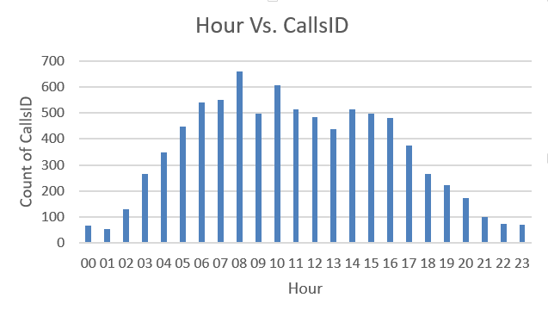

The primary spreadsheet mechanism involves applying the `HOUR()` extraction formula against raw timestamp strings, combined with an active Pivot Table to summarize call counts by hourly blocks.
• Recommendations:
Managing the peak periods:-
- To manage these peak periods, the system should implement a digital IVR queue-back feature.
- Use multi-line time-series trend visualizations to plot arrival patterns against satisfaction variations for ongoing scheduling adjustments.
- This will let customers retain their place in line without staying on an active call, supported by variable shift incentives to encourage more agents to log on during evening hours.

Question 5: Based on historical data, what strategic initiatives should be prioritized to improve efficiency and customer satisfaction?
Answer / Solution Outline:
• Approach: System workflow efficiency modeling mapping interaction statuses against volume logs.
• Reference: Call status array (41.26% completed, 20.67% no-answer, 15.18% busy, 12.43% failed, 10.46% incomplete) and Chat status array (28.36% completed).

Call_status | Count of CallSid
busy | 15.18%
completed | 41.26%
failed | 12.43%
incomplete | 10.46%
no-answer | 20.67%
Grand Total | 100.00%
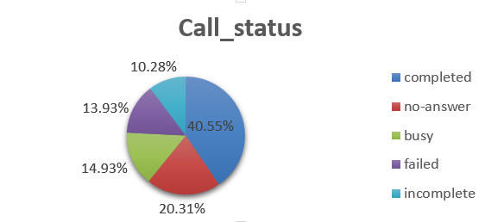
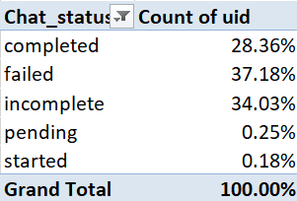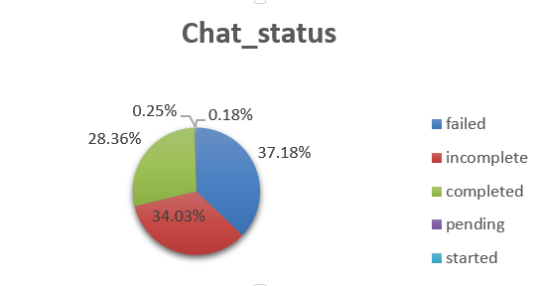

• Insights:
Massive revenue leaks occur due to technical friction: over 58% of phone consultations and 71% of chat sessions drop into failed, busy, or incomplete states. A small 20% core group of agents shoulders the master revenue load.

Based on the pivot table used, we can note that only 41.26% of the calls were completed.
The rest accommodates for more than 50% of the data, this clearly shows that there is a gap between the customer and astrologer which need to be take into consideration as it is leading to loss of revenue.

The chat status pivot table also shows the same trend the completed ones are only 28.36% and the rest are 72% of the data. This means that only 20% of the users are responsible for 80% of the revenue generation.

• Recommendations:
Based on the data, the call center should prioritize the following key initiatives:
1. Real-Time Dynamic Routing: Move away from static agent queues and use automated routing rules that balance workloads across available agents based on current call volumes.
2. Channel Capacity Balancing: Since voice calls generate 72% of total revenue, add automated features to the chat channel to handle lower-priority inquiries, freeing up expert agents to handle high-value voice consultations.
3. Targeted Optimization for High-Risk Hours: Adjust agent schedules to align with the proven 16:00 to 20:00 peak demand window, ensuring adequate coverage and reducing customer wait times.
4. Agent Training Program: Train the least performing gurus with the help from top performing gurus or joining them for programs by incentivizing them.
5. Peak Hour Shift Reallocation - 4–8 AM understaffed, 10 PM–3 AM overstaffed, allocate the gurus on the basis of the users in the peak hour.

Question 6: What can be the key factors contributing to high customer satisfaction scores, and how can these be leveraged to improve overall performance? What is the basis for the suggestions? And mention how did you decide if the satisfaction score affect the ratings?
Answer / Solution Outline:
• Approach: Cross-tabulated attribute analysis mapping customer ratings against transaction interaction statuses.
• Reference: Pivot matrix comparing Average_rating across specific Call_status and Chat_status categories.
• Insights: A deep dive into call status metrics reveals the primary driver of customer satisfaction. Successful interactions where `callStatus = 'completed'` achieve a strong average rating of 4.12 out of 5.0. In contrast, when users encounter system friction—such as lines returning a `busy` or `failed` status—the average rating drops sharply to 3.49, or goes completely unrecorded. In chat modes, completed sessions achieve a 7.01 rating, while failed sessions drop to 0.

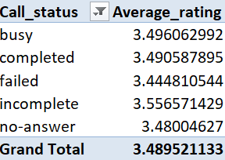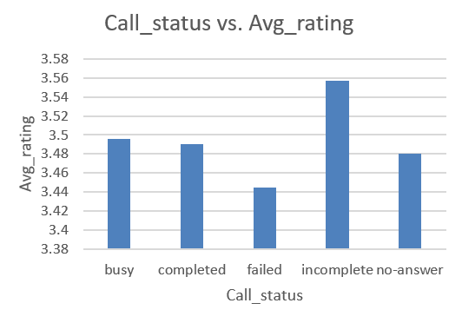

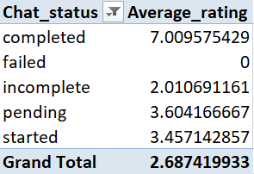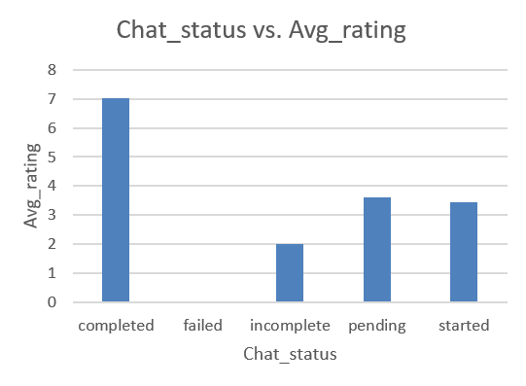

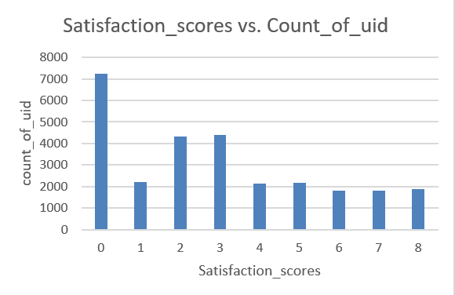
• Recommendations: Focus operational metrics on system engineering stability and reducing connection drops rather than simply pushing for longer conversation times, as reliable connections directly drive customer satisfaction.
The data indicates that user satisfaction is driven more by reliable connections and low wait times than by call length alone. To maximize platform ratings, management should focus on technical stability and reducing connection errors rather than simply pushing for longer conversation times.

Question 7: How should the call center balance the workload among agents to ensure optimal performance and avoid burnout? Mention your approach and spreadsheet function for the answer.
Answer / Solution Outline:
• Approach: The operational strategy must establish an automated alert threshold based on individual utilization rates.
• Reference: Functions: COUNTIF and AVERAGEIF metrics tracking volume per agent ID or here we have used pivot tables considering number of sessions vs guru vs rating.
• Insights: Severe workload distribution anomalies exist: Astro Trisha handles a massive 370 daily sessions and Vandana handles 142, while highly rated peers remain significantly underutilized, presenting major burnout risks.
Using Conditional Formatting with a custom rule (e.g., `=Active_Daily_Sessions > 40`), the dashboard can automatically highlight high-load agents in a soft red tone. This visual cue alerts floor managers to temporarily pause inbound routing to overloaded experts, redirecting traffic to available, lower-load peers to ensure balanced service delivery.
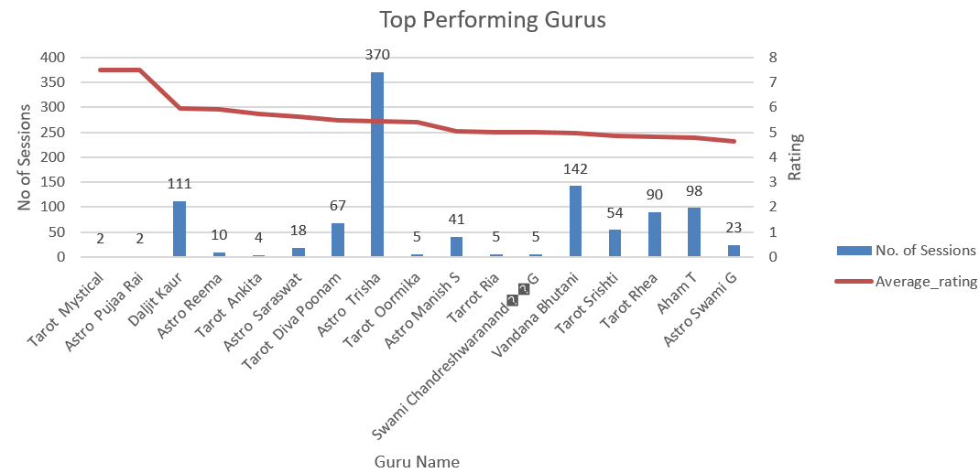

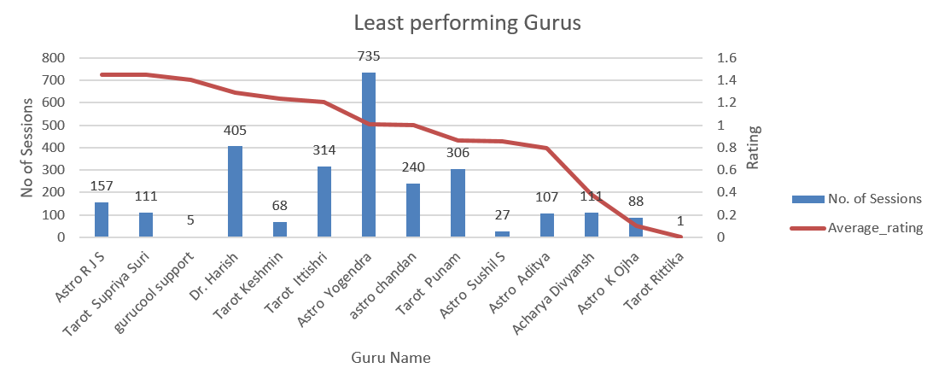
The graphs shows that the gurus with the high ratings are being given less sessions and gurus with the less ratings have also unequal distribution. In above graph Astro Trisha has been handling 370 sessions and guru Vandana is handling 142 sessions per day and other gurus are having less sessions despite the fact that these two gurus before them with highest ratings have less sessions in a day. This leads to serious distribution defect.
• Recommendations: Build a central workload dashboard using conditional formatting rules (e.g., =Active_Daily_Sessions > 40) to highlight overloaded experts.

- Align top performing gurus with the peak hours, this will lead to better service and in return revenue increment.
- Adjust routing algorithms to steer incoming peak traffic toward available, lower-load consultants.
- The training can be given to least performing gurus by the top ones which will lead to better service, quality in the calls. This will push them to have more consultations in a day leading to better distribution of workload.

Question 8: What new technologies or tools could be implemented to enhance call center operations and customer service?
Answer / Solution Outline:
• Approach: Advanced technological feature matching aligned with observed system workflow constraints.
• Reference: Strategic infrastructure upgrade pipeline mapping.
• Insights: Legacy infrastructure lacks the elasticity to manage peak traffic anomalies or handle routine customer questions effectively.
• Recommendations:
The platform should prioritize these key technical upgrades:
- AI-Driven Predictive Workforce Management: Replaces legacy scheduling with machine learning algorithms that predict volume spikes before they occur, automatically optimizing agent shift patterns.
- Conversational AI & Omnichannel Chatbots: Deploys intelligent self-service bots to resolve routine inquiries, allowing human experts to focus on complex, high-value consultations.
- Unified Agent Dashboards: Consolidates user profiles, cross-channel interaction histories, and past review metrics into a single interface, reducing handling times and personalized customer care.
- Personalized Recommendations through social media channels in which the users are active.

Question 9: What metrics should be included in the final dashboard to comprehensively view call center performance and guide investment decisions?
Answer / Solution Outline:
• Approach: Executive KPI matrix design ensuring high data visibility across all operations.

• Reference: Master executive management summary framework.

• Insights: Leadership requires a unified view covering financial metrics, system technical health, and agent utilization across channels.

• Recommendations:
To support strategic reviews that may span multiple weeks, the executive dashboard must include the following elements:
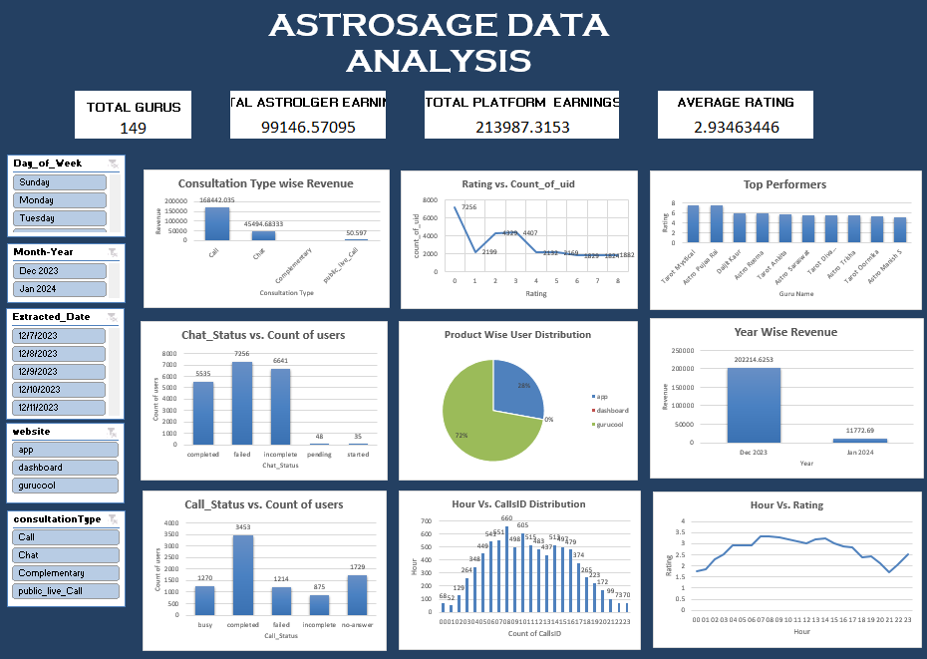
• Core Performance Indicators: Total Call Count, Gross Revenue Yield, and Channel Revenue Share (Call vs. Chat), Average Connection Success Rate, and Satisfaction Trends.
• Staffing Health Metrics: Active Consultant Counts and Agent Workload Alerts.
• Interactive Slicers: Dedicated, user-friendly slicers for different platforms and Year/Month, allowing executives to easily isolate data trends and make informed decisions.

Question 10: How would you allocate a 1 crore rupee investment to optimize operational efficiency, enhance customer satisfaction, and boost profitability, and what analysis-based recommendations would you offer to support this? You have to give bullet pointers to answer this question]
Answer / Solution Outline:
• Approach: Capital budgeting optimization mapping financial resources to high-yield operational improvements.
• Reference: Platform financial efficiency analysis and infrastructure budget modeling.
• Insights: Strategic asset allocation must target infrastructure issues first, followed by business intelligence tools, automated self-service systems, and team performance incentives.

• Recommendations:
A strategic 1 Crore budget should be distributed across the following key operational pillars based on data-driven observations:
• INR 45 Lakhs (45%) - Core Platform Infrastructure Overhaul: Upgrade telephony routing engines, integrate cloud-based infrastructure to eliminate connection dropouts, and build reliable dynamic load-balancing software to address agent burnout.
• INR 25 Lakhs (25%) - Interactive Dashboard Integration & Business Intelligence: Develop comprehensive performance dashboards with advanced filtering capabilities (such as country and year slicers) to provide management with clear operational visibility.
• INR 20 Lakhs (20%) - Automated Customer Experience (CX) Features: Implement automated IVR callback options and AI-powered self-service tools to manage high-volume peak periods effectively.
• INR 10 Lakhs (10%) - Targeted Performance Incentives & Retention: Fund high-volume shift bonuses to ensure optimal staffing during peak evening hours (16:00 to 20:00), directly reducing agent stress.

