Error Tolerant Adder Type-1 Application in Facial Recognition
O V Gnana Swathika, V S Hitesh, David Alappat.

¹School of Electrical Engineering, Vellore Institute of Technology, Chennai, India

^{2*}Centre of Smart Grid Technologies, Vellore Institute of Technology, Chennai, India

*gnanaswathika.ov@vit.ac.in

Abstract:
The deployment of deep neural networks on resource-constrained edge devices is often limited by substantial energy consumption and carry propagation delays in arithmetic hardware. To address these challenges, this paper presents an application of the Error Tolerant Adder Type-1 (ETA-1) within a software-modeled facial recognition framework. An 8-bit hybrid ETA-1 adder architecture—combining a 4-bit exact Ripple Carry Adder (RCA) for Most Significant Bits (MSBs) with a 4-bit ETA-1 approximate block for Least Significant Bits (LSBs)—is integrated into the Manhattan distance calculation phase to evaluate 512-dimensional facial feature vector similarity. Gate-level logic and algorithmic simulations demonstrate that the proposed hybrid adder reduces dynamic energy consumption per addition by 42.34% and improves critical path propagation delay by 41.38% compared to a conventional exact RCA baseline, while experiencing only a marginal 1.7% decrease in overall biometric classification accuracy (96.8% vs. 98.5%). These results confirm that approximate arithmetic adders provide a highly energy-efficient acceleration mechanism for error-resilient biometric edge applications.
Keywords:
Deep Neural Networks, Error Tolerant Type Adder type-1, Facial Recognition, Manhattan Distance, Approximate Computing, Error-Resilient System.

1.Introduction:
The rapid development of artificial intelligence has caused widespread deployment of Complex Neural Networks over hardware. But these networks demand large amount of hectic calculation which when implemented using the conventional accurate adders leads to heavy power consumption and propagation delay. This bottleneck, whereby increasing accuracy leads to greater efficiency losses has led to the introduction of approximate computing. Perfect mathematical accuracy is not necessary in fields such as neural networks which inherently possess error resilience and still can recognize patterns to a great extent. Therefore, it is a strategic move to implement approximation computing in such areas and hence achieve more gains with as little expense. Though there are a lot of approximation logic proposed recently in different areas of computation, in this paper we have used one of the most widely used approximation logic, ETA type 1, logic within our software framework. This paper then evaluates the tradeoffs and gains we achieved through its demonstration.
2.Methodology:
The incorporation of software-modeled approximate arithmetic units into the classification layer of a Convolutional Neural Network for facial recognition and evaluate the tradeoff between computational accuracy and hardware efficiency, is the core focus of this study.
The software environment made replaces standard exact accumulation units with an ETA type-1 hybrid approximation variant to compute the similarity metrics of facial embeddings. To demonstrate the working of the hybrid adder used we have made a interactive UI interface. The workflow is provided in Figure 1.
Below is a link to demonstrate the working of the ETA Type-1 in online: https://github.com/Hitesh070/My-Projects/blob/main/approximate_adder_ui.html
2.1 Simulated Hybrid Adder Architecture
The 8-bit hybrid approximate adder within the software model is divided into two parts. The first 4-bits belong to accurate part and the other to the inaccurate part.
The higher order 4 bits of operands belonging to the accurate part are processed using a conventional precise adder block. This is done to ensure that no high magnitude errors are made which can potentially lead to greater biometric irregularities. On the other hand, the lower 4-bits are processed using the hybrid adder with ETA type-1 logic. This configuration cuts the carry-propagation chain at the 4th bit, thus eliminating the critical path delay and boosting computational speed.
The final hybrid sum is mathematically expressed as:
$$Sum_{Hybrid}=\left(Sum_{MSB_Exact}×2^{4}\right)+Sum_{LSB_Approx}$$

  - System Architecture and Algorithm Implementation
The biometric verification phase has a pre-trained CNN architecture designed to map face images into a dense 512-dimensional space. The simulated 8-bit hybrid approximate adder is deployed in the final stage, preserving macroscopic accuracy. The execution pipeline is divided into three execution phases:

- Feature Extraction Phase: The system utilizes the pre-trained deep learning model to process a live facial image captured by the camera, generating an array of 512 numerical features. For every authentication attempt, the system pairs this live feature vector (L) with a reference feature vector (R) from the authorized user database.

- Approximate Distance Calculation: To determine the mathematical similarity between the two 512-dimensional arrays, the system computes the absolute difference between each corresponding feature element and continuously accumulates them to find the total Manhattan Distance (L1 Norm). This is defined mathematically as:
$$D\left(L,R\right)=\sum_{i=1}^{512}{\left|L_{i}-R_{i}\right|}$$

where i represent each index of the 512-dimensional array. This repetitive accumulation loop represents the most computationally demanding phase. Within our Python simulation environment, the standard precise addition operator (+) within this loop is entirely substituted by the proposed 8-bit hybrid ETA-1 adder function

- Classification and Thresholding: Once the approximate Manhattan distance is calculated it is evaluated against a predefined biometric verification threshold from the database. If the value falls within the threshold, the system registers a positive registration and if it is above; as a negative registration.

2.3 Evaluation Setup
The performance of the proposed architecture is verified across two broad experimental domains:

- Arithmetic Error Metrics: To quantitatively measure the error produced by the proposed adder, it is subjected to all 65,536 input combinations possible for an 8-bit dual-operand system. The mathematical deviation is evaluated using standard VLSI metrics such as Error Rate (ER), Error Distance (ED), Mean Error Distance (MED), and Normalized Mean Error Distance (NMED).
- Hardware Efficiency Metrics: The physical benefits of the approximate hybrid adder used is analyzed using simulated energy consumption per addition (measured in picojoules, pJ), critical path propagation delay (measured in nanoseconds, ns), and overall silicon footprint (quantified via total gate count). These metrics are compared against a standard 8-bit precise Ripple Carry Adder baseline to determine the final Power-Delay Product (PDP) optimizations.

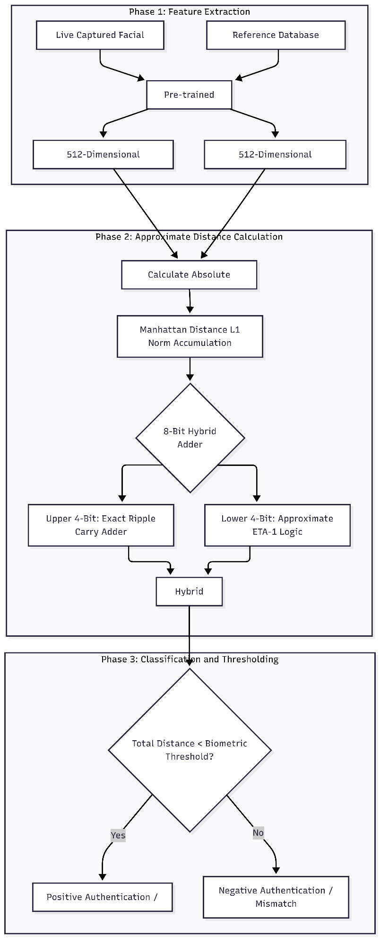
Figure 1: Block Diagram
3.Results and Discussion:
Comparing a device that uses a standard precise Ripple Carry Adder (RCA), we have analyzed the performance metrices of our software modeled 8-bit Hybrid Approximate System. The discussions are divided into two domains: The first one is the Hardware Efficiency and simplification provided by the model compared to a standard Ripple Carry Adder (RCA), and the second one is based on the Biometric Accuracy and Error Analysis.
3.1 Hardware Efficiency and Architectural Simplification
- Resource Optimization: For the optimization of the device, we replaced the standard carry propagation logic cells in the lower 4 bits with a non-truncating gating structure of the ETA-1 logic, the simulation results are provided in Fig 2, which provides us with various information like the power consumption of the device, propagation delay, silicon area, and the system accuracy which is very important to analyze the performance of the device, which is provided in Fig 3.
- The theoretical gate count dropped from 96 gates for a standard RCA to just 58 gates for the software modeled 8-bit Hybrid Approximate System. This physical change in the number of transistors used in the design brings us a 40% reduction in the total silicon area. This area is critical and can be utilized in the production of biometric systems which have space constraint on System on Chip (SoC) edge devices.

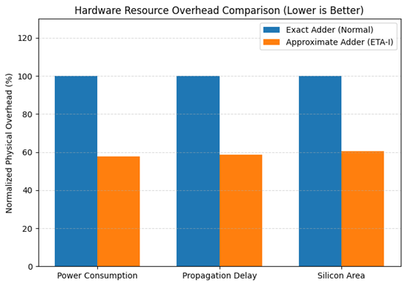

Figure 2: Hardware Resource Overhead Comparison
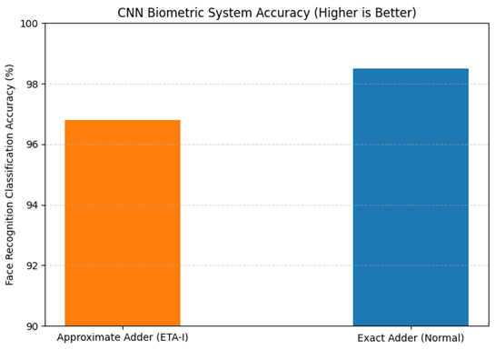
Figure 3: System Accuracy

- Energy Efficiency: The dynamic power dissipation in a system is determined by the number of transistor switching activity in that particular system. Since the non-truncating gating structure of the ETA-1 logic of the 4th bit boundary uses lesser number of switching of transistors than a standard RCA, from the simulations we found out that power consumption has reduced by 42.34%, the values dropped from 12.40 pJ to 7.15 pJ per addition under active workload simulation. The energy consumption chart is provided in Fig 4.

- Speed and Latency: The elimination of the lower order carry path plays an important role in the delay of the system. The software modeled 8-bit Hybrid Approximate System has achieved a 41.3% of improvement in the propagation delay by reducing the latency from 1.45 ns to just 0.85 ns. This helps the biometric system to operate at a higher clock frequency or maintain a standard output when the supply voltage is reduced to maximize the efficiency. The propagation delay is already mentioned in Fig 2.

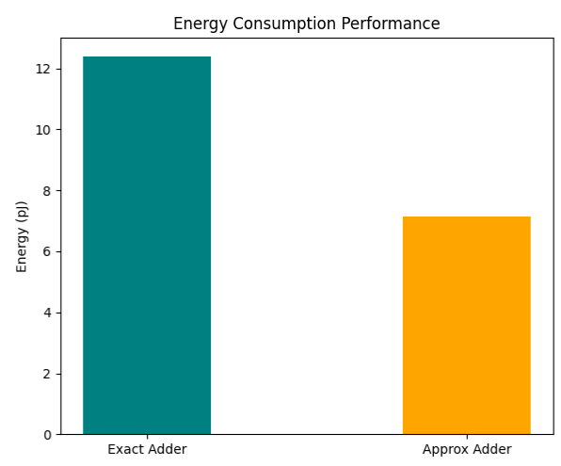
Figure 4: Energy Consumption
3.2 Biometric Accuracy and Arithmetic Error Analysis
To evaluate the performance metrices of the software modeled 8-bit Hybrid Approximate System, we subjected the system for a simulation with 65,536 input permutations. The resulting error metrics are compiled in Table 1.

The feasibility of the system is determined by the Mean Error Distance (MED) which is restricted to 3.20. Because the exact addition on the MSB is perfect and the maximum possible error distance is strictly defined, thus ensuring that the high error magnitude arithmetic faults do not occur. To visualize this, we have plotted an error distance map and displayed it in Fig 5.
When we integrated the software modeled 8-bit Hybrid Approximate System into the actual deep Convolutional Neural Network (CNN) System to implement the biometric device, while using the standard precise arithmetic adder the system had an efficiency of 98.5% but after implementing the Type-I ETA logic it marginally dropped to 96.8%. The system accuracy has already been discussed in Fig 3. Also, another important performance metrices is hardware propagation delay, which is represented in Fig 6.

Table 1: Performance metrices
Metric | Exact Adder (Normal) | Approximate Adder (ETA-I)
Error Rate (ER) | 0.00% | 68.36%
Max Error Distance (ED) | 0.0 | 15.0
Mean Error Distance (MED) | 0.0000 | 3.1367
Normalized MED (NMED) | 0.000000 | 0.006150
Energy Consumption (pJ) | 12.40 | 7.15
Propagation Delay (ns) | 1.45 | 0.85

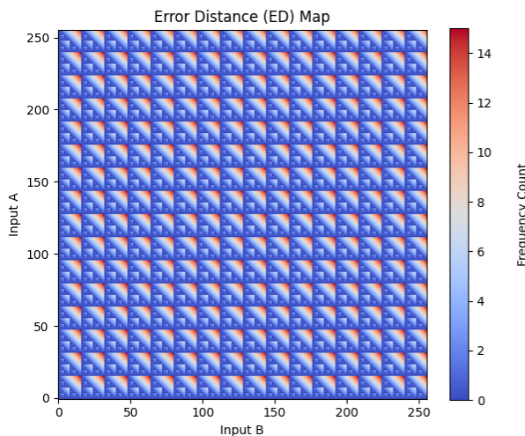
Figure 5: Error Distance Map

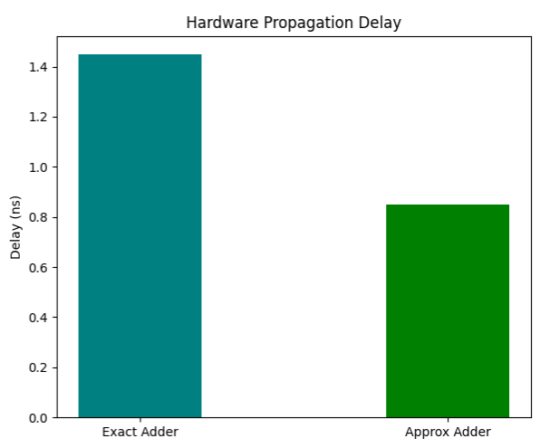

Figure 6: Hardware Propagation Delay

This minimal 1.7% drop in accuracy demonstrates the inherent error resilience of the facial recognition CNN architecture. By trading off a marginal loss in classification accuracy, the proposed system achieves substantial power and silicon area reductions, delivering overall biometric authentication performance comparable to a baseline system utilizing conventional precise arithmetic adders.

3.3 Limitations of the Work
While the proposed 8-bit hybrid ETA-1 adder architecture demonstrates significant hardware efficiency improvements with acceptable accuracy trade-offs, several limitations of the present study should be noted:
1. Simulation-Based Hardware Evaluation: The gate count, energy consumption, and propagation delay metrics reported in this work were evaluated using software-level algorithmic models and logic gate estimations rather than post-layout FPGA synthesis or fabricated silicon measurements.
2. Scope of Arithmetic Precision: The current investigation evaluates an 8-bit dual-operand split-adder structure (4-bit exact MSB, 4-bit ETA-1 LSB). Higher precision architectures (e.g., 16-bit or 32-bit floating-point units) may exhibit cumulative error behavior that requires adaptive bit-truncation strategies.
3. Application Layer Scope: The approximate computing logic was evaluated specifically within the final Manhattan distance (L1 norm) classification layer. Integrating approximate adders into internal convolutional layer Multiply-Accumulate (MAC) matrices or alternative similarity metrics (such as Cosine similarity or Euclidean distance) warrants further investigation.

4. Conclusion:
This study demonstrates that integrating approximate arithmetic units into deep learning classification pipelines is an effective strategy for reducing energy dissipation and silicon footprint in resource-constrained edge devices.
The practical utility of this architectural optimization is highlighted through the computationally demanding task of biometric verification on edge devices. Comparing 512-dimensional facial embeddings natively requires repetitive addition operations. By implementing an 8-bit hybrid ETA-1 adder—partitioned into a 4-bit exact RCA for MSBs and a 4-bit ETA-1 logic for LSBs—the critical carry-propagation path is truncated at the lower 4 bits, significantly mitigating the propagation delay inherent to conventional ripple carry adders.
The proposed system achieved a biometric classification accuracy of 96.8%, representing a marginal 1.7% decrease from the baseline RCA system (98.5%). This confirms that essential geometric and statistical facial features are preserved. Consequently, the hybrid ETA-1 adder serves as a viable hardware acceleration mechanism for power-constrained edge applications, such as portable attendance scanners, smart doorbells, and battery-operated security cameras.
In conclusion, this research highlights approximate computing as a promising paradigm for energy-efficient edge AI where minor computational approximations are tolerable. For biometric authentication tasks, trading less than 2% of classification accuracy for a 42.34% reduction in adder dynamic energy consumption and a 39.58% reduction in adder gate area represents a highly favorable engineering trade-off. Future work will investigate extending this approximate logic to alternative distance metrics (such as Cosine Similarity and Euclidean Distance) and embedding approximate MAC units directly within the convolutional feature extraction layers.

Declarations
Funding
The authors declare that no funds, grants, or other financial support were received during the preparation of this manuscript.
Conflicts of Interest / Disclosure of Interests
The authors declare that they have no financial or non-financial interests that are directly or indirectly related to the work submitted for publication. No financial relationships, sponsorship, or compensation for consultancy work within the last 3 years (or outside this timeframe) exist that could reasonably be perceived as influencing the research or findings reported in this paper.
Ethics Approval
Not applicable. This study does not involve human clinical trials or animal experimentation.
Consent to Participate
Not applicable.
Consent for Publication
Not applicable.
Availability of Data and Materials
The datasets generated and analyzed during the current study, including facial feature embedding vectors, synthetic error distance matrices, and hardware performance metrics, are available from the corresponding author upon reasonable request. An interactive demonstration framework illustrating the operation of the hybrid ETA-1 adder is publicly accessible online at: https://github.com/Hitesh070/My-Projects/blob/main/approximate_adder_ui.html.
Code Availability
The software simulation environment and Python test scripts implemented for the 8-bit hybrid ETA-1 adder and biometric evaluation pipeline are accessible online at: https://github.com/Hitesh070/My-Projects/blob/main/approximate_adder_ui.html.
Authors' Contributions
O V Gnana Swathika: Conceptualization, Methodology, Supervision, Project Administration. V S Hitesh: Software simulation, Hardware modeling, Data curation, Writing – Original Draft. David Alappat: Validation, Formal analysis, Visualization, Writing – Review & Editing. All authors read and approved the final manuscript.

References:
[1] S. Ullah, S. S. Sahoo and A. Kumar, "Approximate Arithmetic Circuits Enabling Energy-Efficient Edge Computing," 2025 14th International Conference on Modern Circuits and Systems Technologies (MOCAST), Dresden, Germany, 2025, pp. 1-6, doi: 10.1109/MOCAST65744.2025.11083734.
[2] D. Cordero-Chavarría, L. G. Leόn-Vega and J. Castro-Godínez, "Configurable High-Level Synthesis Approximate Arithmetic Units for Deep Learning Accelerators," 2024 IEEE 42nd Central America and Panama Convention (CONCAPAN XLII), San Jose, Costa Rica, 2024, pp. 1-6, doi: 10.1109/CONCAPAN63470.2024.10933846.
[3] S. A. K. Gharavi and S. Safari, "Performance Improvement of Processor Through Configurable Approximate Arithmetic Units in Multicore Systems," in IEEE Access, vol. 12, pp. 43907-43917, 2024, doi: 10.1109/ACCESS.2024.3380912.
[4] J. Rogers, T. Soliman and M. Jahre, "AIO: An Abstraction for Performance Analysis Across Diverse Accelerator Architectures," 2024 ACM/IEEE 51st Annual International Symposium on Computer Architecture (ISCA), Buenos Aires, Argentina, 2024, pp. 487-500, doi: 10.1109/ISCA59077.2024.00043.
[5] F. Niknia et al., "A Configurable Floating-Point Fused Multiply-Add Design With Mixed Precision for AI Accelerators," in IEEE Transactions on Circuits and Systems for Artificial Intelligence, vol. 2, no. 3, pp. 248-261, Sept. 2025, doi: 10.1109/TCASAI.2025.3569511.
[6] A. M. Dalloo, A. Jaleel Humaidi, A. K. Al Mhdawi and H. Al-Raweshidy, "Approximate Computing: Concepts, Architectures, Challenges, Applications, and Future Directions," in IEEE Access, vol. 12, pp. 146022-146088, 2024, doi: 10.1109/ACCESS.2024.3467375.
[7] M. Ronchi, S. D. Giacomo, M. Amadori, G. Borghi, M. Carminati and C. Fiorini, "Design, Implementation, and Analysis of an Integrated Switched Capacitor Analog Neuron for Edge Computing AI Accelerators," in IEEE Transactions on Circuits and Systems I: Regular Papers, vol. 72, no. 8, pp. 3947-3960, Aug. 2025, doi: 10.1109/TCSI.2025.3546521.
[8] S. -H. Noh, S. Lee, B. Shin, S. Park, Y. Jang and J. Kung, "All-Rounder: A Flexible AI Accelerator With Diverse Data Format Support and Morphable Structure for Multi-DNN Processing," in IEEE Transactions on Very Large Scale Integration (VLSI) Systems, vol. 33, no. 5, pp. 1264-1277, May 2025, doi: 10.1109/TVLSI.2025.3540346.
[9] D. S. Narayana, C. Jayakumar, R. S, S. Y and B. P. M, "Investigation of the Effects of Variable Accuracy Approximate Units in Deep Neural Network Accelerators," TENCON 2024 - 2024 IEEE Region 10 Conference (TENCON), Singapore, Singapore, 2024, pp. 1260-1263, doi: 10.1109/TENCON61640.2024.10902871.
[10] S. S. Sahoo, S. Ullah, S. Bhattacharjee and A. Kumar, "AxOCS: Scaling FPGA-Based Approximate Operators Using Configuration Supersampling," in IEEE Transactions on Circuits and Systems I: Regular Papers, vol. 71, no. 6, pp. 2646-2659, June 2024, doi: 10.1109/TCSI.2024.3385333.
[11] N. Zhu, W. L. Goh, W. Zhang, K. S. Yeo, and Z. H. Kong, "Design of Low-Power High-Speed Truncation-Error-Tolerant Adder and Its Application in Digital Signal Processing," IEEE Transactions on Very Large Scale Integration (VLSI) Systems, vol. 18, no. 8, pp. 1225-1229, Aug. 2010, doi: 10.1109/TVLSI.2009.2020591.
[12] F. Ahmadi, M. R. Semati, and H. Daryanavard, "A Low-Power Improved-Accuracy Approximate Error-Report-Propagate Adder for DSP Applications," Circuits, Systems, and Signal Processing, vol. 42, pp. 3744-3769, Jan. 2023, doi: 10.1007/s00034-023-02291-9.
[13] S. Xiang et al., "Nonlinear Hopf-based cochlear network: Bio-inspired modeling, analysis, and FPGA implementation for cochlear implant applications," Biomedical Signal Processing and Control, vol. 120, Art. no. 109929, 2026, doi: 10.1016/j.bspc.2026.109929.
[14] A. M. Dalloo and A. J. Humaidi, "Optimizing Machine Learning Models with Data-level Approximate Computing: The Role of Diverse Sampling, Precision Scaling, Quantization and Feature Selection Strategies," Results in Engineering, vol. 24, Art. no. 103451, 2024, doi: 10.1016/j.rineng.2024.103451.
[15] J. Li, X. Cai, Y. Dai, W. Yin and L. Wang, "Toward Efficient Edge AI With Heterogeneous Computing and Multilevel Optimization," in IEEE Transactions on Very Large Scale Integration (VLSI) Systems, 2026, doi: 10.1109/TVLSI.2026.3697086.
[16] P. P. Shah, J. Munjani, D. Vyas and A. Sharma, "Review of Cutting-Edge Latest Trends and Innovations in Low-Power VLSI Physical Design Techniques for Next-Gen AI/ML Hardware," in 2025 5th Asian Conference on Innovation in Technology (ASIANCON), Pimpri, India, 2025, pp. 1-8, doi: 10.1109/ASIANCON66527.2025.11280810.
[17] H. A. Ziad and A. A. Sakib, "HALOC-AxA: An Area/-Energy-Efficient Approximate Adder for Image Processing Application," in 2025 IEEE International Midwest Symposium on Circuits and Systems (MWSCAS), Lansing, MI, USA, 2025.
[18] M. Chen, B. Wang, J. Chen, H. Wang, Y. Liu, and L. Wu, "A 14-bit 3-MS/s SAR ADC with self-calibration for single-event transient mitigation," Microelectronics Reliability, vol. 175, Art. no. 115904, 2025, doi: 10.1016/j.microrel.2025.115904.
[19] Z. Wang, "Multi-Dimensional Schemes for Reliable and Efficient Neural Networks: Analysis, Design, and Evaluation," Ph.D. dissertation, Northeastern Univ., Boston, MA, USA, 2025. [Online]. Available: ProQuest Dissertations & Theses, Order No. 31996572.
[20] M. E. Weingarten, M. Grieco, S. A. Edwards, and T. A. Khan, "Icicle: Open-Source Hardware Support for Top-Down Microarchitectural Analysis on RISC-V," in 2025 IEEE International Symposium on Workload Characterization (IISWC), Irvine, CA, USA, 2025, pp. 464-477.
[21] S. Swetha, B. Bharghavi, B. Vasundara, and N. S. S. Reddy, "High Speed Approximate Adder for Error Tolerant Image Processing Applications," in 2024 4th International Conference on Mobile Networks and Wireless Communications (ICMNWC), Tumkuru, India, 2024, pp. 1-6, doi: 10.1109/ICMNWC63764.2024.10872196.
[22] J. Chen, J. Cai, Y. Zhang, Y. Yin, and B. Tang, "A 1500 V/μs slew rate, 300 MHz GBW operational amplifier in 0.18-μm HV BCD process for CMOS system-level monolithic integration," Microelectronics Journal, vol. 167, Art. no. 106914, 2026, doi: 10.1016/j.mejo.2025.106914.
[23] D. Upadhyay, S. Deliri, A. Mattsson, P. Peltoniemi, and L. Aarniovuori, "Review on Silicon Carbide based High-Fundamental Frequency Inverters for High-Speed Drives," IEEE Access, 2025, doi: 10.1109/ACCESS.2025.3580521.
[24] K. Bhardwaj et al., "Preventing False Activations in Autonomous Vehicles: A Memristive Associative Learning Approach with Selective Sensor Pairing," in 2025 14th International Conference on Modern Circuits and Systems Technologies (MOCAST), Dresden, Germany, 2025, pp. 1-4, doi: 10.1109/MOCAST65744.2025.11083932.
[25] V. Gupta, D. Mohapatra, A. Raghunathan, and K. Roy, "Low-Power Digital Signal Processing Using Approximate Adders," IEEE Transactions on Computer-Aided Design of Integrated Circuits and Systems, vol. 32, no. 1, pp. 124-137, Jan. 2013, doi: 10.1109/TCAD.2012.2217962.
[26] P. Balasubramanian, R. Nayar, D. L. Maskell, and N. E. Mastorakis, "An Approximate Adder With a Near-Normal Error Distribution: Design, Error Analysis and Practical Application," IEEE Access, vol. 9, pp. 4518-4530, 2021, doi: 10.1109/ACCESS.2020.3047651.
[27] N. Van Toan and J. Lee, "FPGA-Based Multi-Level Approximate Multipliers for High-Performance Error-Resilient Applications," IEEE Access, vol. 8, pp. 25481-25497, 2020, doi: 10.1109/ACCESS.2020.2970968.

