**RESTAURANT ORDERS ANALYSIS**

1. Convert Dataset to SQL Database: -

* Create SQL statements to define and populate tables for menu_details and order_details using the provided dataset.

Solution: - We have used the inbuilt feature of importing csv file in SSMS as it was not possible to insert every value one by one

Output:

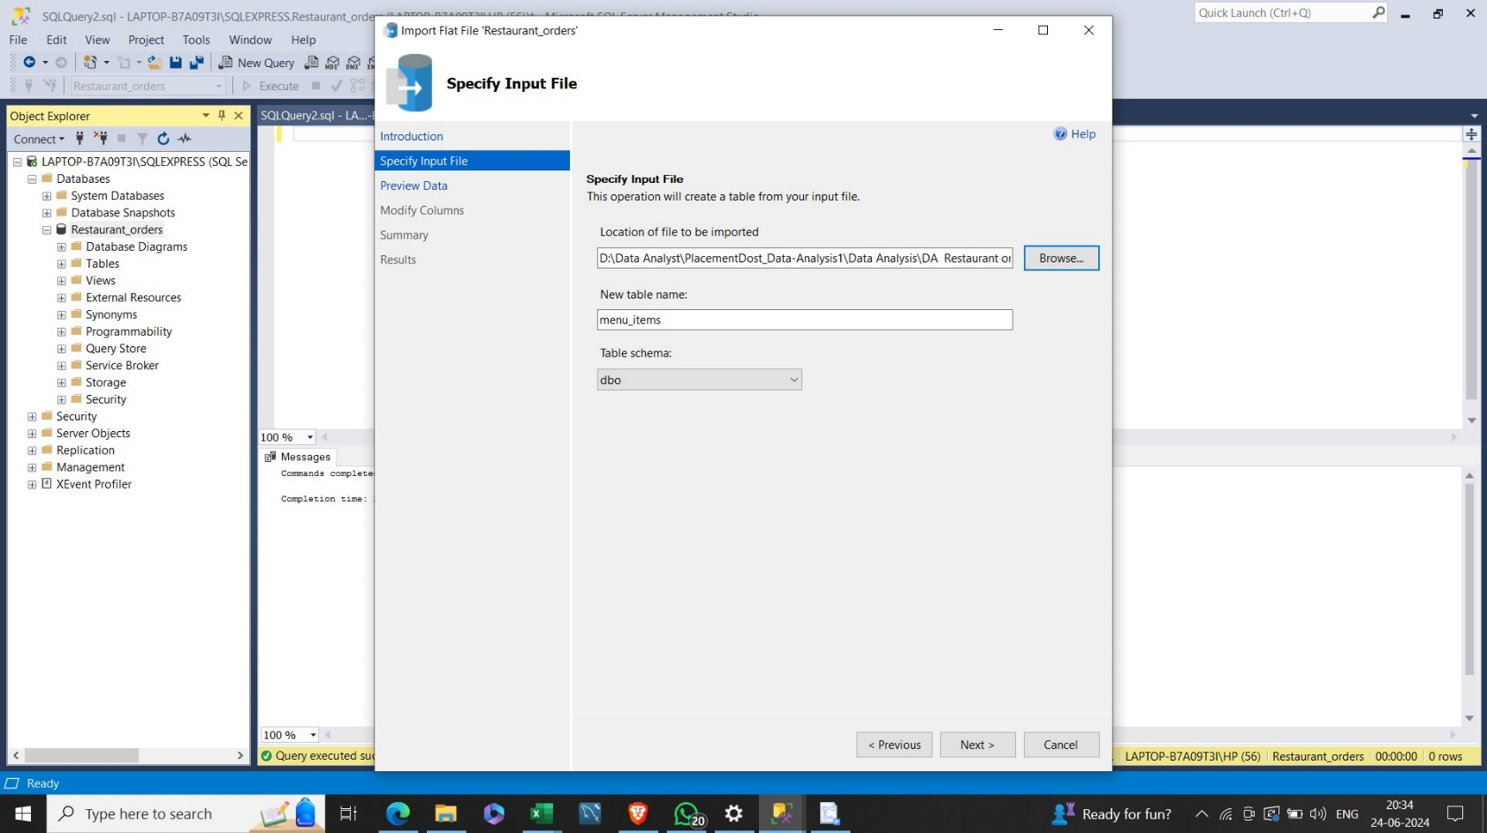

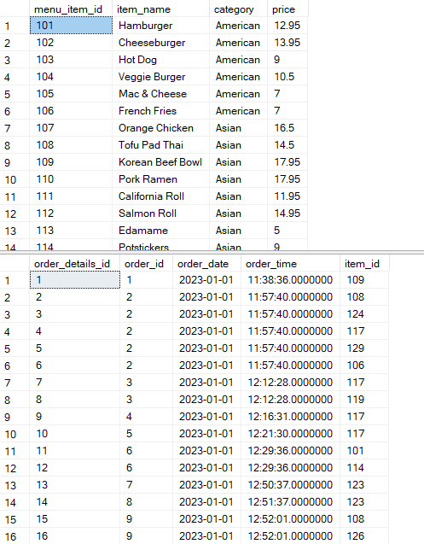

1. Basic SELECT Queries: -

* Retrieve all columns from the menu_items table. –

Output:-

Query : SELECT * FROM dbo.menu_items

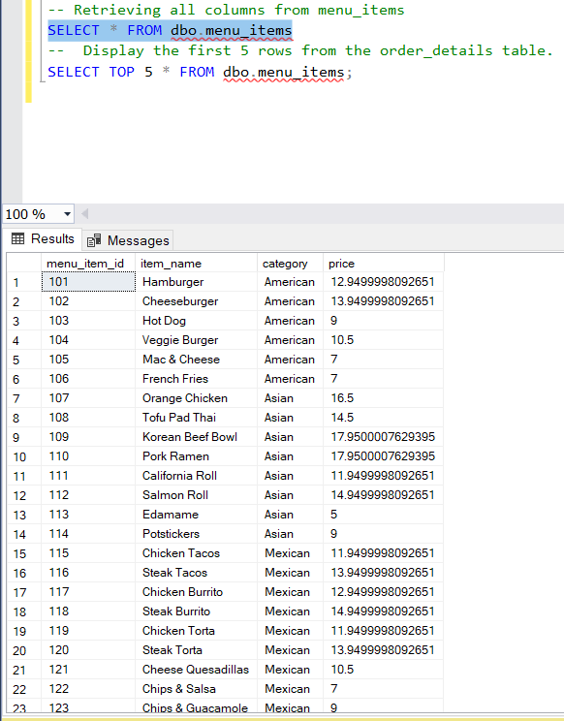

* Display the first 5 rows from the order_details table.

Solution : SELECT TOP 5 * FROM dbo.menu_items;

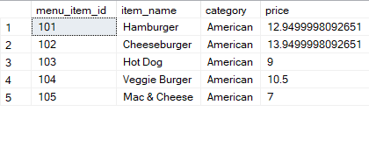

1. Filtering and Sorting: -

* Select the item_name and price columns for items in the 'Main Course' category.
* Sort the result by price in descending order.

Solution: SELECT item_name, price FROM dbo.menu_items

WHERE category= 'Main Course'

ORDER BY price DESC

There is no ‘Main Course’ Category there for result is blank

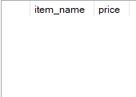

1. Aggregate Functions: -

* Calculate the average price of menu items.

Solution: SELECT AVG(price) as avg_price FROM dbo.menu_items



* Find the total number of orders placed.

Solution: SELECT COUNT(DISTINCT(order_details_id)) as

total_orders FROM order_details



1. Joins: -

* Retrieve the item_name, order_date, and order_time for all items in the order_details table, including their respective menu item details

Solution:

SELECT item_name, order_date, order_time,menu.menu_item_id as item_id, category,price FROM order_details AS orders

LEFT OUTER JOIN menu_items AS menu

ON menu.menu_item_id= orders.item_id

;

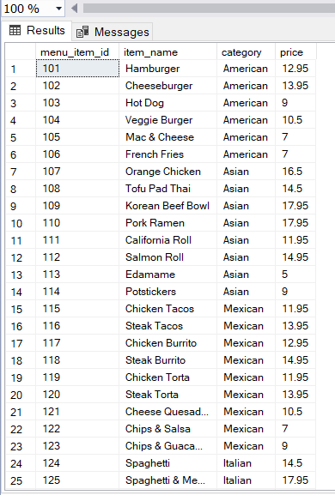

1. Subqueries: - List the menu items (item_name) with a price greater than the average price of all menu items

Solution: SELECT item_name FROM menu_items

WHERE price> (SELECT AVG(price) FROM menu_items);

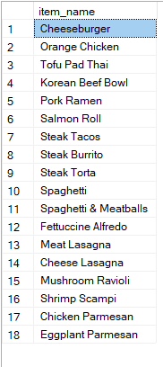

1. Date and Time Functions

* Extract the month from the order_date and count the number of orders placed in each month.

Solution:

SELECT MONTH(order_date) AS months,

COUNT(order_details_id) AS num_orders_placed

FROM order_details

GROUP BY MONTH(order_date)

ORDER BY 1;

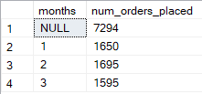

1. Group By and Having

* Show the categories with the average price greater than $15.

Solution: SELECT category,AVG(price) AS avg_price

FROM menu_items

GROUP BY category

HAVING AVG(price)>15



* Include the count of items in each category.

Solution:

SELECT category,AVG(price),COUNT(category) AS avg_price

FROM menu_items

GROUP BY category

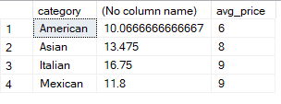

1. Conditional Statements: -

* Display the item_name and price, and indicate if the item is priced above $20 with a new column named 'Expensive'.

Solution:

SELECT item_name,price,

CASE

WHEN price>20 THEN 'Yes'

ELSE 'No'

END AS Expenisve

FROM menu_items

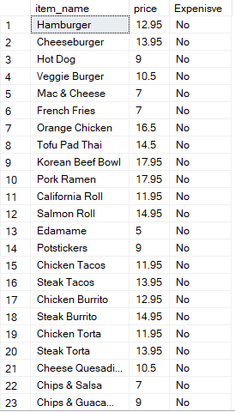

1. Data Modification - Update: -

* Update the price of the menu item with item_id = 101 to $25

Solution:

UPDATE menu_items

SET price=25 WHERE

menu_item_id = 101;

* To see the changes execute select query

SELECT * FROM menu_items

WHERE

menu_item_id = 101;



1. Data Modification - Insert: -

* Insert a new record into the menu_items table for a dessert item.

Solution:

INSERT INTO menu_items

VALUES(133,'Dessert','Sweet',2);

* To see the changes execute select query

SELECT * FROM menu_items

WHERE item_name='Dessert'



1. Data Modification - Delete: -

* Delete all records from the order_details table where the order_id is less than 100.

Solution:

DELETE FROM order_details

WHERE order_id<100

* To recheck running select query and found no records with order_id<100

SELECT * FROM order_details

WHERE order_id<100

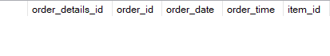

1. Window Functions - Rank:

* Rank menu items based on their prices, displaying the item_name and its rank.

Solution: SELECT item_name,

RANK() OVER(ORDER BY price) as "rank"

FROM menu_items;

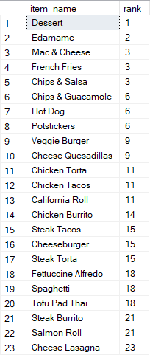

1. Window Functions - Lag and Lead:

* Display the item_name and the price difference from the previous and next menu item.

Solution:

SELECT item_name,price,

CASE

WHEN prev_item_price=0 THEN 0

ELSE

ABS(price-prev_item_price)

END as prev_price_diff,

CASE

WHEN next_item_price=0 THEN 0

ELSE

ABS(price-next_item_price)

END as next_price_diff

FROM(SELECT item_name,price,

LAG(price,1,0) OVER(ORDER BY menu_item_id) as prev_item_price,

LEAD(price,1,0) OVER(ORDER BY menu_item_id) as next_item_price

FROM menu_items) as sub

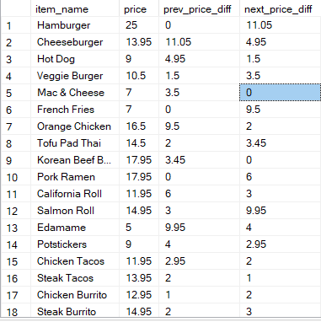

1. Common Table Expressions (CTE): -

Create a CTE that lists menu items with prices above $15.

Use the CTE to retrieve the count of such items.

Solution:

WITH menu_item AS

(SELECT * FROM menu_items

WHERE price>15)

SELECT COUNT(*) as count_above_$15

FROM menu_item



1. Advanced Joins: -

* Retrieve the order_id, item_name, and price for all orders with their respective menu item details.
* Include rows even if there is no matching menu item.

Solution:

SELECT order_id,item_name,price,menu_item_id,category

FROM order_details as orders

FULL JOIN menu_items as menu

ON orders.item_id=menu.menu_item_id

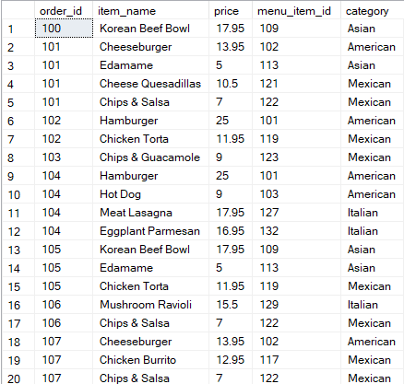

1. Unpivot Data: -

* Unpivot the menu_items table to show a list of menu item properties (item_id, item_name, category, price).

Solution:

SELECT

menu_item_id,

item_name,

property,

value

FROM

(SELECT

menu_item_id,

item_name,

CAST(category AS VARCHAR(50)) AS category,

CAST(price AS VARCHAR(50)) AS price

FROM

menu_items

) AS source

UNPIVOT

(

value FOR property IN (category, price)

) AS unpvt;

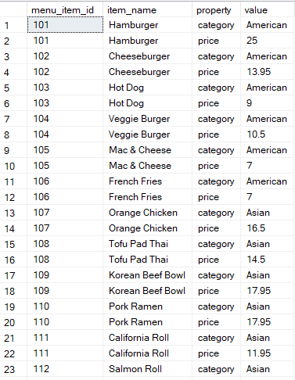

1. Dynamic SQL: -

* Write a dynamic SQL query that allows users to filter menu items based on category and price range.

Solution:

DECLARE @Category NVARCHAR(50) = NULL;

DECLARE @MinPrice DECIMAL(5,2) = NULL;

DECLARE @MaxPrice DECIMAL(5,2) = NULL;

DECLARE @SQL NVARCHAR(MAX);

SET @SQL = N'

SELECT menu_item_id, item_name, category, price

FROM menu_items

WHERE 1=1';

IF @Category IS NOT NULL

BEGIN

SET @SQL = @SQL + N' AND category = @Category';

END

IF @MinPrice IS NOT NULL

BEGIN

SET @SQL = @SQL + N' AND price >= @MinPrice';

END

IF @MaxPrice IS NOT NULL

BEGIN

SET @SQL = @SQL + N' AND price <= @MaxPrice';

END

SET @SQL = @SQL + N' ORDER BY price';

PRINT @SQL; -- This will show you the constructed query

EXEC sp_executesql @SQL,

N'@Category NVARCHAR(50), @MinPrice DECIMAL(5,2), @MaxPrice DECIMAL(5,2)',

@Category, @MinPrice, @MaxPrice;

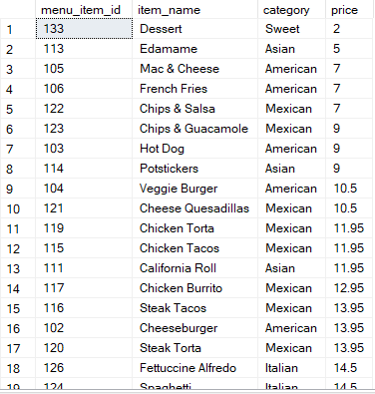

1. Stored Procedure:

* Create a stored procedure that takes a menu category as input and returns the average price for that category.

Solution:

CREATE PROCEDURE avg_price_provider

@menu_category VARCHAR(50)=NULL

AS

BEGIN

SELECT AVG(price) as avg_price FROM menu_items

WHERE category=@menu_category;

END

EXEC avg_price_provider @menu_category= 'Asian'



1. Triggers: -

* Design a trigger that updates a log table whenever a new order is inserted into the order_details table.

Solution:

CREATE TRIGGER tr_LogNewOrder

ON order_details

AFTER INSERT

AS

BEGIN

INSERT INTO order_log (order_details_id, order_id, log_date, action)

SELECT

i.order_details_id,

i.order_id,

GETDATE(),

'New Order Inserted'

FROM

inserted i;

END

INSERT INTO order_details (order_details_id, order_id, order_date, order_time, item_id)

VALUES (12235,5371, '2023-06-26', '14:30:00', 5001);

SELECT * FROM order_log;

