1. INTRODUCTION
The AI-Based Smart Supermart Billing System aims to overcome these limitations by utilizing Artificial Intelligence (AI) and Computer Vision (CV) to recognize products directly through images, without the need for barcode scanning. This is achieved through a web application that accesses the camera, captures the product image, and sends it to a Machine Learning (ML) model for recognition. The identified product’s details, such as its name, description, and price, are then automatically retrieved from a database and added to a virtual cart.

1.1 Background
In today’s fast-paced world, technology-driven automation has become essential in almost every sector, especially in retail and supermarket operations. Traditional billing systems in supermarkets rely heavily on barcode scanning or manual data entry, which can be time-consuming and prone to errors. These systems also depend on human intervention for checkout, which causes long queues, slower processing.
This system integrates deep learning, web development, and database management to provide a fully automated and contactless billing process. It not only enhances speed and accuracy but also demonstrates how AI can be applied effectively in real-world retail scenarios.

1.2 Problem Context
The current billing process in supermarkets has several drawbacks that impact both customers and store management. Barcode-based systems, though widely used, depend on proper printing and placement of barcode stickers. If a barcode gets damaged, misplaced, or becomes unreadable, the cashier must manually enter product details, increasing processing time. During peak shopping hours, these small inefficiencies multiply, causing longer queues and customer frustration.
Additionally, barcode systems cannot easily handle unpackaged or local products, such as fruits, bakery items, or loose groceries, that lack proper labeling. Manual billing for such items further delays the checkout process. The pandemic period has also emphasized the importance of contactless technology, where minimal physical handling of products and billing devices is desired.
Hence, there is a clear need for a smart billing system that can automatically identify products using image recognition, reduce manual involvement, and deliver a faster, safer, and more efficient checkout experience.

1.3 Problem Definition
The primary challenges in the current billing systems can be summarized as follows:
- Dependency on Barcodes – Each product requires a barcode label that can be damaged, misplaced, or duplicated.
- Manual Workload – Cashiers must scan or enter every product manually.
- Increased Wait Time – During busy hours, queues become longer, reducing efficiency.
- Human Error – Incorrect scans, skipped products, or duplicate entries lead to billing mistakes.
- Limited Contactless Interaction – Traditional systems require human handling, which is undesirable in the modern context.
These issues collectively reduce the efficiency of supermarket operations. Therefore, there is a need for an intelligent system that can automatically detect and identify products using image data instead of barcodes, improving both speed and accuracy.

1.4 Proposed Solution
The proposed AI-Based Smart Supermart Billing System provides a solution by combining AI, ML, and web technologies to automate product recognition and billing. The workflow is as follows:
- The user opens the web application and grants camera access.
- The camera captures an image of the product placed before it.
- The image is sent to a pre-trained deep learning model (CNN) that identifies the product.
- The system retrieves the product’s name, description, and price from the database.
- The product is automatically added to the virtual cart displayed on the web interface.
- Once all items are added, the user can proceed to checkout and complete payment.
The model uses Convolutional Neural Networks (CNNs), which are widely known for their accuracy in image classification tasks. The frontend is built using Next.js (React framework), while the backend operates on Flask (Python) for handling AI prediction and database operations. The system database, implemented using MongoDB or Firebase, stores product information and pricing data.

1.5 Scope of the Project
The scope of this project includes:
- Designing a real-time web-based system capable of scanning products using a camera.
- Training a deep learning model for image-based product classification.
- Building an interactive web interface for cart management, checkout, and displaying recommendations.
- Integrating a cloud-based database for product storage and retrieval.
- Providing additional features such as a store map, quick tips, and thank-you page for better user experience.
In the long term, this system can be extended to include voice assistants, mobile app integration, and IoT-based shelf tracking, making it a complete AI-powered retail solution.
The AI-Based Smart Supermart Billing System demonstrates how artificial intelligence can be effectively applied to solve real-world problems. Its significance lies in several aspects:
- It introduces automation in retail billing, minimizing human involvement.
- Provides a contactless, hygienic checkout process, suitable for modern retail needs.
- Reduces time and human errors, improving overall operational efficiency.
- Encourages the adoption of AI and deep learning in everyday applications.
The system not only benefits customers by saving time but also assists store owners in reducing staff costs and improving accuracy in sales tracking.

1.6 Expected Outcomes
Upon completion, the project is expected to deliver:
- A functional AI-based billing system that operates through a web browser.
- A trained CNN model that identifies products with high accuracy.
- A database-integrated backend that dynamically retrieves product details.
- A responsive frontend interface for scanning, billing, and checkout.
- A user-friendly design with optional recommendation and store map features.

1.7 Chapter Summary
This chapter introduced the concept and necessity of an AI-based smart billing system for supermarkets. It explained the background, motivation, and challenges of existing barcode-based systems, and presented a new AI-driven solution capable of automated product detection, billing, and checkout through image recognition.
2. PROBLEM STATEMENT

2.1 Introduction
The supermarket and retail industries are growing rapidly, yet the checkout and billing process remains one of the most time-consuming operations. Customers often spend more time waiting in billing queues than they do selecting products. Traditional billing systems rely on barcode scanning or manual entry, which has remained unchanged for decades.
While barcode technology was once a breakthrough innovation, it now poses several limitations in modern, fast-paced environments. In addition, the post-pandemic world has accelerated the need for contactless, hygienic, and AI-powered solutions to minimize human touchpoints during shopping.
The AI-Based Smart Supermart Billing System has been conceptualized to overcome these challenges by integrating AI, Computer Vision, and Machine Learning to automate product recognition and billing without the need for barcodes or human intervention.

2.2 Existing System
The current retail billing system widely used in most supermarkets follows a barcode-based or manual entry approach. Each product in the store is tagged with a unique barcode, which contains its identity and price details.
Although this system is reliable to an extent, it suffers from several limitations that hinder efficiency and scalability:
- Dependency on Barcodes:
Every item must have a barcode printed and attached. Any damaged or missing barcode makes the product unidentifiable, forcing manual entry.
- Manual Intervention:
A cashier or billing staff is required to scan and verify every product, which increases operational costs and delays.
- Time Consumption:
During peak hours, even scanning barcodes becomes slow, leading to long queues and customer dissatisfaction.
- Human Error:
Errors can occur due to missed scans, duplicate entries, or incorrect data input, resulting in inaccurate billing.

2.3 Limitations of the Existing System
The existing barcode-based billing system, though operationally stable, fails to address the changing technological and customer demands in retail environments. The following are its major limitations:
- Physical Dependency: Requires physical scanning devices and barcode stickers.
- Lack of Automation: No integration with AI or ML for object recognition.
- Maintenance Overhead: Continuous reprinting and re-labeling of barcodes is required.
- No Real-Time Intelligence: Cannot predict or suggest related products to the user.
- Limited Contactless Support: Physical scanning is mandatory, leading to potential hygiene and efficiency concerns.

2.4 Proposed System
To overcome these challenges, the proposed AI-Based Smart Supermart Billing System is developed to utilize Computer Vision and Artificial Intelligence for automatic product recognition and billing.
The proposed system introduces a camera-based detection mechanism that identifies a product visually rather than through barcodes. The system captures the image of the product, processes it using a Convolutional Neural Network (CNN) model, and classifies it into predefined categories such as snacks, beverages, toiletries, etc.
Once identified, the system automatically fetches the product details (name, price, and description) from a connected database and adds them to a virtual cart in real time. This eliminates manual scanning and accelerates the entire checkout process.
Main features of the proposed system include:
- Automated Product Identification: Uses AI models to detect products through images.
- Database Integration: Automatically fetches details from cloud or local storage.
- Real-Time Cart Update: Adds detected products to the cart instantly.

2.5 Comparative Analysis: Existing vs Proposed System
Parameter | Existing Barcode System | Proposed AI-Based System
Product Identification | Manual barcode scanning | Automatic camera-based image recognition
Hardware Requirement | Barcode scanner | Standard webcam or phone camera
Human Involvement | High (requires cashier) | Low (automated AI process)
Speed and Efficiency | Moderate; depends on staff | High; real-time processing
Error Handling | Prone to scanning errors | AI model trained for accuracy
Maintenance | Barcode replacement needed | No barcode maintenance
Cost Efficiency | Requires hardware investment | Software-based, low cost
User Experience | Traditional and slow | Modern, fast, and contactless

This comparison clearly illustrates the superiority of the proposed AI-based system in terms of speed, accuracy, automation, and scalability.

2.6 Problem Definition
“To design and implement a smart billing system using Artificial Intelligence and Computer Vision that can automatically recognize retail products through images, fetch product details from a database, and generate a digital bill without using barcode scanners.”

3. OBJECTIVES
3.1 Introduction
Every successful project begins with clearly defined objectives that guide the entire development process. The AI-Based Smart Supermart Billing System is designed to create an automated, intelligent, and contactless billing solution using Artificial Intelligence (AI) and Computer Vision (CV).
The objectives of this project are aligned with the need to minimize human effort, enhance efficiency, and improve the customer experience in retail billing systems. By leveraging AI and Machine Learning (ML) technologies, this project aims to replace traditional barcode-based checkout systems with an image-based recognition mechanism that provides faster and more reliable billing.
This chapter outlines the major, minor, and technical objectives of the project, providing a roadmap for system design, model training, and application deployment.

3.2 Major Objectives
The major objectives of the AI-Based Smart Supermart Billing System are to automate the billing process and enhance user experience through advanced technologies. The following points summarize the key goals:
- To develop an AI-powered system for automatic product identification:
The primary goal is to design a system that can identify and classify supermarket products using image recognition without relying on barcodes.
- To design a web-based platform for real-time billing:
The system should operate within a web browser, allowing users to scan products through a webcam or device camera, view details, and proceed to checkout instantly.
- To create a contactless and efficient billing environment:
The project aims to eliminate physical interaction with barcode scanners or cashiers, enabling a faster, safer, and more hygienic billing process.
- To reduce manual labor and human error:
Automating product detection minimizes staff involvement, thereby reducing the chances of human errors, double entries, or missed scans.
- To demonstrate the integration of AI, ML, and Web Development:
The project showcases how artificial intelligence and web technologies can be combined to create real-world applications for the retail industry.

3.3 Minor Objectives
In addition to the major objectives, several supporting objectives ensure that the system is practical, scalable, and user-friendly:
- To build a responsive and intuitive user interface:
The web interface should be simple to navigate, visually appealing, and accessible on different devices such as desktops, tablets, or smartphones.
- To implement a cloud-connected product database:
Product details such as names, categories, images, and prices should be stored and retrieved dynamically from a database like MongoDB or Firebase.
- To design a real-time virtual cart system:
The system should automatically add recognized products to a digital cart, allowing users to view, update, or remove items before checkout.
- To provide additional smart features:
Include features such as “Recommended Products,” “Quick Tips,” “Store Map,” and a “Thank You” page for an enhanced user experience.

3.4 Technical Objectives
The technical objectives define the engineering aspects that ensure the system performs efficiently, accurately, and reliably.
- AI Model Development:
  - Train a Convolutional Neural Network (CNN) model using TensorFlow/Keras for classifying product images.
  - Achieve a minimum accuracy of 90% on the test dataset.
  - Implement image augmentation techniques (rotation, flipping, scaling) to improve model robustness.
- Computer Vision Integration:
  - Use OpenCV to capture live video frames from the camera.
  - Preprocess the images (resize, normalize, crop) before feeding them into the CNN model.
- Backend Development:
  - Build a backend using Flask (Python) to handle AI predictions, manage API requests, and connect to the product database.
  - Implement endpoints for product recognition, fetching details, and generating bills.
- Frontend Development:
  - Develop the frontend using Next.js (React) for dynamic user interaction and seamless camera integration.
  - Use Tailwind CSS for designing a responsive layout.
- Database Management:
  - Create a MongoDB/Firebase database to store and retrieve product data such as ID, price, and image URL.
4. METHODOLOGY
The methodology explains the systematic approach used to design, develop, and implement the Smart AI-Based Checkout System Cart. It includes hardware setup, software architecture, AI integration, and testing procedures to achieve a fully automated checkout system.

4.1 Overview of Methodology
The proposed system is developed using a combination of AI-based object detection, database management, and automated billing algorithms. The methodology ensures that the system can detect products in real time, retrieve price details, and generate a bill automatically.
The development process follows the System Development Life Cycle (SDLC), particularly an Agile iterative model, allowing continuous improvement through testing and feedback.

4.2 System Development Life Cycle (SDLC)
The SDLC is divided into five phases:
- Requirement Analysis:
  - Studied existing supermarket checkout systems to identify challenges.
  - Collected requirements for real-time product detection, automated billing, and user-friendly interface.
  - Defined functional requirements (product recognition, billing) and non-functional requirements (speed, accuracy, reliability).
- System Design:
  - Designed hardware layout: placement of camera on cart, optional load sensors, and display for bill output.
  - Developed software architecture: AI object detection module, database connectivity, and billing module.
- Implementation:
  - Integrated YOLOv5 / TensorFlow AI models for product recognition.
  - Built backend using Node.js and MongoDB for product storage and billing operations.
  - Developed frontend interface using React.js to display products, prices, and total bill.
- Testing:
  - Conducted tests to ensure accuracy of product recognition under different lighting and angles.
  - Validated billing correctness by comparing AI-generated invoices with manual bills.
  - Performed load testing to handle multiple items in a cart simultaneously.
- Deployment and Maintenance:
  - Deployed the system in a controlled supermarket environment.
  - Regularly updated the AI model to improve recognition accuracy for new products.

4.3 Hardware Architecture
The smart cart system integrates several hardware components for real-time detection and billing:
- Camera Module: Captures images of items in the cart for processing.
- Raspberry Pi / Microcontroller: Acts as the processing unit running AI algorithms locally.
- Load Sensors (optional): Measure weight to cross-verify product identification.
- Display Module: Shows products, prices, and total bill.
4.4 Software Architecture
The software is modular and consists of four major components:
4.4.1 AI Object Detection Module
- Uses YOLOv5 or TensorFlow-based Convolutional Neural Networks (CNN).
- Recognizes products in real time with high accuracy.
- Dataset includes images of all supermarket products with multiple angles and lighting conditions.
- Algorithm:
  - Capture image from camera.
  - Preprocess image (resize, normalize).
  - Run object detection model to classify products.
  - Output product ID for billing module.
4.4.2 Database Module
- Stores product details, such as name, price, category, and stock status.
- Uses MongoDB / Firebase for fast read/write operations.
- Supports real-time queries to fetch product information for each detected item.
4.4.3 Billing Module
- Calculates total price automatically.
- Generates digital invoices for printing or display.
- Supports multiple payment methods (UPI, card, wallet).
4.4.4 User Interface (UI) Module
- Displays cart contents, individual product prices, and total bill.
- Allows manual adjustments if the AI misclassifies a product.
4.5 Workflow of the System
The methodology workflow is as follows:
- Product Placement: Customer places items in the cart.
- Image Capture: Camera captures the item images in real time.
- Object Detection: AI model identifies each product.
- Database Lookup: Product information and price are fetched from the database.
- Billing: Total bill is calculated automatically.
- Display & Payment: Bill is displayed, and customer can pay digitally.
Optional: Weight sensors cross-verify product identification to prevent errors.

4.6 Algorithm Description
Product Recognition Algorithm:
- Input: Image of cart contents.
- Preprocessing: Resize and normalize image.
- Detection: Pass image through YOLOv5 model.
- Classification: Identify product ID.
- Output: List of products with price.
Billing Algorithm:
- Input: List of product IDs.
- Fetch product price from database.
- Sum total cost.
- Generate invoice with product names, prices, and total.

4.7 Testing and Evaluation
- Accuracy Testing: Check AI recognition accuracy (>95%).
- Stress Testing: Test with multiple items and complex arrangements.
- Performance Testing: Evaluate speed of recognition and billing (<2 seconds per item).
- User Testing: Gather feedback on UI and user experience.

5. SYSTEM ARCHITECTURE
The System Architecture explains the structural design of the Smart AI-Based Checkout System Cart. It highlights how hardware, AI modules, backend, and frontend components work together to create an automated checkout system.
This architecture ensures real-time product detection, accurate billing, and seamless user interaction. The system follows a modular design for scalability, maintenance, and performance optimization.

5.1 Overview of System Architecture
The system can be broadly divided into three layers:
- Hardware Layer – Responsible for capturing data from the environment.
- AI & Processing Layer – Detects products using object recognition models.
- Software Layer (Backend & Frontend) – Stores product data, generates bills, and provides a user interface.

5.2 Hardware Architecture
The hardware components form the physical base of the smart cart. The main components are:
- Camera Module:
  - High-resolution camera mounted on the cart.
  - Captures images of items in real-time for processing by AI models.
- Processing Unit (Raspberry Pi / Microcontroller):
  - Runs object detection models locally.
  - Processes data from camera and sensors.
  - Connects with the backend database for retrieving product information.
- Load Sensors (Optional):
  - Measure the weight of products.
  - Helps cross-verify product detection by AI.
- Display Module:
  - Shows detected items, individual prices, total bill, and payment status.
  - Can be a touch display for interactive user interface.
- Connectivity Module:
  - Wi-Fi or LAN connectivity ensures the cart can communicate with the central database.
Hardware Flow Diagram :
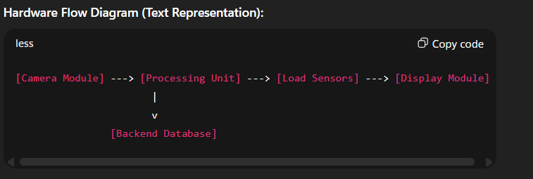

5.3 Software Architecture
The software side of the system consists of three main components:
- AI Object Detection Module:
  - Uses YOLOv5 / TensorFlow CNN models.
  - Detects products from camera images.
  - Outputs product IDs and coordinates to the backend for billing.
- Backend Module:
  - Built using Node.js and Express.js.
  - Connects to MongoDB / Firebase database for product information.
  - Handles billing logic, price calculation, stock updates, and invoice generation.
  - Manages authentication and data security.
- Frontend Module (UI):
  - Built using React.js.
  - Displays product list, prices, total bill, and payment options.
  - Provides interactive features for adding/removing items manually if needed.

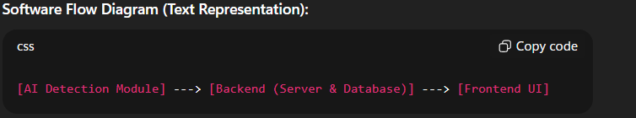

5.4 Data Flow of the System
The data flow explains how information moves through the system:
- Step 1: Customer places items in the cart.
- Step 2: Camera captures images of products.
- Step 3: AI module identifies products and generates a list of product IDs.
- Step 4: Backend queries the database to fetch product details and prices.
- Step 5: Billing module calculates total cost and generates invoice.
- Step 6: Frontend displays the products, prices, and total bill for the customer.
- Step 7: Customer makes payment, and database is updated with stock details.
Data Flow Diagram :

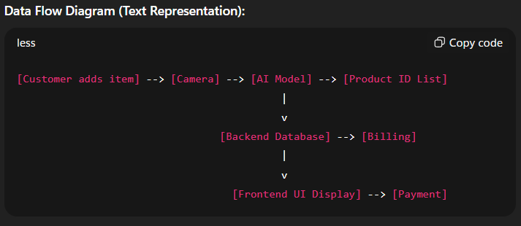
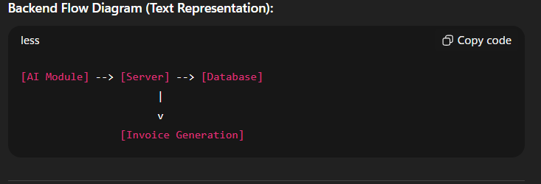

5.5 Backend Architecture
The backend handles data storage, billing, and server-side processing.
- Database Layer:
  - Stores product information: name, category, price, stock.
  - Stores user session and transaction history.
- Server Layer:
  - Receives product IDs from AI module.
  - Fetches product details from the database.
  - Computes total price and generates invoices.
- Security Layer:
  - Ensures authentication and secure communication.
  - Protects against unauthorized access or data leaks.

5.6 Frontend Architecture
The frontend is the customer-facing part of the system.
- Dashboard / Cart Display: Shows detected products, prices, and total bill.
- Interactive Options: Add/remove products manually if AI misclassifies.
- Payment Gateway Integration: Supports digital payment options (UPI, wallet, card).
- Responsive Design: Works on cart-mounted display or mobile devices for remote viewing.

5.7 Integration of Hardware and Software
The integration ensures real-time performance:
- Camera captures images and sends to Raspberry Pi.
- AI model identifies products and sends IDs to backend server.
- Backend fetches prices and generates total bill.
- Frontend displays invoice to customer.
- Payment updates the database for inventory and transaction history.

5.8 Advantages of Proposed System Architecture
- Modular Design: Easy to upgrade AI models or database without affecting other modules.
- Real-Time Processing: Immediate recognition and billing.
- Scalability: Multiple smart carts can work simultaneously in the same store.
- Error Minimization: Hardware-software integration ensures accuracy.
- User-Friendly: Intuitive UI and seamless experience for customers.

5.9 Conclusion of System Architecture
The Smart AI-Based Checkout System Cart architecture combines hardware, AI processing, backend database, and frontend UI to create a fully automated, real-time checkout system. The modular design ensures scalability, reliability, and ease of maintenance, making it suitable for modern retail environments.
With proper deployment, the architecture can be extended to include mobile integration, multi-cart networks, smart shelves, and advanced inventory management, paving the way for fully intelligent supermarkets.
6. UI/UX DESIGN
The UI/UX Design of the Smart AI-Based Checkout System Cart focuses on providing a user-friendly, intuitive, and interactive interface for customers. A well-designed UI ensures smooth interactions, reduces confusion, and improves customer satisfaction.

6.1 Design Principles
The design follows key UI/UX principles:
- Simplicity:
  - Minimalistic interface showing only essential information like product name, quantity, price, and total bill.
  - Avoids clutter to make interactions easier for all age groups.
- Consistency:
  - Consistent placement of buttons, fonts, and colors across all screens.
  - Uses a uniform color scheme to highlight important actions (e.g., “Pay Now” button).
- Feedback:
  - System provides real-time feedback for every action (product detected, total updated, payment successful).
- Accessibility:
  - Large fonts and clear icons for easy readability.
  - Supports touch-based interaction on cart-mounted display.
- Responsiveness:
  - The UI adapts to different screen sizes, ensuring smooth operation on displays or tablets.
6.2 User Interface Layout
The main interface of the system is divided into sections:
- Header:
  - Displays the store name and logo.
- Product Display Section:
  - Shows images of detected products with names, quantities, and individual prices.
  - Allows manual adjustments if an AI misclassification occurs.
- Billing Section:
  - Shows the subtotal, taxes, discounts (if any), and total bill.
- Payment Section:
  - Provides multiple payment options such as UPI, card, wallet, or cash.
  - Displays confirmation messages after successful transactions.
- Navigation & Settings:
  - Buttons for removing products, starting a new cart session, or calling for assistance.
6.3 User Experience Flow
- Start Shopping: Customer activates the smart cart.
- Add Items: Items are placed in the cart, AI detects them automatically.
- Verify Items: Detected items appear on the display; customer can adjust quantity or remove items if needed.
- Review Bill: Subtotal, taxes, and total are displayed in real time.
- Payment: Customer selects a payment method and completes the transaction.
This flow ensures a smooth and fast checkout process, eliminating traditional queuing delays.

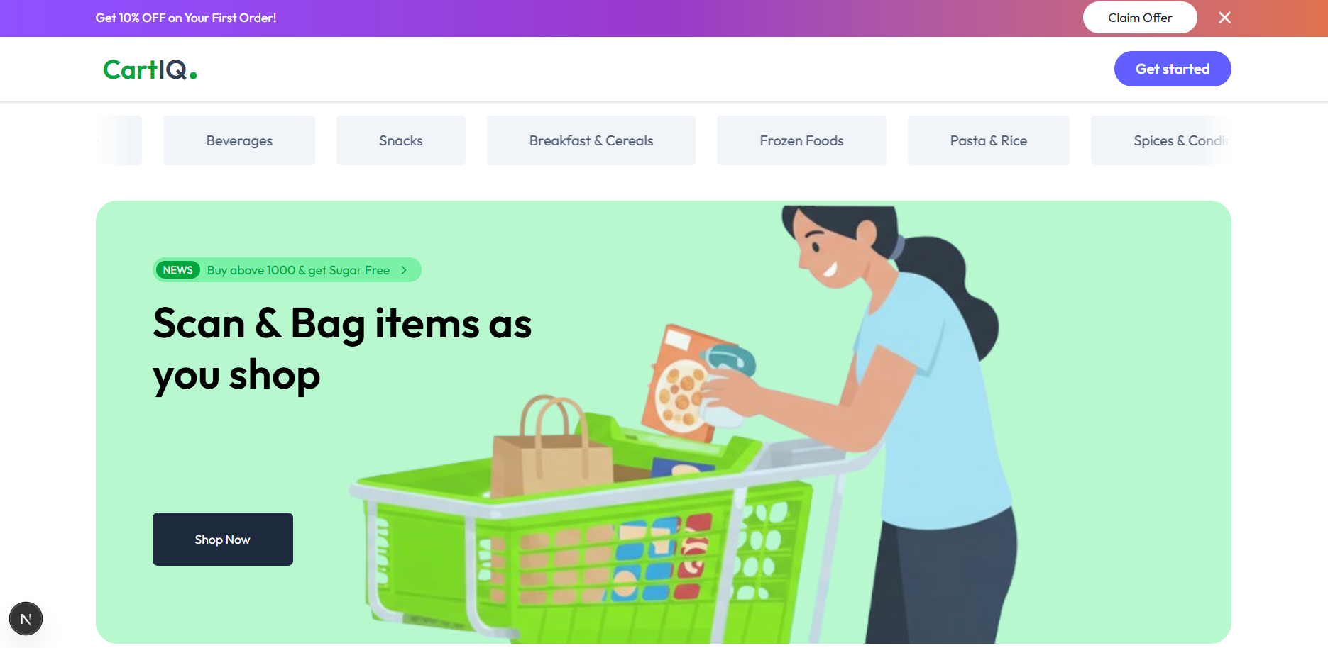

7. WEB PAGES DESCRIPTION
The Smart AI-Based Checkout System also provides a web-based interface for store administrators and backend management. This interface helps manage products, monitor sales, and analyze customer behavior.

7.1 Home Page
- Purpose: Provides a dashboard view for administrators and store managers.
- Features:
  - Quick overview of total products, sales, and transactions.
  - Graphical representation of sales trends.
  - Quick links to product management and settings.

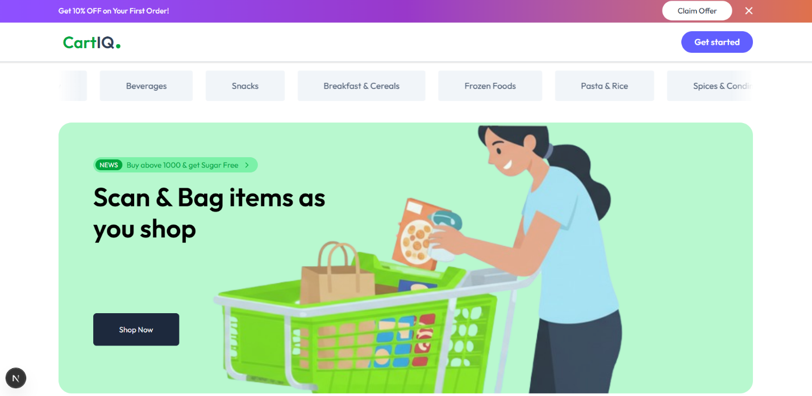

7.2 Product Management Page
- Purpose: Manage all products in the system.
- Features:
  - Add new products with images, prices, and categories.
  - Update product details.
  - Delete outdated or unavailable products.
  - View stock availability.
Admin Product Page Layout:

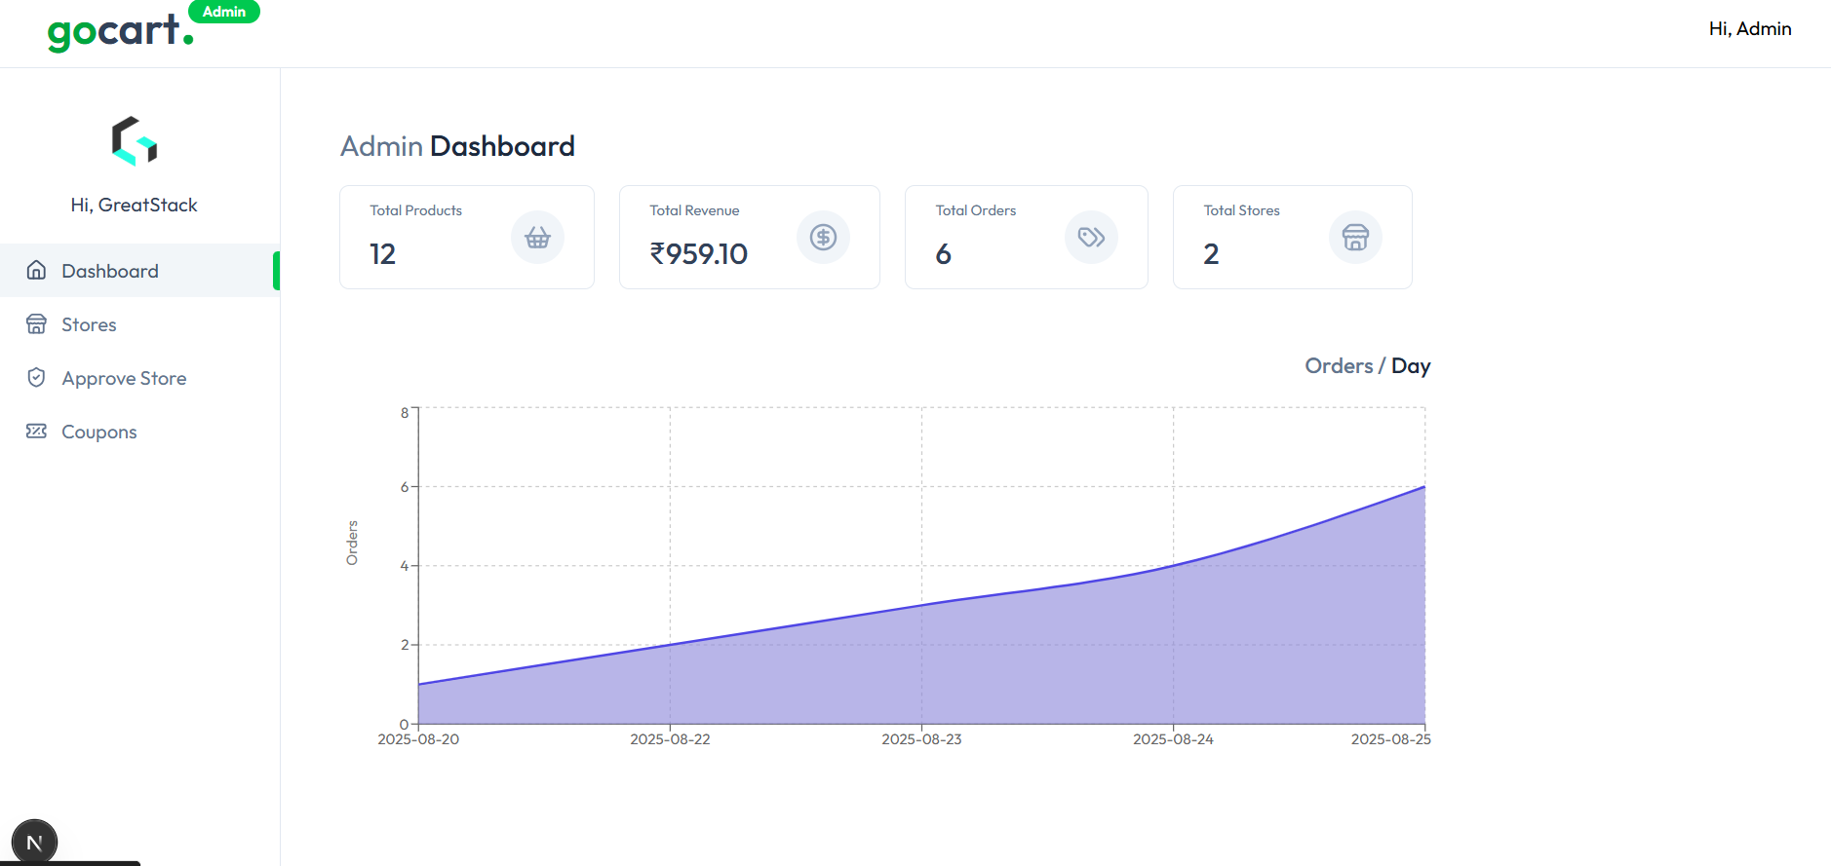

7.3 Billing and Transaction Page
- Purpose: Allows administrators to view all transactions and generate reports.
- Features:
  - View detailed invoices for each checkout session.
  - Filter transactions by date, product, or customer.
  - Export billing reports in Excel/PDF format.

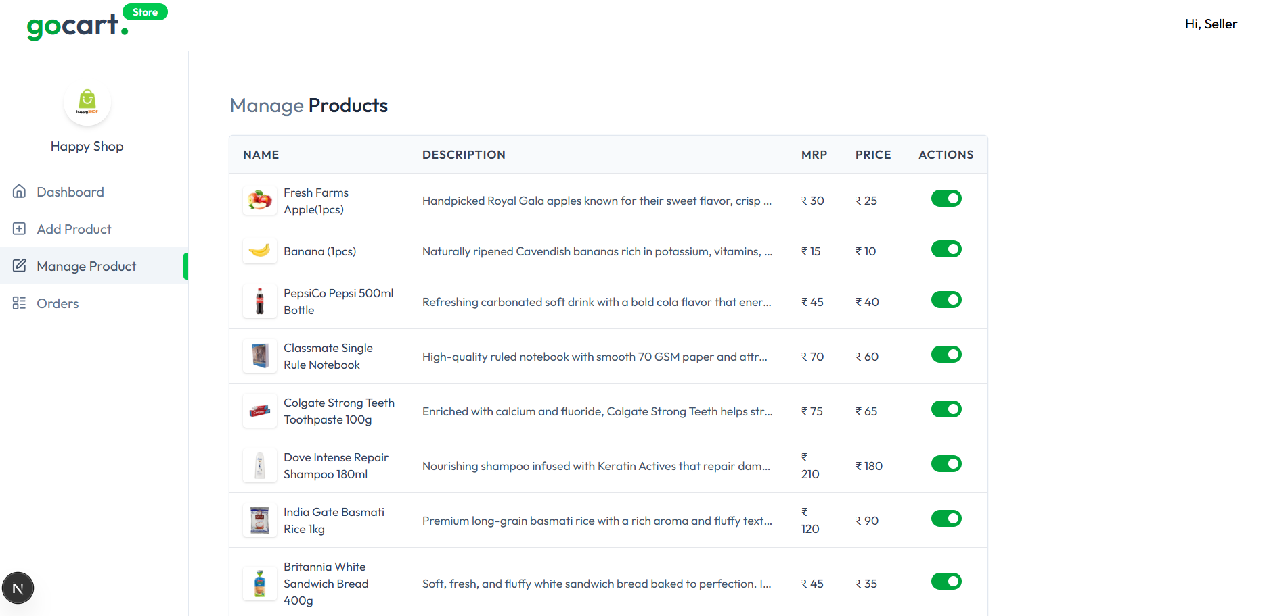
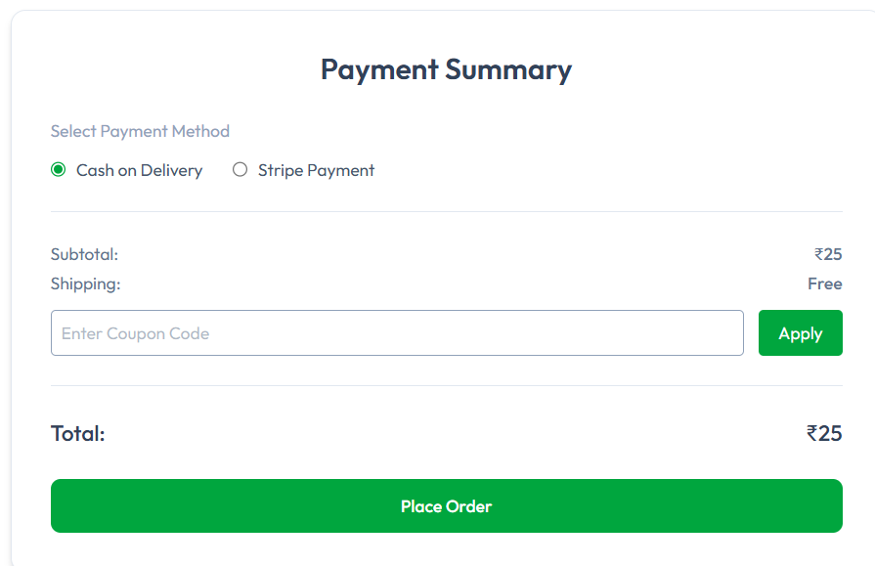

7.4 User Management Page
- Purpose: Manage users who have access to the system (staff or admin accounts).
- Features:
  - Add, remove, or update user accounts.
  - Assign roles and permissions.
  - Monitor login activity.

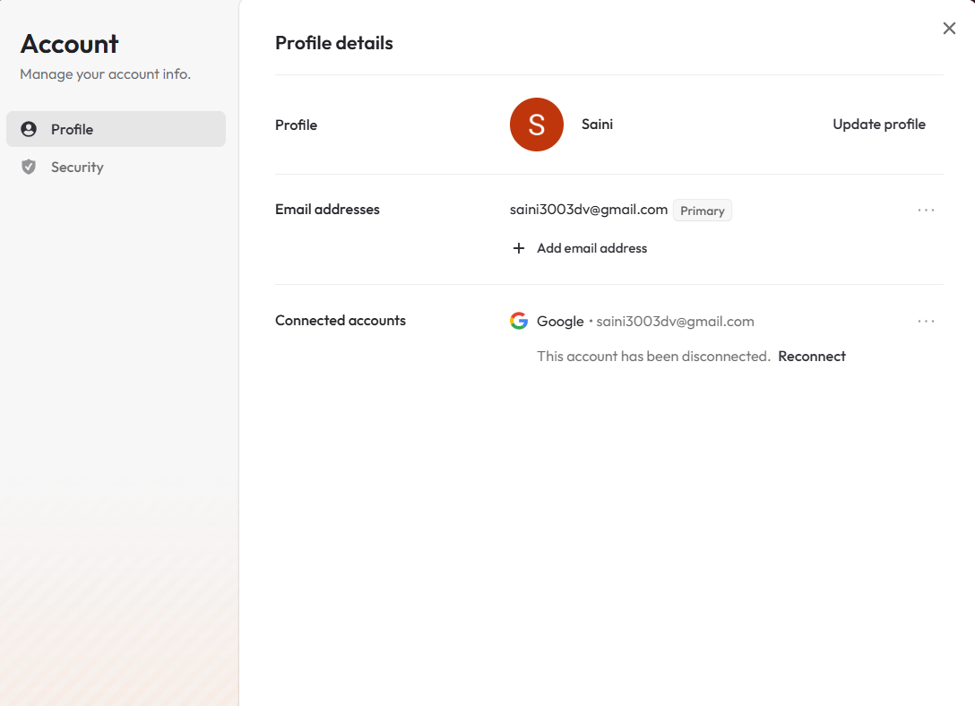

7.5 Analytics & Reports Page
- Purpose: Provide insights into sales, popular products, and inventory status.
- Features:
  - Graphs and charts showing top-selling products.
  - Daily, weekly, monthly sales statistics.
  - Predictive analysis for inventory restocking.

7.6 Responsive and Interactive Design
- All pages are responsive and work on desktops, tablets, and smart cart displays.
- Provides interactive buttons, charts, and alerts to improve user experience.
- Designed using React.js for frontend interactivity and REST APIs for backend communication.

7.7 Conclusion of UI/UX and Web Pages
The UI/UX and web interface design of the Smart AI-Based Checkout System Cart ensures:
- Ease of use for customers during shopping.
- Efficient management for store administrators.
- Real-time updates of products, billing, and transactions.
- Scalable architecture for future enhancements like mobile app integration or advanced analytics.

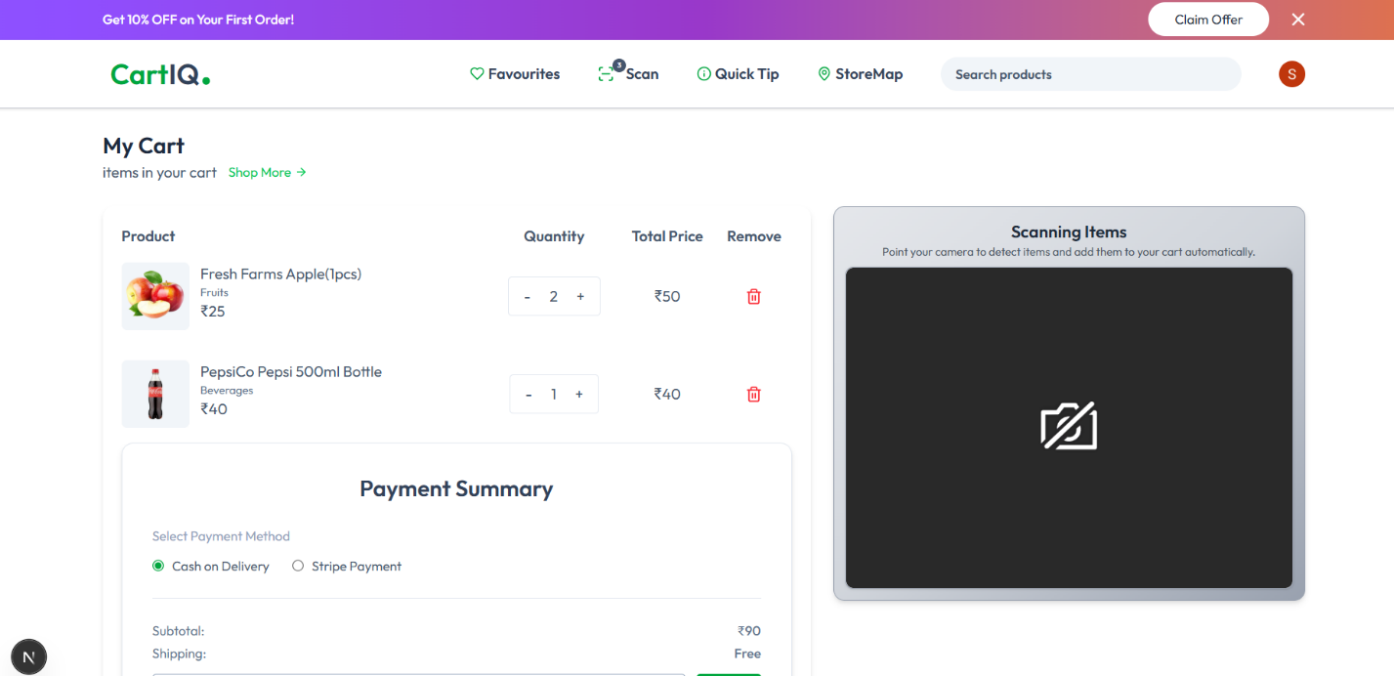

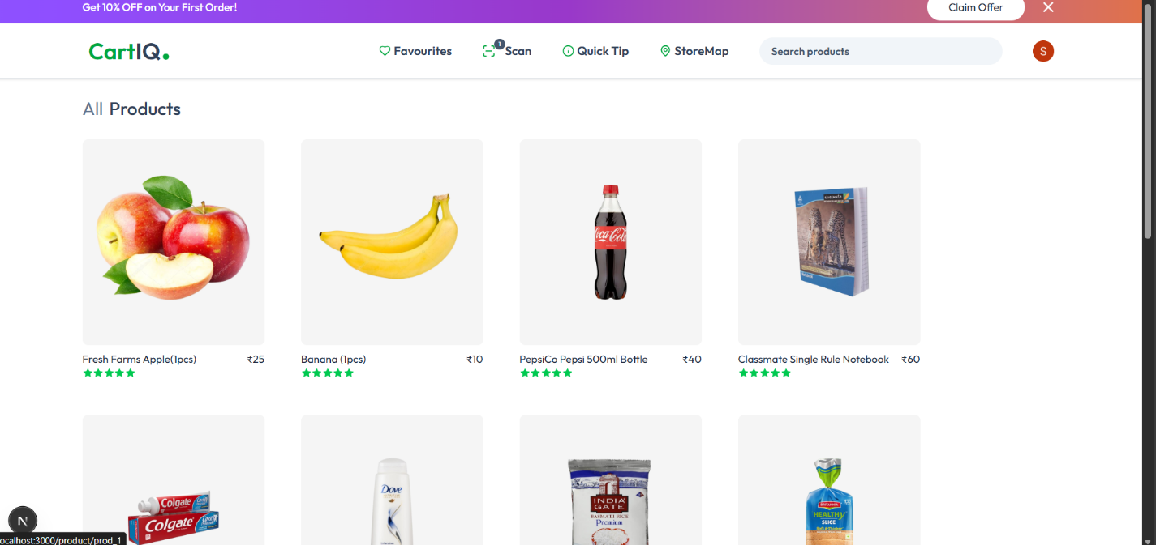

8. BACKEND ARCHITECTURE
The backend architecture is the backbone of the Smart AI-Based Checkout System Cart, responsible for processing data, managing databases, and handling transactions. It ensures seamless communication between the AI module, database, and frontend interface.

8.1 Overview of Backend Architecture
The backend is designed as a modular, scalable, and secure system. It consists of three layers:
- Database Layer – Stores product information, transactions, and inventory.
- Server Layer – Handles requests from AI modules and frontend interfaces.
- Application Logic Layer – Implements billing, authentication, and inventory management algorithms.
The architecture allows simultaneous handling of multiple smart carts in a supermarket without delay.

8.2 Components of Backend Architecture
8.2.1 Database Layer
- Technology: MongoDB / Firebase
- Purpose: Store product details, stock, prices, and transactions.
- Structure:
  - Products Collection: ProductID, Name, Category, Price, Stock
  - Transactions Collection: TransactionID, Product List, Total, Date, Payment Status
  - Users Collection: UserID, Name, Role, Credentials

8.2.2 Server Layer
- Technology: Node.js, Express.js
- Purpose:
  - Receive product IDs from the AI module.
  - Query database for product information.
  - Calculate total bill and taxes.
  - Generate invoices and update inventory.
8.2.3 Security Layer
- Handles authentication for admin and staff accounts.
- Encrypts sensitive information like payment details.
- Prevents unauthorized access to the system.
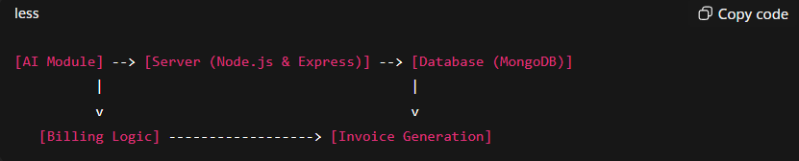
Backend Flow Diagram (Text Representation):

8.3 API Structure
The backend exposes REST APIs to communicate with frontend and AI modules:
- /getProductDetails – Fetches product info from database.
- /generateBill – Computes total bill and returns invoice.
- /updateInventory – Updates stock after transaction.
- /addProduct / removeProduct / updateProduct – CRUD operations for product management.
Example API Call:
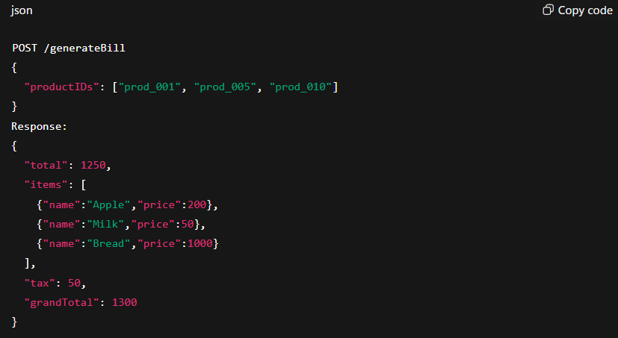

9. FRONTEND ARCHITECTURE
The frontend architecture represents the user interface for customers and admin users. It is designed for ease of use, real-time updates, and responsiveness.

9.1 Overview of Frontend Architecture
- Developed using React.js for modularity and performance.
- Uses REST APIs to communicate with backend.
- Provides interactive UI for both customers (cart display) and admins (web dashboard).

9.2 Components of Frontend Architecture
- Customer Interface (Cart Display):
  - Shows detected products, individual prices, and total bill.
  - Allows quantity adjustments and removal of products.
  - Displays payment options and confirmation messages.
- Admin Interface (Web Dashboard):
  - Product Management: Add, update, delete products.
  - Transaction Overview: View invoices and sales reports.
  - User Management: Assign roles and permissions.
  - Analytics: Graphical charts of sales trends, top-selling products, and inventory status.
- UI Libraries:
  - Tailwind CSS for responsive styling.
  - Recharts for analytics graphs.
9.3 Frontend Flow
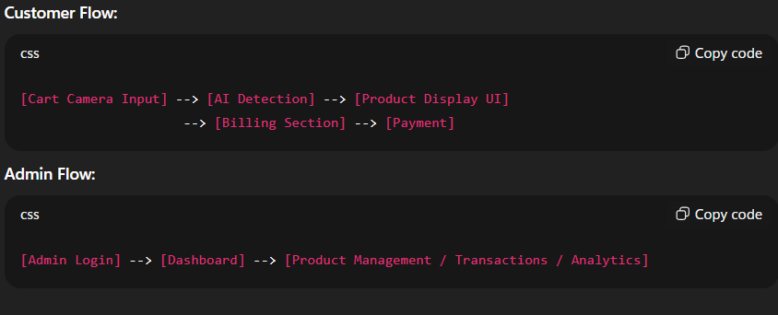

The backend exposes REST APIs to communicate with frontend and AI modules:
- /getProductDetails – Fetches product info from database.
- /generateBill – Computes total bill and returns invoice.
- /updateInventory – Updates stock after transaction.
- /addProduct / removeProduct / updateProduct – CRUD operations for product management.
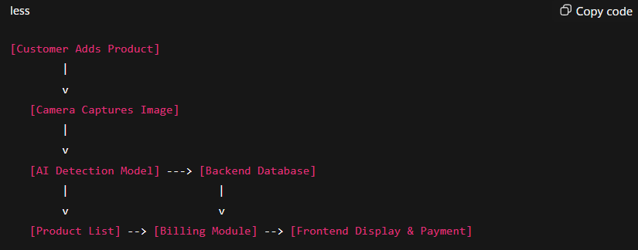

10. SITE OVERVIEW
The Site Overview provides a complete picture of how the Smart AI-Based Checkout System Cart operates in a real-world retail environment. It explains the integration of hardware, software, and user interfaces, showing how the system functions from the moment a customer starts shopping until the payment is completed.
This section ensures that the reader understands the full workflow, modules, and interactions between the components of the smart cart system.

10.1 Objective of Site Overview
The main objectives of the site overview are:
- To explain how the smart cart functions in a supermarket or retail store.
- To provide a visual and textual representation of the system workflow.
- To describe the interaction between AI detection, backend processing, frontend UI, and payment system.
- To highlight the advantages of integrated, automated checkout systems for both customers and store administrators.

10.2 System Modules Overview
10.2.1 Smart Cart Module
- Equipped with a camera, processing unit (Raspberry Pi), optional load sensors, and a display screen.
- Captures images of products in the cart in real time.
- Sends captured images to the AI module for object detection.
- Displays the recognized products and total bill to the customer.
10.2.2 AI & Processing Module
- Uses YOLOv5 / TensorFlow models for product recognition.
- Processes images captured by the camera to detect multiple items simultaneously.
- Sends product IDs to the backend for price lookup and billing.
10.2.3 Backend Module
- Built with Node.js and Express.js for server-side operations.
- Connects to a MongoDB / Firebase database that stores product information, inventory, and transaction history.
- Performs billing calculations, updates inventory, and generates invoices in real time.
10.2.4 Frontend Module
- Displays recognized products, prices, and total bill on a cart-mounted screen for customers.
- Provides interactive features to adjust quantities or remove items.
- Admin web interface allows management of products, transactions, and users.

10.3 Workflow of the Site
The workflow of the system shows the interaction between modules and the step-by-step process of a smart cart session:
- Product Placement: Customer places items into the smart cart.
- Image Capture: Cart-mounted camera captures images of all items.
- Object Detection: AI module detects products and generates a list of product IDs.
- Database Query: Backend retrieves product names, prices, and availability.
- Billing: Billing module calculates the subtotal, taxes, discounts, and total bill.
- Display: Frontend interface displays the bill to the customer in real time.
- Payment: Customer completes payment via UPI, card, wallet, or cash.
- Inventory Update: Database updates stock levels and logs the transaction.
Text-Based System Flow Diagram:
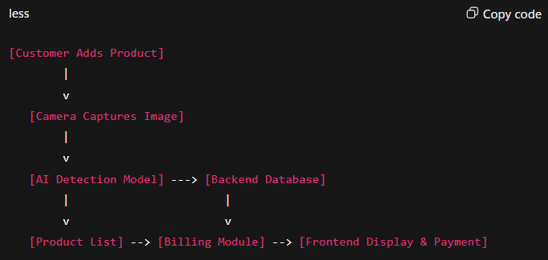

10.4 Interaction Between Modules
- Smart Cart ↔ AI Module:
  - Camera continuously captures images.
  - AI detects items and generates product IDs.
- AI Module ↔ Backend:
  - Detected product IDs are sent to the backend for price and inventory verification.
  - Backend returns detailed product information and bill calculation.
- Backend ↔ Frontend:
  - Sends real-time updates to cart display.
  - Generates invoice for payment processing.
- Frontend ↔ Customer:
  - Provides visual confirmation of products, prices, and total.
  - Allows interaction for removing items or adjusting quantities.

10.5 Advantages of Site Overview Design
- Seamless Integration: Hardware, AI, backend, and frontend modules work together in real time.
- Time Efficiency: Customers can checkout in seconds without waiting in queues.
- Accuracy: AI detection and automated billing reduce errors.
- Inventory Management: Real-time stock updates help avoid overstocking or shortages.
- User-Friendly: Both customers and admins benefit from an intuitive interface.
- Scalable: Multiple smart carts can work in parallel in a large store.

10.6 Conclusion of Site Overview
The Site Overview of the Smart AI-Based Checkout System Cart demonstrates how hardware, AI, software, and user interfaces integrate to create a fully automated retail solution. By streamlining the checkout process, reducing human errors, and providing real-time analytics, the system enhances customer experience and improves operational efficiency.
This overview serves as a foundation for understanding the detailed Admin Panel, Features, Challenges, and Solutions sections in the subsequent chapters of the project report.

11. ADMIN PANEL
The Admin Panel is a critical component of the Smart AI-Based Checkout System Cart. It provides store administrators and managers with complete control over the system. Through this panel, admins can manage products, monitor transactions, control users, and generate reports. The panel ensures that the system operates smoothly, securely, and efficiently.

11.1 Purpose of Admin Panel
The Admin Panel serves the following purposes:
- Product Management: Add, edit, and remove products, along with stock control.
- Transaction Monitoring: Track all checkout sessions and generate invoices.
- User Management: Manage staff and admin accounts, with role-based access.
- Inventory Control: Maintain up-to-date product stock levels.
- Reporting & Analytics: Generate insights for business planning.
- Alerts & Notifications: Monitor low stock, failed transactions, or system errors.

11.2 Admin Panel Modules
11.2.1 Dashboard Module
- Provides a quick overview of the store’s operations.
- Displays total sales, total products, active carts, and pending alerts.
- Uses charts and graphs for visualization of daily, weekly, and monthly data.

Example Layout:
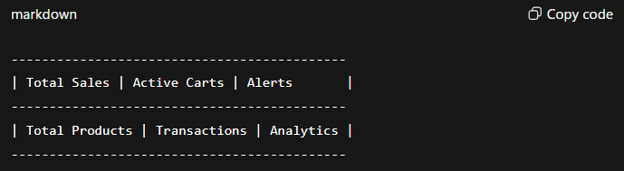

11.2.2 Product Management Module
- Allows adding new products with images, price, category, and stock quantity.
- Enables editing existing product details.
- Supports removing discontinued products from the database.
- Provides search and filter options to easily locate products.

Product Management Layout:
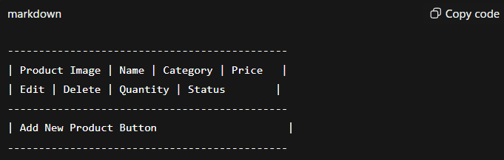

11.2.3 Transaction Monitoring Module
- Tracks all checkout transactions in real time.
- Provides filter options by date, product, or customer.
- Generates transaction reports in Excel or PDF.
- Detects anomalies such as canceled, duplicate, or failed transactions.

11.2.4 User Management Module
- Admins can create, update, or delete staff accounts.
- Assign roles and permissions (e.g., Admin, Cashier, Manager).
- Track login activity for security purposes.

11.2.5 Analytics and Reporting Module
- Generates sales trends, top-selling products, and low-stock alerts.
- Provides daily, weekly, monthly sales reports for business planning.
- Uses charts and graphs for visual representation.

11.2.6 Alerts & Notifications Module
- Sends alerts for:
  - Low stock items.
  - Hardware or software issues.
- Ensures proactive problem-solving by administrators.

11.3 Advantages of Admin Panel
- Centralized Control: Admin can manage all aspects of the system from one interface.
- Efficiency: Reduces manual effort in managing products, transactions, and users.
- Real-Time Monitoring: Immediate updates on sales, stock, and system performance.
- Data-Driven Decisions: Analytics help optimize inventory and increase revenue.
- Security: Role-based access ensures sensitive data is protected.

11.4 Admin Panel User Interface Design
- Header: Store name and quick access menu.
- Sidebar Navigation: Dashboard, Product Management, Transactions, Users, Analytics, Settings.
- Main Area: Displays selected module (e.g., product list, charts, transaction table).
- Interactive Components: Buttons, modals, and forms for CRUD operations.
- Notifications: Alerts appear on the dashboard in real time.

11.6 Conclusion of Admin Panel
The Admin Panel is a comprehensive control hub for the Smart AI-Based Checkout System Cart. It ensures efficient management of products, users, and transactions, provides real-time monitoring, and enables data-driven business decisions. The combination of intuitive UI, analytics, and security features makes it an essential part of the smart checkout ecosystem.

12. FEATURES
The Smart AI-Based Checkout System Cart is designed to provide a fast, accurate, and automated shopping experience. Its features combine AI-based product detection, automated billing, real-time inventory management, and user-friendly interfaces, making it an innovative solution for modern retail stores.

12.1 AI-Based Product Recognition
- Uses YOLOv5 / TensorFlow CNN models to detect products in the cart.
- Captures images via a cart-mounted camera and identifies multiple items simultaneously.
- Eliminates the need for manual barcode scanning, saving time during checkout.
- Can handle various packaging types, sizes, and orientations.
- Improves accuracy over time through dataset updates and model retraining.
Advantages:
- Reduces human error.
- Enhances checkout speed.
- Ensures accurate product identification even in crowded carts.

12.2 Automated Billing
- Calculates subtotal, taxes, discounts, and total bill automatically.
- Generates digital invoices that can be displayed on the cart screen or printed if required.
- Supports multiple payment methods:
  - UPI
  - Credit/Debit Cards
  - Digital Wallets
  - Cash (optional for hybrid stores)
Advantages:
- Reduces billing errors.
- Speeds up the checkout process.
- Provides a seamless, contactless payment experience.

12.3 Real-Time Inventory Management
- Updates stock automatically after each transaction.
- Alerts admins for low-stock products.
- Helps prevent overstocking or stockouts.
- Stores historical sales data for future demand prediction.
Advantages:
- Optimizes inventory management.
- Reduces losses due to unsold or expired products.
- Supports automated restocking decisions.

12.4 User-Friendly Interface
- Cart Display UI: Shows recognized products, quantity, price, and total bill.
- Interactive Features: Allows customers to remove items or adjust quantity.
- Admin Dashboard: Provides easy navigation for managing products, transactions, and users.
- Responsive Design: Works on desktop, tablet, or cart-mounted screens.
Advantages:
- Ensures smooth and intuitive user experience.
- Reduces confusion for both customers and staff.
- Enhances accessibility with large fonts and clear icons.

12.5 Security and Authentication
- Secure login for admin and staff accounts.
- Role-based access ensures that sensitive functions are only available to authorized users.
- Encrypts payment and transaction data to protect customer privacy.
- Maintains audit trails for all system operations.
Advantages:
- Protects sensitive data.
- Prevents unauthorized access or misuse.
- Ensures accountability of all users.

12.6 Analytics and Reporting
- Provides detailed sales reports (daily, weekly, monthly).
- Shows top-selling products and trends for business planning.
- Helps predict demand and optimize inventory using data-driven insights.
- Visualizes data using charts, graphs, and dashboards.
Advantages:
- Supports strategic decision-making.
- Improves store efficiency and revenue.
12.7 Scalability and Flexibility
- Supports multiple smart carts operating in parallel in the same store.
- Modular design allows integration of new features:
  - Mobile app for remote monitoring.
  - Loyalty programs or discounts.
  - AI-powered recommendations for customers.
Advantages:
- Future-proof system design.
- Easy to upgrade and expand based on business requirements.
- Supports growth of retail operations without major system changes.

12.8 Summary of Key Features
Feature | Description | Benefits
AI-Based Product Recognition | Detects products automatically | Reduces manual effort and errors
Automated Billing | Calculates totals and generates invoices | Fast, accurate checkout
Real-Time Inventory Management | Updates stock and alerts low-stock items | Efficient inventory control
User-Friendly Interface | Cart display and admin dashboard | Smooth and intuitive experience
Security & Authentication | Role-based access, data encryption | Protects sensitive data
Analytics & Reporting | Visual reports on sales & trends | Supports data-driven decisions
Scalability & Flexibility | Supports multiple carts, new features | Future-ready system

12.9 Conclusion of Features
The features of the Smart AI-Based Checkout System Cart provide a comprehensive solution for modern retail environments. They ensure:
- Fast and efficient checkout for customers.
- Accurate billing and inventory management for store administrators.
- Data-driven insights for better decision-making.
- Future scalability for adding new functionalities.

13. CHALLENGES AND SOLUTIONS
Developing the Smart AI-Based Checkout System Cart presented multiple technical, operational, and usability challenges. This section highlights the key challenges faced during the project and the solutions implemented to overcome them. Understanding these challenges demonstrates the practical aspects of designing a smart retail system.

13.1 AI and Product Recognition Challenges
Challenge 1: Product Detection Accuracy
- AI models initially struggled to detect overlapping or similarly packaged products.
- Misclassification occurred when items were partially obscured or stacked.
Solution:
- Improved dataset quality by including multiple angles, lighting conditions, and product variations.
- Implemented YOLOv5 model with data augmentation, improving detection accuracy.
- Added cross-verification using optional load sensors to validate AI detection.

Challenge 2: Real-Time Processing
- AI processing on Raspberry Pi faced latency issues for real-time detection.
Solution:
- Optimized AI model using TensorRT and lightweight CNN models.
- Implemented frame skipping and selective processing to reduce processing load.
- Ensured real-time results without compromising detection accuracy.

13.2 Hardware Challenges
Challenge 3: Camera Positioning and Lighting
- Improper camera placement led to blurred images and missed detections.
- Variations in store lighting affected detection accuracy.
Solution:
- Mounted cameras at optimal angles and height to cover entire cart surface.
- Used LED lighting strips on the cart to maintain consistent lighting for AI detection.
Challenge 4: Power and Connectivity Issues
- Continuous operation of cameras, sensors, and displays consumed significant power.
- Occasional network disruptions affected real-time database updates.
Solution:
- Used high-capacity rechargeable batteries with voltage stabilizers.
- Implemented offline caching mechanism, allowing temporary local storage until network reconnects.

13.3 Software Challenges
Challenge 5: Backend Scalability
- Handling multiple carts and simultaneous transactions could overload the server.
Solution:
- Designed a modular backend architecture using Node.js and MongoDB.
- Implemented asynchronous request handling to manage multiple cart sessions efficiently.
- Used database indexing and caching for faster query responses.
Challenge 6: Data Security
- Ensuring secure transactions and sensitive data protection was a critical requirement.
Solution:
- Implemented role-based access control for admin and staff users.
- Encrypted all sensitive data (payment info, credentials) using AES and SSL protocols.
- Maintained audit logs for all activities to ensure accountability.

13.4 User Experience Challenges
Challenge 7: Cart UI and Usability
- Initial UI designs were cluttered and confusing for customers.
- Customers found it difficult to manually adjust or remove misclassified items.
Solution:
- Redesigned the interface with simplified layout, large fonts, and clear icons.
- Added interactive touch features for removing or adjusting items.
- Ensured real-time feedback messages for every action.

Challenge 8: Admin Panel Complexity
- Admin panel initially had too many nested menus, making navigation difficult.
Solution:
- Simplified layout with sidebar navigation, dashboard overview, and module-based structure.
- Integrated search and filter options for easy access to products, transactions, and reports.
13.5 Integration Challenges
Challenge 9: Hardware-Software Synchronization
- Synchronizing camera, AI module, backend server, and frontend display in real time was challenging.
Solution:
- Defined clear data flow protocols between modules.
- Used REST APIs for communication between AI, backend, and frontend.
- Implemented error handling and retry mechanisms to prevent data loss or delays.

13.6 Summary of Challenges and Solutions
Challenge | Solution
Product detection accuracy | Improved dataset, data augmentation, cross-verification with load sensors
Real-time processing | Optimized AI models, selective frame processing
Camera positioning & lighting | Optimal mounting, LED lighting strips
Power & connectivity | High-capacity batteries, offline caching
Backend scalability | Modular architecture, asynchronous requests, caching
Data security | Role-based access, data encryption, audit logs
Cart UI usability | Simplified layout, interactive touch features, real-time feedback
Admin panel complexity | Sidebar navigation, module-based layout, filters
Hardware-software sync | Clear data flow, REST APIs, error handling
Multi-cart coordination | Unique session IDs, asynchronous handling, database locks
14. CONCLUSION
The Smart AI-Based Checkout System Cart represents a significant advancement in modern retail technology. By integrating AI-based product recognition, automated billing, real-time inventory management, and a user-friendly interface, the system addresses the common challenges of manual checkout processes, such as long queues, billing errors, and inefficient inventory tracking.

14.1 Key Achievements
- AI-Powered Product Detection:
  - The system accurately detects multiple products simultaneously using advanced YOLOv5 / TensorFlow CNN models.
  - Reduces manual scanning, saving time for both customers and store staff.
- Automated Billing System:
  - Calculates total cost, including taxes and discounts, automatically.
  - Generates digital invoices instantly, supporting multiple payment methods.
- Real-Time Inventory Management:
  - Updates product stock in the database automatically after every transaction.
  - Alerts administrators for low-stock products, preventing shortages or overstocking.
- Efficient Admin Panel:
  - Provides a comprehensive control hub for managing products, users, and transactions.
  - Includes analytics and reporting tools for informed business decisions.

14.2 Advantages of the System
- Time-Saving: Customers can complete checkout in seconds, reducing queues and waiting times.
- Accuracy: AI detection and automated billing reduce errors in product identification and pricing.
- Operational Efficiency: Admins can manage multiple carts, products, and transactions seamlessly.
- Scalability: The system is modular and can be upgraded with new features like mobile apps or loyalty programs.
- Data-Driven Decisions: Analytics provide insights for sales trends, inventory management, and business strategy.
- Security: Encrypted transactions and role-based access protect sensitive data.

14.3 Lessons Learned
- Integration is Key: Proper synchronization between hardware, AI, backend, and frontend modules is crucial for smooth operations.
- User-Centric Design: Both customer and admin interfaces must prioritize ease of use, clarity, and responsiveness.
- Continuous Improvement: AI detection accuracy improves with dataset expansion, augmentation, and model retraining.
- Scalable Architecture: Modular design ensures the system can handle multiple carts and future upgrades efficiently.
- Problem-Solving Skills: Overcoming challenges in AI processing, hardware limitations, and real-time communication strengthened technical and practical skills.

14.4 Future Applications
The system can be adapted for larger retail chains, convenience stores, and smart warehouses, offering:
- Predictive Inventory Management: Using AI to forecast demand and automate restocking.
- Customer Personalization: Recommending products based on shopping history.
- Integration with Mobile Apps: Allowing customers to monitor their carts remotely.
- Loyalty Programs and Discounts: Automated integration with customer accounts.
- Advanced Analytics: Using machine learning to predict trends and optimize store layouts.

15. FUTURE SCOPE
The Smart AI-Based Checkout System Cart is a pioneering project that demonstrates the potential of AI and automation in retail. While the current system provides a highly efficient and reliable checkout process, there are several avenues for enhancement, expansion, and research that can further improve its functionality and application.

15.1 Integration with Mobile Applications
- Development of a mobile app for customers to track items in their cart remotely.
- Features like pre-ordering, automatic payment, and digital receipts can be integrated.
- Notifications on offers, discounts, or low-stock items can enhance the shopping experience.
Benefits:
- Improves customer convenience and satisfaction.
- Reduces dependency on in-store displays.

15.2 Advanced AI Capabilities
- Predictive Shopping Recommendations: Suggest products based on customer purchase history.
- Improved Object Recognition: Include non-standard packaging or bulk items in detection models.
Benefits:
- Personalized shopping experience.
- Enhances efficiency and accuracy in product identification.

15.3 Enhanced Inventory Management
- Use AI to predict demand and optimize stock levels.
- Integrate automated restocking alerts to suppliers.
- Analyze sales trends and seasonal demand to reduce wastage.
Benefits:
- Minimizes stockouts and overstocking.
- Supports data-driven inventory planning.

15.4 Multi-Cart and Multi-Store Synchronization
- Enable simultaneous operation of multiple carts across large stores or shopping malls.
- Synchronize real-time data across stores to provide a centralized analytics dashboard.
- Implement cloud-based architecture for scalability.
Benefits:
- Supports large-scale retail operations.
- Improves efficiency and centralized monitoring.

16. REFERENCES
The following references were consulted and used to develop and design the Smart AI-Based Checkout System Cart:
- Aurélien Géron, Hands-On Machine Learning with Scikit-Learn, Keras, and TensorFlow, 2nd Edition, O’Reilly Media, 2019.
- Joseph Redmon et al., YOLOv3: An Incremental Improvement, arXiv preprint, 2018.
- Ian Goodfellow, Yoshua Bengio, Aaron Courville, Deep Learning, MIT Press, 2016.
- Raspberry Pi Foundation, Raspberry Pi 4 Hardware Documentation, 2022.
- MongoDB Documentation, MongoDB Atlas Cloud Database and CRUD Operations, 2023.
- TensorFlow Documentation, TensorFlow Object Detection API Guide, 2023.
- Node.js Documentation, Building Scalable Backend APIs, 2023.
- IEEE Standards for Smart Retail Systems and AI-based Checkout Automation, 2022.
- Research papers and articles from arXiv.org on AI object detection, smart retail automation, and computer vision applications.
- Online tutorials and resources for YOLOv5, TensorFlow, and real-time AI processing.
Note: Additional resources included online forums, official hardware manuals, and vendor guides for Raspberry Pi, cameras, and sensors.

