**Analysis of 28 CiPA compounds**

Figures 3 to 30 below show the plots of the raw kinetic data used by CiPA in their most recent study (Li et al., 2018). The data was obtained from their GitHub site: <https://github.com/FDA/CiPA/tree/Brad-Sandbox/hERG_fitting> . For each figure there is an estimated IC50 and maximal inhibition, Imax, value based on analyzing the end of the experiment, the last millisecond of data i.e. when it reaches steady state, using:

A comparison of these dynamic IC50 values to the original static IC50s is shown in Figure 1, they appear to be similar. However, when deriving the dynamic IC50 it’s noticeable that for certain compounds the Imax value is very different to the standard value of 1 which is used when deriving the static IC50 value, see Figures 11 and 13 as an example. Therefore, when we calculate the fraction of block at the free Cmax value we find that static block (Bkr-static) does not necessarily correlate strongly with dynamic block (Bkr-dynamic) for all compounds, see Figure 2.

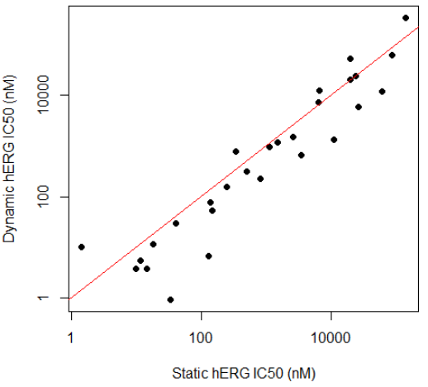

**Figure 1:** Plot comparing the static to dynamic IC50 values for the hERG channel.

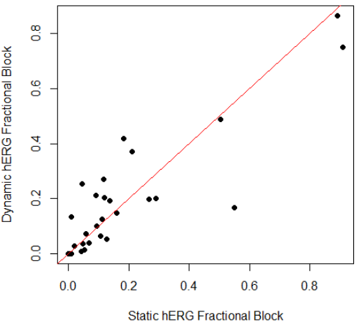

**Figure 2:** Plot comparing the static to dynamic fractional block at free Cmax.

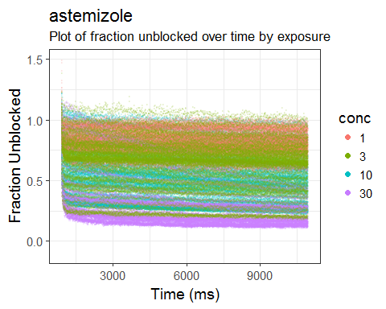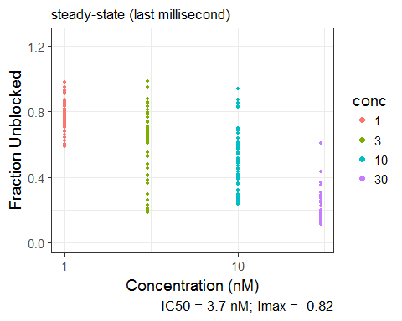

**Figure 3:** Top-panel: Fraction unblocked over time for increasing concentrations of astemizole. Bottom-panel: Fraction unblocked as a function of increasing drug concentration at steady-state (last millisecond of assay run-time).

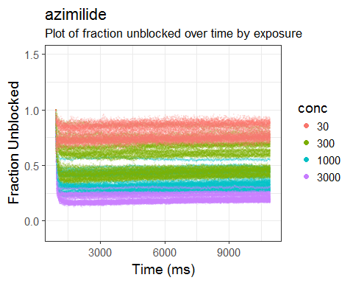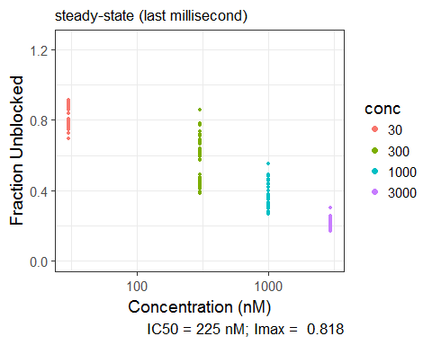

**Figure 4:** Top-panel: Fraction unblocked over time for increasing concentrations of azimilide. Bottom-panel: Fraction unblocked as a function of increasing drug concentration at steady-state (last millisecond of assay run-time).

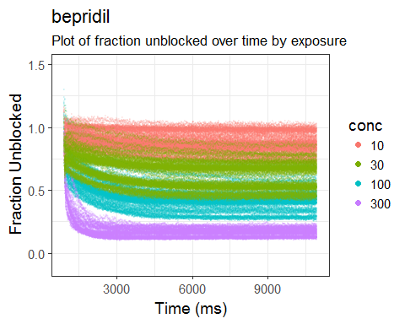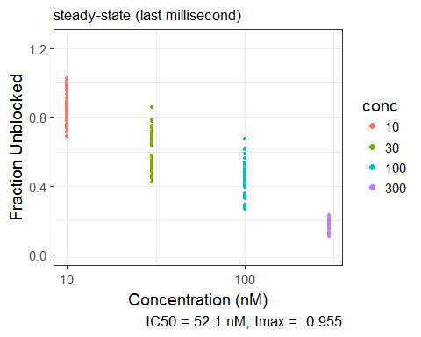

**Figure 5:** Top-panel: Fraction unblocked over time for increasing concentrations of bepridil. Bottom-panel: Fraction unblocked as a function of increasing drug concentration at steady-state (last millisecond of assay run-time).

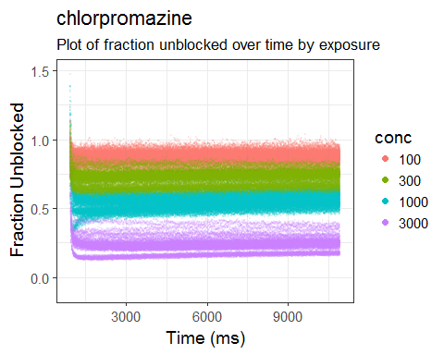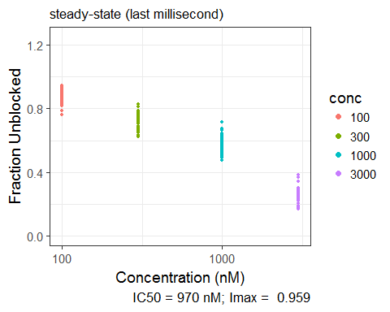

**Figure 6:** Top-panel: Fraction unblocked over time for increasing concentrations of chlorpromazine. Bottom-panel: Fraction unblocked as a function of increasing drug concentration at steady-state (last millisecond of assay run-time).

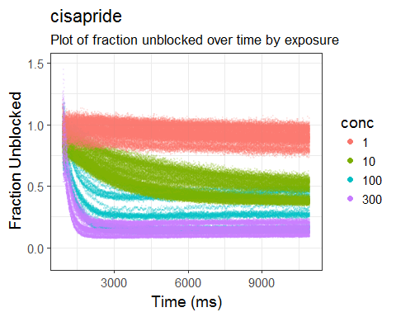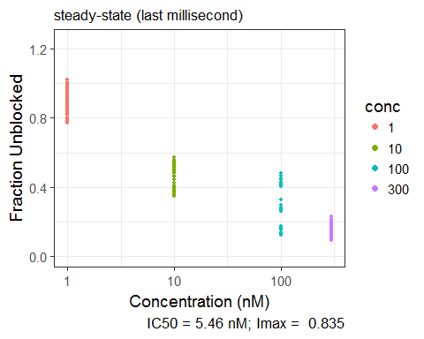

**Figure 7:** Top-panel: Fraction unblocked over time for increasing concentrations of cisapride. Bottom-panel: Fraction unblocked as a function of increasing drug concentration at steady-state (last millisecond of assay run-time).

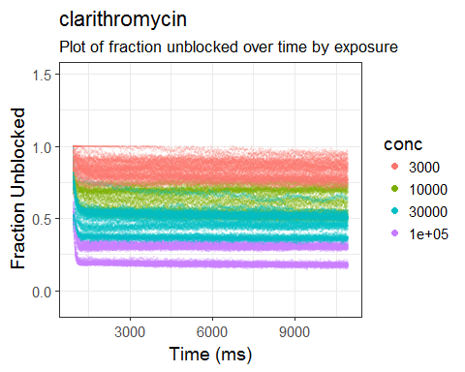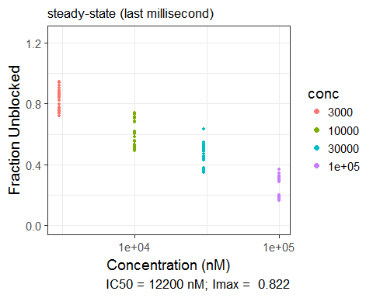

**Figure 8:** Top-panel: Fraction unblocked over time for increasing concentrations of clarithromycin. Bottom-panel: Fraction unblocked as a function of increasing drug concentration at steady-state (last millisecond of assay run-time).

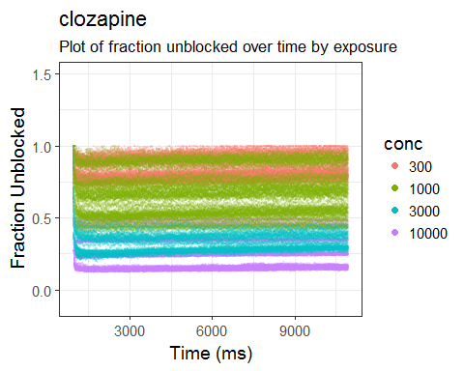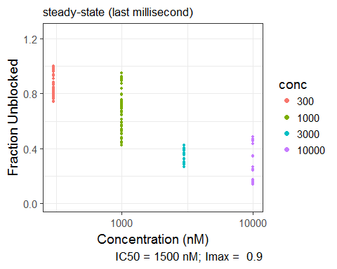

**Figure 9:** Top-panel: Fraction unblocked over time for increasing concentrations of clozapine. Bottom-panel: Fraction unblocked as a function of increasing drug concentration at steady-state (last millisecond of assay run-time).

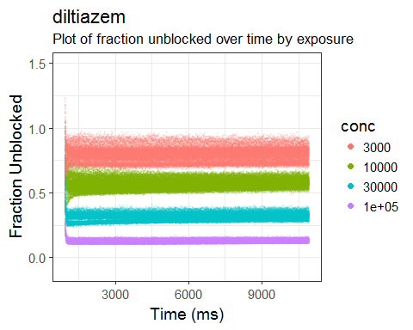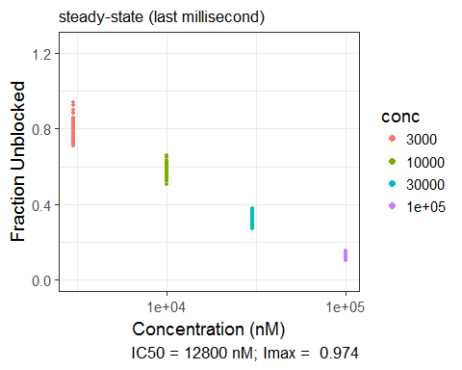

**Figure 10:** Top-panel: Fraction unblocked over time for increasing concentrations of diltiazem. Bottom-panel: Fraction unblocked as a function of increasing drug concentration at steady-state (last millisecond of assay run-time).

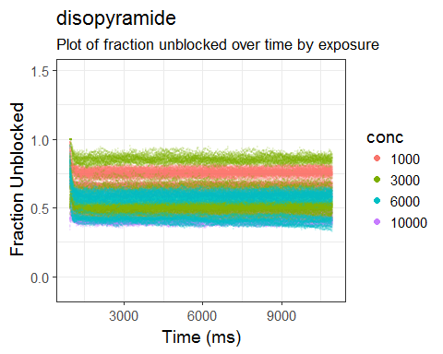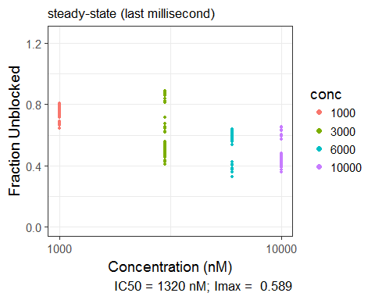

**Figure 11:** Top-panel: Fraction unblocked over time for increasing concentrations of disopyramide. Bottom-panel: Fraction unblocked as a function of increasing drug concentration at steady-state (last millisecond of assay run-time).

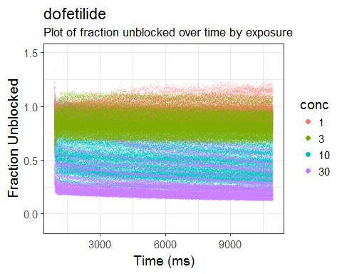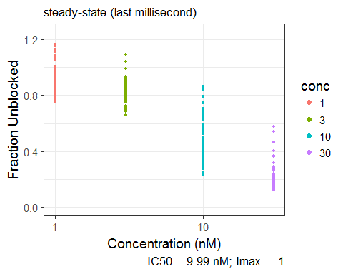

**Figure 12:** Top-panel: Fraction unblocked over time for increasing concentrations of dofetilide. Bottom-panel: Fraction unblocked as a function of increasing drug concentration at steady-state (last millisecond of assay run-time).

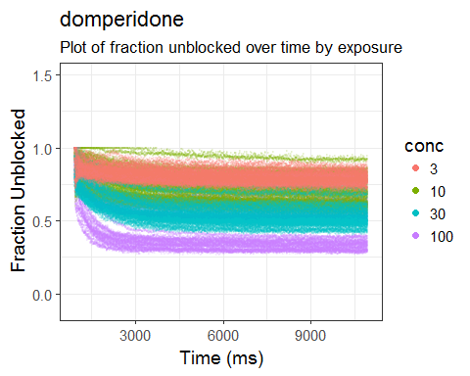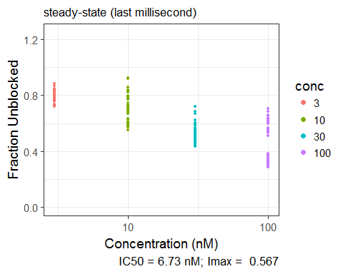

**Figure 13:** Top-panel: Fraction unblocked over time for increasing concentrations of domperidone. Bottom-panel: Fraction unblocked as a function of increasing drug concentration at steady-state (last millisecond of assay run-time).

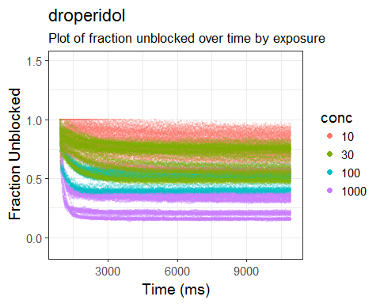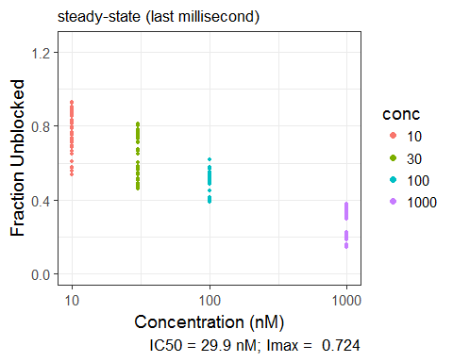

**Figure 14:** Top-panel: Fraction unblocked over time for increasing concentrations of droperidol. Bottom-panel: Fraction unblocked as a function of increasing drug concentration at steady-state (last millisecond of assay run-time).

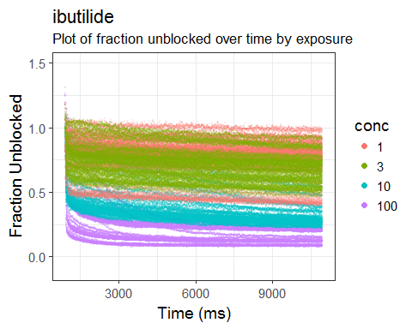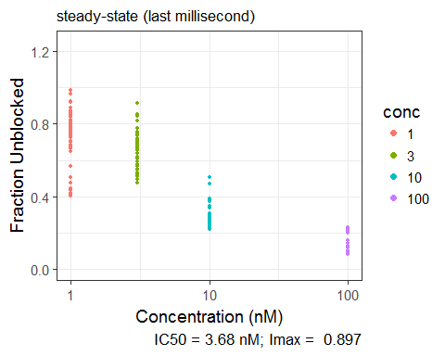

**Figure 15:** Top-panel: Fraction unblocked over time for increasing concentrations of ibutilide. Bottom-panel: Fraction unblocked as a function of increasing drug concentration at steady-state (last millisecond of assay run-time).

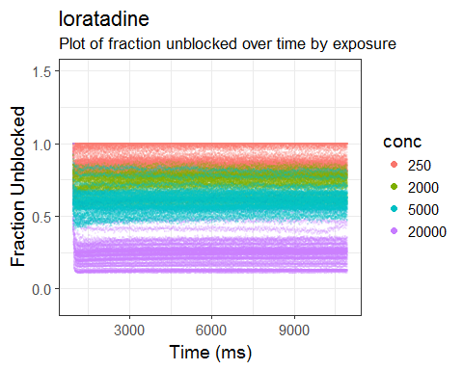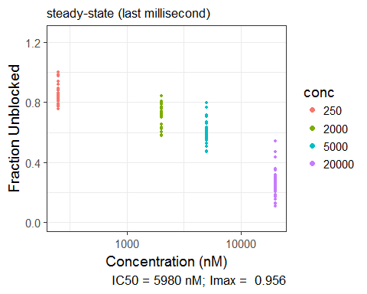

**Figure 16:** Top-panel: Fraction unblocked over time for increasing concentrations of loratadine. Bottom-panel: Fraction unblocked as a function of increasing drug concentration at steady-state (last millisecond of assay run-time).

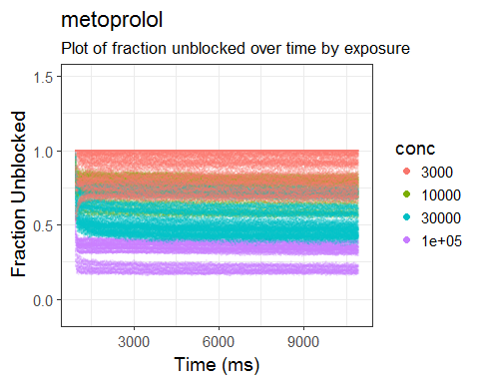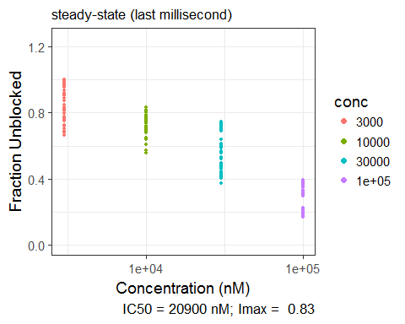

**Figure 17:** Top-panel: Fraction unblocked over time for increasing concentrations of metroprolol. Bottom-panel: Fraction unblocked as a function of increasing drug concentration at steady-state (last millisecond of assay run-time).

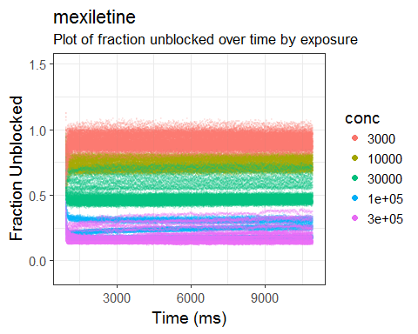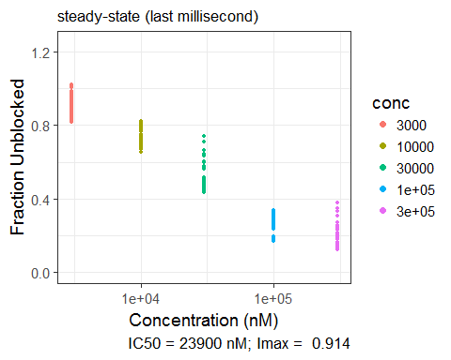

**Figure 18:** Top-panel: Fraction unblocked over time for increasing concentrations of mexiletine. Bottom-panel: Fraction unblocked as a function of increasing drug concentration at steady-state (last millisecond of assay run-time).

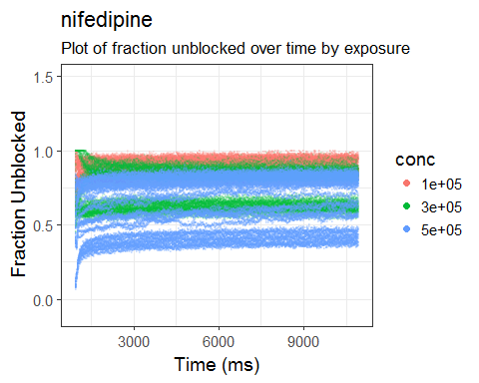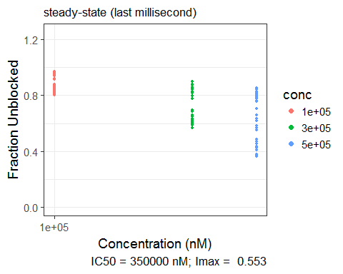

**Figure 19:** Top-panel: Fraction unblocked over time for increasing concentrations of nifedipine. Bottom-panel: Fraction unblocked as a function of increasing drug concentration at steady-state (last millisecond of assay run-time).

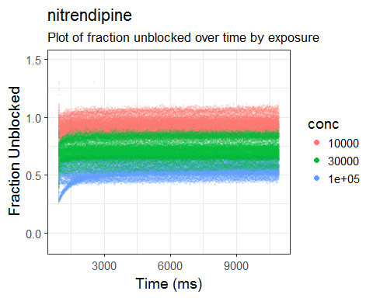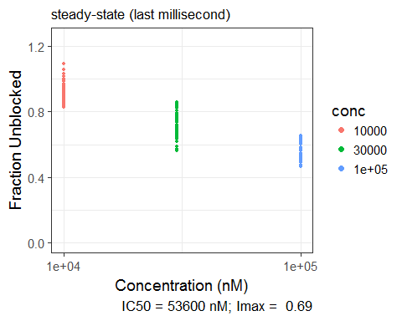

**Figure 20:** Top-panel: Fraction unblocked over time for increasing concentrations of nitrendipine. Bottom-panel: Fraction unblocked as a function of increasing drug concentration at steady-state (last millisecond of assay run-time).

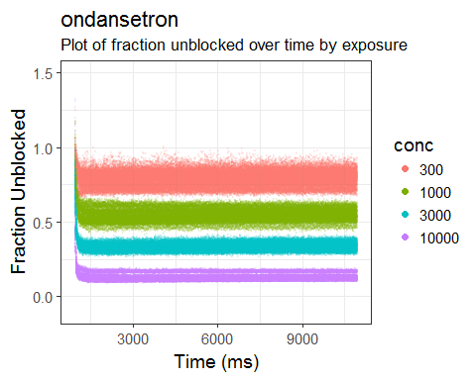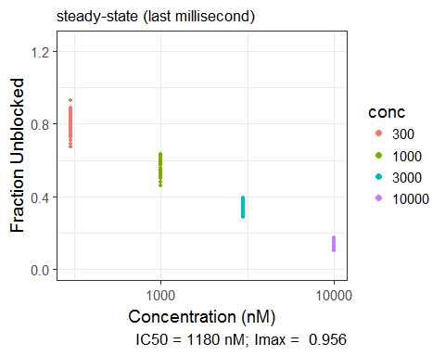

**Figure 21:** Top-panel: Fraction unblocked over time for increasing concentrations of ondansetron. Bottom-panel: Fraction unblocked as a function of increasing drug concentration at steady-state (last millisecond of assay run-time).

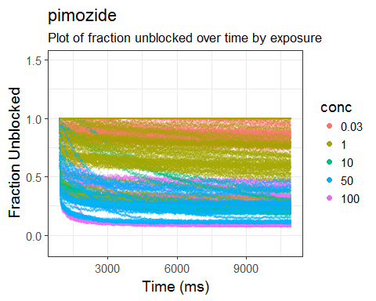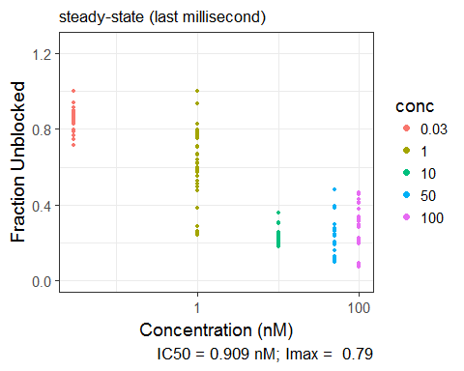

**Figure 22:** Top-panel: Fraction unblocked over time for increasing concentrations of pimozide. Bottom-panel: Fraction unblocked as a function of increasing drug concentration at steady-state (last millisecond of assay run-time).

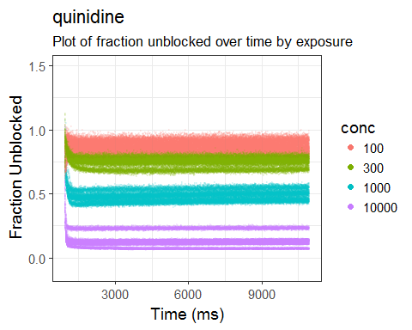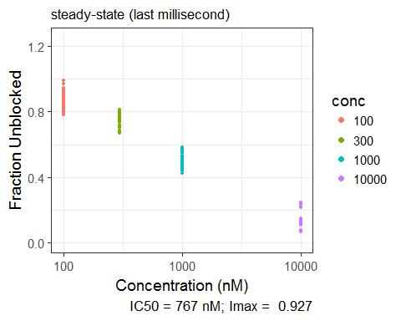

**Figure 23:** Top-panel: Fraction unblocked over time for increasing concentrations of quinidine. Bottom-panel: Fraction unblocked as a function of increasing drug concentration at steady-state (last millisecond of assay run-time).

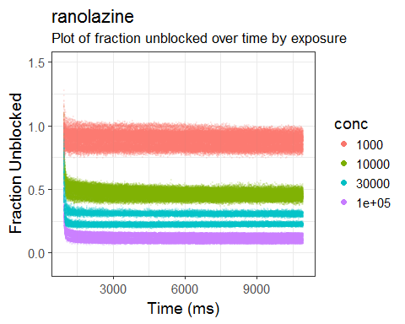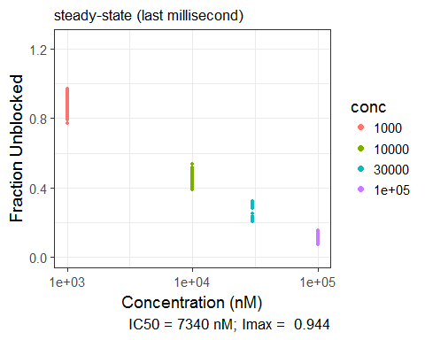

**Figure 24:** Top-panel: Fraction unblocked over time for increasing concentrations of ranolazine. Bottom-panel: Fraction unblocked as a function of increasing drug concentration at steady-state (last millisecond of assay run-time).

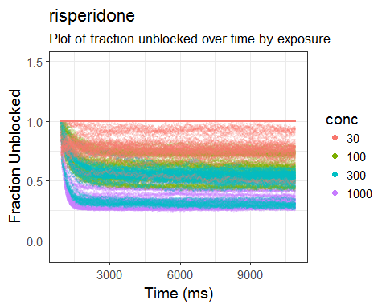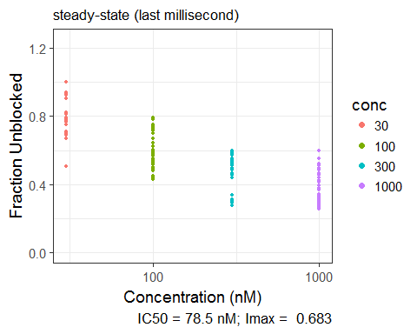

**Figure 25:** Top-panel: Fraction unblocked over time for increasing concentrations of risperidone. Bottom-panel: Fraction unblocked as a function of increasing drug concentration at steady-state (last millisecond of assay run-time).

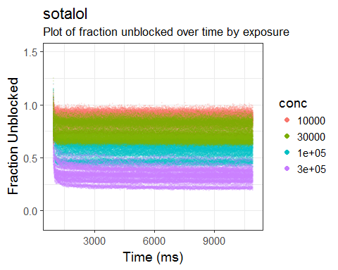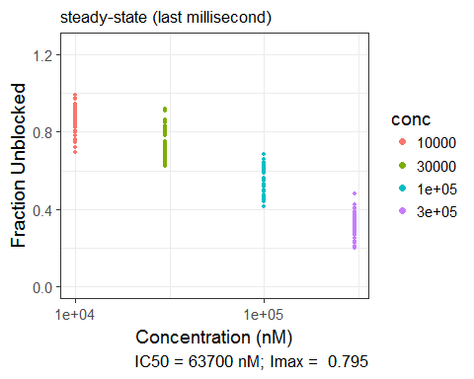

**Figure 26:** Top-panel: Fraction unblocked over time for increasing concentrations of sotalol. Bottom-panel: Fraction unblocked as a function of increasing drug concentration at steady-state (last millisecond of assay run-time).

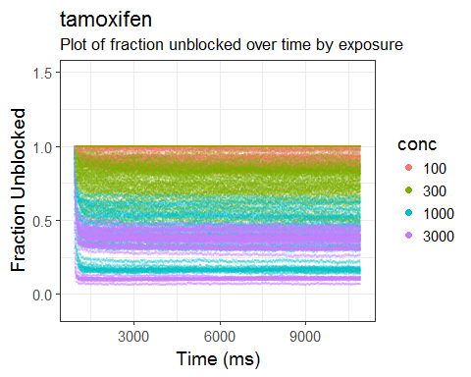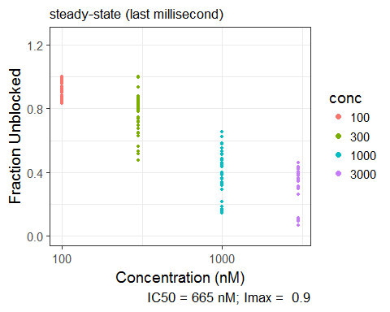

**Figure 27:** Top-panel: Fraction unblocked over time for increasing concentrations of tamoxifen. Bottom-panel: Fraction unblocked as a function of increasing drug concentration at steady-state (last millisecond of assay run-time).

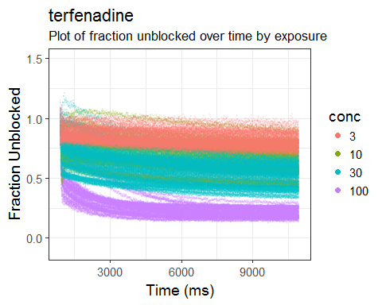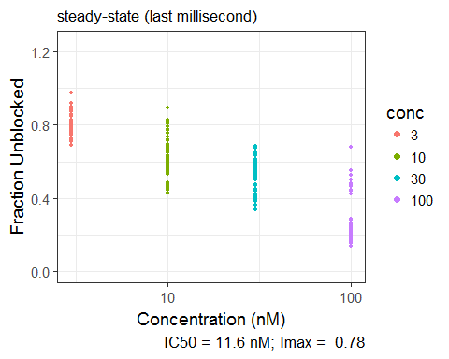

**Figure 28:** Top-panel: Fraction unblocked over time for increasing concentrations of terfenadine. Bottom-panel: Fraction unblocked as a function of increasing drug concentration at steady-state (last millisecond of assay run-time).

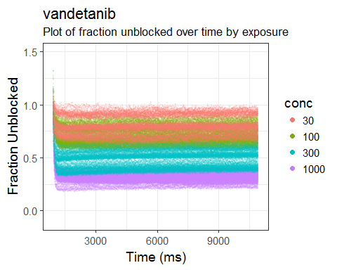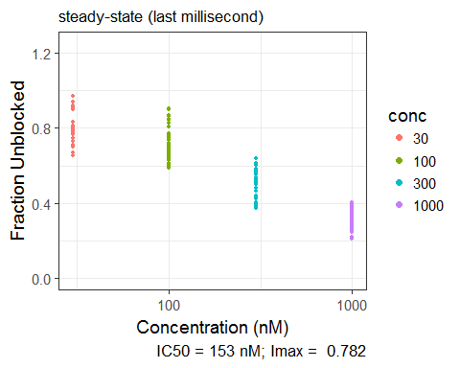

**Figure 29:** Top-panel: Fraction unblocked over time for increasing concentrations of vandetanib. Bottom-panel: Fraction unblocked as a function of increasing drug concentration at steady-state (last millisecond of assay run-time).

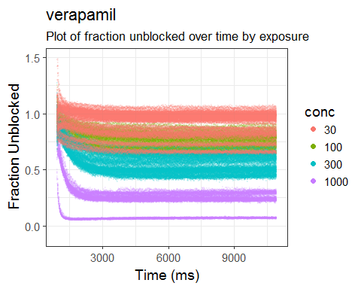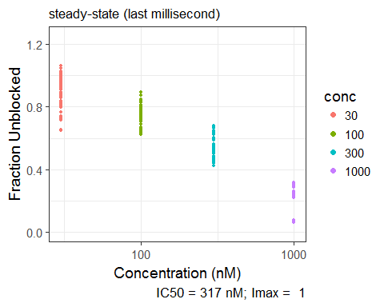

**Figure 30:** Top-panel: Fraction unblocked over time for increasing concentrations of verapamil. Bottom-panel: Fraction unblocked as a function of increasing drug concentration at steady-state (last millisecond of assay run-time).

**References**

Li, Z., Ridder, B.J., Han, X., Wu, W.W., Sheng, J., Tran, P.N., Wu, M., Randolph, A., Johnstone, R.H., Mirams, G.R., Kuryshev, Y., Kramer, J., Wu, C., Crumb, W.J., Strauss, D.G., 2018. Assessment of an In Silico Mechanistic Model for Proarrhythmia Risk Prediction Under the CiPA Initiative. Clin. Pharmacol. Ther. https://doi.org/10.1002/cpt.1184