Security and Privacy Risks in Healthcare IoT
An AI-Assisted Threat and Privacy Assessment
Dataset: Synthetic Healthcare IoT Telemetry
Tools: Python, pandas, scikit-learn, Draw.io
Deliverable: Threat / Privacy Assessment Report
September 2026

Executive Summary
This project builds an end-to-end pipeline to identify security threats and privacy risks affecting Internet of Things (IoT) devices used in healthcare settings. Because real patient telemetry cannot be used for security testing, a synthetic dataset of 20,872 readings across 72 simulated devices (six device types: ECG wearables, SpO2 wearables, smart infusion pumps, glucose monitors, smart thermometers, and blood-pressure monitors) was generated in Python/pandas, with realistic attack and privacy-risk patterns deliberately injected and labeled.
Two independent detection approaches were then applied: an explainable rule-based detector (signature rules an analyst would configure in a SIEM/IDS) and an unsupervised Isolation Forest model (the AI/ML layer). The rule-based detector achieved 0.96 F1 against the injected ground truth (recall 0.92, zero false positives); the ML detector alone achieved 0.39 F1, and the combined detector reached 0.92 recall — illustrating that rule-based signatures outperform generic anomaly detection for well-specified attack patterns, while ML adds value for catching novel or unspecified anomalies at the cost of more false positives.
On the privacy side, a k-anonymity analysis using ward, device type, and hour-of-day as quasi-identifiers found that all 672 groups tested had k ≤ 5 (336 groups with k ≤ 2), meaning a patient's device telemetry is potentially re-identifiable from a small set of indirect attributes even when patient IDs are pseudonymous. This is flagged as the highest-priority privacy finding.
The report concludes with a STRIDE-based threat model (data-flow diagram and attack tree provided as Draw.io files), a device-level risk register, and prioritized technical and governance recommendations covering encryption, device authentication, firmware integrity, anomaly-based monitoring, and data minimization.

1. Objective and Scope

1.1 Objective
Identify security threats and privacy risks in a representative healthcare IoT ecosystem, quantify them using a synthetic telemetry dataset and AI-assisted anomaly detection, and produce an actionable threat/privacy risk assessment supported by data analysis and threat-modeling diagrams.

1.2 In Scope
- Wearable vital-sign monitors (ECG heart rate, SpO2), smart infusion pumps, glucose monitors, smart thermometers, and blood-pressure monitors.
- The data path from bedside device → hospital gateway → cloud/backend → EHR/dashboard.
- Network- and application-layer threats: spoofing, tampering, replay, unauthorized access, denial of service, firmware integrity.
- Privacy risks arising from metadata correlation and re-identification, independent of direct identifiers.

1.3 Out of Scope
- Physical/hardware-level attacks requiring device teardown (side-channel analysis, JTAG extraction).
- Real patient data — all data used is synthetically generated (Section 3).
- Formal regulatory certification (HIPAA/GDPR audit); frameworks are referenced for risk framing only, not as a compliance attestation.

2. Methodology and Tools
Stage | Tool / Technique | Purpose
Data generation | Python, pandas, numpy | Simulate 72 devices over 72 hours with injected attack/privacy patterns
Threat detection | pandas rules; scikit-learn Isolation Forest | Rule-based signature detection + unsupervised ML anomaly detection
Privacy analysis | pandas (k-anonymity grouping) | Quantify re-identification risk via quasi-identifier grouping
Threat modeling | Draw.io (diagrams.net) | Data-flow diagram with STRIDE overlay; attack tree for a critical scenario
Reporting | Word (.docx) | Consolidated threat/privacy assessment deliverable

Methodology follows four steps: (1) generate synthetic telemetry with known ground-truth threat labels; (2) run detection to test whether labeled events are recoverable from telemetry alone; (3) run a privacy re-identification analysis independent of the security labels; (4) synthesize both into a STRIDE threat model, device risk register, and recommendations.

3. Synthetic Dataset and Simulated Ecosystem
The dataset simulates a small hospital network: 6 device types x 12 devices each = 72 devices, each reporting a vital-sign reading every 15 minutes over a 72-hour window (20,872 total records). Each device carries a synthetic patient ID, hospital ward, home subnet, and firmware version.

3.1 Injected Threat / Attack Patterns (Ground Truth)
Label | Pattern | STRIDE category | Count
spoofed_vital_reading | Physiologically implausible spike/drop in a vital-sign value | Tampering | 39
brute_force_auth | Burst of failed authentication attempts before a success | Spoofing | 116
replay_attack | Exact duplicate reading re-sent out of time order | Repudiation | 20
unauthorized_ip_access | Device traffic from a non-hospital / external IP range | Elevation of Privilege | 24
denial_of_service_burst | Abnormally high request rate (150–400 req/min) | Denial of Service | 86
firmware_downgrade | Device reports rollback to known-vulnerable firmware | Tampering | 18

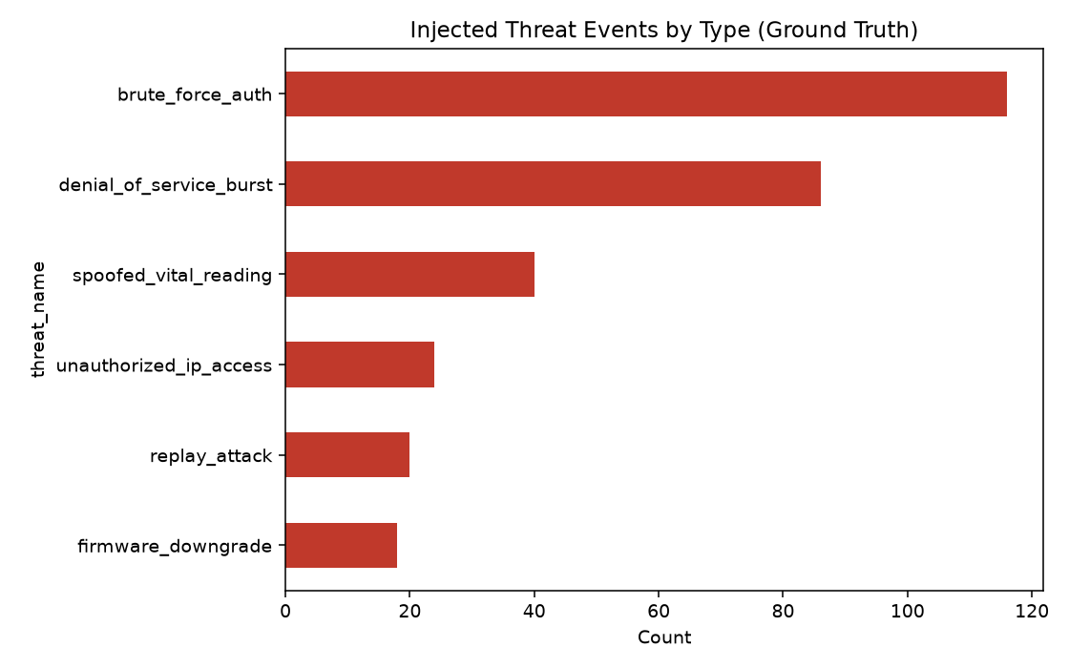
Figure 1. Injected threat events by type (ground truth), out of 303 total labeled events.

4. Threat Model: Data-Flow Diagram and STRIDE Analysis
A data-flow diagram (DFD) was built in Draw.io covering the full path from patient to clinician: Patient → IoT Device → Hospital Gateway → Cloud/Backend API → EHR/Dashboard → Clinician, with three trust boundaries (bedside, hospital network, cloud/vendor) and three data stores (telemetry store, device identity store, audit log). The file dfd_stride_threat_model.drawio (delivered alongside this report; open at diagrams.net or desktop Draw.io) overlays STRIDE threats at each boundary crossing.
STRIDE category | Example threat in this system | Primary control
Spoofing | Attacker impersonates a device using brute-forced or default credentials | Unique per-device certificates/keys; account lockout; mutual TLS
Tampering | Vital-sign values altered in transit, or firmware rolled back to a vulnerable version | Message integrity (HMAC/signing); signed firmware; anti-rollback protection
Repudiation | A replayed/duplicated reading cannot be distinguished from a genuine new one | Sequence numbers / nonces; server-side timestamp validation; audit logging
Information Disclosure | PHI-bearing telemetry intercepted over unencrypted or misconfigured links | TLS/DTLS everywhere; encryption at rest; strict access control on data stores
Denial of Service | A device or attacker floods the gateway/cloud with requests | Rate limiting; anomaly-based throttling; network segmentation
Elevation of Privilege | Traffic from an external/unauthorized IP is accepted as a trusted device | Network allow-listing by subnet; zero-trust device authentication; least privilege on APIs

4.1 Attack Tree: Compromising a Smart Infusion Pump
Because an infusion pump directly controls medication dosing, it represents the highest-consequence single-device compromise in this ecosystem. An attack tree (attack_tree_infusion_pump.drawio, delivered alongside this report) decomposes the goal “deliver an incorrect medication dose” into four alternative attack paths: (A1) compromising pump network communications to inject a spoofed dosage command, (A2) exploiting weak or default device authentication to push a malicious configuration, (A3) forcing a firmware rollback and exploiting a known vulnerability in the older version, and (A4) misusing legitimate clinician credentials (insider or stolen-credential path). Each path lists its concrete sub-steps and a corresponding mitigation, directly reusable as a design checklist for procurement or hardening of infusion-pump deployments.

5. AI-Assisted Threat Detection Results
Two detectors were run over the full telemetry set and scored against the injected ground-truth labels (303 true threat events out of 20,872 records):
- Rule-based: source IP outside hospital subnets; request rate > 20/min; failed authentication; known-vulnerable firmware version; vital-sign z-score > 4 within device type.
- Isolation Forest (scikit-learn): unsupervised outlier detection over reading value, battery %, signal strength, and request rate, with contamination = 2%.

Detector | True Pos. | False Pos. | False Neg. | Precision | Recall | F1
Rule-based | 278 | 0 | 25 | 1.00 | 0.92 | 0.96
Isolation Forest | 141 | 277 | 162 | 0.34 | 0.47 | 0.39
Combined (rule OR ML) | 280 | 277 | 23 | 0.50 | 0.92 | 0.65

Interpretation: the rule-based layer alone catches 92% of injected threats with zero false positives, because the injected patterns (bad IPs, failed logins, vulnerable firmware, extreme values) are exactly the signatures it was written to catch. The Isolation Forest, used generically without tuning to these specific attacks, has weaker precision — expected, since unsupervised anomaly detection flags any statistical outlier, including benign edge cases (e.g., a genuinely sick patient's extreme vitals). In a production deployment, the two are complementary: rules handle known attack signatures cheaply and precisely, while ML anomaly detection is retained specifically to catch novel attacks that have no existing signature — accepting a higher false-positive rate as the cost of that coverage.
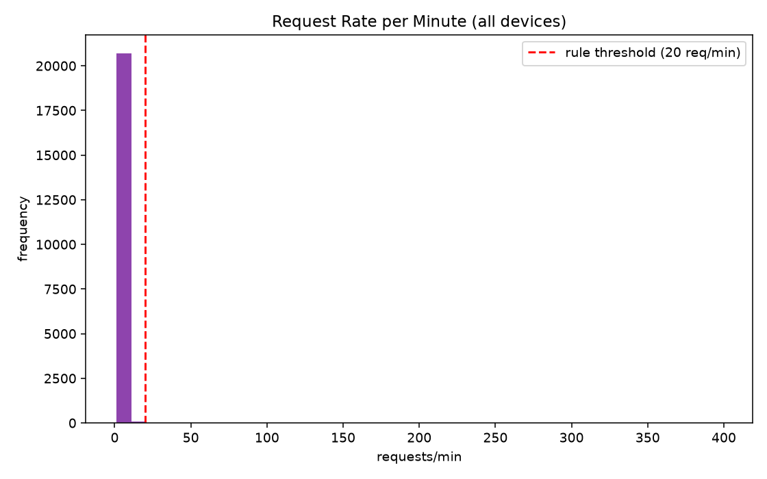
Figure 2. Request-rate distribution across all devices; the red line marks the DoS rule threshold used by the rule-based detector.
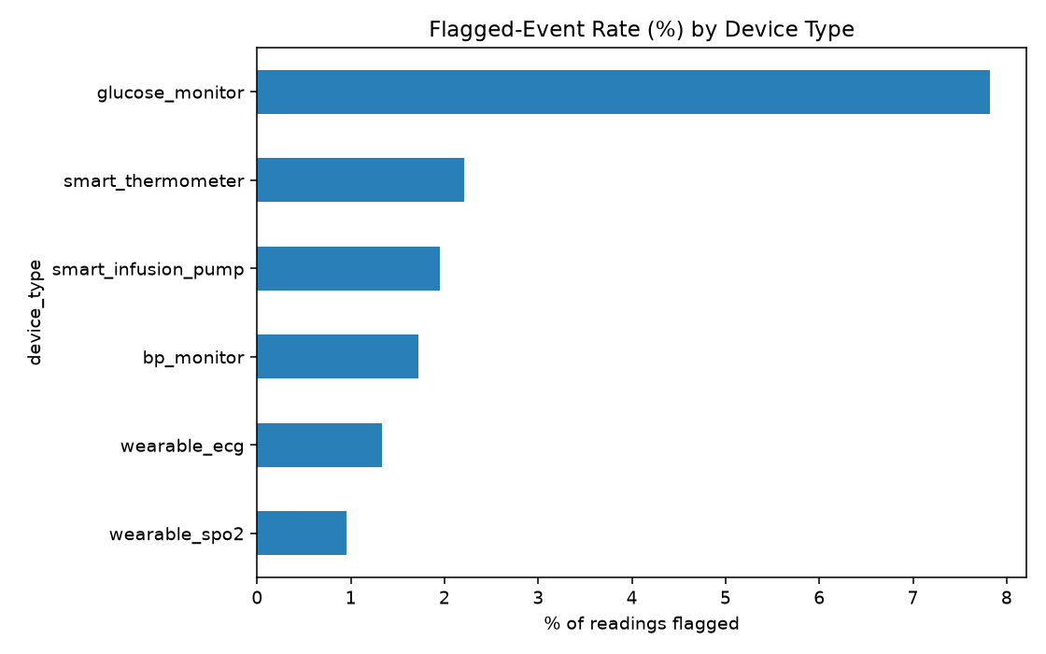
Figure 3. Percentage of readings flagged (rule OR ML) by device type — glucose monitors show the highest flag rate.

5.1 Device-Level Risk Summary
Device type | Total readings | Flagged events | Flag rate
glucose_monitor | 3,475 | 251 | 7.22%
smart_thermometer | 3,487 | 84 | 2.41%
smart_infusion_pump | 3,471 | 74 | 2.13%
wearable_ecg | 3,478 | 63 | 1.81%
bp_monitor | 3,475 | 49 | 1.41%
wearable_spo2 | 3,486 | 36 | 1.03%

Glucose monitors show the highest flag rate in this simulation; combined with the fact that glucose data directly drives insulin-dosing decisions, this device class is treated as elevated priority in the risk register below (Section 7).

6. Privacy Risk Assessment

6.1 Data Sensitivity Classification
Field | Category | Sensitivity | PHI/HIPAA-relevant?
patient_id | Pseudonymous identifier | High | Yes (linkable)
reading_value (vitals) | Health data | High | Yes
device_id | Device metadata | Medium | Indirect
ward | Location metadata | Medium | Indirect
timestamp | Temporal metadata | Medium | Indirect
source_ip | Network metadata | Medium | No (security-relevant)
firmware_version | Device metadata | Low | No
battery_pct / signal | Telemetry metadata | Low | No

6.2 Re-identification Risk (k-Anonymity Analysis)
Even when a patient identifier is pseudonymous, combining a handful of indirect attributes can single out an individual's records. This was tested by grouping records on three quasi-identifiers — ward, device type, and hour-of-day — and counting how many distinct patients share each combination (k). A small k means few individuals could produce that combination, so an observer who knows just those attributes (e.g., “ICU, infusion pump, around 2 PM”) can narrow a record down to one or two possible patients.
k range | Risk level | Groups observed (of 672)
k ≤ 2 | CRITICAL — near-unique re-identification | 336 (50%)
k ≤ 5 (and > 2) | HIGH | 336 (50%)
k ≤ 10 (and > 5) | MODERATE | 0
k > 10 | LOW | 0

Finding: 100% of quasi-identifier combinations tested fall into the CRITICAL or HIGH re-identification risk bands. This is the report's single most significant privacy finding — it shows that ward + device type + hour of day alone, all of which are operationally necessary and routinely logged, are already sufficient to re-identify a specific patient's telemetry in a hospital of this size. Smaller wards (e.g., Pediatrics) and less common device types (e.g., smart_infusion_pump, glucose_monitor) are the most exposed, since fewer patients share those combinations at a given hour.
Recommended mitigations: generalize timestamps to coarser buckets (e.g., shift/quarter-day rather than hour) before sharing with any secondary system or analytics vendor; suppress or generalize ward for small wards below a minimum patient count; apply k-anonymity or differential-privacy techniques before any telemetry leaves the primary clinical system; and treat device-level metadata (device_id, ward, timestamp together) as PHI-adjacent for access-control purposes, not merely as “operational data.”

7. Consolidated Risk Register
# | Risk | Likelihood | Impact | Priority
R1 | Re-identification of patients via ward/device/time metadata correlation (k-anonymity failure) | High | High | Critical
R2 | Tampered/spoofed vital-sign readings leading to incorrect clinical decisions | Medium | High | Critical
R3 | Infusion pump command injection or firmware rollback leading to incorrect dosing | Low–Medium | Very High | Critical
R4 | Brute-force or credential-reuse attacks against device authentication | High | Medium | High
R5 | Unauthorized external network access accepted as trusted device traffic | Medium | High | High
R6 | Denial-of-service floods disrupting telemetry availability for clinical monitoring | Medium | Medium | Medium
R7 | Replay of old readings masking a real deterioration or masking an attack | Low | Medium | Medium
R8 | Insider misuse of legitimate clinical credentials on high-consequence devices | Low | High | Medium–High

8. Recommendations

8.1 Technical Controls
- Encrypt all device-to-gateway and gateway-to-cloud traffic (TLS/DTLS with mutual certificate authentication); never rely on network isolation alone.
- Issue unique per-device credentials/certificates; enforce account lockout and rate-limit authentication attempts to blunt brute-force attacks (R4).
- Require signed firmware images with anti-rollback protection so devices cannot be downgraded to versions with known vulnerabilities (R2, R3).
- Add sequence numbers or timestamps with server-side freshness checks to reject replayed packets (R7).
- Enforce network allow-listing by hospital subnet and treat any device traffic from an unrecognized IP range as high-priority alert, not silently accepted data (R5).
- Deploy the rule-based detector as a first-line, low-false-positive filter, and layer an ML anomaly detector behind it to catch attacks with no existing signature — tune contamination/thresholds per device type rather than globally, since flag rates varied 7x across device types in this analysis.
- Apply rate limiting and anomaly-based throttling at the gateway to contain DoS bursts before they reach the backend (R6).

8.2 Privacy / Governance Controls
- Treat ward + device type + timestamp as quasi-identifiers requiring the same access controls as PHI, given the k-anonymity findings in Section 6.2 (R1).
- Generalize or bucket timestamps (e.g., shift-level rather than exact time) and suppress ward detail for low-population wards before data leaves the primary clinical system for analytics, research, or vendor use.
- Apply data minimization: only forward the fields a downstream consumer (e.g., a billing or research system) actually needs, rather than the full telemetry record.
- Maintain an immutable audit log of all access to the telemetry and identity data stores, and review it against the STRIDE Repudiation and Information Disclosure categories on a regular cadence.
- Require dual authorization or an additional confirmation step for dosing-relevant configuration changes on infusion pumps, independent of network-layer controls (R3, R8).

8.3 Priority Order
Given the risk register in Section 7, remediation priority should be: (1) infusion-pump/dosing-device hardening and firmware integrity (R2, R3) given very-high clinical impact; (2) telemetry re-identification mitigation (R1) given it affects 100% of analyzed groups; (3) device authentication hardening (R4, R5); (4) availability/DoS controls (R6); (5) replay and insider-misuse controls (R7, R8).

9. Conclusion
This assessment demonstrates that combining synthetic telemetry generation, rule-based and ML-based anomaly detection, k-anonymity privacy analysis, and STRIDE/attack-tree threat modeling produces a concrete, evidence-based risk picture for a healthcare IoT deployment — without requiring access to real patient data. The clearest findings are that (a) known attack signatures are detected reliably by explainable rules, with ML anomaly detection serving as a complementary safety net for unknown attacks, and (b) metadata alone, not just direct identifiers, creates a severe patient re-identification risk that most healthcare IoT deployments do not currently treat as PHI. Both findings translate directly into the prioritized recommendations in Section 8.

Appendix A: Deliverable Files
- scripts/generate_data.py — synthetic dataset generator with embedded attack/privacy patterns
- scripts/analysis.py — rule-based + Isolation Forest threat detection and evaluation
- scripts/privacy_analysis.py — k-anonymity re-identification analysis and data classification
- data/healthcare_iot_telemetry.csv — 20,872-row synthetic telemetry dataset
- data/device_inventory.csv — 72-device fleet metadata
- outputs/flagged_threats.csv — all detector-flagged events with STRIDE category and detection source
- outputs/detection_performance.csv, device_risk_summary.csv, k_anonymity_report.csv, data_classification.csv
- diagrams/dfd_stride_threat_model.drawio — data-flow diagram with STRIDE overlay (open in diagrams.net)
- diagrams/attack_tree_infusion_pump.drawio — attack tree for the infusion-pump compromise scenario

