Software Requirements Specification

Version 3.0

8th March, 2016

Financial Grant Management System

Submitted in partial fulfillment

Of the requirements of

CS 223 Software Engineering

This work is based upon the submissions of the course Software Engineering (CS223). The students who submitted this team projects were :

* Gaurav Kamal – B14CS019
* Hitesh Hingorani – B14CS021
* Pranali Pawar – B14SS011
* Rinku Kumar Meena – B14CS027

**Version 1.0 : Basic idea about our software.**

**Version 2.0 : Some changes have been made.**

1. **Another user – MIDWARE is added to reduce the workload of Admin.**
2. **A service book database will also be maintained to realize how much time is taken by the midware to deal with the application.**

**Version 3.0 : Basic Idea about software.**

# 

# Table of Contents

Table of Contents i

List of Figures ii

1.0. Introduction 1

1.1. Purpose 1

1.2. Scope of Project 1

1.3 Constraints 1

1.4 Assumptions and Dependencies 1

1.3. Glossary 1

1.4. References 1

1.5. Overview of Document 1

2.0. Overall Description 2

2.1 System Environment 2

2.2 Functional Requirements Specification 2

2.2.1 Use case 1 2

Use case: 2

2.3 User Characteristics 2

2.4 Non-Functional Requirements 2

3.0. Requirements Specification 3

3.1 Functional Requirements 3

3.1.1 << Name of the first feature>> 3

3.1.2 << Name of the second feature>> 3

3.3 Detailed Non-Functional Requirements 3

***3.4*** ***Logical Structure of the Data*** 3

4.0 Supporting information 3

4.1 Table of contents and index 3

4.2 Appendixes 3

# List of Figures

<< *Keep it blank for time being* >>

*<< Grants allotted to faculties, PhD / M.Tech scholars & project fellowers >>*

*<< Exact data not in access >>*

*<< Will be assumed for practical execution* >>

# 1.0. Introduction

## 1.1. Purpose

The purpose of this document is to present a detailed description of the Financial Grant Management System. It will explain the purpose and features of the system, the interfaces of the system, what the system will do, the constraints under which it must operate and how the system will react to external stimuli. This document is intended for both the stakeholders and the developers of the system.

## 1.2. Scope of Project

This software system will be a Financial Grant Management System for an organization, which allots some grants for institute members. The software will allow the applicant to apply for grant application, which would otherwise have to be performed manually. This system will be designed to maximize the admin’s productivity by providing tools to analyze & update database, By maximizing the admin’s work efficiency and production the system will meet the admin’s needs while remaining easy to understand and use. More specifically, this system is designed to notify admin about new applications. The system also contains a relational database containing a list of Applicants, status of their grants & required information.

## 1.3 Constraints

* Implemented for a particular institute.
* No registration for Admin.

## 1.4 Assumptions and Dependencies

* Exact amount of grants are not known, so grants amounting to Rs 10,000 are accepted only.
* We are only handling cases of Applicant, Midware & Admin.
* Uploaded bills will be verified manually by Admin.
* Only limited grants will be considered, Travel & Medical.
* All the users are valid and part of the organization.
* Database of users has been created by Register use case only.
* Enough amount for grants.
* User is not making a fake entry in registration.
* Once the application is approved by admin, user can contact administration regarding that grant approval.

## 1.3. Glossary

|  |  |
| --- | --- |
| **Term** | **Definition** |
| Admin | User on administration side |
| Applicant | User who applies for grant |
| Database | Collection of all the information monitored by this system. |
| Grant | A sum of money given by a government or other organization for a particular purpose. |
| Software Requirements Specification | A document that completely describes all of the functions of a proposed system and the constraints under which it must operate. For example, this document. |
| Stakeholder | Any person with an interest in the project who is not a developer. |
| User | Admin or Applicant or Midware |
| Midware | Guide above the Applicants |

## 

## 1.4. References

* IEEE. *IEEE Std 830-1998 IEEE Recommended Practice for Software Requirements Specifications.* IEEE Computer Society, 1998.
* [*www.cse.msu.edu/~chengb/RE-491/Papers/****SRSExample****-webapp.****doc***](http://www.cse.msu.edu/~chengb/RE-491/Papers/SRSExample-webapp.doc)***.***
* <http://172.16.100.118/moodle/pluginfile.php/1365/mod_forum/attachment/141/SRS_Template.docx>.

## 1.5. Overview of Document

The rest of the document is designed in the following way:

# 2.0. Overall Description

## 2.1 System Environment

## 2.2 Functional Requirements Specification

.

### 2.2.1 **Complete Use case** C:\Users\Hp\Desktop\FinancialGrantManagement\UseCaseTotal.jpg

#### Use case:

**Diagram:**

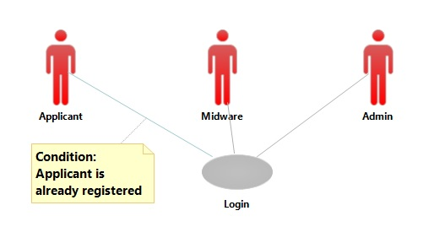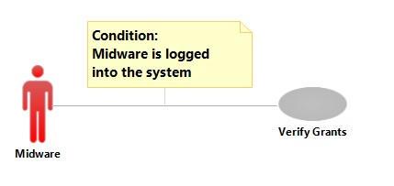

**Brief Description: Class Diagrams** 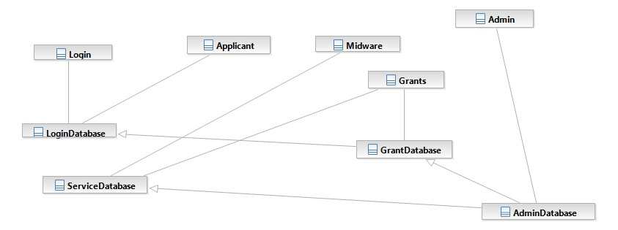

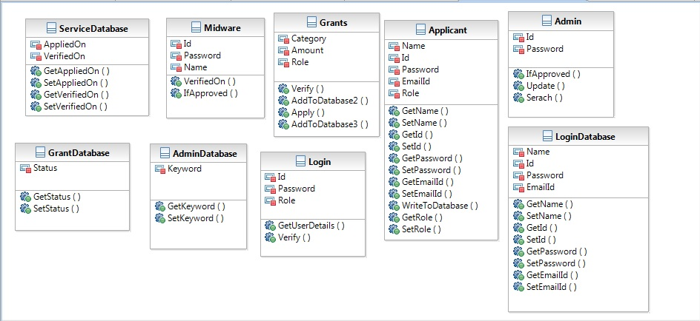

**Brief Description: Sequence Diagrams**

1. **REGISTER**

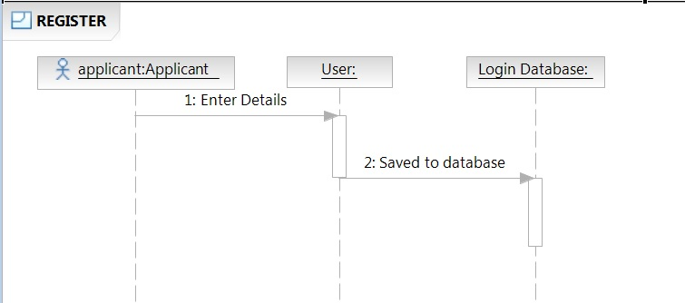

1. **LOGIN**

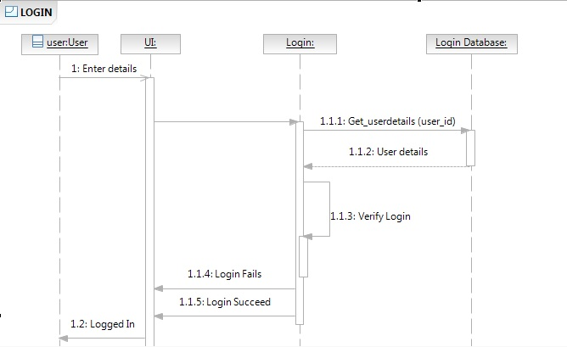

1. **Apply For Grants**

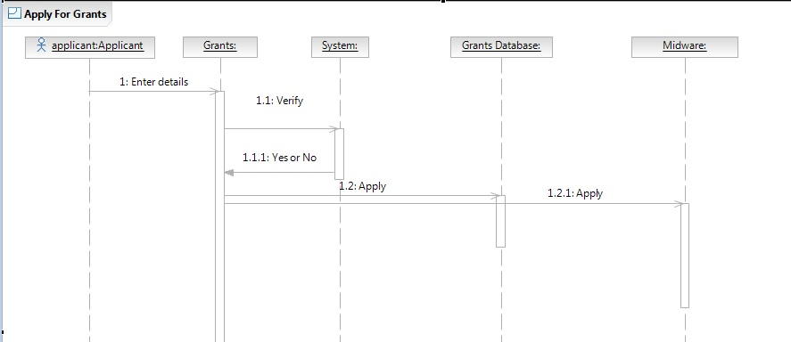

1. **View Grant History**

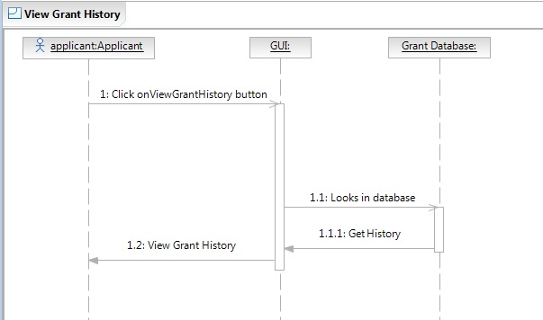

1. **Verify Grants**

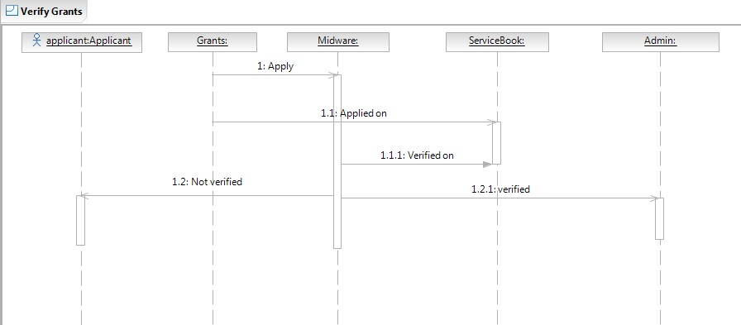

1. **Verify Bills**

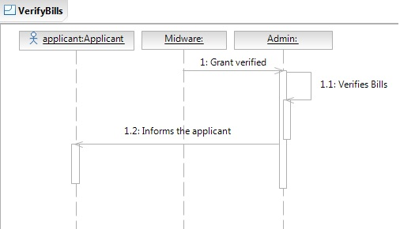

1. **Update**

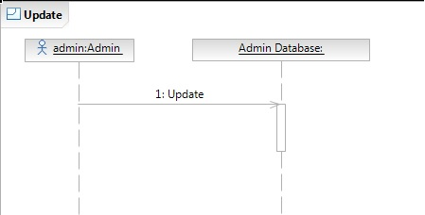

1. **Search**

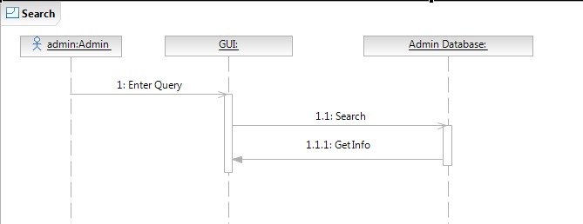

**ACTIVITY Diagrams:**

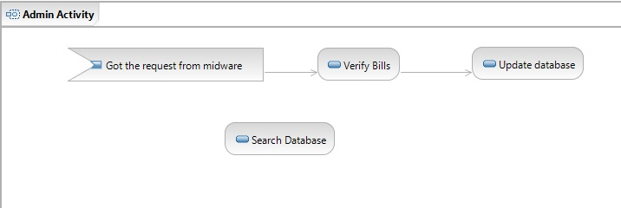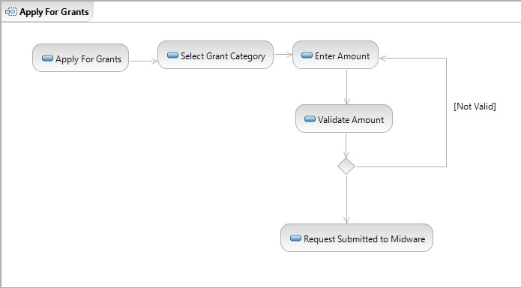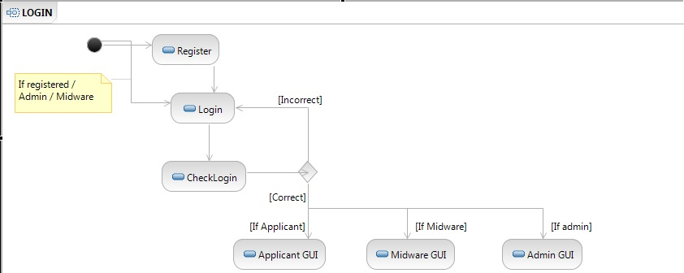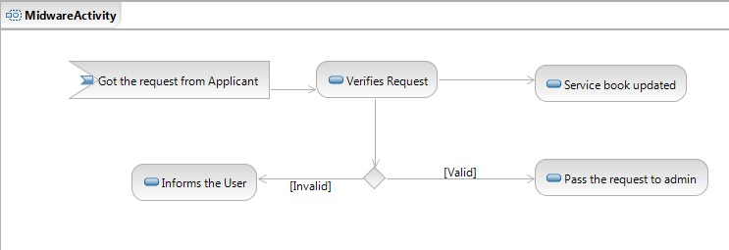

## 2.3 User Characteristics

No pre-requisite Software Skills is required.

## 2.4 Non-Functional Requirements

# 3.0. Requirements Specification

## 3.1 Functional Requirements

### 3.1.1 Register

|  |  |
| --- | --- |
| **Use Case Name** | Register |
| **Trigger** | User wants to be a part of system |
| **Precondition** | User must belongs to institute |
| **Basic Path** | 1. Click Register option 2. Enter details:   User Id – Roll No.  Email Id – provided by college (@ and . are manadatory)  Phone No.- 10 digit numeric.   1. Create password   Password – No constraints.   1. Submit |
| **Alternative Paths** | 4`. Incorrect details  5`. Ask again |
| **Postcondition** | Successfully registered |
| **Exception Paths** | N/A |
| **Other** | N/A |

### 3.1.2 Login

|  |  |
| --- | --- |
| **Use Case Name** | Login |
| **Trigger** | User wants to log in to system |
| **Precondition** | User must be registered into the system . |
| **Basic Path** | 1. Enter username & password 2. Click login |
| **Alternative Paths** | 2`. Invalid credentials.  3`. Ask again. |
| **Post condition** | Successfully logged in to the system |
| **Exception Paths** | N/A |
| **Other** | Applicant & Admin gets separate UI after login |

### 3.1.3 Apply for Grants

|  |  |
| --- | --- |
| **Use Case Name** | Apply for grants |
| **Trigger** | User requires a grant |
| **Precondition** | User is logged into the system. |
| **Basic Path** | 1. User selects appropriate grant.   (i) Travel  (ii) Medical   1. User enters details of grant.   Amount : Greater than zero & Less than 10,000  Details: Reason & description of grant  (3) User applies for grant. |
| **Alternative Paths** | (2`) Enters invalid details.  (3`) Shows error. |
| **Post condition** | Grant successfully applied. |
| **Exception Paths** | User may logout anytime. |
| **Other** | N/A |

### 3.1.4 View Grant History

|  |  |
| --- | --- |
| **Use Case Name** | View Grant History |
| **Trigger** | User wants to view his/her previous grants. |
| **Precondition** | User is logged into the system. |
| **Basic Path** | (1) Clicks History button |
| **Alternative Paths** | N/A |
| **Post condition** | History will be shown. Status of application will be visible. |
| **Exception Paths** | User may logout anytime. |
| **Other** | Grants status can be checked as :   1. Pending 2. Midware Approved 3. Midware Disapproved 4. Admin Approved 5. Admin Disapproved |

### 3.1.5 Verify

|  |  |
| --- | --- |
| **Use Case Name** | Verify |
| **Trigger** | Admin needs to verify applications |
| **Precondition** | Admin must be logged into the system |
| **Basic Path** | (1) Admin gets notifications about new application  (2) Checks the application.  (3) Approves the grant. |
| **Alternative Paths** | (2`) Application is invalid.  (3`) Disapprove/Skip the grant. |
| **Post condition** | Application status will be updated. |
| **Exception Paths** | Admin may logout anytime. |
| **Other** | N/A |

### 3.1.6 Update

|  |  |
| --- | --- |
| **Use Case Name** | Update |
| **Trigger** | To maintain an updated record |
| **Precondition** | Admin is logged into the system. |
| **Basic Path** | (1) Admin verifies the application  (2) Database gets updated |
| **Alternative Paths** | N/A |
| **Post condition** | Database updated. |
| **Exception Paths** | Admin may logout anytime. |
| **Other** | N/A |

### 3.1.7 Search

|  |  |
| --- | --- |
| **Use Case Name** | Search |
| **Trigger** | Admin wants to access any details about financial grants. |
| **Precondition** | Admin is logged into the system. |
| **Basic Path** | (1) Click Search button.  (2) Select category- Name, Id, Email, Type, Amount, Applied On, Verified On.  (3) Enter respective keywords.  (4) Enter search |
| **Alternative Paths** | (4`) Keyword not found  (5`) Ask again |
| **Post condition** | Details found. |
| **Exception Paths** | Admin may logout anytime. |
| **Other** | N/A |

### 3.1.8 Midware Verification

|  |  |
| --- | --- |
| **Use Case Name** | Midware Verification |
| **Trigger** | N/A |
| **Precondition** | Midware must be logged in. |
| **Basic Path** | 1. Verifies the request. 2. Respond accordingly. |
| **Alternative Paths** | (2`) Skip : Application will be served next time Midware logs in. |
| **Post condition** | Request verified. |
| **Exception Paths** | Admin may logout anytime. |
| **Other** | Midware has to respond in 5 working days. |

## 3.3 Detailed Non-Functional Requirements

### ***3.4 Logical Structure of the Data***

<< Keep this blank for the time being>>

# 4.0 Supporting information

## 4.1 Table of contents and index

## 4.2 Appendixes