1. **For the given JSON iterate over all for loops (for, for in, for of, forEach)**

**Please find the code Below**

Const data=

[{

"userId": 1,

"firstName": "Krish",

"lastName": "Lee",

"phoneNumber": "123456",

"emailAddress": "krish.lee@learningcontainer.com"

},

{

"userId": 2,

"firstName": "racks",

"lastName": "jacson",

"phoneNumber": "123456",

"emailAddress": "racks.jacson@learningcontainer.com"

},

{

"userId": 3,

"firstName": "denial",

"lastName": "roast",

"phoneNumber": "33333333",

"emailAddress": "denial.roast@learningcontainer.com"

},

]

console.log("------------------Using FOR LOOP---------------------") ;

//using for loop

for(var i=0;i<data.length;i++) {

console.log(`

id : ${data[i].userId}

firstName : ${data[i].firstName}

lastName : ${data[i].lastName}

EmailAdress : ${data[i].emailAddress}

`);

}

console.log("------------------Using FOR IN LOOP---------------------") ;

//using for in loop

for(let x in data){

console.log(`

id : ${data[x].userId}

firstName : ${data[x].firstName}

lastName : ${data[x].lastName}

EmailAdress : ${data[x].emailAddress}

`);

}

console.log("------------------Using FOR OF LOOP---------------------") ;

//using for in loop

for(let x of data){

console.log(`

id : ${x.userId}

firstName : ${x.firstName}

lastName : ${x.lastName}

EmailAdress : ${x.emailAddress}

`)

}

console.log("------------------Using FOR EACH LOOP---------------------") ;

//using for in loop

data.forEach(function(x){

console.log(`

id : ${x.userId}

firstName : ${x.firstName}

lastName : ${x.lastName}

EmailAdress : ${x.emailAddress}

`)

})

**Output**

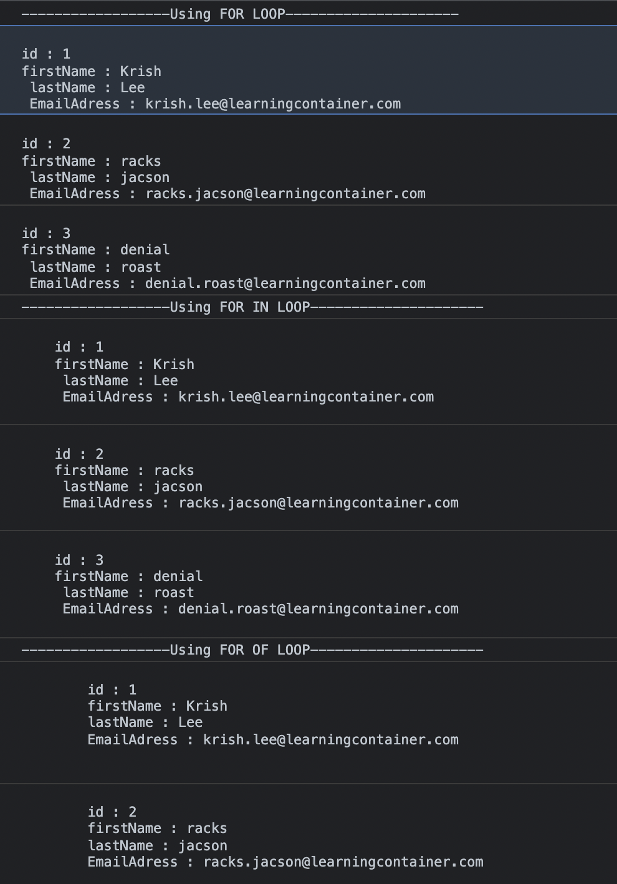

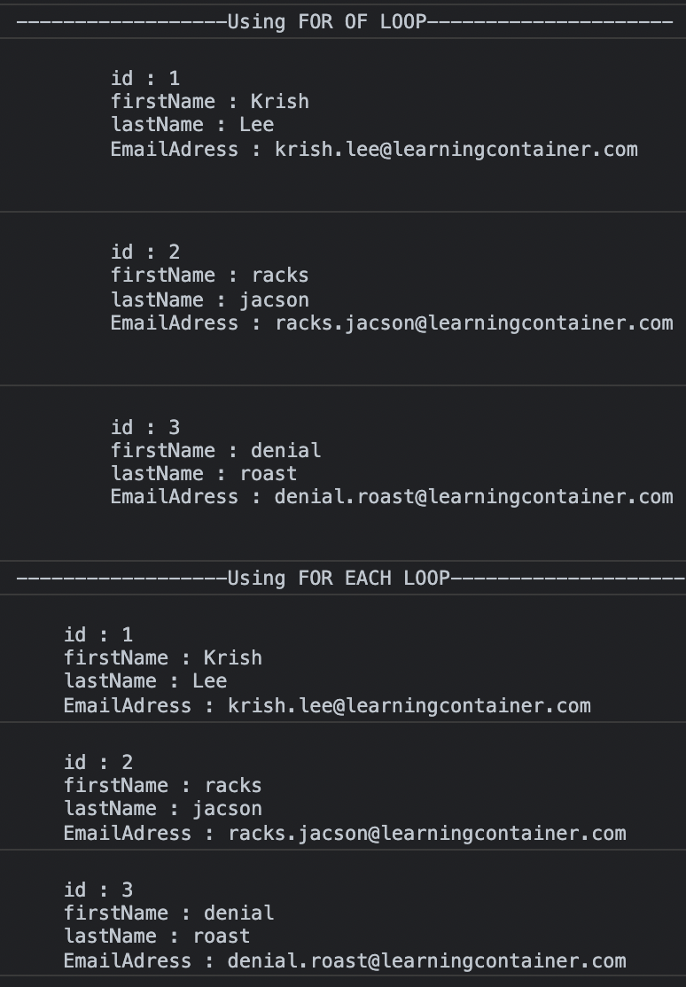

1. **Create your own resume data in JSON format**

{

“FirstName” : “Hitesh”,

“LastName” : “MSR”,

“Gender” : “Male”,

“Age” : 24

“Company” : “Google”,

“Phone No” : 9948700008,

"address":

{

"streetAddress": "MG Road",

"city": "Vijayawada",

"state": "Andhra Pradesh”,

"pinCode": "534447"

},

}