1. How to compare two JSON have the same properties without order?
   1. var obj1 = { name: "Person 1", age:5 };
   2. var obj2 = { age:5, name: "Person 1" };

**Code:-**

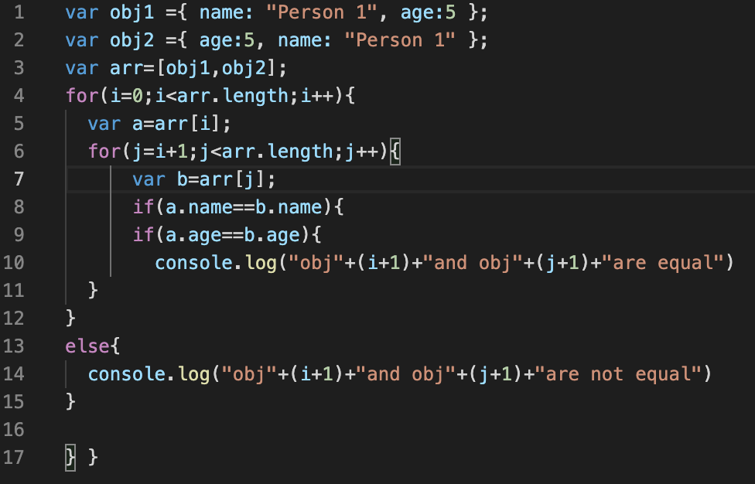

**Output:-**





1. Use the rest countries API url -><https://restcountries.eu/rest/v2/all> and display all the country flags in console

**Code:-**

var request = new XMLHttpRequest();

request.open("GET","https://restcountries.com/v2/all",true)

request.send();

request.onload = function () {

var data = JSON.parse(this.response);

for(i=0;i<data.length;i++) {

var a=data[i].flags.png

console.log('%c ','font-size:200px;background: url('+ a +') no-repeat;');

}

}

**Output:-**

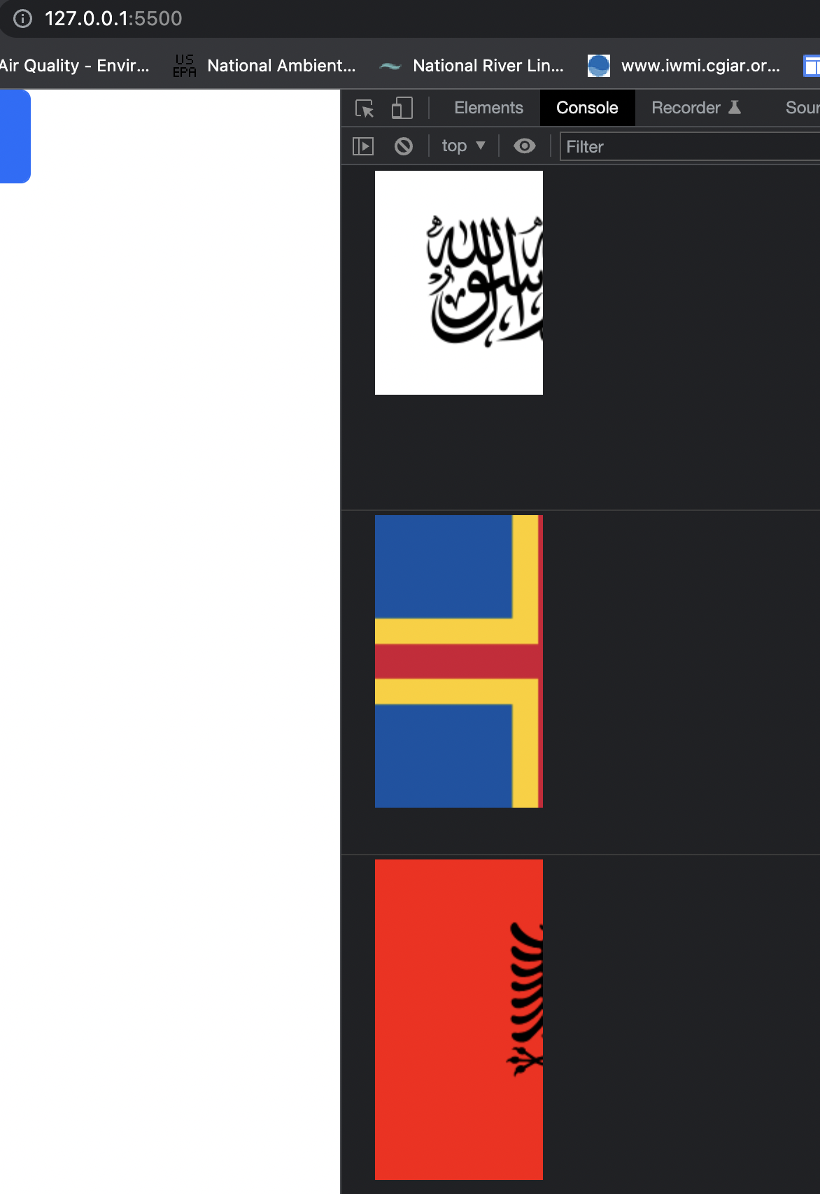

1. Use the same rest countries and print all countries name, region, sub region and population

**Code:-**

ar request = new XMLHttpRequest();

request.open("GET","https://restcountries.com/v2/all",true)

request.send();

request.onload = function () {

var data = JSON.parse(this.response);

for(i=0;i<data.length;i++) {

var a=data[i].flags.png

console.log(`Name : ${data[i].name}

Region : ${data[i].region}

SubRegion : ${data[i].subregion}

population : ${data[i].population}

`)

}

}

**Output:-**

