1. <https://github.com/rvsp/typescript-oops/blob/master/Practice/Movie.md>
2. Write a constructor for the class Movie, which takes a String representing the title of the movie, a String representing the studio, and a String representing the rating as its arguments, and sets the respective class properties to these values.

**Code:-**

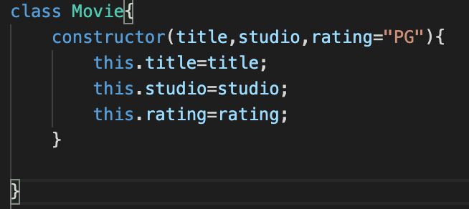

1. The constructor for the class Movie will set the class property rating to "PG" as default when no rating is provided.

**Code:-**



1. Write a method getPG, which takes an array of base type Movie as its argument, and returns a new array of only those movies in the input array with a rating of "PG". You may assume the input array is full of Movie instances. The returned array need not be full.

**Code:-**

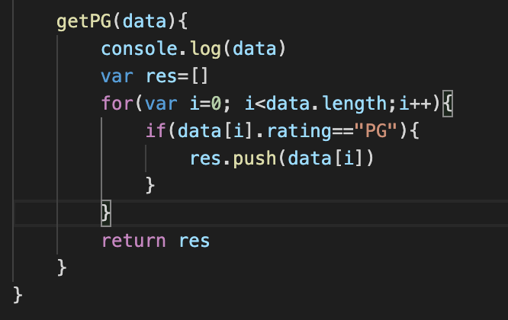 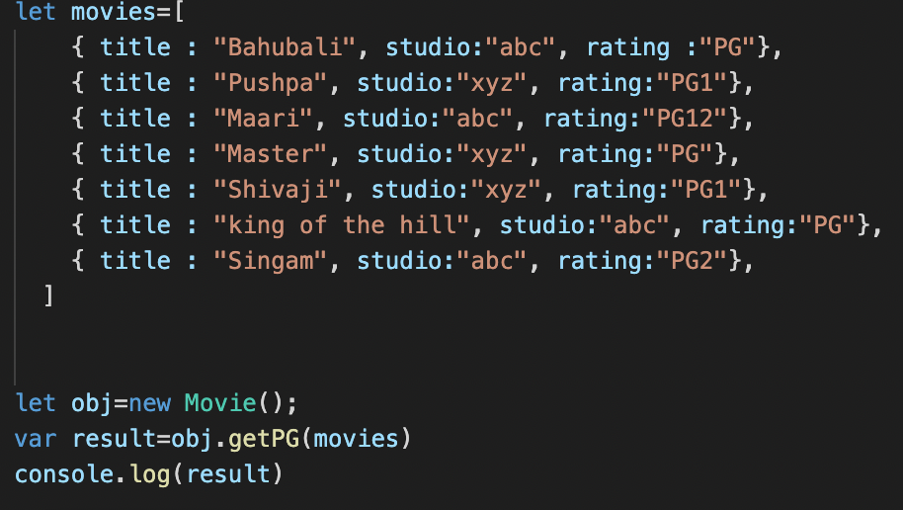

**Output:-**

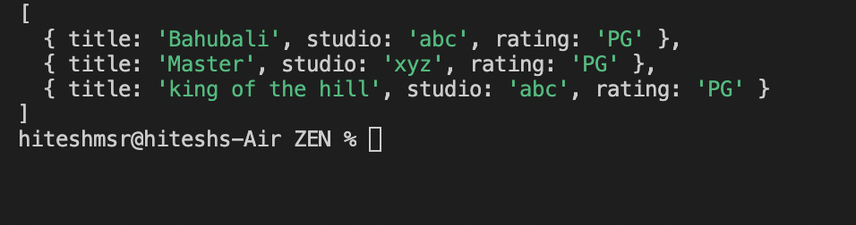

d) Write a piece of code that creates an instance of the class Movie with the title “Casino Royale”, the studio “Eon Productions”, and the rating “PG­13”

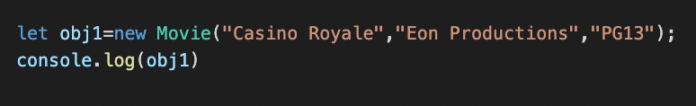 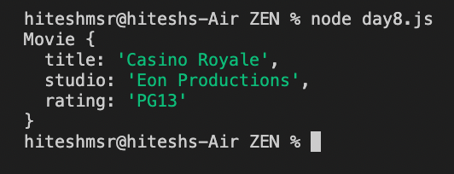

1. https://github.com/rvsp/typescript-oops/blob/master/Practice/class-circle.md
2. Write a “person” class to hold all the details.

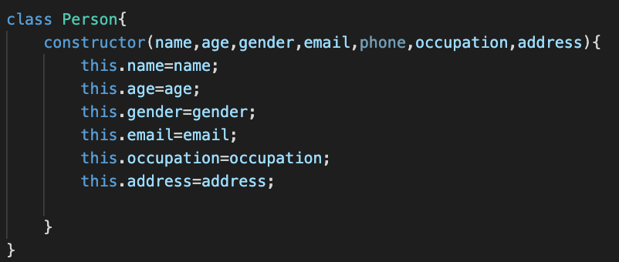



**Output:-**

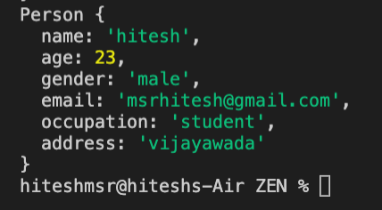

1. write a class to calculate uber price.

**Code:-**

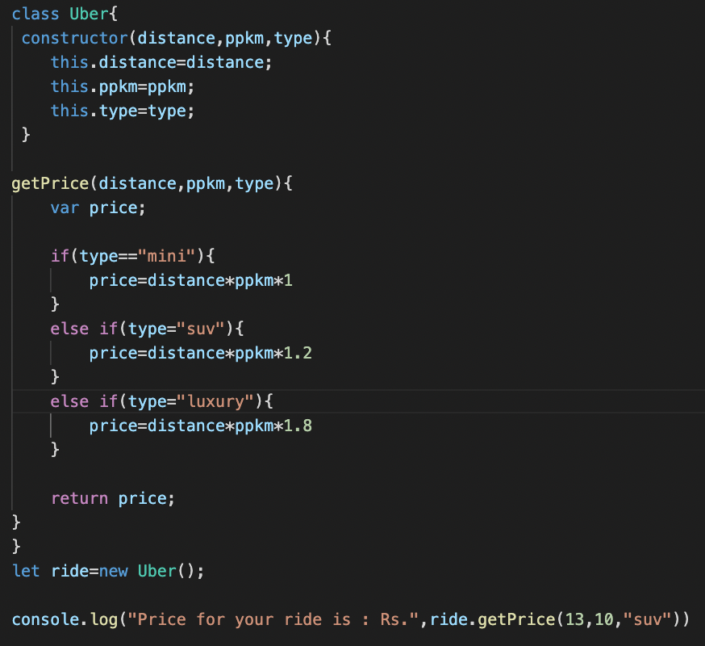

**Output:-**

