1. Solving problems using array functions on rest countries data.
   1. **Get all the countries from Asia continent /region using Filter function**

**Code:-**

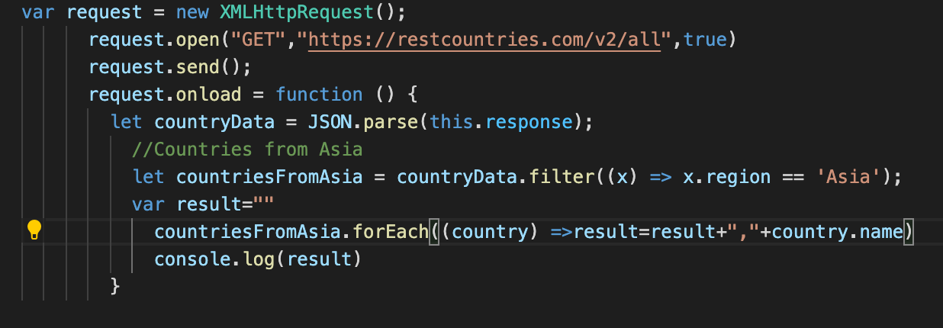

**Output:-  
**

* 1. **Get all the countries with a population of less than 2 lakhs using Filter function**

**Code:-**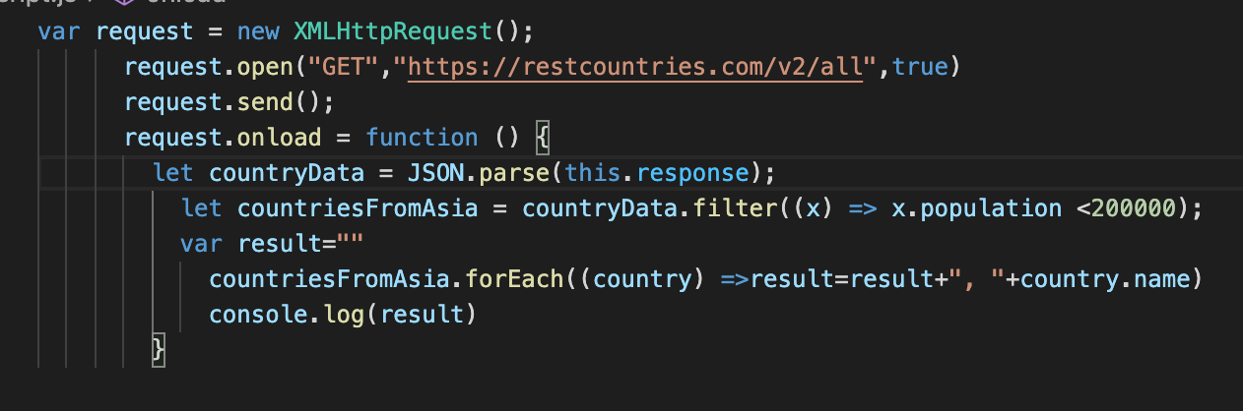

**Output:-**

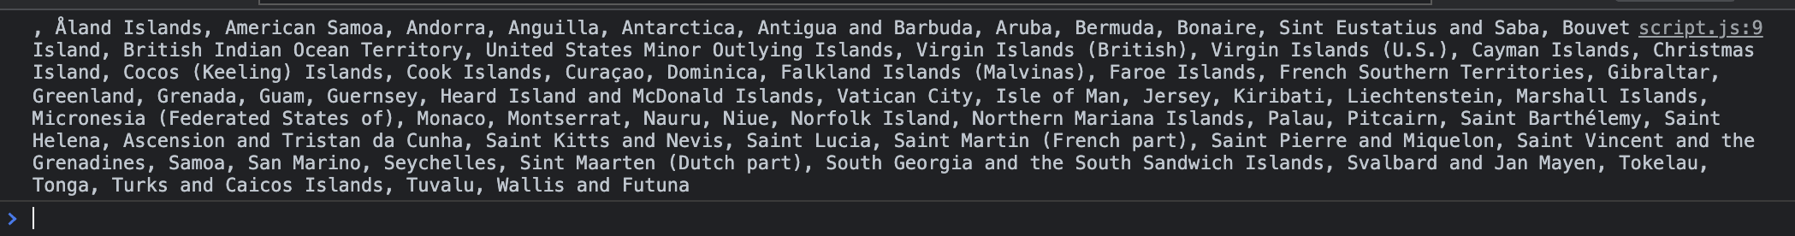

* 1. Print the following details name, capital, flag using forEach function

**Code:-  
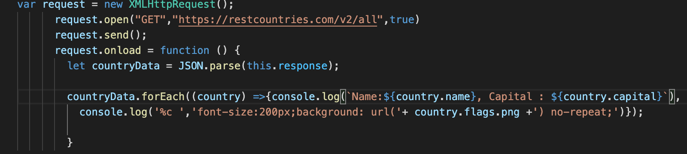**

**Output:-  
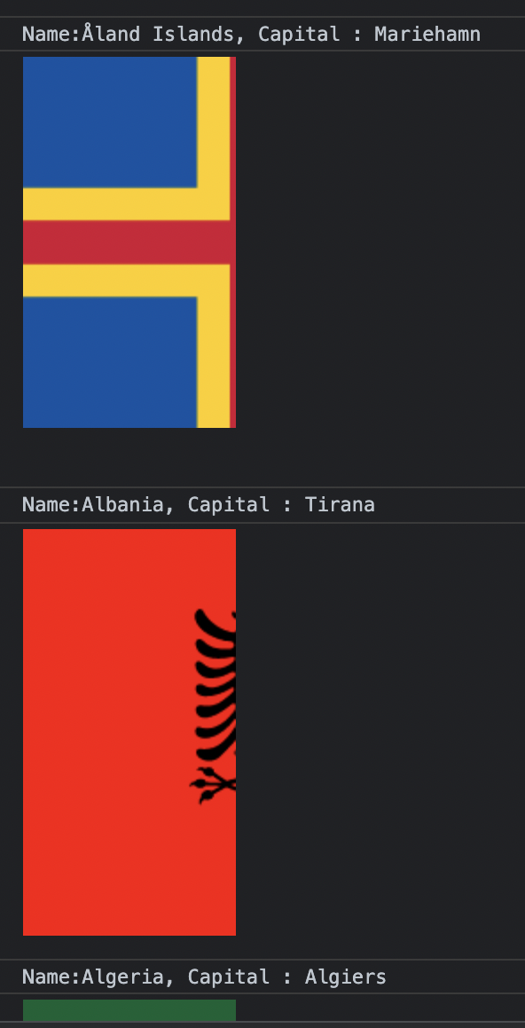**

* 1. Print the total population of countries using reduce function

**Code:-**

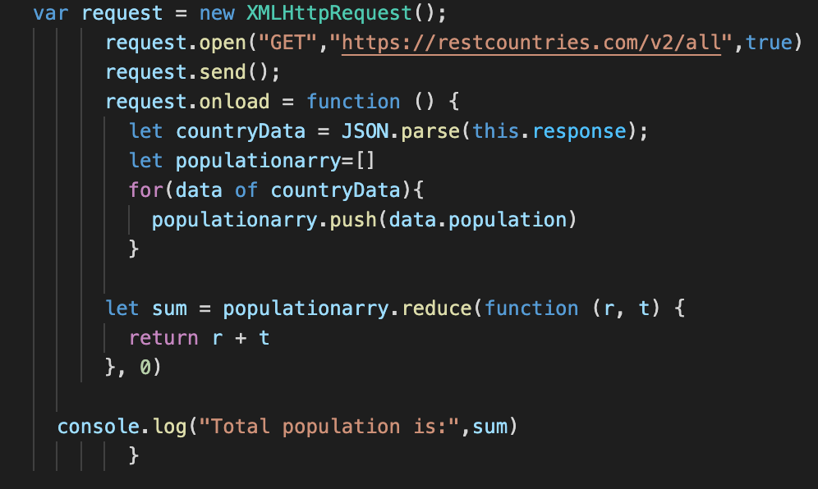

**Output:-**

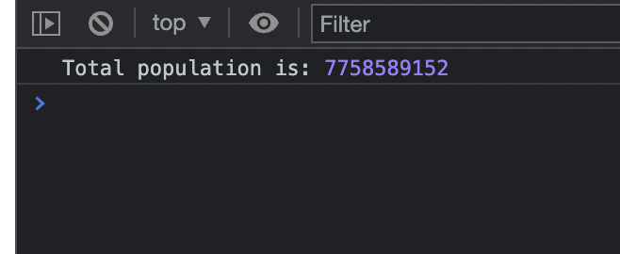

* 1. Print the country which uses US Dollars as currency.

Code & Output

