1. Find all the information about each products

**Query:-** db.products.find().toArray()

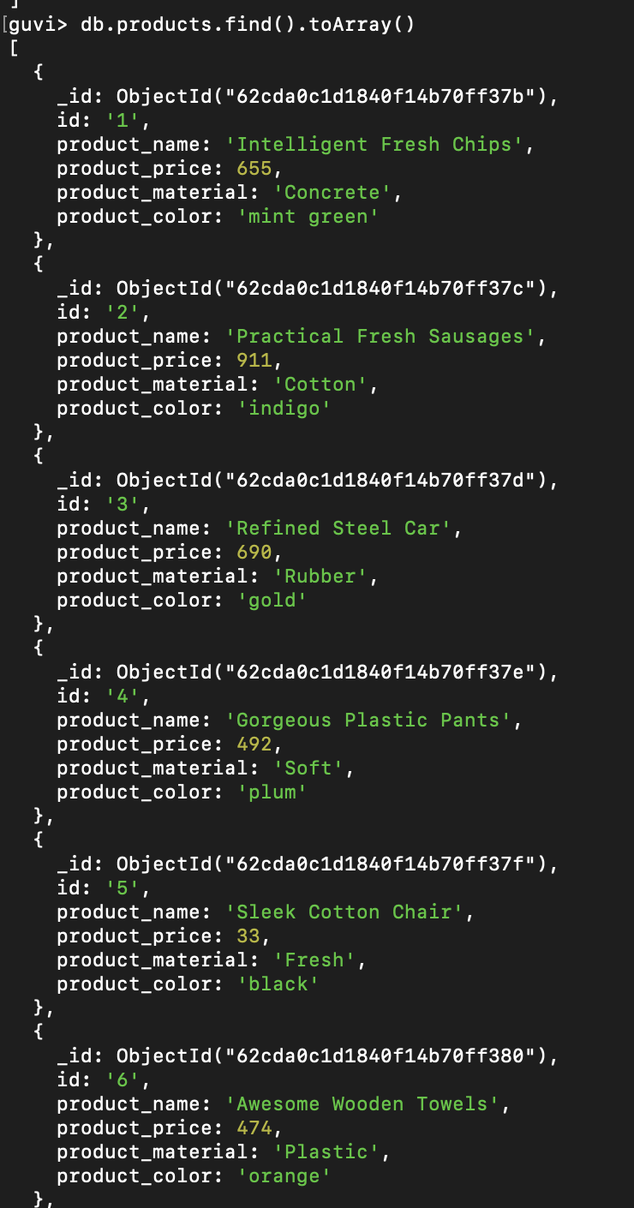

1. Find the product price which are between 400 to 800

**Query:**-db.products.find({$and:[{product_price:{$gte:400}},{product_price:{$lte:800}}]},{product_name:1,product_price:1,_id:0})

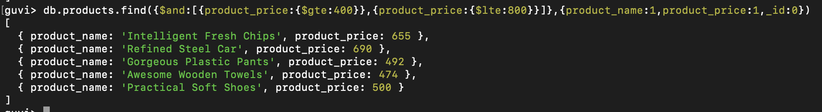

1. Find the product price which are not between 400 to 600

**Query:-** db.products.find({$or:[{product_price:{$lte:400}},{product_price:{$gte:600}}]},{product_name:1,product_price:1,_id:0})

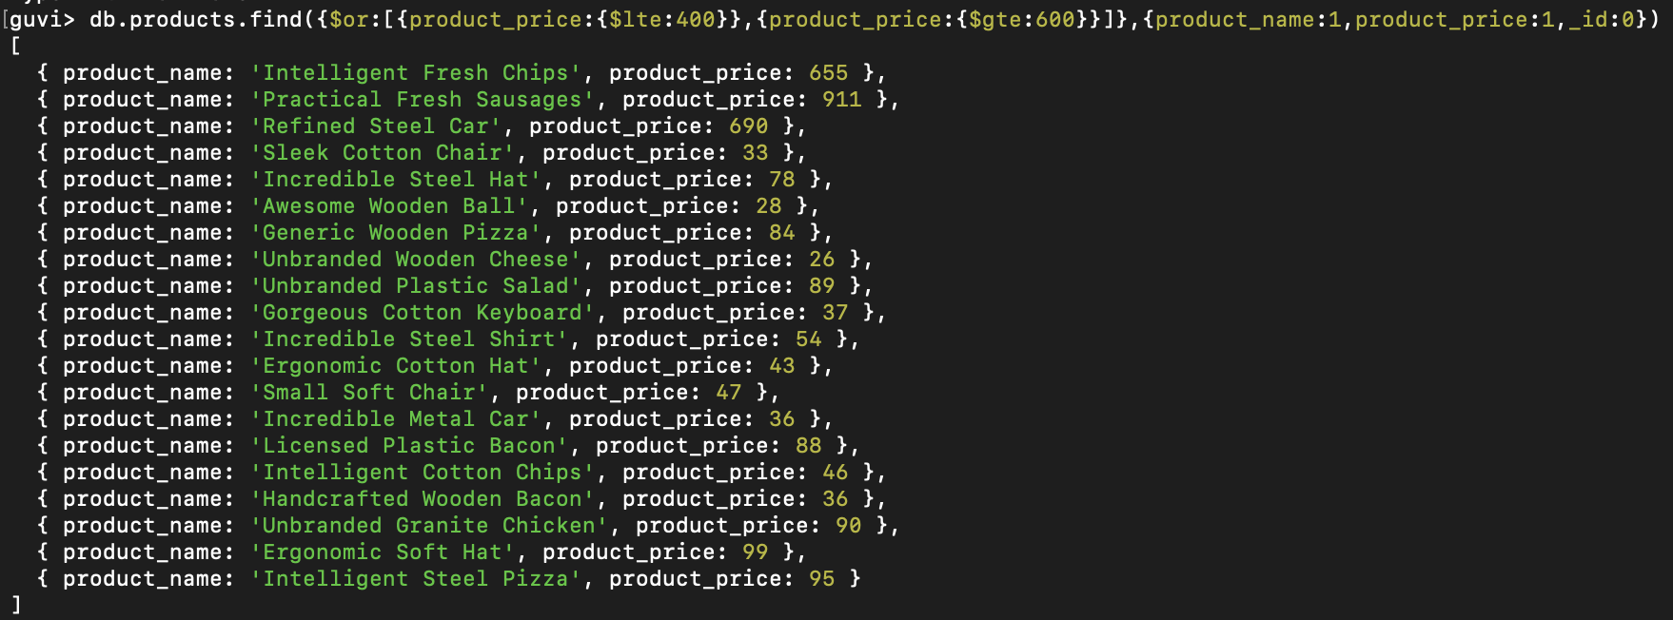

1. List the four product which are grater than 500 in price

**Query:-**db.products.find({product_price:{$gt:500}}).limit(4)

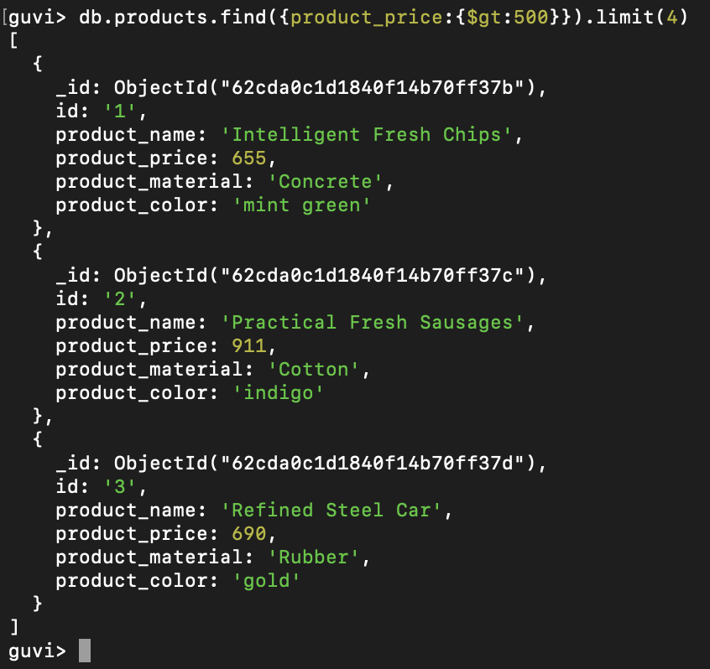

1. Find the product name and product material of each products

**Query:-**db.products.find({},{product_name:1,product_material:1})

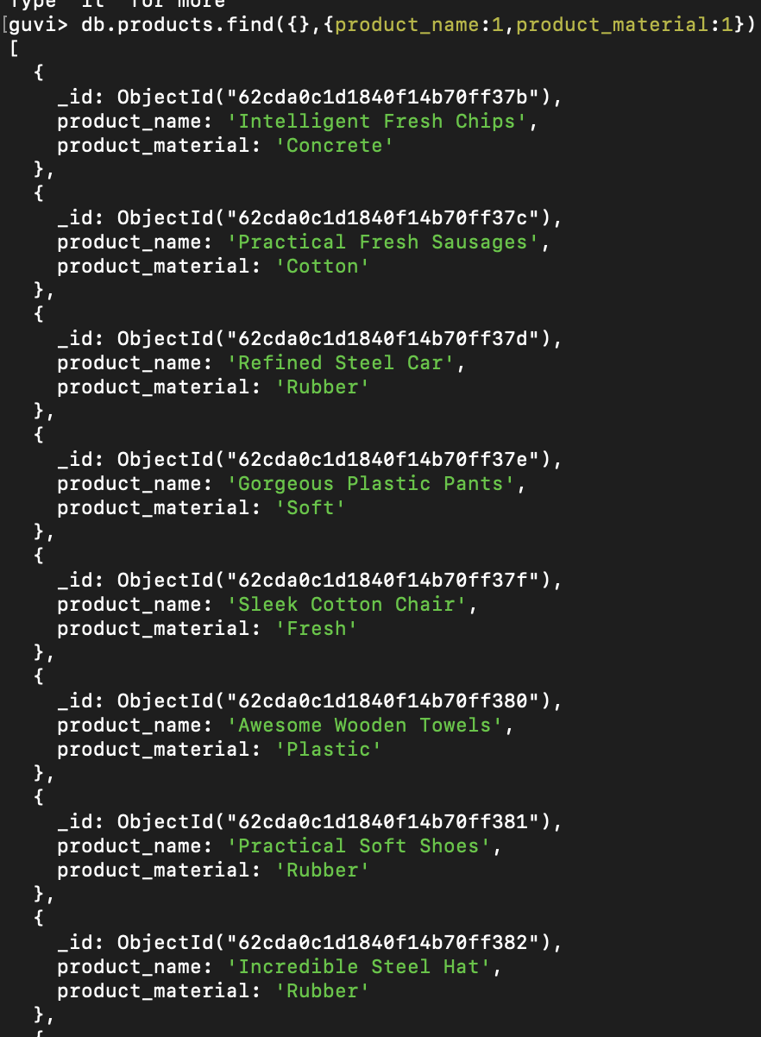

1. Find the product with a row id of 10

**Query:-**db.products.find({id:'10'})

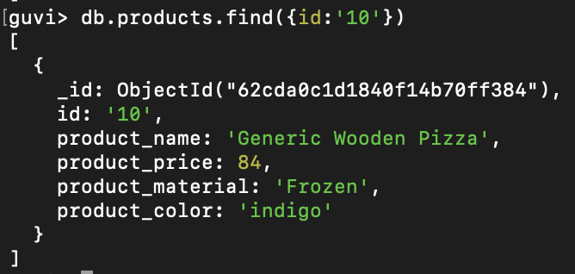

1. Find only the product name and product material

**Query:-** db.products.find({},{product_name:1,product_material:1,_id:0})

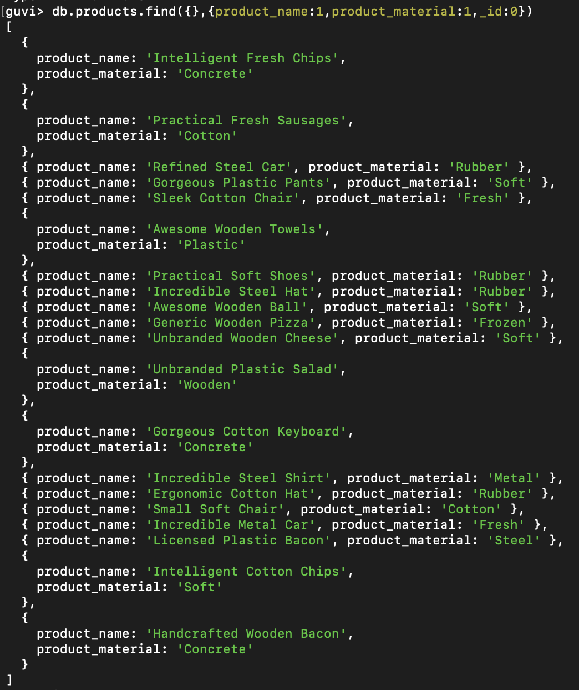

1. Find all products which contain the value of soft in product material

**Query:-**db.products.aggregate([ { $match: { product_material: 'Soft' } }])

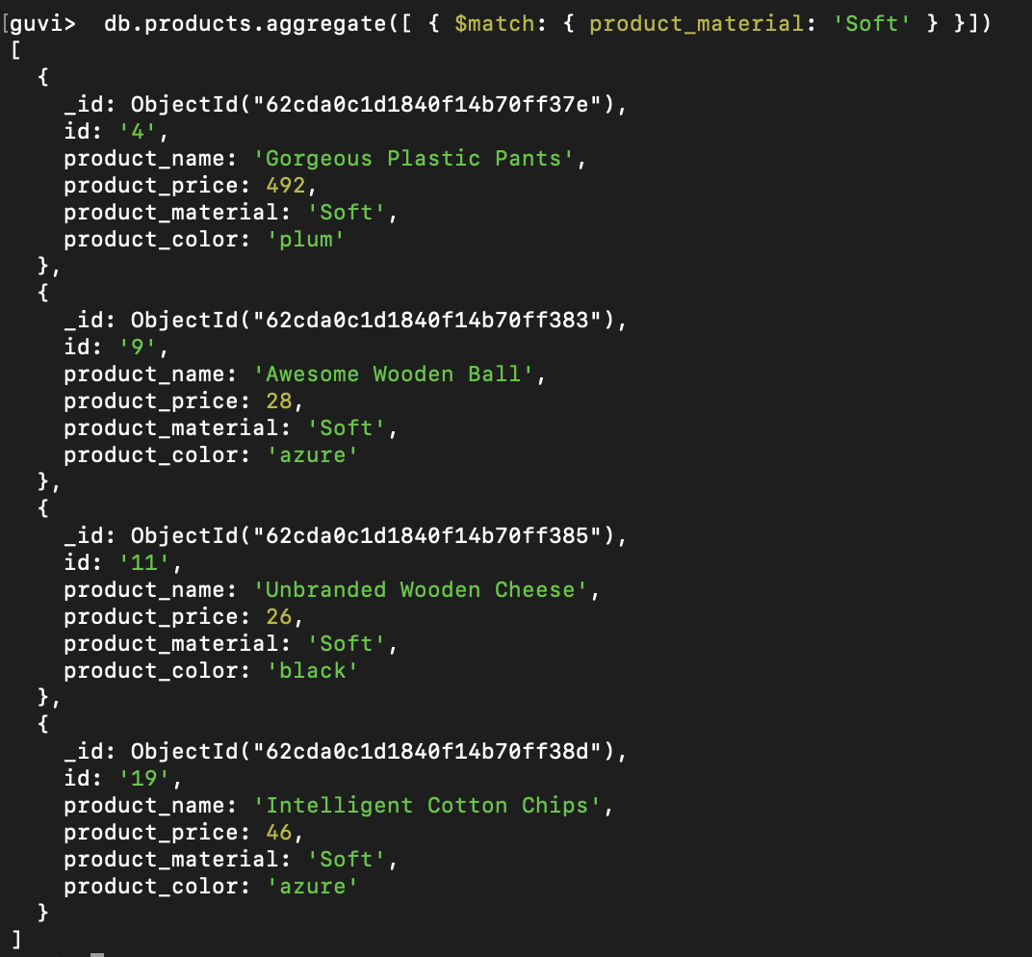

1. Find products which contain product color indigo and product price 492.00

**Query:-**db.products.aggregate([{$match:{$and:[{product_price:492},{product_color:"indigo"}]}}]

**There are no products that has color indigo and price 492**

1. Delete the products which product price value are same

Code to find the repetitive prices:-

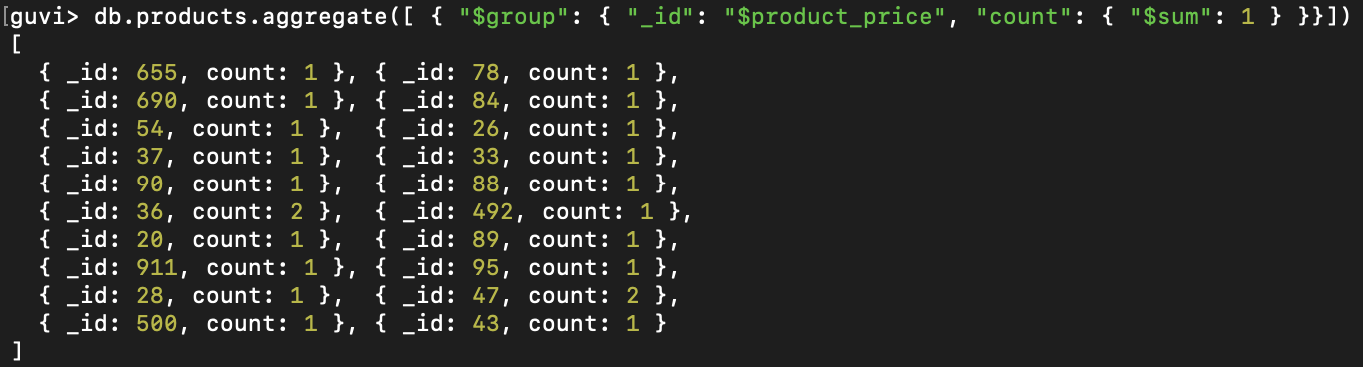

From the above snippet, its seen that 47 and 36 are the prices that are repeating.

To delete those document, we used remove function:-



Snippet of Collection post removing:-

